CERN REVS UP TO TOP SPEED TO OPEN PORTALS

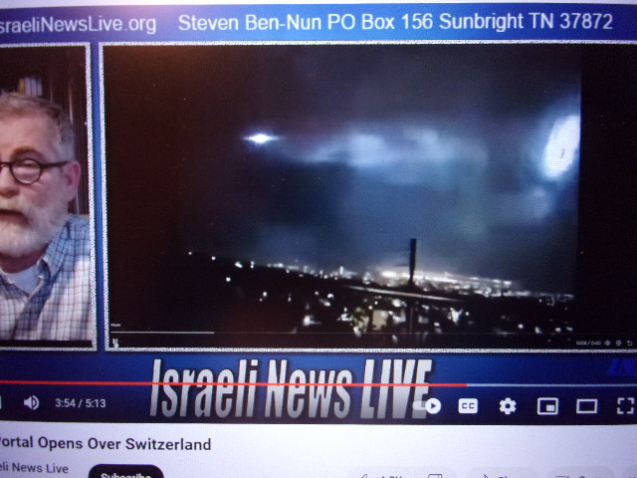
DECEMBER 26, 2023 CERN Turns Up Super Power Opening Portals
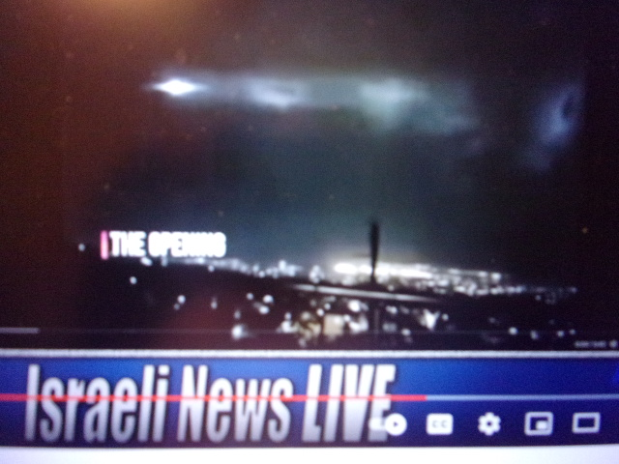
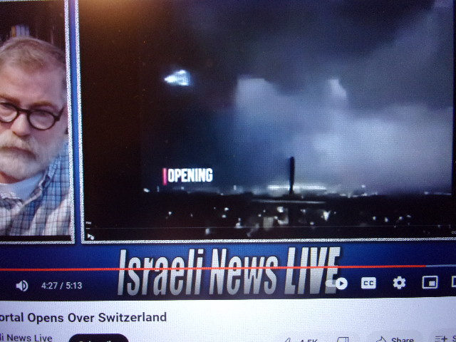

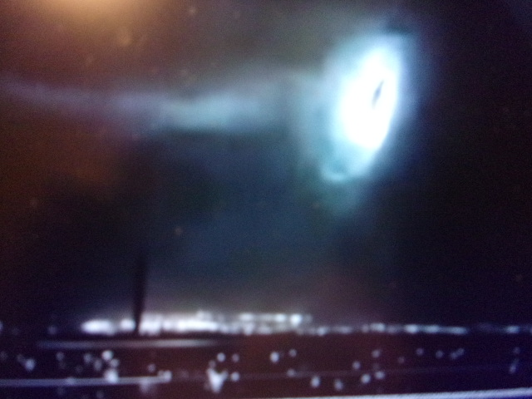
OLSO, NORWAY: OBAMA ARRIVES TO RECEIVE PEACE PRIZE:
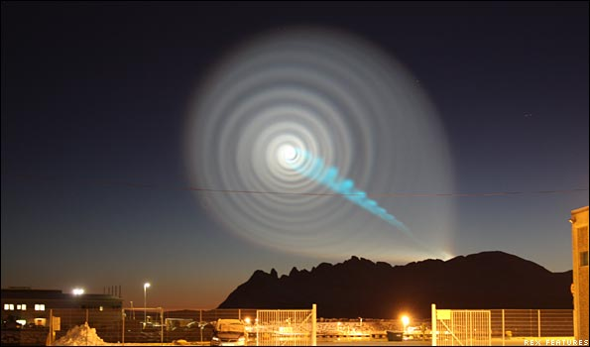
The lying public news, as always lying, said this spiral was a failed Russian missile launch. NO! 7:50 PM local time in Oslo, Norway - December 9, 2009: It is a portal opening, a stargate opening, into another dimension.

“On December 9, 2009, a curious spiral of blue and white light appeared in the night sky over northern Norway and Sweden. Hundreds of people called the Norwegian Meteorological Institute to ask what it was. Everything from anomalous Northern lights to aliens and trans-dimensional wormhole was suggested. Some even linked the event to the high-energy experiments that was going on at that time at the Large Hadron Collider in Switzerland. The light was seen from all across northern Norway as well as from northern Sweden and was reported to have lasted
for 10 minutes.”

We’ve known since his campaign that Obama carries some powerful spiritual “qualities,” being literally worshipped as a god world over, before and during his presidency. His going to Oslo to get a “peace prize” was very strange to say the least. Recently the U.N. has admitted openly that Obama “in his third term as president,” still controlling the White House.

The realm of the supernatural fallen angels, and their Nephilim offspring with human women, are flooding the earth, bringing their technology to the forefront, as in “the days of Noah.” We are here – with earth being taken over by the ones evil that Yahuwah had to cast them into the earth. Lucifer is now in the earth ruling national government leaders, uniting the world around his agenda to destroy Yahuwah and Yahushua and all of Their angels. Nimrod’s tower is back in the forefront of the world’s agenda. The international language at this point is English, but also computer jargon, tech-jargon.

However, a lot has happened since Genesis 11. Yahushua has come, died in our place to remove our sin, to empower us to be the true children of Yahuwah, even returnees to the time of Genesis 1 and 2. The Spirit of Yahuwah is indwelling a remnant of His children who are His trained ones for reigning – Spirit-taught, Spirit-led, Spirit controlled, Spirit transformed.

Now, the time of the final judgment on the fallen ones is at hand. They know the Word well about their demise. Lucifer knows his time is short, so he is going about like a roaring lion, to devour the earth’s people in body, soul, and spirit. The portals to other dimensions are opening – and through them are coming fallen angels and mutates of their own mixing of species. Yes, they have power, yet for those serving Yahuwah and Yahushua, we have Luke 10:19: “I give you authority over all the power of the enemy…” That promise, as with all of Elohim’s promises, comes with a condition: You must be the faithful servant of the Master Yahushua. A lazy-bum has no place in the Kingdom – see Luke chapters 12-14.
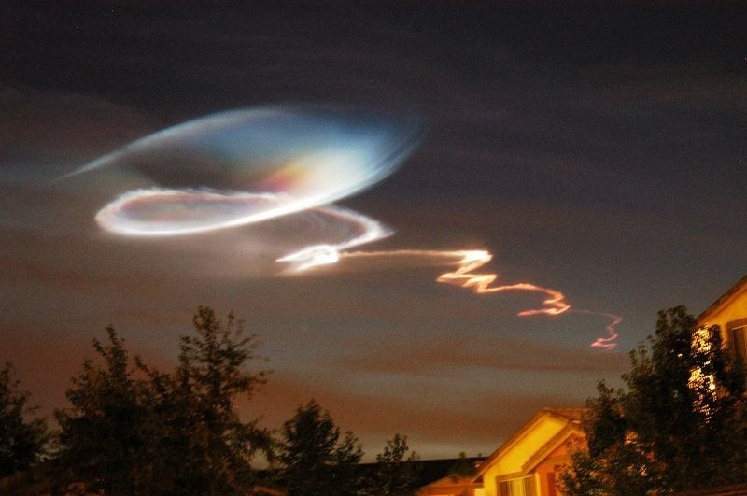
Spirals, strange lights, such as this one over Geneva, over European capitals, are associated with CERN’s firing up more and more speed in the LHC, to collide particles, opening dimensional gateways into other realms. Physicists say there are at least 12 different dimensions.

Our earth dimension is 3 dimensional. Yahuwah’s dimension is outside the cosmos, an eternal reality. However, the fallen ones have discovered how to inhabit planets, moons, and other dimensions. They are coming through dimensions also that are being opened by technology such as CERN. CERN is located on the area that was once a temple dedicated to Apollo. CERN is a highly occultic/fallen angel operation.

Revelation 9:11: The rising of the Beast to take his throne – is “Apollyon” in Greek, just a different way of saying “Apollo.” He was also known as Gilgamesh, also known as Egypt’s Osiris. His body was exhumed from Iraq in 2003 as Gulf War II began. German archeologists worked with US military to not just find his body, but the plans for his tower, his portal-opening tower, i.e. Genesis 11. These plans were given to CERN to continue on with what Nimrod started and Yahuwah stopped. Now, we see portal opening of all types in cosmic lights. The fallen angels are coming through by the tens of thousands.

We are IN THE DAYS OF NOAH right now. Judgment is in the hands of the Judge, Yahuwah. Before Messiah returns, humanity will be almost extinct on the earth, as the Beast is a devouring Beast – to rid earth of humanity, or all life forms of animals, birds, fish, good insects, etc. to return earth to the condition of Genesis 1:2, when the fallen ones ruled earth.

We are near the end of planet earth as we know it. Messiah will once again have to do another Genesis 1:3, as we see in II Peter 3:8-18. As the portals open these lights appear, many of them, as on December 9, 2009, when Obama arrived in Oslo. Spirals are symbolic of portal openings into other dimensions, the opening of a stargate, a vortex, and wormhole – connecting our dimension with other dimensions of space and time.

Notice in the first three pictures I took during the video Steven ben Nun was showing, there is a clear triangular vehicle and a saucer-like vehicle – and open space in the center of circular tunnels entrances, doorways, stargates…
CERN is using Nimrod’s original plans for opening those dimensions. And where did Nimrod get the plans for such openings? Of course, after the flood, the fallen angels were there to empower Nimrod biologically to become a giant, a nephal – a fallen one – and carry on their pre-flood operations to destroy mankind.

We are physical beings but live in a supernatural environment that is within the natural-physical environment. We live in a 3-dimensional reality: We see up and down, to our right and to our left, forward and backwards. This is our space.
It is said that “time” is a fourth dimension for us, because with those 3 dimensions of movement, we are also engulfed in time, which was created in Genesis 1:3, the rotation of earth that is based on the sun’s rising and setting, and the moon’s rising, setting, and time-guarding. The first command: “Let there be light.” The light divided from the darkness and time began.

We, as spiritually transformed being, “born again” by faith in the shed blood of Yahushua Messiah, are also able to go into the dimension of Yahuwah and Yahushua, by faith, and by the Spirit of Yahuwah’s transformation. We can “sit with Them in heavenly places.” We can sit in Their Presence. For Their dimension is right with us, in our eternal spirit, if indeed we have been baptized into the Spirit, into His realm, by Messiah following a true new transformational new birth (II Corinthians 5:17). When He said “all things become new,” He meant it. We are no longer earth bound, in body yes, but not in spirit. If He is dwelling within us in the temple of our re-born spirit, then He can show us things that earth-bound soulish people can’t fathom, let alone see. He can talk to us in our spirit, the portal being in our belly area, as Messiah said in John 7:37-39.

I have heard Yahushua speak to me beginning at age 4 1/2. I know that lovely baritone voice. I also know the booming voice of His Father. He speaks to our spirit through the Word, in fact in 40 different ways. “Forty Ways Yahuwah Speaks to His People” is #4.0 under the Mikvah of the Spirit.

The theatrics of the fallen realm should neither frighten nor entertain Yahuwah’s children. The theatrics are manifested in so many ways, via TV, movies, video games, thoughts implanted into the mind by the fantasyland lovers … dreams of the fairy godmother and her magic wand. So much of religion is simply that – God as a “fairy godmother.”

In the days ahead the “false prophet” will call down fire from heaven and wow everyone. Such parlor games will frighten or enthrall the hell-bound lost, and weak and frivolous Christian too. But those who know the Word, taught by Yahuwah Himself to our spirit as we “study to show ourselves approved by Yahuwah, a workman who needs not to be ashamed,” those who are filled with Yahuwah’s Spirit and have the 9 gifts of the Spirit, as in I Corinthians 12:1-11, will keep on going stabilized in faith.

As the Word so clearly teaches, by Messiah, by the Apostles, we must pass through great suffering and trials and testing – but as we prove our loyalty to Yahuwah, even as Job/Iyob did, the enemy is defeated. Now tens of thousands of guillotines are stuffed in FEMA camps, government facilities, on military bases, for the Really Good News About Martyrdom and Death”/#58.0 Mikvah of Preparation.

So here we are facing reality like never before, as multi-millions are facing in many countries for their faith. We either prepare by knowing the Master and receiving His love for us, serving Him, being unafraid to witness of His salvation, or we fall apart as scared little worms and join the hell-bound. I wrote the article about why Messiah said not to prepare beforehand what you are to say to your executioners. It is because A.I. has the ability to read your thoughts and put thoughts into your mind too. A.I. can read your emotions too, and your thoughts will appear on a computer screen before you say anything. If you are truly baptized into the Spirit of Yahuwah, which is sanity to the max, you will remain in peace. The Spirit of Yahuwah can then tell you what to say that will bring wisdom, and perhaps even lead to your escape. But, if you go in all scared, and whiny, it’s over for you!

The portals are opening to the realm of the fallen ones. Yahuwah’s portal is open to His children. Soon we will see the full reality of those called “aliens,” which are simply creations of the fallen ones using genetic material of various species. They can’t create, only use what is available material to them. The lies that will come with the “saviors” from space will draw in most all of the world’s people to obey and worship the Beast/”son” of Lucifer.

We are on a fast-tracking now to the finish line. Once America is destroyed, and it will be, that’s already been planned, the Beast/anti-messiah can rise to power. He’s already on the earth, empowered by the spirit of Nimrod/Apollyon. The two witnesses will immediately go into action also. The new world order will go into effect. Once Christians are done away with, the House of Israel/Ephraim is destroyed for the most part, the House of Judah also, and the born again, the “short time” for Lucifer and his “beast,” the 4th beast of Daniel 7, the final beast of Revelation 17, will begin.

Your personal relationship with Yahuwah and Yahushua, for real relationship, obedient to Them as Master/Lord of all, submitted, knowing, will determine your eternal status. “Come Yahushua Come!”
In His love, SHALOM! Yedidah (now 10:30 PM Dec. 31st, 2023)

