CHILLING TRUTH ABOUT THE RECENT BALLOONS OVER AMERICA

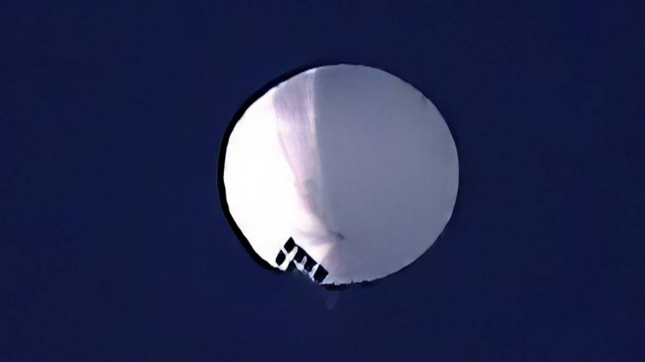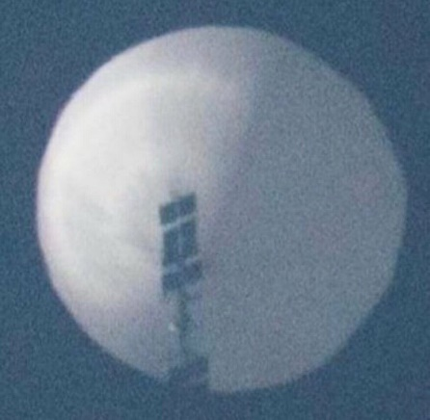

The wise love truth enough to completely reject the ambassadors of lies, deceptions, ease and comforting messages that all is all right when it is anything but all right. Those that cling to the lies and deceptions out of fear, or out of rebellion, out of cowardly fear, or out of laziness, apathy, disregard for truth as if it were an obstacle to their desires, selfishness, self-centeredness, lust of what feels good, is convenient, is easy, is comfortable, which appeasing the mind, emotions, reasoning, and makes what is lusted after to be all right.
This self-obsessed mentality changes one’s understanding of the Persons of Father God/Abba Yahuwah and the Son/Savior/soon-coming Beloved One as King. It makes Them into being unacceptable to one’s cravings of the flesh, cravings of the mind, cravings of the emotions, cravings of the will. Thus the mind takes verses of the Bible that sounds good and puts them together to form their own doctrine for their own belief-system. Anything they consider to diminish soulish lusts is forsaken as in “I don’t believe it.” Having no responsibility to the Elohim (Father and Son) is unacceptable. The self-absorbed want only what they want. Yet, piously, when at church or congregation, they are purely saints – so religious righteous – with a façade of holiness. This is because religion masks truth, or eliminates it all together.
Thus again, as is usual, from their script all saying the same things, public news is no different than it was under the dictators of Hitler and Stalin – saying only what is false to back the false and make truth seem like the lie.
“Woe to those who call good evil and evil good,…” Isaiah 5:20-21: “Woe to those who call evil good, and good evil; who put darkness for light, and light for darkness; who put bitter for sweet, and sweet for bitter! 21Woe to those who are wise in their own eyes, and clever in their own sight!”
Yes “woe!” So few walk the narrow path to the narrow gate that leads to life (Matthew 7:13-14) because the path is “hard-pressed,” the way is that of suffering, of study, or laying down one’s life for the Master--of service to the Master, or obedience to the Master. Yahushua, our Master, to train us for reigning in the Kingdom. The Spirit of Yahuwah within speaks to us and teaches, and as we obey we become “set-apart” from this world, and prepared for the eternal Kingdom of heaven.
For those who do not understand that submission for training, as a servant to a Master, is mandatory for entrance into the Kingdom of Light. The one biggest thing to avoid is to hear Him say: “I do not you; depart from Me…,” as in Matthew 7:21-23; 25:1-2, and Luke 13:23-30. He has to KNOW us, as we KNOW Him as Friend.
OK folks, you want to know why this is posted under PRESENT REALITY. Yes, what I wrote above is “present reality.” But, what I want to share with you is the present reality of how close we are in America to being totally destroyed, as in Isaiah 13, 47, Jeremiah 50-51, Revelation 17 and 18.
The angel of death stands at all our borders, and has infiltrated all of our interior. We are now a communist nation whose American bodies are about to be served up as corpses on the platter to Lucifer, aka Satan.
There is a remnant as I taught in today’s podcast that KNOW their Elohim – and are “echad” with Them. The end-time remnant isn’t a bunch of spoiled kids having fun with “God” – but consists of a few - those who “know” shall the “strong” and do “exploits.” They are 100% passionate for two main things: 1) Their Savior and Friend, Yahushua, and 2) His Word is what they cling to and love to obey with great peace, joy, and enthusiasm. Their focus, not on self, but on eternity.
These “few” are blameless. However, we all must be “blameless” to enter the Kingdom: I Thessalonians 5:23: “And the Elohim of peace Himself set you completely apart, and your entire spirit, and being, and body - be preserved blameless at the coming of our Master יהושע Messiah!”
He calls us to the highest realm, but before the foundation of the world, He knew who would walk the narrow path and who would not. He knew who would bring forth the 30-fold fruit of the guests, the 60-fold fruit of the attendants, aka “friends of the Bride Groom, and the 100-fold of the Bridal remnant.
A “remnant” in the terms of ancient textile mills, are the strings, the dust “bunnies,” the fringes of fabric that are cut off and fall on the floor. Modern culture surmises that a remnant is what is left on a bolt of cloth after most all has been cut off, and perhaps a yard or two is left. No! It is talking about the things considered insignificant, not worth keeping, the throw-away of the fabric--the things that man wants to sweep up and put in the garbage.
In the days ahead of martyrdom, these will be His remnant that He will not sweep up or throw away, but those He will translate into the Garden of Eden once again, within the three portals reaching into the throne room of heaven, and from there take this totally 100% submissive Bridal remnant to do the exploits no one else would dare to do – in the face of the Beast.
These work with the two witnesses, but also with many of the cloud of witnesses that are returning now to finish their course of service to the Master – like Enoch, Moshe/Moses, Eliyahu/Elijah, Daniel, Yochanan the Apostle (John), Iyob/Job, Yac’ob/apostle “James,” brother of Yochanan (John), and the Apostle Sha’ul
In our day, there will be so many martyrs. The word “martyr” means “witness.” We are all called to lay down our lives as a witness to the salvation of Yahuwah through Yahushua’s death and resurrection.
If Yahushua Messiah does not return soon, no flesh will be saved. Not only is this talking about nuclear destruction, but destruction that is coming from the cosmos.
Does that sound like great revival? The Beast is with us now, and Israel is preparing for its own destruction. The world is preparing for alien invasion, death, destruction, and an end to life on earth as it was in the finalities of Genesis 1:2.
America is so close to being destroyed in the judgment of Yahuwah. About a month ago, as I have been closely watching the use of Russia to perpetuate war, prodding and provoking Russia and China, North Korea, and Iran to attack and destroy the nation totally. Russia pleaded with the West to agree to a peace treaty. Russia was faced with Ukraine on its border. Russia never intended to go into Ukraine. Read my articles of the last few months about Russia and reality.
Western leaders literally laugh at Putin’s attempts for peace. Putin only wanted to protect his nation. Russia is the only self-professed Christian nation in the world. Russia rejects the LGTBQ, 100 gender, rainbow flag culture, “woke” culture of the West. When Putin told the US embassies to get out of Russia, he added “and take your rainbow flags with you.”
Its money, the “Ruble” is backed in gold – all of it. It had a bumper wheat crop. It was supplying gas and oil to Europe. It was prospering. It is rich in minerals and elements in natural form used in much of the West’s technology. But, the West (England/US) had to blow up their pipelines supplying western Europe with oil and gas. They had to fire into Russia to provoke more. Russia did not even bring out its world-superior technological weapons until more recently, using Muslims, not Russians, as troops to use their low-grade weapons, so as not to destroy Ukraine.
America sent Ukraine almost all of our weaponry now – so that America is left vulnerable if attacked with nothing to retaliate with.
The weapons that are sent into the Ukraine by the US and by other nations are sold on the black market. Every evil group almost in the whole world is making its way through the open US southern border and infiltrating the U.S. besides Russia, China, Iran on the inside. We are taken over near 100%.
And still the mind-dead, those entertained-to-death, are saying “everything’s going to be all right,” calling for the return of Donald Trump but not calling for the return of Messiah Yahushua, though most are so-called “Christians.”
Talk about delusionary! Around 1946-1947, the CIA and associates - NAZI-based organizations at a time - when former Nazi scientists, teachers, doctors, surgeons, space technologists, etc. flooded into the US, brought in by the military, under “Operation Paperclip” to turn the U.S. into the “Fourth Reich,” hired a man who changed the minds of American citizens. The man they chose to hire was the owner of several movie studios, which he used to make pornography films. They asked him to create cartoons for children and movies for young people to program the minds of the “baby boomer generation” into fantasy and separate them from faith in the God of the Bible to put faith in the gods of Lucifer – fallen angels.
The man, Walt Disney, took the great challenge and all the great money and began with things like “Mikey Mouse and the Sorcerers Apprentice.” He went on to program the young, or lonely of any age, into the hope of Cinderella, Snow White and the Seven Dwarfs, Sleeping Beauty – and their fairy godmother, dwarfs of the dark kingdom, the waving of a magic wand to get what they want. Faith transferred from the Elohim (Father and Son) of the Bible to what they could get out of faith in the supernatural realm and their own abilities. It turned from the new birth, infilling of the Spirit, obedience to a new Master, to what can I do to make myself a god/goddess? “Aladdin and the Magic Lamb”: Of course – rub the lamp and out will come a genie. Then we had “I Dream of Genie” and her witch-mom, i.e. twitch the nose and make it happen your way.
Slowly the minds of Americans became so lustful for entertainment that where was the time to study the Word of talk to Yahuwah? Today, the Bible, Jesus, Truth in general, incurs laughter, mockery, jokes, or anger and hostility.
Here’s the brunt of what I want to bring to you. To get information that few have, like below, correct information of the highest granddaddies of truth-tellers, I recommend that you go to gensix.com and sign up for the private briefings. They come 2-3 a week from the highest intel sources possible who love truth. You’ll be kept up on the inside of what hardly anyone knows, or wants to know. Yes, you pay all at once, but it’s sure worth it. You’ll also save a lot of time and effort that you can use to check it all out in the Bible!
While the news media is trying to get everyone to believe it was China who sent the balloon (balloons) over north America, or a false flag of the U.S. government. It was NOT either of them. It was a combination of the nation that America has declared war on, Russia, and their ally Iran! The balloon stayed stationary over our strategic missile silos, gathering information on what freedom they have to destroy all with little to no resistance.

“NO SHORTAGE OF LIES…” Steve Quayle reporting – Feb. 6, 2023
“Did you notice how no one mentioned how a balloon could possibly stay parked over America's missile silos and nuclear bomber bases for so long? And another question that needs to be asked: What nation has the capability to move the high-altitude winds to direct the surveillance platform to the exact epicenter of the United States nuclear defense areas? No one else but Russia!
It's also curious that the victory of shooting down the so-called ‘Chinese weather balloon’ wasn't undertaken until all the necessary communications, signal intelligence, and photographic data was gathered up. The only nation that the United States, NATO, and Great Britain have declared war on is Russia!”
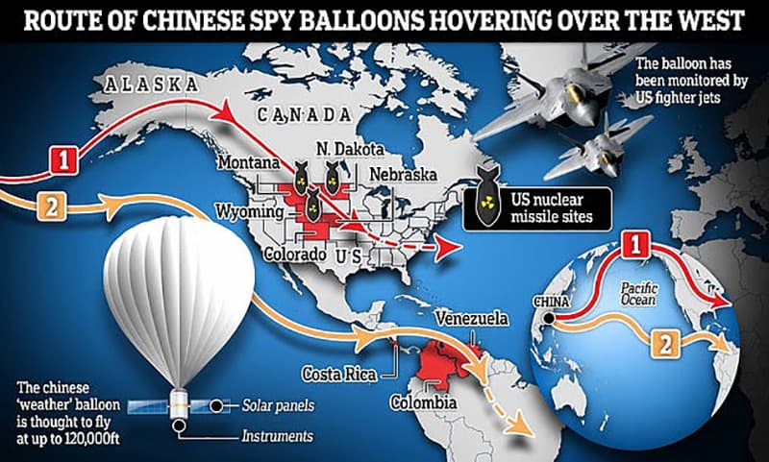
Yedidah: Do you see the lies of the news media pointing to China, when they knew they were Russian balloons? I knew when I heard the languages used on the balloons were Russian and Farsi.
Quayle: “I would like to remind everybody that the decision to shoot down the balloon (the one parked over Montana) only came after it had achieved its stated purpose: To gather exact Intel for updating Russia's hypersonic missiles and their ICBMs with the most up to the minute data. They now have all the critical target-data they needed.
Next question: what if everything you've been told about Iran's nuclear capabilities is a lie? As you know, the United States and Israel are on record is stating they are going to bomb 3,000 targets in Iran!
The signals emanating from the balloon spy platform (in Farsi and Cyrillic) prove that the whole Chinese narrative is a coverup for the fact that Iran and Russia are getting set for a pre-emptive nuclear strike upon the United States.”
[Yedidah breaking in: Russia has already warned the Pentagon of the first three pre-emptive strikes: 1) Washington D.C., 2) New York City (Revelation 18), 3) NORAD in Colorado Springs.
In the book of Revelation, NYC will be destroyed in an hour, and the nation in a day. Then the millions of inside military and groups will to work confiscating all property – killing anyone left alive. The Word is clear about it. How do we know Revelation 18 is NYC? It’s obvious in its wording, however, that list of 26 “commodities” in that chapter, especially #26, are only bought and sold through one main avenue in the world, Wall Street NYC Stock Exchange.
Since 1992, when Yahuwah said to me clearly as I read Jeremiah 50-51: “This is America.” We have used our 70 years allotted to us by Yahuwah to destroy the world’s people, and prepare them for the take over by fallen angels and Lucifer.
Quayle: “In their accelerated time frame, the West will claim that they didn’t see it coming! Which is another blatant lie… They want war and they'll get it.
Fragments of the balloon are seen being brought ashore on Sunday in Myrtle Beach, South Carolina. Always ask yourself: Who has the most to gain in this whole fiasco? Obviously, neither Russia or Iran are going to wait for nuclear strikes against their country.
Israel plans to strike Iran in the next couple weeks -- or sooner -- and Russia has already based on their intelligence gathering ability aware that the whole NATO crew is going to attempt a pre-emptive nuclear strike on Moscow very soon. The stakes could not be any higher, nor the ramifications to all of this any deadlier! We are at the point in culinary terms of a ‘mushroom cloud flambé,’ so to speak, so seek the face of the Living God in repentance and praise for these truly are the end of days!”

BY A REAL BORN-AGAIN SCIENCE EXPERT: Date: February 5, 2023
"THE US, NATO AND GREAT BRITAIN HAVE ALL DECLARED WAR ON RUSSIA OPENLY" "THE US, NATO AND GREAT BRITAIN HAVE ALL DECLARED WAR ON RUSSIA OPENLY" REMEMBER IT WAS THE WEST, WHO FIRST THREATENED RUSSIA WITH NATO'S NUCLEAR WEAPONS TO BE USED AGAINST THEM!” THIS PRIVATE BRIEFING UPDATE IS TO HELP CLARIFY SOME THINGS…
THE MAIN STREAM MEDIA REPORT THAT IT WAS “CHINESE” CAME BEFORE ANYONE IN THE PENTAGON COULD HAVE CHECKED ALL THE FACTS OF THE DEVICE WHICH COULD ONLY OCCUR WITH THE FOLLOWING INFORMATION WHICH WAS ONLY DISCOVERED AFTER THE MAIN STREAM MEDIA REPORTS CAME OUT:
1.1 DID THE CLOSE-UP PHOTOS OF THE DEVICE UNDER THE BALLOON ENVELOPE HAVE ANY WRITING OR SYMBOLS ON THEM? YES OR NO AND IF YES WHAT WERE THEY? 1.2 WHAT RF TRANSMISSION FREQUENCIES AND MODULATION TYPES WERE BEING USED? 1.3 WHAT OTHER DETAILS SURROUNDING THE INCIDENTS ARE SIGNIFICANT? 2 DETAIL 2: EXACTLY HOW, MANY OF THE BALLOON TYPE DEVICES ARE THERE THAT WE KNOW OF EVEN IF THE GOVERNMENT AND MASS MEDIA DO NOT TALK ABOUT THEM? WE CAN ACCOUNT FOR 3 OF THEM, BUT WHEN YOU HAVE THAT NUMBER AND WE ARE SO CLOSE TO WORLD WAR 3 IT WOULD BE FOOLHARDY NOT TO EXPECT THAT THERE WILL BE MORE OF THEM.
2.1 THE FIRST BALLOON: 2.1.1 ITS PATH: 2.1.1.1 IT STARTED IN THE ARCTIC CIRCLE REGARDLESS OF WHAT MASS MEDIA SAYS. 2.1.1.2 THEN OVER ALASKA 2.1.1.3 THEN OVER CANADA 2.1.1.4 PARKED FOR A LONG TIME OVER MONTANA 2.1.1.5 THEN MOVED TO MISSOURI 2.1.1.6 THEN TO NAVAL BASES IN THE CAROLINAS 2.1.1.7 THEN TO THE OCEAN JUST EAST OF SOUTH CAROLINA 2.1.1.8 THEN SHOT DOWN
2.2 THE SECOND BALLOON: 2.2.1 ITS PATH: 2.2.1.1 IT STARTED IN THE ARCTIC CIRCLE REGARDLESS OF WHAT MASS MEDIA MAY END UP SAYING ABOUT IT. 2.2.1.2 THEN OVER ALASKA 2.2.1.3 THEN OVER CANADA 2.2.1.4 PARKING OVER IDAHO BEFORE MOVING ON 2.2.1.5 AFTER THAT WE HAVE NO ACTIVE REPORTS JUST YET BUT WE WILL FIND IT
2.2.2 HOW DO WE KNOW THE SECOND BALLOON OVER THE USA EXISTS? 2.2.2.1 THERE WERE RADIO EYE WITNESSES WHO TRIANGULATED ON A SECOND BALLOON OVER IDAHO WHILE THE FIRST BALLOON HAD MOVED FROM MONTANA TO MISSOURI WHERE PEOPLE WE KNOW WERE EYE WITNESSES TO ITS PRESENCE.
2.3 WE KNOW THE THIRD BALLOON IS ON A TRACK OVER SOUTH AMERICA. 2.3.1 ITS PATH: 2.3.1.1 IT STARTED IN THE ARCTIC CIRCLE REGARDLESS OF WHAT MASS MEDIA SAYS. 2.3.1.2 THEN OVER THE PACIFIC OCEAN 2.3.1.3 THEN OVER COSTA RICA 2.3.1.4 THEN SLOWED DOWN OVER VENEZUELA 2.3.1.5 THEN TOOK OFF TO BRAZIL.
3 DETAIL 3: "WHY IS THERE A CO-ORDINATED, AND MIS- DIRECTED SERIES OF LIES AND FALSE NARRATIVES BY CHINA, THE US LEADERSHIP AND WORST OF ALL THE US MILITARY, WITH EXTREME EVASIVENESS OF DETAILS CONCERNING THE BALLOONS STRATEGIC PLACEMENT OVER THE MOST SENSITIVE NUCLEAR WEAPONS SITES IN THE USA"! (IF YOU READ ON YOU WILL UNDERSTAND ABOUT THE FOLLOWING: UTTER INCOMPETENCE LYING AT ALL LEVELS, AND UTTERLY WEAK LEADERSHIP ON ALL SIDES SO LET’S JUMP INTO THE FACTS:)
3.1 FACT 1: IF IN FACT IT WAS A CHINESE BALLOON WHICH WENT OFF COURSE WHY WAS CHINA UTTERLY SILENT UNTIL SUDDENLY XI MADE SOME PUBLIC STATEMENTS AND PRIVATE DIPLOMATIC APOLOGIES FOR THE “BALLOON GOING OFF COURSE”. 3.1.1 THERE IS AN ASTOUNDINGLY GOOD REASON FOR XI TO SUDDENLY BECOME TALKATIVE. TO SAY IT BLUNTLY HE WAS TOLD TO MAKE THE STATEMENT OWNING THE “SUPPOSEDLY MIS-DIRECTED” BALLOON. WHAT COULD HAVE SUDDENLY LED HIM TO EATING GLOBAL POLITICAL MUD AND SO PROFUSELY APOLOGIZING (BLAH BLAH BLAH).
THE ANSWER IS HIS INBOUND OIL WAS CUT OFF UNTIL HE MADE THE PUBLIC AND PRIVATE DIPLOMATIC STATEMENTS. 3.2 FACT 2: THE WIMPS IN THE WOKE GOVERNMENT AND MILITARY WERE TO AFRAID TO SHOOT DOWN THE BALLOON. 3.2.1 EVEN WHILE OVER ALASKA 3.2.2 EVEN WHILE OVER CANADA 3.2.3 AND EVEN MORE IMPORTANTLY AS THE BALLOON CROSSED INTO THE TERRITORIAL SPACE OF THE USA.
3.2.4 TO BE BLUNT WE KNOW IT WAS A PLANNED FAILURE BECAUSE THERE ARE SEVERAL REPORTS IN THE GOVERNMENT WHICH TALK ABOUT USING “INNOCENT LOOKING BALLOONS” AS A LOW COST YET VERY PRECISE DELIVERY SYSTEM FOR ANY WEAPON OF MASS DESTRUCTION FROM BIO-WEAPONS TO NUCLEAR WEAPONS TO FULL CONTINENTAL LEVEL 1 EMP PULSE WEAPONS WHICH CAN DESTROY THE POWER GRID AND COMMUNICATIONS GRID IN ONE EVENT. (MULTIPLE PEOPLE IN WASHINGTON
D.C. ARE NOW BRINGING UP THEIR WORRIES ABOUT THE EMP DANGER WHICH TEAM BIDEN AND THE DOD TOTALLY IGNORED,)
3.3 FACT 3: WE KNOW THE BALLOON WAS A JOINT RUSSIAN AND IRANIAN OWNED BALLOON BY THE FOLLOWING FACTS: 3.3.1 WRITING ON THE DEVICE HANGING DOWN FROM THE BALLOON ENVELOPE WHICH WAS IN FARSI AND CYRILLIC. (AS DETERMINED BY A VERY HIGH-ALTITUDE PHOTO PASS BY OF THE DEVICE) 3.3.2 THE ACTIONS TAKEN BY THE BALLOON SUCH AS PATH AND THE TYPES AND DETAILS OF THE RADIO TRANSMISSIONS COMING FROM THE DEVICE.
3.3.3 ALSO VERY TELLING WAS HOW THE `HIGH ALTITUDE WINDS AT 90-120,000 FEET’ WERE ALTERED TO STEER THE BALLOON ON A PRECISE PATH AND ONLY A COUPLE OF COUNTRIES HAVE THAT ABILITY WHICH IS IMPORTANT AND SIGNIFICANT.
4 DETAIL 4: `RUSSIA AND IRAN HAVE A MUTUAL DEFENSE TREATY 4.1 IRAN JUST WATCHED ISRAEL AND THE US PRACTICE TOGETHER AS THEY ARE GETTING READY TO BOMB IRAN AT 3000+ TARGETS WHICH HAS ALREADY TRIGGERED THE DEFENSE TREATY OF RUSSIA AND IRAN.
4.2 ACCORDING TO ISRAEL'S PRIME MINISTER THIS INVASION WILL HAPPEN SOON! 4.2.1 THIS WILL HAVE DEVASTATING RESULTS TO ISRAEL, 4.2.2 AND THE USA 4.2.3 AND FRANCE AS WELL AS ALL OTHER MEMBERS OF THE ALLIANCE USA IS TRYING TO FORCE TOGETHER.
4.2.4 I CAN HEAR SOME OF YOU SAYING `NO-NO THAT CAN’T BE” BUT IF YOU CONTINUE READING YOU WILL DISCOVER THAT I AM SPEAKING THE TRUTH!
4.2.5 YES, I AM VERY AWARE OF THE FACT THAT GOD SAID HIS PEOPLE WILL BE PROTECTED, BUT YOU MUST REMEMBER THE BIBLICAL FINE PRINT: 4.2.5.1 AN IMPORTANT FACT IS THAT GOD HAS PUNISHED ISRAEL SEVERAL TIMES BEGINNING IN THE OLD TESTAMENT FOR TURNING THEIR BACK ON HIM.
4.3 HOW IS IT THE WOKE, BROKE, FOLK IN "THE PENTA-WOKE SOON TO BE GONE" DON'T UNDERSTAND THAT RUSSIA AND IRAN WERE CHECKING EVERYTHING THE US MILITARY USES TO TRACK INCOMING FIRST STRIKE NUCLEAR WEAPONS? 4.4 INCLUDING ALL FREQUENCIES AND COMMUNICATIONS 4.5 AND ANY NEW ADDITIONS TO EARLY WARNING SYSTEMS THAT WERE NEVER DESIGNED TO TRACK CONTROLLABLE HYPERSONIC MIRVED WARHEADS LET ALONE INTERCEPT THEM! 4.6 THE FLAMBE MUSHROOM FLASH WILL TAKE PLACE IN LESS THAN 90 SECONDS WHEN ALL SYSTEMS ARE GO. 4.6.1 THIS IS BECAUSE IT IS LESS THAN 90 SECONDS FROM LAUNCH DETECT TO IMPACT AT KEY TARGETS BASED ON THE LOCATIONS OF THE LAUNCH SITES, THE SPEED OF THE WEAPONS, AND THE PRIMARY TARGETS AND IN THOSE 90 SECONDS YOUR LIVES ARE FOREVER CHANGED!
4.7 AND REMEMBER EVERYONE, YOU SHOULD GO BACK AND REFRESH YOUR MEMORY ON THE VERY DETAILED REPORT WE GAVE YOU IN OUR PRIVATE BRIEFING ON IRAN’S TRUE NUCLEAR CAPABILITIES, AND ADVANCED WEAPONRY!
4.8 THE TIME OF HOW SOON MAY BE ANSWERED SOONER THAN WE THINK! 5 THE WEATHER BALLOON ARGUMENT FALLS FLAT ON ITS' FACE IN LIGHT OF THE FACT THAT NOT ONLY WERE THE BALLOONS STEERED AND HELD IN PLACE OVER AMERICAS MOST SENSITIVE MISSILE SILOS, AND NUCLEAR BOMBER BASES, BUT THEY ACQUIRED THE CROWN JEWELS OF AMERICAN NUCLEAR RESPONSE, AND RUSSIA’S ADVANCED ELECTRONIC WARFARE CAPABILITIES COUPLED WITH RUSSIAN WEAPONIZED WEATHER MODIFICATION SYSTEMS WILL PROVE TO BE AMERICA’S END.”
Folks “study to show yourself approved unto Elohim – a workman who needs not to be ashamed.” (II Timothy 2:15) Please refer to the main Scriptures on America as the final Babylon (Isaiah 13, 47, Jeremiah 50-51, Revelation 18), restorer of Nimrod, founder of Babel (Genesis 10, 11). Nimrod’s body exhumed in Iraq in 2003, the plans for his “tower” given to CERN. I’ve written quite a big on that.
Listen to the podcasting of Genesis 6, Parts I and II, and Genesis 10, 11 and articles on the return of Nimrod 2003.
Please read: “Thirty Clues and More …”/Mikvah of Preparation, and “End-Time Babylon”/Mikvah of the Great Adventure 5.9 for Scripture study on America in Prophecy.
Shalom, in His love, peace, and joy,
Yedidah

