CORONAVIRUS: The Latest World-Threatening Panic-Inducing Pandemic

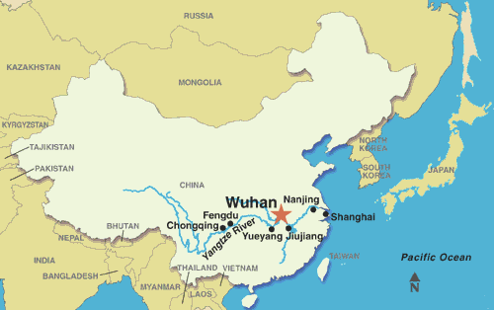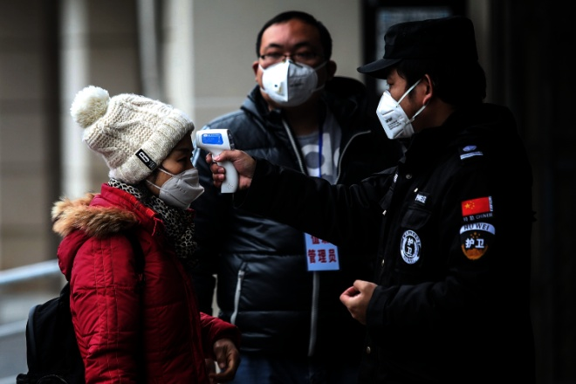
The 11-million residents of Wuhan, China, are now under Quarantine! The city is on lock-down! Right: A police officer is checking this girl’s temperature
Wuhan, a city of 11 million, now under quarantine for a mysterious pneumonia-like disease that is spreading worldwide, as people from China have gone to the nations for Chinese New Year’s celebrations, January 25, 2020: “Year of the Rat.”
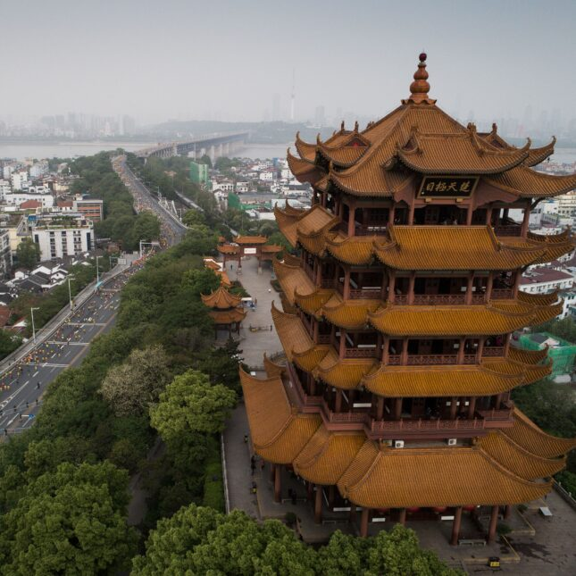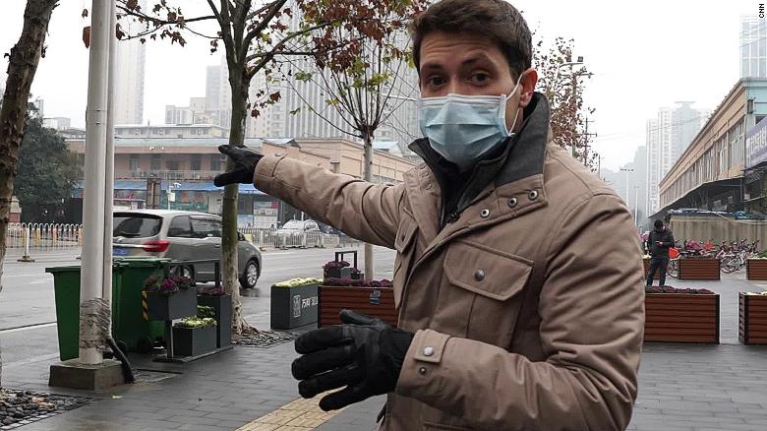
Wuhan CNN reporter
It is a fast-moving virus being called a “mystery.” However, in late 2019, China was reporting a new strain of flu they were fighting. They had a vaccine that was mandatory for all citizens to take. After taking the vaccine, many, especially children, came down a mysterious new disease. Uh…! Mike Adams of Natural News reports on it a lot, that all vaccines contain aborted baby cells, and most all contain new bio-engineered diseases--man-made diseases in a laboratory. This virus is most likely bio-engineered in a laboratory, as part of the depopulation agenda that’s been going on since the 1940s.
The World Health Organization has been meeting in Geneva, Switzerland to determine whether to label this a global pandemic and recommend quarantine.
Paul Begley said that four years ago, he was in a Mensa conference in Florida. A member of the CDC (Center for Disease Control) made a one hour speech. He said that just one mutation from the bird flu would spread it to humans, and they were expecting the mutation to take place in China! Wow - the old Illuminati-Hollywood obsession: Tell what you’re going to do but hide it behind fantasy, or a ludicrous prediction.
Most likely this is another bio-engineered virus, like AIDS at Fort Detrick, and Ebola engineered in South Africa by a CIA scientist. Back in the late 80’s I learned a local Texas University’s bio-engineering Department was creating flu-like diseases and spraying them over the Dallas/Mid-Cities/Fort Worth Metroplex. At the same time, it was reported all over the news how schools were closing due to an outbreak of a new virus. We knew we were lab-rats used for experimentation.
When I was 14 in High School, without our parental permission, we were lined up and taken to get inoculated with the smallpox vaccine. They’re reviving old killer diseases too. Is the Bubonic Plague next? I was sick for about three weeks with smallpox symptoms. The inoculation area on my left arm became pussy and the disease ate about 1/4” into my arm. I still have the scar.
Years ago, the think tank “the Club of Rome” began thinking up all kinds of ways to kill off mankind. They said pandemics were too slow, but they weren’t dropped from the agenda. Actually, the CDC is known to create some of these diseases themselves.
The Coronavirus has spread to other parts of China, like Hong Kong, also to Japan, Thailand, North Korea, and Australia. One case has been confirmed so far in Seattle, U.S.A.
There have been several deaths from it already in China and Japan. It is a respiratory disease, a strain of pneumonia. So far it has not been revealed what this disease actually is, but it is spreading very fast. What are they going to blame this on?
Yes, we’re also inundated with space dust, driving our atmosphere down, which could include pathogens. We’re experiencing close-to-earth asteroids and comets, as well as unusual amounts of radiation waves of energy from space due to our geo-engineering of earth’s outer protective atmosphere. Under-ice lakes in Antarctica are revealing strange unknown pathogens. A Pathogen is a bacterium, virus, or other microorganism that can cause disease.
Perhaps they’ve resurrected the Hong Kong flu of the late 1960s. In 1968, while teaching school, I got the Hong Kong flu. It was a respiratory disease – a very powerful disease. I was in my 20s. I was very sick in bed for 2 weeks. I had pneumonia when I was 5, and it weakened my lungs. The Coronavirus is a pneumonia-type disease as was the Hong Kong flu.
I love Steven ben Nun’s statement in a recent broadcast about it: “Take high doses of Vitamin C!” At this point there is no vaccine, but if they come up with one, just know it is most likely more deadly than the Coronavirus.
Yes, 1,000 mg at least every 1½ to 2 hours. I add to that “a teaspoon of colloidal silver three times a day.” It removes toxins from the body, and runs off diseases quickly. I add to that raw garlic, ginger (raw and ginger tea), and citrus fruits. I add to that diffusing, or inhaling, Peppermint, Sandalwood, and Eucalyptus Globulus essential oils. If you have Frankincense and Myrrh – these work amazingly well together to stop vertigo or dizziness of any type.
If you keep your immune system strong, you don’t have to get what the enemy sends along. (nice poem) Lay off sugar and all processed foods, for they contain things that break down health. Coffee lowers the immune system, so think about green tea, oolong tea, or caffeine-free herbal teas. Get plenty of rest!
Drink lots of filtered water and herbal teas like ginger! Take Juice Plus! Eat lots of antioxidants – green things like broccoli. It the raw garlic and raw ginger don’t run off a disease, along with high doses of C and colloidal silver, prayer will. Go one an alkaline diet; get off the acidic foods. Build your body’s resistance to disease! You might want to buy some face masks too. I’ve seen several people wearing them in Fort Worth, like at Walmart. Keep your hands washed!
Remember my article “The Zika Hoax and the Disease of Fear”? It’s under the Mikvah of Present Reality. You might want to review that and see why it was a hoax. Geo-engineering and the spread of mysterious diseases, or diseases within disease, always has a goal! So, whatever the source of this, it is dangerous!
But, then, strong faith goes a long way to protect you too, demonstrated by praise, prayer, and proclamation of the Word!
John G. Lake had a huge evangelistic and healing ministry back in the 1920-30s. He visited a leper colony in India. He asked the doctors there to put live leprosy virus in his hand. They feared doing it, but he insisted. Then he asked them to put his hand under a microscope. They watch in amazement as the leprosy virus died in his hand. He lived by the power of the Spirit, and so must we.
When a born-again, Spirit-filled, believer dies to self-will, and flows in the Spirit in the nature, ways, thinking, the enemy cannot do as he wills. He is blocked by the submission of that person to Yahuwah, which open up the promises of the Word for their protection.
DO NOT FEAR! Fear opens wide the door for whatever is of the enemy to attack mind, emotions, and body. Keep the doors to your soul and body closed to them by praise, prayer, and proclamation of the Word and of your faith! Just remember, you can’t claim promises if you don’t fulfill the condition! “God” is not the fairy godmother.
Whether it’s an EMP attack, nuclear attack, disease quarantine, famine, blizzard, flood, drought, or civil war, you must have extra water, and have food stored that needs no cooking. You must be prepared for many things now coming on the earth. Noah prepared his ark and so saved his family. What if Noah had not obeyed Yahuwah and did not prepare? We wouldn’t be here!
Do what you can to live a sick-free lifestyle, but get into the Word and proclaim Yahuwah’s promises to you.
In His love and shalom, Yedidah
January 23, 2020

