CORONAVIRUS Update: THE TRUTH Comes Out

January 25, 2020
Pastor Paul Begley, January 24, 2020, reported from Japan where many cases of the recently exposed coronavirus have surface, he posed a good question last night on his broadcast: Why did China impose a quarantine on 11 million people in Wuhan, when only a few hundred are infected and only a few have died?
I checked further. Yes, the virus has spread from Wuhan all over China, to Hong Kong, Japan, Thailand, Australia, North and South Korea, the U.S., France, and now other countries. It is a fast-moving virus.
Today is Chinese New Year’s Day, Year of the Rat, and Chinese people have flown from China all over the world for the celebration. So, I thought I’d check on the spread of the virus. What I found out is shocking. The virus is mutating. It is attacking not just the respiratory system but the inner organs, like the liver.
Now China has quarantined 5 more cities, so up to 32 million are under quarantine and total lockdown. But, we now know more of the truth of it, except we don’t know where the disease started spreading from once it left its epicenter, Wuhan, China. We do know that Wuhan is China’s main science-laboratory for the “study” of infectious diseases, like SARS and Ebola. Oh by the way, as Steve Quayle reported about two weeks ago, the Ebola virus has gone airborne.
Here is the latest reporting I have, from near midnight last night. People are dropping dead in China’s cities, dropping dead on the streets, in subway cars, in hospital corridors, in parking lots, in homes…

CORONAVIRUS UPDATE JAN 24: 2.8 MILLION INFECTED PEOPLE DROPPING DEAD - 112,000 DEAD SO FAR

“Millions QUARANTINED, 2.8 Million Infected; 112,000 DEAD
Nation News Desk 23 January 2020 Hal Turner Radio
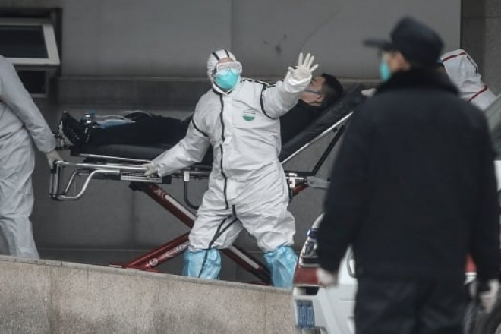
MULTIPLE UPDATES SINCE FIRST PUBLISHED
The outbreak of an alleged new coronavirus in China is completely out of control, and is killing THOUSANDS every day. As of 6:00 PM eastern US time on 23 January, Covert Intelligence sources who are former colleagues of mine from my 15 years with the FBI, the final five years handling National Security, Terrorism and Foreign Counter-Intelligence on the Joint Terrorism Task Force and who are presently inside China, confirm over 2.8 MILLION infected people with one-hundred-twelve-thousand (112,000) DEAD so far. Chief cause of death: Multiple Organ Failure.
This deviates wildly from the PUBLICLY reported number of 830 Infected and 25 deaths because, ready for this, a message from a frontline doc in Wuhan has confirmed the reason for the stopped growing number of infected is because the hospitals have run out virus test kits.
The thousands of dead are being taken directly to incinerators. No funeral. No burial, just burned. Intel is getting its actual Death counts directly from the incinerator operators! People are literally "Dropping-Dead."On trains (Before Quarantine):

On Hospital Floors waiting for treatment:
Now, even Doctors in Hospitals are literally falling down dead
The new virus is different from SARS, in that it causes rapid kidney failure. As of Thursday, 23 January, the government of China has QUARANTINED a total of EIGHT cities: Wuhan, Huanggang, Ezhou, Chibi, Xiantao, Qianjiang, Zhijiang and Lichuan - 20,000,000 + citizens in total.
The Chinese Military is now assisting with the lockdown of multiple Chinese cities. They’re all wearing bio-protective suits. CCP Central Military Commission has ordered Central Command to assist the Wuhan lockdown in response to social instability due to panic emotions.
...Even more astonishing, Chinese in the entire province Zhejiang have been told to stay in their homes. 60 million people are told to stay where they are. It's not an official Quarantine (yet) but rather strongly worded advice.
The systemic failure of Chinese society has already started. By THIS Sunday, full panic will be unavoidable as people realize food, medicine and doctors are finite resources and triage is in effect.Stores are already OUT of food.

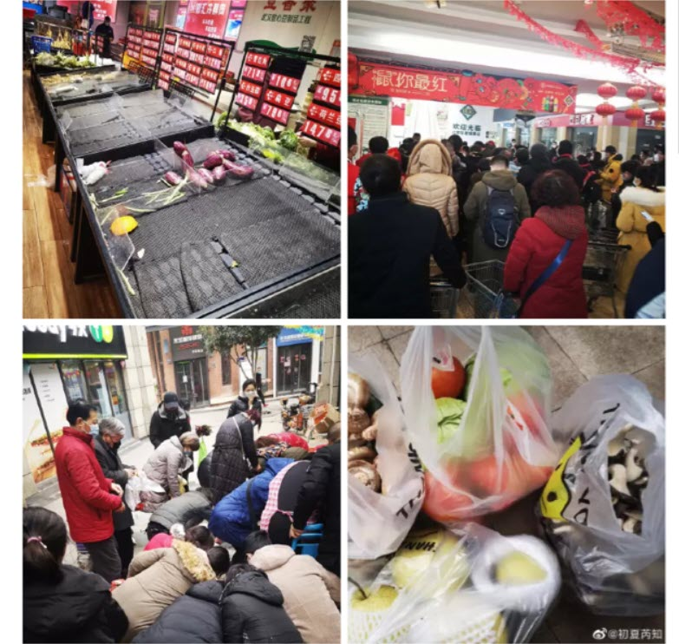
There is literally NO FOOD LEFT in the cities under Quarantine because no trucks are allowed in to deliver!
]When China collapses -- and it looks very much as though it will -- China's collapse will set in-motion a global economic shockwave from which the planet will be unable to recover for decades.”
The article goes on to describe conditions in other countries. Here are just a few reports:
“In Australia: Health authorities have confirmed a person in Sydney is in quarantine as of this morning after possibly contracting the potentially deadly coronavirus disease. Suspected case now in Brisbane.
He goes on with Canada, Columbia, England, India, Italy, Japan, Malaysia, Mexico, Napal, Northern Ireland, Philippines, Saudi Arabia, Scotland, United States, South Korea, Vietnam, Thailand ... (as of the 24th, reports tell of the disease in the UK and France)
The germ is from a family of viruses that cause the common cold, as well as SARS – the severe acute respiratory syndrome that killed some 800 people, mostly in Asia, in a 2003 epidemic. Health experts still aren't sure how humans are being infected. The new coronavirus, which can cause acute pneumonia and kidney failure, is most closely related to a bat virus and scientists are considering whether bats or other animals like goats or camels are a possible source of infection.
Health screenings continue at LAX for passengers arriving from China amid the coronavirus outbreak. The U.S. Centers for Disease Control and Prevention began conducting health screenings of passengers arriving at Los Angeles International Airport from China on Saturday.

PROTECT YOURSELF NOW
Filter masks prevent tiny (microscopic) particles from going into your lungs. They can help protect you long enough for you to get home from work, school, or to evacuate from a contaminated / infected area. These will not function correctly if a man has any kind of beard.[Refer to my previous article on Coronavirus for ways to keep from getting sick]
We have confirmed NEW lockdowns:
- Huangshi (2.5 million people)
- Daye (1 million people)
- Yangxin County (1 million people)
Confirmed lockdown measures in 10 cities and 1 county in the Wuhan area, which is nearly 29 million people. Another city (1 million) is on partial lockdown.
List of locked down cities due to coronavirus: Wuhan (11 million people), Huanggang (7M), Xianning (2.5M), Huangshi (2.5M), Xiantao (1.2M), Daye (1M), Yangxin County (1M), Qianjiang (1M), Chibi (500K), Zhijiang (500K), Enshi City 750k) Total: 29M
UPDATE 1:45 AM EST --
Source in Wuhan reports the following:
>Parents turned away by hospital, both his mother and father were taken by PRC military and loaded onto trucks, not told where they were being taken.
>When he asked too many questions the police were involved by the men escorting patients to the truck loading area, told to leave things alone, go home and stop asking questions
>People in the building opposite him are complaining of bad smells, they believe many families who were told to self-quarantine are now possibly dead in their apartments
>All landlines have no dial tone, his aussie cell phone works with roaming enabled but cannot get even 3g data now.
5pm-9pm yesterday the city was doused in powder by PRC air force, disinfectant - used also in shanghai-He has been watching people from his window, panic has set in because even relatively young are now dropping over even in his street.
Shanghai, Shenzhen, and Ningbo-Zhoushan: These are their three largest container ports. They are necessary for world commerce, and closing any of these three would result in a rapid collapse of their economy. If they quarantine any of these cities, the situation is out of hand.
UPDATE 1:50 AM EST: Jingzhou, a city of nearly 6 million people, will be put on lockdown from 5 p.m. Gov't statement:
- Effective immediately, train services are shut down
- At 5 p.m., all other forms of transportation are shut down
- All public venues are closed
- Public & religious events canceled
People in locked down cities: 35 million
QUARANTINES COULD COME HERE, TOO! (He’s speaking of America)
If YOU could not go out for a total of 6 weeks, do YOU have enough food in your house to feed yourself and your family? If not, what do you think you would do? You can't go out under penalty of arrest. No one can come deliver to you because stores are all closed. So what do you do?”

I also suggested things to help you build your immune system in the first article two days ago: “Coronavirus: The Latest World-Threatening Panic-Inducing Pandemic” (January 23, 2020)
I don’t feel in my spirit that this is just another created virus that panics people and then goes into hiding, or disappears. It is a created virus.
We turned a corner in September with the last Yom Teruah. It is a created virus. It’s no coincidence that Ebola has gone airborne. As I wrote not long ago, five of the seven seals of the “apocalypse” have been broken. (Revelation 6)
Most of all prepare spiritually so that your mind and emotions remain in peace, with sound thinking aligned to Yahuwah’s Spirit within your re-born spirit.
If you are not born again, please read “The True New Birth” under the Mikvah of Eternal Salvation. Give your life to the Savior who died and rose again to give you eternal life. Once born again, you must be filled with the Spirit of our heavenly Father.
Please read: “Immerse in the Mikvah of the Spirit of Yahuweh” and “The Spirit of Yahuweh and You” under the Mikvah of the Spirit. (comeenterthemikvah.com)
I noticed this morning that on January 25, 2007, 13 years ago today, I sent out the article “Faith Walk.” It is actually a how-to manual. Go over it and learn, for “we walk by faith and not by sight.”
The prophet Habakkuk wrote: “The just shall live by his faith.” Child-like faith in a wonderful Savior and a wonderful heavenly Father who love us, brings peace, knowing that even in passing from this life into eternity we are not alone, but They are with us always – Father and Son.
Put into practice what I wrote in the Coronavirus article of the 23rd. The essential oils I mentioned must be “steam extracted” in order to work. Essential oils must be processed by steam extraction so that the life of the plant or tree is intact, and ready to be transmitted to you for your health. There are two good companies I’ve used, 1) Young Living, which I consider the most reliable high quality of all, and 2) Hopewell Essential Oils, home based in Texas (formerly known as Heritage Essential Oils). Hopewell imports the best oils they can find from around the world, and they’re less expensive than Young Living. But, so far, in using the oils of these two companies for many years, I’ve found they work well!
In ancient times, tomb robbers left the gold, silver, and gems, but stole the oils. The oils put on Messiah’s body by Joseph of Arimathea and Nicodemus, are estimated in today’s dollars to have been about $250,000.00 (John 19:38-40).
It is said that “alos” is Sandalwood. I rely a lot on Sandalwood, Peppermint, Lavender, Eucalyptus Globulus, Frankincense and Myrrh, The mixture of Myrrh and Frankincense is powerful to stop vertigo and dizziness of all types, and open the mind for clarity. Sandalwood, Frankincense, and Cedarwood, are the three highest oils in “sesquiterpenes.” The life in these oils go beyond the blood brain barrier to bring oxygen into the brain.
I was on a plane from Miami (sea level) to La Paz, Bolivia, which is 13,000+ feet up above sea level. When the plane doors opened, the lack of oxygen was causing people to be lightheaded, nauseous, and even faint. Oxygen tanks were outside the plane to help people. I began taking deep breaths of these three oils with the “sesquiterpenes.” Within hours I could walk around like the locals with a lot of energy. The next day I went higher into the Andes on an 18-hour intercession trip with my friend, Sharon, and was strong through the whole time. These were Young Living oils – guaranteed to be “therapeutic grade,” steam-extracted, and life-giving. Hopewell imports Sandalwood from Sandalwood, India – excellent quality.
So take high doses of Vitamin C with rosehips, and get some colloidal silver either from a health food store or buy your own unit to make it (take 1 tsp. 3 times a day). It is a natural antibiotic. Build up your immune system!!! I’ve taken Juice Plus since 1998 – it’s natural immune-system building – real fruit and vegetables in a kosher capsule.
Prepare! I give you Ezekiel 14:12-25 to take to Yahuwah in prayer. This is not just for “a land,” or small area, this aligns to Revelation 6.
In His love, Yedidah
January 25, 2020

