Creation is Shaking!
The Recent Escalation of Earthquakes, Volcano Eruptions,
Weather Anomalies and Worldwide Crop Destruction

Matthew 24, Luke 21, and all Scripture prophecies, are very clear. First we see great deception covering the earth, and a great falling away from Scriptural faith-- the minds of people being manipulated and reprogrammed by evil ones. There are the signs of earthquakes, famine, plagues, violence, and wars. There are the signs of the pre-flood world--the activities of fallen angels and their offspring, the Nephilim. There are the signs of overwhelming advanced technology that is working to replace the human race, and all life forms, with artificial intelligence and form. Between these things and Messiah’s coming there is great persecution of the set-part ones. All of this is happening at once now. Worldwide, natural signs are increasing, but along with it is the persecution and slaughter of the set-apart ones worldwide. We see our human rights deteriorating, the destruction of the “middle class,” the geoengineering of weather patterns, the destruction of the oceans, the rise in perversions of all types and public acceptance of them, as it was in Sodom and Gomorrah.
Ezekiel 14:12-23 is a personal warning for us today! Please read! Yahuwah will use His pattern of judgment to separate out the true set-apart ones, strong in faith, obedient to Him, from the religious pretenders. Please refer to these two articles, both under the Mikvah of the Heart of Elohim: “Yahuwah’s Pattern of Judgment,” and “Scriptural Reasons Why Yahuweh Will Judge Mankind.”
Matthew 24:6-13: “And you shall begin to hear of wars and reports of fighting. See that you are not troubled, for these have to take place, but the end is not yet. For nation shall rise against nation, and reign against reign. And there shall be scarcities of food, and deadly diseases, and earthquakes in many places. And all these are the beginning of birth pains. Then they shall deliver you up to affliction and kill you, and you shall be hated by all nations for My Name’s sake. And then many shall stumble, and they shall deliver up one another, and shall hate one another. And many false prophets shall rise up and lead many astray. And because of the increase in lawlessness, the love of many shall become cold. But he who shall have endured to the end shall be saved.”
There have been many signs. The “birth pangs of the Messiah” have increased especially since Yom Teruah 2015/2016. As we get nearer to the mid-point of this current 7-year cycle, Passover 2019, the birth pangs are accelerating and getting stronger, many of them reportedly are historic in magnitude.
From Lisa Haven’s August 24, 2018 You Tube video: “Something Very Strange is Happening,” https://www.youtube.com/watch?v=ZT2J8x7BfnI, we learn up-to-date statistics of the week of August 19-25. For one thing, earthquakes have increased 50% above normal!
Lisa begins by sharing an article from Infowars.com, “Seismic Shocker: The Number of Global Earthquakes the Last 30 days is More Than 50% above Normal”
Article from Michael Snyder August 24 2018 of End of the American Dream…
Here is information backing that from earthquaketrack.com:
As of August 24, 2018: There have been 154 earthquakes in the last 24 hours
There have been 1,210 earthquakes in the past 7 days
There have been 10,495 earthquakes in the past 30 days.
There have been 82, 894 in the last 365 days
(or 6,907 per month on an average)
The number of earthquakes is greatly increasing. The biggest earthquakes of 2018 so far have measured 8.2 on the Richter scale recently.
From Lisa Haven News: “What! 140 4.5 magnitude earthquakes in 7 days – what does it mean?” She went to USGS and got the latest on this.
Lisa said: “Now there are 161 4.5-4.9 earthquakes counted in the last 7 days. 65 over 5.0 counted in the last 7 days”
Comparisons:
In 2002, statics showed 7.0-7.9 magnitude: 13
In 2011, there were 19
In 2002, statics showed 6.0-6.9 at 127
In 2011, there were 185
In 2002, statics showed 5.0-5.9 at 1,201
In 2011, there were 2, 276
The stats have slowly increased to this present historic week
2018 August 19-24: There have been 65 5.0-5.9 quakes.
That’s about 260 per month – multiply 65 X 12

From UK Express August 22, 2018: “Europe facing shortage as heat wave destroys crops – EU exports drop”
From UK Express: “River Danube Dries Up: Heat Wave Sees Levels Sink”
News Archeology, August 14, 2018: “Heat Wave Reveals Hidden Archeological Sites Across Britain’s Countryside”
Germany now has a rat problem along with their drought problem. It has a spiritual rat problem, too, but the natural rat problem confirms that “the beasts of the earth” are coming into play. Many animals, rodents, sea creatures, and the like, are showing signs of the assassination attempts of man on Creation. We’re being bombarded from all angles by various chemicals, metals, microscopic robots, electromagnetic pulse waves, and many forms of DNA-changing and deadly man-made experiments. Life on earth has become one giant experimental laboratory for the ones taken over by the dark kingdom.
Going back to Lisa Haven, she brought up a good point to do with the South African government seizing white farmer’s land. In the seizure, they are letting crops die that need to be harvested. They are destroying the food supply. How long will it take to replant, if they do? This is creating famine conditions.
I’ve reported on this many times, but it’s a reality: Famine conditions, whether by drought, or floods, heavy rains, tornadoes, wildfires, or strange blizzards, are being purposely created worldwide! Refer to: “Geoengineered Wildfires, Burning of Green Things, Oceans and Waterways Dying, Earth Overheating: Revelation 7, 8, and 9”/Mikvah of the Heart of Elohim.
These conditions are being created, in lots of cases, at the time of harvest. The oceans are being purposely heated, thus the food supply of ocean creatures is destroyed at the plankton level – the “green things” that sustain the small fish that are eaten by the big fish. The “green things” are not just on the earth, but in the seas, rivers, lakes …
The purposed destruction of trees and “green things,” like crops, new plantings, grass, is being destroyed, showing us that we’ve moved onward from Revelation 7 into 8:7, in preparation for 9:4.
Not only is Hawaii being battered by massive Hurricane Lane right now, and the Kilauea volcano is “simmering,” but earthquakes are increasing there.
“Hawaii is rumbling: More than 12,000 earthquakes hit Big Island over the last 30 days” – By Strange Sounds - Jun 8, 2018 – “We haven’t seen anything like this since Hawaii first became a state back in 1959. HAWAII’s Big Island has been rocked by over 12,000 earthquakes in the past 30 days according to the United States Geological Survey (USGS), far outstripping the island’s monthly average of 1,000 quakes.”
Strange Sounds - Aug 1, 2018: “…Last week, the Smithsonian / USGS Weekly Volcanic Activity Report (WVAR) reported 22 actively erupting volcanoes and 43 continuous erupting volcanoes. We are in a phase of increased volcanic activity… Our Earth is releasing fire around the world.
…Volcano eruptions increasing: An unusual amount of eruptions are going on … from August 23rd especially. The Ring of Fire is coming alive. 22 volcanoes actively erupting, 43 volcanoes with ongoing eruptions: We are in a period of high volcanic activity.
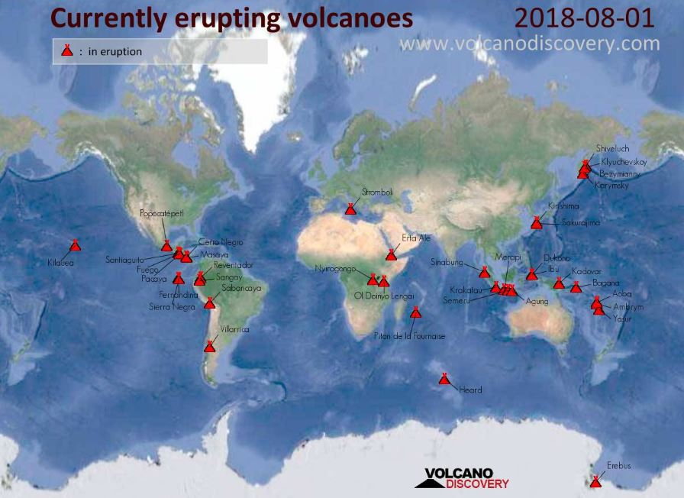
Map of the currently erupting volcanoes around the world as of August, 1 2018 via Volcano Discovery.
“The US Has 169 Volcanoes That Could Erupt, Including 50 That Are Considered `High Priority’ for Monitoring.”- By Strange Sounds - May 15, 2018

“Volcano Anak Krakatau Eruptions Intense Explosions Off the Seismic Scale Krakatau volcano (Indonesia): continuous intense explosions heard 42 km away, off scale seismicity” – from Volcano Discovery - Jul 12, 2018
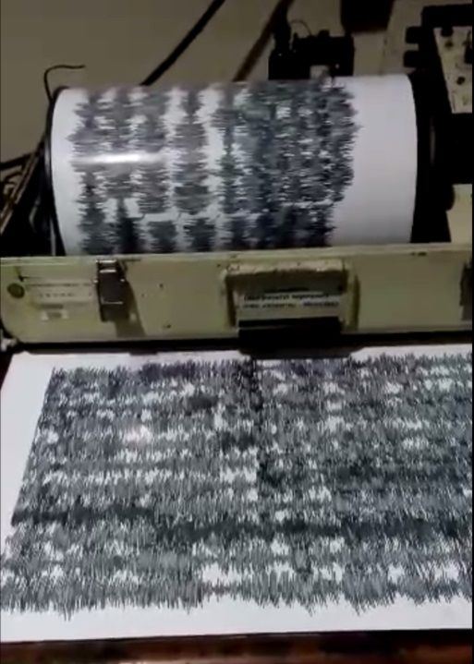
“Our Indonesian volcano expedition leader Andi has sent us the below video of the current seismicity of Anak Krakatau: "Krakatau is going crazy ...100 times explosion a day ... very loud could be heard until Carita 42 km away"
“Enhanced seismic activity and volcanic eruption at Anak Krakatau (Indonesia) The seismicity of Anak Krakatau was particularly high on August 18, characterized by 578 eruption earthquakes, 80 emission / exhalation earthquakes. On August 19, the number of eruptions earthquakes decreased to 248, but that of emission increased to 118.”
Steve Quayle comment: “IT HAS BEEN TOLD TO ME THAT KING ANAK WAS PLACED IN STASIS TO RETURN OR BE GENETICALLY RESURRECTED IN THE LAST DAYS-TAKE IT TO THE LORD IN PRAYER.” [Remember the Anakim! Numbers 13 – they were Nephilim! Refer to: “Facing the Anakim”]

August 24, 2018 AP: “Mount Etna volcano roars into action with ash and lava”
ROME (AP) — Mount Etna in Sicily has roared back into spectacular volcanic action, sending up plumes of ash and spewing lava. Italy’s National Institute of Geophysics and Vulcanology (INGV) says that the volcano, which initially “re-awoke” in late July, sprang into fuller action Thursday evening (August 23, ’18) by shooting up chunks of flaming lava as high as 150 meters (500 feet) almost constantly.”

“Sixty nine major earthquakes hit the Pacific's Ring of Fire in just 48 hours driving fears that the 'Big One' is about to hit California”
Harry Pettit For Mailonline August 21, 2018
“Sixty nine major earthquakes have hit Earth's most active geological disaster zone in the space of just 48 hours. Sixteen 'significant' tremors - those at magnitude 4.5 or above - shook the Pacific 'Ring of Fire' on Monday, following a spate of 53 that hit the region Sunday. The quakes rattled Indonesia, Bolivia, Japan and Fiji, but failed to reach the western coast of the United States, which also falls along the infamous geological ring. The tremors have raised concerns that California's 'Big One' - a destructive earthquake of magnitude 8 or greater - may be looming.
Scientists have previously warned that Ring of Fire activity may trigger a domino effect that sets off earthquakes and volcanic eruptions elsewhere in the region…”

“Over The Last 7 Days Our Planet Has Been Violently Shaken By 144 Major Earthquakes” - August 21, 2018 Michael Snyder - End of the American dream
“According to the Daily Mail, the “Ring of Fire” was shaken by a total of 69 major earthquakes on Sunday and Monday…Sixty nine major earthquakes have hit Earth’s most active geological disaster zone in the space of just 48 hours. Sixteen ‘significant’ tremors – those at magnitude 4.5 or above – shook the Pacific ‘Ring of Fire’ on Monday, following a spate of 53 that hit the region Sunday. The vast majority of the earthquakes that shake our planet take place along the Ring of Fire. It roughly encircles the Pacific Ocean, and it runs right up the west coast of the United States…It simply is not “normal” for 144 major earthquakes to happen in just one week. In addition, dozens of volcanoes are currently erupting all over the globe. We appear to have entered a time when the crust of our planet is going to become increasingly unstable…”
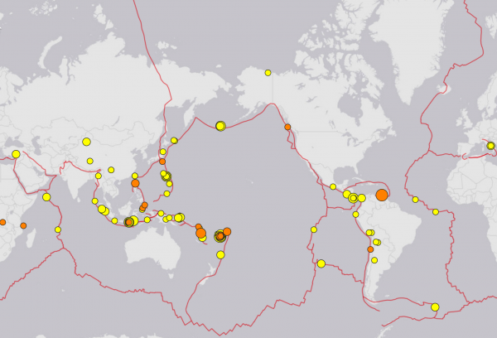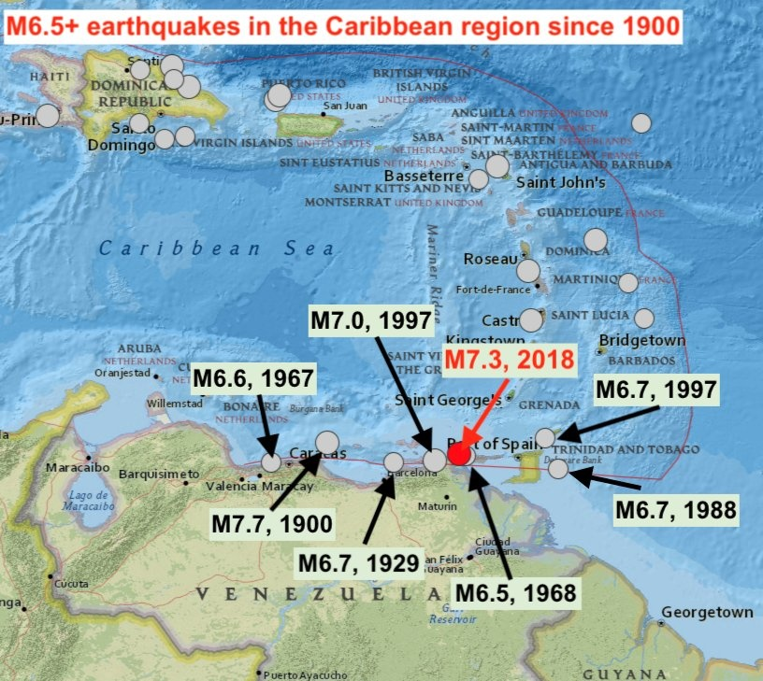
“….Within the past few days, we have seen an enormous magnitude 7.3 earthquake hit Venezuela and a giant magnitude 8.2 earthquake hit Fiji. Where will the next one strike? To many of us, it is becoming exceedingly clear that something very unusual is happening to our planet. I went and looked it up, and I was astounded to learn that the crust of the Earth has been shaken by 144 major earthquakes over the last 7 days, and that includes more than 50 on Sunday alone. And remember, these are not small earthquakes. The USGS considers any earthquake that is at least magnitude 4.5 to be `significant’, and they are happening so rapidly right now that it is difficult to keep up with them.”

“New massive earthquakes and volcanic eruptions around the world: M7.3 quake in Venezuela, M6.6 quake in Vanuatu, enhanced volcanic activity at Etna and Stromboli (Italy), Krakatau (Indonesia) and Ebeko (Russia)” By Strange Sounds - Aug 22, 2018: “There is currently an enhanced earthquake activity around the world. Within 48 hours, more than 5 earthquakes larger than M6.0 have rattled the world, killing people and destroying infrastructures. In parallel, new volcanoes are erupting daily. Although they may be not related, such a geologic unrest is quite scary for people living in active and even less active regions. Be ready and if you aren’t already get prepared!
Within the last two weeks or so, the worldwide seismic activity makes the headlines, rattling and killing in different regions around the Ring of Fire… Since Yesterday, August 21, 2018, another two strong quakes have to be added to the growing list. One hit Venezuela and the Caribbean (M7.3 earthquake) and the other the Archipelago of Vanuatu (M6.6). In Venezuela, the M7.3 earthquake hit at a depth of 123 km just 20 km at the NNO of Yaguaraparo.”
----
A few Scriptures relating to the Earth Shaking as a sign of Yahuwah’s Judgment, and the coming of Yahushua:
Isaiah 2:17-22: And the loftiness of man shall be bowed down, and the pride of men shall be brought low. And יהוה alone shall be exalted in that day, and the idols completely pass away. And they shall go into the holes of the rocks, and into the caves of the earth, from dread of יהוה and the splendor of His Excellency, when He arises to shake the earth mightily. In that day man shall throw away his idols of silver and his idols of gold, which they made, each for himself to worship, to the moles and bats,
to go into the clefts of the rocks, and into the crags of the rugged rocks, because of the fear of יהוה and the splendor of His Excellency, when He arises to shake the earth mightily. Cease from man, whose breath is in his nostrils, for in what is he to be reckoned upon?”
Isaiah 13:13: “So I shall make the heavens tremble, and the earth shall shake from her place, in the wrath of יהוה of hosts and in the day of the heat of His displeasure.”
Isaiah 24:1, 3-6, 19-21, 23: “See, יהוה is making the earth empty and making it waste, and shall overturn its surface, and shall scatter abroad its inhabitants…the earth is completely emptied and utterly plundered, for יהוה has spoken this word. The earth shall mourn and wither, the world shall languish and wither, the haughty people of the earth shall languish. For the earth has been defiled under its inhabitants, because they have transgressed the Torot, changed the law, broken the everlasting covenant. Therefore a curse shall consume the earth, and those who dwell in it be punished. Therefore the inhabitants of the earth shall be burned, and few men shall be left…The earth shall be utterly broken, the earth shall be completely shattered, the earth shall be fiercely shaken. The earth shall stagger like a drunkard. And it shall totter like a hut, and its transgression shall be heavy upon it, and it shall fall, and not rise again. And in that day it shall be that יהוה punishes on high the host of exalted ones, and on the earth the sovereigns of the earth…And the moon shall blush, and the sun shall be ashamed, for יהוה of hosts shall reign on Mount Tsiyon, and in Yerushalayim, and before His elders, in esteem.”
Ezekiel 38:19-20: “For in My jealousy and in the fire of My wrath I have spoken, ‘On that day there shall be a great shaking in the land of Yisra’ĕl, so that the fish of the sea, and the birds of the heavens, and the beasts of the field, and all creeping creatures that creep on the earth, and all men who are on the face of the earth shall shake at My presence. And the mountains shall be thrown down, and the steep places shall fall, and every wall fall to the ground.”
Joel 3:15-16: “Sun and moon shall become dark, and stars shall withdraw their brightness. And יהוה shall roar from Tsiyon, and give forth His voice from Yerushalayim. And the heavens and earth shall shake, but יהוה shall be a refuge for His people, and a stronghold for the children of Yisra’ĕl..”
Haggai 2: 6-7, 21: “For thus said יהוה of hosts, ‘Once more, in a little while, and I am shaking the heavens and earth, the sea and dry land. ‘And I shall shake all the nations, and they shall come to the Delight of all the nations, and I shall fill this House with esteem,’ said יהוה of hosts…Speak to Zerubbaḇel, the governor of Yehuḏah, saying, ‘I am shaking the heavens and earth.’ ”
Zechariah 14:3-5: “And יהוה shall go forth, and He shall fight against those nations as He fights in the day of battle. And in that day His feet shall stand upon the Mount of Olives, which faces Yerushalayim on the east. And the Mount of Olives shall be split in two, from east to west, a very great valley, and half of the mountain shall move toward the north and half of it toward the south. And you shall flee to the valley of My mountain – for the valley of the mountains reaches to Atsal. And you shall flee as you fled from the earthquake in the days of Uzziyah sovereign of Yehuḏah. And יהוה my Elohim shall come – all the set-apart ones with You.”
Matthew 24:29: “And immediately after the distress of those days the sun shall be darkened, and the moon shall not give its light, and the stars shall fall from the heaven, and the powers of the heavens shall be shaken. “And then the sign of the Son of Aḏam shall appear in the heaven, and then all the tribes of the earth shall mourn, and they shall see the Son of Aḏam coming on the clouds of the heaven with power and much esteem.” [Also: Mark 13: 25-26; Luke 21:26-27]
Hebrews 12:25-29: “Take heed not to refuse the One speaking. For if those did not escape who refused the warning on earth, much less we who turn away from Him from heaven, whose voice shook the earth then, but now He has promised, saying, `Yet once more I shake not only the earth, but also the heaven.’ And this, “Yet once more,” makes clear the removal of what is shaken – as having been made – so that the unshaken matters might remain. Therefore, receiving an unshakeable reign, let us hold the favor, through which we serve Elohim pleasingly with reverence and awe, for indeed, our Elohim is a consuming fire.”
Revelation 6:12-17: And I looked when He opened the sixth seal and saw a great earthquake came to be. And the sun became black as sackcloth of hair, and the moon became as blood. And the stars of the heaven fell to the earth, as a fig tree drops its unripe figs, being shaken by a strong wind. And heaven departed like a scroll being rolled up, and every mountain and island was moved out of its place. And the sovereigns of the earth, and the great ones, and the rich ones, and the commanders, and the mighty, and every slave and every free one, hid themselves in the caves and in the rocks of the mountains, and said to the mountains and rocks, `Fall on us and hide us from the face of Him sitting on the throne and from the wrath of the Lamb, because the great day of His wrath has come, and who is able to stand?’ ”
Revelation 16:17-21: “And the seventh messenger poured out his bowl into the air, and a loud voice came out of the Dwelling Place of the heaven, from the throne, saying, “It is done!” And there came to be noises and thunders and lightning. And there came to be a great earthquake, such a mighty and great earthquake as had not came to be since men were on the earth. And the great city became divided into three parts, and the cities of the nations fell. And great Baḇel was remembered before Elohim, to give her the cup of the wine of the fierceness of His wrath. And every island fled away, and the mountains were not found. And great hail from the heaven fell upon men, every hailstone about the weight of a talent. And men blasphemed Elohim for the plague of the hail, because that plague was exceedingly great.”

This word is for Yahuwah’s children: Luke 6:46-49: “But why do you call Me ‘Master, Master,’ and do not do what I say? Everyone who is coming to Me, and is hearing My words and is doing them, I shall show you whom he is like: He is like a man building a house, who dug deep and laid a foundation on the rock. And when a flood came, the stream burst against that house, but was unable to shake it, for it was founded on the rock. But the one hearing and not doing, is like a man who built a house on the earth without a foundation, against which the stream burst, and immediately it fell. And the ruin of that house was great.”

Be not shaken! We stand firm in faith on the Word of Elohim!
We are seeing a fast increase in birth pangs. We’ve been seeing a steady increase in birth pangs since 1896, especially since 1945. We are now seeing details of Scripture’s 223 end-time prophecies coming to pass and accelerating.
I know that when birth pangs begin they may increase slowly, but sometimes they increase extremely fast. For sure, what begins even slowly surely increases to the birth! We’ve passed a cycle-marker. Whether it is the final cycle marker or not, is up to Elohim! But, the birth pangs are speeding up incredibly!
The words to us in I Thessalonians 5:3-6 hold true for the children of Light: “For when they say, `Peace and safety!’ then suddenly destruction comes upon them, as labor pains upon a pregnant woman, and they shall not escape. But you, brothers, are not in darkness, so that this Day should overtake you as a thief. For you are all sons of light and sons of the day. We are not of the night, or of the darkness. So, then, we should not sleep, as others do, but we should watch and be sober!” Dear Children of Light: Don’t be mentally or spiritually asleep!
Shalom and blessings,
Yedidah, Shabbat - August 25, 2018

