DANIEL 5!
“It Was the Medes and the Persians That Took Down Ancient Babylon”

June 18th, in reviewing the current situation with Iran, and Putin’s somber warning to America regarding catastrophic war, Abba Yahuwah spoke to me: “It was the Medes and Persians that took down ancient Babylon.”
O Yes! They took it down and they took over! I did some research. Derek and I fellowshipped about it via phone, and he gave some amazing things to check out. The more I studied, the more Abba opened up my understanding. So, what I write here is what I understand to date about what He said to me on June 18th.
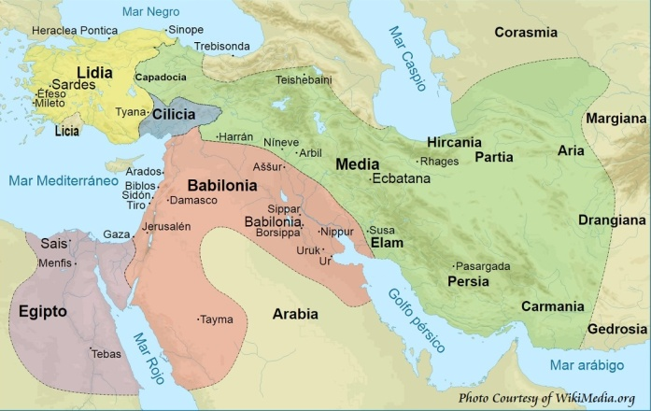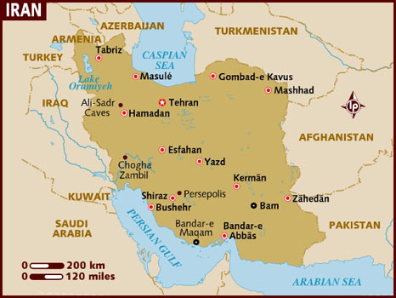
Left: ancient Iran showing the areas of Media and Persia
Notice ancient Babel and Ashshur near Nineveh: On the map “Assur” is in ancient “Babylonia” and Nineveh is in Iran in the area of Media. Persia is in the south. So Media bordered Babylonia – thus Darius just moved West and took it over.
Right: Modern Iran
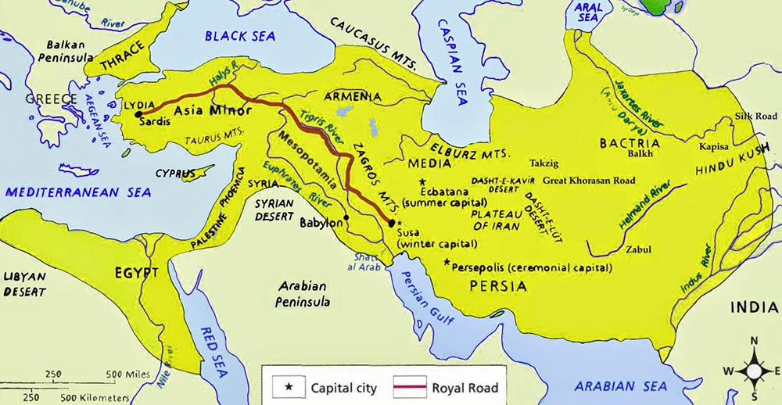
Ancient territory of Iran

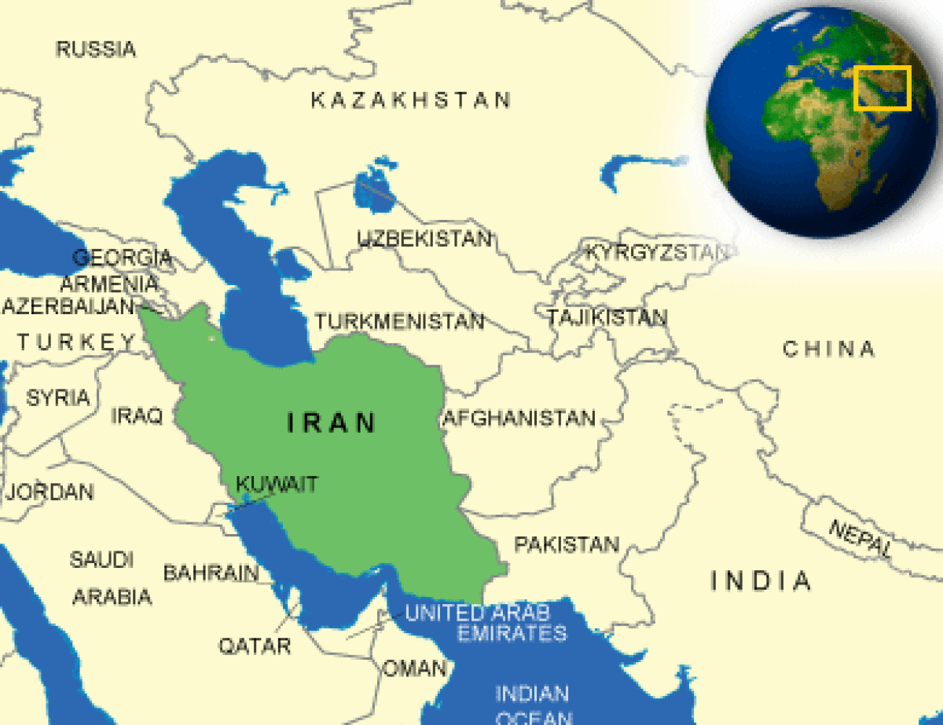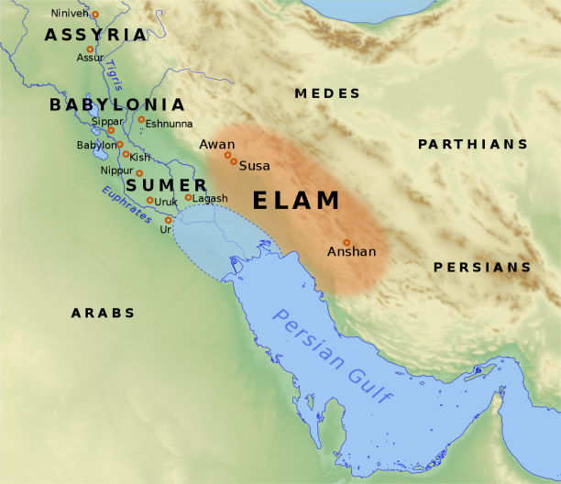
Modern Iran among the nations Ancient Iran noting Elam Genesis 14:1

Darius the Mede was the uncle of Koresh/Cyrus the Persian. The Media-Persian Empire conquered Babylon in the days of King Belshazzar, son of Nebuchadnezzar.
The seven empires, the heads of Beast are: 1) Egypt, 2) Assyria, 3) Babylon, 4) Media-Persia, 5) Greece, 6) Rome, and 7) the Empire of the Beast, the risen Nimrod/Osiris/Apollo – the Apollyon of Revelation 9:11, 11:7: 17:8…
Isaiah 13 speaks about the destruction of America! America has been the end-time Babylon, chosen to reincarnate and restore Babylon’s founder, Nimrod, to world power. [Refer to: “America’s Secret Destiny – What the History Books Never Told Us” and “Thirty Clues and More Identifying America in Prophetic Scripture”/both under the Mikvah of Preparation]
It was the Medes and Persians who quietly took out King Belshazzar and took control of that great super power of the ancient world. Note the words of Daniel 5 interpreted by Daniel to Babylon’s King Belshazzar just a few hours before Darius the Mede took the city. Shrewd Darius took Babylon by quietly diverting the water beneath the city, and taking his troops through the dried water shafts. No one died that night but King Belshazzar.
First the Medes under Darius ruled for about a year, then his nephew Koresh/Cyrus the Persian ruled Babylon.
The “spirit of the Medes” in Isaiah 13 is not the kinder spirit of Darius and Koresh. The “spirit of the Medes” of today are an unmerciful Iran, with Russia, China, and North Korea as allies. When these Medes get ready to take down end-time Babylon, America, the words of Isaiah will come to pass.
Are you seeing the seriousness of what is happening right now?
Isaiah 13:17-22, Septuagint: Behold, I will stir up against you the Medes, who do not regard silver, neither have they need of gold. They shall break the bows of the young men; and they shall have no mercy on your children; nor shall their eyes spare thy children. And Babylon, which is called glorious by the king of the Chaldeans, shall be as when God overthrew Sodom, and Gomorrah. It shall never be inhabited; neither shall any enter into it for many generations; neither shall the Arabians pass through it; nor shall shepherds at all rest in it. But wild beasts shall rest there; and the houses shall be filled with howling; and monsters shall rest there, and devils shall dance there, and satyrs shall dwell there; and hedgehogs shall make their nests in their houses. It will come soon, and will not tarry.”
How did Yahuwah destroy Sodom and Gomorrah? - He reigned down fire and sulfur (“brimstone”), and burnt those cities and other cities of the plain into ash, from the top down. Several times I’ve been to the area that Ron Wyatt named Gomorrah--near the base of Masada. That area reveals is a city burned to ash. Salted all through the area one can still find sulfur balls, which, if lit, burn bright. I put my hand into one of the ash columns and smelled it. Hum, yes, it smelled like sulfur (“brimstone”) Genesis 19. I’ve got ash and a few sulfur balls from there.
What would come close to what Yahuwah did to Sodom and Gomorrah? - Nuclear bomb. If the U.S. proceeds with its war-threats against Iran, waiting behind Iran are Russia, China, North Korea, and other enemies. Read carefully Jeremiah 50-51, Revelation 18.
Jeremiah 51:6-13: Polish the arrows! Put on the shields! יהוה has stirred up the spirit of the sovereigns of the Medes. For His plan is against Baḇel to destroy it, because it is the vengeance of יהוה, the vengeance for His Hĕḵal. Lift up a banner on the walls of Baḇel, strengthen the watch, station the watchmen, prepare the ambush. For יהוה has both planned and done what He spoke concerning the inhabitants of Baḇel. You who dwell upon many waters, great in treasures, your end has come, the measure of your greedy gain.”

The HOUSE OF ISRAEL/JOSEPH/EPHRAIM and the AREA of the ANCIENT MEDES:
II Kings 17:5-6: “The the King of Assyria came up throughout all the lad, and went up to Samaria and besieged it three years. In the 9th year of the Hoshea, the King of Assyria, took Samaria and carried Israel away into Assyria and placed them in Halah and in Habor by the river of Gozan, and in the cities of the Medes.”
Today the greatest concentration of the whole House of Israel (the 10 northern tribes of Ya’cob/Jacob is inside America. America is both Babylon and Assyria… All twelve tribes were represented in Babylon due to the Passover of King Josiah.
Genesis 10:8-11: “And Kush brought forth Nimrod. He began to be a mighty one on the earth. He was a mighty hunter before Yahuwah, therefore it is said `Like Nimrod the mighty hunter before Yahuwah.’ (or “in the face of Yahuwah”)
And the beginning of his kingdom was Babel, and Erek, and Akkad, and Kalneh in the land of Shinar. From that land he went to Assyria (Ashshur) and built Nineveh…”
Nimrod founded the original pagan nations of Babel and Assyria in which Nephilim kept being born to human women. His grandfather Canaan, grandson of Noah, was a hybrid. All Nimrod had to do was take DNA from Canaan, or his father Cush, and give himself a transfusion. The lineage of Canaan became giants, the Nephilim lineage of the Canaanites, of what became the land of Judea and Samaria.
II Kings 18:11: “And the King of Assyria did carry away Israel into Assyria, and put them …in the cities of the Medes.” (722 BCE)
Genesis 14: Chedorleomer was the King of Elyam. Look at the map above –Elyam was a large area of ancient Persia, now a province of modern Iran. Chedorleomer raided Lot’s camp and kidnapped him, taking him clear up to the Mount Hermon area. Abraham armed his 318 trained servants and went after Chedorleomer, who was killed. Abraham brought back Lot. It was this victory that led to Abraham meet with Malek-Zadok, to whom Abraham paid his tithe.
Ezra 6:1-2: “Then Darius the king made a decree and search was made in the house of the scrolls, where the treasures were laid up in Babylon, and there was found at Arhmetha, in the place that is in the province of the Medes a scroll, and therein was a record thus written in the year of Cyrus/Koresh …concerning the house of God at Jerusalem. Let the house be built, the place where they offered sacrifices…”
Prophecy soon to be fulfilled, Isaiah 13:7: “Behold I will stir up the Medes against them…” He speaks of the spirit of the Medes, and the modern-day people of those who inhabited ancient area of the Medes--northern Iran.
Jeremiah 25:15-17, 24-25: “For thus says Yahuwah Elohim of Israel to me, `Take this wine cup of wrath from My hand and make all the nations to whom I send you drink it. And they shall drink and shake and go mad because of the sword I am sending among them. I then took the cup from the hand of Yahuwah and made all the nations drink to whom Yahuwah had sent me…and all the kings of Arabia, and all the king of the mixed multitude who dwell in the wilderness, and all the kings of Zimri, and all the kings of Elyam and all the kings of the Medes…”
Jeremiah 51:11: “Make bright the arrows. Gather the shields. The Lord has raised up the spirit of the king of the Medes, for His device is against Babylon, to destroy it, because it is the vengeance of the Lord…”
Jeremiah 51:28-29: “Prepare against her (Babylon) the nations with the kings of the Medes, the captains thereof and all the rulers therefore, and all the land of his domain. And the land shall tremble and sorrow for every purpose of the Lord shall be performed against Babylon to make the land of Babylon a desolation without an inhabitant.”

DANIEL 5:28: “Peres: Your kingdom is divided and given to the Medes and Persians.”
Today Media-Persia is the nation of Iran. It was once a massive empire expanded West, even to Turkey, see map above.
Iran borders what used to be part of the Soviet Union and are close to both Russia and China today. Iran is close to Russian border on the Caspian Sea at the north.
Nimrod built Babel and Ashshur – Assyria. By the 1st century Rome became known as the “second Babylon.” The spirit of Babylon, the spirit of Nimrod, was in the Romans who sought to conquer the world. That spirit is in all who seek to conquer the world – like Alexander the Great of Greece, and Saladin of the Ottoman Empire. Hitler sought to rule the world. This spirit went across Western Europe.
In the 1500s, secret societies planned to create the nation of America and use it to bring forth Nimrod to rule the world. America is seen in Jeremiah 50-51, Isaiah 10, 13, 18, 47, Zechariah 2, Revelation 17 and 18, as “end time Babylon,” political and economic Babylon. America has closed ties with the “second Babylon,” religious Babylon. Rome never died. It just transferred its power into the Roman Catholic Church.
America and the Roman Catholic Church joined as sisters, both end-time Babylon. Early America wanted to name our capital “Rome.” Refer to the Isis/Osiris legend, foreshadowing the antichrist in the phallic symbol of the obelisk and the dome – the womb of Isis. Their child Horus is symbolic of antichrist. That legend is a guiding light to occultists and to today’s Globalists seeming a new world order.

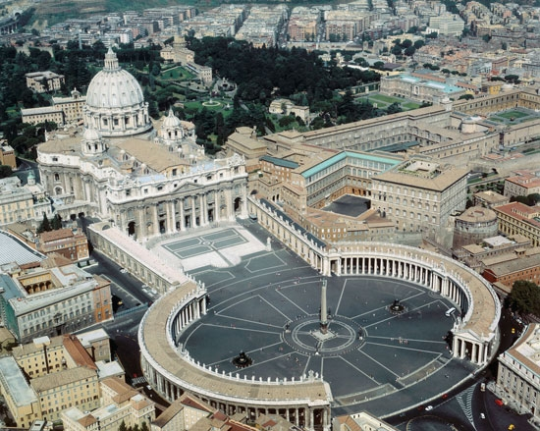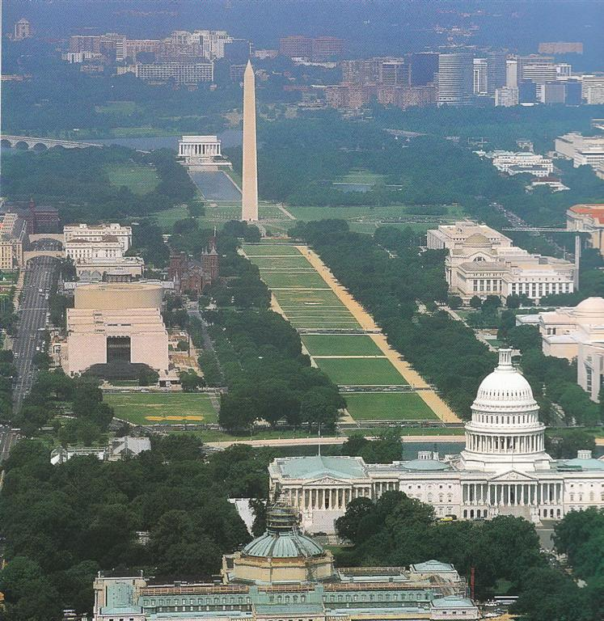
L
L
Left: The Egyptian obelisk in St. Peter’s square with the dome of the Vatican
Right: The Washington Monument and the U.S. Capital Building.
Recently something has surfaced that is shocking. It’s something we knew in the back of our brain but never connected the dots – until now. Jerusalem is called “that great city” in Revelation 11. It will be the headquarters of world government ruled by antichrist—i.e. Nimrod/Osiris/Apollo (Apollyon) of Revelation 9:11, 11:7; 17:8 and II Thessalonians 2:3. There are also such obelisk-dome symbols in Israel, one particularly donated by the Rothschild Dynasty.
In Revelation 18:10, 16, 19, New York City is called “that great city.” In Revelation 17:18, the woman, Mystery! Babylon the great! Mother of harlots! is identified as Jerusalem.
End-time Babylon, the “final political and economic Babylon, America, will fall: Isaiah 21:9; Jeremiah 51:8; Revelation 14 8; 16:9; 18:2.
Jerusalem will become the center of the political, economic, and religious world -- capital of Nimrod, the antichrist and his false prophet. Jerusalem will become the seat, capital, of the world, ruled over by Nimrod incarnated as “Apollyon,” “Abaddon,” the destroyer. (Revelation 19:20)
All “Babylons” will be eliminated, two before Messiah returns: America, political and economic Babylon - Isaiah 21:9 Jeremiah 51:8 Revelation 18: 2 and Vatican Rome, once political and economic Rome, it later ruled through papal religion. By the first century CE, it was known as “the second Babylon.” Plus the culmination of Nimrod’s Babel that will be totally destroyed as He returns: Jerusalem (Revelation 14:8; 16:19).
Daniel 5: King Belshazzar, son of Nebuchadnezzar, was having a magnificent party. He commanded that the utensils used in the temple of Solomon, which were solid gold, be taken out and used for the party. The king and his guests began praising the gods of silver and gold, bronze, iron, wood, stone.
While drunken and laughing their heads off, beginning in Daniel 4:5: “…at that moment the fingers of a man’s hand appeared and wrote opposite the lamp stand on the plaster of the wall of the King’s palace. And the King saw part of the hand that wrote.”
Belshazzar was terrified. His wife told him about Daniel. Daniel was called to interpret the message because the king knew that Daniel knew Elah (Eloah/God).
Daniel 5: “Bĕlshatstsar the sovereign made a great feast for a thousand of his great men, and drank wine in the presence of the thousand. While tasting the wine, Bĕlshatstsar gave orders to bring the gold and silver vessels which his father Neḇuḵaḏnetstsar had taken from the Hĕḵal which had been in Yerushalayim, that the sovereign and his great men, his wives, and his concubines could drink from them. Then they brought the gold vessels that had been taken from the Hĕḵal of the House of Elah which had been in Yerushalayim. And the sovereign and his great men, his wives, and his concubines drank out of them. They drank wine, and praised the elahim of gold, and of silver, of bronze, of iron, of wood and of stone.
At that moment the fingers of a man’s hand appeared and wrote opposite the lamp stand on the plaster of the wall of the sovereign’s palace. And the sovereign saw the part of the hand that wrote. Then the sovereign’s color changed, and his thoughts alarmed him, so that the joints of his hips were loosened and his knees knocked against each other. The sovereign called loudly to bring in the astrologers, the Chaldeans, and the diviners. The sovereign spoke and said to the wise ones of Baḇel, “Whoever reads this writing, and shows me its interpretation, is robed in purple and has a chain of gold around his neck, and shall be the third ruler in the reign.” So all the sovereign’s wise ones came, but they were unable to read the writing, or to make known its interpretation to the sovereign. Then Sovereign Bĕlshatstsar was greatly alarmed, and his color changed, and his great men were puzzled.
The queen, because of the words of the sovereign and his great men, came to the banquet hall. And the queens spoke and said, “O sovereign, live forever! Do not let your thoughts alarm you, nor let your color change. There is a man in your reign in whom is the Spirit of the Set-apart Elah. And in the days of your father, light and understanding and wisdom, like the wisdom of the elahin, were found in him. And Sovereign Neḇuḵaḏnetstsar your father, your father the sovereign, made him chief of the magicians, astrologers, Chaldeans, and diviners, because an excellent spirit, knowledge and understanding, interpreting dreams, and explaining riddles, and solving difficult problems were found in this Dani’ĕl, whom the sovereign named Bĕlteshatstsar. Now let Dani’ĕl be called, and let him show the interpretation.
So Dani’ĕl was brought in before the sovereign. The sovereign spoke and said to Dani’ĕl, `Are you that Dani’ĕl who is one of the sons of the exile from Yehuḏah, whom my father the sovereign brought from Yehuḏah? I have heard of you, that the Spirit of Elah is in you, and that light and understanding and excellent wisdom are found in you. And the wise ones, the astrologers, have been brought in before me, that they should read this writing and make known to me its interpretation, but they were unable to show the interpretation of the word. And I myself have heard of you, that you are able to give interpretations and to solve difficult problems. Now if you are able to read the writing and make known its interpretation to me, you are to be robed in purple and have a chain of gold around your neck, and shall be the third ruler in the reign.
Then Dani’ĕl answered and said before the sovereign, `Let your gifts be for yourself, and give your rewards to another. Yet I shall read the writing to the sovereign, and make known the interpretation to him. O sovereign, the Most High Elah gave Neḇuḵaḏnetstsar your father a reign and greatness, and preciousness and esteem. And because of the greatness which He gave him, all peoples, nations, and languages trembled and feared before him. Whomever he wished he executed, and whomever he wished he kept alive, and whomever he wished he raised up, and whomever he wished he made low. But when his heart was lifted up, and his spirit was so strong as to act proudly, he was put down from his throne of reign, and they took his preciousness from him. Then he was driven from the sons of men, and his heart was made like the beasts, and his dwelling was with the wild donkeys. He was given grass to eat like oxen, and his body was wet with the dew of the heavens, till he knew that the Most High Elah is ruler in the reign of men, and He sets up over it whomever He wishes. And you his son, Bĕlshatstsar, have not humbled your heart, although you knew all this. And you have lifted yourself up against the Master of the heavens. And they brought before you the vessels of His house, and you and your great men, your wives and your concubines, have been drinking wine from them. And you have praised the elahim of silver, and of gold, of bronze, of iron, of wood, and of stone, which neither see nor hear nor know. But the Elah who holds your breath in His hand and owns all your ways, you have not made great. Then the part of the hand was sent from Him, and this writing was inscribed.
And this is the writing that was inscribed: `MENĚ, MENĚ, TEQĚL, UPHARSIN.
This is the interpretation of each word: MENĚ – Elah has numbered your reign, and put an end to it.
TEQĚL – You have been weighed on the scales, and found lacking.
PERES – Your reign has been divided, and given to the Medes and Persians.’
Then Bĕlshatstsar gave orders, and they robed Dani’ĕl in purple and put a chain of gold around his neck, and they proclaimed concerning him that he is the third ruler in the reign. In that night Bĕlshatstsar, sovereign of the Chaldeans, was slain. And Dareyawesh the Mede took over the reign, being about sixty-two years old.”

The people of Babylon woke up the next morning to a new king – Darius the Mede. He enacted over them the very strict laws of the Medes and Persians. But, they had peace.
Revelation 18:10: “Woe, woe to the great city Babel, the mighty city because your judgment has come in one hour.”
After silently entering the city, once inside, the judgment on king Belshazzar and the takeover of Babylon took no more than one hour.
Whose hand wrote those words on Belshazzar’s wall? It was the “right hand of Yahuwah,” aka the “right arm of Yahuwah,” – Yahushua!

Lisa Haven as reported that there are approximately 10,000 sleeper cells of foreign terrorists and armies within America right now, 6,000 of them are Iranian.
All they have to do is come out of hiding, along with the Chinese troop, the Russian troop, and many other terrorist groups within the U.S. Today the Chinese are giving very high-tech weaponry to Iran that can wipe out the entire U.S. Fleet with one missile. Russia has tremendous high-tech weaponry like their supersonic missiles that fly too fast for anyone to shoot them down. America is beneath them in ability.
Obama made sure of that by drastically reducing the size of the military, firing key officers, and failing to provide needed provisions to the ships and airplanes. He brought our military down to smaller in number, with less efficiency than it was before World War II.
In 2019, a huge flood took out America’s #1 reconnaissance Base in Nebraska, our chief base for detecting incoming foreign planes. [Definition: military observation of a region to locate an enemy or ascertain strategic features. Synonyms: preliminary survey, survey, exploration, observation, investigation, examination, inspection, probe, scrutiny, scan]
A man-directed hurricane in 2017 hit a key reconnaissance base in north Florida, a direct hit, damaging many planes, yet a few miles away the hurricane winds were next to nothing.
America is being set up for the Jeremiah 50-51 attacks that will destroy America utterly. With the high tech. military power that will hit America, few will be left alive. New York can easily be destroyed in one hour. The entire nation can be destroyed in 24 hours.
America sits on top of the world’s largest natural gas reserve, covering the whole nation underground, southern Canada, and northern Mexico. One nuclear bomb well placed at the shallowest part of the gas reserve, where, incidentally, America moved its main stash of nuclear weapons a few years ago, will melt the casing on the nuclear weapons, setting off an explosion that will ignite the gas, and no more USA, southern Canada or northern Mexico.
Now what idiot or team of idiots would put their major stash of nuclear weapons on top of the nation’s shallowest part of a highly flammable gas reserve – unless – that’s the plan! The facility that houses the nuclear weapons has its name and phone number published for all to know. I looked it up online. All they need to do is put a big Red X on the top of the building, with a sign in Russian and Chinese: DROP YOUR NUKES HERE! I have to laugh at how ridiculous it is!
The Medes and the Persians today are Iran. As per Yahuwah’s prophecy to me: He said they would once again take down Babylon.
Darius was quiet. He crept in during the night. All one of those nations has to do, including North Korea, would be to create an EMP over America, knock out all our grids, and people would wake up the next morning being ruled by the Medes and Persians, also the Russians, Chinese, jihadists, Iranians, drug cartel gangs, and criminals of all types. They’re already inside America all set up and ready to go. American would be left with would have zero electricity, no water, no food, no cars, no trucks, no lights, no electronics to communicate, no way to get groceries or medicines – everything would go back to the Middle Ages except no horses to ride. The streets would become war zones.
What was the condition of the rulers and people of Babylon before Darius came in? They were just like those in Isaiah 47 and Revelation 18, Jeremiah 50 and 51 – complacent, partying, caring nothing for what belonged to Yahuwah and His worship – totally living for self every day, like before the Flood, too.
Genesis 6! What were the conditions before the Flood? The people thought wickedly all the time. They ate and drank, cannibalized the humans and drank their blood. Today, the ultra-rich pay big money for the blood of babies and little children to drink. Cannibalism is a big thing among the ultra rich, Hollywood stars, and the demon possessed. And we can’ forget the actual reptilians either. Blood is taken from little children to be sold to the ultra rich for drinking. They think they’ll maintain youth if they drink it. Some eat dead babies to get the power of their innocence – the purity of their DNA, so that they, like Nimrod, “become” mighty (a gibbor).
Matthew 24:37b-38a: “…until the day that Noah entered the ark, and they did not know until the flood came and took them all away, so also shall the coming of the Son of Adam be.”
They were too busy satiating the lusts of their flesh to notice that Noah and family were sealed into the ark. When the deep broke up, the Flood came fast, and the people all drowned within a very short time. Abba is patient, but when He gets ready to act, it’s really FAST.
Abba Yahuwah is not a sadist! He is a wonderful Abba/Daddy, Father to His children. But, once His judgment begins to fall on wicked, it is over quickly. The “Day of Yahuwah” is a 24-hour day – the day on which Messiah descends with His wrath. It is poured out quickly.
Globalists are preparing the way for the completion of the Pike-Mazzini Plan of the Zionist Jews – Kabbalist Freemasons – Illuminati. The completion includes World War III to bring the needed chaos to prepare the world for a new world order, a one world government. The plan is right on the back of the U.S. $1.00 bill, even giving the year that the whole thing would begin!
Today America is the same position as Belshazzar and the people of ancient Babylon – complacent, rebellious, lovers of power, money, partying, perversion, and depravity. (II Timothy 3:1-7)
America the great super power is already very weakened by its submission to the LGBTQ agenda, full-term abortion, pedophilia, sex slavery, drugs trafficking, love of entertainment, lust for wealth, idolatry, Satanism, its participation in promoting as Law the Babylonian Talmudic Noahide Laws, and its funding of mercenaries ordered to kill and wipe out Christians, like ISIS. Right now the Mossad is training ISIS in the UAE to carry out the Globalist dirty work to start WW III, setting up Iran as the “fall-guy.”
Oh the privilege to be recognized as one who knows Yahuwah and Yahushua like Daniel did. He went from being a top ruler in Babylon to a top ruler in Media-Persia, because of his incredible integrity and moving in the gifts of the Spirit of Yahuwah.
There is a remnant rising right now who is like Daniel, like Eliyahu and Moshe, like Enoch and Yochanan/John the Apostle who will once again proclaim the message of Jeremiah 25:15-17, 27-33 to the nations before Messiah comes. They will proclaim the message of salvation also to the nation! This remnant is described in Daniel 11:32: “They that know their Elohim will be strong and will act to do exploits.”
Do your own studying in the Word, be led by the Spirit and let Him teach you!
Shalom, in His love,
Yedidah - June 24, 2019

