DAVOS 2023 AND YOUR FUTURE

PART I
In 1996, I went on my first and last tour – my dream come true – I went to Switzerland. My mother had died, and left me a semi-small inheritance. The only thing I wanted for myself out of it was something I dreamed of from 1951, to be where Heidi grew up.
It was September. I had my first trip to Africa planned for late October, my plane ticket already bought from Texas to Nairobi, Kenya. When I went to Zermatt, Switzerland, at the base of the Matterhorn, in the travel agency window was a big sign advertising trips to Kenya. After getting back from Switzerland, I had about two weeks to prepare to go to Kenya. Flying to Nairobi, I looked out the plane window down on the Alps below which I had just left.
In backing up a bit, I went to a travel agent in Fort Worth to book my ticket for the tour of Switzerland. At age 7, I’d sit out on the back porch early in the morning pretending to be Heidi who got up early to milk the cows on a Swiss hilltop. The movie “Heidi” played 7 days in a row on our 12” T.V. Years later, I bought the VHS of it, which I still have. One stop of the tour took us to the Heidi Monument. How special that was!
In getting my ticket for Switzerland, I was told by the travel agent that there were no flights into Zurich on Swiss Air on the day I chose. I asked if there was a flight a day early. Yes, there was one seat for me to go early. I knew that Abba’s blessing. So, while the rest of the tour group entered Zurich very tired the day before the tour began, I welcomed them as I ate dark Swiss chocolate and drank lovely Swiss coffee on the hotel patio. I had spent my extra day walking to and into Zurich and taking pictures of all the exciting things I had only dreamed of.
Our tour guide was with Trafalgar Tours out of England. She was a really nice lady, and our Swiss bus driver was a really nice man. Her philosophy of leading a tour was to tell us where we were, then to let us off the bus in a central location when to meet them back on the bus. I signed up for all six of the extra trips, so while most were shopping, I went on adventures - like to an island in the middle of Lake Maggiore in north Italy, on which was a gorgeous historic castle.
How wonderful. No standing around having a tour guide spend 20 minutes telling us about some statue. I call that “boring.” In Geneva, because I had my Lonely Planet book on Switzerland, I saw all the main sites, and learned what was significant about each one. I feel perfectly confident being independent – and so I got to see lots of special things. I was so thankful for my Lonely Planet book!
The people on the tour came from all over, even Asia. Because no one else had a Lonely Planet book, the other 39 (there were 40 of us) didn’t get to see all of what I saw. We stayed one night at the base of a vineyard before going to Zermatt. The vineyard was planted in rows up a high hill. The Lonely Planet book told of a castle on top of the hill above where we were. So, while the rest of the tour group was downtown shopping, I went up the hill to the castle, and picked a few grapes to eat on the way. I didn’t know where the entrance path to the castle was, so I asked a man walking along the street. Thus, I got to see things, and understand things that the other tourists didn’t get to. Finally, near the end of the tour, which was about two weeks, the others wanted that book! It was funny.
Later, while living in Jordan, I had a friend there who also lived in Montreux, Switzerland. I stayed with her at least two times in her apartment within walking distance of the famous Castle or Chateau of Chillon on Lake Geneva, and took the train north and a boat west, to go to Evian, France. It was during the time of the G-8 Summit. I did much intercession in Evian during that World Summit. I also learned much about why Evian is so special. So much history took place in that area.
My love of adventure and traveling began at age 5 when my parents took me to Sequoia National Park to camp out. Every summer my parents went on a trip from California across to North Carolina, or to Canada when I was 15, where I stood almost right next to Queen Elizabeth and Prince Philip as they boarded their a train for Calgary.
I had bought a manual camera which made professional pictures. On one trip in Switzerland, I remember well the bus descending down a steep hill into a town called Davos. It was a place where Prince Charles often came for skiing.
Today, Davos is the center for yearly meetings of the World Economic Forum – the world government planning group whose membership contains the most important and wealthy people on earth – the trillionaires and world leaders sold out to Lucifer’s plans. They are planning how to bring the world’s people under the authority of the “Beast” and his kingdom ruled by Lucifer. They are making very rapid progress.
OK, I’ve had my fun going down memory lane, but my love of adventure for Yahuwah and Yahushua is still like a fire in my spirit. I like to be on the move with new things - always looking for what Abba has for me to do. It’s the way we live as His servants – His friends with whom He makes His plans! So, while the World Economic Forum is adding more and more nations loyal to Lucifer, the servants of Elohim, Father and Son, are getting more and more excited to get on with the work He has laid out for us.
Please read this in order to take it to Yahuwah in prayer, so that He can help you broaden your vision of what He is doing, and how He wants you to fit into it.
Here are a couple of short videos to show you Davos and explain what this fiasco really is all about. It sure is not anything that is good for mankind!

DAVOS WEF MEETING JANUARY 16-20 FAKERY AND HIDDEN PURPOSE
“EVERYTHING about the World Economic Forum is FAKE” Avi Yemini Rebel news, Au - Live reporting from Davos
https://www.youtube.com/watch?v=9yDS-0zZixk&t=1s 3.57 min.

On the side of a building is written: “Let’s create something that changes everything…Let’s create a better world with a smaller carbon footprint.”
Wow – the “carbon footprint” is that of a human being. We know that their goal is to get rid of most all “carbon footprints” by killing the existing ones and prohibiting the reproduction and life of new ones.
Watch this less than 4-minute video, showing the streets of Davos in its preparation for this time of making plans for us. The whole town is being remodeled for this meeting. There is a special “google” building too.
Davos is a small town. It will be the epicenter for a few days of the plans for world government and the elimination of humanity on earth, and the set-up for the coming Beast system that is already being put in place.

“LEAKED! What the WEF is about to do at Davos 2023 REVEALED” https://youtu.be/AH8d7vOP0wg
Clayton Norris (Redacted) 8-minute video
Notes from the video: Davos attendee list
FBI Director Chris Wray, Amazon director, Google, Facebook, Black Rock, directors, Pfizer, top officials of the Gates Foundation, the Soros Network, the New York Times, - world leaders in the destruction of humanity, promoters of globalism, and friends of the Beast and his system.
Those, like Noah Harari, are leaders in the WEF – mockers and haters of Yahuwah and Yahushua/Jesus – those who hate Their image and likeness reflected in humanity. These WEF members promote Genesis 11, tower of Babel, agenda. “They even have a chair for the C.I.A,” it was said.
“All heavy hitters in the Deep State and worldwide media will be there.”
Many of the plans of the WEF that use what appears to be “planet saving” measures, are actually destroying measures. Many of their policies are world law now – because they are the leader, along with the U.N., using the W.H.O., etc. to promote the end of mankind as we know it. You have a carbon footprint, so be careful where you walk, and with whom you talk. The vice is tightening.
Independent Journalist Jordan Schachtel is seeing the underlying purpose of all of this fakery. For example, the WEF is removing national sovereignty. The unifying of the world around “save the planet” from the humans on it, transhumanism, one world government, the Beast and his system, is taking leaps and bounds forward.
“The WEF is centralizing power,” Jordan said. “They are moving forward with gathering nations under their control.” “To represent the Biden administration, we’re sending the head of the FBI to Davos”
OK researcher-students: Here is the main body of information to use as a platform for understanding that this is not just another meeting of the “big wigs.” “They are actually planning our demise, and the demise of the entire earth.”
Don’t you want to be on the cutting edge and know all that the bad guys are planning? You know that “our Father who is in heaven,” laughs - knowing that the plans of the evil ones are doomed to failure? Read Psalm 2!
Note how far Nimrod got with going into the dimension of Yahuwah to kill Him and kill His Son, and kill all the angels that align with Them. Insane, yes. But, as in Genesis 11, they think they can pull it off. In the meantime, they’ll take a lot of people into hell with them.
Are you a light to the lost who walk in darkness? “Let your light shine before men.” The foolish virgins of Matthew 25:1-12 lost their place in line with those going into the wedding feast, for they let their lamp lights go out. Yahushua said to them: “I do not know you.”

STEVE QUAYLE Daniel Holdings WED JAN 11 2023 Nazi Round Table and The Attempted Usurping of The Kingdom
Davos WEF Meeting 2023: January 16-23
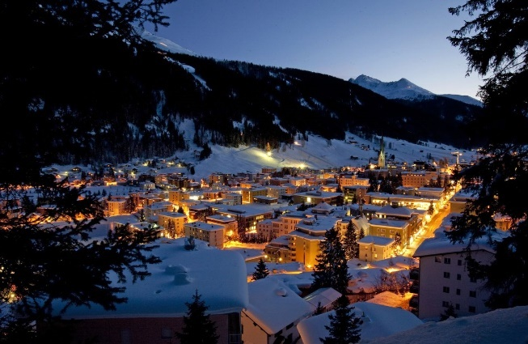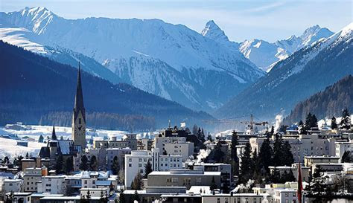

Daniel Holdings speaks of the “round table” discussions that will go on in Davos.
#1 of 4, they are discussing A.I.
Daniel said “it is going to CHANGE EVERYTHING we knew about the world…”
He said “knowledge, from this point on, will be far different than we knew it to be.”
Totally new understanding, concepts, reasoning – all from Luciferic roots …

“AI is the foundational base of the Beast system.”

“The Beast has been released.” He is moving very quickly now.
2) Control over everyone
3) The killing of millions
4) Geo-engineering of the weather

This Davos conference will be far different than any other one previously.

Klaus Schwab, head of the WEF (World Economic Forum): “By 2030 you will own nothing and you will like it.” Schwab is a former Nazi leader who took orders from Hitler.
“This Davos Conference is attended by the wealthiest people in the world.”

Theme “Cooperation in a Fragmented World”
Uh … by the word “cooperation,” the WEF means submission to the Beast and to his In-filler – Lucifer.
Ignorance abounds among Americans! News headlines: “Americans Ignorant About the Hot War in Mexico Near San Diego, starvation in France, and Other Critical Information.” “The World is Changing” Tucker Carlson Fox News Jan 11 ’23.
A concert violinist, a believer, had a vision a few years ago of the earth covered in a thick spider web. The spider web grew stronger, bigger, and darker as he watched it covering the earth. Daniel said that back around 1981, back when CERN was getting known outside Geneva. They created the world wide web.
Daniel asks if what Mr. Lars saw was the web that would cover the earth so that it was 100% covered by this black web.
Daniel asks: “Was what he saw the `surveillance state,’ now covering the earth? Daniel said that a spider catches its prey using its sticky web, and then it slowly devours/eats its pray alive.
The Chinese social credit system is all about surveillance, not social credit specifically. China’s system is taking over America now.
Hollywood star Megan Fox casually tells of drinking human blood in rituals – as well as cannibalism. Her movies have recently revolved around cannibalism.
Yes, human sacrifice of children is openly a part of Hollywood, the cooking of them, the drinking of their blood – babies too – is a now-continual practice.
They are coming out with it openly now – for there is no restraint coming from righteous people. So, things that used to be “conspiracy theory” are now being exposed as real things. The once-vilifying of Christians for talking about hidden things is now just open for all to see. Pedophilia is a common practice in Hollywood, from little children to 12-13-year-olds. Any form of satanic worship or fleshly lusts to go with it is going on.
Kayne West, an actor, told of his mother being sacrificed to Satan – so not all sacrificed are babies and children! Based on occultic sex-magic rituals, the movie “Eyes Wide Shut,” using “Revelation of the Method” – occult symbolism. Once “conspiracy theory” is becoming open fact now.
Daniel: “The UN has more power than the Congress, more power than the Constitution – whatever they want to do, they can legally do … to the US or any other nation.”
Thus, the U.N. has supreme power over the earth, yet must have the pope’s blessing before they make it into law. Oh yes – the pope blesses everything Lucifer wants to do through whoever he wants to work through.
The WEF is meeting January 16-20 to finalize the 46-page document.
OK – Davos and UN making decisions for the human’s race’s extinction at the same time … what is this all about?
Re-read the last article on going through the worm hole, #299.0 under the Mikvah of Present Reality to see what the U.N. is planning.
Daniel showed an article about Switzerland protecting Davos meetings.
Switzerland to deploy 5,000 troops to protect the meetings in Davos.

DATES: “The World Economic Forum in Davos 2023 is scheduled to take place from 16 to 20 January under the theme `Cooperation in a fragmented world’.”
Zelensky will be at Davos, Bill Gates, George Soros, - all the heads of intelligence agencies, - the most wealthy and powerful people on earth – coming together in unity. The head of the FBI will be there – Christopher Whey.
***This is like the Nimrod gathering around the tower! They want to open a portal in the cosmos for all the fallen ones, aliens, Lucifer himself, to come through and for giants to return to the earth from stasis.
This is a meeting of all the chief Luciferic-Satanists … all those plotting with him and his “bestial son” to take over the world.
This is not just a meeting – it is a ceremony of conjuring and invoking and gaining power to destroy all that has anything to do with Yahuwah and Yahushua!!!
Daniel: “THIS MEETING IS A STRATEGY MEETING FOR THE GREAT GLOBAL RESET!”
As above, four themes stand out at his conference - the 3rd and 4th being preparation for the next worldwide pandemic. How many can the next one kill by the disease and the vaccine? It’s all about planning to kill humanity, animals, birds, fish, all sea life, all land life – having a few A.I. controlled slaves, and that’s it.

The SIX MAIN SUBJECTS OF THE CONFERENCE
1) Ukraine shines the light on the need for global cooperation
2) Three interconnected crises: a) climate b) food c) energy
3) Don’t use `recession’ - it might be coming anyway
4) Preparing for the next pandemic requires ending health disparities
5) Gender inequality and preparing for jobs tomorrow
6) Our future is digital

My note: While these topics may seem lukewarm, they are telling what they plan to do to bringing each crisis to fruition. It is out of chaos that order will come, as the Latin phrase on the back of the $1.00 bill says: “Out of chaos – order” referring to the “new world order.”
They are planning crisis – lots of crisis. They are backing confusion as in gender promotion, they are backing death by injection, preparing for the next list of dangerous illnesses that need powerful vaccines that kill more than the sickness.

Daniel: “THE WORLD-WIDE WEB (WWW) AND THE SURVEILANCE STATE ARE COMING TOGETHER,” WHERE WE ARE INCASED IN A SPIDER WEB OF INVESTIGATION LEADING TO ELIMINATION.

My note: The antichrist will bring the chaos. It is out of the chaos that the “order” will arise. Earth’s people will be thrilled. Heaven’s people will be martyred, except for the few who will be hidden, as in Petra, for a while.
Recent AP News: “Air Travel Across the U.S. Thrown Into Chaos After Computer Outage.” ***Refer to the previous article of January 14, 2023 posted under the Mikvah of Present Reality, #300.0.
Then you have the first of 17 waves of energy hitting earth from outside our solar system, as on January 5th, which grounded all flights across the U.S. and deposited a huge amount of radiation into the earth. Please refer to the previous article on going through the Worm Hole -- #299.0 Mikvah of Present Reality. In this article I include much information that the public news is not telling you – neither will they tell you.
This “all flights cancelled” scenario had nothing to do with a computer outage!!! The outage was all across the US due to the wave of energy that hit the earth from outside the solar system. This was confirmed by “Mike from around the world” on Paul Begley’s YouTube channel, Thursday January 11, 2023.

Daily Mail, January 11, 2023: “FAA Fails to Explain Catastrophic Computer Failure that delayed at least 7,000 flights and halted America’s air traffic for the first time since 9-11, after it lifts ground orders on planes after 2½ hours of chaos.”
Besides the Daily Mail staff, “Greg Woodfield at the Tampa International Airport, had input into this article.”
Even the White House admitted there was no computer sabotage. Yet, the news reported it as a computer problem in order to discourage any questions by the few intelligent people still living in America.
Steve Quayle has confirmed to Daniel Holdings that what Hal Turner reported January 15, 2023 about the massive amount of drug dealers, gun dealers, coming across the US border, were paid by Russia to kill the American people. Jeremiah 50-51 is a reality. The final Babylon of Nimrod and his Beast system is America. Refer to: “Thirty Clues and More…” regarding that passage of Scripture.
“Word is coming out of Intelligence Communities that Russia is arming drug cartels in Mexico to cross the open borders to kill Americans.” Of course, they are a part of the inside “clean up” murder-crews that will take over after the bombings by Russia, China, N. Korea, and Iran (from Venezuela).
Also Russia is arming the drug cartel murderers who are crossing the border into Texas. At the time of writing, Hal Turner said this report had no yet been confirmed. However, as of today, January 15, 2023, it has been confirmed by Pentagon hierarchy to Steve Quayle
Russia is also arming Iranians that are inside the U.S. in “sleeper cells.”
They are helping Iranians cross over the border posing as Mexicans.
Because of fears, complacency, laziness, no interest in knowing anything they don’t want here, the American people are getting nothing but deceptions and lies out of public news, so they are clueless about the plans of Lucifer’s team for humanity, or the plans of Yahuwah and Yahushua for us during the execution of Lucifer’s plans.

Daniel: “THE GLOBALISTS ARE BEHIND ALL THE CHAOS THAT EXISTS ACROSS THE WORLD.”
If there is something that happens that is not of their doing, they use it anyway to spread their lies and fears so that people believe their lies.
Breitbart video of extreme weather in northern California – rock slides, flooding, destruction of roads, houses, cars, other buildings – severe. Raging flood waters, as in Montecito.
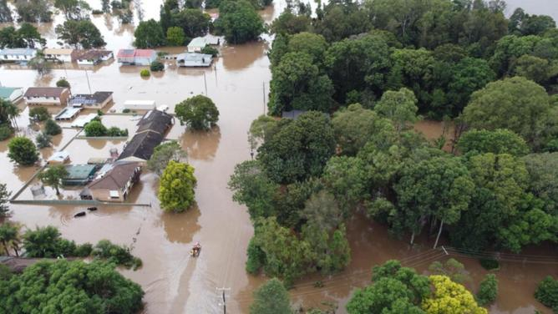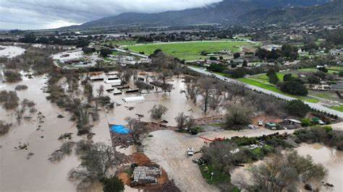
Massive mud slides, huge rock slides, trees slides – covering roads.

Daniel said there are “atmospheric rivers” being “pushed” by geoengineering that is doing this flood damage, loosening rocks and trees, mud, and other debris to roll down over the roads and highways.
Yes, California has had geoengineering taking it down, destroying property, food crops, businesses, etc. for a long time.
I reported on the “direct targeting” of fires in California – showing pictures of houses burned down to ash, yet the trees in between the houses and the grass on the parkways completely untouched. I showed a picture of a tree being burned from the inside out. This is done by airplanes or drones targeting specific targets, whole neighborhoods for example. The use of weather warfare by the U.S. on its own people began back in the late 1940s.
It’s not U.S. warfare against other countries, no, it is warfare against the American people. It has been used greatly in the last 7 years to destroy food crops – and earlier on to destroy world food crops, and people as I remember to 2004.
California is one of the major food crop-growing areas of the U.S. It has provided the nation with most of its fruits and vegetables for a long time. Now I see that most of the fruits and vegetables grown for sale in U.S. grocery markets are imported from Mexico, Central America, and even South America, like Chile, Peru, and Ecuador.
Daniel showed a video of John Paul Jackson (April 2011) recounting a vision he had. Jackson speaks of an earthquake that is going to devastate California. This could mean the BIG ONE to do with the collapse of the entire west coast of America, the Cascadia Subduction Zone and San Andreas Fault Line, and the setting off of at least 12 volcanoes in the Cascadia region of North California, Oregon, and Washington state. He said in the vision he saw “sky scrapers fall.” He said that the whole area will completely change. Jackson spoke of the entire West Coast.
Cascadia Subduction Zone area, which includes Portland, Oregon and Seattle, Washington. Once this begins it will set off the volcanos that are from Vancouver to northern California.
Daniel said “it literally rips down the whole west coast of America.” Yes, it goes from the Canadian border down to Baja. San Diego, as Mike described, will buckle and then fall into the ocean.
He quotes from an article by Michael Snyder regarding the storms that are hitting California and devastating it right now. Michael is asking: “Could the storms hitting California now be the precursors to the devastating earthquakes?”
I remember reading recently – a few days ago – where there was an alert that went out for the Cascadia region regarding huge earthquakes. Now why would that be on the news? That kind of thing is supposed to be silenced so that the public won’t panic.
A sample article by Strange Sounds on January 7th: “Is the Cascadia Subduction Zone about to Blow? Swarm of hundreds of small earthquakes rattle Vancouver Island.”
“According to many scientists, the next rupture of the Cascadia Subduction Zone will spell the worst natural disaster in the history of America.”
The globalists are manipulating the weather to make it look like “climate change” so that their evil plans can go through to control the people of earth to do what they say in the name of protecting the planet. Our carbon footprints and cow farts combine to make it necessary for Lucifer and gang to take over and make all nice for us. Yea, sure…
Again, from page 1 above: “AI is the foundational base of the Beast system.”
1) “The Beast has been released.” He is moving very quickly now.
2) Control over everyone
3) The killing of millions
4) Geo-engineering of the weather

The goal is to control the public for the Beast, feeding on the fears of ignorant humans. Get them scared enough and they’ll be glad to worship the Beast.
The focus of the conference will be: “How do we achieve our agenda.” The most elite of the elite, humans and entities also, will work out a plan that aligns to Beast takeover time.
This is a strategic conference to set in motion final goals, and plans to reach the final goals.
I think it is possible that the conference would actually be controlled by the Beast himself – as Prince Charles, and “Mike,” introduced to our knowledge in October of 2021 when speaking of this Beast who is amassing trillions of dollars for his “military” who will carry out the orders of Lucifer.
Daniel concludes with knowing the coming King of kings by talking to Him, reading His Word, carrying out His commands, general or specific, allowing the Spirit to control our thoughts, emotions, goals, desires, focus … so that we are trained for reigning in the Kingdom of Light.
Daniel closes with this song that he says is particularly special to him:
SOVEREIGN OVER US by Shane and Shane – Daniel Park: a worship song. https://youtu.be/FFO_87VBwNc
Lyrics
There is strength within the sorrow
There is beauty in our tears
And You meet us in our mourning
With a love that casts out fear
You are working in our waiting
You're sanctifying us
When beyond our understanding
You're teaching us to trust
Your plans are still to prosper
You have not forgotten us
You're with us in the fire and the flood
You're faithful forever
Perfect in love
You are sovereign over us
You are wisdom unimagined
Who could understand Your ways
Reigning high above the Heavens
Reaching down in endless grace
You're the lifter of the lowly
Compassionate and kind
You surround and You uphold me
And Your promises are my delight
Your plans are still to prosper
You have not forgotten us
You're with us in the fire and the flood
You're faithful forever
Perfect in love
You are sovereign over us
Even what the enemy means for evil
You turn it for our good
You turn it for our good and for Your glory
Even in the valley; You are faithful

Michael W. Smith singing: htps://youtu.be/vw5osFG4WZk

Please take all of these news updates to Abba in prayer. Some may directly affect you, some may not, but all will affect everyone and everything on the planet at some point, down to the grass and the tiniest flowers hidden in the grass.
It is not “business as usual,” for we have been taken over by the Chinese system we introduced via our Senate putting Mao Tse Tung in power over the Chinese people. I wrote much on that last year (2022) in my 3 articles on the United Nations – under the Mikvah of Present Reality.
Sobriety, watchfulness, sensitivity to what Yahuwah puts into our spirit, is mandatory now as everything is changing almost daily.
In the love of Abba Yahuwah and our Savior Yahushua, Yedidah
January 15, 2023

