Deceptive manipulative PROPAGANDA
TO SILENCE TRUTH and truth-believers

DO NOT BE DECEIVED! LEARN TO DISCERN!
READ SLOWLY! PAY ATTENTION TO THEIR EVERY WORD!

As with all propaganda, there is an element of truth that is subtly mixed in with hate-mongering mind-manipulation, which discretely distorts, mocks, and demeans, what they want to silence. They have to take the edge off of obvious hate-stirring and make it look like a matter of sincere concern. But, also subtly salted in are blatant lies that are well hidden. I want you to read pure Nazi-style propaganda meant to silence you.
In the exposures, below, of amazing propaganda, notice the use of phrases over and over, like: 1) conspiracy theories, 2) anti-vaxxer/anti-vaccine, 3) right-wing extremists, 4) disinformation. The repetition is part of the mind-programming.

The term “conspiracy theory” was created by the C.I.A. during the Warren Commission’s attempt to unravel what happened with the assassination of President John F. Kennedy. Anyone who questioned their conclusions was dubbed a “conspiracy theorist.” Those questioning went against what the C.I.A. wanted the American people to believe.

The obvious goals of this coronavirus “Plandemic” are many, but keeping people safe and well are not in the agenda. It is 1) to unite the world in a world government, 2) depopulate the world of all unusable humans, 3) to ID all usable humans left over, removing their humanity and branding them as servants of a slave society ruled by a central command. It is basically leading to a takeover by the “Beast” and his loyal forces.

The use of fear, subjection, separation, isolation, poverty, and famine, will prepare the world’s people to unite together in a world system with a world ruler, and think they’re happy. Their subjection will include total dehumanizing DNA-change into a hybrid man-machine creature so that they will not disobey or rebel. No free will is allowed. All humans who express a free will are not allowed to continue.

Below I share from two articles to show you the Nazi-like propaganda machine that has been unlashing against anyone with a free-will, who sees the plan, is exposing it, and is encouraging others to stand against it.

Read between the lines – see the hidden deceit, the subtle, or not subtle, mind-programming to make what is good appear wrong, and what is wrong appear good. Read slowly. Look at the snake-like manipulation of words that mix what is good with what is evil, so that the good is considered also bad. It’s genius mind-programming by those in league with the greatest deceiver of all times – the Nachash/Serpent of Genesis 3.

Isaiah 5:20: “Woe to those who call evil good and good evil, who put darkness for light and light for darkness, and put bitter for sweet and sweet for bitter.”

ARTICLE #1
Attack on Truth Labeling it Christian Extremist Conspiracies
“Some evangelicals fear the 'mark of the beast' from a coronavirus vaccine” Caitlin Dickson Reporter Yahoo News May 14, 2020, 1:32 PM CDT
`I’m 70 and I’ve gotten sick before,’ said Popham. `I don’t have a great immune system.’ Popham, who spoke to Yahoo News by phone while quarantining at home in Asheville, N.C., acknowledges that the same factors put her at risk for the coronavirus. `Of course,’ she said, she’s worried about contracting COVID-19. But she’s more worried about a possible vaccine for it. `Absolutely not,’ she said. `I would not take the vaccine.’
That’s a view shared by nearly one in five Americans, according to a recent Yahoo News/YouGov poll, which found that an additional 26 percent weren’t sure if they’d take it. Some of them no doubt have been influenced by the anti-vaccine disinformation that has been spreading for more than a decade on social media — although that has been directed primarily at routine childhood immunizations and their hypothesized link to autism. Popham’s reasons aren’t medical: They are religious and political. Popham believes that Dr. Anthony Fauci, the infectious disease expert on the administration’s coronavirus task force, is part of the `deep state’ along with Bill Gates, another prominent villain of coronavirus conspiracy theorists. She believes their interest in developing a coronavirus vaccine is `driven by money’ as well as `a socialist agenda’ designed to `get control of us.’ Based on research she’s done online, Popham thinks it’s likely that the vaccine will include some sort of human tracking device.
`It will keep track of us,’ she said. `Kind of like in the end days, as the Bible says, you’ll be numbered.’ Popham, who described herself as a lifelong Republican, said that while her beliefs about the coronavirus vaccine `have a lot to do with my political views,’ they also `go along with my faith.’
And, although she suspects the worst of Fauci, rattling off bits and pieces of several conspiracy theories and debunked claims that have proliferated across the internet in recent weeks, she considers her views well grounded, and rejects the extremist position that the entire pandemic is a gigantic hoax — although she believes the death count, now over 85,000 in the United States and more than 300,000 worldwide, is `exaggerated.’ `I might sound like a fanatic, but I’m really not,’ she said. `I’m normal.’
She is, in fact, not out of the mainstream of the large segment of the American population whose views of current events are informed by the Bible, and who interpret every significant political and social development as a possible harbinger of the return of Jesus Christ. Though she is keeping an open mind on whether the coronavirus is the end-times plague, she sees `a lot of correlations’ between the `agenda’ driving the coronavirus vaccine and the `Revelation prophecies in the Bible.’ The coronavirus pandemic created the perfect environment for apocalyptic Christianity to fuse with antigovernment libertarianism, New Age rejection of mainstream science and medicine, and internet-fueled gullibility toward baroque conspiracy theories about secret cabals ruling the world through viruses.
Prominent evangelical pastors, including one who has since died of COVID-19, have promoted baseless claims about Bill Gates, implantable microchips that could be used to control the population under the guise of tracking COVID-19 infections and immunity, and a link between coronavirus vaccination and the mark of the beast, a signifier, in biblical prophecy, of submission to the Antichrist. Such ideas have since spread beyond evangelical circles.
…`I think that Christians, especially evangelicals, are very nervous about the government. They’ve always been nervous about the government,’ said Ryan Burge, an assistant professor of political science at Eastern Illinois University, who studies the intersection between religiosity and political behavior. Burge is also a pastor at First Baptist Church in Mount Vernon, Ill., which he described as a `main-line … moderate version of Baptist.’ He told Yahoo News that `if you get really deep into evangelical theology, you can see that they have a martyr complex.’ `They love the idea that they’re being oppressed, and that they’re being persecuted,’ he said, adding that evangelicals are `always on the lookout for times when the government sort of oversteps its bounds and starts to infringe upon religion.’
Jared Yates Sexton, an associate professor of writing and linguistics at Georgia Southern University, described his religious upbringing as `a split between Baptist and Pentecostals.’ He also emphasized the role persecution and martyrdom continue to play in the evangelical identity…they truly believe they’re engaged in an end-times war, and everything from ‘happy holidays’ to vaccinations extends from that. The idea is that the Christian faith is being persecuted or being oppressed, particularly by state, or by outsiders and conspiracies,’ said Sexton…`I think that the pandemic has not only brought up the narrative of the end times and conspiracies against Christians, but it’s also led to people looking for something to give them an answer, because obviously the government hasn’t done it.’
Popham, who listed QAnon, a fringe internet conspiracy theory, and the far-right One America News Network (as well as the BBC) among her go-to sources for information online, said her views on the coronavirus pandemic are rooted in long-held concerns about the `deep state,’ which she said is basically the `one world order.’ Though she said she’s been spending more time online during the current lockdown, she said social media hasn’t so much influenced her views as it has `confirmed them,’ indicating she’s observed that many more friends, members of her church and her Republican women’s group have started posting things that align with her beliefs.
Recently, Facebook groups dedicated to opposing lockdown measures have become a virtual swap meet of conspiracy theories, where memes tying coronavirus immunizations to the mark of the beast can be found alongside calls for people of faith to `rise up’ against a government that is `pushing us to be silent and compliant.’ ”

The plan is to present Christians as domestic terrorist who are troublemakers that need to be removed. It goes back to the Executive Order signed by President Obama that gives the government power to arrest and incarcerate without trial anyone “suspected” of being a “domestic terrorist,” aka a “resister.”

ARTICLE #2

COVID 19: THE LIES ABOUT THE TRUTH SHOW FEAR THAT PEOPLE WON’T GO DOWN EASY [Note use of words “conspiracy theory” and “antivaxxer”]
A pandemic of conspiracy theories spreads across the internet and around the world
Caitlin Dickson Reporter
Yahoo News May 21, 2020, 2:59 PM CDT and POLITICO

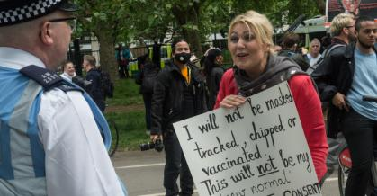

“Depending on who you talk to, the current coronavirus pandemic might be the natural product of evolution, the result of a lab accident or a biological weapon designed by the Chinese. Lockdown measures to impose social distancing restrictions are responsible measures designed to protect public safety or they’re part of a Democratic Party plot to destroy the economy in order to diminish President Trump’s chances of reelection in November. Dr. Anthony Fauci, the nation’s top infectious disease specialist, is either a respected medical professional or devious member of the `deep state’ who is using the coronavirus (which he may or may not have helped create) to control the public through a mandatory vaccination. And those are just some of the narratives that are spreading within the United States.
In countries around the world, equally implausible ideas are circulating, derived in part from their particular political and historical situations, but also cross-pollinating with a wide array of conspiracy theories, misinformation and state-sponsored content, ranging from blatant propaganda to more subtle disinformation campaigns. In some cases, the dearth of verifiable information has resulted in the spread of misinformation by fairly reputable and well-intentioned sources. The coronavirus `infodemic,’ however, has allowed a host of malign actors — from the Russian government to domestic extremists to scam artists peddling bogus cures — to exploit existing societal fissures for their own political or personal gain.
…Disinformation feeds on anxiety and promotes emotional and irrational responses. `I think it’s a common misconception that disinformation creates some sort of new feeling in people,’ Jankowicz says. `Often it's really weaponizing preexisting feelings, or certainly amplifying them. So the anti-vax groups, for instance, are going to be more likely to buy into this narrative about the vaccine being somehow an instrument for global control. The folks who are distrustful of the United States, whether that's in the Middle East, or in China, or Russia, are going to be pawns of their nation's propaganda machines.’
You can see that phenomenon at work in internet metadata. In an interview with Politico last month, Joel Meyer of Predata, a predictive analytics firm, said that since the beginning of the pandemic, his firm has observed an increase in traffic from Persian and Hindi-language internet users to websites that are critical of Western medicine and promote alternative healing methods, including unproven supplements. At the same time, Meyer said that `in European languages, including French, German and Italian, anti-vaxxer attention has really spiked recently.’
`We’re seeing interest rise to unprecedented levels in alternative medicines and treatments,’ he told Politico, concluding that, based on the analytics, `that type of disinformation is sinking in, it’s having an effect.’
Here’s how the pandemic of conspiracy theories is playing out in different countries:
Germany
The German public’s general willingness to comply with strict national lockdown measures — along with a number of other initiatives including widespread testing and aggressive contact tracing — have been credited contributing to the country’s relatively low coronavirus death rate, despite reporting among the highest numbers of confirmed cases. According to the latest data from the Johns Hopkins University as of Tuesday afternoon, Germany had 176,551 confirmed coronavirus cases, falling just below France’s 180,051 with the eighth-largest number of cases worldwide. Germany’s death toll, however, was just over 8,000, compared to 28,025 in France.
In light of this apparent success, over the last several weeks, the German government has begun to slowly lift many of its coronavirus restrictions, allowing schools, shops and playgrounds to reopen, as well as churches and museums. Even the country’s national soccer league was permitted to resume its season over the weekend, albeit without fans in the stands and with elaborate social distancing rules both on (no elbowing allowed) and off the field (mandatory pre-season quarantine and regular testing).
And yet, despite all this, protests against the country’s lockdown measures have been on the rise — growing from just a few dozen marchers last month, to more than 10,000 participating in demonstrations across Germany this past weekend.
Germany’s recent protests against coronavirus restrictions have attracted a hodgepodge of supporters from across the political and ideological spectrums, from far-left anti-capitalists to neo-Nazis, anti-vaccine advocates and regular citizens simply concerned about the economy. According to a recent New York Times report, members of Germany’s far right, including the nationalist and anti-immigrant Alternative for Germany party, and other extreme groups appear to be leading the mobilization effort behind these demonstrations in an effort to capitalize on the shared discontent by these seemingly disparate factions. Yahoo News has reported similar concerns expressed by experts in the United States that anti-lockdown protests here are being co-opted by extreme anti-government and right-wing militia groups.
`Conspiracy theories have always had the potential to bring different people together because they are united in a common enemy,’ said Pia Lamberty, a doctoral student at Johannes Gutenberg University Mainz, in Germany, who studies the psychology of conspiracy beliefs. As an example, she said, the anti-vaccination movement brings together `alternative eco-parents, people from the middle of society and right-wing extremists.’
But there are aspects of the recent anti-lockdown demonstrations that appear to be directly influenced by German history and culture, starting with comparisons she says many conspiracy theorists have made between coronavirus restrictions and the policies of the Nazi era, as well as claims that coronavirus vaccinations will soon become mandatory. Lamberty said that some protesters have even gone so far as to wear yellow Star of David patches or arm bands like the ones European Jews were forced to wear under the Nazi regime, evoking Holocaust imagery to suggest that those who oppose vaccines or believe in conspiracy theories are somehow facing similar oppression under the current government’s coronavirus restrictions.
Signs referencing the QAnon conspiracy theory, which originated in the U.S., are displayed at a demonstration protesting coronavirus quarantine measures in Stuttgart, Germany.
Lamberty and other German researchers have tracked the recent rise in conspiracy theories that echo those that have flourished in the United States, many of which center around distrust of a small group of elites, including medical experts and public health officials, believed to be conspiring against the public good for their own gain. Such conspiracy theories have recently gotten a boost on social media from German celebrities like singer Xavier Naidoo and Atilla Hildmann, a popular vegan chef and cookbook author.
Lamberty also noted that, in recent weeks, `the QAnon conspiracy theories, which had not played a major role in Germany before, had started spreading more and more in the country.’
United Kingdom
Citizens of the U.K. were among the first to demonstrate the potential real-world effects of the coronavirus `disinfodemic,’ as rumors spread linking the virus to the spread of 5G cellular technology, apparently leading to an outbreak of arson against the new infrastructure. As of April 21, AP reported that `Some 50 fires targeting cell towers and other equipment have been reported in Britain this [last] month, leading to three arrests. Telecom engineers have been abused on the job 80 times, according to trade group Mobile UK, making the U.K. the nucleus of the attacks.’ Though scientists have repeatedly debunked claims that COVID-19 is somehow caused by 5G technology, the conspiracy theory has continued to resonate with the British public and merge with anti-lockdown protests.
So far, the British versions of these demonstrations have remained relatively small compared to their counterparts in Germany and the United States. Over the weekend, former Labour Party leader Jeremy Corbyn’s brother, Piers, was among 19 protesters arrested at a gathering of about 50 in London in defiance of social distancing measures. According to the Guardian, prior to his arrest, Corbyn had used a megaphone to promote the discredited 5G conspiracy theories, claim that `vaccination is not necessary’ and declare that the coronavirus pandemic is a `pack of lies to brainwash you and keep you in order.’
The Middle East
Jankowicz pointed to the Middle East as an example of a region where cultural and religious beliefs and political convictions including distrust of powerful outside forces, especially the United States, have allowed a mix of conspiracy theories, misinformation and state-sponsored propaganda to flourish.
During a panel discussion on this topic last week, Merissa Khurma, project manager for Middle East special initiatives at the Wilson Center, outlined the most prevalent examples of coronavirus-related misinformation that have been circulating across the Middle East. Among them are a number of bogus claims about the coronavirus that have proliferated primarily through social media, including baseless warnings that the virus can cause infertility in men, and unproven methods for preventing infection, such as eating garlic, drinking warm water every 15 minutes, and praying five times a day.
Khurma noted that conspiracy theories about the origins of the virus, including deliberately false claims that it was created by the U.S. as part of an economic war on China, have been propagated through more `official networks’ such as the Iranian government as well as Arabic-language TV stations owned by China and Russia. Other conspiracy theories have also been spread by journalists repeating unfounded claims.
RUSSIA
Russian propaganda has been capitalizing on the pandemic to advance Moscow’s long-standing goal of embarrassing Western governments and disrupting American and European societies…`some articles have flirted with the idea that Bill Gates or Kremlin nemesis George Soros might have had a hand in the outbreak,’ while other theories proposed that the virus might be a biological weapon, or part of a money-making plot by pharmaceutical companies.
Though MacKinnon noted that, as of mid-February, the primary audience for this propaganda was `largely domestic,’ the Kremlin soon expanded its coronavirus disinformation campaign beyond Russian borders. Audiences in Eastern Europe, and specifically Lithuania, have reportedly been hit with an onslaught of false or misleading messages designed to stoke fears about the virus and promote negative sentiments toward the U.S. and NATO.
BRAZIL
In March, the Washington Post listed Brazil among several countries where citizens and government health officials had begun sounding the alarm about the use of WhatsApp, the Facebook-owned encrypted messaging service, to spread conspiracy theories and misinformation about the coronavirus, including inaccurate claims about how the virus is spread and ways to treat it.
More than two months later, as Brazil’s count of coronavirus cases continues to climb, the country’s health officials, along with many state governors, have found themselves fighting another, arguably more powerful source of misinformation about the virus: President Jair Bolsonaro. Bolsonaro is among few remaining world leaders who still refuses to take the coronavirus seriously, even as his country is quickly becoming one of the epicenters of the global pandemic.
While recent polling shows that two-thirds of Brazilians support social distancing measures that have been implemented by many state governors per the recommendations of health experts, Bolsonaro has been among the loudest voices calling for businesses to reopen. He publicly defies his own health ministry’s social distancing guidelines with regular, in-person gatherings with large numbers of supporters, and has become a vocal advocate for the widespread use of hydroxychloroquine — a variant of the unproven anti-malaria drug also touted by President Trump — despite the lack of evidence of its effectiveness as a treatment for the coronavirus.
Conspiracy theorists, far-right extremists around the world seize on the pandemic. Civil rights advocates have warned for months that the coronavirus could aid recruiting for the most extreme white-supremacist and neo-Nazi groups.
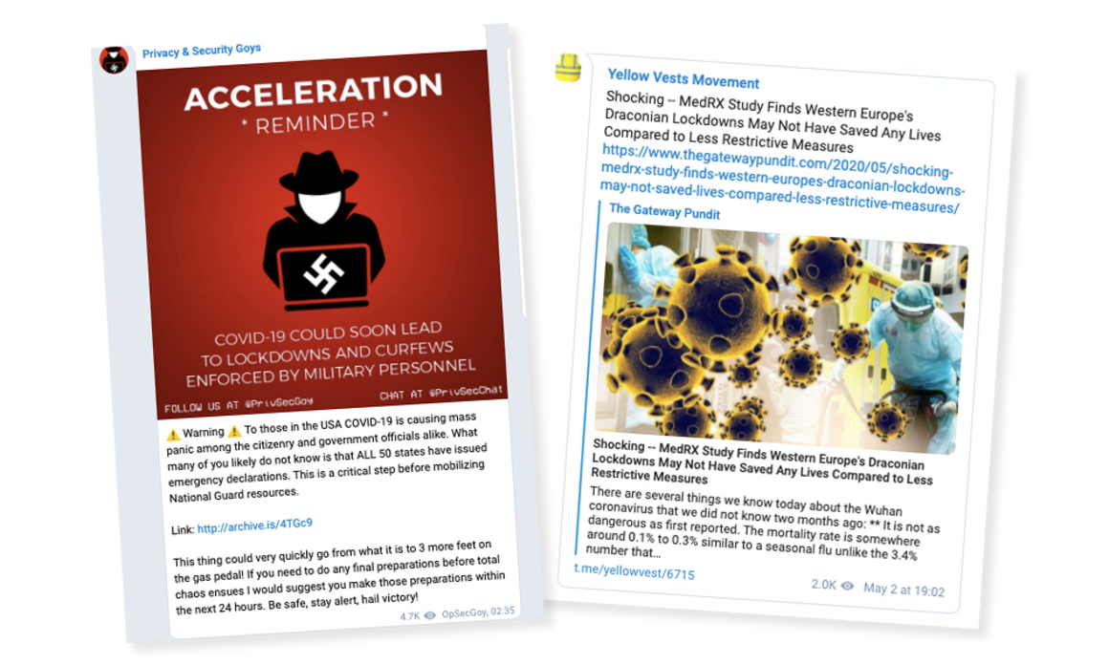
Online platforms like Telegram have become havens for rumors about the pandemic, such as claims that the U.S. is heading to martial law or that the virus is more benign than the flu.
The coronavirus is providing a global rallying cry for conspiracy theorists and far-right extremists on both sides of the Atlantic.
People seizing on the pandemic range from white supremacists and anti-vaxxers in the U.S. to fascist and anti-refugee groups across Europe, according to a POLITICO review of thousands social media posts and interviews with misinformation experts tracking their online activities. They also include far-right populists on both continents who had previously tried to coordinate their efforts after the 2016 American presidential election.
`Honestly, it’s a dream come true for any and every hate group, snake oil salesman and everything in between,’ said Tijana Cvjetićanin, a fact-checker in the Balkans who has watched ultranationalist groups promoting hate-filled messages on social media about the coronavirus, often against Jewish communities.
Civil rights advocates have warned for months that the coronavirus could aid recruiting for the most extreme white-supremacist and neo-Nazi groups — those actively rooting for society’s collapse. Some online researchers say they also worry about the barrage of false messages from extremist groups feeding what the U.N. has dubbed an `infodemic’ that makes it hard to separate fact from fiction.
The themes of far-right posts include long-standing grievances, including allegations that migrants spread disease, support for President Donald Trump’s proposed border wall, antagonism toward the EU or opposition to gun control. One online rumor, accusing Microsoft founder Bill Gates of creating the coronavirus, echoes centuries-old conspiracy theories and Anti-Semitic tropes about global elites pulling the world’s strings.
`These aren’t new lines they are spinning,’ said Imran Ahmed, chief executive of the Center for Countering Digital Hate. `They will use anything they can, whether it’s coronavirus or something else, to bring people into their radical world.’ Public figures helping stoke the fires include French nationalist leader Marine Le Pen, whose Facebook account has more than 1.5 million followers, and Trump, who has defended his use of the term “Chinese virus” and pushed the theory that the disease may have come from a lab in China, despite pushback from his intelligence and defense agencies.
After Trump’s surprise victory in 2016, far-right online communities sprouted up across the U.S. and Europe, at first using online platforms like Facebook and Google before shifting their focus to smaller, less-regulated networks to share conspiracy theories or organize protests.
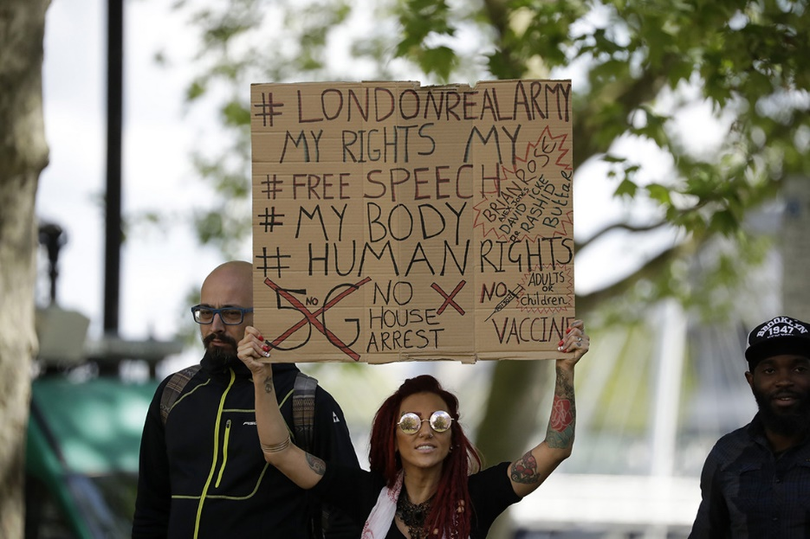
A woman holds up a placard at a coronavirus anti-lockdown, anti-vaccine, anti-5G and pro-freedom protest near Scotland Yard in London on May 2. | Matt Dunham/AP Photo
'There's only one conversation' The anti-vaccine movement on both continents has also latched onto the coronavirus pandemic.
Media Matters for America, a liberal media watchdog, found posts within U.S. Facebook groups claiming the pandemic is an effort to force people into accepting vaccines and, perhaps, even a surreptitious plot to inject people with microchips. Similar messages appeared in WhatsApp messages shared widely in Italy, which has a long-standing anti-vaxxer community, while groups in France have called for a boycott of any government-backed coronavirus vaccine program.
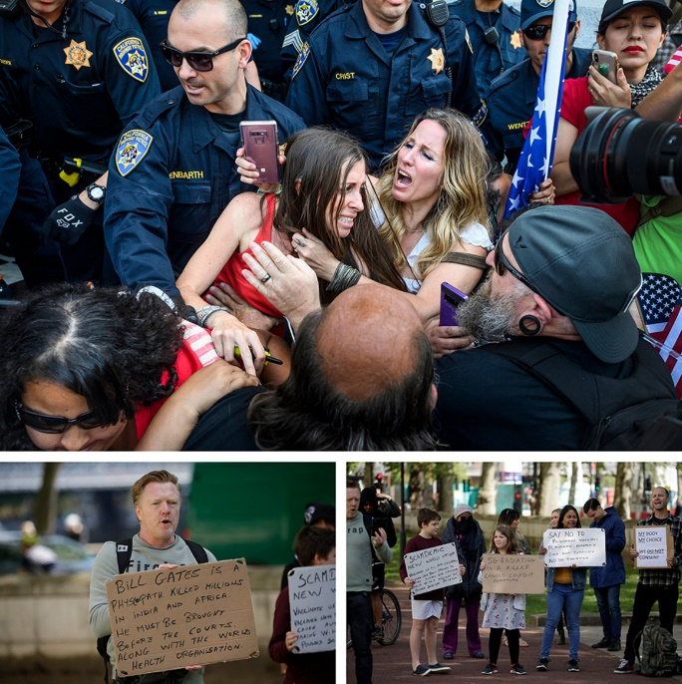
Man on left, his sign reads: “Bill Gates is a psychopath – killed millions in India and Africa – must be brought before the courts along with the World Health Organization.” RIGHT! Gates forced his vaccines on children in India and China killing many – the man’s sign is simply stating the truth)
U.S. anti-vaccine groups also organized an anti-lockdown rally this month outside California’s state capitol and have taken part in protests in New York, Colorado and Texas, using their opposition to state-ordered shutdowns as part of a broader message about personal `freedom,’
The New York Times reported. Other coronavirus themes emerging online include long-running conspiracy theories blaming the `global elites’ for much of the world’s ills, particularly focusing on George Soros, the Hungarian-born billionaire who has long been a target for right-wing and anti-Semitic groups.
Since late January, attacks against Soros and his fellow billionaire Gates have shifted to accusing the men of either spreading the coronavirus or capitalizing on it to push a pro-vaccine agenda. Some Facebook users in private online groups seen by POLITICO also questioned whether Gates was also Jewish. Gates, who has made global public health a priority of his philanthropic efforts, has drawn their attention because of a 2015 video in which he discussed the dangers of a future global pandemic.

Did you notice the manipulating and twisting of truth? Did you notice repeated words like “anti-vaccine/anti-vaxxers” “conspiracy theorists,” “right wing,” and “white supremist?” Did you notice the blatant lies?
What they call “disinformation” is true. The Christian lady was telling the truth. What they’re calling “conspiracy,” or “disinformation,” has been 100% proven to be true by respected and outspoken doctors and nurses. All they know how to do is plant doubt in the mind regarding the truth.
It’s the same tactic used on Adam and Eve by the Nachash/Serpent of the Bible in Genesis 3 – planting doubt, planting emotions against the Truth and the truth-tellers. The Beast System is rising! Take your stand for Truth! Let the Spirit of Yahuwah lead you into all truth (John 16). Let His gift of discernment always be in operation in your life. Know the Word so you are not deceived by the religious. The pastor who said that Evangelicals had a deep-seated martyr complex: Maybe a few do, but I’ve been in the ministry for over 55 years, and never heard of that. Believers are noting the rising persecution of Christians however.
The distortion, the mind-programming, the subtle methods of Satan, are all evident in those two articles. Learn and be wise!
In the love of Yahuwah, Yedidah
May 23, 2020

