DOOMSDAY CLOCK MOVED TO HISTORIC NEW POSITION - JANUARY 24, 2023

INTRODUCTION: No, we don’t go by the predictions of scientists, the speculations, reasonings, and fears of men, as a guide to what we should believe! The “Word” – written, and personified in Yahushua - gives us all the truth we need to know to be transformed into the nature, ways, and thinking of Elohim (Father and Son). However, it is amazing how close these scientists are in understanding from a logical standpoint, whereas most people are so out of touch with reality that they continue to think “nothing’s going to happen to me,” and act in accordance with the denial of reality.
These scientists have seen an overview of reality and moved the clock up again. Yes, with the U.S. and NATO having set WWIII in motion for the globalist-Luciferic plans for humanity’s end by provoking Russia, Yahuwah sees Putin as His “servant,” His Nebuchadnezzar, to bring His judgment to pass against the most evil nation the world has ever known. The House of Judah and the House of Israel were the most evil of all people in Jerusalem in 586 BCE, before Yahuwah sent in His “servant,” Nebuchadnezzar, King of Babylon, to stop their idolatry and the sacrifice of children to Moloch.
As Abba spoke to me in 1992, and has spoken also to the true watchmen of today, America is “end-time Babylon” - the final stance of Nimrod to take down Yahuwah, Yahushua, and all life on earth for Lucifer, as he attempted to do with his “tower” in Genesis 11. Today, again, the world is coming into unity, turning against Yahuwah and Yahushua in great hate, and with great hate for their Word.
The U.S. murders and cannibalizes more babies and children, offers more human sacrifice to Lucifer, spreads more pedophilia, abortion, drug addiction, filthy movies and music, spreads more sexual evils not even normal to most human’s minds – than any other nation has ever done. Yahuwah is in judgment mode now, and it will increase until all evil is gone. We are in “the days of Noah.”
The word “doomsday” is not clear enough. It’s a fear-term that has little substance which the human mind understands in reality. It refers most likely to a time of death and destruction, which is before us now.
Messiah, in Matthew 24, Mark 13, Luke 21. and the book of Revelation laid out more than a “doomsday!” If Messiah does not return, He says “no flesh will be left alive.” All written in the Word, regarding right now, is clearly happening at once.

DOOMSDAY CLOCK TO BE MOVED CLOSER TO MIDNIGHT - January 24, 2023
This year, the Science and Security Board of the Bulletin of the Atomic Scientists moves the hands of the Doomsday Clock forward, largely (though not exclusively) because of the mounting dangers of the war in Ukraine. The Clock now stands at 90 seconds to midnight—the closest to global catastrophe it has ever been.
“90 seconds till midnight – closest to global catastrophe ever recorded”

Jan. 23, 2023: “Doomsday Clock will be moved tomorrow as scientists predict humanity's fate. The Doomsday Clock was first created by the Bulletin of Atomic Scientists in 1947 to warn humanity of the dangers of nuclear weapons.”
By JACOB PAUL Daily Express - Mon, Jan 23, 2023
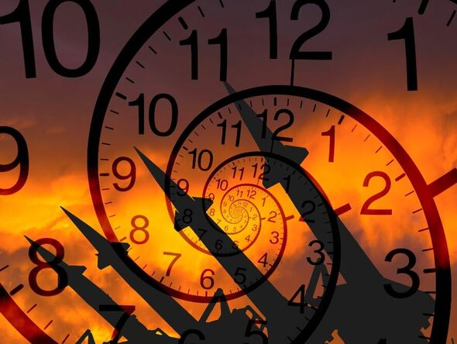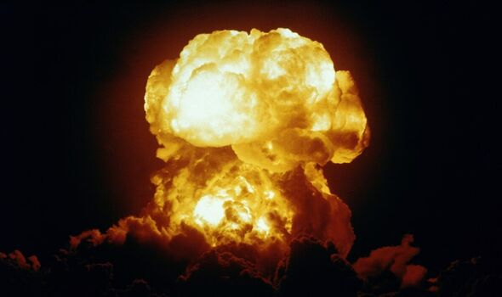
Scientists are set to reveal the newest time on the Doomsday Clock tomorrow, which represents their precision as to how close humanity is to an Armageddon scenario. The Doomsday Clock was first created by the Bulletin of Atomic Scientists back in 1947 to warn humanity of the dangers of nuclear weapons. Still used today, experts from the Science and Security Board of the Chicago-based group of experts in the fields of nuclear risk, climate change, disruptive technologies and bioterrorism, make yearly assessments of humanity’s fate. They do so by moving the hands of the Doomsday Clock either closer to, or further away from midnight.

As of January 23, 2023, the clock is currently set at 100 seconds to midnight and has remained there for the last three years. But given the nuclear threats dished out by Russian President Vladimir Putin amid the war in Ukraine and the Covid-19 pandemic, some suspect the clock could edge closer to midnight.
The scientists originally behind it included some who had participated in the Manhattan Project, which produced the world’s first atomic bomb. Shortly after the clock was first created, Bulletin Editor Eugene Rabinowitch decided whether or not the hand should be moved.
The scientist was one of the prominent figures involved in discussions about nuclear disarmament with other experts from across the globe.
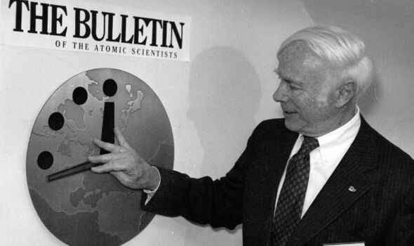
The Doomsday Clock was first created by the Bulletin of Atomic Scientists in 1947 (Image: Getty)
The panel meets twice a year to discuss the current threats and whether a clock reset is necessary. In January 23, 2020, scientists decided to move the clock to 100 seconds to midnight amid `two simultaneous existential dangers - nuclear war and climate change.’
These included conflicts concerning North Korea and Iran, as well as heightened fears that global warming would lead to a climate catastrophe.
The clock was set furthest away from midnight back in 1991, when it was would all the way back to 17 minutes after the Cold War was officially declared over.
But today, it appears that progress on international peace has been reversed. Back in October, President Joe Biden said that the heat of `Armageddon’ is at its most intense since the 1962 Cuban Missile Crisis. It came after Putin put his nuclear forces on high alert and said that he was not bluffing about being ready to press the red button.”

ABC NEWS: “2023 'Doomsday Clock' announcement: What to know and expect
The announcement will be the first since Russia's invasion of Ukraine.”
By Teddy Grant January 23, 2023
Scientists will reveal on Tuesday how close humanity is to Armageddon with its latest edition of the `Doomsday Clock.’
For the past 75 years, the Bulletin of the Atomic Scientists, a nonprofit media organization comprised of world leaders and Nobel laureates, has announced how close it believes the world is to collapse due to nuclear war, climate change and, most recently, the COVID-19 pandemic.
`It is a metaphor, a reminder of the perils we must address if we are to survive on the planet,’ the Bulletin, which created the clock, said on its website, also calling it `a design that warns the public about how close we are to destroying our world with dangerous technologies of our own making.’
Tuesday's announcement will be the first since Russia's invasion of Ukraine, which could move the clock closer to `doomsday.’
`Every year, the Bulletin's Science and Security Board looks at the world's vulnerability to catastrophe from manmade threats,’ Rachel Bronson, president and CEO of the Bulletin of the Atomic Scientists, told ABC News in a statement. `This year, the war in Ukraine and the ripple effects it has caused around the world and on many issues is a major factor in that consideration.’
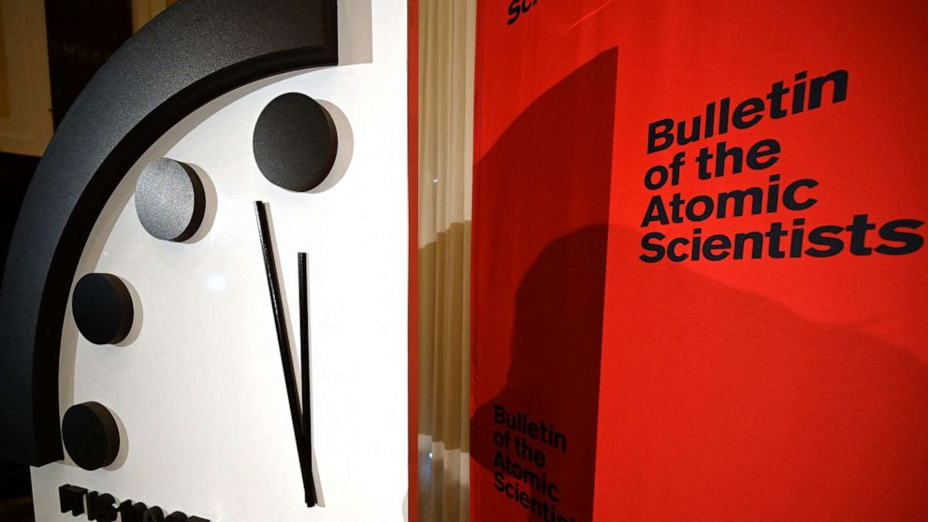
Launched in 1947, scientists wanted to highlight the possibility of catastrophe to the public as it pertained to the nuclear arms race between the U.S. and the Soviet Union, according to the Bulletin, saying that "the greatest danger to humanity came from nuclear weapons" at the time.
The clock indicates how much time remains until midnight, theoretical doomsday. At its launch, the Bulletin of the Atomic Scientists set the "Doomsday Clock" at seven minutes before midnight because artist Martyl Langsdorf, who sketched the clock that appeared on the June 1947 edition of the magazine, said “it looked good” in her eyes, the organization says.
Today, humanity is 100 seconds to midnight, the closest the world has ever been to disaster, according to the Bulletin. Before 2020, the closest the hand was set to midnight was two minutes.
Shortly after Russia invaded Ukraine, the Bulletin kept the clock at 100 seconds to midnight, saying that Russian President Vladimir Putin's threats to use nuclear weapons if NATO stepped in to help Ukraine "is what 100 seconds to midnight looks like."
In September, Putin issued a thinly veiled threat that Russia would resort to using nuclear weapons in its fight against Ukraine following several setbacks.
The Russian-controlled Zaporizhzhia nuclear plant in Ukraine has come under repeated fire since Russia took it over in March 2022, increasing the risk of nuclear disaster. Rafael Grossi, director general of the U.N.'s International Atomic Energy Agency, said last week that he is worried that the world has become complacent about the potential risks to the plant.
The furthest the clock has ever been from midnight was 17 minutes in 1991 after then-President George H. W. Bush and former Soviet leader Mikhail Gorbachev both announced reductions in the nuclear arsenals of their respective countries.
`That reflected a moment when the world was seriously engaging with issues of risk and working together to mitigate it,’ Bronson said.”
Strangely the world is more aware of the reality of timing than those who should know “thus says Yahuwah; thus says Yahushua,” and follow Their directives.
The pathetic unreality to religion that keeps Their people from knowing the truth that sets us free. Thus, Their children are coming under the blanket of numbness, dumbness, and unreality, deceived by willful desire. Let it not be you!
Shalom, Yedidah
January 24, 2023

