DRONES, CAMERAS, and EXOTIC SURVEILLANCE TECHNOLOGY EXPOSED
YOU are being “monitored!”

Why did I use the word “monitored?” – Because that is the right word to use. Here’s its meaning from a couple of online dictionaries: 1) “Monitored”: “being observed, checked on to determine the progress or quality over a period of time; kept under systematic review.” 2) “To monitor” is to: “observe, watch, track, keep an eye on, keep under observation, keep watch on, keep under surveillance, surveil, record, note, oversee, to listen to, and to report on; i.e. `his movements were closely monitored.’ "
In the “olden days” of TV “murder mysteries, all we heard about were “bugs,” or “wire-tapping,” -- listening devices secretly put in houses or cars, in business meetings, etc., or devices to tap into phone calls, so that what was said in private was heard by someone outside sitting in a van or in an apartment next door. Today’s sophistication of “spy technology” is mind boggling.
Yes, you and I are being “monitored.” Anyone who tries to resist the coming “changes” will definitely be monitored. Anyone not thinking, speaking, or acting as the programming has been designed to accomplish will definitely be monitored. How is this monitoring happening worldwide? Here are some examples…

LONDON, ENGLAND
“Based on a small sample in Putney High Street, McCahill, and Norris extrapolated the number of surveillance cameras in Greater London to be around 500,000 and the total number of cameras in the UK to be around 4,200,000. According to their estimate the UK has one camera for every 14 people.” I bet the “merry ol’ Brits” feel safer than ever now! Mass surveillance in the United Kingdom - Wikipedia: https://en.wikipedia.org/wiki/Mass_surveillance_in_the_United_Kingdom

WIKILEAKS: “Surveillance Cameras Around The Country Are Being ...”
www.businessinsider.com/trapwire-everything-you-need-to-know-2012-8
Aug 10, 2012 - WIKILEAKS: Surveillance Cameras Around The Country Are Being Used In A Huge Spy Network...For a program touted as a tool to thwart terrorism and monitor activity ... So: those spooky new "circular" dark globe cameras installed in ... in federal court this week for the ability to imprison American citizens ...”
It is estimated that worldwide there are approximately 500 million cameras installed to keep an eye on citizens.
What city has the most surveillance cameras?
“According to the security industry, the top 5 largest security camera network cities are:

- Beijing. ...
- London. ...
- Chicago. ...
- Houston. ...
- New York. ...
Are we safer because of these cameras? How many reports of captured terrorists, or crazy shooters, or criminals of varying types have the police caught using drones? Or, are they designed to target decent citizens who won’t go along with un-Constitutional changes in our society, i.e. Christians who resist a new world order?
I encourage you to read: “The New Executive Order,” (use the search menu) which gives details on what the government can do without a citizen’s right to refuse. Even President Trump has approved of this order, by which you can be arrested and all taken from you, property and children, if you are even “suspected” of being a terrorist. To read the Order:
http://www.whitehouse.gov/the-press-office/2012/03/16/executive-order-national-defense-resources-preparedness (This was run past the American citizens quietly signed on December 31, 2011 by Obama)
Also check out: White House Continuity Of Government Plan and National Coop ...
https://whitehouse.gov1.info/continuity-plan/index.html ... Maintaining the Continuity of Government in the event of a catastrophic emergency.
Homeland Security has put an emphasis on “home grown terrorists”--American citizens who resist the new world order. The FEMA camps are opening for those who resist and will not be chipped or go along with the new laws of Bestial society. I’ve written so much in the past about the concentration camps, made from closed down army barracks, and how they are stocked, and separated into men, women, and children’s sections. I’ve exposed the “rape camps,” too. I’ve exposed the red list, the blue list, and the green list. You’re on one of them, especially if you live in America. I’ve written on the hundreds of thousands of guillotines on military basis and in Washington DC that are waiting for those who, like the apostle Sha’ul who was beheaded under Nero, will be imprisoned for their faith.
How many terrorists or bombers have America’s TSA detained at airports? Millions upon millions of people fly every day, but first are put through radiation screening, sometimes rude “patting down,” and sometimes ridiculous checking of baby diapers and x-raying of prosthesis. The latest news was the extreme, laborious, and personal pat down of a 94 year old woman in a wheelchair. Yet, Muslim women in their big heavy clothing are not thoroughly checked, if checked at all. Men with thick headdresses are usually not checked either. Is there something that smells rotten in such demonstrations of “partiality of privilege”?
In 2008, while I was teaching in Idaho, a man made the comment that TSA was hiring sociopaths, and a variety of other mentally disturbed people who had short triggers, sadistic natures, and perverted tendencies. What he said is true.
Many, many Satanists and mind-programmed psychopaths are in our military and police forces now. When today’s rulers of earth, Satan and his forces, give them the go-ahead sign, we’ve got the scenario in the opening chapters of Russ Dizdar’s The Black Awakening. This isn’t speculation or conspiracy theory stuff – this is real. I really hope you read Russ’ book for details.
Why are we being so carefully monitored? Why such exotic technology? We know that Yahoo and Google, and other companies are actually spying into our private lives. Of course one of the biggest spies operations is Facebook, along with Twitter and other “social media.”
Google earth can be made to look into your house. Bugging and other listening devices are very sophisticated now. Wire-tapping is a more sophisticated reality.
During my 8 years in Jordan, many times cars were parked outside our apartment buildings had equipment by which they listened to our prayer meetings, our teaching sessions, and our private conversations with their listening devices, which led to he shut down of some of our projects, like the teaching of Hebrew. Our phones and cell phones were also used as listening devices. One day I was near my cell phone and I heard a cell phone conversation between two of my friends who lived a few miles away. I had regular calls, too, at least once a week to check on whether I was home or not.
As we look at China, we will see where our nation is going. For example, America applies many things that China does to suppress their people.

What about China?

***PLEASE, Please listen to this short 15 minute YouTube exposé on China Mass Surveillance System, Sweden’s Microchips Bill Gates’ Plans - Jason A – May 20, 2018 - Entitled: “This Will Expose Everything You Know”
***https://www.youtube.com/watch?v=7uOHh53XdBc - May 20, 2018 - Uploaded by Intense Pulse Light
This YouTube presentation video is a shocker – well documented and letting us know the extremes of technology now to monitor everything we do, zero in on our faces, even read our minds and analyze our “body language.” Today their surveillance technology is vastly superior to any other on earth.

A few of my notes from the YouTube video, link above
In China today, there is a security system that can track every citizen and evaluate their behavior. Each citizen is scored by their behavior. If the score is too low, they are denied privileges, placed on list of those not to be trusted, so that they cannot travel, or their children cannot attend a private school, or other restrictions depending on their score.
Their technology is so far advanced that the police have special glasses that when they put them on and look at a person, they see a write-up of their identity and their score, and basics about them. There are 169 million cameras in major cities of China. To see these glasses in operation, watch the YouTube video.
The Chinese government says they want to “purify society by rewarding those who are trustworthy and punishing those who are not.
CBS News Ben Tracy reporting from China: “Everyone is scored by their behavior.” They track every citizen’s behavior from smoking on a train to jaywalking: The video showed a man jaywalking. The camera zoomed in on his face. Then he as publically shamed by his face appearing on various posters and on TV etc.
Lists are kept of untrustworthy people. One man was deemed untrustworthy, and though he tried to explain, he was told that his explanation was unacceptable, that he was only trying to get out of being punished. Thus, he was denied travel rights and his child could not go to a private school. CBS said the citizens are controlled by “the list.” Each citizen is assigned a “social credit core.”
OAN – “Mainland China’s Socket Credit System Sparks Privacy Concerns Worldwide.” CBS This Morning: “Scoring Its Citizens”
CBS said that now there are 176 million cameras in place in cities and smaller villages and towns. Cameras can name every person, describe what they are wearing, watch them on every bike, every car.
Access Asia video report by Katrina Yu and Antoine Vedeilhe, Charlie Wang, and Liu Lu (France 24): A man who designed the glasses for the police that tapped into an ID data base was interviewed by a CBS foreign correspondent. The man told about the benefits of the glasses for the police. The reporter asked the man: Do you trust the government as to how they use your technology?”
The man replied: “Sorry, I can’t answer this. It is outside our speech allowance.”
“There Are Around Three Thousand Implanted Microchips in Sweden”: CBS News: “Technology Imbedded under the skin helps daily tasks.”
About a 1” microchip is imbedded in the back of the hand for scanning. “The human body becomes a technological platform.” Book: SIGNAL by Gzero Medra, April 20, 2018, about Sweden’s microchip technology, first used in 2015.
The chips are replacing IDs
SIGNAL writer is interviewed by CBS: “The initial 3,000 people taking the chip are part of an experimental project.” Bill Gate just endorsed a start up that could survey every corner of the earth from space. WELCOME to 1984! A company called Earth Now is working on satellite hookups to monitor every person on planet earth. Newsweek magazine: “…even your house would be under surveillance.”
May 11, 2018: The video showed a large white and black robot running through a neighborhood. The robot looked like something out of Star Wars – called an Atlas Robot, made by Boston Dynamics.
April 2018: Amazon desires to build robots. The name of the project is Vesta – named after the Roman goddess of hearth, home, and family.
May 8, 2018 – Cameras in London and China - You Tube: “Secret Global Government Surveillance” CS … AI (Artificial Intelligence) is being created to help police make decisions regarding arrested suspects by doing “PROFILING.” DO YOU OWN RESEARCH!
Yes, the goal is to ID every person on the planet and monitor what they do, what they say, their life patterns, etc. so as to find out who is aligning with the ruling world authority and who is not. The punishment for any deviation from their wishes would result in death. Already laws have been made against witnessing to our salvation openly, and not to children in particular, praying openly, preaching openly, handing out tracts or displaying a Bible in public when witnessing. Soon, there will be zero freedom of speech or action.

What about the drones this week exposed that openly operate in America?
“This is the week that the drone surveillance state became real” by Dave Gershgorn - June 08, 2018 – Quartz
https://qz.com/1299947/this-is-the-week-that-the-drone-surveillance-state-became-real
From this article: “…Other kinds of AI, like facial recognition, are already in use in China to survey ethnic minorities. US authorities, like the Chicago police department are already starting to adopt AI systems for predictive policing, another pursuit rife with bad data. In Baltimore, a plane loaded with cameras was secretly deployed as a surveillance tool until 2016. But now, AI-powered surveillance systems are becoming as easy for a police department to order as a car, handcuffs, or anything else they feel they need to effectively do their jobs. And now, drones are already getting the green light for police use, not just for surveillance but also to dispense pepper spray and tear gas.”
DO YOUR OWN RESEARCH – George Orwell’s 1984 is here! It’s all in preparation for I.D.ing every one on the planet to eventually enforce an international “mark” to ID us with the one world ruler. Read all about in Revelation 13! DO YOUR OWN RESEARCH! Don’t be caught against a wall that you can’t escape from because of being laziness and apathetic in learning your options.
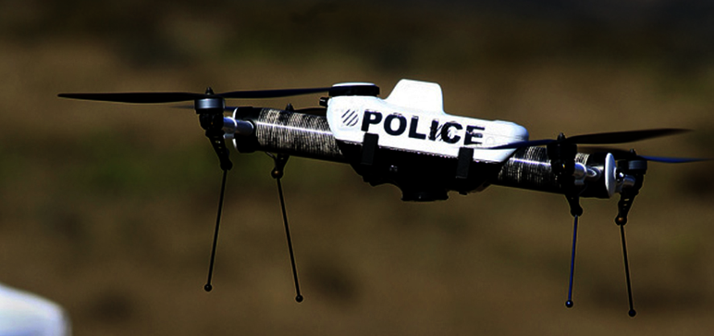
Police drone employed this week over America
Photo: American Freedom Union
USA today says that by 2020 an estimated 2.7 million commercial drones will be flying in our skies
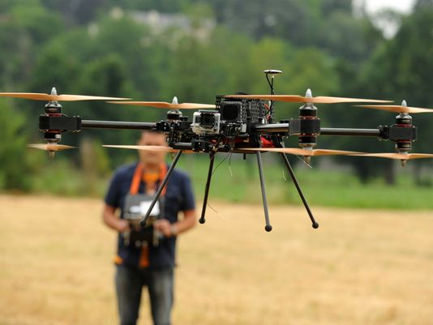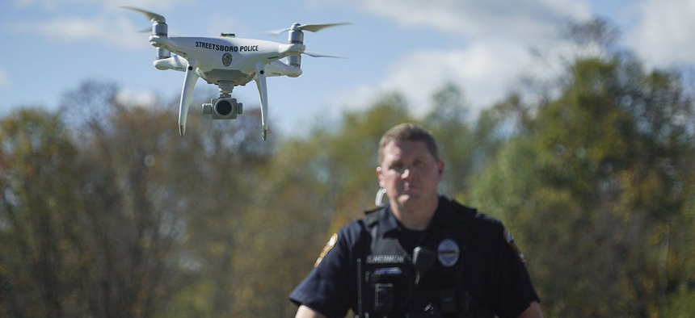
Photos above: “Local police have access to drones and footage from those flying cameras will be automatically analyzed by AI systems not disclosed to the public” from an article by Nextgov.
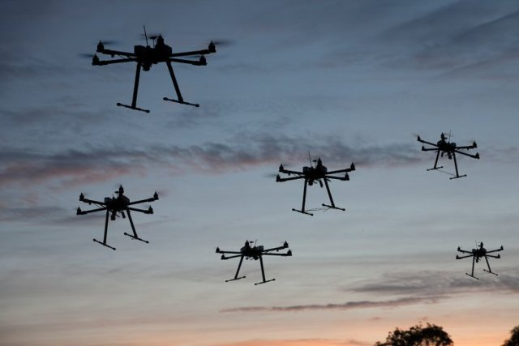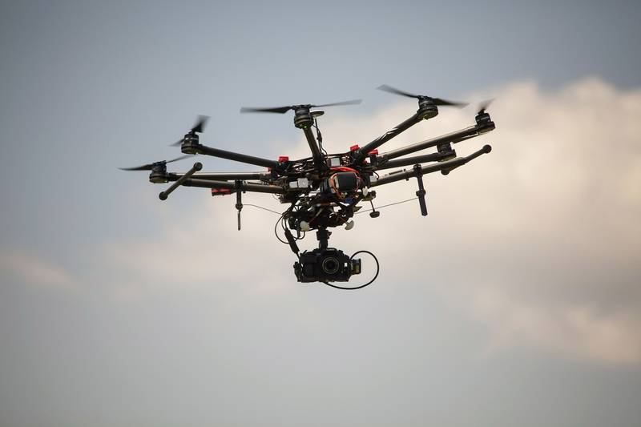
Left: Grand Forks Sheriff’s Department North Dakota owns four of these
Daily Herald: “How US Police Departments are Using Drones” 4/15/17
Right: DJI S1000 drone flies over Calvert Vaux Park in Brooklyn, New York, on June 10, 2015. Bloomberg photo by Michael Nagle
I do no fear-mongering by presenting the Truth! Truth is greater than facts!
The Truth is: Isaiah 41:10: “Fear Not for I am with you! Do not look around in dismay for I am your Elohim! Yes, I will strengthen you! Yes, I will help you! Yes, I will uphold you with the right hand of My Righteousness!” (Of course we know His right hand and right arm are Yahushua!) Yes, you are being monitored and listed – by Yahuwah! Make sure that, above everyone else, you please Him!
Shalom, shalom, in His love,
Yedidah
June 15, 2018

