EXPOSING A BIG PLOT AND A BIG LIE
EMERGENCY CONDITIONS REMAIN

Whether this has gone down as planned or not, the lie and the plot remain and the emergency conditions remain! Here is a brief overview of what was planned for July 5th and the lies spread by the Luciferian news media that blamed it all on Russia’s plotting.

Today is July 5th – the planned target date. I have not yet heard of what has happened 9 hours ahead of my U.S. time in Texas.

UKRAINE NATO FALSE FLAG TO BLAME ON RUSSIA AS EXCUSE FOR NATO TO ENTER THE WAR - DATE MOST LIKELY FOR FALSE FLAG JULY 5 2023

“Attack against Ukraine Nuke Plant within 48 Hours? Local Wind Direction is the key for NATO to find cause to enter the war” WORLD HAL TURNER 03 JULY 2023
The mass-media in the West is already hyping a so-called "Pending Russian Attack" against the Zaporozhye Nuclear Power Plant. The fact they are already laying blame on Russia should clue you in that the truth is the exact opposite; UKRAINE needs this to get NATO into the war.
First, let's take a brief look at some of the headlines here in the West:
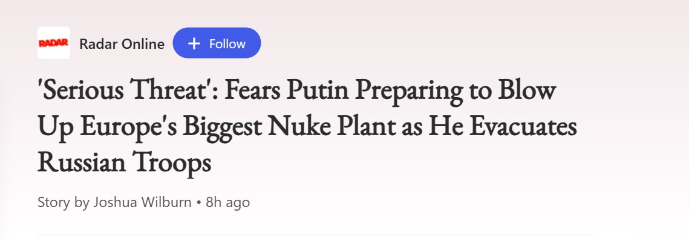
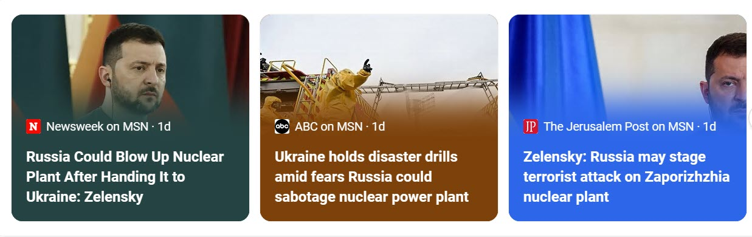
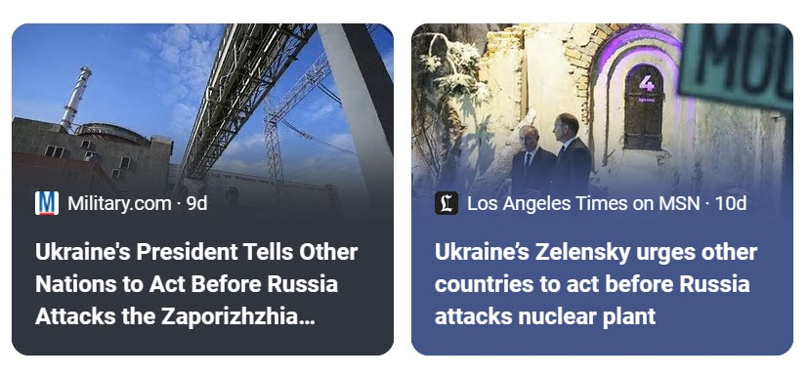
Gee whiz! You think they're laying the groundwork to BLAME RUSSIA?!?!?! That's what this is about: Public perception. They want the public "primed" so that when an attack does take place, Russia gets blamed.
So why is this necessary? Because there is NO NEED for Russia to attack this plant, Russia is winning the Ukraine war!
Besides, prevailing wind patterns in that region __usually__ blow into Russia. Why would Russia blow up a nuke plant when the winds would carry radiation right into Russia? They wouldn't.
Since Russia is winning the war, Ukraine needs some "incident" to prompt NATO to enter the conflict on the side of Ukraine, and they need it fast.
At present, all the Western-supplied arms given to Ukraine, are getting blown-up, bombed-out, and burned. Ukraine has already been told that unless their "Counter-Offensive" yields good results before the NATO Summit on July 11-12, future military aid from NATO countries will no longer be easy to get.
So Ukraine needs something, a win, a breakthrough – something - anything to show progress, and they just don't have it. Moreover, they just can't get it. Russia is too strong. Too dug-in.
In fact, things are going so badly for Ukraine right now, that they have not yet even REACHED the first of Russia's actual defensive lines! They've only encountered Russia scout troops. Those scout troops have beaten the living shit out of Ukraine at almost every encounter. Almost, but, admittedly, not all encounters.
So Ukraine is losing, NATO is running out of surplus weapons and ammunition, and is now demanding results, but Ukraine can't deliver any.
What to do? Well . . . . . NATO made clear that if Russia were to detonate a Tactical Nuke inside Ukraine, NATO would enter the conflict on Ukraine's side.
Then, about a week ago, US Senators Lindsay Graham (R-SC) and Richard Blumenthal (D-CT) went very public with a Resolution in the Senate saying, in sum and in substance, that "If Russia damages a nuclear power plant in Ukraine, which releases radiation, then THAT radiation release would be deemed "an attack upon NATO" causing Article 5 of the NATO Treaty (Collective Self Defense) to be invoked against Russia.
And THAT, that right there, the attack upon a nuclear power plant - THAT is Ukraine's ticket to NATO entry. If that plant is hit and leaks radiation, it's Winner, Winner, Chicken Dinner, for Ukraine; because NATO enters the war.
Moreover, Ukraine started giving out Potassium Iodate/Iodide pills to their citizens and this past weekend, Ukraine announced "permanent evacuations" from areas within 16km of the ZNPP (Story HERE). Permanent??? How would they know it needed to be permanent?
Why would they do these things unless they KNOW the ZNPP is going to leak? And how would they KNOW that unless . . . THEY are the ones who are going to do it?
So, what's been going on the past few days? A Western Media blitz saying Russia is going to attack that nuclear plant. The media is sowing the seeds for their government overlords. Full-on Propaganda. Laying the groundwork to blame Russia. All the while, Russia is still winning and has no reason at all to do any such thing.
WIND IS THE KEY
Prevailing wind patterns in Ukraine are similar to those here in the USA; winds generally blow from west to east; toward Russia. But once in a while, like here in the US, the winds change direction.
With all the hoopla over this ZNPP "attack" allegedly coming, I took a look at the weather forecasting service Ventusky.com to get an idea of how the winds will be blowing over the next few days. Viewing these forecasts, I thought, might give me an idea of the TIME FRAME for any attack against the ZNPP because winds carrying radiation from the plant into NATO countries would likely be necessary in order for NATO to enter the fight. Here's today's wind patterns from Ventusky, as of Noon, eastern US Time. The ZNPP is shown as a radiation symbol on the map:
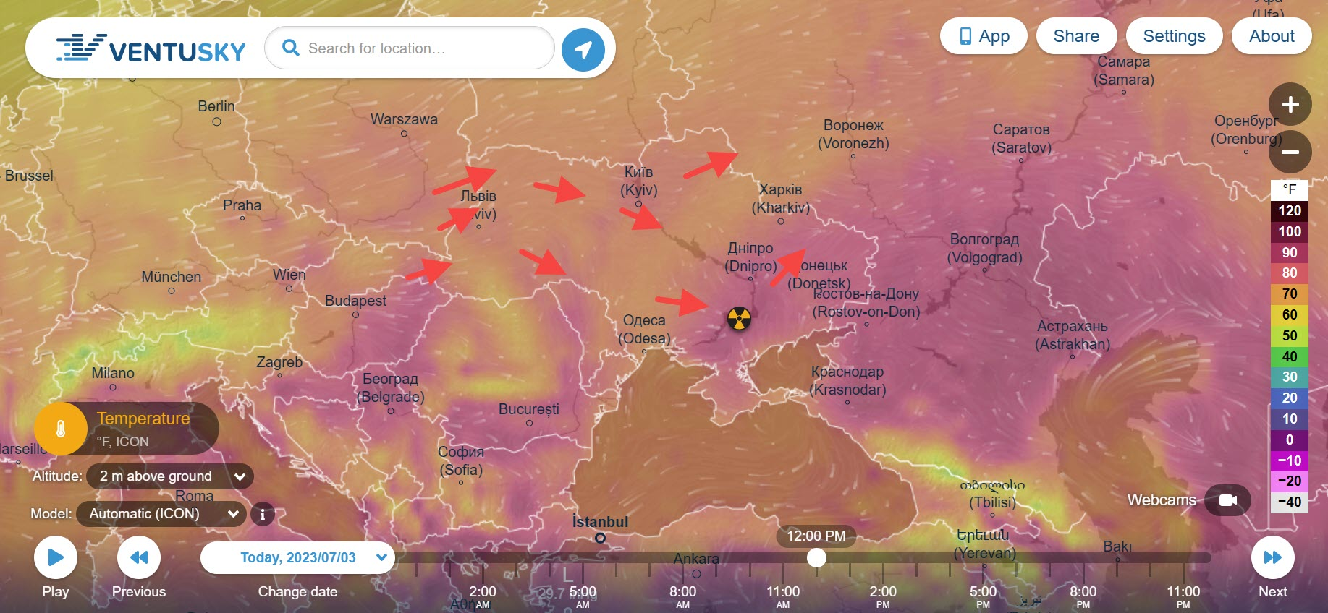
But 24 hours from now, at 12:00 Noon on July 4, a CHANGE begins to take place. Winds start shifting direction:
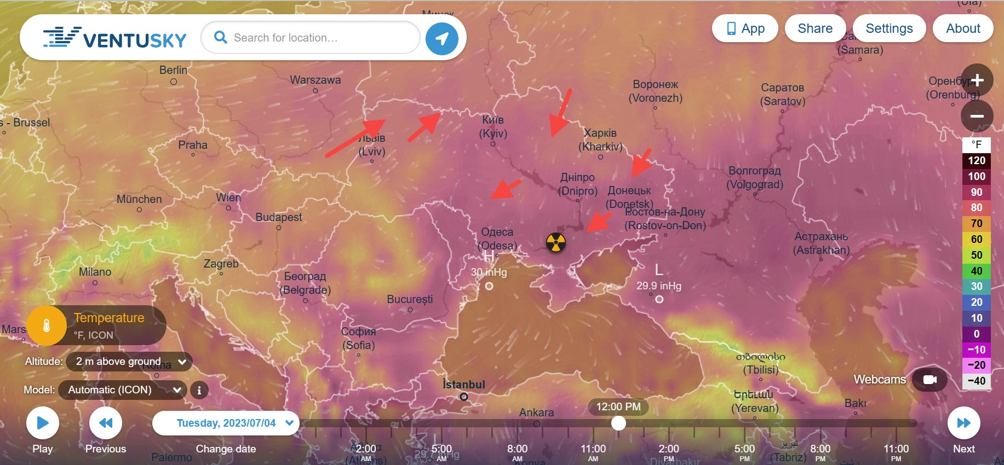
By 8:00 AM eastern US Time on July 5, the winds are clearly shifting from Russia to the west. And By 10:00 AM that same day, the winds are DECIDEDLY from the east to the West, with some wind going south into Romania (NATO) and other wind going north into Poland (NATO):
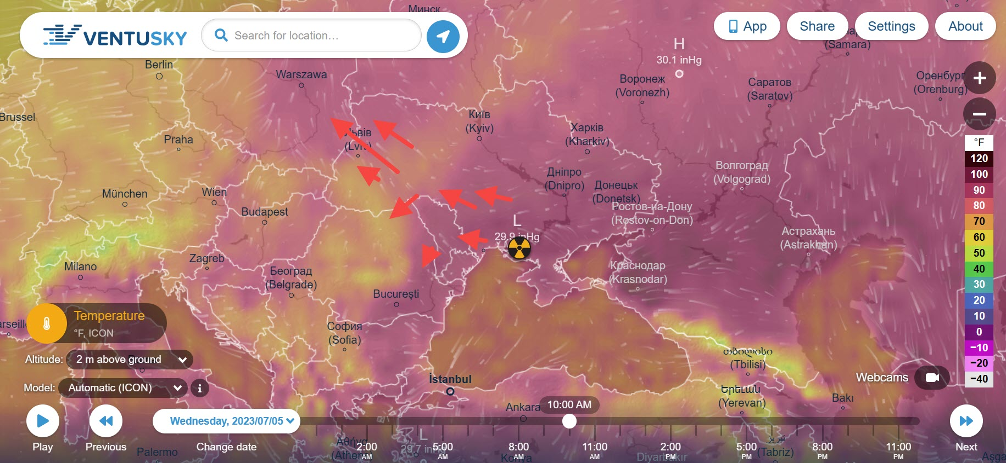
Now, as we all know, weather forecasting is NOT an exact science. Reality sometimes deviates greatly from computer models. What we see above are MODELS.
So conditions on the ground would have to be such, that actual conditions would carry radiation into NATO countries, and within the next few days, according to Ventusky models, the only time that will take place is around 10:00 AM eastern US time, but over in Ukraine. [Yedidah note: At this point Hal Turner says he hopes he’s wrong about this, but everything down to the last detail says he’s right. He’s x-FBI and has access to insider information that is not going to ever be told by the public news media. Steve Quayle with 51 years in reporting truth knows he’s right too! I pass this on to you because I know from my years of reporting that Hal and Steve and others like them are risking their lives literally to give us the truth.]
Russia has repeatedly made clear if NATO Declares Article 5 collective self-defense against Russia, that NATO's conventional forces ARE superior to Russia's. (Yes, Russia admits this!) But, say the Russians, we are also a nuclear power and our nuclear weapons are superior to NATO's. Russia then said they will use every weapon in their arsenal to protect themselves from NATO. To me, that means nukes. So, as this story goes to publish, it is 1:34 PM EDT on Monday, July 3. If I am right, we will all know before 10:00 AM July 5. Get right with God.”

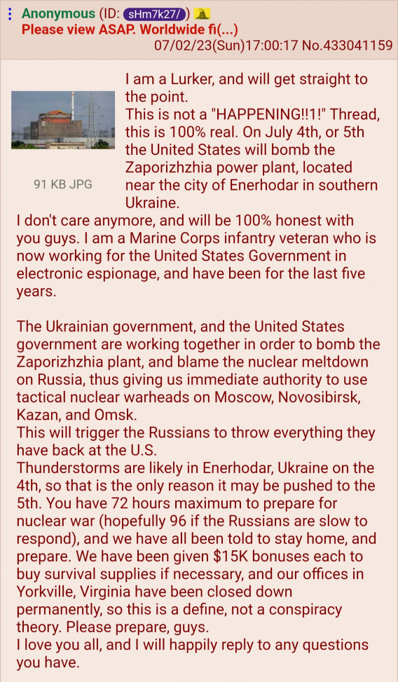

STEVE QUAYLE QFILES EMERGENCY BROADCAST July 4 - 6 Emergency Heads Up!

“EVERYTHING THAT IS BEING PUT OUT IN THE PUBLIC NEWS PRESS IS SETTING UP THE US CITIZENS TO BELIEVE THE LIE THAT IS BEING FORMULATED RIGHT NOW BY NATO – IN ORDER TO ACCUSE RUSSIA OF WHAT THEY WILL DO, TO GIVE NATO THE RIGHT TO ENTER UKRAINE UNDER NATO’S ARTICLE 5.

FROM the JULY 3RD QFILES – Steve Quayle BROADCAST: The Russian DUMA is in agreement. They know that when/if the power plant is blow up – they’ll be blamed for it. Yet, as Hal wrote – Russia has no reason to blow it up. Russia, as Hal reported, only does what is necessary, what they have to do. Russia does not think like the liar-west. Russia is not a game-player who makes up strategies that are deceitful – to fool their opponents. They are straight-shooters – as in playing chess.
OK, if Russia is blamed. NATO will give the signal that Ukraine is to be brought into NATO under article 5 and NATO has the right to enter Ukraine – because “Russia did it.” But Russia won’t do it – it’s stupid to do it. Yet, the world news will say Russia did it, and NATO will jump on the lie and come on into Ukraine to face Russia face to face.
It is then, that Russia will have every right to bomb the capital cities of NATO all at the same time with the 100-megaton bombs – leveling every capital. NATO has been working, since the beginning of the conflict Ukraine made up, on getting into Ukraine so as to have a front row seat in attacking Russia. Yet, NATO’s weapons are pathetic in comparison to Russia’s weapons.
ARTICLE 5: says that if a NATO nation is attacked, all NATO nations are attacked, so they have the right to retaliate.

HAL JULY 2: POWER PLANT RADIATION WOULD BE CARRIED INTO NATO COUNTRIES JULY 4 5 “Wind Shifts from East to West on July 4 & 5 -Would Carry Radiation into NATO Countries WORLD” HAL TURNER 02 JULY 2023
Changes in local wind flow around July 4 & 5, would cause wind from Zaporozyhe Nuclear Power Plant to blow from east to west, carrying radiation into Europe and NATO Countries . . . IF . . . an "event" there caused a leak. Meanwhile, the US sent a nuke-sniffer plane over there . . .
Word is spreading like wildfire that Ukraine plans to attack the Zaporozyhe Nuclear Power Plant (ZNPP) on July 5 or 6, blame the attack upon Russia, and that NATO will then use the radiation leakage into NATO countries as cause to declare "an attack upon NATO" has taken place.
If NATO makes that decision, then Article 5 "Collective Self Defense" may be invoked by NATO, against Russia, thereby bringing NATO into the Russia-Ukraine conflict. Russia has repeatedly made clear that if NATO declares Article 5 against Russia, that NATO's conventional troop strength is superior to Russia, which would force Russia to use its own superior nuclear forces. Put simply, nuclear missiles would fly.
Quite "coincidentally" last week, Ukraine began telling citizens to have Potassium Iodate/Iodide or straight Iodine to take "in case of a nuclear incident."
On Friday night into Saturday, the US sent a Nuke Sniffing plane, called "Constant Phoenix" to the island of Crete in the Mediterranean Sea, just a hop, skip, and a jump from Ukraine.
On Saturday, Ukraine began "permanent evacuation" of places within 16km of the ZNPP. Later Saturday, Russia told the people at the ZNPP, which it controls - they must evacuate the area and "be out BY July 5." Russia suggested they head to Crimea. Russia also instituted a 15KM evacuation of the Kherson region, on Saturday. So, all the civilians on both sides in the area of the ZNPP have been told to leave.
All the’ pieces are now in place for someone to deliberately CAUSE a radiation leak at the ZNPP, and if such a leak takes place, NATO has already said they will deem it an attack upon NATO, brining NATO into the war. If NATO comes in, Russia says they go nuclear…”
“Thus, the NATO effort to find an excuse to come into the Russia-Ukraine fight, which will serve to burn the world to the ground.
Finally, for anyone thinking there might be a negotiated settlement to this situation, Ukrainian President Volodymyr Zelensky declared that he will not participate in any peace negotiations with Vladimir Putin until Russian forces have left the occupied Donbas region and the Crimean Peninsula.
Casting doubt on the prospect of bringing the conflict in Ukraine to an end in the foreseeable future, President Zelensky stated that his country will not entertain a diplomatic solution until Ukraine’s 1991 borders are re-established, meaning that Russia would have to retreat from its heavily entrenched positions in the Donbas and Crimea. That, is not going to happen. Get right with God.”
Yedidah’s conclusion as of 11:00 AM CST USA, July 5th: The horror of this, whether pulled off today, tomorrow, or next week, are the lies being told by the lying western news media nations to blame Russia for their long-planned plot to bring down nuclear holocaust on 250 million americans, on those in the capital cities of Europe, on London – in order to bring the Beast to power.
Please listen to the podcasts on Jeremiah 50-51. Along with all the other podcasts using Scripture in Isaiah, and other prophets, with Revelation 17-18. “This is America,” Yahuwah said to me in 1992 as I read Jeremiah 50-51. Steve Quayle has been repeating his statements lately that America IS end-time Babylon, the Mystery Babylon of Revelation 17-18, Jeremiah 50-51. He and other granddaddy watchmen, truth tellers for over 50, years, as I have been also, understand that what we are seeing is the judgment of Yahuwah on a nation that has gone apostate and is ushering in the new world order, the Beast system, working for Lucifer – America 2023.
All once “Christian nations” must be destroyed, wiped out, as is happening with Canada too. The bulk of the House of Judah and the House of Israel-Ephraim resides in the western nations – especially the U.S. Therefore, in Lucifer’s take over to bring in His “man” to power, all that has authority on this earth backed by heavenly authority has to be annihilated so that Lucifer has supreme authority.
Just take note. If you still watch the cyclops of Satan, the #1 programming device of the world, the TV, you’re probably partially or totally mind controlled by the fallen ones, no matter how well you think of yourself as a “believer.” You can’t take in Lucifer’s propaganda and remain loyal to the Elohim of the Bible who tells us to flee from all that is not of Him.
Take note. Prepare. This is only the start of the judgment of Yahuwah that is planned to go worldwide, as He uses the fallen ones to judge all mankind, and separate out His children from all others.
Siding with Yahuwah and His sold-out children to Him, Yedidah
July 5, 10:30 CST 2023

