EARTH is CRACKING LIKE an EGG
HISTORIC EARTHQUAKES and VOLCANO ERRUPTIONS
PLUS, CHUNKS OF EARTH’S MANTLE ARE PEELING OFF

Isaiah 24:1, 3-5, 13, 18-21: “See, Yahuwah is making the earth empty, and making it waste, and shall overturn its surface, and shall scatter abroad its inhabitants…the earth is completely emptied and utterly plundered, for Yahuwah has spoken this word. The earth shall mourn and wither…for the earth has been defiled under its inhabitants…For thus it is to be in the midst of the earth and among its people like the shaking of an olive tree, like the gleaning of grapes, … for the windows from on high shall be opened, and the foundations of the earth shall be shaken. The earth shall be utterly broken, the earth shall be completely shattered, the earth shall be fiercely shaken…”

Haggai 2:8, 21-22: “For thus says Yahuwah of hosts, `Once more, in a little while, I am shaking the heavens and the earth, the sea and the dry land. And I shall shake all the nations… I am shaking the heavens and the earth, and I shall overthrow the thrones of kingdoms…”

Matthew 24:7: “For nation shall rise against nation, and kingdom against kingdom, and there shall be scarcity of food, and deadly diseases, and earth quakes in diverse place.”

Luke 21:10-11, 25-26: “Nation shall rise against nation, and kingdom against kingdom, and there shall be great earthquakes in various places, and scarcity of food, and deadly diseases. And there shall be horrors, and great signs from heaven…And there shall be signs in the sun, and moon, and stars, and on the earth anxiety of nations, in bewilderment at the roaring of the sea, with agitation, men fainting from fear and the expectation of what is coming on the earth, for the powers of the heavens shall be shaken.”

Hebrews 12:25-29: “Take heed not to refuse the One speaking. For if those did not escape who refused the warning on earth, much less we who turn away from Him from heaven, whose voice shook the earth then, but now He has promised saying `Yet once more I shake not only the earth, but also the heavens.’ And this ‘yet once more’ makes clear the removal of what is shaken – as having been made – so that the unshaken things might remain. Therefore, receiving an unshakable Kingdom, let us hold onto the favor with which we serve Elohim with reverence and awe, for indeed, our Elohim is a consuming fire.”

Revelation 6:12-17: “12And I looked when He opened the sixth seal and saw a great earthquake came to be. And the sun became black as sackcloth of hair, and the moon became as blood. 13And the stars of the heaven fell to the earth, as a fig tree drops its unripe figs, being shaken by a strong wind. 14And heaven departed like a scroll being rolled up, and every mountain and island was moved out of its place. 15And the sovereigns of the earth, and the great ones, and the rich ones, and the commanders, and the mighty, and every slave and every free one, hid themselves in the caves and in the rocks of the mountains, 16and said to the mountains and rocks, “Fall on us and hide us from the face of Him sitting on the throne and from the wrath of the Lamb, 17because the great day of His wrath has come, and who is able to stand?”

Revelation 16:17-21: “17And the seventh messenger poured out his bowl into the air, and a loud voice came out of the Dwelling Place of the heaven, from the throne, saying, “It is done!” 18And there came to be noises and thunders and lightning. And there came to be a great earthquake, such a mighty and great earthquake as had not came to be since men were on the earth. 19And the great city became divided into three parts, and the cities of the nations fell. And great Baḇel was remembered before Elohim, to give her the cup of the wine of the fierceness of His wrath.20And every island fled away, and the mountains were not found. 21And great hail from the heaven fell upon men, every hailstone about the weight of a talent. And men blasphemed Elohim for the plague of the hail, because that plague was exceedingly great.

Abba has turned my focus to events that are destroying the earth, like major earthquakes and volcano eruptions that are increasing worldwide, and the increasing number and intensity of storms on land and sea. Every day the reporting gets more serious. The earth is shaking. It is cracking. The magma of the interior is surfacing. As I do daily research, I sit in front of my computer with chills coursing through my entire body, as I realize “this is it.”
The only thing that will stop the takeover of earth by its destruction will be the return of Messiah! Revelation 11:15-19: “…I will destroy those that destroy the earth.”
Please take these article reports and information as a whole. Don’t get bogged down. This is up-to-date information, but everyday there is more. PLUS, i’ve included loTS of pictures, maps, and charts!
Boldly declare louder: “Come Yahushua Come!”
There is no way I can keep you informed by the day, that’s for you to do. Here I am only sharing a little with you! A good way to keep up with unfolding events is by scanning the article list posted daily on stevequayle.com. This article is up-to-date as of May 19.
What is my reason for giving you such a big bite of information on the subject in one article? It is so that you will see how the sign of earth’s breakup is one of the top signs of the return of Messiah – along with deception, war, famine, and disease. Focus on the Creators!
While reading over this information, open your spirit up to feel the heart of Abba Yahuwah and Yahushua Messiah as They grieve over what man is doing in cooperation with the demonic forces to destroy earth—and its human populations. Praise Them as Creators!!!
I’ve read several articles recently talking about “historic” events--historic fires, earthquakes, volcano eruptions, hail storms, droughts, blizzards, tornadoes, and economic disasters as well. The word “historic” means that there has never been some event previously in earth’s recorded history. In Revelation 16, we read about THE historic future earthquake.
Matthew 24:21: “For there shall be distresses such as has not been since the beginning of the world until this time. No, nor ever shall be.”
----------------
In November of 2005, David J. Smith reported in his article entitled “Is The Earth in Danger of Splitting in Half?”: “Around 1900, a man named Nikola Tesla was well on his way to patent over 900 discoveries, mostly dealing with magnetism and electricity. He gave an interview in World Today in 1912 and stated: `Within a few weeks, I could set the earth’s crust into such a state of vibration that it would rise and fall hundreds of feet, throwing rivers out of their beds, wrecking buildings and practically destroying civilization’. Of course, Tesla never used his discoveries for evil. There is an article that appeared in The New York American on July 11, 1935, in which Tesla claimed he could cause the earth to split in half. His patents stated that he could cause earthquakes, tornadoes, hurricanes, tsunamis, tidal waves, ball lightening, break down of the ionosphere leaving people vulnerable to scorching by the sun, and break down the human immune system. He said he could steer hurricanes and tornadoes to designated targets for the purpose of destruction…Russia captured Yugoslavia in the 1940s and stole all of Tesla’s works from the Belgrade library. In join efforts with the US, Russia has built for themselves quite a powerful arsenal to destroy opposing nations without declaring war or getting the blame. It is WEATHER WARFARE!”
Please refer back to these articles as foundational: “The Rising of Hades from the Inner Earth”/January 28, 2016; “Creation Groaning”/February 4, 2016; “Just Acknowledge Me As Creator/August 2008]

From the article: Why is the planet being struck by so many large earthquakes? Posted on April 17, 2016 by The Extinction Protocol
“We live on a planet that more resembles a cracked egg. Cracked and badly fractured, partially due to its geology but mainly due to the intense heat rumbling within its interior (about 6,000 C and 10,800 F) and the geological dissipative features that try to regulate that heat and resulting kinetic energy.

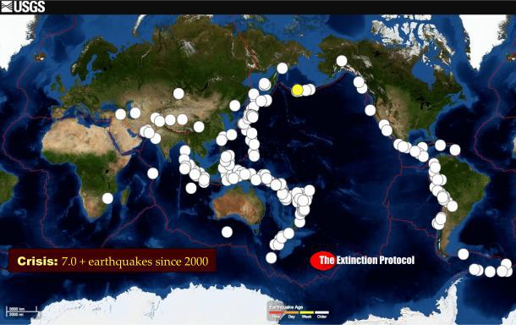
“According to the USGS, the number of large magnitude earthquakes striking the planet doubled in 2014 – Most were/are still around the Pacific’s Ring of Fire
April 2016 – GEOLOGY – `Seismic tension continues to mount in the volatile region of the planet known as the Ring of Fire, where more than 90% of the world’s earthquakes occur, and more than 81% of the largest magnitude earthquakes occur. The extraordinary and precipitous rise in the number of large magnitude earthquakes is both astounding and alarming. On average, only about fifteen 7+ magnitude earthquakes strike the planet each year. We’ve had 2 such earthquake in less than 72 hours.
This has continued to baffle many of the world’s leading geologists…”
“We have recently experienced a period that has had one of the highest rates of great earthquakes ever recorded,’ said lead study author Tom Parsons, a research geophysicist with the U.S. Geological Survey (USGS) in Menlo Park, California… The average rate of big earthquakes — those larger than magnitude 7 — has been 10 per year since 1979, the study reports. That rate rose to 12.5 per year starting in 1992, and then jumped to 16.7 per year starting in 2010 — a 65 percent increase compared to the rate since 1979. This increase accelerated in the first three months of 2014 to more than double the average since 1979, the researchers went on to report. These geologic features include mantle plumes, faults, tectonic plates, submarine vents, and volcanic systems.
In the last 24 hours, moderate earthquakes have struck regions in the far Pacific like Fiji and Tonga, while smaller earthquakes have rattled portions of Japan, Ecuador, Guatemala, El Salvador, Chile, Alaska, California, Indonesia, Puerto Rico and the Virgin Islands, the Adriatic Sea, the Strait of Gibraltar, the Hawaiian Islands, and Greece. Ecuador was struck with a 7.8 magnitude earthquake. Ecuador’s antipodal point is the Sumatra region of Indonesia – which was struck with 5.0, 4.8, and 4.5 magnitude earthquakes in the last 24 hours.
`You might say the entire planet is now reeling from earthquakes from one end to the other. Where will the next big earthquake strike or how long will this current seismic episode last is anybody’s guess? About the only thing we can be certain of is there will be many more such events and they will increase in both severity and intensity.’ ” –Alvin Conway, TEP

WHAT IS MAGMA? “Magma is a molten and semi-molten rock mixture found under the surface of the Earth. This mixture is usually made up of four parts: a hot liquid base, called the melt; minerals crystallized by the melt; solid rocks incorporated into the melt from the surrounding confines; and dissolved gases.”
MAGMA is surfacing. Here we see Isaiah 5:14 and 14:9! Hell is enlarging, expanding, the fire intensifying, and the forces of evil ones are surfacing onto the earth. Pits are opening. Earthquakes are facilitating the process! The Revelation 9 group, and their leader, will soon surface. Look at the description of where they come from. Revelation 14:9-11 speaks of those who take the mark of identification with the Beast: “…the smoke of their torment goes up forever and ever...” also relating to Isaiah 66:24]
Revelation 11:15-18 – With tears I say: In Jubilee Yahushua. Come! Take back what You spoke into existence in all its perfection and beauty. Your earth is no “Humpty Dumpty.” The “cracked egg” will be put back together and restored to its original pristine perfection for you are Creator! By Your power You hold everything together! Come Yahushua Come!
-----
Chunks of Earth's Mantle Are 'Peeling Off'
Kacey Deamer, Staff Writer - LiveScience.com - May 11, 2016

“An odd phenomenon may explain why the Southeastern United States has experienced recent earthquakes, even though the region sits snugly in the middle of a tectonic plate and not at the edges, where all the ground-shaking action usually happens. This seismicity — or relatively frequent earthquakes — may be the result of areas along the bottom of the North American tectonic plate peeling off, the researchers said. And this peeling motion is likely to continue, leading to more earthquakes in the future, like the 2011 magnitude-5.8 temblor that shook the nation's capital.
To figure out the cause of these earthquakes, Berk Biryol, a seismologist at UNC Chapel Hill, and colleagues created 3D images of the uppermost part of Earth's mantle, which is just below the crust and comprises the bottom of a tectonic plate. These tectonic plates scoot around atop a layer of warm, viscous fluid called the asthenosphere. The resulting X-ray images revealed that the plate's thickness in the southeast United States was uneven, with thick regions of dense, old rock combined with thinner areas composed of younger rocks that were also less dense.
At the same time, to fill the void left by the chunks peeling off from the bottom of the plate, the lighter material in the asthenosphere would have moved up to fill in the space. That buoyant material then would have cooled to become the thinner, younger section of the plate. Where parts of the plate broke off or peeled, it became thinner and more prone to slip along fault lines, thus causing seismic activity.”
Bottom line: The Southeast U.S. has sat for millennium on a nice platform plate, the breaking off, or thinning, of the plate puts this area now in jeopardy.
---
Scientists find likely cause for recent southeast U.S. earthquakes
May 3, 2016: http://blogs.agu.org/geospace/2016/05/03/scientists-find-likely-cause-recent-southeast-u-s-earthquakes/
“The southeastern United States should, by all means, be relatively quiet in terms of seismic activity. It’s located in the interior of the North American Plate, far away from plate boundaries where earthquakes usually occur. But the area has seen some notable seismic events – most recently, the 2011 magnitude-5.8 earthquake near Mineral, Virginia that shook the nation’s capital.
Now, scientists report in a new study a likely explanation for this unusual activity: pieces of the mantle under this region have been periodically breaking off and sinking down into the Earth. This thins and weakens the remaining plate, making it more prone to slipping that causes earthquakes. The study authors conclude this process is ongoing and likely to produce more earthquakes in the future.
Old plates and earthquakes: Tectonic plates are composed of Earth’s crust and the uppermost portion of the mantle. Below that is the asthenosphere: the warm, viscous conveyor belt of rock on which tectonic plates ride.”
-------------------------
The south is SINKING: Giant chunks of the Earth's mantle are falling off and causing quakes across the southeastern US - and more are coming, warn researchers - By Mark Prigg For Dailymail.com 4 May 2016

The southeastern United States has been hit by a series of strange unexplained quakes - most recently, the 2011 magnitude-5.8 earthquake near Mineral, Virginia that shook the nation's capital.
Researchers have been baffled, believing the areas should be relatively quiet in terms of seismic activity, as it is located in the interior of the North American Plate, far away from plate boundaries where earthquakes usually occur. Now, they believe the quakes could be caused by pieces of the Earth's mantle breaking off and sinking into the planet.
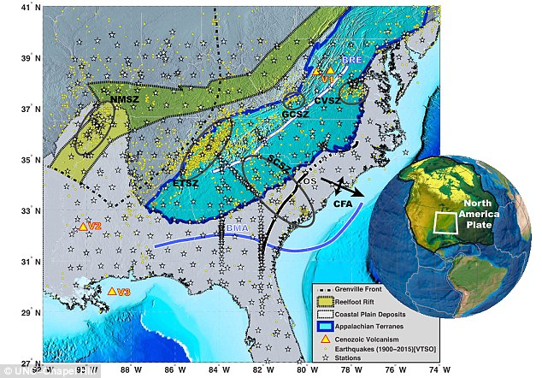
Researchers believe the quakes could be caused by pieces of the Earth's mantle breaking off and sinking into the planet in the affected area (shown here). They say pieces of the mantle have most likely been breaking off from underneath the plate since at least 65 million years ago. This map shows the study area in detail.
WHAT THE MAP SHOWS
This map shows the study area in detail, showing various tectonic attributes of the Southeastern United States.
BMA = Brunswick Magnetic Anomaly, BRE = Blue Ridge Escarpment,
CFA = Cape Fear Arch, OS = Orangeburg Scarp
ETSZ = Eastern Tennessee Seismic Zone
NMSZ = New Madrid Seismic Zone
GCSZ = Giles County Seismic Zone,
SCSZ = South Carolina Seismic Zone
CVSZ = Central Virginia Seismic Zone
V1 = Eocene Virginia Volcanics,
V2 = Jackson, Mississippi Volcanism,
V3 = Offshore Louisiana Volcanism.
Seismicity is from the Virginia Tech Seismological Observatory catalog (1900–2014). Today, the southeastern U.S. is more than 1,056 miles from the nearest edge of the North American Plate, which covers all of North America, Greenland and parts of the Atlantic and Arctic oceans.

WHAT ARE TECTONIC PLATES?
Tectonic plates are composed of Earth's crust and the uppermost portion of the mantle. Below is the asthenosphere: the warm, viscous conveyor belt of rock on which tectonic plates ride.
Earthquakes typically occur at the boundaries of tectonic plates, where one plate dips below another, thrusts another upward, or where plate edges scrape alongside each other.
The world's tectonic plates: Earthquakes typically occur at the boundaries of tectonic plates, where one plate dips below another, thrusts another upward, or where plate edges scrape alongside each other.
Earthquakes rarely occur in the middle of plates, but they can happen when ancient faults or rifts far below the surface reactivate.
These areas are relatively weak compared to the surrounding plate, and can easily slip and cause an earthquake.
'We were intrigued by what was going on and how we can link these activities to structures in deeper parts of the Earth.'
Shaking from the magnitude 5.8 earthquake near Mineral, Virginia on August 23, 2011 was felt by more people than any other earthquake in U.S. history, according to the U.S. Geological Survey. Researchers now believe the quakes could be caused by pieces of the Earth's mantle breaking off and sinking into the planet. But the shapes and locations of the thick and thin regions suggested a different explanation: through past rifting and accretion, areas of the North American Plate have become more dense and were pulled downward into the mantle through gravity.
At certain times, the densest parts broke off from the plate and sank into the warm asthenosphere below. The asthenosphere, being lighter and more buoyant, surged in to fill the void created by the missing pieces of mantle, eventual cooling to become the thin, young rock…”
--------------
Earthquake Ecuador Powerful Many Killed April 17, 2016
At least 233 people are killed and hundreds injured after powerful 7.8 earthquake strikes off the central coast of Ecuador, with tremors felt 300 miles away in Colombia - By Dailymail.com
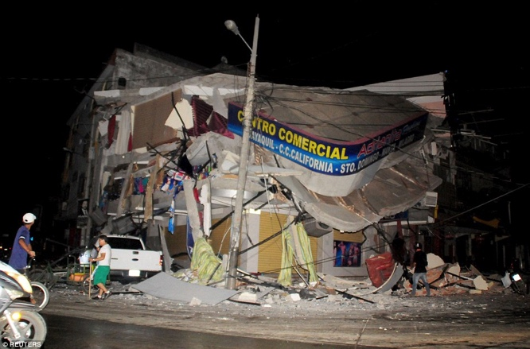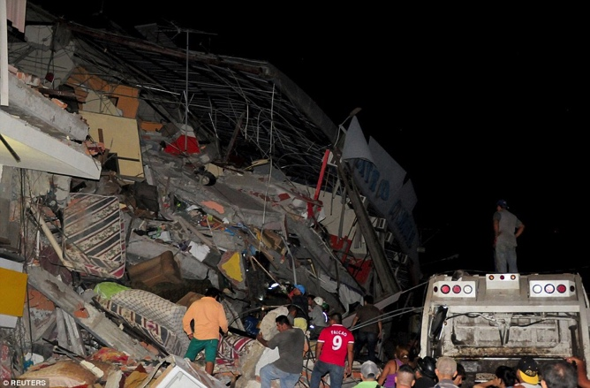
The shockwaves sent confused residents streaming into the streets of the capital Quito
“At least 55 aftershocks followed, one as strong as 6 on the Richter scale, and authorities urged residents to brace for even stronger ones in the coming hours and days. A magnitude-6.5 earthquake struck Thursday near Kumamoto, followed by a magnitude-7.3 earthquake just 28 hours later. The quakes have killed 41 people and injured about 1,500, flattened houses and triggered major landslides. Ecuador lies near a shifting boundary between tectonic plates and has suffered seven earthquakes of magnitude 7.0 or higher in the region of Tuesday's quake since 1900, the USGS said.”
------
Earthquakes across the world including powerful tremor in Ecuador and series of shakes in Japan could herald new MEGA quake, warns top scientist - By Corey Charlton for MailOnline - 17 April 2016/April 20, 2016
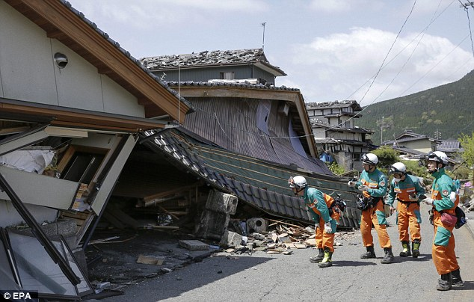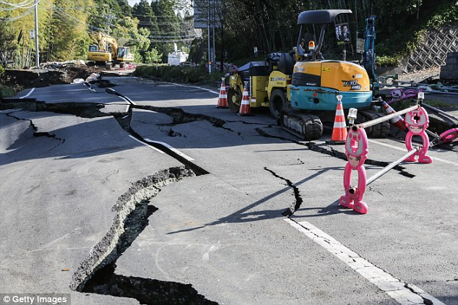
Japan: It is feared 11 people in the region are missing and trapped under rubble and landslides caused by the quakes
“And at the other end of the infamous Ring of Fire, Ecuador was also struggling after a major 7.8 quake which hit last night, killing at least 77. Roger Bilham, a seismologist at the University of Colorado, told The Daily Express: 'The current conditions might trigger at least four earthquakes greater than 8.0 in magnitude.
'And if they delay, the strain accumulated during the centuries provokes more catastrophic mega earthquakes.'
In addition to the four major earthquakes to have struck since Thursday, last week there were also shakes in the Philippines, Vanuatu and Myanmar. All of the earthquakes have occurred in countries straddling the so-called Ring of Fire.”
----------
Japanese supermarket shelves are left completely empty as panic buying takes hold after deadly earthquake - By Sinead Maclaughlin For Daily Mail Australia 18 April 2016
“A 6.4 magnitude quake struck Thursday followed by a 7.3 magnitude earthquake early on Saturday. The two shocks are thought to have killed at least 41 people. Both quakes happened close to the city of Kumamoto, causing huge damage to roads, bridges, tunnels, homes and buildings.
The disaster has left 410,000 homes without water and 200,000 with no power, forcing crowds of people to queue for food and water at emergency aid centres set up in the wake of the aftershocks.
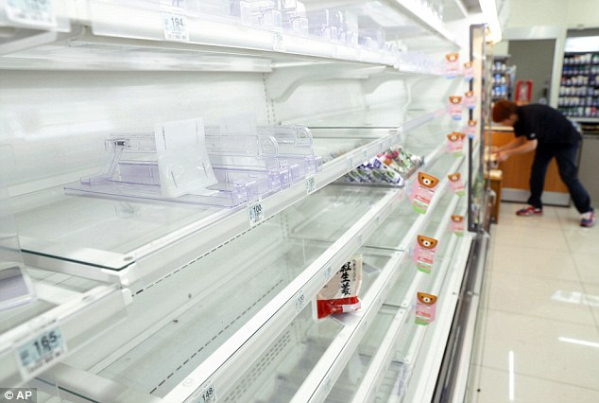
Japanese locals panic buy supplies until the shelves are empty, leaving many to queue up for food and water after two deadly earthquakes
The disaster has left 410,000 homes without water and 200,000 with no power, forcing crowds of people to queue for food and water at emergency aid centres set up in the wake of the aftershocks. According to Japan Today over 196,000 people had been evacuated to shelters by Sunday morning, including about 12,000 in Oita Prefecture.”
DISTABLILIZING DISASTERS BRING FAMNE AND DISEASE, DANGEROUS BEASTS OF THE EARTH, AND INCREASED VIOLENCE OF HUMANS AGAINST HUMANS! (Ezekiel 14:12-23)
-----
May 5, 2016 – ANP - Experts Warn America Is 'Ready To Rumble' - 'Springs Have Been Wound Very, Very Tight'
“The bizarre story from the Daily Mail on Wednesday sounds almost like a Hollywood disaster movie; "The South Is SINKING!" the headline screams at us before dropping the bombshell: "Giant Chunks Of The Earth's Mantle Are Falling Off And Causing Quakes Across The Southeastern US - And More Are Coming" researchers warn.
A story that the Drudge Report linked to on Wednesday over at the Los Angeles Times tells us that the San Andreas fault is 'locked, loaded and ready to roll' with a big earthquake according to experts, as our entire planet is being rocked by 'big ones' along the Ring of Fire.
On Sunday May 1st, a 3.5 magnitude earthquake struck near middle America in the New Madrid Seismic Zone. According to Michael Snyder, the quake was felt all the way over in Miller, Missouri, more than 267 miles away, and could be a 'foreshock' of something much bigger to come. Snyder proceeds to tell us that the New Madrid, which covers parts of Illinois, Indiana, Ohio, Missouri, Arkansas, Kentucky, Tennessee and Mississippi is not only 6 times larger than the San Andreas Fault Zone but is, in fact, about 30 years overdue for a major event, and because of the nature of the Earth's crust in that part of the country, a major earthquake would do significant damage all the way to the east coast.
As was pointed out in a recent blog entry by DutchSinse that was linked to by Steve Quayle in his hot news headlines, scientists are now beginning to learn a lot more about the workings of planet Earth and now confirm that earthquakes in interior regions of the US are being caused in part by magma under our continent rising up from below to fill voids left by broken plates. We're also told how this is pushing earthquakes to the East.
New magma is then rising below the North American plate, and PUSHING UP to fill the void left from the broken off pieces of the plate.
These new findings explain the upwelling pressure which has been displacing the fracking operations and dormant volcanoes all along the interior of the plate – causing noteworthy earthquakes as the pressure transfers upwards, and across the plate to the East
…scientists are now saying about the San Andreas fault line being 'locked, loaded and ready to pop.' We get an update on the Earth's mantle breaking apart…72 hours of Earthquakes up to November 25, 2015 shows a clear progression of earthquakes along the interior craton plate edge from the West coast to the East coast, coming up from below the plate, and pushing all the way to the Southeast USA in the Carolinas from the Pacific Northwest near Washington State.”
-------------------
Scientists say CRATON EDGE Earthquakes caused by new UPWELLING magma from the ASTHENOSPHERE - May 3, 2016 - Michael Janitch – Dutchsense
“The new study confirms chucks of the plate are breaking off below, being replaced by new upwelling magma. The upwelling magma below the plate also explains the metamorphic rock forming at the bottom of some deep drilled frack wells on the WEST coast, AND this explains the plumes popping off from frack wells during times of seismic unrest along the edge of the craton. This also explains the transfer of earthquakes across the edge of the craton now that it is proved there is upwelling magma replacing rock below the plate.”
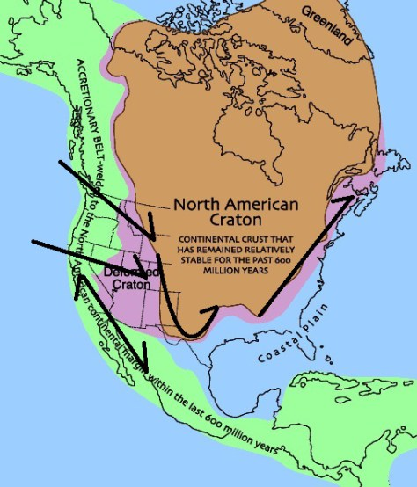
“Above: Graphic showing the interior craton “edge” and the direction of displacement that occurs from BELOW, pushing to the East Southeast while the pressure rises towards the surface. The upwelling pressure causes earthquakes along the interior edge of the plate at the weak points in the crust.”

My question: IF the cration plate has remained relatively stable for 600 million years, then WHY is it all of a sudden falling apart at the very time when events are matching the whole of the Word that precede the return of Yahushua? It isn’t all because of fracking or under-earth drilling of other types. Something’s going on under the earth, and I believe the Isaiah 5:14 and Isaiah 14:9 tell us what it is. Scientists say that the magna is heating and expanding. Of course it is. It is getting ready to receive nearly 7 billion people into its inner core, including the fallen angels, demons, and Satan/Lucifer himself.
-------------
Foreshock? A Significant Earthquake Just Hit The New Madrid Fault Seismic Zone - By Michael Snyder, May 1, 2016
“The New Madrid fault seismic zone is six times larger than the more famous San Andreas fault zone in California, and it covers portions of Illinois, Indiana, Ohio, Missouri, Arkansas, Kentucky, Tennessee and Mississippi. Scientists tell us that the New Madrid fault is about 30 years overdue for a major event, and because of the nature of the Earth’s crust in that part of the country, a major earthquake would do significant damage all the way to the east coast...The New Madrid seismic zone of southeast Missouri and adjacent States is the most seismically active in North America east of the Rockies…The New Madrid seismic zone of southeast Missouri and adjacent States is the most seismically active in North America east of the Rockies… In Matthew 24, Jesus warned us that the time just prior to His return would be marked by earthquakes in diverse places, and right now we are witnessing a dramatic rise in seismic activity all over the planet.
A great shaking is coming to this nation, and the majority of Americans are completely unprepared for it. Are you?”
----------
Mount St. Helens Is Recharging Its Magma Stores, Setting Off Earthquake Swarms - Erik Klemetti - 5.05.16 – Wired- Science

“Since the start of 2016, an earthquake swarm has been detected underneath the currently-quiet Washington volcano. These earthquakes have been occurring from depths of ~2 to over 7 kilometers beneath the volcano. USGS volcanologists and seismologists are interpreting this swarm as a response to the slow “recharging” for the volcano, where new magma is rising up underneath St. Helens as it slumbers. As the magma intrudes, it imparts pressure on the rock around it and it heats up water/releases gases that can add to that pressure. This generates small earthquakes as the rocks shift in response to that stress.”
-----------
Earthquake Prep in California Sidewalks Buckling BREAKING: Sidewalks Starting to Buckle in California; Earthquake Fears Grow! April 22, 2016 -- from Prepper Dome
“The same tectonic plate that caused the tremendous earthquakes in Japan, and later in Ecuador last week, is now pushing against the west coast of the US. It is crushing-into the ground in California… What many people do not know is that the San Francisco earthquake was part of a pattern of quakes which took place that year; first in Ecuador, then in Japan, and finally, the great San Francisco earthquake of 1906. Folks are starting to wonder if history is repeating itself?”
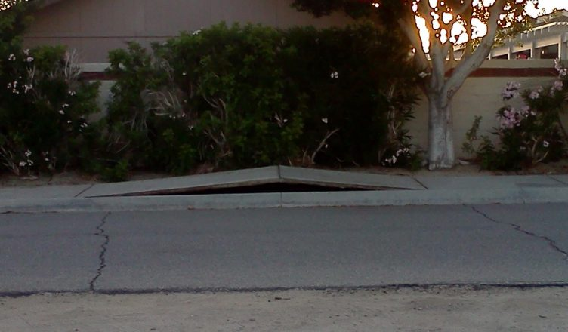
“Sidewalks outside of Palm Springs, CA are starting to lift up off the ground as the same force which caused the earthquakes in Ecuador and Japan is now hitting California; pressure from the Pacific Tectonic plate has now begun crushing into the US west coast.”
-----
Earthquake San Andreas Los Angeles Times
May 4, 2016 Rong-Gong Lin II

Southern California’s section of the San Andreas fault is “locked, loaded and ready to roll,” a leading earthquake scientist said Wednesday at the National Earthquake Conference in Long Beach. Thomas Jordan, director of the Southern California Earthquake Center: `The springs on the San Andreas system have been wound very, very tight. And the southern San Andreas fault, in particular, looks like it’s locked, loaded and ready to go,’ Jordan said in the opening keynote talk.”

Did you watch the movie San Andreas? Quite realistic! TSUNAMIS OFTEN ACCOMPANY EARTHQUAKES …
-----
The San Andreas Fault New Madrid and East Coast are all set to For A DANGEROUS Earthquake – May 6, 2016 -
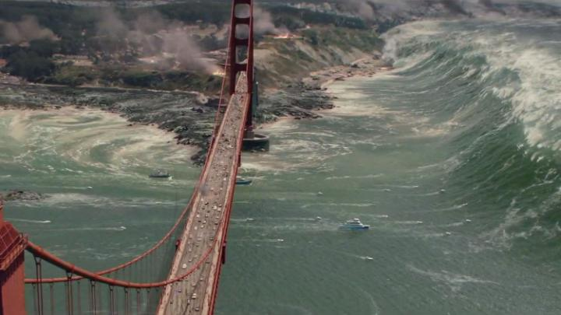

“With research compiled, it appears as though America better get ready for a set of detrimental earthquakes over the next few years affecting the San Andreas region, the New Madrid region, and the East Coast. Multiple scientists claim that all of these regions are well overdue for a big one.”
------
Earthquake swarm in NW Arizona keeps rolling on
Posted: Apr 24, 2016 - by Phil Benson from azfamily.com
“More small earthquakes shook northwest Arizona Sunday adding to the list of temblors that have struck the area since March 29.
There has been a swarm of 21 quakes in an area along the Arizona-Nevada line south-southwest of Littlefield, AZ, which is also close to southwestern Utah and the frequency and span puzzles geologists.
The survey said the area has several active faults and that its geologic features suggest there could be additional potentially active faults just north of the largest quake. The largest in the swarm was a magnitude 3.4 quake was reported at 2:23 a.m. on April 8.”
-----
The Big Ones: Scientist warns up to 4 quakes over 8.0 possible under ‘current conditions’ - 18 April, 2016
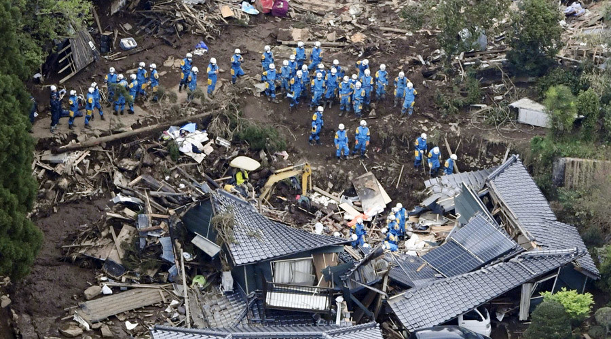
Rescue workers conduct a search and rescue operation to a collapsed house at a landslide site caused by earthquakes in Minamiaso town, Kumamoto prefecture/Japan © Kyodo / Reuters
“Sunday’s devastating earthquake in Ecuador might just be the beginning, according to a seismologist who says that current conditions in the Pacific Rim could trigger at least four quakes with magnitudes greater than 8.0. A total of 38 volcanoes are currently erupting around the world, making conditions ripe for seismic activity in the Pacific area.
More than 270 people are now confirmed dead after Sunday’s quake in Ecuador, with the number expected to rise.” [Refer to maps of the Pacific Rim]
---------
Earthquakes Near Oklahoma
Oklahoma, United States, May 7, 2016 (M1.5 or greater)
earthquaketrack.com/p/united-states/oklahoma/recent

5 earthquakes today
39 earthquakes in the past 7 days
225 earthquakes in the past month
3,395 earthquakes in the past year
The largest earthquake in Oklahoma, United States:
today: 4.0 in Luther, Oklahoma, United States
this week: 4.0 in Luther, Oklahoma, United States
this month: 4.2 in Crescent, Oklahoma, United States
this year: 5.1 in Fairview, Oklahoma, United States
Places Near Oklahoma, United States
Dallas, Texas, United States
Fort Worth, Texas, United States
Austin, Texas, United States
Houston, Texas, United States
Oklahoma
Northern Texas
Texas Panhandle
Eastern Texas
Central Texas
Southeastern Missouri
Western Texas
Southern Texas
Western Kentucky
Colorado
----------------------------
Earthquakes of Biblical Proportions Lead to this Alarm Predictions Of Biblical Quakes On Horizon Lead To This Alarm: 'We Are In A Race Against Time'
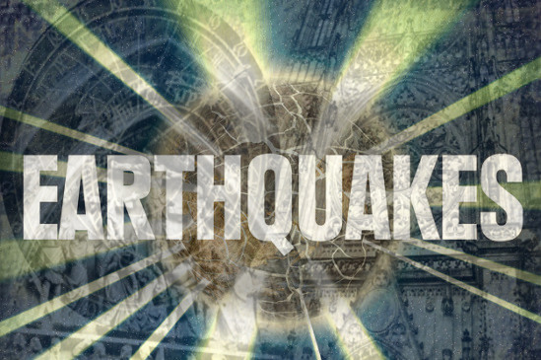
By Stefan Stanford - All News Pipeline - April 16, 2016
“According to a new story from Michael Snyder at End Of The American Dream and seismologist Roger Bilham of the University of Colorado, 'current conditions' happening right now upon our planet Earth 'might trigger at least four earthquakes greater than 8.0 in magnitude and what we've been witnessing in seismic activity across the planet in recent days may only be 'the beginning'
After a 5th major earthquake in just 72 hours has struck Asia, killing at least 20 people, scientists fear a 'monster quake' is about to strike as the Prime Minister of Japan, Sinzo Abe, has warned: "We are in a race against time". We also learn from CNN that the ground in Japan is 'swaying every hour'. From Snyder: According to Volcano Discovery, 38 volcanoes around the globe are erupting right now. This is definitely an unusually high number. Even a single magnitude 8.0 earthquake in a major city in Japan, China or the United States would cause global markets to crash and would mean billions of dollars in economic damage.
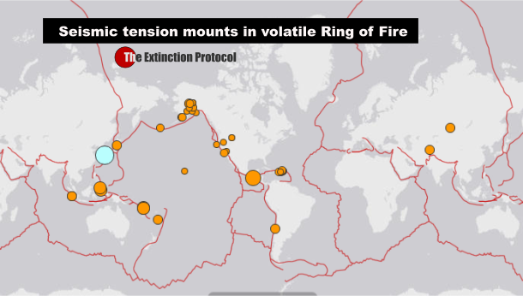
We also learned today that Japan's Mount Aso has had a minor eruption (though officials don't know if the eruption was tied to the earthquake) while the Extinction Protocol tells us that massive Mount Paektu, an enigmatic and dangerous volcano on the border between China and North Korea, is also on the verge of eruption. We're also told the last time this volcano erupted, it rivaled the largest eruptions in recorded human history, throwing rocks and ash as far away as Japan.
We're told that earthquake tremors in Japan from the latest quake were felt as far away as 500 miles and 20,000 troops had to be deployed following a 7.3 magnitude quake at 1:25 a.m. local time Saturday morning. More than one-thousand people were injured and others trapped inside of collapsed buildings only one day after a quake killed 9 in the same area.
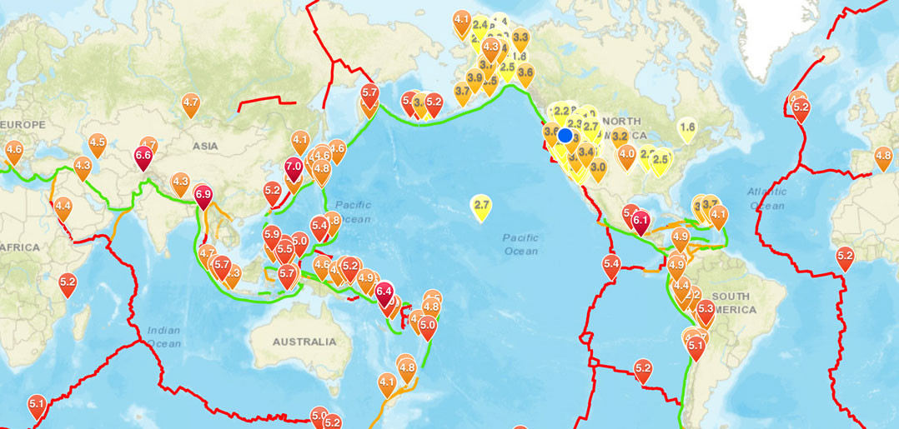
-------------------------------------------
Ring of Fire: Three Deadly Earthquakes In Three Days - 'Earthquake Outbreak' Has Scientists Concerned
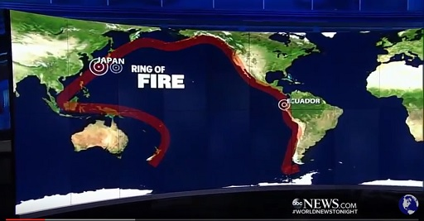
By Susan Duclos - All News PipeLine April 18, 2016
“Ecuador, Japan and the US all reside on the same tectonic "Ring of Fire," which can be seen in the map above, and both Ecuador and Japan have just suffered three deadly earthquakes in rapid succession along that ring. As can be seen in the ABC News report below titled "Third Earthquake in Rapid Succession on 'Ring of Fire', we hear what the newscaster refers to as the "Earthquake Outbreak," along the ring of fire with Ecuador suffering a 7.8 magnitude earthquake and Japan being hit twice with 7.3 and 6.5 magnitude quakes followed by hundreds of aftershocks which is hampering rescue efforts.
Just two days ago Stefan Stanford reported on a warning from the Prime Minister of Japan, Sinzo Abe who said "we are in a race against time," as we learned that the ground in Japan was "swaying every hour," in an article titled "Predictions Of Biblical Quakes On Horizon Lead To This Alarm: 'We Are In A Race Against Time'.
RT reports `A total of 38 volcanoes are currently erupting around the world, making conditions ripe for seismic activity in the Pacific area.’
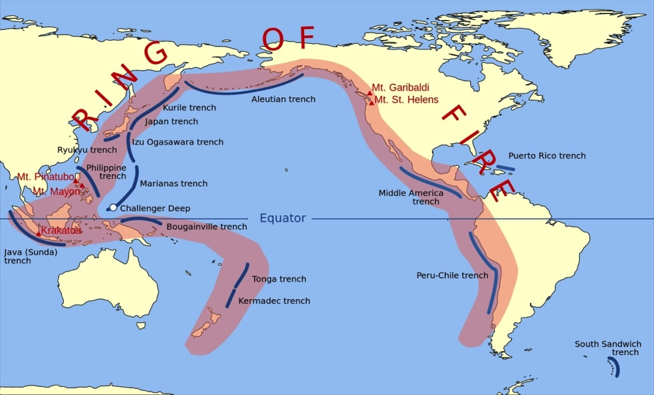
In order to understand the scope of the seismic activity being seen, the map below is a screen shot from Earthquakes-Volcanoes Discovery, who also provide a list of volcanoes erupting currently.
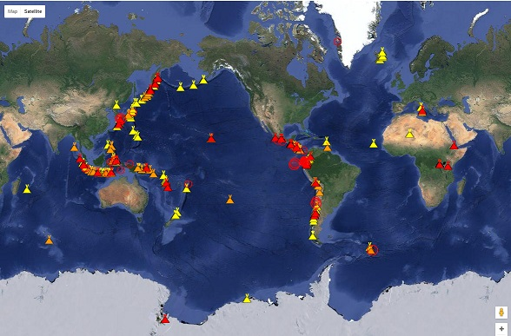
We are reminded by a link found at Steve Quayle's website the importance of being as prepared as possible, because when the `big one’ hits in the U.S., it will be too late. We see that store shelves in Japan are empty as people start "panic buying" after the deadly earthquakes hit. While no one can be prepared for total devastation if their home is destroyed, those left without transportation because of inaccessible roads, or access to their bank account or ATM machines, should have, food, water, medical supplies, and cash on hand before catastrophe hits.”
***[Yedidah’s input: In 2005, after the Katrina disaster, prophecy went all over America. The Katrina disaster that displaced so many people came shortly after American troops helped Israel pull nearly 9,000 people out of their homes in Gaza and Samaria so that Hamas could take over. The prophecies, referring to this basically all had Elohim saying “You divide My Land and I’ll divide yours.” America has been leading the world to divide up Israel and give much of it to their enemies. The dividing of the United States along the New Madrid Fault Line is a strong reality!]

---------------------------------------------------
Volcanic Eruptions Gone Global
Tuesday, 29 March 2016 – The Big Wobble
Global volcanic unrest as six eruptions registered since last Wednesday in The Democratic Republic of the Congo, Philippines, Chile, Alaska, Mexico and Japan
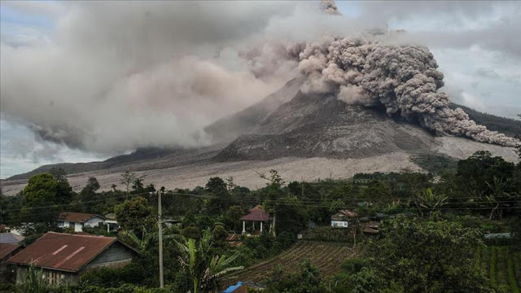
Kanlaon Volcano Philippines
“March had been a quiet month for volcanic activity....until yesterday that is!
After the three mighty colossi, Pavlof volcano Alaska, The Popocatepetl volcano Mexico, and Sakurajima volcano in South Japan all erupted within hours of each other yesterday a fourth and fifth volcano have erupted today!
The volcanic peak Copahue, which sits at the border of Argentina and Chile, erupted today after weeks of gradually increasing activity along with the Kanlaon Volcano in the Philippines.
Last Wednesday The Democratic Republic of the Congo's Nyiragongo volcano was also releasing up to 50,000 tonnes of polluted gas per day as eruption thought to be imminent.
Rincon de la Vieja Volcano Costa Rica spews a column of vapor and gases reaching more than 700 meters high
Yet another Ecuador volcano...Sangay showing an increase in activity along with Tungurahua and Cotopaxi
A very dangerous volcano which is in the center line of tomorrow's Solar Eclipse Makian Island's Kie Besi, Indonesia has begun to rumble
'We have had an attack from the earth like never before!' Ecuador’s Tungurahua volcano spews ash 4000m high.
Big volcano uptick! Fuego volcano Guatemala sends ash plums 2,000 meters above the crater
The Tungurahua volcano in Ecuador maintains high activity!
Indonesia's Mount Sinabung causes huge concern after two eruption send smoke and ash 3km into the sky
Tungurahua volcano, Ecuador eruption: Spews ash plume approx. 5000 meters above the summit.
Bulusan Volcano Philippines spews ash and gas 500 meters into the sky
Fears grow as evidence shows North Korean nuclear test's will trigger a volcanic eruption of Mount Baekdu causing chaos to the Western Pacific”
---------
Volcano eruption and Earthquake reports increasing April 2016
“From just April 10, 2016 – plus typhoons, hurricanes, cyclones, tornadoes, and other types of land-storms of violent nature of all types worldwide, the earthquakes and volcano eruptions are increasing greatly – the earth is revolting under the sin of man that turns against the Creator” ….

Mexico’s Popocatepetl Volcano at high risk for exploding
Posted on April 9, 2016 by The Extinction Protocol

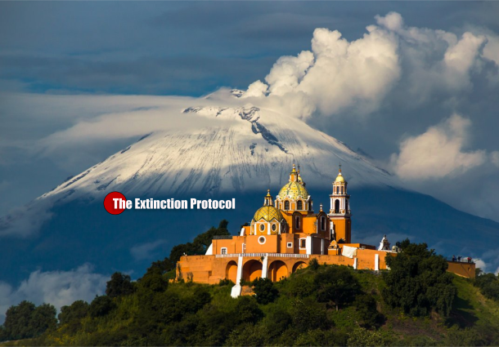
April 2016 – MEXICO –
“Mexican authorities are warning of the potential for major activity at an active volcano just 50 miles southeast of Mexico City. Experts on the Popocatepetl Volcano issued the warning Wednesday after observing an increased level of explosive activity in recent months. In the last two weeks alone, the volcano has exploded on several occasions resulting in the expulsion of gases and smoking, fiery fragments. Authorities are carrying out flyovers to inspect the crater with the support of the federal police, experts, and civil protection authorities.”
-------------
earthquakes and volcano activity 4/08/2016
“Explosion”/Blast near Oregon dormant Volcanoes/Newberry Crater--April 8, 2016 Michael Janitch
“An explosion of some kind has occurred on the flanks of Newberry Volcani Crater(s) in Central Oregon. The explosive blast measured in at a magnitude 2.5 (M2.7), with an epicenter located in the forests between Three Rivers, OR and Newberry volcano. The actual epicenter of the earthquake resides at the end of a lava field / old lava flow.”
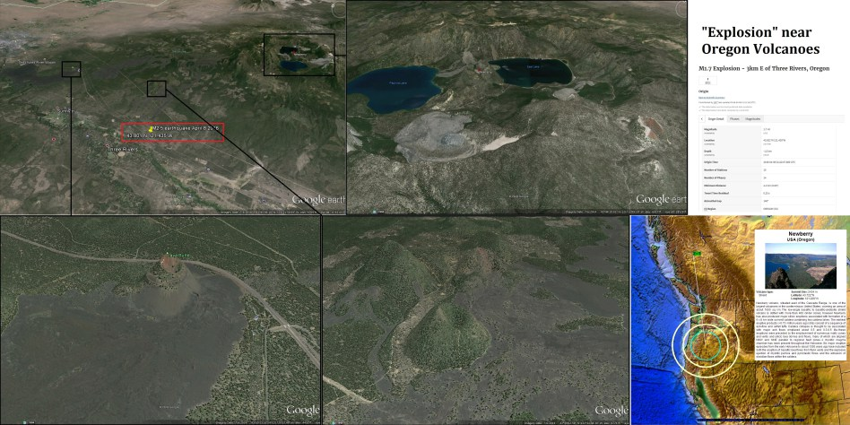
“Just a few hundred miles West of Newberry crater there is a new volcanic field being formed undersea. If there was no quarry blast near Newberry Volcano, then we can assume this explosion was volcanic in nature. If the explosion is the result of volcanism, then we should be aware of the possibility of coming larger seismic activity in the region (larger earthquakes off the West coast for instance). See the earthquake forecast video talking about this exact same subject – volcanic earthquakes showing up BEFORE movement off the West coast.” http://earthquake.usgs.gov/earthquakes/eventpage/uw61140236#origin
----------------
Earthquake Hits Major Volcano Site By Alëx Elliott - April 08, 2016
ICELAND…
“There was a major earthquake on the northern edge of the Bárðarbunga volcanic craters at around midnight last night. The quake measured 4.2 on the Richter scale and is therefore the largest quake to have hit the famous volcano since it stopped erupting in February last year. According to Bjarki Fries, a natural disasters specialist with the Icelandic met office, the earthquake emanated from 3.5 kilometers underground. Around 15 aftershocks have already been measured, the most powerful of which was a 3.5 quake at 01.00 this morning.
The recent eruption at Bárðarbunga, often known as Holuhraun, lasted from late August 2014 to late February 2015, and despite not affecting aviation or physically threatening any human settlements, it caused dangerous levels of pollution around Iceland and produced more new lava than almost any other eruption in Iceland since the Vikings first arrived.”
--------------
6.6 magnitude earthquake jolts Afghanistan; tremors felt in north India CNN-IBN April 10, 2016
New Delhi: An earthquake of magnitude 6.6 jolted Hindukush region of Afghanistan on Sunday. Strong tremors were also felt in Jammu and Kashmir, Delhi and other parts of north India. The tremors were felt for almost 1.5 minutes.
Delhi Fire Department said control rooms have not received any calls reporting major damage or collapse of any buildings. Deputy Chief Minister Manish Sisodia, who was in Delhi Secretariat when the tremors were felt tweeted, "earthquake!!! It was really scary! I could see plants and furniture shaking at 6th floor office of Delhi secretariat. Wish all is well." Delhi Metro services were affected for a brief period in the wake of the tremor and resumed later.”
------------
Costa Rican colossus Turrialba volcano spreads ash across capitol city San Jose after strong eruption - May 13, 2016-from the big wobble and ticotimes.net
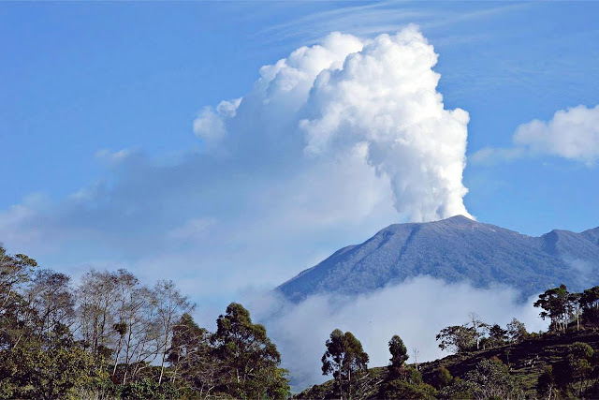
Photo ticotimes.net
“The strong eruption by volcano Turrialba at the 01:19 local time (Thursday, May 12, 2016) affected a great part of the Costa Rican capital, which got up Thursday covered by a thin layer of ashes. Television stations transmitted images of the exact moment of the explosion, with a column of smoke and ashes, gases and other materials. The Turrialba is 3,340 meters high.”
---------
Watch Mount Etna 'breathing' in this mesmerizing NASA animation: Earth's crust is seen swelling and dipping as the volcano gets ready to explode - By Ryan O'Hare for MailOnline - 12 May 2016
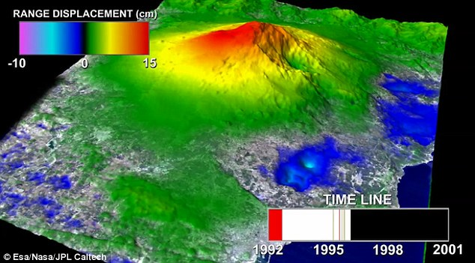

FEMA Prepares For West Coast Carnage As New Madrid Awakening And Mount St. Helen's Shaking Are More Signs That 'Imminent Destruction May Be Coming Soon'
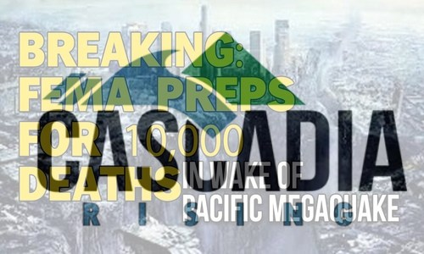
By Stefan Stanford - All News Pipeline – May 11, 2016
“Beginning in less than a month on June 7th and lasting until June 10th, FEMA and Cascadia Rising 2016 are preparing for a devastating earthquake followed by a tsunami on the Northwest Coast of America that has scientists and other experts asking not IF it will come, but WHEN it will come.
As we learn from Gary Franchi of the Next News Network in the 1st video below, FEMA is also now preparing for 10,000 deaths along the Northwest Coast of America in the region of the Cascadia Subduction Zone due to the quake and the resulting tsunami.
We're told that Cascadia Rising will be the most complex disaster scenario that emergency management and public safety officials have ever faced and the drills will feature preparation for a 9.0 magnitude quake along the Cascadia Subduction Zone and the resulting tsunami that experts believe will devastate much of the Northwest Coast.
We also learn below that scientists believe it's inevitable that America will be hit by absolutely monstrous earthquakes, and possibly in our near future, as shared in the linked story from Michael Snyder at End Of The American Dream.
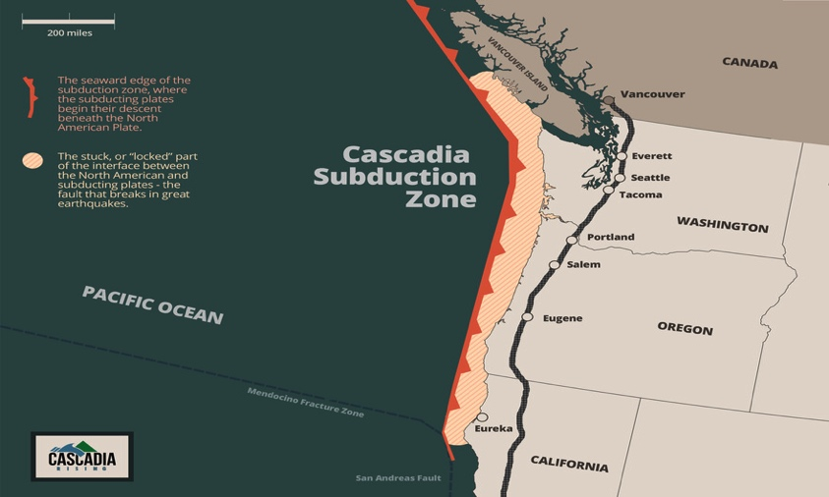
Just days ago we learned from scientists that Mount St Helens volcano is 'recharging' 36 years after the most deadly volcanic blast in 'modern' US history. We're told that the volcano's replenished magma stores have been responsible for setting of a series of earthquakes, more than 130 small magnitude quakes since March with steadily increasing frequency.
According to The Pacer, UTM's award-winning college newspaper, the recent small earthquake in the New Madrid seismic zone may be a sign that imminent destruction is coming soon. They have a very keen interest in this as their college is well within the New Madrid Seismic zone. From their story.:
If an event like the ones in 1811 and 1812 happened today, UTM and the city of Martin would not be safe from it. Certainly, buildings would suffer damage. Many would probably fall. People could get injured or killed. There is a high possibility that surviving citizens would be left without running water, electricity, or the ability to communicate via cell phones or the internet. The roads could be damaged by the event, so transportation is not a given luxury. Citizens in need of help might not receive assistance from police, hospitals, or government agencies for a long time, depending on the availability of resources. That is especially true if relief efforts focus on larger population centers than Martin, such as Memphis or Nashville.
Because the affected areas were so rural and so thinly populated during the 1811-1812 events, the damage and death toll of the earthquakes were minimal compared with what could happen now.
“Very large quakes (8-9 moment magnitude) would be extremely devastating to the point of being ‘catastrophic.’ If the 1811-12 tremors were to occur today, with our increased population, cities, and dependence on technology and transportation, the result would probably be the worst natural disaster in American history. The 1811-12 quakes were felt from Canada to Mexico. We are in the middle of the country, so a quake of that proportion would affect all of the country to some degree, even if they didn’t actually feel the quake,” Gibson said.
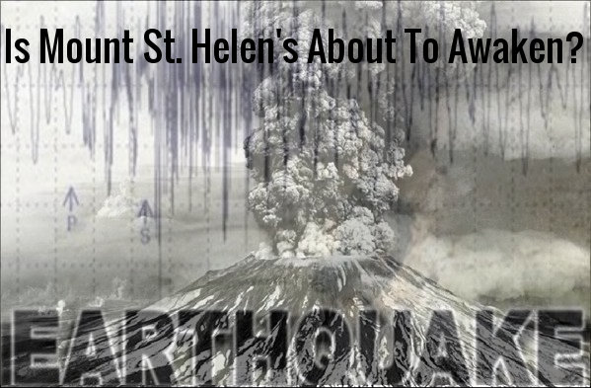
As we hear in the 2nd video below, governments across the planet are preparing for massive earthquakes recently, especially in the US and Canada along the West coast. What do they know that we don't know? In the 3rd video below, we hear more about what is now happening underneath Mount St. Helen's, a series of small quakes that are could be looked at as more signs of what FEMA and Cascadia Rising are preparing for in that region. In the 4th video below, we get more 'Signs of the End' from YouTube videographer Angel of Apocalypse.”
--------------------------
First, from the Cascadia Rising website:
June 7-10, 2016 Emergency Operations and Coordination Centers (EOC/ECCs) at all levels of government and the private sector will activate to conduct a simulated field response operation within their jurisdictions and with neighboring communities, state EOCs, FEMA, and major military commands.
Conducting successful life-saving and life-sustaining response operations in the aftermath of a Cascadia Subduction Zone disaster will hinge on the effective coordination and integration of governments at all levels – cities, counties, state agencies, federal officials, the military, tribal nations – as well as non-government organizations and the private sector. One of the primary goals of Cascadia Rising is to train and test this whole community approach to complex disaster operations together as a joint team.
Recent subduction zone earthquakes around the world underscore the catastrophic impacts we will face when the next CSZ earthquake and tsunami occurs in our region:
Indonesia (2004): M9.1 --- 228,000 fatalities
Chile (2010): M8.8 --- 500 fatalities
Japan (2011): M9.0 --- 18,000 fatalities
The Cascadia Subduction Zone off the coast of North America spans from northern California to southern British Columbia. This subduction zone can produce earthquakes as large as magnitude 9 and corresponding tsunamis. Scientific evidence indicates that a magnitude 8.0-9.0 earthquake occurs along the 800-mile long fault on average once every 200 to 500 years. The last major earthquake and tsunami along the fault occurred over 300 years ago in 1700.
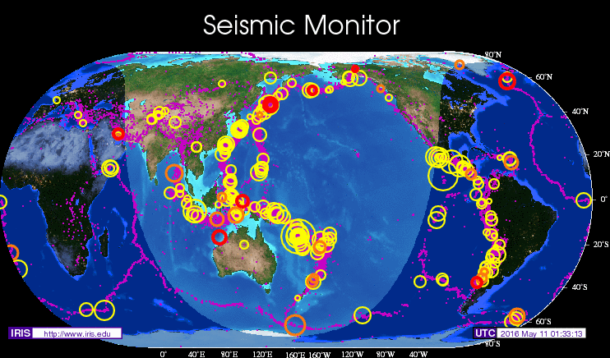
Will America soon be hit by a devastating earthquake unlike anything that we've seen in this country in years? The signs of impending catastrophe are clearly all around us. With FEMA preparing for a massive quake and the resultant tsunami along the Northwest coast of America, we feel that it's best that we all take similar preparations.
Even though preparing for an earthquake involves differing elements than preparing for other catastrophes, food, water and shelter are always top priorities no matter what catastrophe we're preparing for. As Snyder told us in his story, one team of scientists has concluded that giant chunks of the Earth’s mantle are “breaking off and sinking into the planet” under the North American plate, and that this is what has caused some of the unusual earthquakes in the eastern part of the country in recent years.
While quite obviously, having food, water and shelter won't protect us from our country breaking apart and falling into 'inner Earth', Snyder reminds us that the chances of that actually happening are rather small no matter how ominous it might sound. Certainly an event of that magnitude would be Biblical and a final, devastating 'sign of the end'.”
------------
Volcano New Zealand showing elevated signs of activity
Scientists monitoring Mt Ruapehu after volcano displays signs of elevated activity - Posted on May 9, 2016 by The Extinction Protocol
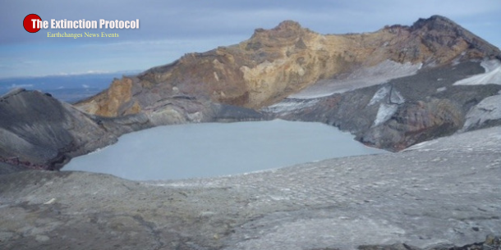
May 2016 – NEW ZEALAND – An aerial observation was being conducted over Mt Ruapehu yesterday after temperatures in the active volcano’s bubbling Crater Lake rose to the hottest on record.”
---------------------------------
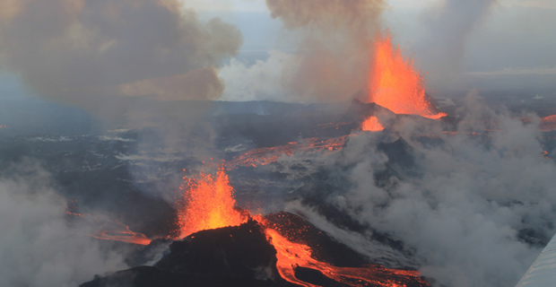
40 Volcanoes Are Erupting Right Now and 34 of Them Are Along The Ring Of Fire - May 15, 2015 - by MICHAEL SNYDER | ECONOMIC COLLAPSE
“You may not have noticed, but our planet is becoming increasingly unstable. According to Volcano Discovery, 40 volcanoes around the globe are erupting right now, and only 6 of them are not along the Ring of Fire. If that sounds like a very high number to you it is because it is a very high number. As I have written about previously, there were a total of 3,542 volcanic eruptions during the entire 20th century….
And of course we are witnessing a tremendous amount of earthquake activity as well. Nepal was just hit by the worst earthquake that it had seen in 80 years, and scientists are telling us that the Himalayas actually dropped by an astounding 3 feet as a result of that one earthquake. How much more does our planet have to shake before people start paying attention?...If it seems like earthquakes and erupting volcanoes are happening more frequently, that’s because they are.. Iceland (which is home to some of the most dangerous volcanoes on the planet), Santorini in Greece, Uturuncu in Bolivia, the Yellowstone and Long Valley calderas in the U.S., Laguna del Maule in Chile, Italy’s Campi Flegrei – almost all of the world’s active super-volcanic systems are now exhibiting some signs of inflation, an early indication that pressure is building in these volcanic systems.
But of course most Americans are never going to care about any of this until it starts affecting them personally. Well, perhaps they should start paying attention to the warning signs. In recent weeks we have seen significant earthquakes in Michigan, Texas, Mississippi, California, Idaho And Washington. In addition, it is being reported that pressure is building in dormant volcanoes in Arizona and California…If you are not familiar with the Ring of Fire, just imagine a giant ring that runs around the outer perimeter of the Pacific Ocean. Approximately 90 percent of all earthquakes and approximately 75 percent of all volcanic eruptions occur within this area, and the entire west coast of North America is considered to be part of the Ring of Fire…Meanwhile, a series of very strong earthquakes have struck Papua New Guinea recently as well.
The following comes from the Washington Post… A powerful earthquake rattled Papua New Guinea on Thursday, the fourth strong quake to hit the South Pacific island nation in a week. The temblor prompted officials to issue a local tsunami warning, but it was lifted shortly afterward with no reports of damage. The 7.1-magnitude quake struck about 150 kilometers (94 miles) southwest of the town of Panguna on Bougainville Island at a depth of 23 kilometers (14 miles), the U.S. Geological Survey reported…Scientists already know that magnetic north shifts. Once every few hundred thousand years the magnetic poles flip so that a compass would point south instead of north. While changes in magnetic field strength are part of this normal flipping cycle, data from Swarm have shown the field is starting to weaken faster than in the past. Previously, researchers estimated the field was weakening about 5 percent per century, but the new data revealed the field is actually weakening at 5 percent per decade, or 10 times faster than thought.”
---------
List of volcano eruptions recently – May 2016:

“Mount St Helens is recharging 36 years after 'deadliest blast in US history’: Has scientists worried!
The Cleveland Volcano in the Aleutian Islands erupts steam and ash emissions
After 60 years of inactivity: The Bristol Island volcano, spews ash gas and steam into the South Georgia sky after heavy quake activity
Volcano Uptick: North Sulawesi's Mount Karangetang Indonesia and White Island volcano in Bay of Plenty New Zealand erupt on Wednesday
Volcano Eruption Uptick -San Cristobal volcano Nicaragua spews ash 2 km into the sky
Eurasia's largest volcano Klyuchevskaya Sopka, Russia, spews hot ash "miles" into the sky on Sunday
Authorities evacuate over 10,000 as Mount Kerinci volcano Indonesia shows increasingly intense eruptions over the last two weeks
Volcano Uptick...Santiaguito volcano Guatemala has a powerful eruption only five day's after a major quake in the same area
Mexico's Popocatepetl volcano spews ash more than two miles above the crater
Scientists raise the threat level of Alaska's Cleveland Volcano from yellow to orange after a lower-level eruption
After two deadly earthquakes and dozens of powerful aftershocks Japan's Mount Aso volcano erupts adding to the chaos

Global volcanic unrest as six eruption's registered since last Wednesday in The Democratic Republic of the Congo, Philippines, Chile, Alaska, Mexico and Japan
Pavlof volcano Alaska: The Popocatepetl volcano Mexico: And Sakurajima volcano in South Japan all erupt within hours of each other!
Democratic Republic of the Congo's Nyiragongo volcano is releasing up to 50,000 tonnes of polluted gas per day as eruption thought to be imminent
Rincon de la Vieja Volcano Costa Rica spews a column of vapor and gases reaching more than 700 meters high
Yet another Ecuador volcano...Sangay showing an increase in activity along with Tungurahua and Cotopaxi
A very dangerous volcano which is in the center line of tomorrow's Solar Eclipse Makian Island's Kie Besi, Indonesia has begun to rumble
'We have had an attack from the earth like never before!' Ecuador’s Tungurahua volcano spews ash 4000m high.
Big volcano uptick! Fuego volcano Guatemala sends ash plums 2,000 meters above the crater
The Tungurahua volcano in Ecuador maintains high activity!
Indonesia's Mount Sinabung causes huge concern after two eruption send smoke and ash 3km into the sky”
-----
Mt. St. Helens Volcano Rumbles with 130 Earthquakes, Growing Magma Bulges, New Steam Emissions - Two Quakes Strike Cascadia Subduction Zone . . . Scientists Sound Alarm over San Andreas Fault!
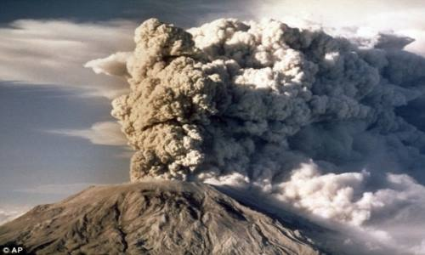
NewsRoom May 7, 2016 DISASTER, News, from My Daily Informer
Alarm over San Andreas Faul, Mt. St. Helens Volcano, Two Quakes Strike Cascadia Subduction Zone
“The most active volcano in the Pacific Northwest USA has begun to stir again with more than 130 small earthquakes beneath Mount St. Helens, and today, two more earthquakes struck the CASCADIA SUBDUCTION ZONE!
This behavior indicates that the volcano is steadily recharging – but while it may sound alarming, the experts say they haven’t yet spotted any signs of an imminent eruption.
Washington’s notorious volcano is best known for its ‘cataclysmic’ 1980 eruption, which brought devastation and destruction that stretched on for miles, and visible ash fall nearly 1000 miles away. The event killed 57 people and blasted more than 1,300 feet off the top of the mountain. Now, scientists say its recharging for another eruption.
THE NEW ACTIVITY
Beginning on March 14, 2016, scientists detected low magnitude earthquakes from 1.2 to 4 miles beneath Mount St. Helens. In just the last eight weeks, there have been more than 130 earthquakes, mostly of magnitudes .5 or less. The largest so far has been a magnitude 1.3.
Scientists say the earthquakes have been steadily increasing in numbers, with up to 40 occurring per week.
So far, though, there have not been any atypical gas emissions, increases in ground inflation, or shallow seismicity.
Scientists claim this means that there are currently no signs of a potential eruption.
Washington’s notorious volcano is best known for its ‘cataclysmic’ 1980 eruption, which brought devastation and destruction that stretched on for miles, and visible ash fall nearly 1,000 miles away. The event has come to be known as one of the 'deadliest eruptions in US history'.
It reawakened in 2004, spewing steam and ash up to 10,000 feet into the air. This activity continued until January 2008, and five months later, scientists concluded Mount St. Helens had gone to sleep.
Now, the volcano is once again recharging…The ‘earthquake swarm’ located by the Pacific Northwest Seismic Network is steadily becoming more frequent, but the tremors are not strong enough to be felt at the surface.
As the volcano recharges, ‘most of the action is happening far beneath our feet,’ explains Erik Klemetti, an assistant professor of Geosciences at Denison University, in Wired’s ‘Eruptions’ blog. While the volcano appears to be sleeping, magma is pushing its way upward. The scientists predict that the rising magma is applying stresses to the surrounding crust, pushing fluids through the cracks and spurring the small earthquakes.
MAGMA BULGES APPEARING, CRATER NOW GIVING OFF STEAM!
As red hot magma travels upwards from deep within the earth, it is pushing the land above it, upwards. This is now evident as new lava dome bulges have appeared inside the volcano crater!
The photo below was taken on May 6, 2016 and in it, you can see the two new bulges in the center of the crater, and see steam very clearly emanating from the ground.
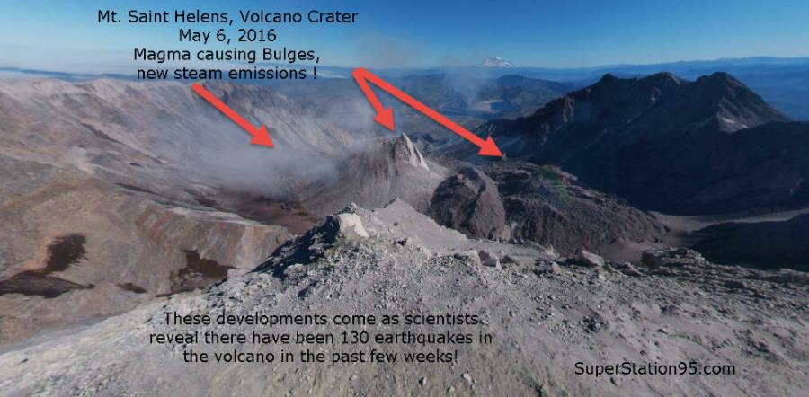
This image was taken from the official volcano camera installed atop the mountain. The camera is on the peak. In the distance can be seen the other nearby volcano, Mt. Hood.
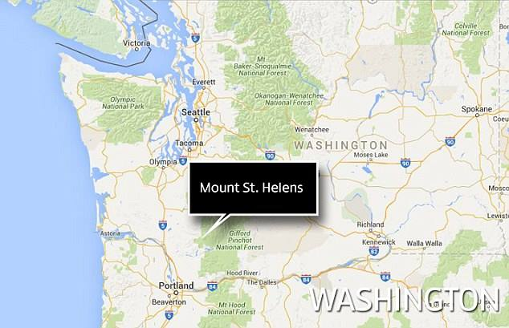
Mount St. Helens is located in Skamania County, Washington.
When this volcano blew its top in 1980, roughly 520 million tons of ash were blown across the United States, causing complete darkness in Spokane, Washington – 250 miles away from the volcano. The cloud circled the Earth in 15 days.
CASCADIA SUBDUCTION ZONE SHOOK TWICE TODAY
While attention is now being focused on Mt. St. Helens, the notoriously unstable "Cascadia Subduction Zone" (CSZ) in the Pacific Ocean just off the coasts of Oregon and Washington, was hit by two earthquakes within 21/2 hours of each other today!
This image, from the US Geological Survey, shows the locations of those quakes:
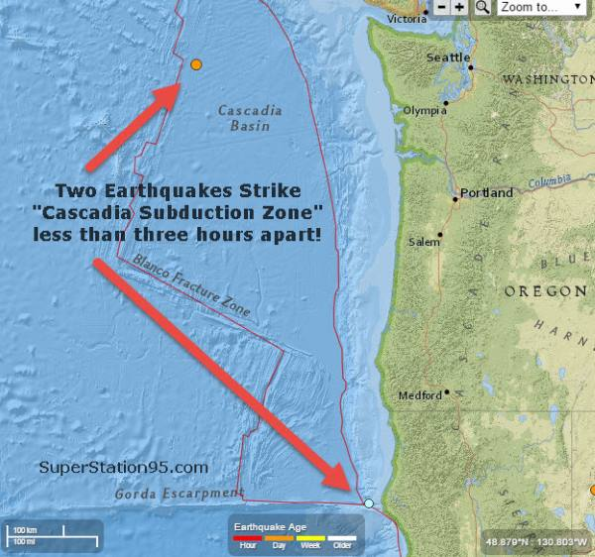
The fact that one took place at the bottom of the CSZ and the other toward the top, indicates tremendous pressure is being applied to that entire area by the huge Pacific Tectonic Plate.

TWO DAYS AGO NEW WARNINGS ABOUT SAN ANDREAS FAULT TOO!
Today's CSZ quakes take place just two days after other noted Scientists began sounding warnings about the San Andreas Fault in California. According to the latest analysis, the San Andreas Fault is "locked and loaded" for a MAJOR earthquake which will likely devastate California. The geologists say it has been "too quiet for too long" and are talking now about an earthquake in the range of Magnitude 8.0 ! ! ! !
The southern part of the San Andreas fault is `locked, loaded and ready to roll,’ according to Thomas Jordan, director of the Southern California Earthquake Center. Jordan issued the warning during a keynote speech at the National Earthquake Conference in Long Beach, Calif. Wednesday.
`The pressure has been building on that part of the fault without being relieved for more than a hundred years,’ he said. Parts toward the southeast of the San Andreas fault haven't moved since about 1680, according to the report. `The springs on the San Andreas system have been wound very, very tight,’ Jordan said.
The San Andreas fault runs almost the entire length of California, close to 800 miles, but it is the section close to Los Angeles that concerns scientists the most.
FOLKS ON THE WEST COAST SHOULD CHECK THEIR PREPS
SUGGESTED PREPS
Put fuel in your car gas tank and keep it topped-off for the next week or two in case evacuation becomes necessary. You don't want to wait until a quake hits before trying to get fuel – which will be almost impossible to obtain if disaster strikes.
Have a supply of fresh water to drink and cook with for fourteen days. (Never mind for washing or flushing toilets – we mean water for SURVIVAL). Each human being requires six to eight (8 ounce) glasses of water per day. That's 1/2 gallon per person, per day
Have a small, gravity-fed water filter. You may need this because in a major earthquake, municipal water mains may rupture; leaving entire cities without water. You may have to get water from a local stream, river, pool or lake. If you have to get water from such places, filter it first before drinking or cooking with it! With a water filter, you'll need a storage bucket or containers to store the water you filter. So have a clean bucket or clean containers on-hand.
Those within 500 miles of Mt. Saint Helens should also have a supply of either N-95 or N-100filter masks for each member of the family. They cost about $8 and will keep out the volcanic ash which is DEADLY IF INHALED. Volcanic "ash" is not really "ash" at all; it is pulverized rock. Unlike smoke ash which the body can cleanse with time, volcanic ash turns into mud when it hits the moisture in our lungs. Our bodies cannot get rid of that mud. Persons who inhale volcanic ash are immediately in danger and if they get a few good breaths of it, they drown on the mud in their lungs. There is no treatment and no cure for this, so the only way to protect yourself is to filter the ash out before it gets in you. Keep a filter mask within reach at all times, keep a few in your car too.
Volcanic ash clogs car air filters. This stalls the car. When the driver gets out to see why the car stalled, he breathes the volcanic ash and within minutes he is as dead as his car.
Have canned foods (soups/meats/beans/fruits) or dried foods (rice/pasta/grains) that will not spoil in the absence of electricity – and a MANUAL CAN OPENER to access that food.
Have basic emergency gear like battery operated flashlights and radios with spare batteries.
Have spare clothing to keep warm and dry if your home is ruined and you are forced to be outside for awhile.
Some of you may have, or want, an emergency electrical source like a small generator to provide limited electricity. If you get one, make sure you learn how to use it . . . AND NEVER, EVER, EVER, USE IT INDOORS. The exhaust gas from the generator motor will kill you if used indoors. Also, generators need fuel. Make certain you have only the lawful, safe, amount of properly containerized and stored FUEL to supply that generator. DO NOT STORE FUEL INDOORS, it could catch fire and make things worse. Be smart, not careless.
Those of you with outdoor propane gas grills, might want to make sure the propane tank is full or get a spare for cooking.
Of course, having some first aid supplies is a good idea to treat any cuts or bruises or to help someone seriously hurt by a quake.
Have a supply of medications that you may routinely take — and may need to rely upon for a week or two — until supply chains can be brought back online after a major disaster.
***Much of this stuff can be packed into a "go bag" for each member of your family. Put the essentials in each bag (per person), make sure everyone knows where each bag is, and have a plan to grab the bags and meet at a particular place inside our outside your home if a quake hits.”

______________________
Earthquake Megaquakes 30 times more energy than San Andreas May 19, 2016 Earthquakes and Tsunamis related in certain areas
“Is the US ready for the 'Big One'? Simulations set to prepare California for megaquakes that could have 30 times more energy than San Andreas - By Ellie Zolfagharifard For Dailymail.com - 19 May 2016
The threat of a massive earthquake and tsunami have been looming over the Pacific Northwest for decades. Now, experts are taking it seriously. This summer the Federal Emergency Management Administration (Fema) is conducting a large-scale drill to see if it's ready for worst.
The test will simulate a 9.0 magnitude quake along the Cascadia Subduction Zone, followed by a tsunami that could create waves more than 50ft-high.
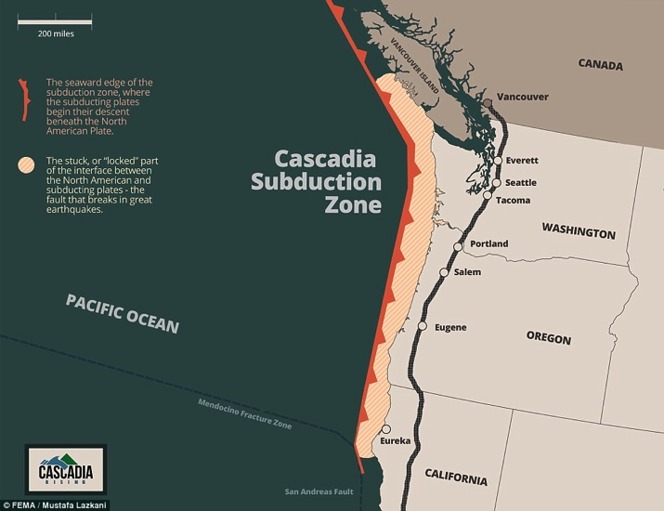
This summer's drill, dubbed Cascadia Rising, will test to see how local and state emergency responders, Fema, and a number of military groups work together.
The simulation will run from June 7-10, 2016, and will use past events to help plan the future response.
There is, for instance, the evidence for frequent and large earthquakes and tsunamis occurring within the past 2,000 years in parts of the Eastern Aleutian Islands.
There are signs that these earthquakes have spanned the boundary between the locked and creeping portions of the region's mega-thrust fault.
Earthquakes in the area could cause significant tsunami effects across the Pacific, especially in Hawaii and California.
'Despite the fact that we have learned a significant amount about the earthquake sources for tsunamis, there are gaps in our understanding of past tsunamis, especially prehistoric tsunamis,' says Rick Wilson, a senior engineering geologist with the California Geological Survey.
'If we can demonstrate when and where tsunamis occurred in the past, that information will give us a better understanding of the return periods in these areas, and that can go into the probabilistic analyses that help us understand our hazard and risk better.'
Wilson, who also serves as the science coordinator for the State of California Tsunami Preparedness and Hazard Mitigation Program, noted that more than 440,000 people have died worldwide since 1850 as a result of tsunamis.
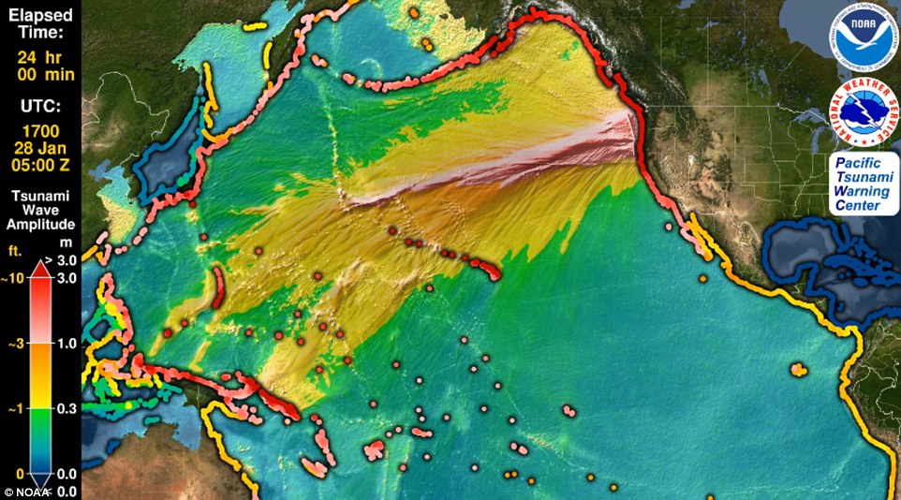

+6
A powerful earthquake thought to be as large as 9.2 magnitude ripped through the earth in 1700, along the 600 mile stretch of the Cascadia Subduction Zone, causing severe shaking and a massive tsunami. An animation from the Pacific Tsunami Warning Center plotted the path of the tsunami as it traveled from the US to Japan
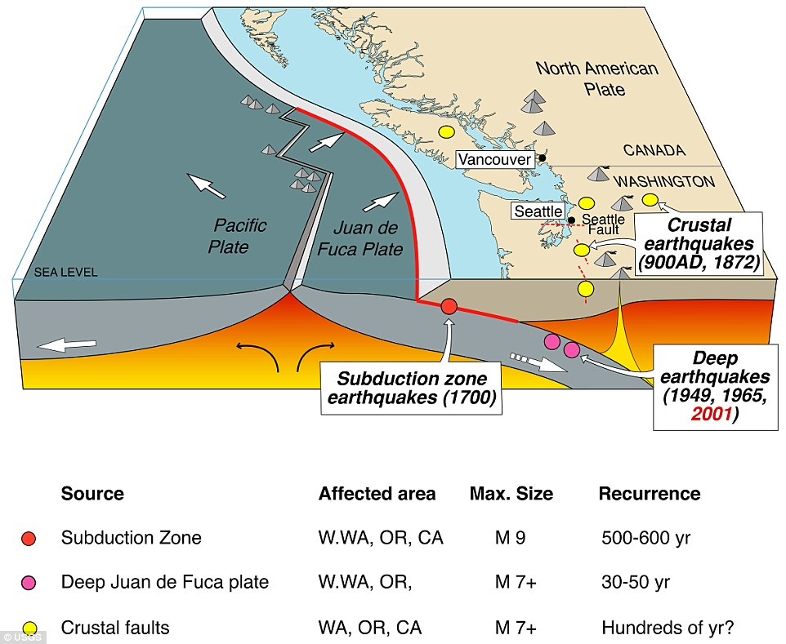

+6
The San Andreas Fault in California, has a quieter, far more dangerous cousin that could make itself known at any moment. Running from Northern California to British Columbia, the Cascadia subduction zone can deliver a quake that's many times stronger than San Andreas
The deadly tsunamis caused by the 2004 Sumatran earthquake and the 2011 Tohoku earthquake brought increased public attention to tsunami science, warning and preparation.
At the SSA meeting, Wilson will discuss how California officials used state tsunami response playbooks to respond to a tsunami advisory issued after the September 2015 magnitude 8.3 Illapel earthquake in Chile.
Last month, scientists were finally able to trace the origins of the historic tsunami that struck the coasts of Japan just before midnight on January 27, 1700.
They linked it to a powerful seismic event in the Pacific Northwest of the United States, along the Cascadia Subduction Zone.
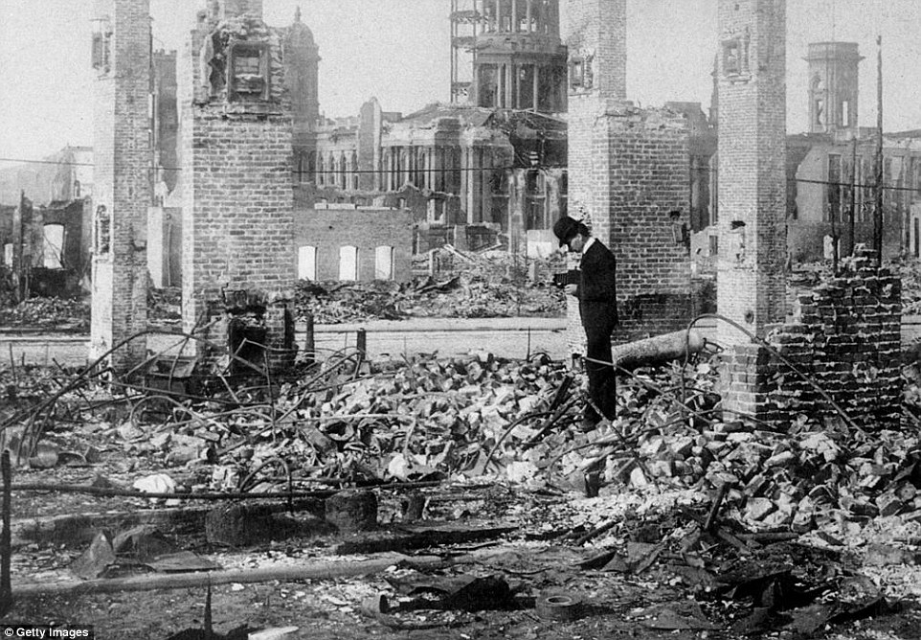

+6
The last time the San Andreas really let loose was in 1906. Pictured are the ruins of a building block in front of the remains of City Hall after the 1906 earthquake in San Francisco. Roughly three thousand people died in this event
…'Cascadia can make an earthquake almost 30 times more energetic than the San Andreas to start with,' Chris Goldfinger, a professor of geophysics at Oregon State University told CNN.
'Then it generates a tsunami at the same time, which the side-by-side motion of the San Andreas can't do'.
The Cascadia could deliver a huge 9.0-magnitude quake and the shaking could last anything from three to five minutes, scientists claim. 'In this case, three minutes - and I've been in a 9 in Japan - three minutes is an eternity,' said Goldfinger. 'It is a very, very long time.'
Goldfinger says we'll lose bridges, highway routes and that the coast will probably be entirely closed down.
As a result it would be difficult to get around, and rescue crews will be overwhelmed.
Federal, state and military officials have been working together to draft plans to be followed when the 'Big One' happens.
These contingency plans reflect deep anxiety about the potential gravity of the looming disaster: upward of 14,000 people dead in the worst-case scenarios, 30,000 injured, thousands left homeless and the region's economy setback for years, if not decades.
As a response, what planners envision is a deployment of civilian and military personnel and equipment that would eclipse the response to any natural disaster that has occurred thus far in the US.
There would be waves of cargo planes, helicopters and ships, as well as tens of thousands of soldiers, emergency officials, mortuary teams, police officers, firefighters, engineers, medical personnel and other specialists. 'The response will be orders of magnitude larger than Hurricane Katrina or Super Storm Sandy,' said Lt. Col. Clayton Braun of the Washington State Army National Guard.
ADVICE ON HOW TO SURVIVE A PACIFIC NORTHWEST EARTHQUAKE AND TSUNAMI
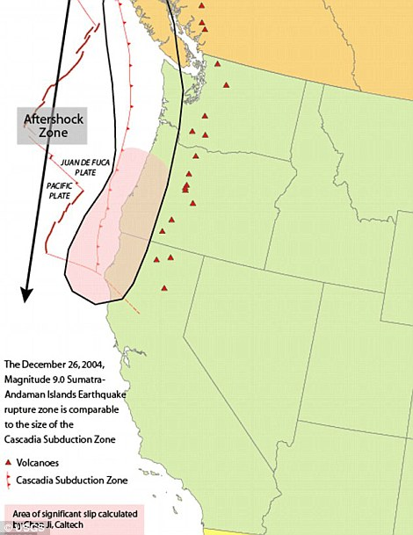
This diagram show the areas where land will be most affected by the shocks, causing landslides or liquefaction
Last year, scientists outlined their alarmingly unhelpful tips on how to survive the earthquake that will hit the Pacific Northwest.
The killer quake along Cascadia, a fault line which runs from Cape Mendocino, California, to Vancouver Island, Canada, is 72 years overdue, according to peer-reviewed studies.
The 'Big One' will hit when Juan de Fuca, a 700-mile chunk of the Pacific Ocean, slides under Canada and America, causing the entire coastal region to sink at least six feet.
When - not if - it arrives, it is unlikely the people of coastal Oregon, Washington and California will be able to escape.
But if they want to try, there are a few tips they should keep in mind:
Run, don't drive, to higher ground, says Kevin Cupples, the city planner for the town of Seaside, Oregon, in an interview with the New Yorker.
The force of the quake will cause liquefaction, when solid ground acts like liquid, across vast swathes of the porous region. In the areas that aren't 'liquefied', the highways will likely be crumpled by landslides, with 30,000 avalanches set to hit Seattle alone. Citizens will have a 20-minute interval to climb to the highest altitude possible before the full force of the tsunami hits, scientists predict.
Their alert will be when dogs start barking.
The first sign the quake is coming will be a set of compressional waves, only audible by dogs. Then there will be the quake, then 20 minutes later, the tsunami.
Geographers estimate that many could survive just by walking - however, they need to be going at least 3.5mph.
If everyone ups their average speed from 2.5mph to 3.5mph, the death toll drops to 15,970. About 70 per cent of them would be in Washington, nearly 30 per cent in Oregon and only 4 per cent in California.
And there is no point being a hero. 'When that tsunami is coming, you run,' Jay Wilson, the chair of the Oregon Seismic Safety Policy Advisory Commission, tells the New Yorker.
'You protect yourself, you don't turn around, you don't go back to save anybody. You run for your life.'
The only other safety measure is to relocate away from the Pacific north west. Oregon's response plan is called the Cascadia Playbook, named after the threatening offshore fault — the Cascadia Subduction Zone. The plan, unveiled last year, has been handed out to key officials so the state can respond quickly when disaster strikes.
'That playbook is never more than 100 feet from where I am,' said Andrew Phelps, director of the Oregon Office of Emergency Management.
A magnitude 9.0 earthquake and tsunami that devastated parts of Japan in 2011 gave greater clarity to what the Pacific Northwest needs to do to improve its readiness for a similar catastrophe.
Worst-case scenarios show that more than 1,000 bridges in Oregon and Washington state could either collapse or be so damaged that they are unusable.
The main coastal highway, US Route 101, will suffer heavy damage from the shaking and from the tsunami. Traffic on Interstate 5 — one of the most important thoroughfares in the nation — will likely have to be rerouted because of large cracks in the pavement.
Seattle, Portland and other urban areas could suffer considerable damage, such as the collapse of structures built before codes were updated to take into account a mega-quake.”
------------
Mount Hood, Mount Rainier And Mount St. Helens simultaneously hit by earthquake swarms - By Strange Sounds - May 18, 2016
“There is something weird and somehow terrifying happening right now at some of the most dangerous volcanoes in the Cascade Range in northwest United States. Namely, Mt Hood, Mt Rainier and Mt St. Helens have been rattled by large earthquake swarms simultaneously in the last few days. Is an eruption of one or more of the major volcanoes in the northwest United States imminent?
It is certainly not unusual for each of these volcanoes to experience earthquake swarms from time to time, but right now we are seeing this happen at all three volcanoes simultaneously, and this comes at a time when seismic activity along the Ring of Fire is on the rise all over the planet.
Beginning March 14, 2016, a number of small magnitude earthquakes have occurred beneath Mount St. Helens, at a depth between 2 and 7 km (1.2 to 4 miles).
Over the last 8 weeks, there have been over 130 earthquakes and many more earthquakes too small to be located. The earthquakes have low magnitudes of 0.5 or less; the largest a magnitude 1.3.
Earthquake rates have been steadily increasing since March, reaching nearly 40 located earthquakes per week.
Scientists believe this seismic activity is linked to the magma chamber recharging.
Mt. Hood earthquake swarm via USGS
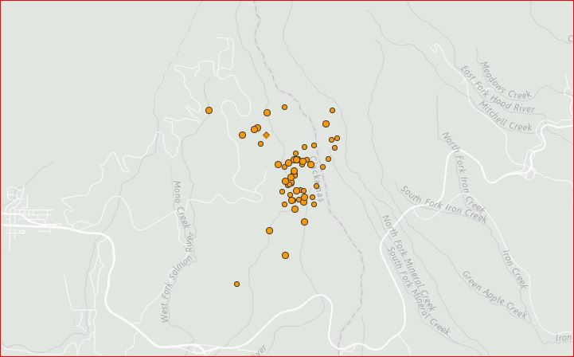
A series of 62 earthquakes rattled Mount Hood Volcano, Oregon within 24 hours on May 15, 2016 and over the past month at least 96 earthquakes hit the dangerous volcanic peak, mostly on its southern side.
It seems these earthquakes are occurring along a fault three miles deep on the south of the volcano. Is magma ascending?
Mount Rainier earthquake swarm
In the past 30 days, Mount Rainier has been hit by ‘only’ 37 earthquakes but an eruption of this volcano would have more catastrophic consequences as it sits very close to major population centers. The series of quakes is centered directly along the core of Mt. Rainier.”
-----------

Guatemala’s Mt. Fuego erupts, prompting evacuations – Italy’s Mt. Etna grows more active - May 19, 2016 by The Extinction Protocol

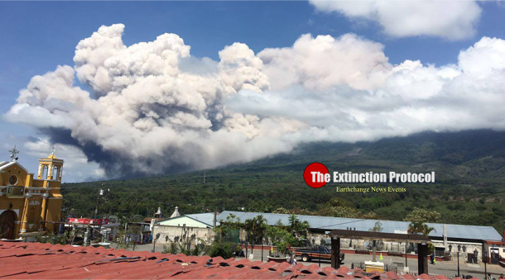
May 2016 – GUATEMALA –
“A volcanic eruption at Guatemala’s Volcan de Fuego, one of the most active volcanoes in Central America, has sparked the evacuation of the area surrounding the peak. Guatemala’s National Institute for Seismology and Vulcanology are reporting that an ash column reaching 5,500 meters (18,000 feet) above sea level has emerged, while “moderate” lava flow is pouring out of the mountain. RT News
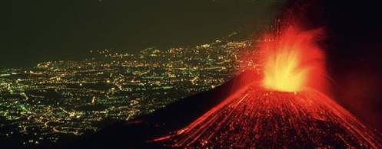
Massive explosions at Mt. Etna: Europe’s most active volcano has spent the last 24 hours sending huge plumes of ash and smoke hundreds of meters into the skies above Sicily. The 3350-metre high volcano began to stir on Tuesday, with emissions from its north-east crater growing in intensity throughout the day. “On May 17th we witnessed an increase in the amplitude of volcanic tremors and recorded intense degassing accompanied by occasional, weak emissions from the north-eastern crater,” explained the Catania branch of Italy’s National Vulcanology and Geophysics Institute (INGV).
Vulcanologists are classing the eruption as ‘Strombolian’ – a category characterized by explosive bursts of activity during which cinder, ash and smoke are ejected from the crater with great force. –The Local

To conclude this compilation of what’s going on under our planet, and on its surface, what is known as the Great Rift Valley Fault Line runs from Turkey down through the Sea of Galilee, down through East Jerusalem, the Temple Mount, the Mount of Olives, down the Negev Desert, through the Red Sea into Kenya and Ethiopia. Right now, the African and Asian Continents are separating down the Red Sea because of the Graben Fault Line. In fact, it is the greatest and most vulnerable fault line in the world.
I grew up in southern California. I have been through many earthquakes, a few quite large. I felt many quakes while living in Jordan and while staying in Israel, in the north and in the south. One of the biggest I experienced was while I was in Tiberias in 2012. Many years ago, the earth in Tiberias just opened up and swallowed people.
From Zechariah 14:1-5: “A Day shall come for Yahuwah… and Yahuwah shall go forth and He shall fight…And in that day, His feet shall stand upon the Mount of Olives, which faces Jerusalem on the East. And the Mount of Olives shall split in two, from east to west, a very great valley. And half the mountain shall move towards the north, and half towards the south…And Yahuwah, my Elohim, shall come and all the set-apart ones with Him.”
As Messiah descends for the battle of Isaiah 34, 63:1-6; Ezekiel 38-39; Joel 2; Revelation 19:11-21 etc, the great earthquake of Revelation 6:12-17 and 16:18-21 will take place – the greatest earthquake the world has ever known.
REJOICE! Let’s hear the end of the matter:
Revelation 11:15-19: 15”And the seventh messenger sounded, and there came to be loud voices in the heaven, saying, “The reign of this world has become the reign of our Master, and of His Messiah, and He shall reign forever and ever!” 16And the twenty-four elders sitting before Elohim on their thrones fell on their faces and worshipped Elohim, 17saying, “We give You thanks, O יהוה Ěl Shaddai, the One who is and who was and who is coming, because You have taken Your great power and reigned. 18“And the nations were enraged, and Your wrath has come, and the time of the dead to be judged, and to give the reward to Your servants the prophets and to the set-apart ones, and to those who fear Your Name, small and great, and to destroy those who destroy the earth. 19And the Dwelling Place of Elohim was opened in the heaven, and the ark of His covenant was seen in His Dwelling Place. And there came to be lightning, and voices, and thunders, and an earthquake, and great hail.”
“Lift up your heads, your Redemption draws near”
In His love,
Yedidah
May 20, 2016

