EXTREME EARTH CHANGES NOW TAKE CENTER STAGE!

With a very heavy heart I address these things. Numbing information is coming regarding extreme earth changes, weather changes, and cosmos changes that are speeding up. It is hard for me to report on some of this. I’ve been studying and reporting on the fulfillment of prophetic events from 1962, especially from 1985, but now, we’re entering the dark and final days when all prophecy is being fulfilled. We’ve entered the time of “radical changes” in everything we have thought was stable. We read II Peter 3, and we realize that at Messiah’s coming the earth and the cosmos will melt with fervent heat and all will be destroyed. He will speak a new cosmos and a new earth into existence. This earth and the cosmos itself, planets, stars, and all that is in it, has become so polluted by the fallen angels and Satan himself, that it has to be destroyed and made anew as the Kingdom of Light comes to earth under the reign of King Yahushua Yahuwah.
The cosmos itself, our Milky Way galaxy, is beginning to show signs of instability, as earth is being filled with wars, violence, power-plays, open greed of elite world rulers, and sin is now openly demanding acceptance. Yes, the heavens and the earth are reacting to the revolt/rebellion of fallen angels and their hybrid offspring, and to the sin of mankind in his revolt/rebellion against the Creators – Yahuwah and Yahushua.
Yahuwah is preparing us for the entrance of His Son, Yahushua ha Machiach. Much will happen between now and then to the earth itself, our sun, our moon, other planets in our solar system. Right now, much is changing in the sun, the moon, in other planets around us, and the entire universe itself.
Isaiah 24 speaks of a great shaking of earth. Yes, we’ve been in a pole shift since at least 2007. Refer to “Pole Shift.” But, the earth itself is also mysteriously shaking from interior forces and outside forces.
More and more asteroids, some of great size, are coming closer and closer to earth. In fact, a record of these asteroids with ID names is kept by scientists daily.
NASA has something called the “Schumann Resonance,” “Earth’s heart beat.” On January 9th another pulse wave of electricity and radiation hit earth. It hit so hard that it went into the soil of Norway, and scientists recorded it. These waves of energy are coming from opposite the sun are increasing in strength and frequency. More are due any day now. Graphs below…
For years I’ve followed these things. However now hearing the results of the energy waves hitting earth so hard, the potentials of asteroids, what is happening to heat up the Southern Hemisphere, the movement of magna beneath the earth, and the literal geo-engineering of earth’s weather, its patterns, the destruction of our life support systems, the terraforming of the earth, destroying food crops, animal life, insect life, birds, fish, sea life of all types, to prepare it for another Genesis 1:2 and Jeremiah 4:21-28 I feel the finalities.
I posted an article entitled ““Terraforming the Earth – We Have Little Time Left! – Our Planet is Being Radically Destroyed to Prepare It For `Them’ ”/Mikvah of the Heart of Elohim, and recently “Happening Right Now! Australia Wildfires! Temperatures So Hot People Won’t Be Able to Live There,” Mikvah of Present Reality. I recommend that you read both to understand this report.
The entire Southern Hemisphere is heating up. Magma is flowing underground, heating earth further. Crops are dying from the roots up because they have little to no moisture. In other places, floods, blizzards, fires, and disease is destroying food crops, as well as cattle, chickens, sheep, goats, and other farm life we depend on.
Australia is heating up. Tasmania is also suffering likewise, for the whole Southern Hemisphere is heating up from under the ground and top of the ground.
The reported setting of fires by Muslims, caught by Australian police, only added to what was already there. Now it is estimated that a billion animals have died in the fires. Many are taking boats out into the ocean to live on.
The same thing that is causing the Southern Hemisphere to heat up is also causing a lot of radiation/energy waves to hit earth. Something is approaching from the south that has a strong gravitational pull. I am not advocating “Nubiru,” “Planet X,” or whatever it’s called in ancient mythology of present reasoning. But there is something out there that is affecting earth, not just from the sun, or from other planets in our solar system, or the asteroid belt either, but from the opposite direction from the sun, something coming at our Southern Hemisphere.
The numbing thing is that the heating of earth is moving north very quickly. It is moving up as far as Mexico right now, creating conditions that were similar to those in Australia which have produced these disastrous fires. The southern U.S. is in danger also of being like Australia.
Messiah could have given a lot more signs of His coming than He did. He spoke first of deception, which is now rampant. He spoke secondly of earthquakes in many different place, then of famine, disease, wars, and rumors of wars. He stressed the horrors that would come on earth that would cause men’s hearts to fail for fear. He stressed the persecution of believers in Him, saying that all men would hate us for His Name’s sake. He spoke of winds and waves roaring.
It is winds that cause the waves to roar. Now, higher and higher straight-line winds are accompanying thunder storms, with hail, and tornadoes. I just went through that scenario last night. But, I’ve known how to command weather since my 20s as per Mark 4:35-5:1. Yahushua expects us to command weather so that His servants get where they’re going without disaster. The catch is, you must be a servant in the flow of obedience to the Master’s will in order to have the right to command anything to do with protecting yourself.
Last night our Prayer Center leader was on her way home from work. It was sunny. Abba spoke to her to go right home and cancel the meeting at the Center. She’s hears from Him, and obeys, so she did just that. Right at 6:00 PM when everyone was supposed to be at the Center, the storm hit, and in some areas where people would be driving from, it hit very hard.
Lies continue to spread and grow as to why the weather is changing, and people are dedicated to fighting causes that don’t exist. The truth about the weather anomalies, incoming objects, and earth changes, is being hidden from Americans, and from all people on earth in general.
For you who are flowing in alignment with Yahuwah and Yahuwah and Their will on the earth, you have such promises and exhortations as:
Isaiah 60:1-2: “Arise, shine, for your light has come! And the esteem of Yahuwah has risen upon you. For look, darkness covers the earth and thick darkness the people, but His esteem is seen upon you!”
Isaiah 35:3-4: “Strengthen the weak hands and make firm the weak knees. Say to those with anxious heart, `Be strong, do not fear!’ See, your Elohim comes with vengeance, with the recompense of Elohim. He is coming to save you!”
Like Pastor McQueen said today, “His people are whining, `Why don’t I hear from God?’ ” Her simple answer was: “That’s not His fault.” He speaks to those He knows because of their submission and obedience to Him in the smallest ways without questioning, analyzing, or arguing.
Your job and mine are the same--prepare the weak to be strong in the power of His might, calm the fearful, wake up the sleeping, and preach the Good News of salvation to the lost!
Radical weather changes, increasing number of earthquake and volcano eruption, increasing wars, preparations for world government, worldwide violence, and the nature of human beings, that main indicators of the timing of the coming of Yahushua. All 223 prophecies of the Word of Yahuwah are in process of coming to pass, as we enter a fast-paced darkness that is covering the earth. But, as darkness covers the earth, there is a remnant of light arising that is becoming stronger by the day in the power of the mighty of Elohim.
From Earthquake Track January 11, 2020
What is happening to do with earthquake worldwide is horrendous. In the last few days, Puerto Rico has had historic earthquakes of high magnitude.

Puerto Rico has had: (M1.5 or greater):
40 earthquakes in the past 24 hours
525 earthquakes in the past 7 days
1,463 earthquakes in the past 30 days
4,587 earthquakes in the past 365 days
Reuters
“YAUCO, Puerto Rico, Jan 10 (Reuters) - A 5.2 magnitude earthquake cracked walls and brought down power lines in Puerto Rico on Friday as the Caribbean island was recovering from its worst quake in over a century on Tuesday” (January 7).

Now, I want to share with you some graphs and information on recent incoming pulse waves and what is expected for at least the first half of 2020… so that you can be in the light about things and prepare. Not telling us the truth, when people know of pending disasters, is to keep us in the darkness. Yahuwah tells us the end from the beginning. He does not want us ignorant. Have you heard about May 12th?

Paul Begley January 9, 2020: “Breaking COSMIC WAVE Hits Sun & Earth 6.3 MEGA QUAKE in Russia”
Begley showed a NASA chart (see below) called “Schumann’s Resonance” “Earth’s Heartbeat” which records the pulse of the earth. Today earth’s heartbeat was going along at its norm of 279 beats a minute. All of a sudden it spiked to 745 beats per minute. Even now at 7:30 PM CDT it is 474. It has not yet stabilized.
For seven years Begley has periodically hosted an insider informer simply known as “Mike from around the world.” After “Mike” had his first interview with Begley seven years ago, Begley got lots of chat telling him that “Mike” was crazy. He took it to Abba. Abba told him that “Mike” was not crazy, and to keep interviewing him. I am glad that Begley obeyed Abba, and so are tens of thousands of other people.
Regarding the spike in the earth’s heartbeat on the 9th, “Mike from around the world” said last week that there would be three major spikes, cosmic pulse waves, hitting earth. One was on January 6th that hit into the ground in Norway, which made world news. The 9th was another one. Just a short time after the 745 spike, there was a 6.3 earthquake in Russia. (map below) Another one is coming January 12th or 13th.
Pastor Paul Begley said there were loads of fireballs the 9th. Here’s the diagram from Space Weather today:
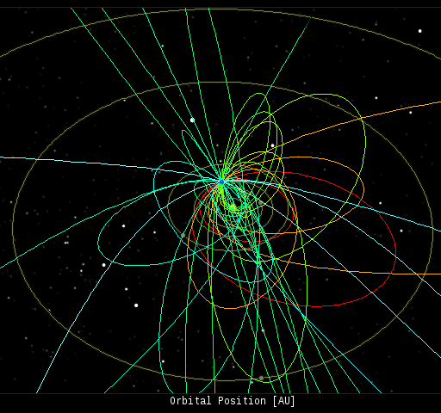
In this diagram of the inner solar system, all of the fireball orbits intersect at a single point--Earth. The orbits are color-coded by velocity, from slow (red) to fast (blue). All Sky Fireball Network
Spaceweather.com:
“Every night, a network of NASA all-sky cameras scans the skies above the United States for meteoritic fireballs. Automated software maintained by NASA's Meteoroid Environment Office calculates their orbits, velocity, penetration depth in Earth's atmosphere and many other characteristics. Daily results are presented here on Spaceweather.com.

As the waves of energy enter earth, some amazing auroras have been seen.
From spaceweather.com
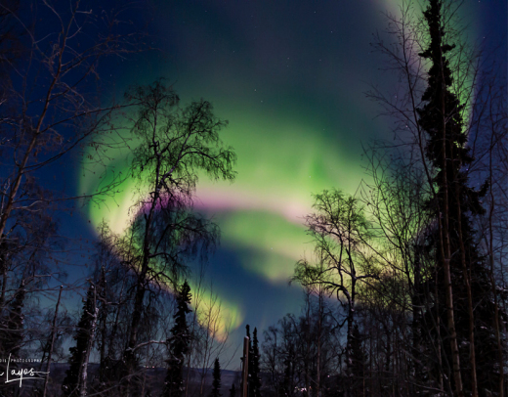
“Something appears to have collided with the Milky Way and created a huge wave in the galactic plane.” Strange News – Gala space probe discovers dark matter Radcliffe wave in Milky Way. January 9, 2020 – First-noticed by the European Space Agency’s Gaia Satellite
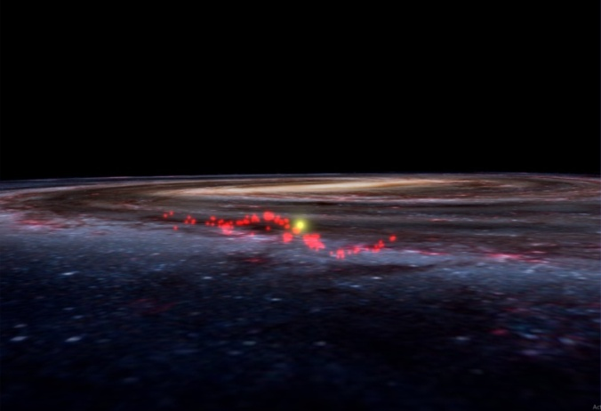
Phys.org
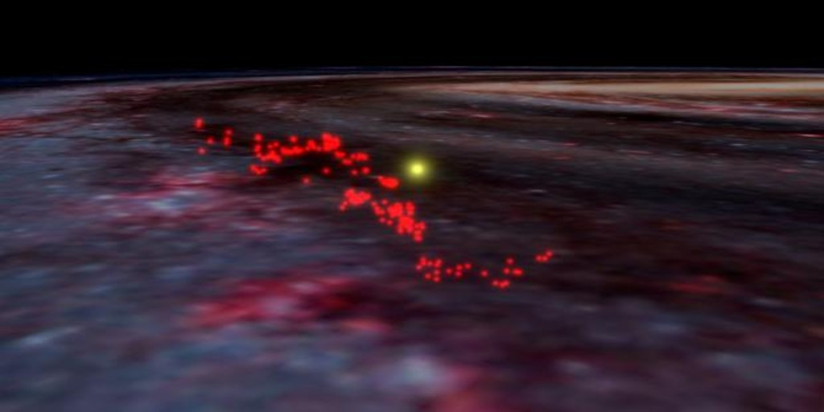
Archyde – like a space tsunami
Is there dark matter in the center of the Milky Way? Phys.org
“This cosmic wave was caused a gigantic disturbance. Tex and Science says that it is `a dark wave of energy, perhaps formed by a collision with a massive mystery object!’ This is called “the clump” of dark matter – that whatever it is hit. This information was gathered from the EU Space Agency’s Gala Satellite. The `Radcliffe Wave’ covers half the sky.”
Paul: “Our galaxy is a spiral, flat galaxy...It’s about 100O light years across the sky, but only 1,000 light years thick.”

Paul Begley: Mike from around the world January 9, 2020 “Breaking: DARK MATTER WAVE of ENERGY” - Smashes Into Milky Way / MFATW & Paul Begley
Paul’s broadcast at 10:00 PM

***Cosmic wind on the sun spiked at 2:43 mph EST
Sun winds spiked from 279 km per second to 745 km per second
55 minutes later, the spiked wave of energy smashed into the earth causing a 6.3 earthquake in Russia (from Laura Wells research)

Chukotskiy Avtonomnyy Okrug, Russia
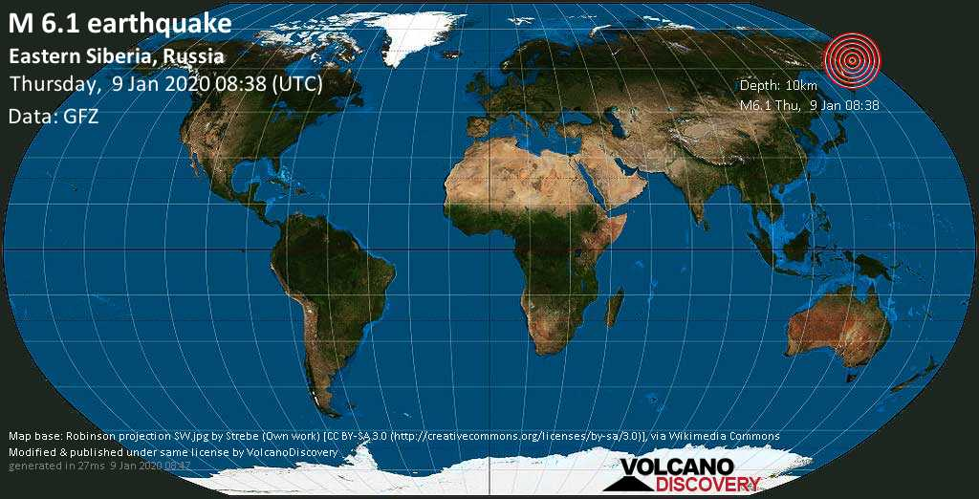
A wave of energy off the sun hit the earth causing this earthquake in Russia

Schumann’s Resonance (NASA) showed the spike on the 9th
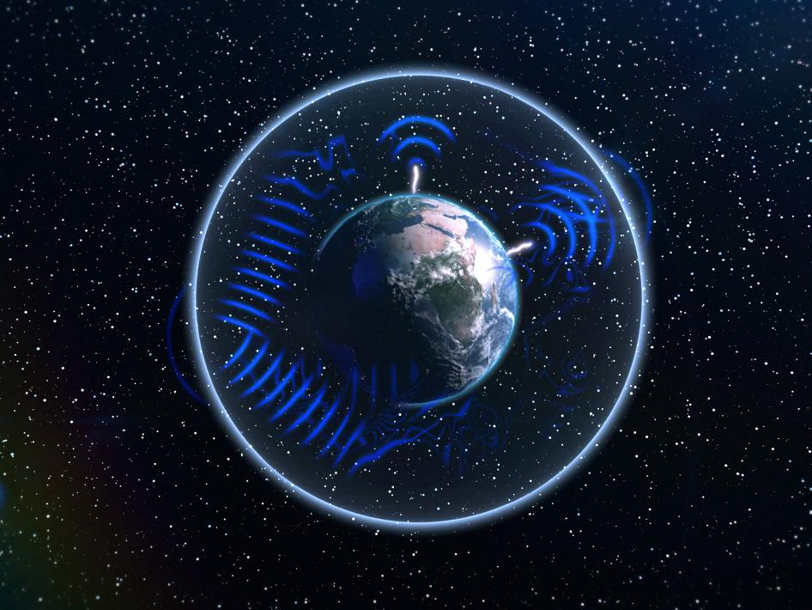
Earth’s heartbeat (NASA diagram)
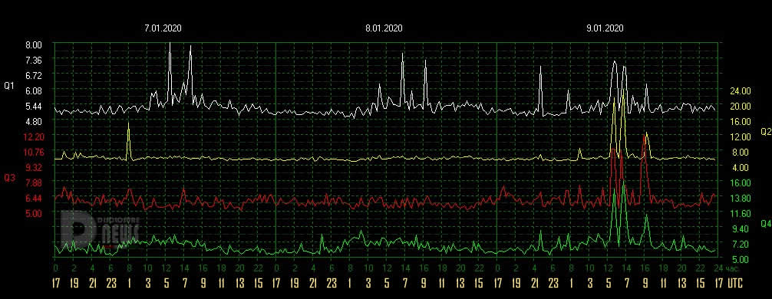
January 9, 2020

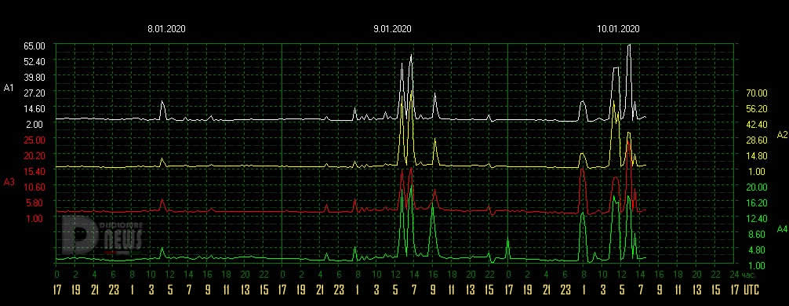
January 10 10:15 AM EST
“Schumann Resonance Today from NASA: `We will try to keep you updated about the variations of the Resonance with this page. The great variations that nobody can explain but that give us a clear sign that the planet is changing. The Earth’s vibration higher and higher, just like us!’ ”

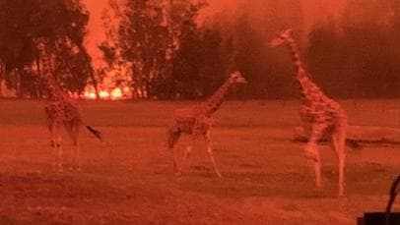
Australia Fires - Mogo Zoo threatened Koala escapes fire

Mike from around the world phoned in at 33 minutes into the program:
He began by saying “Gravitational waves and dark matter go hand in hand”
“This was one of CERN’s findings”
“It is a miracle that we’ve not been devastated on the surface of the earth already … It’s a miracle we haven’t been hit by an asteroid, and a miracle that we haven’t been hit by stronger cosmic waves,” Mike said.
Begley asked about what hit the dark matter: Mike said there are Cosmic rays and gravitational wells, and magnetism, which united that hit of the dark matter.
What hit the dark matter caused a huge “ripple” of cosmic rays. Mike said it was caused most likely by a cosmic energy burst hitting the dark matter. The energy burst did not come from the sun.
“If the magma under the earth’s crust crosses magnetic field lines you’re going to have current spikes coming from within the earth,” Mike said. He said this has happened before, but it is very rare. He said it’s like a tornado that sucks up radiation from space – but it shoots from the ground into the air and is highly dangerous. It goes on for hours. People in the ancient world were terrified of it.
Radiation levels on earth are up 20% since 2016, Begley said.
From my research I’ve learned that we’ve got radiation coming in from the sun because of damaged Ionosphere, damaged radiation belts, etc., radiation from damaged nuclear power plants like Fukushima, radiation from nuclear waste dumping, like into the ocean around the Marshall Islands, and now we’ve being covered with 5-G radiation. There is radiation coming into the earth from these cosmic waves of energy, coming from our opposite side to the sun, and southern hemisphere.
Our little galaxy is moving quite fast in space, and we’re entering areas we’ve never been in before, so we’re experiencing new things from the cosmos.
From online information: “How fast are we moving right now? - About 43,000 miles per hour. Relative to the local standard of rest, our sun and earth are moving at about 43,000 miles per hour (70,000 km) roughly in the direction of the bright star Vega in the constellation Lyra. The speed is not unusual for the stars around us and is our `milling around’ speed in our suburban part of the galaxy.”
Wherever we are in the galaxy right now, something is shaking us up from the outside, something coming at our Southern Hemisphere.
“THE CONDITION IN AUSTRALIA ARE SLOWLY FORMING IN THE SOUTHERN REGIONS OF THE U.S.” About two months ago, Mike said that Mexico would be like Australia – uninhabitable because of the heat. In this interview, he said that this heat is moving up into Texas. He said it would not surprise him if this summer the southern U.S. became like Australia. He said “Texas could easily become just like Australia.” Last summer TXU asked us to turn up our thermostat because of the overload of people using low settings on their air conditioners.
Higher wind speeds will be hitting the southern U.S. region--20% more than what they’re used to having.
Mike said that in a week and a half we have a weather phenomenon that will not change – it will be an abrupt change in the weather. Areas that should be moist are drying out. He said this abrupt change would affect the whole U.S.
“…the seas and the wave roaring” (Luke 21:25-26) – Mike said “that’s a wind problem.” “The waves are driven by wind, and when the Bible talks about hail, we’re looking at wind speed our atmosphere cannot handle. People can’t handle it.”
Begley commented on the “charged particles” in the air that are pushing down on the jet stream causing more straight-line winds, causing crop destruction, famine, the spread of disease, and other deadly thing that are becoming more and more frequent.
***Mike: “Radiation translates into heat.” … “Heat takes moisture out of the atmosphere, creating almost no humidity. We lost a lot of crops this year because we didn’t have enough moisture. We lost a lot of crops because the plants were dying from the root up.” He said that the heat of the earth is rising and the plants were burned up from the root.
***“Areas that were once green are now turning into dessert regions.”
But, that’s what is being said by men like Mike Adams to do with the terraforming of earth by the fallen ones, the aliens, for their own survival.
Ironized dust is floating in the air. This is causing higher winds.
Mike said: “In a week and a half we’re going to have a severe weather-pattern change.” (I figure that’s around January 20-21)
These changes began a long time ago, but they’ve been working to increase, and they will not go backwards/reverse. There’s been a build-up in all fulfillment of prophecy, like wars, from January 2011.
Mike said our infrastructure cannot sustain the weather that is coming – like extremes in heat and cold and high winds. Our grids are weak. Our power plants are vulnerable, our houses are flimsy. We’re a weak nation in the face of a horrendous reality. Lake levels are going down, and some have disappeared entirely. Some lakes are going up, but contaminated with salt water. A world wide water problem looks ahead. People’s wells on the east coast are drying up.
Breathing will be difficult for anyone with breathing problems, but as the air fills with ash and dirt, etc. it will be difficult to breathe for everyone. Animals will die, plants will die, trees will die – oxygen levels will be diminished.”
Begley asked Mike once again: “What about Tuesday, May 12th!”
Once again without being direct, Mike began his dialogue of telling, but not telling. He said that people won’t doubt a creator because they’re lives are going to be threatened. He said there might not be much buildup to it. It is something that will leave people terrified, “not just scared – terrified.”
“People will not be light about it, as in “this will pass.” He’s not being specific.
He’s not being dogmatic, but he is close to being dogmatic. It sounds like an incoming asteroid. As described, it fits the description of Revelation 8:7-9.
Mike concluded with: “Somewhere around that date, we’re going to see some very frightening things.” … “We’re not talking about something theoretical. We’re not talking about something anyone can handle.”
Evidently it’s something from space that only Yahuwah can handle. If Mike’s with NASA, he might be trying to warn us of what NASA knows that they’re not telling. It is obvious that the trajectory of such an asteroid, or two, or one that breaks into two pieces, will hit the Pacific Ocean. If such an incoming object struck the Juan de Fuca tectonic plate, that would take out the whole Cascadia region of three states. The Revelation description pinpoints the Pacific Ocean.
Mike went on to say: “This will disturb the minds of everyone living. The only ones it won’t disturb are the dead.” … “Humanity has not seen anything like this.”
…“May 12th could actually be very real.” We watch! We pray! We prepare!
Begley had no comments. He began advertising his conference Megaquake 2020.
He said “it will be May 1st and 2nd, Lord willing.” I had to chuckle at that. Begley did say earlier that “others” are now mentioning May 12th.
Begley asked Mike a profound question: “Are you anticipating the President or anything from the Federal government saying anything to do with what’s coming May 12th? Mike replied: “If it’s going to be too bad, and too many lives will be lost, no.” … “What the government will do is to begin moving people.”
These realties should cause even the most world-loving to be sober, pray, praise, proclaim, and prepare. It’s not meant to cause fear! However, we must take the breaking events seriously. We’re entering the time-tunnel that leads to eternity.
May you seek Abba with all your heart, shalom,
Yedidah
January 11, 2020

