FAMINE IS COVERING THE EARTH
A close look at Joel 1

Foundation Article: “Famine! The Black Horse Goes Forth! – Worldwide Destruction of Crops and Livestock 2019.” The great devastation began in the spring of 2019 in America and worldwide.

On Famine in America Prophesied by Kay Arthur in 2008
“Beth Moore, who spoke at the conference in Atlanta along with her friend Kay Arthur sent this prophecy to all her people. The following was re-published July 7, 2008, in the church newsletter of Valley View Church, Louisville, KY, and distributed.
Beth said: On June 27th and 28th I attended a conference in Atlanta. When Kay Arthur took the stage you could just tell that her spirit was heavy and there was a certain 'heaviness' in the atmosphere even before she started to speak. She said that she had been literally physically sick to have to bring us this message and right out the gate she said, 'We are in grave danger.' She said that God had revealed to her that a literal famine is coming to America--physical, not spiritual. She said that God is moving in judgment against our nation. Kay is a seasoned speaker and she had to BATTLE to get through her message. She stumbled over scriptures and had an extremely difficult time. At times I was almost expecting her to collapse. At one point she just had to stop and pray. There was no person, myself included, that I could see who did not have tears streaming down their faces. As you may know, Kay Arthur is normally a very confident, composed speaker, but she was literally in a spiritual battle and it was taking place right before my eyes. I have never seen anything like it.
She went on to give 7 things that Christians must do during this time and I am going to give those to you now:
1. Return to God. Jeremiah 4:3 - Break up the fallow ground - return to Me. Repent. Get on your face before God and ask him to break our heart with the things that break His heart.
2. Mourn. Jeremiah 9:17-18 and Ezekiel 9 - It is time to weep because our nation's sin is incredible.
3. Pray. Jeremiah 36:7 - Pray fervently, passionately for America.
4. Love God's Word. Jeremiah 20 - You MUST love the Word of God and be in the Word of God. I was particularly convicted here because I know I have not been as deeply in His Word as I need to be. She said we must get serious about this.
5. Love others as Jesus loved them. Jeremiah 31:3 and John 13:34
6. Introduce people to Jesus Christ. It's time to get serious about this. This is no time for timidity. Jeremiah 31:31; Jeremiah 33:1-9, 15, 17
7. Rest. If you will do these things, then rest in the fact that you have done God's will. She said that it is going to be vitally important for us to get enough physical rest. She went on to say that God has not given us a spirit of fear and that if we are obedient to Him, we will be protected. She said to read Ezekiel 14 over and over until you understand it. This is what God will do if a country turns against Him. She said that this is going to be a calamity (she used the word calamity in such a way that you knew this is going to be no small thing for our country), and gave many more scripture references, but what I have given you are the main points that she made.”
I’m sure some of you know the names Beth Moore and Kay Arthur. These sisters have taught believers much about their heritage in Israel, and shared insights that few share. We appreciate all of Yahuwah’s children--especially those who know the heart of Yahuwah and Yahushua, obey Them, and lead others know Them. Kay says to read Ezekiel 14 over and over. I emphasize that too!
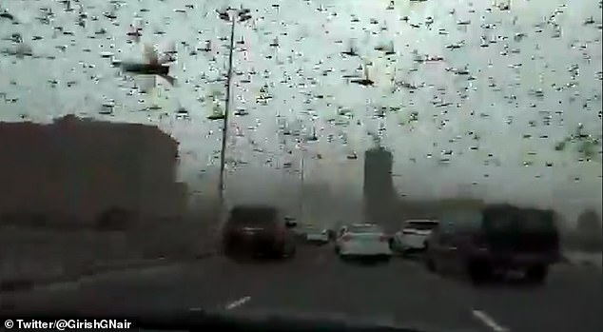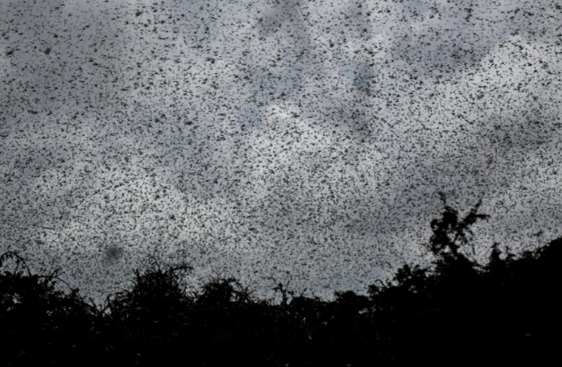
Left: Daily Mail, February 21: “…A swarm of locusts stopped traffic on a major highway in Bahrain yesterday, as the insects entered the country on high winds.”
Right: Locust Plague in Kenya turn skies black

As of this morning, news exposes the truth that not only is America facing great famine, disease, civil unrest, economic collapse, and war, but so is the entire world.
Exodus 10, Joel 1-2, with Revelation 9:1-11: The locust plagues of the Middle East, East Africa, Pakistan, China, and now Bahrain, have come with darkness over the earth, with famine, economic collapse, disease, death …
Plagues 8 and 9 of Egypt are now aligning – locusts and darkness – before earth sees the deliverance coming to Yahuwah’s people, i.e. spiritually crossing the Red Sea into the Promised Land at Messiah’s literal coming.
Some of my articles on famine go back over to 2008. I was reporting on famine at the same time Kay Arthur prophesied it. Abba gives His Word to His people through many of His servants so that all can hear His warnings.
Today, we still go to Walmart or Sprouts, our local markets, and all looks well. But all is not well. Many items are beginning to disappear from the shelves and prices are rising. Almost all of the beautiful fruits and vegetables we see in our big grocery stores come from Mexico, Central, and South, America. But, things like lentils and many varieties of beans are disappearing from the shelves. We are becoming depending on imports and the means of importing are narrowing.
I reported last spring and summer about the terrible global devastation of crops, and how American farmers were facing bankruptcy and poverty because of the destruction of our crops. I wrote an article that covered world destruction of crops entitled
Right now, the flooding in Mississippi continues to destroy crops as well as homes, businesses, schools, and the lives of the people along the Mississippi and Pearl Rivers.
Back in 2004, I reported on the devastation of crops beginning in Bangladesh, and Australia, and other nations by cyclones, tsunamis, hurricanes, floods, drought as in Somalia, and in America (i.e. Texas), blizzards, and hail. Now we have historic locust plagues, locusts in the billions swarming onto crops, destroying whole fields in 30 minutes. Yes, people are eating the locusts, but how will that sustain life?
In China, President Xi sent 150,000 ducks to the area where the locusts swarms entered into China from Pakistan, to eat the locusts. Good idea, except for one thing: The swarms are so dense the ducks couldn’t fly! Can you picture that!
We’re seeing the return of the plagues of Egypt. We’re seeing invasions of biting gnats, i.e. mosquitos, in Wuhan, China. We’re seeing devastation from hail.
We’re seeing more and more birds just dropping out of the sky in mass. The latest report yesterday is about this happening in Spain. Much of this is caused by the waves of energy hitting earth from space but not always from the sun’s direction. These waves are pushing down on the jet stream, and the air space is becoming difficult for birds to fly in. The affect on the jet steam is dangerous.
This big situation with fish, birds, and sea life devastation began in January of 2011. Obviously, much of it has been targeted hits by DNA-targeting technology, to test how to target specific DNA, which they’re using as a military weapon on the human race. Birds continue to fall dead onto the earth in many places from outside forces also. Sea life is dying due to the purposed heating of the oceans by tampering with earth’s Ionosphere. I wrote that in the latest article on 5-G.
Yes, definitely much destruction of the planet has been caused by man’s geo-engineering of the weather warfare, the targeting of crops for destruction by tech-giant nations, like America, began in the late 1940s. (“70 Years of Geoengineering”/Mikvah of Present Reality)
However, we’re also seeing earth changes that are beyond the control of man. Perhaps man has brought some of these things on us also, for we know what the H.A.A.R.P. facility in Alaska is doing to punch holes in our Ionosphere, allowing the suns radiation, and other cosmic radiation, to come into the earth. Please refer to: “5-G: HAARP, the Military, and the Forerunning of Earth’s Destruction/Mikvah of Present Reality.
Then there is the purposed dimming of the sunlight, which they say is to stop “global warming.” Yet, global warming is caused by the same waves of energy, melting the magma under the earth, which is moving, heating the core of the earth, heating the surface of the earth. However, dimming the sunlight purposely blocks photosynthesis – which is produced by sunlight, water, and CO2 gas, which we breathe out. Photosynthesis produces oxygen, which we breathe in. The purposed dimming of sun light via chem.-trails, etc., is causing the crops to be stunted or not to produce much at all.
Our grain crops, “grass,” as mentioned in Revelation 7:1-3, 8:6; 9:4, are failing. Trees are burning up worldwide. Have you noticed the rise in the price of paper goods, and the price of lumber? Now the locusts are eating everything, including the leaves and fruit of trees.
Here’s a recent picture of locusts swarming a tree in Bahrain and a picture of a swarm devouring crops in Somalia.
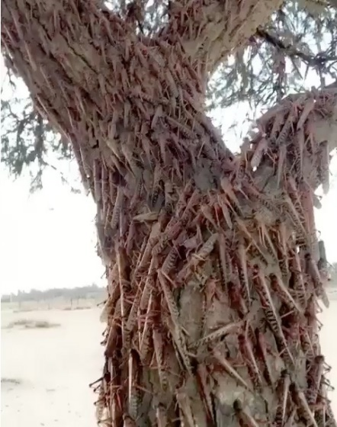 go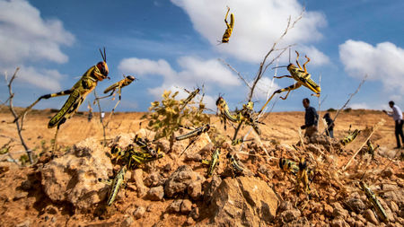
Please read: Please listen to podcast CLXVIII

The little locust creatures are symbolic of the Joel 1 and 2 locust army of Yahuwah – an army of demons that He allows to go forth for His judgment.
Disembodied Nephilim are “demons.” These are ones like Messiah cast out of the man from Gadera (Mark 5). In that passage the demons are described in military terms as “legions” within him. Demons, like weaponized locusts, destroy everything in their path. Joel 2, also reflected in Revelation 9, says that before them is a Garden of Eden, but behind them is nothing but devastation.
In Africa, I cast out many demons from people whose spirit had been born again and perfected. The demons in their spirit fled into their flesh, and into their mind (soul), controlling their thinking and emotions, taking over their bodies. When the demons were cast out they became peaceful, calm, filled with the light of Yahushua Messiah in body, soul, and spirit.
Apostle Sha’ul wrote in I Thessalonians 5:23-24: “And the Elohim of peace Himself, set you completely apart, and your entire spirit, soul, and body be preserved blameless at the coming of our Master Yahushua Messiah! He who calls you is trustworthy, who shall also do it.” (also read Philippians 1:6)
When we submit to Yahuwah’s Spirit to align our soul and re-born spirit, we become one complete spirit-man within our body. It is then that the door, portal, between Yahuwah and our spirit is opened up to the whole spirit-man to enjoy the presence of heaven on earth.
The prophet Yo’el (Joel) gave us a tremendous prophetic word for right now in those brief 3 chapters that became his book – covering events between right now and the “Day of Yahuwah,” the Day Messiah descends with His wrath.
The swarms of locust devouring the life-sustenance of the people everywhere they go – moving straight forward as a single unit, army-like, consuming the food supply of many lands on the continents of Africa, Asia Minor and East Asia – is a message to us of the soon-opening of the pit (Revelation 9:1-11), out of which will come the Joel 2 army of demons, moving across the earth like locusts, devouring everything in their path. So this locust invasion is symbolic of the now-happening, and soon-to-happen, demonic invasion onto the surface of planet earth.
Only those with the seal of Yahuwah on their foreheads will not be affected (Revelation 9:4). These sealed ones, the first fruits of the resurrection, and 100% under the control of Yahuwah’s Spirit, in mind, emotions, body, and spirit. These are the ones of Revelation 3:12, 7:1-3, 14:1-5, 22:3-5 and Daniel 11:32.
It’s not that they’re “better” than anyone else, super-saints, or super anything! No! It is simply because in their child-like nature, they have forsaken all to follow their Master (Luke 14:25-33). They have only His will as their will. They live to do as He tells them. Their personal relationship with Yahuwah and Yahushua is intimate, deep, solid, abiding. They literally, by their spirit, live in two dimensions – earth and the throne room of Yahuwah. Though in the world, they are set-apart from any allurements from the world. Thus Revelation 14:1-5 begins with their living in His portal as a lifestyle, and then after translation at the time of the breaking of the 5th seal in its fulness, they live in His Presence in two dimensions literally in the Garden of Eden (East Jerusalem area between Mount Moriah, Mount Zion, and the Mount of Olives.)
These are not super spiritual snobs, but humbled people who know what it means to be born again and follow the Master Yahushua. The 5th seal’s fulness is seen in Revelation 6:9-11 and Revelation 14:12-13. There will be millions of martyrs (Revelation 7:9-17; 14:12-13). But do you see where those of Revelation 14:1-5 are positioned? They are on Mount Zion, the City of David, and also in the throne room of Yahuwah! Do you see where the martyrs are positioned in Revelation 7:9-17 – also in the throne room.
The locust plague was followed by darkness over Egypt. But, at the same time, there was light in Goshen. There was light in the area where the children of Ya’cob/Israel lived. The rest of the land was covered in darkness following the locust plague. In the pictures above, you see that the locusts in Bahrain covered the sky to the point where the sky went dark, as in after sunset. The people in their vehicles on the road could not see to drive for all of the locusts.
Darkness shall cover the earth, Isaiah wrote, and great darkness the people, but “arise, shine, for your light has come.” Walk in the Light as children of light – Messiah exhorts us, and Sha’ul exhorts us in Ephesians chapter 5.
In Revelation 9:1-11, we see that as this locust-like demonic plague comes out of the pit, opened from under the sea after the asteroid strikes in Revelation 8:6-12, and the earth is covered in darkness.
Revelation 9:1-4: “And the 5th malack/messenger/angel sounded and I saw a star from heaven which had fallen to the earth. And the key to the pit of the deep was given to him. And he opened the pit of the deep and smoke went up out of the pit like the smoke of a great furnace And the sun was darkened, also the air, because of the smoke of the it. And out of the smoke locusts came upon the earth and authority was given to them as the scorpions of the earth possess authority. And it was said to them that they shall not harm the gras of the earth, or any green thing, or any tree, but only those men who do not have the seal of Elohim upon their forehead.”
The sixth seal judgment: Revelation 6:12-17. This leads to the coming of Messiah. Do you see that darkness precedes the coming of the Passover Lamb! The three plagues: locusts, darkness, death of the 1st born of Egypt, then the Passover of Exodus 10-12 and His people’s deliverance from the land of slavery and plagues. We’ve been taken from the kingdom of darkness into the Kingdom of light if we’ve put faith in the shed blood of the Lamb of Yahuwah and in His resurrection.
The seventh seal opens the trumpet judgments.
Why are things compacting together so quickly? It is because Yahuwah, our heavenly Abba/”Daddy” is no sadist. He grieves that He has to destroy earth and mankind in general. He does not want to judge, or to send down His wrath as His Son descends to take possession of His Kingdom of earth.
Please read these two articles to understand His heart! “The Day Yahuwah Will Stop the Praise” [Podcast CXXXXV] and “The Day Yahuwah Opens the Door That He Shut” [Podcast CXXXXIV]
Revelation 6:12: “And I looked when He opened the sixth seal, and saw a great earthquake came to be. And the sun became black as sackcloth of hair, and the moon became as blood.” We see that at the end of Joel chapter 2 also.
In Revelation 6:13-17, as darkness covers the earth, look who is terrified? The most powerful people on earth are hunkered down in Petra, in today’s Jordan. How do I know that? I lived in Jordan for 8 years, and visited Petra many times. Every June, the most powerful men and women on the planet met in Petra with King Abdullah. The ultra-rich hired super jets to take them to Petra on tours.
I even did a phone interview with Noah Hutchings about the hiding place for His people in Petra in which I told about the returning House of Israel/Ephraim/Joseph. I was supposed to meet him on his final tour of Petra, but I had already booked my ticket to Africa. What a dear man! He led the Southwest Radio Church from the 1940s, and worked with J.R. Church, Gary Stearman, and other watchmen.
Revelation 12:17 tells of those hiding across the wings of the great eagle in the topography of the Dead Sea (the Lisan Peninsula), which leads to the King’s Highway and Petra.
In Isaiah 26:19-21 it talks about His people hiding in the clefts of the rocks until they are delivered at Messiah’s return. The word for rooms” in Hebrew is “chambers.” I’ve seen the “chambers” at Al Beda, aka “little Petra,” former home of Esau, like little condominiums with carved beds and little niches for your coffee (smile). Sorry, though, no electricity! There is plenty of underground water, and each condo section has a water storage tank.
Let’s look at Joel 1. What are we, as priests unto Yahuwah, as His ambassadors, His representatives on this earth, supposed to do as we see the demonic locust swarm of Joel 2, the massive destroying army of Yahuwah, beginning to move across the earth? It’s the time to intercede and to act. It’s the time of the release of the Daniel 11:32 forerunning army of Messiah – the ones we call “the remnant.”
Does Joel describe conditions in our day? Oh yes he does! His book prophesies of the “Day of Yahuwah.” Please refer to: “The Day of Yahuwah”/Mikvah of Present Reality.
Joel 1: The word of יהוה that came to Yo’ĕl son of Pethu’ĕl. Hear this, you elders, and give ear, all you inhabitants of the land! Has this ever been in your days, or even in the days of your fathers? Relate it to your children, and your children to their children, and their children to the generation after them. What the gnawing locust left the swarming locust has eaten, and what the swarming locust left the crawling locust has eaten, and what the crawling locust left the consuming locust has eaten. Wake up, you drunkards, and weep. And wail, all you drinkers of wine, on account of the new wine, for it has been cut off from your mouth. For a nation has come up against My land, strong, and innumerable. Its teeth are the teeth of a lion, and it has the fangs of a lioness. It has laid waste My vine and splintered My fig tree. It has made it entirely bare and cast it away, its branches became white. Wail like a maiden girded with sackcloth for the husband of her youth. The grain offering and the drink offering have been cut off from the House of יהוה. The priests, servants of יהוה, have mourned. The field is ravaged, the ground has mourned, for the grain is ruined, the new wine has dried up, the oil fails.
The farmers are ashamed, the vinedressers wail over the wheat and over the barley, for the harvest of the field is destroyed. The vine has dried up, and the fig tree droops, pomegranate, also palm, and apple tree, all the trees of the field are dried up, because joy has dried up among the sons of men. Gird yourselves and lament, you priests. Wail, you attendants of the altar. Come, lie all night in sackcloth, you attendants of my Elohim. For the grain offering and the drink offering are withheld from the house of your Elohim. Set apart a fast. Call an assembly, gather the elders, all the inhabitants of the land, into the House of יהוה your Elohim, and cry out to יהוה. Alas for the day! For the day of יהוה is near, and it comes as destruction from the Almighty. Is not the food cut off before our eyes, joy and gladness from the House of our Elohim? The seed has rotted under their clods, storehouses are laid waste, granaries are broken down, for the grain has withered. How the beasts moan! The herds of cattle are restless, because they have no pasture. The flocks of sheep also perish. I cry to You יהוה, for fire has consumed the pastures of the wilderness, and a flame has set on fire all the trees of the field. Even the beasts of the field cry out to You, for the water streams are dried up, and fire has consumed the pastures of the wilderness.”

Taking this section by section: Yahuwah prophesying through Yo’el/Joel is talking about a “historic invasion.” We’re seeing a historic plague of locusts covering many countries on two continents spanning from Africa to China.
He speaks of waking up the drunkards. Look at Luke 21:33-36:
“The heaven and the earth shall pass away, but My words shall by no means pass away. And take heed to yourselves, lest your hearts be weighed down by gluttony, and drunkenness, and worries of this life, and that day come on you suddenly. For it shall come as a snare on all those dwelling on the face of all the earth. Watch then at all times, and pray that you be counted worthy to escape all this about to take place, and to stand before the Son of Aḏam.”
This is an end-time prophecy. He speaks to His fig tree – the whole House of Ya’cob, the House of Judah and the House of Ephraim/Joseph/Israel. Also see Hosea 9: The fig tree prophecy of Matthew 24 is speaking of His people – the restoration of His people i.e. Ezekiel 38:15-28. Refer to: “The Aliyah Scriptures.”
Famine, crop destruction, will come upon the whole earth. Watch and pray that you might join the end-time remnant of Yahuwah and be counted “worthy” to escape the “great tribulation.”
There is no 7-year tribulation mentioned in the Bible. There is a final 7-year cycle. There is a mid-point of a final seven-year cycle when great tribulation accelerates over the earth. The final 7-year cycle begins with launching “sorrows.” This is because the returned Nephilim are no longer held back by the “striving” of the Spirit of Yahuwah, and He allow them a time-period to do as they will before the wrath of Yahuwah descends with the coming of Yahushua.
As the final 7-year cycle progresses, events move into more and more severe events which Messiah calls “great tribulation.” It all unfolds into the last half of the cycle at some point only orchestrated by Yahuwah.
Messiah said in Matthew 24:21-25 that He would cut the days of great tribulation short, making them “few.” In other words, He will compact events so that they occur quickly, in rapid succession, and then He will come.
Abba Yahuwah is NO sadist. He is a good Daddy. He judges, He separates out His children from the fakes, or those that were never born again. He sends His wrath upon the remaining earth, the anti-messiah, the false prophet, and Satan, and the remaining evil ones at the coming of Messiah. But, he does not drag out either the judgment or His final wrath. He acts swiftly for His own sake, as well as the sake of His creation.
We haven’t got much time to get in alignment with the Master. Developing personal relationship requires time, knowing His faithfulness so that we remain at peace in the worst of it. Set your heart on eternity. Follow the steps Kay Arthur laid out. The locusts are flying, and the demons are awaiting their release.
Apollyon/Abaddon is awaiting his release – the Beast of Revelation 13. He is the risen Nimrod who became Osiris, Horus, and Apollo (i.e. Apollyon). The name means “the destroyer.” He awaits his empowering by Satan, as in Revelation 13:1-2. He awaits the time when he will sit in the temple in East Jerusalem, in the midst of the Garden of Eden which is still there in Yahuwah’s dimension. He awaits His rule over mankind as he once took over the minds of Adam and Eve.
Everything that you’re learning and seeing unfold has direct Scriptural foundation!
Are you allowing the Spirit of Yahuwah to teach you? John 16: “He will show you things to come.” Are you becoming “worthy” to be a part of that final remnant of Yahuwah (Daniel 11:32) who know their Elohim and who go forth in the power of Yahuwah in the face of anti-messiah/Beast?
If you are truly born again, you’ll ride on a white horse behind Yahushua as He descends. You’ll come from heaven and receive your new body as it is raised from the earth to unite with you (I John 3:1-4; I Corinthians 15:51-58). Or you’ll rise from earth to join Him as He descends (I Thessalonians 4:13-18). His coming is described in Isaiah 34, 63:1-6, Zechariah 14:1-5, Revelation 19, and many other Scriptures also.
May you increase daily in your relationship with the coming King!
Shalom, Yedidah - February 23, 2020

