FROM RUSSIAN SUBS OFF THE US COAST TO 5-G and AIRPLANES

In this article, I update several happenings – all interlocking at once.

Russian Sub Off Coast of United States January 24, 2022
Short video: https://youtu.be/zUPML8kg_d0 Pravda.ru
“Russia's super powerful nuclear submarine with 160 nukes on board appears off US coast”
Steve Quayle commented: “All Russia is asking for is guarantees that the US and NATO won’t infringe on Russian territory – i.e. security guarantees.”
What’s wrong with securing one’s borders against attack? Isn’t that normal?
However, from back in 1871, Satan and his loyal followers began demanding war, a world-wide blood sacrifice, for his “son-anti-messiah” to tread on while making his entrance as world ruler.
Securing one’s borders is wrong only if there is an ulterior motive backing the disregarding of the sane request. In other words, America and NATO, knowing they can’t win against Russia’s superior weapon-technology, are provoking Russia to strike the United States to destroy it. This has been planned for centuries. It’s called “drawing fire.” We are in the way now of the new world order. We’ve been the womb of it since the days of the Mayflower, but now, the baby has been born, and we’re no longer needed.
The prophetic word is full of warning to us, Yahuwah’s children. This is why He said many times in those prophetic passages, “Come out of her My people lest you share in her sins and lest you receive of her plagues.” (Revelation 18:4)
Jeremiah 50:8: “Flee from the midst of Babel, come out … for look, I am stirring up and bringing against Babel an assembly of great nations from the land of the north…”
Jeremiah 51:6-8a: “Flee from the midst of Babel and let each one save his life! Do not be cut off in her wickedness, for this is the time of the vengeance of Yahuwah…Babel was a golden cup in the hand of Yahuwah, making drunk all the earth. The nations drank her wine, that is why the nations went mad! Babel shall suddenly fall and be broken…”
Revelation 51:45: “Come out of her midst My people! And let everyone deliver his soul from the burning displeasure of Yahuwah.”
Isaiah 13, Jeremiah 50-51, and Revelation 18 tells us that it will destroyed totally, and so radiated from nuclear fallout that no life will remain in it.
Back in 1995, when I began warning and teaching on this, it was like a Hollywood horror movie – not real, but scary.
I wrote “End Time Babylon”/Mikvah of the Great Adventure, and later “Thirty Clues and More…”/Mikvah of Present Reality, explaining all the passages of Scripture that speaks of a nation that is the final end of what Nimrod started with Babel (Genesis 10-11). In the 2nd century AD, Rome was known as the “Second Babylon.” The conclusion of all that Nimrod started was placed into the hands of the founders of America – members of secret societies, even coming over among the Pilgrims on the Mayflower, pretending to be “believers.”
So many books have been written about it since Yahuwah spoke to me in 1992 while reading Jeremiah 50-51, “This is America.” Dimitru Dudaman also got much prophecy about it and others since. Henry Gruver had a clear vision of Russia attacking the U.S. via submarines.
I’ve taught on it many years. Revelation 18 is a clear description of New York City. Refer to: “America’s Gate: New York City, New York State…” for a fascinating adventure in knowledge/Mikvah of Present Reality #207.0
Russia has hypersonic missiles that are 10-20 years ahead of anything America has. The U.S. military knows this. This is why the provoking – not to start a war America can win, but a war America is sure to lose.
It’s all too obvious that this insane provoking of Russia, not giving them security guarantees, is a provoking of war. Recently representatives of the Senate and House went to the Ukraine to show their support. As we learned from Biden’s son’s crimes, Hunter Biden’s crimes, to do with Ukraine. Ukraine is a hotbed of international criminal activity.
Leave Putin alone – he’s not trying to start WWIII. He is not a Globalist. He’s not trying to bring about the “new world order.” Putin has got a steal-trap military mind. As a chess champion, he knows how to figure his moves ahead to get victory as quickly as possible. He’s not after the blood of the Ukrainians to start WWIII.
Truth is, sadly, Lucifer has ordered that America draw fire for our total destruction, and his loyal subjects will carry out his demands. It’s the blood of Americans that Lucifer wants most. Reason: America is the largest container of the House of Ephraim/Joseph in the world. More with lineage to the ten northern tribes of Israel live in American than anywhere else.
The false flag news is that Russia is the bad guy – just like the hype that it was Osama bin Laden who is the one behind 9-11. A few days after 9/11, he was dying of kidney failure in Dubai. He had nothing to do with 9/11. David Icke’s “tell it all” in his documented book The Trigger, which goes into details to exposing enough truth to take the lid off all the lies. Actually, bottom line, as with Iran 2020, the same “dynamic duo” was at work in 9/11. The United States’ CIA and the Israeli Mossad came up with the whole high-tech plan for 9/11 and pulled it off. They used their expertise in 2022 to make it look like Iran was sinking ships and doing all kinds of awful things.
In the 9/11 trickery, truth is, not one Arab had anything to do with it. It was a Hegelian dialectic move to launch the way to the new world order, starting with a reason to go into Afghanistan – which was actually to protect our heroin and opium fields from the Taliban who was burning them. It was the launch pad of the new world order for sure, and almost all people believed the lie. Alex Jones did not. He put out a video showing the news lunacy, not long after September 11, 2001. Icke tells it all in The Trigger, and then goes into “whose at the top” running the entire world – clear back to 1666 and before.
You can also read the shocker-article #70 under the Mikvah of Israel our Eternal Inheritance “1666: Shabtai Tzvi and Redemption Through Sinning.” Four great forces were set in motion by Shabtai Tzvi in 1666, and later Jacob Frank, all interconnected with the fallen ones that goes back to the deadly enemies of Yahushua and Yochanan/John the baptizer, the “viper seed.” If you love truth, it is available to you. Abba leads my studies, and directs me to His Word to explain it.
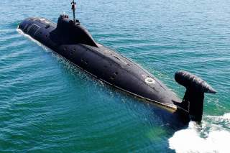
Russian submarine
In the last couple of days, the US has not been able to track this nuclear submarine, the Pravda, Ru video explained. “They were trying to locate it two days ago in the waters off Manhattan Island between the Island and the NYC coastland.”
Russia US Military Hunting for Submarines in Long Island Sound
NATION NEWSDESK 23 JANUARY 2022 Hal Turner
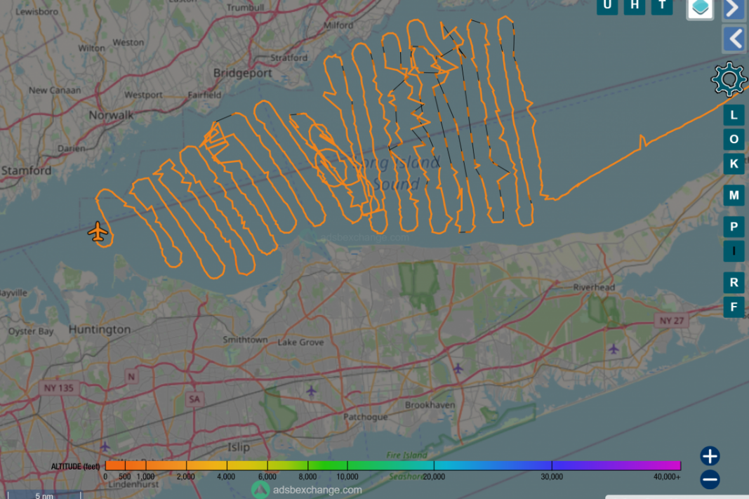
Path of US military plane seeking to locate the Russian submarine

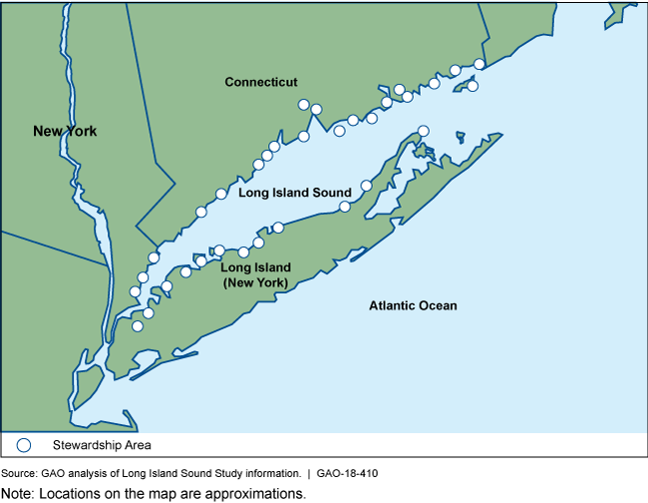
“A military aircraft Squawking 4422 (Federal Law Enforcement) is in a search pattern over Long Island Sound at this hour -11:48 AM Sunday- looking for Submarines! The aircraft is flying very low, only about 1500 feet above the water! A source on Long Island has visually confirmed to the Hal Turner Radio Show the aircraft "is a large double propeller aircraft. Similar to a C130."

The Pravda.ru video (link above) said that with a submarine of this size, it “is capable of destroying most of the United States in minutes.”
The video said Russia is patrolling along the U.S. east coast, but could also “build a naval base in Cuba or Venezuela.”
That is an interesting statement since Russian missiles are already in Venezuela, as well as Iranian missiles from Russia, aimed at the southern coastline of America. Within a short time, these missiles could be launched and take out most of the U.S. They are in position to do so now.
Steve Quayle asks a reasonable question: WHAT'S WRONG WITH GIVING RUSSIA WHAT THEY ARE ASKING FOR? In the recent Geneva meeting between Vladimir Putin and Anthony Blinken, there was no compliance by the U.S. with Russia’s demands for security of its own borders. This shows that the US and NATO are basically declaring war on Russia. It is insane, due to the facts that Russian nuclear and electromagnetic, and electronic warfare means are at least 10 years advanced from anything America or NATO have. It’s purposed insanity to start WWIII. However, the U.S. military is now being systematically hybridized to the full extent.
Jeremiah 50:9-10, 30: “For `Look, I am stirring up and bringing up against Babel an assembly of great nations from a land of the north, and they shall array themselves against her. From there she shall be captured – their arrows [#2671 Strong’s: something shot towards a target which pierces the target - today that would be launched “missiles” at a target] are like those of a mighty skilled man, not returning empty handed. And Chaldea shall become plunder, all who plunder her shall satisfy themselves,’ declares Yahuwah.” … `her young men shall fall in the streets and all her men of battle shall perish in that day,’ declares Yahuwah”
Jeremiah 51:28-32: “Separate the nations against her with the kings of the Medes…so that the land shakes and withers in pain. For every plan of Yahuwah shall be established against Babel, to make the land of Babel a ruin, without inhabitant. The mighty men of Babel have ceased to fight, they remained in the strongholds. Their might has failed. They became as women. They have burned her dwelling places. Her bars of her gates have been broken. One runner runs to meet another and one reporter to meet another to report to the king of Babel that his city is take on all sides, and he fords have been captured, [“the passageways have been blocked”] and they have burned he reeds with fire and the soldiers are startled.”
By this time, all communication means will be down – perhaps by a preliminary EMP attack, thus news will have to be carried by “runners.” The President will be hiding out, along with favored elite with him. There are no hiding places for the military.
Strong’s #4569 “ma’abar” meaning “a ford, a pass, a passing.”
Strong’s #98 “agam” meaning “reeds, a pond, marsh, a swamp.” Fire has been set to marshland, deserted empty land, where “men of war” are hiding out. The soldiers are startled; they fearful. As in Jeremiah 51:30, “the mighty men of Babel have ceased to fight; they remained in their strongholds. Their might has failed. They became as women. Their dwelling places, hiding places, were burned with fire.”
Part III of the Mazzini/Pike plan is being provoked.
Refer to: “The Pike Mazzini Plan of 1871-The Plan for Global Government, #59.0/Mikvah of Israel, Our Eternal Inheritance.”
Parts I and II, i.e. WWI and WWII, were played out exactly as Albert Pike, leader of the Scottish Rite Freemasonry, and Giuseppe Mazzini, creator of the MAFIA, planned it. Therefore, what we are seeing in the formation of WWIII of the Plan is designed to be the super-blood sacrifice to Lucifer-Satan to bring out the “new world order.” The Beast is with us now, and already having “trillions of dollars at his disposal,” as Prince Charles referred to him, for his rule of earth.
Yes, all has been planned out and begun to be put in place from 1896, when Enoch’s 70 generation prophecy came to an end, and the fallen angels were allowed by Yahuwah to return for their short 120 years before His Spirit would withdraw in order to allow the fallen ones a short time to do as they’ve planned, as the Scriptures foretell, before Yahuwah sends Messiah Yahushua with His wrath in His return for the “first resurrection.” (Revelation 19-20:6)
Steve Quayle commented, January 24th: “IT SHOULD BE OBVIOUS THAT TANKS AND INFANTRY ARE NO MATCH FOR HYPERSONIC FIRST STRIKE ON US-NATO IS TOAST AS MEMBERS CUT PRIVATE TREATIES WITH RUSSIA!”
What we are watching is a purposed, planned, and intense provoking of Russia in order to start WWWIII, for the great blood sacrifice necessary to bring the Beast to power for his short reign with his power, authority, and throne from Lucifer.
As you’ve read recently in The Midnight Meeting/Mikvah of the Great Adventure recently, and clear back to the elections in 2016, in “Strange Reconciliations…”/ Mikvah of the Great Adventure #37.0, the leaders of the world were summoned to Antarctica to meet in the palace of “Lord Lucifer,” as he is called to get their directives for the implementation of a new world order - a Revelation 13 “order” without Yahuwah, without Yahushua, without anything that reminds him of his past position in heaven.
It’s all very, very real. It’s all coming down very, very fast. In my recent article updates on this, “Everything Is About to Change,” #254 under the Mikvah of Present Reality, I give you quotes from a top military intelligence officer over many men who shares with us his reaction to what he is learning in many, many areas – geological as well – referring to the one dubbed “Mike from around the world.”
I’ve been writing for a long time, and so have other watchmen, that America, was chosen by secret societies in England and Europe in the early 1600s, maybe earlier, to make the “new world” the nation to return Nimrod to power over the earth again, and bring his “tower” into reality.
I wrote “America’s Secret Destiny” explaining much of this/Mikvah of Preparation. It’s historically validated. Nimrod’s Genesis 11 “tower” was designed to be a portal opener for all the fallen angels, and their alien creations in the cosmos, to come into the earth and once again repeat pre-flood history.
THE EARTH WAS IN UNITY UNDER NIMROD. THE EARTH WAS IN UNITY TO RETURN THE FALLEN ANGELS AFTR THE FLOOD, AND RETURN EARTH TO ITS PRE-FLOOD “GLORY,” TO BE RULED BY NIMROD.
Thus, in 2003, America started the Gulf War II in order to get into Iraq with our soldiers and German archeologists and unearth Nimrod’s remains, his treasures, and also his plans for his tower. The body was shipped to the U.S., and the plans given to CERN to open the portals. I’ve written a lot in the last few years, especially in 2021, about the return of Nimrod in literal actual form. He was taken underground by DARPA scientists to clone. Now he’s not only been cloned and restored from the underworld, but he’s been given trillions of dollars “at his disposal” for his plans, as Prince Charles spoke of recently.
All events of prophetic Scripture are compacting. We are literally “in the days of Noah” technology-wise, as well as the time of Yahuwah’s judgment. He has moved into Judgment stance, and will not turn back until Messiah comes for His people.
2016 ended the 120 years allotted to the fallen ones. Therefore, in that year, the Spirit of Yahuwah began His withdrawal to let them have their time of set up and the fruition of their plans. Soon, He will step in for His finale: Revelation 19!
2015/2016 Yom Teruah ended the 70 years allotted America to be the super power (1945-August to 2015 Yom Teruah/September) Notice the shift in America from that time. Refer to: “Jeremiah 25”/#34.0 Mikvah of Present Reality. 2015/2016 began a new 7-year cycle. We are now in the Shmittah Year of that cycle.
Following up on the recent article “Everything Is About To Change,” #254 Present Reality, here are more quotes from “Mike’ in last Thursday’s broadcast.
In speaking of the geological problems earth is having, like earth’s axis tilting changing, the north pole moving more towards the sun, January 13th, he said “There is an alternate force moving out there near the binary system that is going to cause everything to accelerate in timing. In speaking of this alternative force,” he said “I’d stake my life on it, but my life belongs to Christ.’” (smile).
So, besides the binary system there is another force moving into our solar system. Now, not only is the binary system – a dead dwarf-star plus 2 suns out there - but other large objects moving in on us too. This is now known reality. Our solar system has moved into a new area of space we’ve not been in before. It is affecting all the planets and the sun and moon. Even Jupiter and Saturn are being affecting in their orbits. Earth’s orbit has altered to the point where the constellations are not in usual positions.
In my most recent article on the shaking of heaven and earth, “The Latter House…”/#154 Mikvah of the Heart of Elohim, I talking about the shaking, wobbling, of both sun and moon.
“Mike” said: ““These unknown elements are going to speed things up quite a bit.”
MIKE: “THINGS ARE UNFOLDING QUICKER THAN THEY SHOULD – AT AN ABNORMAL PACE…” … “WHEN SOMEONE REPORTS WHAT IS GOING TO TAKE PLACE, ITS ALMOST INSTANTANEOUOS THESE DAYS.”
“WHAT WE EXPECTED TO HAPPEN A YEAR FROM NOW IS HAPPENING IN SIX MONTHS. AND WHAT WE EXPECT IN SIX MONTHS HAPPENS IN TWO MONTHS. THINGS HAVE REALLY SPED UP!”
Who is speeding things up behind the scenes? Yahuwah is in total control. He’s totally “cool-headed.” The “Devil” can’t do anything outside of His will, His allowance, i.e. Job 1. The idea that Lucifer and beast are trying to push things ahead of Yahuwah is ludicrous, as if they had their say in it.
Lucifer is ruling from his palace in Antarctica, as I’ve explained. He’s knows his time is short, so yes, he’s trying to get things moving – but in doing so, he is flowing with the will of Yahuwah! Yahuwah holds the leash on Lucifer and the Beast.
Just know that our Elohim are victorious Conquerors, so because we are with Them, Father and Son, we’re also victorious conquerors. Shalom! Shalom! Shalom!
Mike: “5-G is not all the way in yet – simply because of airport security.”
A lot of planes run on 3-G. If they take off into a 5-G atmosphere, their planes are not going to be able to handle it. America is the main one holding out – but also other world airports. “IT’S THE AIRLINES THAT ARE HOLDING BACK THE FULL GLOBAL IMPLIMENTATION OF 5-G.” It’s holding up a lot of flights. Mike said: “I don’t think 5-G is going to go backwards in its implementation.”
Mike asked a good question: During the pandemic when the airlines were shut down, why didn’t they implement 5-G then? Why hold up the flights now because of it? He answers his question: “BECAUSE THEY’RE WORKING ON SHUTTING DOWN FLIGHTS OUT FROM COUNTRY TO COUNTRY OR AREA TO AREA. THIS WAY THE NEW WORLD ORDER CAN TAKE OVER EASIER.”
MIKE: “THE ENTIRITY OF THE HEAVENS IS ABOUT TO CHANGE BEFORE OUR EYES.”
MIKE SAID: “NO ONE HAS EVER SEEN A PACE THIS FAST BEFORE.”
He says just our geology, our planetary changes – radical, fast, earth shaking, tipping, volcanoes, earthquakes—it went from a small increase to this gigantic leap of activity in less than 2 years (2020-2021)
Mike: “It’s changing so quick. It’s altering so quick.”
Mike: “The earth is going to be one united world under a single leader. To be a citizen of earth, all sovereignty you might acknowledge other than him has to be renounced or you’re disposed of.”
In other words, all citizens of earth will have to pledge loyalty to the one world ruler or be beheaded. The martyrs: Rev. 20:4, 6; Revelation 7:9-17; Revelation 6:9-11 (the 5th seal), and Revelation 14:13-14.
Mike: “Loyalty to the Beast world ruler is going to be highly religiously charged - as he demands, and Lucifer demands, all people must worship him. This is a totally evil counterfeit of our Father and His Son.
That’s all the enemy can do -- counterfeit, lie, deceive, twist truth, promise illusions, bring fear, and tantalize the mind to reject Yahuwah and Yahushua.
Mike: “Satan is `the author of confusion.’ We see the White House in confusion right now. Satan is bringing mental confusion to earth’s people - via 5-G and his own network of demonic spirits.”
Mike said “…people are looking for alternatives to believe in – and Satan loves that … He will fill in the blanks and lead them to aliens or whatever to believe in.”
Truly, the “alien agenda” is on its way – more and more disclosure comes forth every day of sightings of alien “saucers,” by the U.S. military for one voice. Abba has allowed me to see so many – even accompanied by large “orbs,” which are also a form of transportation for “entities.” Lots of close sightings … yet no fear because what is not of Yahuwah can only be used against us if we fear them.
In my recent article on what is happening to the minds of earth’s people, I got more confirmation of that today from a subscriber in Panama. People are becoming more angry, more aggressive, more violent, more without any concern for anyone else – no mercy, no kindness, no love, joy and peace. Please make sure you’ve read the recent article: “The Rising Insane Change in Human Nature”/Mikvah of Set-Apartness.
Yes, “Everything is About to Change,” Mikvah of Set-Apartness, because since 2020, everything has been changing, and accelerating greatly. It only means one thing – be prepared in all ways, especially in your spirit, wrapped around the peace of Yahuwah at all times. Get His mind on what He wants you to do. We must make no decisions unless it comes from His direction coupled with His peace in our spirit. With peace comes understanding and wisdom.
In His love, Yedidah
January 25, 2022
[Happy Birthday tomorrow Jonathan – Happy 16! Grama loves you!)

