FAMINE! THE BLACK HORSE GOES FORTH!
WORLDWIDE DESTRUCTION OF CROPS AND LIVESTOCK 2019

Revelation 6:5-6: “And when He (Yahushua Messiah) opened the third seal, I heard the third living creature say `Come and see.’ And I looked and saw a black horse, and he who sat on it holding a pair of scales in his hand. And I heard a voice in the midst of the four living creatures saying `a quart of wheat for a day’s wages and three quarts of barley for a day’s wage. And do not harm the oil and the wine.’”

Questions: Has Messiah Yahushua already opened the first four of the seven seals? Yes, He has! Has Yahushua opened the 5th seal? (Revelation 6:1-11) Note the fifth one is mentioned in detail in Revelation 7:9-17. The 5th seal has been opened. The reality of it in its fullness is shown in Revelation 14:9-15. Look at the layout of timing. We are in the early stages of the first five seals. As we progress towards the coming of anti-messiah/antichrist, we will see them greatly intensify.

In 2006, Abba Yahuwah literally placed information in my hand to do with the last three Shmittah year cycles before Daniel’s 70th week. Refer to: “The Shmittah Year Prophecy” and “The Shmittah Year Prophecy Revisited”/Mikvah of Preparation.
I began watching the detailed unfolding of the information on the final three Shmittah year cycles, traced by Jewish sages 400 years ago from the time Joshua entered the Land. I have been following end-time prophecy since 1962, watching it being fulfilled slowly but surely. However, as we entered the last of the three cycles detailed by the sages, there began an acceleration that was dramatic.
The 1st of the last three began on Yom Teruah, September 13, 1993, with the signing of the Oslo Accord on the lawn of the White House (1993 beginning 1994 on the Creator’s calendar. The Oslo Accord was a seven-year Accord.
The second cycle was from Yom Teruah 2000/2001 to September 13, 2007/08.
The third cycle was from September 13, 2007, beginning 2008 on the Creator’s Calendar, Yom Teruah/Tishre 1 to September 23, 2015 beginning 2016.
The details given 400 years ago has all come to pass exactly as written by the sages. Some of the details paralleled Genesis 41:15-57. While there are only 14 years mentioned to do with the famine in Egypt at the time of Joseph, the two extremes happened in America and the world in general within 21 years.
I was in Jerusalem for Passover and for Yom Teruah and Sukkot of 2007/2008. I heard others from several nations in Jerusalem and in America in 2007, saying that they felt they had to get to Jerusalem for Sukkot but did not know why – it was something Abba was leading them to do. All of them were from nations where the ten northern tribes of the House of Israel/Ephraim/Joseph settled finally, after their 722 BCE dispersion.
Abba led me to do the mathematics in Ezekiel 4 and Leviticus 26. I learned that the end of the punishment of 2,730 years allotted to the ten tribes, the House of Israel/Ephrain/Joseph, was finished on Yom Teruah 2007/2008. I did not know that the Orthodox Jews knew that too, but I found out at Sukkot. They were celebrating greatly that the end of Ephraim’s punishment had come.
On the eve of Yom Teruah, Abba asked me to proclaim 18 things at the Wall – the chief one was the end of Ephraim’s punishment. This is why the Christians and Messianics in March through July in Jerusalem and the U.S. told me that they had to get to Israel for Sukkot, but did not know why. It was to celebrate the end of the punishment on the ten tribes. The great passion of our Abba Yahuwah and His Son is the uniting of the whole House of Ya’cob, The House of Judah and the House of Israel/Ephraim/Joseph. (Ezekiel 37:15-28) Judah is the scepter-holder of the tribes; Ephraim is the birthright-holder of all the tribes, thus says Yahuwah!
In noting how these Shmittah cycles matched up perfectly with what was happening in America, and the world, to do with Genesis 41, I said to Abba on Yom Teruah 2007/2008, “If I’m right in my understanding, the first thing I am going to hear in the news is worldwide FAMINE.”
Two months after Yom Teruah, the pubic news was filled daily with reports of worldwide famine. I will never forget the newscaster on NBC saying: “The first nation to report on famine is EGYPT.” How’s that for repeating Genesis 41!
In Genesis 41, famine occurred in the second of two cycles in Egypt under Yosef/Joseph. Before that came great increase in the food production and in prosperity as a whole, just as 1993-2007 in our time in America. The famine in Egypt at the time of Joseph was a “WORLDWIDE FAMINE.”
Genesis 41:56-57: “And the famine was over all the face of the earth and Yosef opened all the storehouses and sold to the Egyptians. The famine was severe in the land of Egypt. And all the earth came to Yosef in Egypt to buy grain because the famine was severe in all the earth.”
NOW in 2019, WORLDWIDE FAMINE IS BEING REPORTED AGAIN!
The worldwide famine that has been created by the purposed destruction of earth’s life-support systems, and the methodical targeting of crops with severe weather all over the earth by evil ones and their geoengineering. Earth is going into famine conditions for no other reason except to aid in the deaths of the world’s people, the goal being 7.5 billion at least, and to prepare mankind for the “mark of the Beast,” the ID – identification - needed under the world ruler/antichrist to buy or sell in the days to come. We now see that the new world order and the “ID” will be hooked up with the Talmudic Kabbalist Noahide Laws under the Sanhedrin.
Revelation 13:16-17: “And he (the Beast out of the earth) causes all both small and great, rich and poor, free and slave, to be given a mark upon their right hand or on their foreheads, that no one will be able to buy or sell except he that has the mark of the name of the Beast, or the number of his name.”
I’ve been reporting for the last three years especially about the devastation of the earth by geo-engineering. I reported on the beginnings of this in 1947: “70 Years of Weather Geoengineering – 70 Years of Man’s Destroying Earth’s Life Support Systems”/Mikvah of Present Reality. Please read that article to learn how we ended up with such horrible weather and the destruction of crops and livestock.
HAVE YOU NOTICED THAT FOOD PRICES ARE GOING UP? NOTICED ALL THE FOOD RE-CALLS? NOTICED EMPTY SHELVES? NOTICED THAT IMPORTIG OF FOOD IS INCREASING?
About two to three years ago, multi-millions of chickens had to be killed because three or four chickens were found to have bird-flu. I mean major chicken companies like Tyson. Do you remember “mad cow disease?” The source turned out to be ground up dead cows put into living cow’s feed. It was an experiment to learn how ground up dead cows eaten by living cows would affect the living cows.
Scientists began telling us, from around 2016, that human flesh was a good source of protein. Remember the 1970s movie “Soylent Green?” When mankind ran out of food in America, ground up dead people became the food.
Now we see pictures of chicken coops under flood waters. We’ve learned that around a million calves drowning in spring flood waters the US Midwest. We learned a few years ago that the drought in Texas killed many cattle. But, we also see drought in poor nations destroying crops and animals.
I’ve been following the increasing historic weather anomalies and crop destruction since 2004. Whether destruction by hurricane, cyclone, tsunami, drought, wildfires, blizzards, tornadoes, or massive inland flooding of rivers, I’ve noticed that almost all of them occur just before harvesting, in other words geo-engineered weather targeting the world’s food supply. World food destruction has been methodically carried out as part of the global agenda. Of course, I cannot forget the oceans, rivers, seas, and waterways that are dying and all life in them dying. I cannot forget the targeting of certain species of birds and fish from Januar of 2011. I’ve written several articles on the ocean dying, like “Creation Groaning,” “The Oceans and Their Sea Life Are Being Purposely Murdered,” and “Radiation Clouds--Another Earthquake at Fukushima--Oceans Dying--the Earth is Cracking--`to destroy those that destroy the earth,’ ” under the Mikvah of Present Reality.
Farmers all over the world are suffering greatly, as in Zimbabwe and South Africa. In America, this spring alone, farms have being devastated, totally wiped out, even the reserve grains and food for livestock.
Not much reporting has gone on about the destruction of some of America’s chief military bases. Two bases were targeted using weather warfare, There is proof, like with the hurricane in 2017 in north Florida, and recently America’s #1 Reconnaissance Base in Nebraska wiped out by flooding. A lot of the planes of the Air Force and National Guard are being destroyed by hurricanes and inland floods. So when America is attacked by Russia, China, North Korea, Iran, and perhaps as suggested even France and Germany, our National Guard, our Reconnaissance ability will be gone to protect us. The word “reconnaissance” refers to “military observation of a region to locate an enemy or ascertain strategic features. Synonyms include: preliminary survey, exploration, observation, investigation, examination, inspection, probe, scrutiny, scan.”

“Home of Strategic Command and Some of the USAF's Most Prized Aircraft in Flooding” March 17, 2019 The War Zone – The Drive – 55th Wing Command
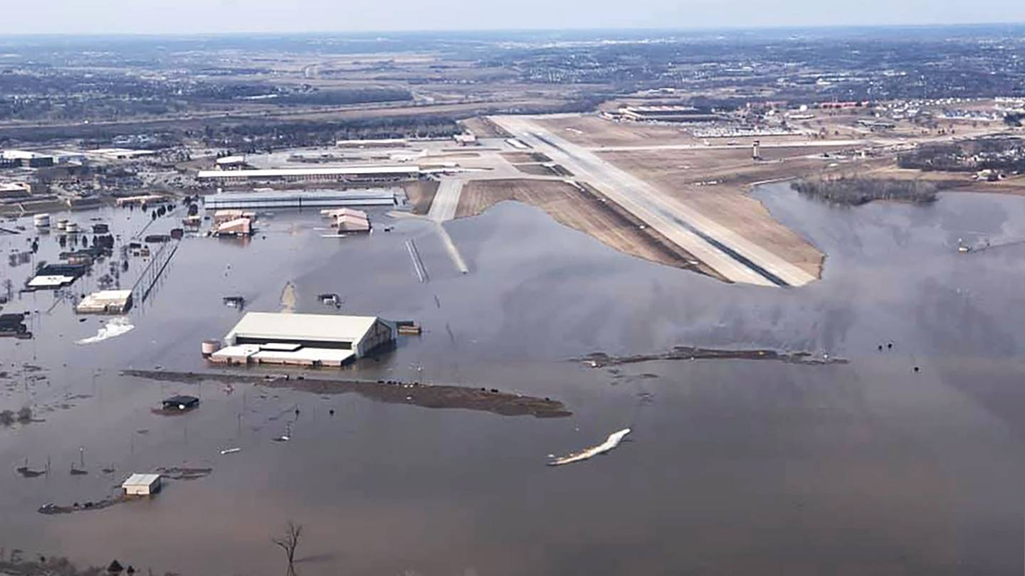
The home to America's prized RC-135 "Rivet Joint" strategic reconnaissance and E-4B "Nightwatch" Advanced Airborne Command Post aircraft, as well as others, and the headquarters of U.S. Strategic Command (STRATCOM), is flooding with water from a swollen Missouri River.
Offutt Air Force Base sits near Omaha, Nebraska and is considered one of the most critical installations in the U.S. Air Force's portfolio. Not only does it house extremely high-value, but low density reconnaissance and command and control aircraft—massively expensive platforms that are essential to national security—but it is also the beating heart of STRATCOM that oversees America's strategic nuclear forces. In fact, a brand new command bunker, buried underground at the base, was just opened in January—which sounds far less than ideal considering water is now nearly covering the end of the base's runway…” This is NOT GOOD FOLKS! Read the rest of the article online.

“With America's Food Prices Expected To Skyrocket, Are Catastrophic Floods In Midwest 'A Sign From God' Or Globalists Weather Warfare Upon America?
Now They Warn America's Breadbasket Under Water Could Be 'The New Normal'”
By Stefan Sanford, All News Pipeline, March 25, 2019
“…Uttered by Globalist Henry Kissinger back in 1974: `If you control the food supply, you control the people.’ ”
“As this story over at WYFF reports, Midwestern flooding could become 'the new normal' though officials are blaming 'global warming' and 'climate change' for the disasters that have already caused over $1.4 BILLION worth of losses to the U.S. food supply in Nebraska alone with experts warning that the flooding has only just begun.”
As Michael Snyder over at End of the American Dream reported just days ago in his story titled "Catastrophic Flooding In The Midwest Could Last “For Months”, And That Is Going To Mean A Dramatic Drop In U.S. Food Production", America's breadbasket under water for much of the food growing season is a recipe for disaster in our country already hit by numerous food recalls and vast food shortages. And as Nebraska's governor recently stated, when Americans see our food prices spiking in the months ahead, we should think instead about the farmers who have lost everything.
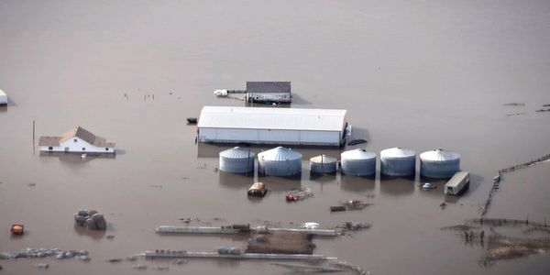
Nebraska farm flooded March 2019
“Certain losses could be covered under farm insurance policies, but they're very specific. They may not cover grain that isn't stored in a silo or a power outage for the refrigeration needed on a dairy farm. Many farmers have federally subsidized crop insurance. But the problem is that under these policies, they'll have to work extremely fast to make sure their seeds are planted by a certain time, said Worters. And that could prove impossible if fields remain flooded.”
As Steve Quayle had warned… `Floods equal famine' - weather warfare is destroying America's ability to feed its people and that is the ultimate clandestine system of war.’ For anyone who still hasn't learned of weather modification and weather warfare, we suggest that you read Steve's excellent and well ahead of the times book Weather Wars & Un-Natural Disasters to get caught up to speed. Steve had warned in his book long ago.” [I also recommend Steve’s book--it covers a lot of important information.]
Many farmers have lost their seeds, lost their stored grain in the silos, too--food for surviving animals is low, like formerly stored hay.

“2019 is the year when the farming industry began to unravel as extreme weather and disease is hitting already stressed farmers around the world” - The Big Wobble 4-13-2019
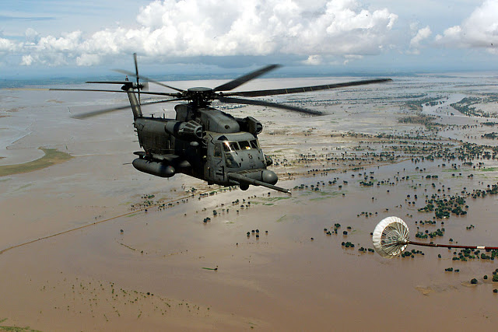
Photo Wikipedia showing the Mozambique flooding 2019
“2019, will be the year when the farming industry began to unravel as China, who produce half of the world's pork is set to drop by almost one-third because 200 million pigs are to be culled or die from being infected as African swine fever spreads through the country. [I don’t eat pork but I am sad for the pigs dying]
2019 is now officially the worst agricultural disaster in modern American history with catastrophic flooding. The US is experiencing unprecedented and catastrophic flooding with NOAA issuing a warning the flooding will continue through to the end of June. With more than 90% of the upper Midwest and great planes still covered by nearly 11 inches of snow and all that snow is beginning to melt. That means the US will transform from one of the worst winters in modern history into a flood season that has already taken an apocalyptic turn for farmers across the US.
Millions of acres of farmland are already under water meaning thousands of farmers will not be able to plant crops this summer, with thousands of more farmers who have been financially ruined by the floods and will never return to farming again.
Australia, after years of drought, 2019, has delivered the hottest January ever, the wettest February ever, the hottest start to Autumn in 30 years, and the hottest March heat wave in 52 years, is already hitting struggling Aussie farmers hard.
Thousands of cattle were lost in the first three months of this year.
In the first 4 months of 2019, heat waves in the southern hemisphere are killing wildlife ‘on a biblical scale’ from record-breaking heat.
Record heat in Australia, Chile, Argentina and Brazil with NASA and NOAA claiming the last 5 years have been the warmest since modern records began.
The intense heat in Uruguay that affected the country in 2019 did not affect only human beings, who persistently complained about the thermal sensations through social networks, chicken farmers, in particular, suffered the heat stroke in its economy when more than 100,000 chickens died by high temperatures in Montevideo. Thousands of cattle died as temperatures hit 45 deg C, (110 deg F) early in 2019 in Argentina.
Iran's farmers have had farms destroyed by unprecedented floods which have killed more than 70 people, destroyed or damaged 100,000 homes and damaged one-third of the country's roads. Thousands of cattle are thought to have been killed in the floods.
2019: South-East Africa: It has been described as a 'disaster on a scale we have ever experienced.' …As well as the immediate threat caused by flooding, hunger and illness are growing concerns, with crops and wildlife destroyed and waterborne diseases likely to spread.”

“Food Crisis: Hail storm smashes 4 million avocados in under 10 minutes in Australia” by Strange Sounds Mar 30, 2019
“A hail storm that ripped through an avocado orchard in the Northern Rivers of New South Wales last week has destroyed an estimated 4 million avocados…”

“Gov. Pete Ricketts: Worst flooding damage in our state’s history – As many as a million calves lost in Nebraska” - By Strange Sounds Mar 22, 2019
“Nebraska: Historic floods kill millions of livestock. `We’ve got at least 400 million in livestock losses and 140 million in crop losses,’ says Ricketts. `There may be as many as a million calves lost in Nebraska,’ says agriculture secretary Sonny Purdue, United States Secretary of Agriculture. Soon we will fight in the streets for food!’

“Flooding threatens more than a million private wells in US Midwest” by Michael Burke - The Hill - Tue, 26 Mar 2019
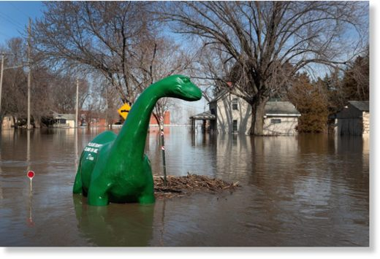
`Flooding in the Midwest is posing a risk of contamination to more than 1 million private wells that supply drinking water to rural areas in the region,’ The Associated Press reported Tuesday.”

“U.S. Farmers Face Devastation Following Midwest Floods” by Humeyra Pamuk, P.J. Huffstutter, Tom Polansek – March 21, 2019 - Reuters
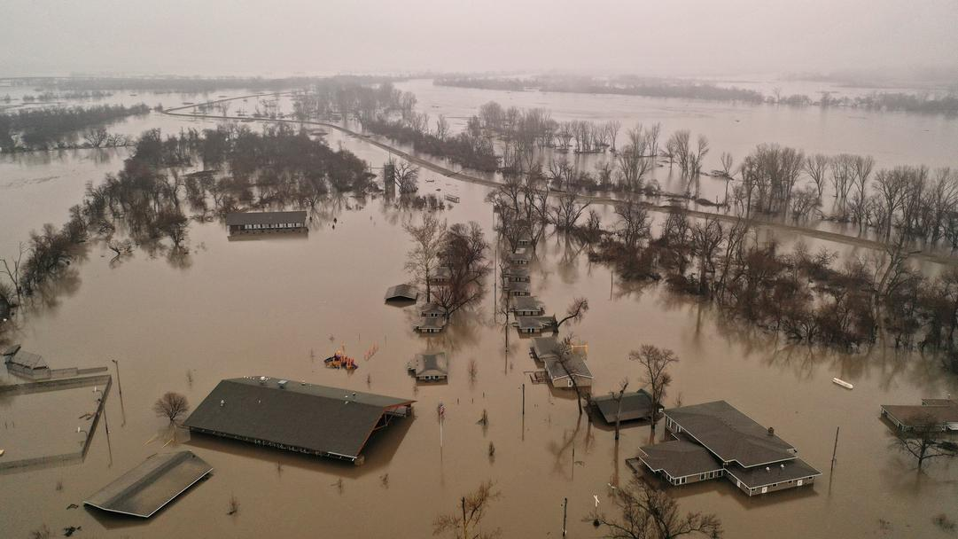
FILE PHOTO: A flooded parcel of land along the Platte River is pictured in this aerial photograph at La Platte, south of Omaha, Nebraska, U.S. March 19, 2019. REUTERS/Drone Base/CORN AND SOYBEANS DESTROYED
… “Farmers say they are now finding storage bags torn and bins burst open, grain washed away or contaminated. Jeff Jorgenson, a farmer and regional director for the Iowa Soybean Association, said he has seen at least a dozen bins that burst after grains swelled when they became wet…
` The water came so fast…That’s the toughest pill to swallow,’ Jorgenson said. `This could end their career of farming and the legacy of the family farm.’
As of Dec. 1, producers in states with flooding - including South Dakota, Nebraska, Kansas, Minnesota, Iowa, Missouri, Wisconsin and Illinois - had 6.75 billion bushels of corn, soybeans and wheat stored on their farms - 38 percent of the total U.S. supplies available at that time, according to U.S. Department of Agriculture data.
Iowa suffered at least $150 million in damage to agricultural buildings and machinery, and 100,000 acres of farm land are under water, said Keely Coppess, a spokeswoman for the Iowa Department of Agriculture and Land Stewardship.
Jorgenson surveyed more than two dozen local farmers to assess the damage and tallied about 1.25 million bushels of corn and 390,000 bushels of soybeans lost just in Fremont County, Iowa, worth an estimated $7.3 million. Early estimates put flood damage at $400 million in losses for Nebraska’s cow-calf industry and another $440 million in crop losses, Nebraska Governor Pete Ricketts told a news conference on Wednesday.’ ”
Cattle carcasses have been found tangled in debris or rotting in trees, while tractors and other expensive machinery are stuck in mud, unable to be moved. At Geisler’s farm in Winslow, Nebraska, two trucks and a tractor were seen buried in mud in wooden barns where water pooled.
`We should have been getting into planting for next season, but now all of our equipment is flooded and it’s going to take at least three to four weeks to bring back that equipment into shape,’ said Geisler.”

“Exclusive: More than 1 million acres of U.S. cropland ravaged by floods”
By P.J. Huffstutter and Humeyra Pamuk March 29, 2019
“Fields are strewn with everything from silt and sand to tires and some may not even be farmed this year. The water has also destroyed billions of dollars of old crops that were in storage, as well as damaging roads and railways.
Justin Mensik, a fifth-generation farmer of corn and soybeans in Morse Bluff, Nebraska, said rebuilding roads was the first priority. Then farmers would need to bring in fertilizer trucks and then test soil before seeding, Mensik said. The flood `left a lot of silt and sand and mud in our fields, now we're not too sure if we're going to be able to get a good crop this year with all the new mud and junk that's just laying here,’ Mensik told Reuters.
CORN CONCERN: For farmers, `the biggest concern right now is corn planting," said Aaron Saeugling, an agriculture expert at Iowa State University who does outreach with farmers. "There is just not going to be enough time to move a lot of that debris.’
Fields are strewn with everything from silt and sand to tires and some may not even be farmed this year. The water has also destroyed billions of dollars of old crops that were in storage, as well as damaging roads and railways.
Justin Mensik, a fifth-generation farmer of corn and soybeans in Morse Bluff, Nebraska, said rebuilding roads was the first priority. Then farmers would need to bring in fertilizer trucks and then test soil before seeding, Mensik said. The flood "left a lot of silt and sand and mud in our fields, now we're not too sure if we're going to be able to get a good crop this year with all the new mud and junk that's just lying here," Mensik told Reuters.
Nearly 1.1 million acres of cropland and more than 84,000 acres of pastureland in the U.S. Midwest had flood water on it for at least seven days between March 8 and March 21, according to a preliminary analysis of government and satellite data by New-York based Gro Intelligence at the request of Reuters. The extent of the flooding had previously not been made public.
LOST CATTLE: In Wisconsin more than 1,000 dairy and beef animals were lost during winter storms and 480 agricultural structures collapsed or damaged, according to an email from Sandy Chalmers, executive director of the Wisconsin state office of the USDA’s Farm Service Agency.
In the Dakotas and Minnesota, melting snows in coming months will put spring wheat planting at risk. Gro Intelligence found nearly 160 million acres have already been flooded in Minnesota.”

“Government Warns Of Historic, Widespread Flooding `Through May’ – Food Prices To Skyrocket As 1000s Of Farms Are Destroyed By Michael Snyder March 24, 2019 by Michael Snider
…. “More than 90 percent of the upper Midwest and Great Plains is currently covered by an average of 10.7 inches of snow, and all of that snow is starting to melt. That means that we are going to transition from one of the worst winters in modern history to a flood season that has already taken an apocalyptic turn for farmers all across America. At this moment, millions of acres of farmland are already underwater. Thousands of farmers are not going to be able to plant crops this year, and thousands of other farmers that have been financially ruined by the floods will never return to farming again. This is already the worst agricultural disaster in modern American history, and it is going to get a whole lot worse.
I am troubled by the fact that most Americans don’t seem to understand the gravity of what we are facing.
Millions of bushels of wheat, corn and soybeans have been destroyed by flood waters, hundreds of millions of dollars worth of livestock have been lost, and all of us will soon be feeling a lot more pain at the grocery store.
Of all the natural disasters that we have seen in recent years, this is the biggest, and U.S. food production is going to be dramatically affected because many farmers will not be able to grow crops at all in 2019…
This is the worst blow to U.S. agriculture that I have seen in my entire lifetime.
The amount of food that has just been lost is absolutely staggering. Due to the trade war, farmers were storing more wheat, corn and soybeans than ever before, and now the floodwaters have destroyed much of what had been stored… [Can you imagine if this happened to Yosef’s silos in Egypt (Gen. 41)?]
As prices plummeted last year amid the ongoing trade fight, growers, faced with selling crops at a loss, stuffed a historic volume of grain into winding plastic tubes and steel bins. Some cash-strapped families piled crops inside their barns or outside on the ground. Farmers say they are now finding storage bags torn and bins burst open, grain washed away or contaminated…Nationwide, the losses are off the charts. Needless to say, prices will be going way up at the grocery store, and they will keep going up for the rest of the year. Sadly, even after the flood waters are gone the damage that has been done to our agricultural infrastructure will take years to repair.
In Nebraska alone, hundreds of miles of rural roads have been completely washed out, and farmers such as Annette Bloom are having an extremely difficult time just getting to a main road…
`Lot of folks won’t be able to continue after this,’ said Julius Schaaf, 66, who said 1,500 of his 4,000 acres were currently under water. In the end, it is going to be a while before we know the full extent of the damage to America’s farms and our food supply, but all of the experts agree that it will be unprecedented.
Much less food will be produced in our heartland this year, and that will mean skyrocketing prices at our grocery stores. Courtesy of The Economic Collapse Blog”

California’s huge Napa Valley is one of the major crop growing areas of the U.S. It has been devastated with wildfires and flooding in the last 3-4 years, so that our fruit and vegetables, and the wine and oil too, are lacking.
“Harm not the wine and the oil.” The wine is for lifting the spirit of man, the oil for making the face to shine. Psalm 104:14-15: “He causes the grass to grow for the cattle and herbs for the service of man, that He may bring forth food out of the earth, and wine that makes glad the heart of man, and oil that makes his face to shine, and bread which strengthens man’s heart. The trees of Yahuwah are full of sap…”
Our Abba Yahuwah has given us all that we need in this earth for our good. Today, evil men under the orders of fallen angels and Nephilim, are preparing the way for the annihilation of mankind and all the good creatures of earth, plus the good trees and grass, rivers and seas, beautiful flowers, herbs, and food that we need to live, even wine for joy and oil to shine our faces.
Revelation 6:6: “And I heard a voice in the midst of the four living creatures saying `a quart of wheat for a day’s wages and three quarts of barley for a day’s wage. And do not harm the oil and the wine.’ ”
Wine and oil are symbolic. The joy of man is being taken away and only suffering is ahead of us UNTIL the One who spoke creation into existence returns for us – our Master Yahushua Messiah!
Plagues are in the earth destroying crops - “Biblical locust invasions spark UN warning for UAE, Saudi Arabia and Egypt” - Strange Sounds - Feb 18, 2019
“Massive swarms of locusts are bearing down on Saudi Arabia and Egypt as they spread rapidly along the shores of the Red Sea, the United Nations has warned. Breeding along the coasts of Eritrea and Sudan, the swarms are spreading farther afield, with at least one having crossed over the Red Sea to Saudi Arabia in mid-January and more a week later. Swarms also went north along the Red Sea towards Egypt.
Adult locusts can eat their body weight in fresh vegetation every day and the FAO warned that even a small swarm can eat enough food for 35,000 people in just 24 hours. A female locust is able to lay around 300 eggs in her short life, meaning swarms can measure miles wide and be made up of hundreds of millions of individuals. They can strip the land bare as they fly through.
Tackling swarms is also made difficult because they are highly mobile and able to fly up to 150 kilometres a day.
`The devastating impact locusts can have on crops poses a major threat to food security, especially in already vulnerable areas,’ the FAO said. The issue of higher breeding is not only confined to Eritrea and Sudan. Rains from cyclones Mekunu in May and Luban last October triggered a mass breeding of locusts in Saudi Arabia’s Empty Quarter, near the Yemen-Oman border.’

“Iran is facing the worst locust attack in the past 40 years: Biblical invasion threatens crops and food security” - Strange Sounds - Apr 23, 2019
“`A locust outbreak in the Arabian Peninsula has been spreading to Iran, threatening crops and food security in large areas of the coastal province of Hormozgan,’ an official said…Iran is facing the worst locust attack in the past 40 years.”
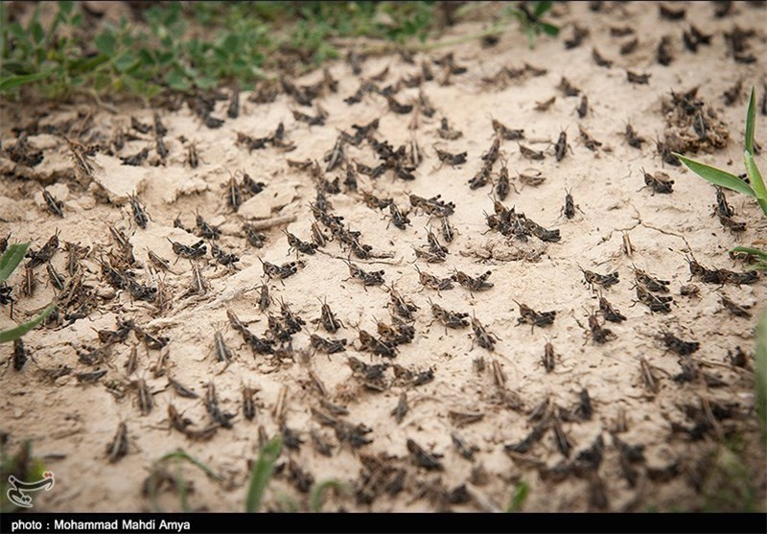
In conclusion, people in third world nations especially, are suffering from crop destruction of all types like with the rice fields of Asia being washed away, suffering from dead cattle like in North Africa, or famine like in Venezuela or Yemen because of US sanctions. Multimillions are hurting because of wars, terrorist attacks, hate rampant worldwide, racial wars, etc. Worldwide, human beings are suffering. But, Europe also is suffering from flooding, like in Germany.
It is very difficult for me to write this article. I keep fighting back tears. I have worked and lived in many countries of our world, on five different continents, and I’ve learned that most humans are just people who want peace, want to enjoy their families and the joys of life in general. They want to smile. They just want the chaos to stop, the fear of war, poverty, and famine. The problem is that human beings were created in the likeness and image of Yahuwah. Satan and his forces are working to destroy anything associated with Yahuwah, including the earth itself.
Jeremiah 4:23-27: “I looked at the earth and saw it was formless and empty. And the heavens had no light. I looked at the mountains and saw they shook and all the hills were swaying. I looked and saw there was no man and all the birds of the heavens had fled. I looked and saw the garden land (“Carmel”) was a wilderness and all its cities were broken down at the presence of Yahuwah by His burning displeasure. `For look,’ said Yahuwah, `all the earth shall be a ruin, but I shall not make a complete end.’ ”
Jeremiah saw Isaiah 24. He saw “the Day of Yahuwah,” the coming of Messiah with the wrath of His Father! Read Romans 8:18-25 and Revelation 11:15-19. Let the Spirit of Yahuwah lead you as you pray for all people, and for all on the earth that was created by Yahuwah. Prepare as you can with water and food, but mainly prepare to enter eternity with a smile on your face!
In His love,
Yedidah - April 24, 2019

