GLOBAL JIHAD begins
THE RIDER ON THE
PALE HORSE

GLOBAL JIHAD BEGINS OCT 13 2023 HAL TURNER
Here are a few notes from excellent reporter Hal Turner about Gaza, followed by more for you to know in order to understand where we are on the prophetic calendar. Right now, Yahuwah is separating out who will go forward for Him – the Gideon 300 from the other near 32,000 who fell short of His expectations to be part of seeing the end-time victory of Yahushua ha Machiach!

Hal writes: “Today is Friday, 13 October 2023 the date which HAMAS Terrorists in GAZA called for what they call `Global Jihad.’ Clearly, their call was heard. The troubles seem to have begun:
“In Jordan, HAMAS Supporters break through barricades and are STORMING the Israel border:
UPDATE 8:27 AM EDT -- The __ENTIRE__ New York Police Department (NYPD), approximately 38,000 officers have been ordered to report to work today IN UNIFORM. Detectives too! The city is doing everything it can to keep Order and maintain civility within the five boroughs of New York City.
Banks in New York City have invoked Global Security. New York City - 13 Oct, 3PM ET: International Day of Action for Palestine Location: Broadway between 41st & 42nd St, New York - 13 Oct, 2PM ET, CUNY Rally and March for Palestine Location: 151 Bernard Baruch Wav”
UPDATE 8:38 AM EDT -- In Lebanon: Armed Israeli Settler engages and opens-fire on Palestinian -- (there seemed no good reason for him to do this)
🚨 FOOTAGE: An Armed Israeli Citizen opens fire directly at a Palestinian in Masafer Yatta, West Bank. pic.twitter.com/WiRw2fTdlk
— Mario Nawfal (@MarioNawfal) October 13, 2023
In Israel, it __really is__ war. Palestinians fire Anti-Tank Guided Missile (ATGM) into crowd of Israeli Soldiers.
New video shared by the Palestinian Islamic resistance hitting a group of the Zionist army with Atmg shot. pic.twitter.com/Y7iy6mO7HX
— Lebanese_Russian_🇷🇺🇱🇧 (@Operationz2p) October 13, 2023

UPDATE 8:46 AM EDT --
Unjust! “The Israeli Army using a Bulldozer to smash a restaurant in the West Bank, because the Restaurant used its social media account to SAY something the Israelis didn't like. Yes, it was grossly offensive, but it was only words. It's things like THIS that cause people to hate the Israeli government and people:

UPDATE 8:57 AM EDT --
Hundreds-of-thousands of people in the country of Jordan are trying to get to the Israeli border in multiple places, to break-through and fight against Israel. The government of Jordan is making an effort to prevent that: In Israel, the government CLAIMED HAMAS was using the rooftops of these apartment buildings "to launch drones." SO the Israeli government used fighter jets, to knock down the ENTIRE Apartment complex. Thousands lost their homes in seconds. A little heavy handed? Or is THIS what Israel actually is? Gross tyranny.
In nearby Cairo, Egypt, THOUSANDS gather in Tahir Square to protest Israel and support the Palestinians:
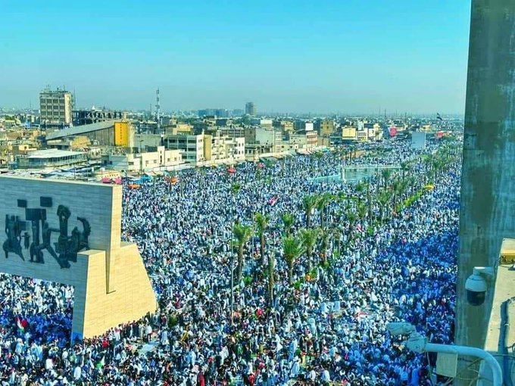
UPDATE 10:07 AM EDT -- France: Ireland: USA: University of Washington . . .
Germany:
********** BULLETIN **********
F-16 ALLEGEDLY SHOT DOWN BY HAMAS
Video has emerged from inside the Israel-HAMAS war ALLEGEDLY showing an Israeli F-16 fighter jet having been HIT by a HAMAS surface-to-air missile:
UPDATE 10:29 AM EDT --
***** FLASH: Russia *****
PUTIN: "The Israeli siege of the Gaza Strip is unacceptable and is like the Nazi siege of Leningrad"
UPDATE 10:42 AM EDT -- Tahir Square in Cairo, Egypt has more than tripled in protest size: now . . . over a MILLION
In France, one teacher has been STABBED TO DEATH by a man shouting "Allah Ahuakbar" - What did you think "Multi-culturalism" actually meant?
UPDATE 11:09 AM EDT --
In the UK! In Sweden! Meanwhile, in Israel itself, the rockets being fired by HAMAS seem to be getting Bigger. No, not just MORE but also BIGGER. Entire building in Tel Aviv knocked down:
In Australia! In Baghdad, Iraq, hundreds-of-thousands show support of Palestine:
********** BULLETIN **********
Israel just upped-the-ante in a gigantic way: The Israeli Defense Force (IDF) just declared The West Bank, a CLOSED MILITARY ZONE.
(Hal Turner Analysis: I believe this means the Israelis are not merely going to go into the Gaza Strip, they are also going to hit the West Bank.
Uh Oh! Emir of Qatar WARNS he will stop Gas shipments WORLDWIDE.
Emir of Qatar: "If the bombing of Gaza doesn't stop, we will stop gas supply of the world." pic.twitter.com/GZa633a34B
— Citizen Free Press (@CitizenFreePres) October 13, 2023
-- The crew of the Reuters live stream just got hit by an explosion. The woman could be heard screaming "I can't feel my legs!" Occurred in northern Israel near the Lebanon border.
-- The Israeli Army: "We are moving more reinforcements to the North preparing for a potential ground offense from Lebanon"
SIDE NOTE:
U.S. military deploys four B-1B Lancers, nuclear-capable, heavy bombers, to the UK amid "growing global instability"
(HT Remark) So as of now, within this past week, we have deployed at least 12 B-2 Stealth, nuclear-capable, bombers, and today, four more B-1b Lancer, nuclear-capable, heavy bombers. I think they are positioning for a nuclear strike against someone and I think that someone is Russia and Iran.
UPDATE 11:39 AM EDT --
The IDF is once again dropping Leaflets over northern Gaza Strip telling people they must leave their homes and go to southern Gaza IMMEDIATELY because Israeli Army action is coming.
UPDATE 4:06 PM EDT--
Earlier this week I reported to you that among the Aircraft Carriers deploying would be the USS Dwight D. Eisenhower, leaving next week. The US Navy "surged" it and the ship departed Norfolk, VA TODAY. It is heading to the eastern Mediterranean Sea.
- Pro Palestinian rally in Sana, Yemen today
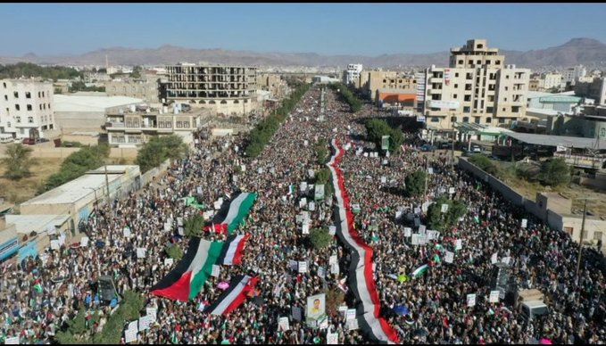
--Hamas has set up blockades so civilians can’t leave northern Gaza!”
[Yedidah: Often Steve Quayle, friend of Hal Turner, posts Hal’s reporting on his website address: stevequayle.com. Quayle’s website has a daily list of articles and videos to watch on subjects that Yahuwah wants knowledgeable about. I do only top-quality research and do not waste time on theories, ideas, opinions, or reporting that has no solid base. Let Abba lead you too! We are told by Yahuwah: “Redeem the time, for the days are evil.]
Folks, World War III has been planned by the evil worshippers of Lucifer/Satan and the fallen angels. Use this information to pray, praise, and proclaim the victory of Yahuwah for His people. Pray for Messianic Rabbi Zev Porat, who was on his way towards Gaza to share the Good News of Yeshua/Isa/Jesus. Many Palestinians in Gaza also are born-again believers. Pray for those whose, especially in Gaza, whose lives are in danger because they claim Jesus, Isa (Arabic), Yeshua/Yahushua as Savior!
Folks listen up: Hamas jihadists, as reported yesterday, are coming across U.S. southern border into Texas by the thousands. Tens of thousands of military age Chinese are flowing into America at that border. Drug cartels, terrorists of every type – pouring into America – given perfect freedom to do it by the U.S. Satanist government officials from the top down. I’ve also written, with pictures, the kidnapping of children at the southern U.S. border, for example at Brownsville, to be sent overseas as sex-slaves. Biden is even allowing some dangerous groups to come across into southern Texas that will be instrumental in killing Americans once the nuclear attacks abate.

THE RIDER ON THE PALE HORSE: REVELATION 6:7-17

The 7-seal judgments parallel the first six-seal judgments. All prophecy is coming down at once in some manner. The cry for the Beast reign is taking over the earth.
Revelation 6:7-11: “When he opened the fourth seal, I heard the voice of the fourth living creature say, “Come!” 8And I looked, and behold, a pale horse! And its rider’s name was Death, and Hades followed him. And they were given authority over a fourth of the earth, to kill with sword and with famine and with pestilence and by wild beasts of the earth. 9When he opened the fifth seal, I saw under the altar the souls of those who had been slain for the word of God and for the witness they had borne. 10They cried out with a loud voice, `O Sovereign Lord, holy and true, how long before you will judge and avenge our blood on those who dwell on the earth?’ 11Then they were each given a white robe and told to rest a little longer, until the number of their fellow servants and their brothers should be complete, who were to be killed as they themselves had been.”
Strong’s Concordance, Greek, meaning of “pale” horse. The word “pale” in Greek is “chloros.” It is #5515 in the Greek Strong’s. It means: “pale green.” Actually, in this one Scripture it refers to a yellowish pale color,” a color of death. It still maintains the idea of being pale and greenish, but this is more distinctive – a pale yellowish-green, an ashen color, as in something sick and dying that takes on a yellowish-green ashen pale color of death.
Recently, Daniel Holdings spoke of this in his presentation of the Green Agenda, the “save the planet” campaign of the globalists, whose goal is to turn everything beautiful into what is sickly, dying, death-looking. Daniel said that the “Green Agenda,” the so-called “Climate Change Agenda,” is so full of lies, deceptions, and death for the ignorant, - that he believes this horse of death that rides over 1/4 of the earth will be a result of the “Climate Change” insanity that wants to block out sunlight and get rid of Co2, fresh water, sunshine – which causes photosynthesis and causes the earth to breathe, and us to breathe, crops to grow, flowers to bloom, etc.
Yes, the “green agenda” is definitely connected to the “pale horse” riding. Yes, the 4 horsemen of the Apocolypse are riding.
The word “Apocolypse” means “the reveling,” in Greek. The Apocolypse is simply the revealing of Messiah at His return. HalleluYah!
Messiah described in Matthew 24, Mark 13, Luke 21 what would come to pass before His return. He told of great earthquakes, volcano eruptions, wars, rumors of wars, and then He said: “these things MUST come to pass, but the END IS NOT YET.” Folks seek Abba for your position in this progression of events leading to Yahushua’s return in power and great esteem/glory. Revelation 19!
I want to encourage you, that no matter what happens, our Master, our Savior, our Beloved One, is with us. He will see us through everything we need to go through to prepare us for the Kingdom that will rule over on earth. We must be concerned and diligent about preparing ourselves for our part in the Kingdom. Know the Word, as taught to you by Yahuwah, the Father, in your own re-born spirit, filled with His Spirit, so that you have already a relationship with Father and Son and are going forward in doing Their will.

Notes from Daniel Holdings Oct. 4, 2023 “Green Agenda” broadcast for Steve Quayle:
All evil being put under the Green Agenda as an excuse for killing off the greater portion of the world’s population. The vilification of “carbon” is insane. At least 6,000 years of known human history, and carbon has been a necessary benefit to humanity – along with sunshine and fresh water – crop growing, air quality. Now it is vilified – lies in abundance!
Early in the broadcast, Daniel did a study for us on the “pale horse” of Rev. 6. The word translated “pale” actually means a green horse that rides out with all sorts of ways of killing mankind. He said he believes it is the “Green Agenda,” for by it, the evil ones under Lucifer are coming up with many ways to kill humanity off, and all mammals, and food supply etc. The “green agenda” is a depopulation of earth hoax – to justify leaving only about 500 million or less on earth of humans. Everything the evil ones are doing they are blaming on “green agenda” to “save planet earth,” by killing off its people, its land animals, its bees, its butterflies, its food supplies, its pure water supplies – its main base of life and health – carbon
Revelation 6:8: “And I looked and saw a pale horse. And he who sat on it had the name Death, and the grave followed with him. And authority was given to them over a fourth of the earth, to kill with sword, and with hunger, and with death, and by the beasts of the earth.”
Revelation 7:9-17: 9 “After this I looked, and behold, a great multitude that no one could number, from every nation, from all tribes and peoples and languages, standing before the throne and before the Lamb, clothed in white robes, with palm branches in their hands, 10and crying out with a loud voice, “Salvation belongs to our God who sits on the throne, and to the Lamb!” 11And all the angels were standing around the throne and around the elders and the four living creatures, and they fell on their faces before the throne and worshiped God, 12saying, “Amen! Blessing and glory and wisdom and thanksgiving and honor and power and might be to our God forever and ever! Amen.”
13Then one of the elders addressed me, saying, `Who are these, clothed in white robes, and from where have they come?’ 14I said to him, `Sir, you know.’ And he said to me, `These are the ones coming out of the great tribulation. They have washed their robes and made them white in the blood of the Lamb. 15 Therefore they are before the throne of God, and serve him day and night in his temple; and he who sits on the throne will shelter them with his presence. 16They shall hunger no more, neither thirst anymore;
the sun shall not strike them, nor any scorching heat. 17For the Lamb in the midst of the throne will be their shepherd, and he will guide them to springs of living water, and God will wipe away every tear from their eyes.’”
Revelation 14:9-13: “And another angel, a third, followed them, saying with a loud voice, “If anyone worships the beast and its image and receives a mark on his forehead or on his hand, 10he also will drink the wine of God’s wrath, poured full strength into the cup of his anger, and he will be tormented with fire and sulfur in the presence of the holy angels and in the presence of the Lamb. 11And the smoke of their torment goes up forever and ever, and they have no rest, day or night, these worshipers of the beast and its image, and whoever receives the mark of its name. 12Here is a call for the endurance of the saints, those who keep the commandments of God and their faith in Jesus. 13And I heard a voice from heaven saying, `Write this: Blessed are the dead who die in the Lord from now on.’ `Blessed indeed,’ says the Spirit, `that they may rest from their labors, for their deeds follow them!’”
Folks, soon Bibles will be illegal materials. In some places it is already, or the quoting of it, the preaching of it, the teaching of it.
Where does all this leave you? Are you “about your Father’s business?” Messiah warned: “Night comes when no man can work.” We’re entering that time period when insanity will reign, A.I. will step in as a god, aliens too as our saviors, and human beings will remain so ignorant of what is really going on until they are swept away in the depopulation agenda as well.
Lockdowns are coming. The destruction of America is coming. The banks failing, the terrorists roaming the streets, the death of millions, the lack of food, clean water, clean air – danger coming and going – it is increasing.
Are you prepared with food, fresh water, water purifier, gun/guns, if Abba leads you in that direction, - medicines you might need, places to hide if need be?
It is all coming down at once. Where do you stand: As one standing in the “power of His might,” or one cowering in fear and losing faith. We must get our mind and emotions ready so that we hear Him daily, live in His peace, joy, and love, keeping focused on the Kingdom to come.
I thank you for your prayers! After 3 major surgeries, and all I’ve been through with set-backs, and long drug-out procedures to normalcy, the breaking of the left leg femur really set me back in healing from the other surgeries. Last Saturday, I fell – ambulance called, emergency room horrors, surgery, and now in a therapy facility. But I am learning so many things from Abba through all of this, since July 29, 2022. I’m getting some chance again to witness here. In a group therapy session, the leader asked me to share some wisdom with the group. Well, what wisdom is outside of knowing Yahuwah and Yahushua? So, I encouraged the people to seek Them for wisdom and obey.
In His love, Yedidah October 14, 2023

