GOING THROUGH THE WORMHOLE
THE COMPACTING OF PROPHECY TO SHORTEN THE DAYS

Reporting on the next moves of the Globalist Agenda

Matthew 24: … “For nation shall rise against nation, and kingdom against kingdom. And there shall be scarcities of food, and deadly diseases, and earthquakes in places. 8 And all these are the beginning of birth pains. 9 Then they shall deliver you up to affliction and kill you, and you shall be hated by all nations for My Name’s sake. 10 And then many shall stumble, and they shall deliver up one another, and shall hate one another. 11And many false prophets shall rise up and lead many astray. 12 And because of the increase in lawlessness, the love of many shall become cold. 13 But he who shall have endured to the end shall be saved…21 For then there shall be great distress, such as has not been since the beginning of the world until this time, no, nor ever shall be. 22And if those days were not shortened, no flesh would be saved, but for the sake of the chosen ones those days shall be shortened.”

NOTES: From Daniel Holdings’ Presentation for Steve Quayle, January 5, 2023: “THROUGH THE WORM HOLE”
The principle of physics regarding a worm hold is that instead of traveling in time straight from point A to point B, as in traveling by car from Fort Worth to Los Angeles, space is bent in half, as in folding a piece of paper in half. By doing so, one can go from the starting point to the finishing point almost instantly to where the starting point and ending point meet. (see pictures below).
Daniel Holdings began talking about Yahushua will shortening time. Remember, we are “in the days of Noah,” precisely. The Flood was six weeks. Yahuwah is no sadist! He is a Father, a Daddy/Abba. As in Genesis 6, His heart breaks that He has to judge mankind for siding with Lucifer/Satan, and destroy the whole earth.
There are many ways to shorten time. Instead of dragging things out one prophetic event at a time over a period of seven years like the rapture deception teaches, time is greatly shortened by compacting prophetic events – many things happening at the same time. [Refer to: “Dismantling a Highly Dangerous Collage”/#216.0 Mikvah of Present Reality” and a foundational article: “Warning! Nine Lies…”/Mikvah of Present Reality #44.0]
In fact, now all prophetic events, approximately 223 of them, are happening at the same time. Charts that show a chronological progression of events were all made up by man’s reasoning that is not in line with the whole Word of Yahuwah. You can make the Bible say about anything by taking random scriptures to back up what the religious mind has “thought.” Thus at least 143,000 Christian organizations and denomination and Messianic offshoots abound in our world.
Right now, we’re seeing things taking place leading to the short period of “great tribulation” which ends with the “10 days of awe” - Yom Teruah and Yom Kippur.
Holdings worm hole example and the folding of time causes all prophetic events to fall into place during a very short period of time.
Once Noah was safe in the ark with family and creation animals, etc., all happened within a 6-week period, and Noah ended up on Mt. Ararat in Turkey. Yahuwah has the heart of a good Father, a Daddy. He does not enjoy even punishment the most wicked. He longs for all to come to repentance and join His family.
Daniel Holdings said, “thus as time is shortened, we’re seeing things around us accelerating greatly.” This is because of the compacting of events.
The Beast and the two witnesses come at the same time, following WWIII and great earth upheaval in many ways as the Beast takes over his rule of planet earth.
The long 7-year chain of events imagined by the rapture theory is just that – imaginary. This is why you must know Yahuwah personally for yourself, thus know His Son personally for yourself! Knowing Their nature, ways, and thinking allows you to understand why, before the foundation of the world, the plan of salvation was decided upon, Yahushua agreed to die for us who would sin against He and His Father. Then the names were put in the Book of Life of those whom They foreknew would be “born again” by faith in the salvation of the Son.
All of those 143,000 different belief systems are only possible by taking Scripture out of context and making a collage of it … one verse here, one verse there, and out comes a doctrine that is against the nature, ways, and thinking of Yahuwah.
So much is compacting … by this, the days are shortened. I’ve heard that in the original Creation, the wormhole effect was used -- the bending of space, so that in 7 days earth-time, all of creation took place. (Ephesians 1:1-7, I Peter 1:1-5) Abba gets things done quickly and thoroughly. Then it is over and order can be restored.

WIKIPEDIA: A wormhole is a hypothetical structure connecting disparate points in spacetime, … A wormhole can be visualized as a tunnel with two ends at separate points in spacetime (i.e., different locations, different points in time, or both).
…Many scientists postulate that wormholes are merely projections of a fourth spatial dimension, …Theoretically, a wormhole might connect extremely long distances such as a billion light years, or short distances such as a few meters, or different points in time, or even different universes.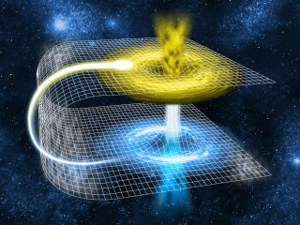 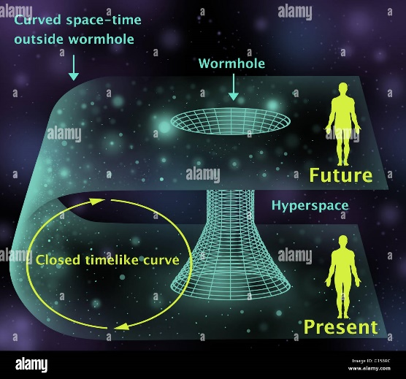
Left: It’s like folding a paper in half … poke a hole from bottom to top as in the line in the picture, and what would have take a long time to achieve by going from start of the mesh to the end, happens very quickly. Space bending shortens time.
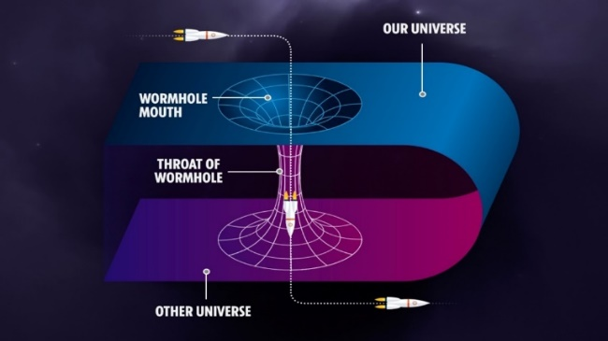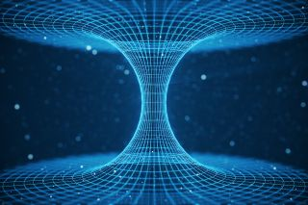
Every one of the over 200 prophecies regarding the time before, during, and after Yahushua’s return is now in play. They are not traveling along a long path to their goal. The space-time continuum has been folded, and all prophecies are now meeting in a short period of time to be fulfilled. This is how love works – as you parents understand.
The compacting of events to shorten days is akin to the worm hole effect.
Matthew 24:21-23: “For then there shall be great distress, such as has not been since the beginning of the world until this time, no, nor ever shall be. 22And if those days were not shortened, no flesh would be saved, but for the sake of the chosen ones those days shall be shortened.”
We saw the beginning of things around 2016, but around the dawn of 2020, as I podcasted at the time, it was like the “paper” was folded in half by Yahuwah, time was bent forward, so that everything began accelerating among the nations, and the earth began responding with upheavals like never before.
We’ve had “wars and rumors of wars” for a long time, earthquakes, diseases, famine conditions, peace taken from mankind, sin abounding openly, perversion of truth, perversion of humanity, i.e. the slaughtering of babies and children, pedophilia and cannibalism uniting, etc.. As America’s 70 years as a super power ended in late 2015, early 2016, we saw a surge of changes for the worst. Now, America is no longer the nation it was but has become no more than a “vassal state” of China. The U.S. government has sold out to China’s rule. I’ve expounded on the details, but the details are rising in number.
Russia has told the Pentagon that their “first strike” will be on Washington D.C., then New York City, then NORAD in Colorado Springs. Both Russia and China are positioned off of both the East Coast and the West Coast and the Gulf of Mexico. I began teaching on Isaiah 13, 47, Jeremiah 50-51, (the nation) and Revelation 18 (NYC) in 1992, for Abba told me clearly while studying Jeremiah 50-51, “this is America.” Now the watchmen proclaim it.
America has to be totally annihilated before world government will take over. The American government-military has been provoking of Russia to attack the U.S. It is now quite obvious to those who are not fooled by the propaganda lies of the public news media. I’ve written several articles on this provoking under the Mikvah of Present Reality. My sources are of the highest rank of truth-tellers!
China needs the resources of America and Canada for their people. China owns great portions of the U.S. already. They are inside, even having been given the Panama Canal and a Navy base in San Diego.
The horrors of tribulation are getting stronger and stronger as the earth itself is revolting against the incredible evils of man, given over to Lucifer’s will. In “The Midnight Meeting”/Mikvah of Present Reality, I tell about Lucifer’s summoning of U.S. leaders to Antarctica to give them their assignments, including Biden.
The goal of the globalists is to kill all human beings on planet earth. Thus when Messiah said that if He didn’t come NO Flesh would be saved alive, He wasn’t joking! The vaccines are turning humans who survive it into non-humans, their DNA signature of Yahuwah changed. Transhumanism will allow some to survive but not as 100% humans. All life on earth that was created by the Word of Yahushua, Genesis 1, is targeted for extinction, from animals to every blade of green grass.
“Families film the openly literal burning of corpses in China” Star News Jan. 4 2023 Tiffany Lo
The people are being burned in the streets – because the morgues are too full and there is no one to bury them. “China is one of the most vaccinated countries on earth,” Daniel said. Many of the deaths are of vaccinated people who just drop dead like some of our athletes.
Hal Turner reported on the young NFL player who dropped dead on the field during a Monday Night Football game– January 3, 2023: “Vaxxident?” “Pro football player collapses in cardiac arrest during televised football game.” (Buffalo Bills team)
All NFL players have to be vaxxinated to keep their right to play with NFL.
Nov. 22 – “The average age of athletes dropping dead is 26.” This is a result of their having to be vaccinated. Babies, children, dying of heart failure following vaccinations. Insane parents abounding …
It’s not just athletes in the U.S., but in other countries as well as a soccer player in Brazil. As of today, 270 top athletes have dropped dead from heart failures of some type due to the vaccines.
Female athletes dying – age 20, 22, 18 (several 18-year-old athletes) They are dying of heart attacks, huge blood clots hitting the heart or brain …
Airline pilots dying while flying commercial flights, co-pilots dying …
The deceiving authorities have dubbed this as “sudden death syndrome.”
Unless Messiah returns NO FLESH WILL BE SAVED ALIVE ON EARTH.
Tucker Carlson Fox News had a show in which he interviewed Dr. Peter McCullough who discussed the unusual amount of athletes dying from, dropping dead from, heart problems. Dr. McCullough attributed the deaths to the Covid 19 vaccine. Insurance company’s life insurance deaths up 1,500% in the last year – to do with quick death from vaccines.
“91-Divoc,”Covid tracking visualizations, John Hopkins, etc: What does Divoc mean in Hebrew? Spelled backwards it spells “covid.” (Jewish Shop)
In Hebrew Divoc means: “The possession of a pernicious soul” - “To separate, tear apart, to annihilate.” It also means “the possession of a demon,” or “possessed by an evil spirit.” The root refers to the evil soul. Dybbuk is a Hebrew word associated with Divoc that is an offshoot of Divoc, and refers to the evil soul of a deceased person. The English equivalent is “divoc” is “possession.” Holdings said that in satanism it is common to say something backwards or use a word backwards … i.e. Divoc and covid.
*One of the side effects of Covid vaccine is `stiff person syndrome.’ That is a very rare disease. One in a million people get this disease. A well-known public person just was diagnosed with “stiff person syndrome” after taking the vaccine.
CNN January 2, 2023 is reporting that 1/3 of world economy will be in recession in 2023. There you have the 1/3rd appearing, as in Revelation – 1/3 this and 1/3 that – to do with judgment stats.
Yahoo News is reporting that Kroger is showing a loss of food supply.
“Lots of empty shelves” – January 3, 2023
“Kroger is the largest supermarket chain in the U.S.” In their various stores under various names, the shelves are emptying … Walmart is also showing empty shelves in the last few months.
Now the push towards digital currency. It’s control; it’s take over; It’s bringing the world into unity under a SYSTEM – the rising Beast system.
Denmark is a cashless nation – having gone to digital currency. It has zero bank robberies because all is done digitally. No more cash, no credit card thefts. Using the digital system, complete no-privacy control will be over each person – all will be seen on the screen as to what is bought, what is sold, what a person likes in their purchases, patterns of shopping, etc. No such thing as using cash and hiding “stocking up” for example.
The US dollar has no backing – it’s just paper – backed by the government’s word as to its worth. It is not worth the paper it’s printed on. It’s just an illusion – spendable only because the government says it has worth. But, it doesn’t…
Russia’s ruble is backed 100% by gold. When the U.S. government goes, the nation goes, the cash is worthless.
I surely do NOT write for sensationalism, nor on subjects that are speculative.
I have written recently about the US failing economy – Mikvah of Present Reality. If you keep up with the Present Reality articles, you’ll learn things the public is totally ignorant of. Public news is like the news of Josef Gobels, Hitler’s propagandist. Gobels turned the nation against the Jews, and the rest is history. Yet, all the while the nation was deeply steeped in Satanism. So, I do not give you hearsay, but actual facts from the highest of sources who are speaking out the Truth. Truth now seems like the lie, and the lies seem like the truth (Isaiah 5:20)
The U.S. money is only as good as the faith people have in what the government says it is worth. The government could change its mind, its rhetoric, at any time, or be forced to by a “Force Majeuer,” – other nations declaring it worthless. Already many other nations are rejecting the dollar. The Russian Ruble is backed 100% by gold. The U.S. dollar is not worth the paper it’s printed on. It has NO backing of anything worth anything except people’s misplaced “faith.”
Daniel: “The FDIC insures your deposits at your bank.”
Video posted by Hal Turner January 2, 2023
“VIDEO: FDIC Brokers Discuss Business Collapse – How to Prevent Public Freak Out.” Reality: “…the FDIC may not be able to insure our money in our bank much longer.”
There is a monstrous binary system entering our solar system. It’s “hot sun” is affecting our sun. Our sun is throwing enormous CMEs (Coronal Mass Ejections) at earth. Its great energy is hitting the earth. It put a hole in our heliosphere recently.
Every planet in the Milky Way solar system is being affected adversely. Dangerous asteroids are entering earth’s atmosphere, or barely skimming past, as Revelation tells us in chapter 8.
Unusual phenomenon is happening – portal openings, as we saw over the White House for a long time in 2022. Here is a picture of a portal opening over Taiwan.
“Interdimensional Portal Opened Over Taiwan”
In dreams, Abba showed Daniel portals in the sky, under the ground, etc. with demons/entities coming out. He talked about the portal over the White House, and a new portal opened over Taiwan.
Whether stargates, portals, doorways, wormholes, - the sky is opening up and things from other dimensions are entering earth. These are affecting human beings – changing their nature – causing them to lose sanity.
I’ve also been writing about the insanity that is taking over the human mind. This is not something we’ve seen before. This is atmospheric anomalies affecting the human brain’s function. It will be used as a “smoke screen” to trick the world’s people into accepting fallen angel creations entering the earth, aka “aliens.”
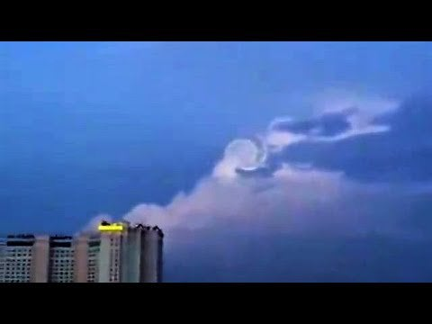
Portal over Taiwan
Video shows this spiral twirling in the sky over Taiwan, much like the one over Oslo when Obama arrived to get his “Peace Prize.” It keeps twirling and twirling round and round. Daniel says the portal is a “worm hole.” It has a cone in the middle that appears to be an entrance point.
We are in a pole shift, have been since at least 2007. Daniel asks: Is the extreme increase in volcanic activity caused by a polar shift?
Strange Sounds article: “Our Entire Solar System is Changing Rapidly and No One is Talking About It,” Dec. 12, 2022.
*Scientists are Predicting that in a short time there will be a massive earthquake on the Cascadia Fault Line … and/or San Andras Fault Line …
China is positioned off the west coast of America, and in the Gulf. Russia is positioned off the west coast and east coast. All China and/or Russia would have to do is hit the two fault lines with a massive nuclear bomb, and the whole west coast would break off and fall into the ocean, from Vancouver to San Diego – all would be gone.
Daniel reported: “Something, we believe, is INCOMING.” Let me say a speck on this. The great telescope of the Vatican on Mount Graham in Arizona, is fixed on the area of the star cluster, Orion, and on it’s belt in particular. For some time now, a gigantic brilliant form is coming down through that belt. The Bible mentions Orion. Steve Quayle, Tom Horn, and others believe that what they are seeing is the descent of the City – as in Revelation 21. John/Yochanan saw it descending and described it. The Catholic astronomers at this huge observatory, using their “Lucifer” device, an infrared device, have been tracking it for a few years and are terrified of what it is. Its trajectory is towards the earth. The astronomers on Mount Graham told Tom Horn and Chris Putnam that they often have to wait until all the UFO alien vessels get out of the way to track anything through the telescope. Supposedly, it is the largest telescope of its kind in the world.
The binary system is bigger than at least 4 Jupiter planets. Some call it Planet X, or Nubiru, but it is a real thing entering our solar system. It has been seen more recently as two suns from various places on earth.
TWO SUNS IN DUBAI October 18, 2022
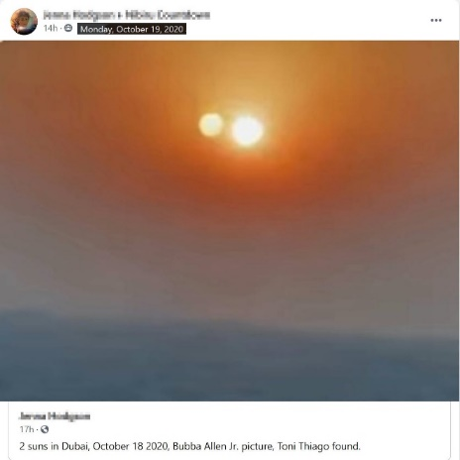
TicTok – sunrise
This type of two-sun thing has been seen by lots of people all over the world.
Planet X has a “hot sun” that is affecting our sun right now, which will ultimately draw the protons out of our sun and it will go dark – not lose heat, but just not shine. Thus, the Bible talking about the sun turning black and the moon turning to a blood-red color, “before the great and terrible Day of Yahuwah.”
Daniel said: “Things are very different this year than they were last year.” We are moving forward almost daily with end-time events prophesied in the Word, yet the majority of lollypop sucking fantasy lovers refuse to take notice, and instead are substituting false doctrines for truth in an attempt to hold onto their fantasy world.
AI is going to unleash more major technology this year. Elon Musk believes the world will be controlled by whoever has the most AI technology
CHAT GPT – THE SYSTEM of A.I. technology: “It’s being called: “The rough beast that is slouching towards Jerusalem.” Daniel said: “That is prophetic”
I say it like this: IT WILL A.I. THAT WILL UNIFY THE WORLD UNDER THE ROUGH BEAST WHO REIGNS FROM JERUSALEM…
“AI will change the world,” Daniel said. AI will control the world for Lucifer and Beast. It is known as “Artificial Intelligence,” but originally known as “Alien Intelligence.” Yes, it is technology from the fallen angels. I know of Israel and the U.S. who have fallen angels giving them the most advanced technology, but I also know that Russia’s extreme advanced weaponry was not something that they just made up. Werner von Braun, head of NASA, former Nazi leader in Germany, said that his knowledge of space, German scientists’ knowledge of space, was given to them by “aliens.” Others who worked with German scientists whom the U.S. military took in under “Operation Paperclip” after WWII, also spoke of their getting technology, like flying saucer technology, space travel technology, from giant fallen angels. The technology was given by séance to the Vril Society in Germany in 1922. Thus saucers were common by the end of WWII, in Antarctica and America. The U.S. space program was going out into the cosmos in the 1950s.
Daniel said, “the Beast system is accelerating – not sometime in the future.”
This is an AI computer image of “God”
Yahushua said: “If you have seen Me you have seen the Father.”
Messiah sure didn’t look like this satanic/demonic creature.
John 14:8-9: “Philip said to Him, `Lord, show us the Father, and that will be enough for us.’ 9 Jesus replied, `Philip, I have been with you all this time, and still you do not know Me? Anyone who has seen Me has seen the Father. How can you say, ‘Show us the Father’? 10Do you not believe that I am in the Father and the Father is in Me? The words I say to you, I do not speak on My own. Instead, it is the Father dwelling in Me, performing His works.’”
AI has created pictures of what WWIII using nuclear weapons will look like on earth. Daniel: “AI has produced pictures of the future that IT INVISIONS. AI is controlled by Lucifer and fallen angels – so it is projecting what it is planning.”
“The power behind the Beast, Lucifer, is projecting what He wants to see done.” Daniel: “WE’RE GOING THROUGH THE WORM HOLE.”
Here is information from an article that you might want to be aware of.
“BULLETIN *** FLASH - URGENT: W.H.O. Meeting in Secret to convert themselves to Enforceable Law under EXISTING Treaty; FORCED VACCINES, OUTLAW GUNS "Public Health Issue" HAL TURNER Jan 9 2023
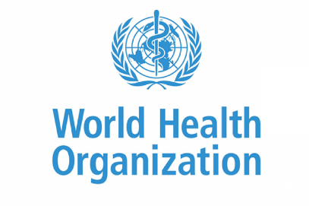
The International Health Regulations Review Committee (IHRRC) of the World Health Organization (WHO) is planning to meet in secret from Monday, January 9, 2023 to Friday January 13, 2023.
The IHRRC will be working to finalize what is now a 46-page document that includes proposed amendments to the International Health Regulations (IHR).
The proposed amendments would: Change the overall nature of the World Health Organization from an advisory organization that merely makes recommendations to a governing body whose proclamations would be legally-binding. (Article 1)
Greatly expand the scope of the International Health Regulations to include scenarios that merely have a “potential to impact public health.”
Seek to remove “respect for dignity, human rights and fundamental freedoms of people.” (Article 3)
Give the Director General of the WHO control over the means of production through an “allocation plan for health products” to require developed states parties to supply pandemic response products as directed. (Article 13A)
Give the WHO the authority to require medical examinations, proof of prophylaxis, proof of vaccine and to implement contact tracing, quarantine and TREATMENT. (Article 18)
Institute a system of global health certificates in digital or paper format, including test certificates, vaccine certificates, prophylaxis certificates, recovery certificates, passenger locator forms and a traveller’s health declaration. (Articles 18, 23, 24, 27, 28, 31, 35, 36 and 44 and Annexes 6, 7 and 8)
Redirect unspecified billions of dollars to the Pharmaceutical Hospital Emergency Industrial Complex with no accountability. (Article 44A)
Allow the disclosure of personal health data. (Article 45)
Greatly expand the World Health Organization’s capacity to censor what they consider to be mis-information and dis-information. (Annex 1, page 36)
Create an obligation to build, provide, and maintain, IHR infrastructure at points of entry TO ENABLE THE W.H.O. TO UNDERTAKE THIS CENSORSHIP (Annex 10)
The 76th World Health Assembly is scheduled to occur from Sunday May 21, 2023 to Tuesday May 30, 2023. In order for the proposed amendments to be considered during the 76th World Health Assembly, they must be submitted to the World Health Organization at least 4 months in advance.
The IHRRC plans to submit these proposed amendments to the WHO by Sunday, January 15, 2023.
***The International Health Regulations are existing, legally-binding international law. If the proposed amendments are presented to the 76th World Health Assembly, they could be adopted by a simple majority of the 194 member nations. According to the already agreed upon rules of the IHR, if the proposed amendments are adopted, the member nations would not need to take any additional actions.
The United States Senate would not be required to provide a two-thirds vote to give their “advice and consent.” No signatures by national leaders would be needed.

Hal Turner Editorial Opinion
This is precisely how all the elected politicians around the world intend to FORCE Vaccines on everyone, FORCE Vaccine Passports, and FORCE quarantines; by DELEGATING those powers to unelected people at the World Health Organization, then telling YOU "Our hands are tied, this is required by International Law and Treaty, we have no power to stop it."
Worse, the WHO deems to decide for you and me, what constitutes "disinformation and misinformation, and they are giving themselves power to not only decide that, but to be able to actively CENSOR all of us, to prevent us from getting information out to the public when WHO and their pals are all wrong . . . as in the just recently proved "COVID-19" nonsense, and their phony "vaccines" that are causing people to drop dead in public.
Because they are making changes within an EXISTING TREATY, no vote by the US Senate is needed and nothing can be done (other than abrogate the Treaty and quit the WHO) to stop these FORCED changes.
You, your family, your children, could be FORCED to be vaccinated with God only knows what, simply because these unelected people in Geneva, Switzerland, say so! You or your children could be FORCIBLY QUARANTINED just because these unelected people in Geneva Switzerland say so.
This is the single most outrageous power grab in world history. It should be stopped.
Now. Because this is an existing Treaty, it, along with the US Constitution, is, by virtue of the Supremacy Claus of our Constitution, "the highest law of the land." No state would be able to "opt-out." There could be no redress of any of it via courts because it is a Treaty. All of us would find ourselves completely helpless.
It has never been decided by a US Court, as to whether or not a Treaty can usurp or over-rule provisions of the US Constitution. Are you willing to trust the present US Judiciary to protect our rights? I'm not. I've seen the federal courts in action up close and personal. They are now fabulously corrupt and completely unreliable.
If this secret meeting is allowed to put forth the changes outlined above, you and I would no longer have a right to speak the truth about things they do; they can censor it by law. You and I would not have the right to say "no" to their new, phony, and harmful, 'vaccines."
This is a usurpation of liberty taking place right before our eyes. We must step up right now to put a stop to it while we can still do so peacefully, and not by force of arms.
Oh, and `arms’ could be deemed a matter `potential to impact public health’ and they could BAN the private ownership of firearms, and it would be legal because . . . a Treaty!”
In conclusion: Keep an eye on what the U.N. is plotting, planning, and putting into world law. Please go over the three articles on the U.N. under the Mikvah of Present Reality #243, 244, 246, to review where this is heading.
The U.N. is a spokesman for the Beast system, a promoter of what Lucifer wants done. Isn’t it fascinating that they do nothing unless it is blessed by Pope Francis!
Just as the sacrifice of children is going on in the White House, so it is going on in the Pentagon, and in the United Nations. These centers are Beast-system centers that have the power to execute all on earth who do not comply with their will.
I close this general overview of just a few things compacting together right now of Lucifer’s plans, being carried out by his chosen people, with a question: “What are Yahuwah’s children doing every day, and praying through even at night, to fulfill His will? In western so-called “Christian nations,” or once-Christian nations, messianic-believing nations, too, what are the professors of “Jesus” or “Yeshua” doing to change the hearts and minds of their people to bring righteousness into the earth, the true new birth, a knowledge of Yahuwah as “Abba,” as “Daddy”, “Father,” and Messiah as the soon-coming King of kings and Master of masters?
The true message of the Word is almost non-existent in the earth today, especially in western culture nations, Greco-Roman culture nations. This is why the few are few. As the pressure/tribulation continues to conform to the will of the Beast/Lucifer’s empowered entity, more and more will reject “Jesus,” or anything related to Him in any way, in order to survive martyrdom.
It's time for much soul-searching, and questioning of our relationship with Father and Son, so that we stand solidly on Their Word rather than being scared into preparing for hell.
In His love, Yedidah – January 10, 2023

