HESHVAN
THE DAYS OF NOAH 2023
AS IT WAS, SO SHALL IT BE… AS IT WAS, SO IS IT NOW!

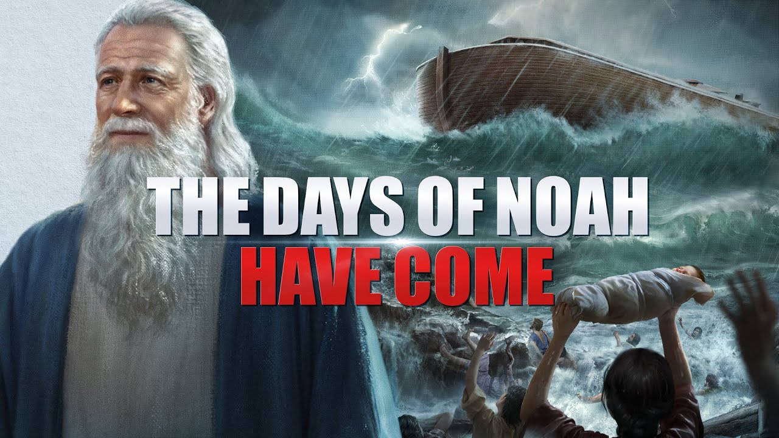
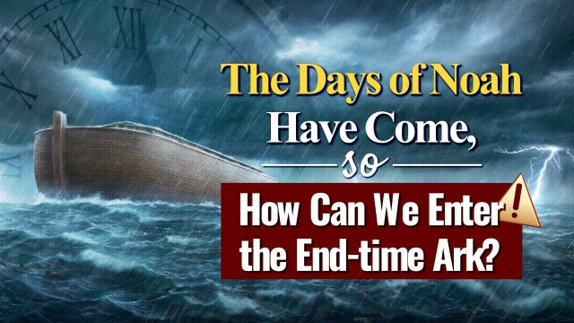

Matthew 24:37-39: “And as the days of Noaḥ, so also shall the coming of the Son of Aḏam be. 38 For as they were in the days before the flood, eating and drinking, marrying and giving in marriage, until the day that Noaḥ entered into the ark, 39and they did not know until the flood came and took them all away, so also shall the coming of the Son of Aḏam be.”

The eve of October 16th began Heshvan 2023. My son sent me a video of his blowing of the shofar, as per Psalm 81. The sliver could be seen clearly in the darkening sky behind him.
The 24th of this month will be the 2-week marker since my surgery from a broken femur. I see the surgeon and believe I’ll be able to stand on the left leg as well as the right leg. I thank you for your prayers that the healing process go into high gear! While keeping up with some things, I have not kept up with other things. The month of Heshvan is very important to me! Abba began showing how it was important to Him also. Heshvan is the second month on the Creation Calendar, the 8th month on the Festival Calendar. In 2023, Heshvan 17 will be the 2nd of November 2023.
The ark sailed on Heshvan 17 with one family, led by father Noah, whose name means “comfort.” He comforted Yahuwah because Yahuwah could trust him to obey Him. Noah was the great grandson of Enoch; Methuselah was his grandfather.
Noah was a “preacher of righteousness” who walked by faith the book of Hebrews tells us. He was not the only full-blooded human on earth, the only non-Nephilim - the only totally uncorrupted one mentally and spiritually. There were others. But Noah was chosen to be “translated” to Mt. Ararat and rescue his family, too, because he “pleased” Yahuwah.
We are in days like his. There are lots of people on the earth, near 8 billion, yet as more-evil takes over, the Noah-like remnant will be extremely small.
I’ve written much about Noah. He went through the Flood to the end of it and was victorious. Isaiah talks about going through the fire, though the flood.
Isaiah 43:1-3: “1Now this is what the LORD says—He who created you, O Jacob, and He who formed you, O Israel: `Do not fear, for I have redeemed you; I have called you by your name; you are Mine! 2When you pass through the waters, I will be with you; and when you go through the rivers, they will not overwhelm you. When you walk through the fire, you will not be scorched; the flames will not set you ablaze. 3For I am the LORD your God, the Holy One of Israel, your Savior; …”
In his days all of mankind had turned against Elohim in favor of Lucifer, fallen angels, Nephilim, and Rephaim. Those days are back when the world’s people will soon worship the antichrist/8th Beast of Revelation 13 or be martyred. The Noah-remnant will be tiny! Just as the Gideon 300 were a tiny remnant (Judges 7), so the requirements of Yahuwah for His remnant in 2023 are fine-tuned. Such scriptures speak of them: Daniel 11:32, Revelation 3:7-13, 7:1-8, 9:4, 14:1-5, 22:3-5. Martyrs are also honored in heaven as in Revelation 6: 7:9-17, 14:
Yahuwah is now in strong judgment stance. The great Shaddi, the ElYon of heaven and earth and eternity, has risen up. There will be no stopping Him. Noah couldn’t and wouldn’t stop Him. So much of humanity now is biologically mutated, even actual Nephilim as in Genesis 6. They walk among us. They make our laws. They direct the minds of humans by the power of Lucifer, and their own power, having limited angelic powers.
Revelation 13: the worship of the 8th Beast of Revelation 17 … the world will worship him and anyone who does not will be martyred. A few hidden ones will survive in places like Petra, in Jordan. The 144,000 will have been translated and on the path of Jeremiah 25 with the message Yahuwah gave him. He went to all the existing kings worldwide in his day. So will this remnant.
Heshvan is the month of Abba’s rescue – rescue from this prison house of death that earth is becoming. Noah and family were not “raptured.” They went “through” because Noah obeyed. Noah represents the remnant of our day in the above Scriptures. His family were hidden/rescued because Abba was good to Noah. It was his personal relationship to Yahuwah that caused Yahuwah to save his family also. Our Elohim (Father and Son) are so gracious and compassionate. However, we each individually must stand before the judgment seat of either Messiah (the saved) or Yahushua (the damned, i.e. Revelation 20.)
Hebrews 11:7: “By faith Noah, when warned about things not yet seen, reverently prepared an ark to save his family, and by faith he condemned the world and inherited the righteousness that comes by faith.”
Abba Yahuwah told us that He would never again flood the earth with water. But in His final judgment, He will cover the earth with fire. As in Jeremiah 51, regarding America and the soon nuclear extinction of it, “they wearied themselves for fire,” or because of fire.
We’re seeing fire destruction in Canada that is horrendous, and also in the U.S. Weather warfare, yes. But, not all of it. Asteroids from space have, and will, come into our atmosphere and bombard the earth, setting off many huge fires. Russia’s Siberia is experiencing huge fires now.
The final upheaval of mankind to its maximum, and the killing off of all life on earth that reminds Lucifer of the Creators, Yahuwah and Yahushua (Genesis 1:3 ff), is being stirred up now. The fallen ones want the earth returned to the time when the powerful ones ruled – Genesis 1:2 – and destroyed everything during it.
This is the time when Lucifer/Satan is given his chance to do pretty much as he wills - not totally, but near totally. Yahuwah has His hands on Lucifer’s leash.
Heshvan is a time of given to the born-again, Spirit-filled, servants of Yahushua, in preparation to go forward into Yahuwah best. Please refer to the article about the joys of martyrdom.
The Jeremiah remnant, as I call it, as in Daniel 11:32 and those Scriptures in Revelation above, is being prepared now to gather to Messiah on Mount Zion in East Jerusalem. All prophecies of Yahushua’s return are coming down now – and nearly 8 billion people will die.
I’ve been reporting on this with Word foundation Genesis to Revelation, but few are taking action across board to prepare themselves. We must be about our Father’s business as Yahushua said. For “night comes when no one can work.” We must prepare for our own survival also.
The chaos created by such evil in the Middle East, the provoking of a highly emotional ancient people-group to do the dirty work of the globalist workers for Lucifer, is a heart break for me. When I lived there for 16 years, 7 years in Jordan, 7 years in Israel, there was peace. There was cooperation between the Middle Eastern nations surrounding Israel.
When Obama single-handedly destabilized the Middle East, taking out the peace and replacing it with unjustified war, as George Bush Sr. with Gulf War I, and George Bush Jr with Gulf War II and the Afghanistan war to protect America’s heroin and opium fields. Then Obama comes and attacks Bashar Assad in Syria. Syria was a stronghold for Christians and Kurds. I met Christian Syrians. I talked to Iraqis – young men of college age.
“Why” is the big question. Why tear up what is peaceful for the people? To steal Syrian oil – yes, that was part of the reason for tearing the peace from Syria. Now Netanyahu wants to destroy Damascus and Iran’s capitol.
Hussein was like other such ancient-type national leaders - but the people were content. Same with Egypt. I still cannot wrap my mind around Obama’s power to tell Egyptian President Hosni Mubarak to get out of office, and he did. What power was behind that? Egypt and Israel had a good pact established. Russia came in to help Syria protect the Christians and Kurds. Russia is poised to help Syria again.
The whole thing was a tragedy perpetrated by the U.S. to start the fires of evil. The average citizens died in terrible scenarios for no reason.
So now we see the increase in evil, the provoking of regional and international war by the U.S., by Israel, by the U.K., by NATO. All of this provoking to slaughter humans, along with abortion, and the sacrificing of children to Lucifer by the millions.
Sad to say that during Heshvan we have Halloween. The stores make it look like a big fun time - harmless, innocent. Yet, as I reported last year, millions of children and babies were sacrificed to Lucifer-Satan on Halloween in America and worldwide. This year the sacrifice will be worse than ever. Lucifer’s blood lust is increasing. He is growing in power and arrogance.
This year, Lucifer will require an extreme sacrifice as he moves forward with total world takeover. Key places of sacrifice still – yes, like the White House underground, the Pentagon, the U.N. – so many other underground places across the U.S. – and around the world, under the Vatican included. So many children have been and will be kidnapped for sacrifice. Recently several hundred children just “disappeared” from Cincinnati, Ohio.
The judgment of Yahuwah will be thorough and final! Heshvan is a month to make sure you are like Noah – known by Yahuwah, trusted by Yahuwah to do His will.
According to the book of Jasher, the building of the ark took Noah and his sons 5 years. Yahuwah has been working with His children through the centuries, especially now, on their building of their arks of safety for them and their family - spiritually, and physically in preparation as He leads. He provides an ark of safety for those who submit to His instructions and align to His nature, ways, and thinking.
Good question in the second picture above. Make sure you are truly born again and understand what it means to be saved out of the kingdom of darkness and transferred to the Kingdom of light because of your faith in Yahushua/Jesus Messiah. Refer to: “The True New Birth, Mikvah of Eternal Salvation. Salvation is not about adopting a belief system, a religion of man. It is about becoming a totally new creation, i.e. II Corinthians 5:17-21.
Yet, a true new birth is just the 1st step. In order to be set-apart unto Him, we must be filled with His Father – the Spirit. We must give our lives into the hands of Yahuwah and Yahushua/Yeshua/Jesus to teach us the Word from Genesis 1:1-Revelation 22:21. It all interlocks. It begins with Messiah, Yahushua, the Word speaking Genesis 1:1. It ends with eternity for those born again by faith in His shed blood and resurrection.
We must obey what we learn. He is our Teacher. He speaks to us from within our re-born Spirit-filled spirit, as He once spoke from the Ark in Solomon’s Temple. We become His Temple. He wants to be very personal with you. However, if you are lazy, religious, and a lover of this world and your carnality of mind and emotions, He can do nothing to help you prepare. Seek Them (Father and Son) with all your heart, mind, soul, spirit, strength!
Thank you for your prayers for me. The fire of the Spirit of Yahuwah is growing stronger. I feel it in body, mind, emotions, spirit. He is bringing those who are willing into their full calling for these latter days. Those sensitive to the Spirit within their temple of Yahuwah, are always ready to share the Good News of salvation and lead others to be born again, praying for them to receive the Spirit, praying for healing, praying for deliverance from demonic strongholds. These are His warriors of our day.
I hope that’s you!!!
In His love, the greatest of all love, Yedidah
October 21, 2023

