HISTORIC MILITARY EXERCISE JUNE 12-24
FORCING WWIII TO LEAP FORWARD

The coming Beast Empire (Reich) is well on its way to uniting the world under its authority and power. It’s right to rule will be based on lies, deceptions, and great fear taking over human beings all over the earth.
This is the largest military exercise in history. It is well considered that it could be a set up for united attack on Russia. Whatever its goals are, the U.S., NATO - they are aimed at starting World War II. This war will be a nuclear war. It will begin and end quickly – but more human lives will be lost than in all the wars of history, especially in western Europe, om the U.K., and especially the U.S., since the annihilation of the U.S. is the prime goal.
In 1992, as I read Jeremiah 50-51, Yahuwah spoke to me clearly – “this is America.” That has been confirmed by His key watchmen ever since, especially now.
Yahuwah took me further to portions of Isaiah 10, all of Isaiah 13, to Jeremiah 25, and to Revelation 17-18 as New York City. About 5 weeks ago, Yahuwah spoke to me: “Vladimir Putin is MY Nebuchadnezzar.” The Scriptures call Nebuchadnezzar Yahuwah’s SERVANT. Yahuwah must judge nations who have had the Word of Yahuwah for over 2,000 years, yet, they are now turning from it in mass, to embrace “doctrines of devils,” as Sha’ul warned us.
What the fantasyland-programmed people of America don’t understand is that Yahuwah and Yahushua, Father and Son, Elohim of Israel, have been in judgment mode, especially from 2016 forward, as in Genesis 6. The great separation between Their children and the world’s children submitted to Satan/Lucifer and the fallen angels, is taking place. The great falling away is greatly happening, foretold in II Thessalonians 2. We are well into “the days of Noah.” Yahuwah seeks those who will obey Him as Noah did.
As reported for some time, it is now just fact that the “Apollyon,” of Revelation 9:11 is with us, aka the “Beast” of Daniel 7 and Revelation 13:1-10. The “Nimrod” returnee, aka “Apollyon,” is asking for trillions of dollars from the nations for his army, as then Prince Charles reported to the assembled national leaders in Scotland in 2021.
Here is a concise update on the Largest and Most Historic Military Exercise being conducted by NATO this weekend – with its epicenter in Germany. This has the potential of igniting the outbreak of WWIII. At the end, I also include the targets Russia has told the Pentagon they will nuke if the U.S. continues to provoke Russia, continues to lie about Russia, and threaten the nation of Russia and its people.
This concise update is by an ex-FBI man who is on top of the truth in this all the way. I’ve been following it from the beginning. The persistent provoking, the blatant lies told about Russia by America, Ukraine, NATO – gave Russia no choice but to enter Ukraine to protect the Russian people from planned attack on Russia.
German Chancellor Angela Merkel explained how we set up Russia by the Minsk Agreement – lying to Russia, then pulling the rug out from under their feet. The U.S. public propaganda lying news has caused Americans to hate Russia, while the Russian

are praying for the American people that lives not be lost if Russia has to drop its hypersonic nuclear bombs on us. They especially pray for Christians since Russia is the ONLY declared Christian nation on earth. Actually, I was Russian Orthodox for a few years during Abba’s vast training program He took me through. In 1999, I spent 3 ½ months in Russia working with Ebenezar - with Russian Jews, with the Jewish Agency in Birobidzahn, to bring Jewish Russians back to Israel to make “Aliyah.” [Online info: “Birobidzhan is a town and the administrative center of the Jewish Autonomous Oblast, Russia, located on the Trans-Siberian Railway, near the China–Russia border.”] In all my years of travel and work for the Master in 39 countries, living in 4 of them, I must say that I experienced more miracles of His leading in Russia in that short time than ever in any other place on earth. And I was there from September through December in Far East Russia.
It is well possible that Russia is the “king of the North” in Daniel 11, since they completely control the Artic to our north. The four nations that Yahuwah gave me in 1992 that would infiltrate and destroy America are the four nations that are uniting who will join to kill, destroy, steal, and erase America from the map: Russia, China, North Korea, and Iran.
Russian troops by the tens of thousands are already in the U.S. Chinese troops by the tens of thousands are already in America. Men of military age are being allowed to cross the Mexican border into the U.S. by the thousands. The border guards are instructed to give them cell phones to contact their leaders. Many of them are being put up in $500.00-a-night hotels in New York City and given three meals a day.
Many Chinese are going to underground bases, or living quarters in Chinese shipping containers across America, complete with air conditioning. Iran has “sleeper cells” all over the U.S. North Korea is chaffing at the bit to fire nuclear rockets into the U.S.
It has been planned for a very long time by those in America, to destroy America so that the anti-messiah/antichrist Beast of the 8th kingdom can establish his one world government without any opposition or competition.
Below are notes from Hal Turner, former FBI, insider today, telling the truth, as the watchmen of Yahuwah know. He’s kept us up with correct reporting since this whole deception began to be laid out for an ignorant world. WWIII has to precede the arrival of the Bestial genius who will unite earth’s people around himself.
RUSSIA AND NATO AIR DEFENDER 2023 EXERCISE LED BY GERMANY JUNE 12 - UPDATED AGAIN 10:48 AM EDT -- TODAY! NATO "AIR-DEFENDER 2023" EXERCISE BEGINS . . .HAL TURNER 12 JUNE 2023
https://halturnerradioshow.com/index.php/en/news-page/world/today-nato-air-defender-2023-exercise-begins
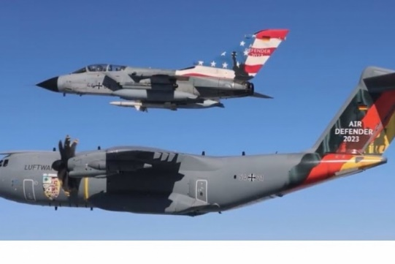
“The largest air force deployment exercise in NATO history, Air Defender 23, kicks off today. Many people fear this "exercise" is actually a "cover" for NATO to directly involve itself in the Russia-Ukraine conflict, and thereby commence World War 3, which would go nuclear.
From 12 to 23 June, 10,000 participants from 25 countries will train on 250 aircraft, including 190 combat aircraft, in European airspace.
Wunstorf Air Base in Germany is the centerpiece of the exercise, home to a purpose-built field tank farm.
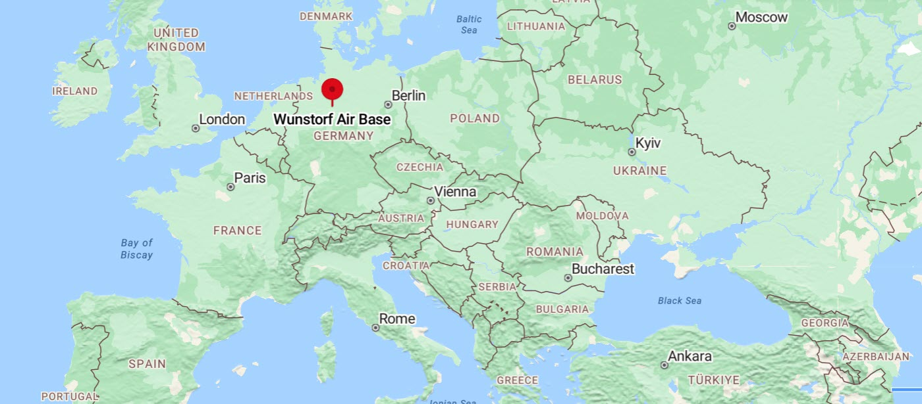
The warehouse is the largest in Germany and holds about 2.4 million liters of kerosene. We are not hinting at anything. On Saturday, about 300 people protested in front of the air base against NATO exercises. The protesters demanded diplomatic solutions instead of the use of weapons and called for an end to the conflict in Ukraine.
Hal Turner Editorial Opinion
Everyone is waiting for the other shoe to drop with the Russia-Ukraine Conflict which NATO uses as an excuse to involve itself directly. God knows NATO has done everything it knows how, to get Russia to attack them: NATO has provided Ukraine with guns, ammunition, artillery, shells, missiles, HIMARS MLRS, Intelligence, Surveillance, Reconnaissance and even targeting info on how and where to hit Russian troops. Countless BILLIONS in cash money has poured into Ukraine from NATO countries, to kill Russians.
That Russia has not taken this bait is amazing. The patience and self-discipline of the Russians and their leaders is mind-boggling. Yet, God bless them, the Russians have stayed the course.
In World War 2, Russia fought Nazi Germany. At the time, Russia was part of the then the Soviet Union, but it was Russia that lost the most in that war: 27 MILLION Russians were killed fighting NAZIS.
Fast-Forward to 2014, what pops-up in Ukraine? A NAZI infested government, installed by the West, after the West fomented, incited, and financed riots that toppled the government of President Viktor Yanukovich.
After overthrowing the Ukraine government, the West goaded Ukraine to start attacking the Russian-speaking populations of Luhansk and Donetsk. Those two provinces wanted to join Crimea and secede from Ukraine after its government was overthrown by the West. The new puppet government of Ukraine refused to allow those two provinces to secede, and instead, sent troops to begin attacking the Russian-speaking civilians there.
Russia covertly intervened with troops to help defend Luhansk and Donetsk. The two provinces, with Russian help, fought Ukraine to a standstill.
So, the West got sneaky. A peace conference was called to meet in Minsk, Belarus. Ukraine, Luhansk, Donetsk, France, Germany, and Russia, attended. A peace agreement was signed . . . and Ukraine did not abide ANY of it for years after.
Turned out, the West overtly LIED during the Minsk Peace Talks. It came out later, that then-German-Chancellor Angela Merkel, and then-President of France, Francois Hollande, signed the Minsk Agreements knowing it was a ruse; they told the press in 2022 - they just wanted to buy time to arm Ukraine!
So, all the way back in the year 2014, it was the West's intent to start a war between Ukraine and Russia!
For eight years, from 2014-2022, the West armed and trained Ukraine to NATO Standards. Ukraine had a standing army of 800,000; the largest in Europe.
In December, 2021, Ukraine massed more troops, tanks, artillery, fighter jets and the like, on the borders of Luhansk and Donetsk. The earlier years from 2014-2022 where Ukraine killed upwards of 13,000 civilians in Luhansk and Donetsk apparently wasn't good enough; Ukraine was going to slaughter the people there. Russia said "no" and stepped-in on February 24, 2022.
The West went nuts, claiming this was "an unprovoked aggression by Russia." It wasn't. It was provoked over, and over, and over again, by the West.
In the almost 16 months since the conflict began, NATO has done anything and everything it can to help Ukraine kill Russians. NATO failed. Ukraine is getting smashed on the battle field despite all of NATO's help. Ukraine is losing the conflict - badly.
It is so bad for Ukraine that they have to draft 16-year-old boys off the streets, at gunpoint - to force them to the front to fight. The bloodbath is horrifying, but NATO will not stop pushing Ukraine to fight further.
Yet for all its pushing of Ukraine to fight-on, and for all the equipment NATO has supplied to Ukraine . . . Russia is still winning. Russia just smashes all the gear being sent by NATO. Within the past 48 hours, look at what Russia did to NATO's "advanced" weaponry:
Three out of the six Leopard 2R mine-clearing vehicles Finland donated to Ukraine have been lost in the same field. With other engineering vehicles in the field as well, this is a massive loss for the brigade, no matter what.
Russia just moves right along, smashing and destroying everything NATO sends.
As you read this story on June 12, 2023, Ukraine's only hope is for NATO to enter the war and fight Russia directly. But Russia has not attacked NATO. So, at this point, an "incident" has to take place so as to justify NATO's entry into the conflict. And THAT is what this "Air Defender, 2023" exercise is likely all about. Someone is likely to create an "incident" which NATO will then use to justify its entry into the war.
From today through June 24, is the single most dangerous time in this world since the Cuban Missile crisis of 1962. If an "incident" is made to happen, and NATO enters the fight, it will go almost immediately to nuclear war. There will be no warning for any of us.
The world is going to look a lot different, and sooner than people might suspect. All it takes is one Keystone removed from the arch to threaten the entirety of the system upon which our society is based.
UPDATE 7:56 AM EDT -- NATO has already begun probing! NATO military aircraft are penetrating air space of the Black Sea:
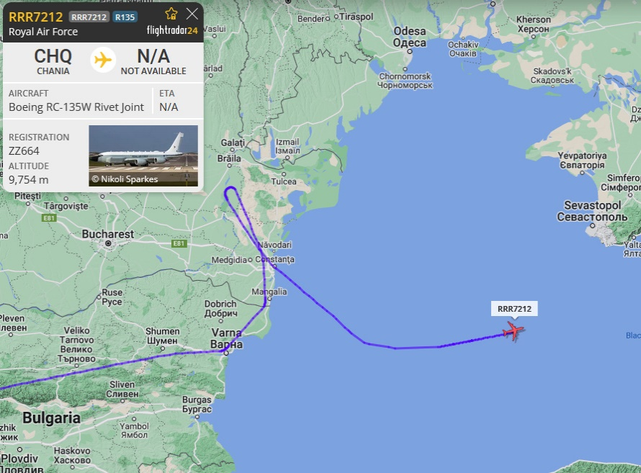
Above is a "Rivet Joint" aircraft. The RC-135V/W Rivet Joint reconnaissance aircraft supports theater and national level consumers with near real time on-scene intelligence collection, analysis and dissemination capabilities.
The purpose of these flights is to test Russian reaction times and gather up-to-the-minute Intelligence. NATO is fixin' for a fight…”
Folks, pray for the Russian people. Russia is a peaceful nation. They do not want war. Pray for those who are in republics that joined Russia, republics who have incurred, and are still incurring, much death from Ukraine for deciding to be free from tyranny. Pray for Yahuwah’s family who have been caught up in the manipulation going on by Satan’s forces in many countries of Eastern Europe.
Russians died in huge numbers fighting Nazis in WWII. America made sure Nazis reigned in Ukraine. I have photos of U.S. military in Ukraine with Nazi badges on their sleeves, working with Ukraine’s Nazi military force. Putin said he entered Ukraine to “de-nazify” it. Pray for Russia’s leadership. In many ways, Russian leaders are more just than those ruling western nations. They love their people and do not want them harmed.
In the love of Yahuwah, siding with His justice, Yedidah
June 12, 2023

