HISTORIC NEW POPE AND HIS DARK PAST

Newly Elected Pope Leo XIV Has Dark History Of Ignoring Child Sex Abuse In Catholic Church says Info Wars - May 8th, 2025 by Kelen McBreen

Pictures below! As the world dives into the background of Cardinal Robert Francis Prevost, now known as Pope Leo XIV, it is being revealed that he has a disturbing background of allegedly covering up for priests accused of sexually abusing children despite formerly being in charge of investigating such cases. Pope Leo is the first American-born pontiff in the history of the Vatican, but sadly his legacy is beginning with a shroud of darkness due to his controversial connections to colleagues charged with molesting kids.
During his time as provincial of the Augustinian Province of Chicago from 1999 to 2001, Prevost allowed a known accused pedophile named Father James Ray to live at St. John Stone Friary, which was just around the corner from a Catholic elementary school. Diocesan records reviewed by Catholic news outlet The Pillar showed Ray was restricted in ministry in 1991 and “had been accused multiple times of sexually abusing boys, at least one of them for years.” The Illinois Attorney General filed a report detailing 13 allegations of abuse by Ray dating from 1974 to 1991.
In another case of Prevost allegedly turning a blind eye to accusations of child abuse within the church, the new Pope reportedly failed to open an investigation into two priests at the Diocese of Chiclayo, Peru, which he led from 2014 until 2023, when three sisters went public saying they were molested by the men. The three alleged victims said the abuse took place when they were underage in 2007 by Fr. Eleuterio Vásquez Gonzáles and Fr. Ricardo Yesquen.
One of the victims, Ana María Quispe Díaz, later went public by posting videos to social media discussing her abuse and encouraged more victims coming forward.
She claimed seven other alleged victims contacted her and “that some of them had suffered abuse as far back as 1997.”
The Pillar reported “the diocese — now under the authority of apostolic administrator Bishop Guillermo Antonio Cornejo Monzón, following Prevost’s departure – decided to reopen the case” and that “Vásquez admitted the abuse.”
Despite these scandals about Prevost ignoring sexual abuse allegations, Pope Francis selected him as Prefect of the Dicastery for Bishops in 2023 where Prevost took the role of overseeing bishop appointments worldwide and enforcing Vos estis lux mundi (2019), Pope Francis’ decree on addressing episcopal negligence in abuse cases.
Now, the controversial cardinal has reached the highest position in the Catholic Church after being named Pope Leo XIV on Thursday. May 8, 2025

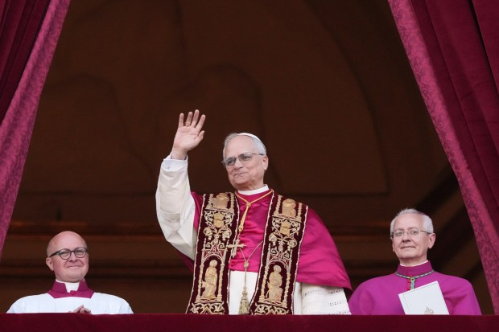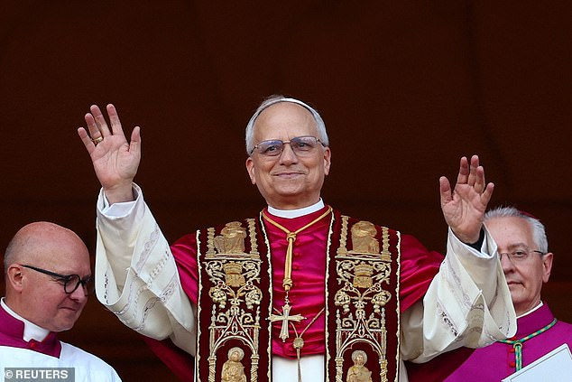
Newly elected Pope Leo XIV, Robert Prevost addresses the crowd from the main central loggia balcony of the St Peter’s Basilica for the first time, after the cardinals ended the conclave, in The Vatican, on May 8, 2025. Robert Francis Prevost was on Thursday elected the first pope from the United States, the Vatican announced. A moderate who was close to Pope Francis and spent years as a missionary in Peru, he becomes the Catholic Church’s 267th pontiff, taking the papal name Leo XIV. (Photo by Tiziana FABI / AFP) (Photo by TIZIANA FABI/AFP via Getty Images)

From Daily Mail May 8 2025
Robert Prevost has been named as the new Pope and will become Francis' successor following two days of voting inside the Sistine Chapel. The pontiff, who will be named Pope Leo XIV, is the 267th Holy Father - becoming the religious leader of Catholics across the globe. The 69-year-old is also history's first American
Pope.”
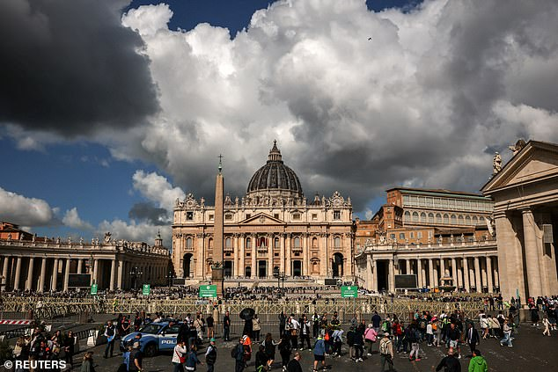
Crowds forming and waiting for the white smoke to appear. May 8 2025 in front of the Vatican in Vatican Square. My addition: According to St. Malicai’s very accurate prophecies, this is the last pope. Will he be “Peter the Roman?”
Yedidah reporting May 8 2025

