HURRICANE MILTON AND THE GOALS OF RIGHTEOUSNESS HATERS

OCTOBER AGAIN! Lucifer’s month to amass death and destruction – and kill as many as possible as a great sacrifice to him. Sounds spooky and bizarre? Not so …
It’s just fact that few notice unless the Spirit of Yahuwah points things out.
I was friends with man named Ken McBride and his wife. My youngest was in first grade that year. Ken wrote a book describing his testimony and what Halloween is all about. I shared it with my daughter’s teacher. The next morning at school, she called me aside to tell me that she read the book, and she would not ever celebrate Halloween again, nor have any reference to it in her classroom. Ken was former satanist, leader of several covens of witches in the Ft. Worth area of Texas. He was well known in that world. A few days before he was going to participate in a ceremony in which he would incarnate a demon, something happened from Yahuwah. Some Christian witnesses to the power of Jesus came to his door and began preaching the gospel. They knew who he was. He heard them. Then on the day of a miracle, Ken was muttering his speech that he had to say to incarnate the demon. All of a sudden demons appeared in his living room, ready to kill him. He was not supposed to recite those words until the time of incarnation. Ken had been very involved with the kidnapping of children for sacrifice in the Fort Worth area for the annual Halloween sacrifice to Lucifer. He knew where all the children were kept before Halloween in cages. When Ken saw those demons and knew they would kill him for he was outside the required pentagram, he called out “Jesus, Jesus, Jesus,” and passed out. When he woke up, he crawled on the floor to his bathroom to see himself in the mirror. He thought he had to be dead, but he wasn’t. He quickly gave his life to Jesus and became a strong witness to His power over the power of Lucifer and the fallen ones. He became a threat to them. I’ve seen them in various forms. I’ve smelled the sulfur smell that comes from them. I know that they take the form of snakes often, especially the anaconda python. I know this for sure.
In my 30 years of “learning” about satanism firsthand, and the insanity in those who follow he and his minions, and experiencing the sadism and evil of them, I understand what evil is behind what is happening in America, as it is taken over by Lucifer. America is a Luciferic controlled nation. We are just now beginning to see the intensity of the evil in the treatment of the victims in North Carolina, and this attack on Florida. The evil ones have taken over leadership nation-wide and world-wide. So you can imagine their hate of Florida Governor DeSantis.
My son told me that Governor DeSantis has a task force, and about half on the task force are pastors. Florida’s governor is going to bat against the evil in his state. He is an enemy of “the deep state” – but then so is Yahuwah.
Geo-engineering Watch Director Dane Wigington Exposes The Federal Government’s Secret Weather Weapons System Now Targeting All Life on Earth
geoengineeringwatch.org. If you really want to know what’s going on with weather tragedies in the U.S. and worldwide, I suggest you learn from Dane Wiginton!!!
Hurricane Nadine following Milton! It’s an attack on Governor DeSantis for his campaign to uproot evil and bring righteousness in his state. He is working on enforcing righteousness in Florida because of the governor’s love of right and truth. We see the enemy’s wrath against the Governor and all the Floridian people who stand with him for right and truth!

From Daily Mail October 10, 2024 with pictures:
“Monster storm Hurricane Milton left a path of destruction across Florida overnight, leaving several people dead and 3million without power as it heads to the Atlantic. The first casualties were reported even before Milton made landfall as a Category 3 storm around 8:30pm EST, bringing 'catastrophic' flooding, 120mph winds and several twisters - some of which proved lethal.
After making landfall, Milton began rumbling east, ripping up everything in its path before ripping apart the roof of Tropicana Field, the home of the Tampa Bay Rays baseball team in St. Petersburg
At least 117 tornado warnings were issued in communities across the state overnight and into this morning, with dozens reported to have materialized and wrought havoc. More than 3 million homes and businesses were without power Thursday morning in Florida.
Daylight photos show the devastating floods that have struck Punta Gordon in Florida. The coastal resort sits about 55 miles south of Sarasota, where Milton made landfall. Its streets have been filled with water, with multiple boats tossed inland by the force of Milton's winds.
Milton struck as a category 3 hurricane and has now moved across Florida and out into the Atlantic where it will weaken to a tropical storm. But Tampa Bay residents are bracing themselves for a storm surge in the next few hours as the tide comes in. The record-breaking wall of water is forecast to reach heights of 10 feet and will destroy everything in its path.
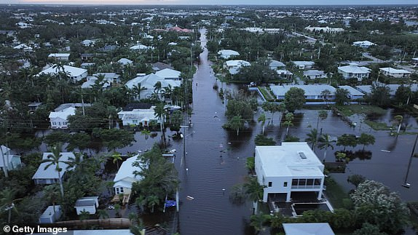
The Tampa area is bracing for a storm surge on Thursday morning after Hurricane Milton made landfall in Siesta Key. The storm pounded cities with ferocious winds and rain, whipping up a barrage of tornadoes and causing an unknown numbers of deaths and leaving 3 million without power. St. Petersburg recorded over 16 inches of rain, prompting the National Weather Service to warn of flash flooding there as well as other parts of western and central Florida.
As dawn broke Thursday, officials repeated that the danger had not passed: Storm surge remained a concern in many parts of Florida and tropical storm warnings were in place for much of the east-central coast.
Officials in the hard-hit counties of Hillsborough, Pinellas, Sarasota and Lee urged people to stay home, warning of downed power lines, trees in roads, blocked bridges and flooding. 'We’ll let you know when it’s safe to come out,' Sheriff Chad Chronister of Hillsborough County, home to Tampa, said on Facebook.
Tampa mayor Jane Castor said she was pleased the area did not see the predicted storm surge. However, she urged residents to stay inside and warned that 'it's not over' as Hillsborough County could flood when the high tide comes in at 7am EST. Meanwhile Sarasota officials said: 'We know everyone is eager to see how our community fared following Hurricane Milton. 'At this time, please stay where you are and continue to shelter in place. It is not safe to venture outside yet.' 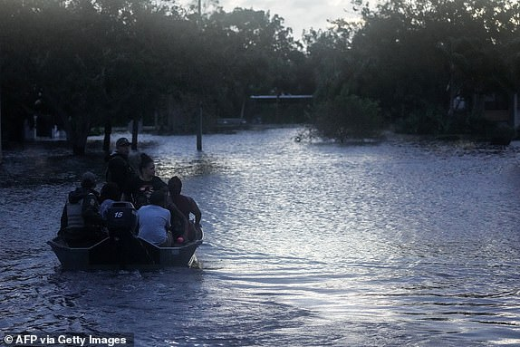
Residents are rescued from an apartment complex in Clearwater that was flooded from and overflowing creek
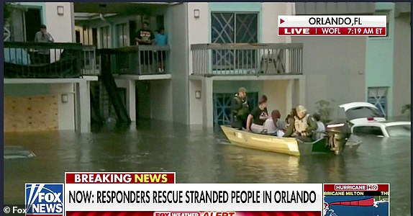
Hurricane Milton makes landfall in Florida: Everything you need to know
Hurricane Milton, one of the most powerful storms to hit the US in recent years, made landfall in Florida on Wednesday night resulting in record flooding and extreme winds that have already caused multiple fatalities. Milton hit Siesta Key, a barrier island off the coast of Sarasota, at around 8.30pm local time on Wednesday according to the National Hurricane Center.
Once a category five hurricane, the storm has since been downgraded to category one as it barrels its way across the Sunshine State, but officials warn it is still capable of generating life-threatening storm surges and deadly tornadoes.
At least two people have been killed after a tornado levelled more than 125 homes in St Lucie County in southeastern Florida while others were taken to hospital. More than three million people were left without power as several months' worth of rain fell in just a few hours
The roof of Tropicana Field, home to Major League Baseball's Tampa Bay Rays, was ripped to shreds when devastating 100mph-plus winds came ashore leaving huge sections of the domed stadium in tatters. In St. Petersburg, a gigantic crane teetered off the top of a building and crashed into the offices of the Tampa Bay Times, demolishing several stories.
Tampa airport saw minimal damage, and will reopen tomorrow
Florida governor Ron DeSantis said on Thursday morning that Hurricane Millton was not 'the worst case scenario.' He told reporters that the worst storm surge appeared to be in Sarasota County, where it was 8 to 10 feet — less than in the worst place during Helene. The Governor said the Tampa airport sustained minimal damage and is expected to open tomorrow.
Milton did cause deaths in the state, though a number of fatalities is not yet known, DeSantis said. The storm weakened before it made landfall but still cause significant damage, particularly due to the tornados it formed as it approached the Gulf Coast.
Now Milton ravages Florida's east coast, with cars overturned and homes damaged in Palm Beach County: Hurricane Milton has ravaged the Palm Beach County area, with people rescued from under debris and overturned vehicles littering the streets. Palm Beach County Fire Rescue responded to multiple reports of tornadoes, associated injuries, and trapped people in the Wellington, Acreage, and Loxahatchee areas on Wednesday. Several people in Palm Beach county were rescued after they were trapped under debris or stuck in under turned vehicles due to strong winds.
Officials said 911 calls began coming in just before 5pm and did not stop for over 50 minutes. At least 40 units were deployed to help while the tornadoes were ongoing. Storm surge remained a concern in many parts of Florida and tropical storm warnings were in place for much of the east-central coast.”
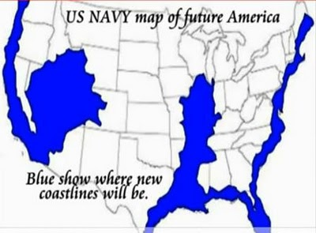
Above is a Navy map I got about 8-10 years ago. I’ve got a bigger more detailed one. But they all show Florida underwater. I lived in Florida with a daughter and her family for several years. Abba opened many doors there for me to minister in meetings. I met one of my very dearest friends in the Tampa area. I met her when she invited me to speak at her house. It is amazing how many people we both knew in different states. What a miracle relationship. I flew in and out of the Tampa airport to different countries. Tampa was supposed to be the major hit-point of this hurricane. The hurricane was said to be a 5, then a 4, but hit as a 3. I know much damage has been done – irreparable damage – lives lost. But Abba has had mercy and answered prayers!
A little baby boy was born a couple of days before the hit of the first hurricane – a grandson of my dear friend in Tampa. They were in the hospital in Tampa while Milton hit Tampa – and are safe. Mom and dad evacuated to northeast with the first 3 children and their families. HalleluYah!
When I was in Florida staying with my daughter and family, we were in the Parrish-Bradenton area. I remember how close Sarasota was. We were near Anna Maria Island. Such a beautiful area. My son and his wife lived near us for a while.
Good memories of Florida! All over the world Yahuwah’s people are suffering because of the evils of Lucifer, fallen angels, and the offspring of those angels with human women – just like in Genesis 6.
It’s like someone threw a switch and all of a sudden evil rises up to an extreme that is shocking the nation and the world. WHY?
Foks, no doubt about it: WE ARE IN THE DAYS OF NOAH! The Judgment of Yahuwah is over the earth against all ungodliness. But, because of the concentration of the House of Israel/Ephraim in America, we see the result of the sin going back to 722 BCE. Yes, we’re watching the fallen ones attacking the righteous and on their influence for righteousness. The Nephilim, and fallen angels leading them, are in control of Washington D.C. and the U.S. government. If you’ve read my recent article taken from Xi Van Fleet’s book Mao’s America, you know a lot more than 99.8% of the American people know. It’s under Present Reality; or Recent Articles. The America we once knew is gone. That’s obvious from all angles.
What happened to the world under the judgment of Yahuwah (Genesis 6-9)? It was flooded. Read Genesis 6 and 7. We are in the month of Heshvan by the Creation calendar, when Noah’s ark sailed. Heshvan 17 this year is October 24th.
Noah was able to save his family by his obedience to Yahuwah. Now, we have help also because we have the Savior, Yahushua our Messiah and soon-coming King. Obedience to Their will, to Their commands is the only way to eternal life and help down here as He wills. It is said Hurricane Nadine is next.
Pray for the children and families of America, of the world, as Abba leads you! Lucifer wants the greatest sacrifice to him of all history – this year.
In His love, shalom always, Yedidah – October 10, 2024

