HAPPENING RIGHT NOW! AUSTRALIA WILDFIRES!
TEMPERATURES SO HOT PEOPLE WON’T BE ABLE TO LIVE THERE

In a late December interview with “Mike from around the world” on Paul Begley.com Youtube, Mike said that Australia will get so hot (temperature-wise) that people won’t be able to live there. The wildfires are overwhelming. Magma is moving also, causing great heat. And, they’re just entering summer. This extreme heat is affecting New Zealand and Tasmania also.

From the Big Wobble - Monday, 30 December 2019
“Aussie Bushfire Update No 14: 'Suicide': More than 30,000 trapped in East Gippsland: Melbourne on fire: Fires creating own lightning: Sydney surrounded: Wildlife annihilated”
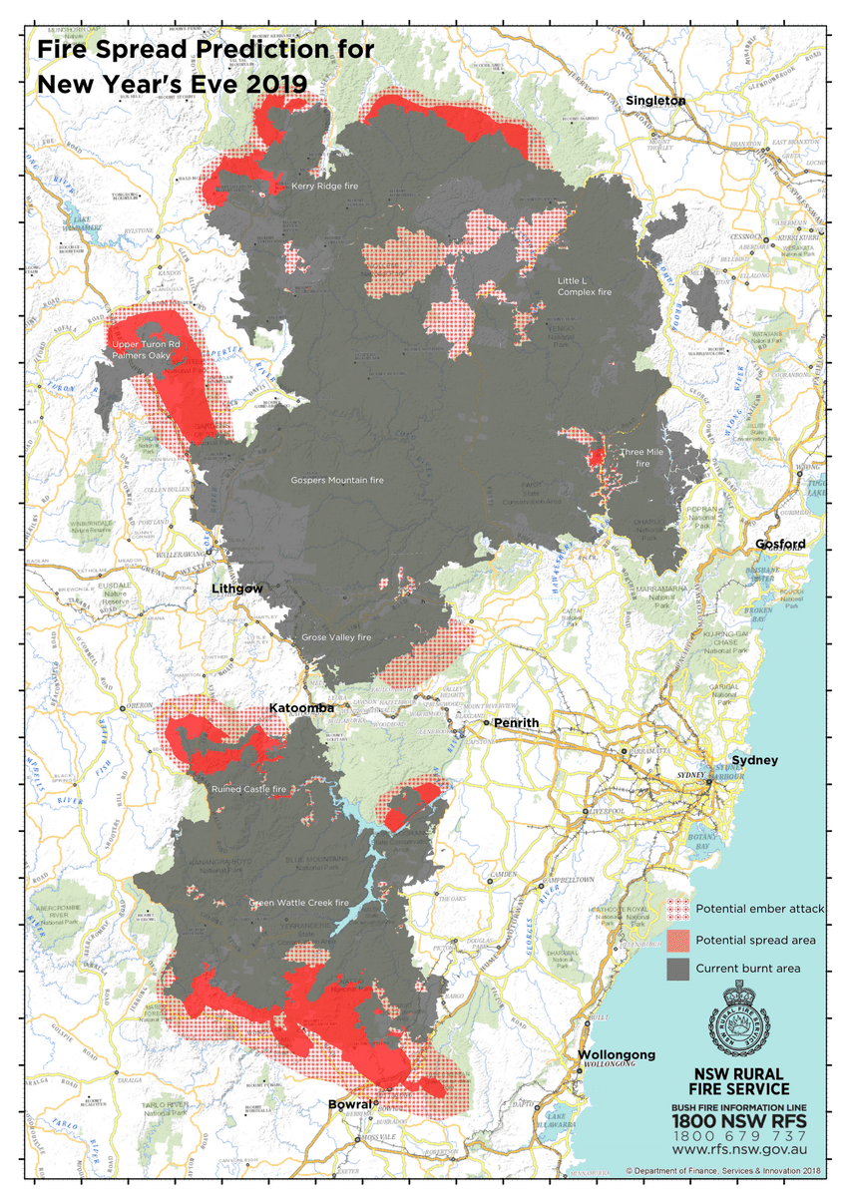
Dire looking fire map for greater Sydney as the city is surrounded!
Fires surrounding Greater Sydney: This map displays the predicted fire spread for NYE. The map indicates the communities that are expected to come under threat from embers or fire fronts. Other areas surrounding the fire may still come under threat if conditions change #NSWRFS
More than 30,000 tourists in Australia who refused to evacuate an area east of Melbourne amid raging bushfires are now 'trapped' after locals warned earlier that staying would be 'suicide'. Hundreds of blazes are burning across Australia, which is experiencing a devastating summer bushfire season fuelled by a prolonged drought and climate change. Hundreds of thousands were told to evacuate Victoria State's popular East Gippsland region on Sunday amid fears soaring temperatures and gusting winds would stoke three large blazes, cutting off the last major road still open. Emergencies chief Andrew Crisp told residents and holidaymakers to leave by 9am Monday or risk getting stranded, before giving an update later in the day saying it is now 'too late' to get out safely. His agency has also warned it is 'not possible' to provide aid to all visitors. Meanwhile, residents in northern Melbourne were told to 'act immediately to survive' as out-of-control wildfires bore down on the suburb of Bundoora. Daily Mail
Ash is falling on the streets of Melbourne.
`Strong winds could fan flames in Melbourne’ a Bureau of Meteorology spokesman said strong winds would continue to affect the Melbourne metro area into the night: Wind Change Chart updated…wind storms moving through Melbourne now. BOM
The massive fires are creating thunderstorm clouds capable of producing dry lightning. Some of Australia's most devastating bushfires have fuelled their own fury by creating thunderstorm clouds capable of producing dry lightning, violent winds, black hail and even a fire tornado.
The unpredictable changes brought on by the storms can be extremely dangerous, and make fighting fires even harder. ABC
Emergency warnings for fires in Victoria, Tasmania, and South Australia
Bushfire emergency in Victoria, Tasmania and South Australia as out-of-control blaze threatens Melbourne homes. Out-of-control bushfire damages homes in Melbourne's north as East Gippsland blazes intensify. Power cut to 10,000 homes amid bushfires, dust storms and lightning in SA. The weather deteriorates, Western Sydney tipped to hit +40C amid more fire warnings. A firefighter has died and another two have suffered burns when their truck rolled while they were battling the Green Valley bushfire near Jingellic, 70 kilometres east of Albury near the New South Wales-Victoria border. There are several emergency warnings for fires in Victoria, Tasmania and South Australia.
50 to 100 endangered species that have been severely impacted. The country is in the midst of a wildlife catastrophe. "Australia had the worst mammal extinction rate on Earth long before this fire and drought," he said. The threatened “Tiger Quoll” was another species that the fires would have hammered. "This entire fire range is a Tiger Quoll habitat. They will have been annihilated. "You're talking probably 50 to 100 endangered species that have been severely impacted."
Some of the other threatened species known to live in the national parks include the squirrel glider, grey-headed flying-fox, regent honeyeater, Grey-crowned babbler, speckled warbler, brown tree creeper, broad-headed snake, black-chinned honeyeater, masked owl, barking owl, turquoise parrot, east-coast freetail-bat, black bittern and brush-tailed phascogale.
The NSW Office of Environment said many wildlife species can endure fires `by maintaining populations in refuge areas or habitats which have not been recently impacted by fire. The severity of the current bushfires combined with ongoing drought will have an impact on wildlife, including threatened species,’ a department spokesperson said. Newcastle Herald
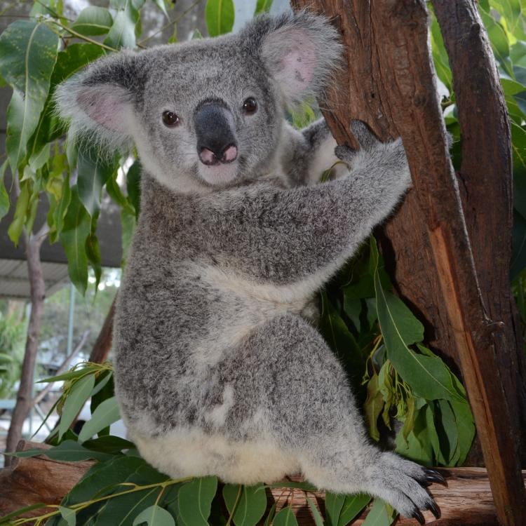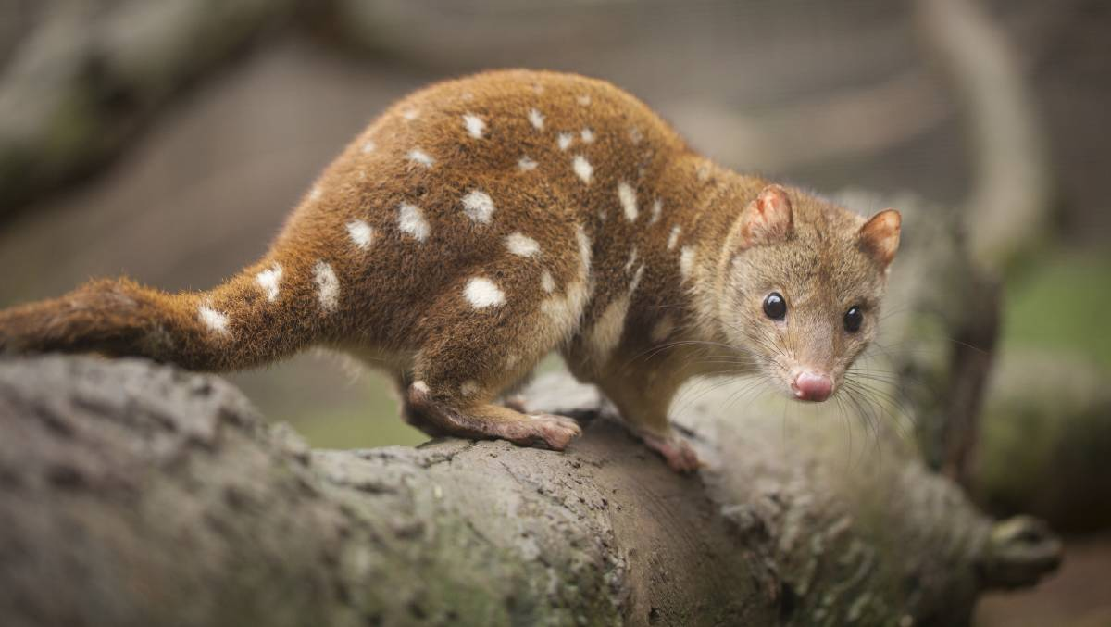
Koala Bear The “Tiger” Quoll

480 million animals are feared to have died in the bushfires sweeping Australia. Nearly a third of the koalas in their main habitat of New South Wales may be among the 480 million animals to have died in the Australian bushfires. Ecologists believe that 8,000 koalas have burnt to death on the state’s mid-north coast, about 240 miles north of Sydney. The site, one of the most populous koala habitats, was ravaged along with a leading hospital for the marsupials at Port Macquarie. “It may well be up to 30 per cent of the population in that region [was killed] because up to 30 per cent of their habitat has been destroyed,” Sussan Ley, the federal environment minister, said. More than five million hectares have been burnt across Australia in an unprecedented bushfire season.”
“Mike from around the world” is very concerned for Australia (Paul Begley.com YouTube Dec. 10th) Mikes said “January 16th, 2020 - another pulse wave to hit earth - volcano activity will show out. The energy from the cosmos will stimulate the magma chambers. We’re talking certainty – certain spots – huge spots. Even a minor eruption can cause thousands to die. Mike continues to check his data; he’s not being dogmatic.
Mike is concerned for 2020: He said that Mexico along with Australia will be so hot no one can live there. Mike November 27th, Paul Begley interviewing: Mike talks about the core of the earth and the movement of the magma…the magma is moving in dangerous places. Australia is very hot from the magma.

Daily Mail article pictures December 29, 2019

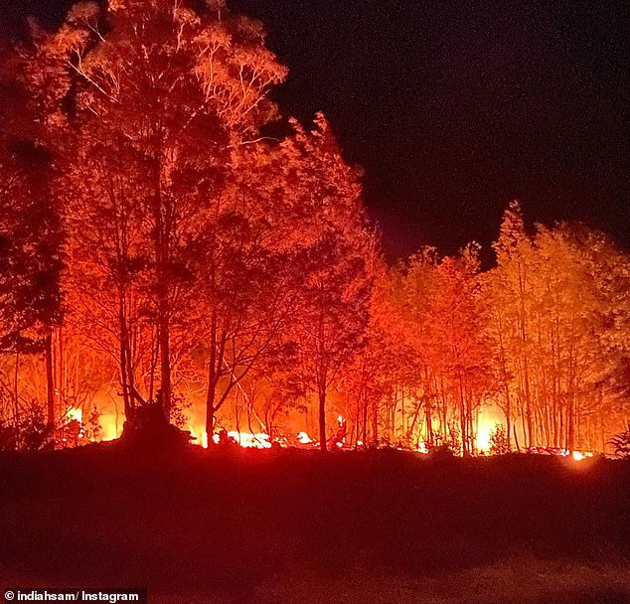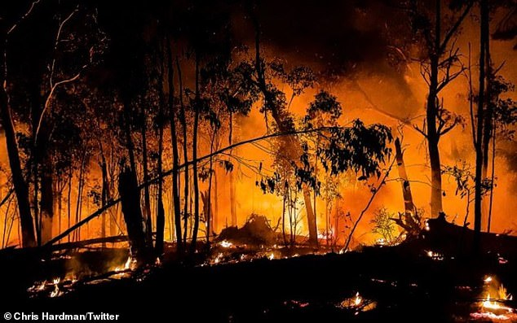
The fire front is approaching areas in East Gippsland and is expected to worsen on Monday (December 30, 2019)

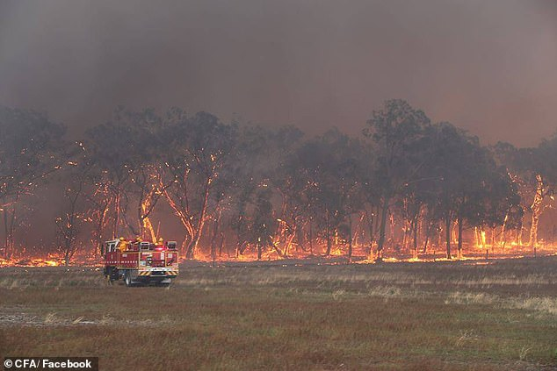
Firefighters tackling a blaze in Gippsland: Victorian authorities warn holiday makers to evacuate immediately
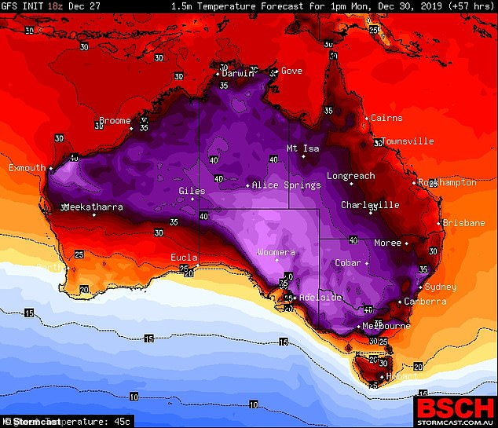
A 'severe' heat wave sweeping across Australia is expected over the New Year period. Pictured: National forecast for Monday, with light purple meaning 45C and red 28C

Magma is moving under the earth from thousands of volcanoes, warming the surface of the earth, creating fires. Magma is moving under oceans and seas warming them. We continue our pole shift, which I reported on as far back as 2007. Tectonic plates under the seas keep moving. Portals and trenches are opening, so we have a duel happening on earth: Extreme heat in some areas, even melting huge ice blocks around Antarctica and the Arctic, some as large as Rhode Island, and then we have blizzard temperatures in other places.
Pray for the people of Australia, New Zealand, and Tasmania. The earth is groaning, and we groan with it: “Come Yahushua Come!”
Shalom in His love, Yedidah
December 31, 2019

