Hitler’s Secret Plan for
World Conquest EXPOSED
IT IS UNFOLDING BEFORE OUR EYES in
Western Europe, the U.K., and America

You’re not supposed to know this!!!

***Please review “The Fourth Reich Rising - Globalism - America, Nazis, Hitler, and the Bestial Anti-Messiah” as a foundation for this article.

First off, let me say that during most-of my sixteen years living among Muslim people, I learned that we must never judge a people-group as a whole. We must see each individual as a human being, as an individual for whom Messiah died. I loved living among Muslims! I felt comfortable; I felt at home. They were kind to me, whether Arab, Palestinian, or Bedouin, whether Jordanian, Israeli, Egyptian, Sudanese, Iraqi, Arabian, Syrian, or Lebanese. I met Muslims and Christians from these countries, even Iranians who are Persians, not Arabs. I learned a lot about good basic human nature. I learned that extremists, those who have been mind-programmed and weaponized, mostly by the influence from western powers, are in the minority.
In this article, I open doors for understanding, giving many resource materials for you to do your own research, showing you pictures, explaining things that few explain. So, please, read this objectively, and learn. It will really help you put the complete picture into focus. Use this information to open your ears to hear and your eyes to see, so that you are not blinded by news block-outs and propaganda. Be objective! Abba wants you to know “The Plan” that the Globalists are now using to cause the chaos to bring “the Order,”--a “New World Order.” Use this information so that as you watch The Plan unfold, you will have no fear. You’ll just have valuable knowledge to help you prepare In shalom!

What I’m going to reveal to you is a secret held quietly by the Illuminati since 1776, its details held quietly from 1871, held quietly through two world wars, and now coming to light as the final touches are being put on The Plan to bring it to pass! I’m going to show you the Globalist Plan, Hitler’s dream, now set in motion and leading to the takeover of the world. Will Hitler return as Apollyon to see his Plan through to its completion??? Many believe so. His relation to the Rothschild family has also come to light, with most likely his grandfather being Salomon Rothschild. [Our Occulted History by Jim Marrs, pages 247-253]

Mark 4:22-23: “For whatsoever is hidden shall be revealed, and whatever has been kept secret shall come to light. If anyone has ears to hear, let him hear.”

Isn’t it great to be trusted with important secrets withheld from the world’s people by the mainstream media? Isn’t it great to have an inside track from an inside source that is 100% accurate all the time? I’m talking about Yahuwah! His Spirit does lead us into all Truth!
Daniel 2:19-23, 28: “…He reveals deep and secret things. He knows what is in the darkness and light dwells with Him…There is an El in the heavens who reveals secrets.”
Amos 3:7: “For the Master Yahuwah does nothing unless He reveals His secrets to His servants the prophets.”
The plans of the very real and presently active Illuminati, through many of their Front Men, like the United Nations, the Vatican with its world-controlling Jesuits, Globalists, Council on Foreign Relations, Trilateral Commission, the Bilderberg Group, Satanists, Masons, Luciferics, the Elite “Black Royalty” of Europe, Nazis and Communists, are all working together in unity through world governments, International Banking, world media, and religion, to block you from learning the secrets of what they are doing to bring about Satan’s world rule.
The reason their plans have been so well kept is because they know that to reach their goals it is of the utmost importance to keep everything they do a secret until they openly pull off the lid and reveal it worldwide.
II Kings 6: The King of Syria wondered how the army of Israel knew every move he made and moved to block his army. He thought he had a spy in his government. But, one of his aides told him he had no spy in his government, it was the Prophet Elisha who could hear the words of the King in his bedroom, and then informed the army of Israel. Elisha had no “bugging” devices, no satellite connections--no listening technology at all. He heard what the king was planning from the Spirit of Yahuwah. It was Spirit-to-spirit communication.
You can hear Him like that too, and see clearly what the enemy is doing so that you can prepare to stand against him. We wear the armor of battle because we war not against flesh and blood but against the wiles of the Devil and his forces.
The plans for world government have gone on since the time of Nimrod, but in America from since the 1600s at least especially using America to present day. Please refer to the recently edited: “America’s Secret Destiny”/Mikvah of Preparation. To learn about this plan from the 1600s, I highly recommend Chris Pinto’s DVDs: “The New Atlantis,” “Riddles in Stone,” and “The Eye of the Phoenix.” They will help you see through the lies promoted about the history of America. I recommend Des Griffin’s Fourth Reich of the Rich, Jim Maars’ The Rise of the Fourth Reich, and Linda Hunt’s Secret Agenda.
Most of the history of the last 2,000 years at least has been greatly fabricated, especially to do with the goals of the Roman Catholic Church, the continuation of the Roman Empire via its religious Caesars/popes, the globalist agenda of Satan, and especially the true history since the end of the 1800s to present, the time of the return of select fallen angles and Nephilim. Traditional history of America, Britain, France, Russia, Germany, and Western and Eastern Europe in general is so far off base that to learn the truth can be very shocking!
Understanding the historic cover-ups of truth really clears up what’s going on now as the plans since the late 1800s and involvement of satanic forces with power-hungry people is now in its final stages of operation to bring those plans to completion. Thus the speeding up of events that appear disconnected, but are not.
How did Communism come about? How did it intertwine with the goals of the Jesuits and the Vatican, the International Bankers, the Americans and the British, with the German Nazis and the Arab Nazis– all socialistic enterprises? That is a mind-boggling fact that Des Griffin exposes in Fourth Reich of the Rich.
These groups are all “echad”--all in unity as one for one specific goal: Global government. The glue that holds all these groups together, promotes them and creates “helpers,” like Al Qaeda, the Taliban, ISIS, terrorist groups, Muslim jihadists, and CIA-mind-controlled Manchurian Candidates, is the Illuminati via America, International Bankers, and the Vatican, creating wars since the 1600s. Illuminists/Globalists boldly say that the only way to get the masses of humanity under control and unified is through creating war.
We must see the links between the various groups and how they unite, what their final goals are, and their goals of getting to their final goal. The propaganda- controlled news media worldwide, saying little to nothing, will not explain to you what you are seeing. Everything is much further along than most realize.
Here is a quote, which you can find online by John Swinton (1829–1901). He was a Scottish-American journalist, newspaper publisher, and orator. When he made this statement, he was at the "Journalists' Gathering" in the rooms of the Twilight Club in the Mills Building, New York City, on April 12, 1883. The subject of Swinton's talk was "Some Things an Editor Dare Not Discuss." A man at the meeting raised a toast to America’s Independent Media. It was in regards to his toast that Swinton made this statement: “There is no such a thing in America as an independent press, unless it is out in country towns. You are all slaves. You know it, and I know it. There is not one of you who dares to express an honest opinion. If you expressed it, you would know beforehand that it would never appear in print. I am paid $150 for keeping honest opinions out of the paper I am connected with. Others of you are paid similar salaries for doing similar things. If I should allow honest opinions to be printed in one issue of my paper, I would be like Othello before twenty-four hours: my occupation would be gone. The man who would be so foolish as to write honest opinions would be out on the street hunting for another job. The business of a New York journalist is to distort the truth, to lie outright, to pervert, to vilify, to fawn at the feet of Mammon, and to sell his country and his race for his daily bread, or for what is about the same — his salary. You know this, and I know it; and what foolery to be toasting an "Independent Press"! We are the tools and vassals of rich men behind the scenes. We are jumping-jacks. They pull the string and we dance. Our time, our talents, our lives, our possibilities are all the property of other men. We are intellectual prostitutes.”
From Doc Marquis DVD #3 of “Front Men of the Illuminati,” he told how in the early 1900s, J.P. Morgan a famous newspaperman, an Illuminist, a member of The Council on Foreign Relations, used the newspaper to change the minds of the America people to the globalist way of thinking. At this time, and forward, the public school system was engaged to program the minds of children and youth, and then the TV, books, magazines, organizations, and advertising. Morgan bought up 175 of the 179 major newspapers in America, to use as globalist propaganda tools.
Today we see a new strategy used to program the minds of the world’s people.
We see the implementation of George Orwell’s prophetic book 1984. Perhaps it was not prophetic at all, since Wells was an Illuminist insider. Where did this new strategy originate? Whose plan was it? It originated as early as the turn of the 20th century, but today its full blown thrust is in motion in Western Europe, the UK, and moving swiftly into America.
I begin here with recent news about the dying of England. I’ll begin with the arrest of Tommy Robinson. What crime did he commit that the London police arrested him, and took him to court immediately, and the judge pronounced sentence immediately to jail him? I will also tell you about a woman known as Amy, who walks with a cane, but is not infirmed in mind or spirit. She was arrested also recently by the London police. What was her crime?
Tommy Robinson is a London journalist who dedicated himself to exposing the Muslim rape gangs, the atrocities they have done in England, to expose to the public that these men are not “refugees” or “migrants,” but “sent ones” to destroy western civilization. Robinson was standing in front of a courthouse in London where rape gang members were being tried for their crimes. He was speaking quietly into his cell phone to record his broadcast. He was doing it all as discretely as possible, not to draw attention to himself. Yet, police saw him and arrested him, took him before a judge, and he was immediately sentenced to 13 months in prison. You can watch the arrest on YouTube – he went quietly. But, this has caused international uproar. Demonstrations have been going on protesting his arrest and demanding his release.
At this same time, a lady named Amy was in a public park in London. She saw that Muslim men were putting down their prayer mats for their daily prayer. She asked a police man, and this was videotaped, why they could pray in a public park when it was the law in London that no one could pray in a public park. The police would not answer her. She pressed them for an answer, and they arrested her.
The Muslim takeover of England is well underway. This event with Robinson has been called England’s “tipping point.” Shira law is being enforced by the police. Germany is also following suit. Angela Merkel said that the Muslims belonged to Germany. Germany is turning towards Shira law – law that emanates from the 6th century in Arabia.
France and Sweden are becoming Muslim nations. The takeover of Western Europe, the UK, and finally America has not only begun but has been planned and orchestrated for decades. It is happening. ISIS has camps in all 50 states.
America created the Taliban under Jimmy Carter’s administration, then Al Qaeda was promoted and aided during the two terms of George W. Bush, and ISIS under Obama’s administration. America’s funding, and weapon-supplying of Fatah, the terrorist wing of the Palestinian Authority, the jihadists in Syria, helping Hezbollah along with the U.N., and Hamas, with the help of the UN and Russia, has furthered the spread of Islam, and the deaths of Christians by the millions.
The world is at a “tipping point.” All the evil contained in the vessel of Satan is being poured out upon the earth, while Yahuwah’s people suffer persecution and death in many countries. Australia is also being overrun with Muslims.
I want to expose those behind-the-scene puppeteers of the New World Order who use the Arab/Palestinian people as weapons to promote their Globalist Plan. In America, one of the main supporters of Islam and propagandists for anti-Islamophobia legislation is Georgetown University – a Jesuit College that has great influence on U.S. policy. But, since Obama forbade the FBI to investigate terrorist camps in America, and there are lots of them including ISIS camps, something has happened to the FBI. They have become promoters of propaganda against “Islamophobia.” Soon, to expose truth about the extremists of Islam, terrorists, haters of Jews and Christians, haters of western culture, will be a legalized “hate crime,” and many will be arrested like Tommy and Amy.
All the while, the Nazi/Illuminati mind-programming, mind-control, to keep people ignorant and happy, yet fearful and obedient, has gone on since the early 1900s, especially since 1941.
Now for some hard hitting facts and revealed truth to show you why there is a Muslim invasion into Western Europe, the UK, and America, and where we stand because of this invasion in mid-2018. To hear a complete narrative from May 2018 on this subject, I recommend highly that you purchase Chris Pinto’s new CD set on “Hitler’s Jihad,” from adulamfilms.com.
Here I will give you a background of Hitler’s Plan, a Nazi Socialist Plan, which was also a Communist Plan, and Jesuit Plan, a papal Plan, and a Muslim Plan—all united together!
Notes and quotes from: “Hitler’s Jihad - The Socialist Plan for Islam to Conquer the World” - Chris Pinto CD #1 - May 2018
It is estimated that at least 50 million Muslims are now in Europe as of spring 2018. These “refugees” are destroying Europe and the UK. One million girls, ages 11-13, have been raped in the UK by Muslim rape gangs. They call these girls “Easy Meat…” “Easy Meat” is a movement among mostly Pakistani men. By 1958, there were 50,000 Muslims in the UK. These Muslims who are allowed in by the leaders of nations in Europe are aligned to Hitler’s Plan.
The LBGT movement is aligned with Islam! Islam believes in teaching young men to be homosexuals until their marriage; and many consider, and boldly say so, that having a woman is only for making babies, but having a “boy” is for sexual pleasure. So homosexuality and Islam are united. Muslims are raping in the UK and Western Europe so that girls will have Muslim children, as well as raping to show their superiority over Christian girls and women as an act of warfare.
Tragically, Europe, the UK, and America have turned away from the true faith of the Scriptures, and so judgment is being poured out on this concentration of the “House of Israel” and “the House of Judah.” Yet, to watch this happen is horrifying.
In Chris Pinto’s radio broadcast of The Voice of Thunder Radio, May 31, 2018, entitled “England is Dead,” he gives several quotes of archbishops of the Anglican Church of England and its American counterpart, the Episcopal Church, in which these highest of religious leaders mock the Bible, mock the resurrection of Messiah, demean Him, demean faith in Him, and basically make a joke of the very beliefs they supposedly represent. Here is the link for listening to this broadcast: http://www.adullamfilms.com/NewsUpdate2018June2.html - About ½-way down on the main page you’ll see Voice of Thunder Radio and the name of the broadcast “England is Dead.” You can also see where you can purchase “Hitler’s Jihad” CD set.

History: Islam and Nazi Socialism
The Grand Mufti of Jerusalem, Amin al-Husseini aligned with Adolf Hitler and the Nazi movement.
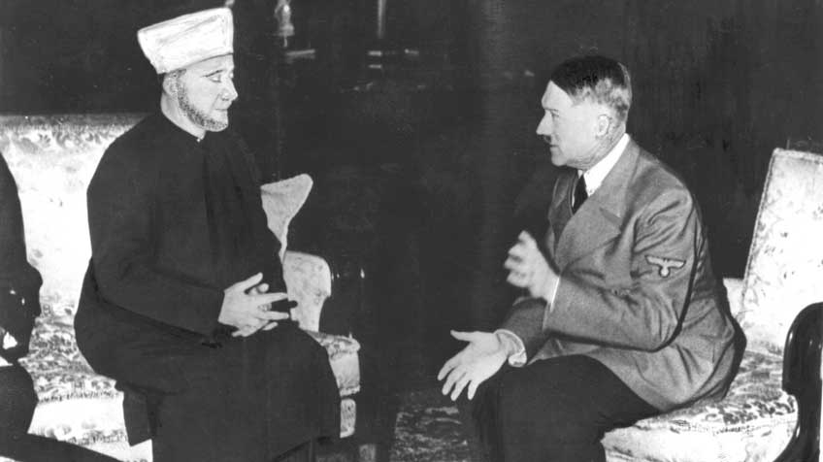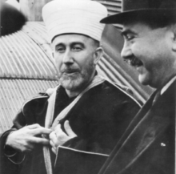
Husseini with Adolph Hitler Husseini with Mile Budak in
Occupied Sarajevo – 1943

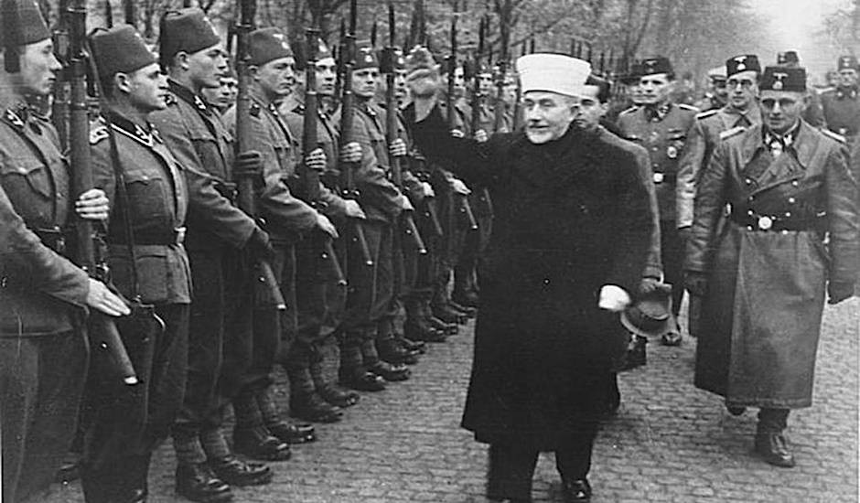
Haj Amir al-Husseuni with Nazi troops (Jerusalem Post)

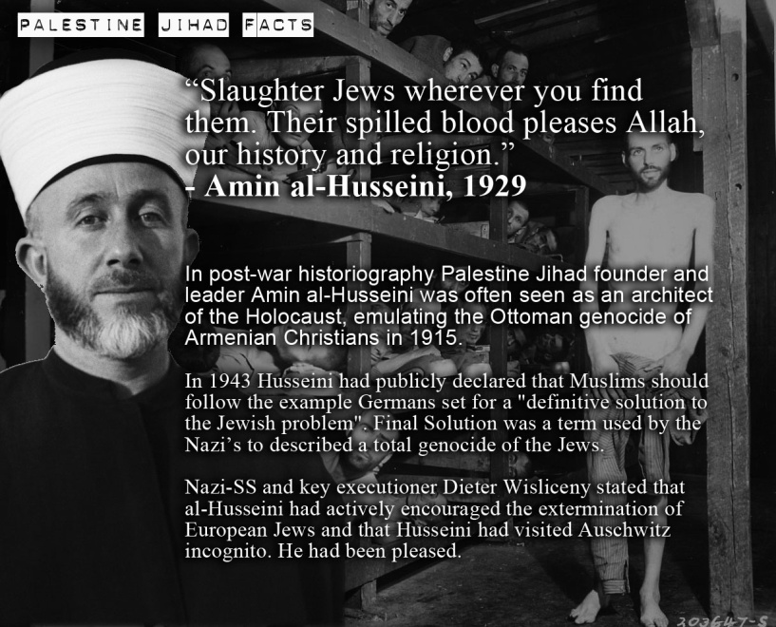
Al-Husseini trained Yassar Arafat in the tactics of jihad – right: Yassar Arafat
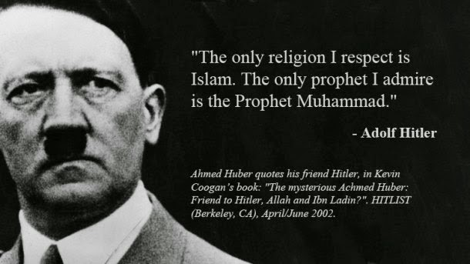
Though Hitler was a baptized Catholic, he turned against Christianity, yet was still aided by Jesuits, the Vatican, and the Catholic Ustachi in his murder of Jews, Eastern Catholics, and European Christians
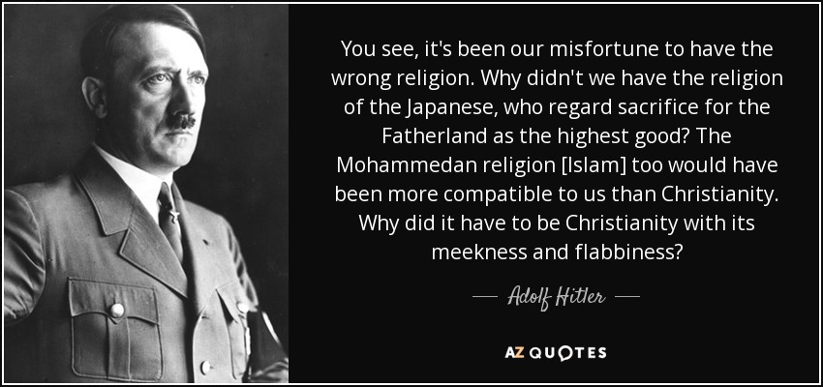
Did you know about Hitler’s connection with Islam?

Charles Martel, a Germanic leader, defeated the Arabs in 732 at the Battle of Tours, Hitler explicitly wished Martel had lost the battle. “Had Charles Martel not been victorious,” Hitler told his inner crowd in August 1942, “then we should in all probability have been converted to Mohammedanism, that cult which glorifies the heroism and which opens up the seventh Heaven to the bold warrior alone. Then the Germanic races would have conquered the world.” Hitler told Albert Speer that Islam is “perfectly suited to the Germanic temperament.”
If the Muslims had won in Tours, the whole of Europe would have become Muslim in the 8th century and (Hitler said) “the conquering Arabs, because of their racial inferiority, would in the long run have been unable to contend with the harsher climate and conditions of [Europe]. They could not have kept down the more vigorous natives, so that ultimately not Arabs but Islamized Germans could have stood at the head of this Mohammedan Empire.”
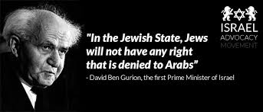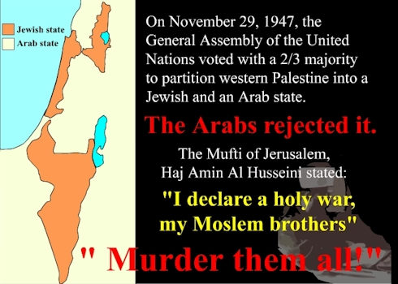
See the difference in spirit…

There were Communist Muslims and Nazi Muslims. There were many Muslims who were Nazi soldiers. When Hitler was first coming to power, he used his unity with Christianity, being a Catholic, as a smokescreen for his real intent – a façade – a mask. Later he came out against Christianity and persecuted Christians to their death. When he came into his power, he sided with Muslims in their hate of Jews and in their merciless love of killing all who oppose them.
Christians stood in the way of Hitler’s goal of world domination. They stood in the way of Muslim aggression at that time. Catholicism and Islam are “echad,” united as one. The Vatican created Islam as a weapon to gain Jerusalem for the papacy. Islam has always been a weapon of the Roman Catholic Church. Hitler hated Jews; the Vatican hates Jews; the Arabs hate Jews; Satan hates Jews--they are in one big happy Jew-hating family. And Satan knows where the 10 tribes of Ya’cob went, the House of Israel/Ephraim/Joseph--mostly into Western Europe, the U.K., America, Australia, and New Zealand.
Yet, it is a fact that the U.S. and Western European nations handed technology to the Muslims to use against the US, Europe, the UK, and Israel.
In the early 1800s, the Jesuits were in league with Karl Marx. In 1825, the Communist Manifesto was written, influenced heavily by the Jesuits. Please know that Communism is just and an advanced type of Socialism. Fascism also is a type of Socialism. Benito Mussolini’s regime in Italy during World War II was a Fascist regime in league with Hitler. They are all united, though appearing to be different. The word “Nazi” means “National Socialists.” The basic tenants of Socialism are at the base of all these forms of government.
In WWI, Germany was in league with the Ottoman Empire. Even acting as enemies in World War I and World War II, Germany, Russia, Japan, America, Britain, France, were all working together backed by the International Bankers to make multi-millions of dollars, and open the doors for the Globalist Plans to go forward, as outline by Albert Pike and Giuseppe Mazzini of the illuminati in 1871.
[David Motadel: Islam and Nazi Germany’s War.] Chris Pinto suggests that we read this book, November 30, 2014. I’ve ordered it.
Do you notice that German President Angela Merkel is actually fulfilling Hitler’s dream of using Muslims to overtake Europe, weaponizing Islam? Hitler’s Plan for world conquest is happening under the guidance of today’s Socialist/Nazis, Communists, Jesuits, and Muslims.
Using Muslims are weapons for conquering “Christian” countries, opening the door for world conquest, was the great plan of Hitler, but quickly it became the plan of Globalists in general.
Here I insert some information regarding Germany today from “Mass migration of Muslim invaders posing as asylum seekers has caused crime rates to soar by 92%” - May 24, 2018 - by BareNakedIslam:
“A massive 92% increase in crime, especially violent crime and sexual assaults in Germany, is the direct result Chancellor Merkel’s decision to open the borders in 2015 to more than a million predominantly Muslim invaders pretending to be refugees and asylum seekers, with at least 200,000 more expected to arrive in Germany each year going forward. According to a study funded by the government, and carried out by criminologist Christian Pfeiffer, the massive invasion of mostly young Muslim males has fueled a rise in violent crime in Germany...Things have gotten so bad in Germany now that 458 so-called ‘refugees’ are being arrested everyday for serious crimes, including 267 murders…According to the latest Kriminalität im Kontext von Zuwanderung (“Criminality in the Context of immigration”) 2017 report issued by the Bundeskriminalamt (“Federal Criminal Police Office”), 167,268 “non-Germans and immigrants (asylum-seekers)” were arrested during that year for serious crimes. This works out to 457 arrests per day, every day, for 365 days… The overwhelming majority, 87%, of the arrested invaders were male, and 66 percent were younger than 30 years old… There were 5,258 recorded sex offenses committed by the fake refugees in 2017, a marked increase compared to 2016, when there were 3,597 such attacks.”
“We Are Coming and We Will Take Your Country”- Muslim Biker Gangs and Boxing Clubs Training to Take Over Germany - May 22, 2018 - cvikas.com:
“German Muslims have established a self-styled biker gang, which is said to be modeled on the Hells Angels and aimed at protecting fellow Muslims from the “ever-growing hatred of Islam,” according to Die Welt. The emergence of the group, which aspires to open chapters in cities and towns across Germany, has alarmed German authorities, who have warned against the growing threat of vigilantism in the country. Muslim vigilantes enforcing Islamic justice have become increasingly common in Germany. The government’s inability or unwillingness to stop them has led to the rise of anti-Muslim counter-vigilantes.”
It’s all been a sham! Regarding America’s “Cold War” with Russia--Nazi scientists in America gave Russian top secret space information so that they produced a moon-launch before the U.S. did. The giving of technology to the Muslims and to Russia by the U.S. was a common thing. After all, the U.S. got the technology from the Nazis after World War II. And, after all, the Nazis got the technology from the returned Nephilim from the 1920s.
All work together, while the masses of humanity think there the good guys and the bad guys pitted against each other in war. No! It’s the bad guys working together under Satan to destroy the truly good guys.
Islam is no more than a created human weapon by the Vatican, by world Globalists, Communists and Nazis, to bring about world rule under the Beast – perhaps a Nazi-Beast returned – Hitler – the “Fourth Reich” is rising. The word “Reich” means an “Empire” or “Kingdom.”
THE WEAPONS: Angela Merkel and Theresa May of England are allowing Muslims to overrun their countries – against the backdrop of horrors for their own people. It is part of the Globalist agenda for a new world order – to bring about chaos. When no longer needed, the rulers of this world will then destroy the weapon – Islam – destroy the Jews too – and destroy another weapon – the LBGTQ.
Homosexuality is a weapon itself against the increase of humankind. Islam is also a weapon to destroy the House of Israel and the House of Judah at the same time – the children of Ya’cob.
The Vatican created Islam as their weapon to gain Jerusalem for the pope and at the same time to kill Jews. Read: Guilo Meotti: The Vatican Against Israel]
Max von Oppenheim was a German who converted to Islam. He advocated the
revolutionizing of Islamic territories using “holy war” as a weapon.

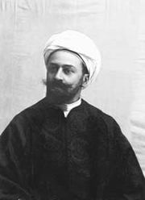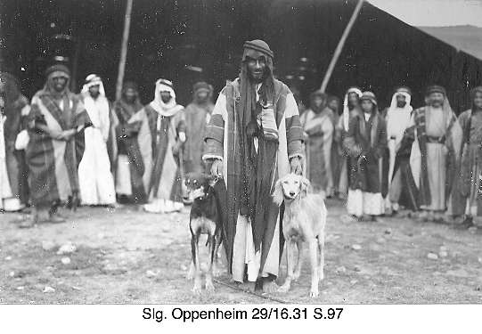
1896 Max von Oppenheim, German archeologist
Wikipedia: Max (Freiherr) von Oppenheim was a German lawyer, diplomat, ancient historian, and archaeologist. He was a member of the Oppenheim banking dynasty.
The Armenian Massacre: 1.5 million Christian Armenians were killed-- murdered by the Turkish Ottoman Muslims. It was called the Armenian Genocide.
This genocide was an inspiration to Hitler to practice genocide against Jews
The Turks paved the way for Hitler and his death camp. Now Turkey’s President Erdigan wants to revive the Ottoman Empire with him at the helm.
It was especially during WWI that Germany and Islam connected. The connection began with the Armenian Genocide. Chris Pinto suggested we google “German and Turkish Atrocities” ***The German Connection | Facing History and Ourselves - https://www.facinghistory.org/resource-library/german-connection
Learn about German-Ottoman military cooperation in the early 1900s and the Armenian Genocide.
“The Muslim Brotherhood Strategic Plan for America” is on page 7 of the above-mentioned article. Islam has been working inside America to bring about jihad. Who supported Obama’s college efforts and his rise to the Presidency? – The Muslim Brotherhood. Whom did Obama put in control over Egypt after he ousted Mubarak in 2011? -The Muslim Brotherhood. Who is related through the Nazis to this “Brotherhood?” – The CIA. The shocking truth goes on and on…
The Muslim Brotherhood was founded in Egypt in 1928 aided by Amir al-Husseini. The interlocking of Hitler with al-Husseini, the Muslim Brotherhood, and the CIA is more than amazing. The Muslim brotherhood infiltrated the US with the help of the US government, bankers, and corporation leaders. “Arabs were prepared to work with Germans with all their hearts,” said al-Husseini.
As Chris Pinto points out, today we are watching a continuation of WWII, in which Muslims, the Muslim Brotherhood, Nazis, and the Vatican are working together for the take down of America, and Europe, the UK, and eventually the world.
Chris Pinto: “Islam is a religion of cruelty and slavery.” Even former Muslims who have become Christian believers admit to the slavery of Islam. The word “love” does not exist in the Koran. True Muslims believe that showing love is a sign of weakness. The promote power and control through violence.
While living in Jordan, I learned how Muslim men teach their little older boys to beat up their little brothers by the time they are 3 in order to make them learn to fight. Islam has been used against the UK and France, now Germany, Sweden, etc., as a weapon of destruction. Yet, the lying news media, and men like Obama, keep saying it is a religion of peace.
Here I insert information and pictures from a recent article about a performance at a kindergarten in Gaza by Hamas children. I also have information about the United Nation’s sponsoring of Jihad camps among children, even as young a five. In these “camps,” the children learn the pride of being a suicide bomber. In previous articles, I’ve included pictures of little children strapped with bombs, proudly saying they want to be a suicide bomber. We have the internet and google a while longer—use it! Do your own research! The United Nations is a front for the Illuminati!
“Proud parents video under-fives dressed as heavily-armed jihadis as they storm an Israeli building with mock assault rifles at Gaza nursery school graduation: Palestinian children no older than five were seen performing a staged play. They are seen carrying fake guns and gas masks while raiding Israeli locations. In the play, a soldier is shot and a hostage is taken by the schoolchildren. Their proud parents film the shocking school play on their mobile phones.” Charlie Bayliss - Mailonline - 2 June 2018
“Disturbing footage has emerged of children at nursery school in Gaza dressing up as jihadis and storming an Israeli building. The children, who are no older than five-years-old, are seen carrying fake rifles, handguns and gas masks. The young children then take a child dressed in Orthodox Jewish clothing hostage, before pretending to kill an Israeli soldier during the performance at the Al-Hoda nursery.
Their end-of-term production also includes smoke going off in a cardboard building as the young boys children carry out an invasion, placing a sign down which read 'Israel has fallen' in Hebrew and Arabic on the back of a soldier.”
The footage was posted on the pre-school's YouTube account and included Hebrew lyrics threatening Israelis with missiles and terror attacks. They also mock Israeli soldier Oron Shaul, whose body has been held by Hamas since 2014.

Himmler and al Husseini
Al-Husseini was the leader of the Palestinians who taught Yassar Arafat jihad tactics, and prepared him to be the next Palestinian leader. Arafat joined the Palestinian Arabs into a political force. Heinrich Himmler and al Husseini joined to work together. Palestinians/Arab Nazis joined for jihad against Jews and Israel.
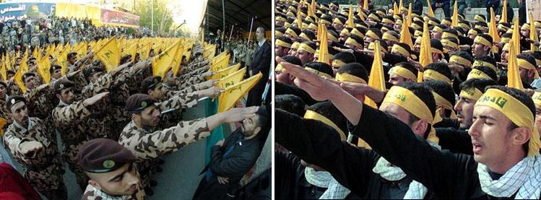
Gaza Muslims salute Hitler
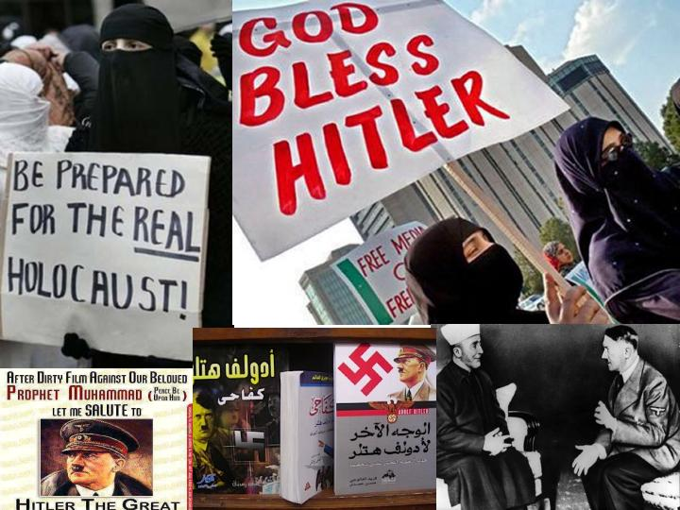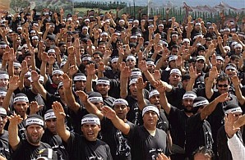
Members of a newly deployed Fatah militia salute as they parade in the West Bank town of Jenin Saturday Photo: AP “Hitler would be so proud.”
Back to notes from Chris Pintos DVDs of “Hitler’s Jihad”: “Operation Warrior 1944: Otto Skorzeny--Hitler’s Commando used Muslim tactics against the Allies. Otto Skorzeny taught the tactics of jihad to Islam. He trained Yassar Arafat and the Muslim Brotherhood in guerrilla warfare tactics; he taught Palestinians these tactics using Israel and Europe for `practice.’
Hitler and Muslims United – Otto Skorzeny - Hitler’s Commando

Hitler's commando Lt-Col Otto Skorzeny 'worked as an assassin for ...
https://www.telegraph.co.uk
Mar 29, 2016 - A notorious former SS officer known as `Hitler’s commando’
reportedly worked as an assassin for Israeli intelligence. Lt-Col Otto Skorzeny, once described by British and American intelligence as `the most dangerous man in Europe,’ was secretly recruited by the Mossad after…”
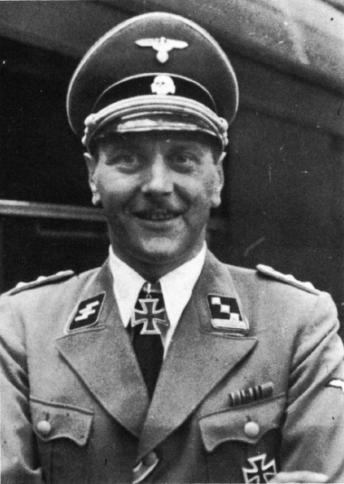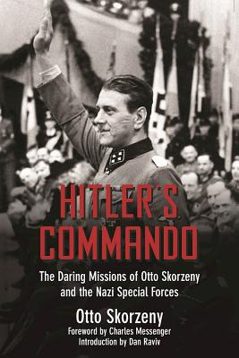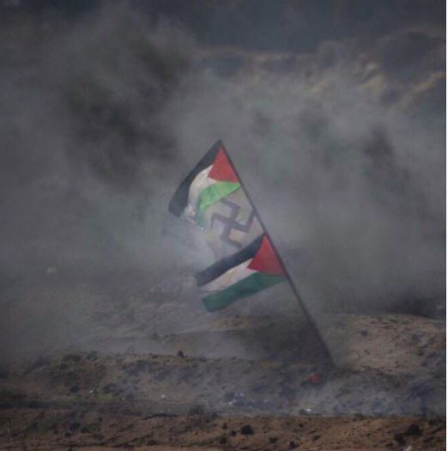
Otto Skorzeny Gaza Protest in March 2018

My note: The Vatican, Hitler, Nazis, Globalists in the West, etc. created a weapon of mass destruction using Islam and naïve Arabs … they are a weaponized unit, thinking they’re serving Allah. Islam was created by the papacy for the purpose of using the Arabs to secure Jerusalem for the Papacy to rule from.
I learned while in Jerusalem in May of 2013, when Pope Francis visited, that the muftis were prepared to put him a throne on the Temple Mount. Refer to my article on the Pope’s Visit, with lots of pictures, “The Hidden Agenda Behind the Pope’s Visit”/Mikvah of Present Reality.
Yet, the Globalist’s goal after using the Arab murderers against the Jews is to eliminate them both – letting them kill each other off. This is M/P Plan Part III. Then the anti-messiah and the false prophet can come into Jerusalem unhindered and take over. That’s the plan! That’s been the plan since 1871!
Read my article--see the pictures: “The Pergamum Altar”/Mikvah of Present Reality to learn how far back the Plan goes--back to Nimrod. In 1871, Berlin was a new capital then of a new state … that’s when the Pergamum Altar, altar of Zeus, began to come into Germany for restoration – the seat of Satan, “where Satan dwells.” (Revelation 2)
What about America? America created and armed the Taliban, and created Al Qaeda as a CIA data base for mercenaries to carry out their dirty deeds of killing, and created ISIS to bring terror and wipe out Christianity in northern Iraq and Syria. Yes, I have documentation on that!
America aids the PA terrorist group Fatah with money and weapons while the Russian counterparts fund and send weapons to Hamas and Hezbollah. The United Nations has worked to weaponize Muslims for their united purposes with the other Globalist groups.
America supports, funds, and provides weapons to the jihad groups fighting Assad in Syria. But, why fight Assad? Assad had religious freedom in his nation, and protected Christians. He allowed Israel to keep the Golan without a fight. He protected Jews. Yet, we find that America funds their creation, ISIS, and Jihadists who are killing Christians and Jews, and Syrian citizens. It’s because of the Globalist plan of Mazzini/Pike 1871 – three world wars, three forms of interlocking governments, to bring about the chaos that will bring the order, and eliminate Jews and Christians, Muslims, and all LGBTs all together. That’s the plan. Notice how America is pushing the LGBT agenda to the max, all the while not addressing the attacks on Christianity, yet protecting Islam?
The International Bankers have made billions of dollars on starting wars and funding them, like World War I and World War II, clear back to America’s Revolutionary War, but before that in Europe. To understand the world rule of International Bankers under the Rothschilds, the Rockefellers, the Jesuit Order, the City of London, and what their plans are now, I suggest again Des Griffin’s book The Fourth Reich of the Rich, and my article “The Mysterious City of London – Gog and Magog”/Mikvah of Present Reality. That’s not referring to England’s London!
Starting in 2011, Obama singlehandedly destabilized the Middle East, taking down peaceful nations towards Israel and loosing jihadist nations against Israel, arming them, funding them, helping them get nuclear weapons.
At the same, we know that the destabilizing of the Western world to bring it down to nothingness is mandatory for world conquest of the combined united front of Socialism, Communism, Nazism, Fascism, (all three socialist based), the Vatican, and the Globalist’s arm – the United Nations.
Did you ever question why the five permanent members of the U.N. Security Council were the U.S., France, Britain, Russia, and China? It was Russia who backed the founding of the U.N. – All one big happy family, bent on killing us all.
Why has America, Britain, and leaders of Western Europe, the E.U., as well as the U.N., helped weaponize Islam to rape, murder, steal, torture, destroy, lie, and takeover Christian countries? -- To bring about the chaos and death that will usher in the New World Order. Hitler’s Plan is now well on its way to completion!
Men like Hungary’s President are standing boldly for right, and are closing their borders to Muslim refugees, not just from Syria, but North Africa as well. The Globalists are sending in young men to destabilize “Christian” nations. Oh how the EU is pressuring Viktor Orban! Pray for him. President Orban is a Bible-believing Christian man who is acting in faith for his people. He is greatly criticized for not letting in Muslims. From Wikipedia: “Viktor Mihály Orbán is a Hungarian politician. He is the current Prime Minister of Hungary, in office since 2010. He also served as Prime Minister from 1998 to 2002.”
“Hungary to criminalize migrant helpers with ‘Stop Soros’ legislation”
“Viktor Orbán: `Our duty is to protect Hungary's Christian culture.’ Ahead of re-election as prime minister, rightwinger talks of building a ‘Christian democracy’” - 29 May 2018 The Guardian …
Chris Pinto CD #II: “Hitler’s Jihad”
Chris Pinto: “Islam is the historic enemy of Christianity and Jews. They still promote slavery to this day. For 150 years the Jesuits, Vatican, Democrats, and Islam has promoted slavery. How did America and Britain get slaves 150 years ago? They went to African slave traders, Muslim slave traders, to work deals to buy them in great numbers…”
“`Islam’ means `submission,’ as a slave to a Master. All `infidels,’ non-Muslims must be killed or made slaves. They are responsible for 1,400 years of slave trade out of Africa. The Vatican has supported and helped with this trade. They recognize slavery as OK, the Jesuits in particular favor slavery. Today there are at least 6 million slaves in Africa, controlled by Islam. Africans ran the slave trade for 1400 years. White slavery supposedly ended in the 19th century. Right now, there are 6 to 10 million African slaves across North Africa, which the Arabs sell.”
Georgetown University, a Jesuit University, spends much money promoting Islam. The FBI also is engaged in promoting Islam. Obama ordered the FBI away from all Muslim camps, terrorist camps, jihad camps, ISIS camps in America. Obama ordered them to leave Muslim alone. Now they’re promoting Islam by their “Bridge Initiative.”
Hitler wanted Islam to take over the world for him. In other words, weaponize them as slaves to bulldoze through Europe making way for Nazis to take over, and for him to be the world Fuhrer.
Chris Pinto: “During the Second World War, the Nazis worked on plans to build the `Amerikabomber,’ an airplane specially devised to fly suicide missions into Manhattan’s skyscrapers. Albert Speer, the Nazi Minister for Armaments, recalled in his diary: `It was almost as if [Hitler] was in a delirium when he described to us how New York would go up in flames. He imagined how the skyscrapers would turn into huge blazing torches. How they would crumble while the reflection of the flames would light the skyline against the dark sky.’ Hitler hated Manhattan. It was, he said, `the center of world Jewry.’ Less than 60 years later, Hitler’s plans were executed by Muslim immigrants living in Germany…The parallels between Nazism and Islamism are overwhelming. Yet the subject is a taboo. … Hitler’s real successors are the Jihadists.”
Today, Germany, like the rest of Western Europe, is rapidly turning Islamic. In addition to the many Muslim immigrants, 4,000 Germans convert to Islam each year. As always the converts are among the most radical. Last September, Fritz Gelowicz and Daniel Schneider, two young German converts to Islam were arrested as they were preparing to bomb Frankfurt International Airport. Hitler would have been proud of them.”
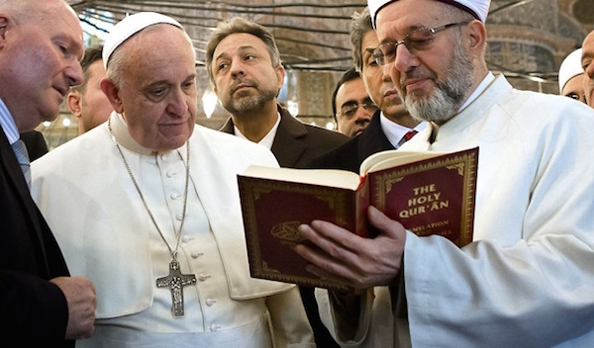
In the 1960s, there were approximately 60 million Muslims throughout western Europe. Only 1% of the American population was Muslim. Hillary in her campaign speech 2016 said she wanted to increase the Muslim population of America by 500%. She was well into working with Muslim, like Huma Aberdeen.”
“Report: Islam ports to overcome Christians in UK” - Theresa May announces the end of free speech in UK: `We value free speech…we also value tolerance to others’ - May 20, 2018 - Robert Spencer – Jihad Watch
UK: A New Drive for Islamic Blasphemy Laws? by Judith Bergman - June 2, 2018: https://www.gatestoneinstitute.org/12270/uk-blasphemy-laws:
“Prime Minister Theresa May last year described `Islamophobia’ as "extremism," and compared it to Islamic terrorism: `...terrorism, extremism and hatred take many forms; and our determination to tackle them must be the same whoever is responsible... there has been far too much tolerance of extremism in our country over many years – and that means extremism of any kind, including Islamophobia.’ ”
Chris Pinto asks: “Why are socialists promoting Islam?”
***He answers: ***“The democratic party has adopted almost all the Nazis policies from the 1930s, 1940s including homosexuality, environmentalism, animal rights activism, nature is more important than human beings, abortion, euthanasia, Nazi doctrines about a superior race, the inferiority of Jews and Christians, promoting Islam and anti-Semitic pro-Palestinian beliefs,”…and I add mind-control of the public, control of the public media, experimentation on the public of diseases, biological and chemical warfare, the use of technology, and the use of drugs to control the public, and etc.
The Muslim slogan is: “Saturday first and then Sunday,” meaning their plan of destruction is first the Jews then the Christians. [Satan says it like this: first the House of Judah, then the House of Ephraim] Hitler wanted to kill Jews first, then begin to kill Christians in Europe. Hitler said: “Christianity is the most insane thing

that people in their delusions have brought forth.”
Chris Pinto comments: “Hitler thought that Christianity was a Roman plot to undermine the power of the Roman Empire.” Hitler said: “Sneaky Rabbi Paul repackaging Judaism to bring down the Roman Empire.”
Chris Pinto said: “Hitler’s hate of Christ is the same as the Muslim’s hatred of Christ.” In the second CD, he gives details of the attempted takeover of Western civilization by Islam from its beginning and under the Ottoman Empire.
Islam and Western Culture
Earliest beginnings were in the 6th century, around 570 CE. By 610 CE, Mohammed preached about his revelations. His armies began raping, murdering, pillaging villages all over Arabia and neighboring countries. By their violence producing terror, they conquered and made converts.
Chris Pinto said that Islam was a mixture of apostolic-era Judaism, apostate Christianity, and Gnosticism, with the savagery of the Arabian tribes. As I’ve learned, Mohammed took the 350 or so gods worshipped by the tribal people of Arabia and reduced them down to one – the Moon god, Allah, saying he was the last and more powerful of the prophets. In 632 Mohammed died at age 62.
In 732 was the Battle of Tours (information above)
In 1453 Constantinople, center of Byzantine Christianity finally fell to the Ottoman Empire.
As Chris pointed out, the Islamic world is not into democracy or intellectual achievements, they have to be given technology and taught how to use it.
My input: It is obvious that the western nation globalists have weaponized Muslims to do their dirty work. Like I’ve reported, the CIA created Al Qaeda as a data base for mercenaries to be hired to do their dirty work of killing. Osama died a few days after 9/11 of a kidney disease. A few days before 9/11/2001, he was noted to be in Dubai dying. He had to be on dialysis all the time. He was a business partner with George W. Bush and the Queen of England in the Carlyle Group. The ben Laden family built most of America’s military bases in the Middle East. His brother was also a business man. In 2001, Osama was a dying business man who was usable. Oh the lies we’ve been told! Every believer must be a researcher and expose lies.
Hitler wanted Muslims to conquer Europe for him so he could rule the world. He could just walk in and take over and have the killed as well.
The globalists being Nazi-minded saw what Hitler saw in Islam. This is why America and Britain, and the International Bankers specifically joined with Hitler and his Nazis, with German bankers, with I.G. Farben chemicals company to develop chemicals for warfare, and learn their technology for space travel, rockets, bombs, etc.
Hitler got his knowledge from Nephilim and fallen angels. After the war, the U.S. desperately wanted that knowledge! America got it! This savagery continued in America from 1945 especially when we took Nazi war criminals, scientists and psychologists, medical men, space and weapons experts into American under Operation Paperclip.
I highly recommend Linda Hunt’s Secret Agenda for an expose of this. She documents the using U.S. soldiers as guinea pigs for experiments, just like the Nazis, is well documented back to the 1920s at Edgewater, Maryland.
Experiments on our own soldiers on the use of poisonous and chemicals to kill, and to experiment on mind control techniques, yes began in the 1920s in America. Eugenics began in America by the early 1900s. Today, these experiments continue on our solders in wars, like the Viet Nam war and the Gulf Wars. Now, it is out in the open that the Pentagon wants to chip soldiers. Yet, they have been chipping soldiers, even turning some men into cyborgs and “super enhanced soldiers,” erasing their humanity. The more you uncover, the deeper the horrors get.
I’d read this before, but Chris Pinto confirmed it, that on May 15, 1948, Britain, and “the West,” turned give Muslim nations against Israel, using Nazi Muslims. The West (America, Britain, Western Europe) gave Jews their weapons, and also gave weapons to the Muslims. Both sides were armed to advance the goals for the “new world order.”
Mazzini/Pike Plan III from 1871 said that there would be a third world war in which Jews and Muslims would annihilate each other. America, the UK, and Western Europe are helping this along. Unity!
Chris Pinto pointed out that “Muslims do not believe in freedom, in science, in achieving an education, in advancement, or in cleaning up their filthy ways …” He is not being mean in saying this. One example are the Bedouin shacks on Highway 90 south of Jerusalem, the highway to the Dead Sea. They live in squalor! Many Muslims live like the tribes did in the barbaric 6th century. Some still live in their big tents. However, those aligned with Western powers are extremely rich! Many still embraced the passion to kill, steal, rape, lie, cheat, in their attempts to subject all mankind to their god. But, then, many live in wealth and power too.
Americans take heed! Did you know that positions in our Government, our Congress, CIA, in many Government organizations, city Mayors, and state government officials, are fast being taken over by radically minded Muslim politicians? Did you know that the Mayor of London was a Muslim? His name is: Sadiq Aman Khan. Do research!
“U.S. Muslim preacher: Soon America will be Ours” by Pamela Geller – The Geller Report – May 13, 2018: “In a few centuries, in Syria, where more than 90% percent of the population were Christians, and in Iran where an overwhelming majority of citizens were Zoroastrians, the demography drastically shifted to majority-Muslim. Neither nation could have anticipated such a change.
And here in the United States: The number of Muslims in the US has increased by 40% in just five years — between 2010-2015 — while in the same period the non-Muslim population of the US has grown by only five percent.” This means that the Muslim population is growing almost eight times faster than the non-Muslim population in the US.
Many extremists believe that their religious desire — for a `Muslim takeover of the White House, a directive from Muhammad himself’ — is coming true in the US. Religiously speaking, for these Muslims, ruling America is Allah’s (God’s) word, a sacred promise is coming to fruition.
A recent survey and demographic research released by the Pew Research Center found that Muslims will soon overtake members of other religions, including Jews, as the second-largest religious group in the United States.”
Winston Churchill spoke of “retrograde,” civilization turning backwards to a savage form. Churchill said: “Islam is a retrograde culture.” For 1,400 years Islam has been causing retrograde in non-Islamic cultures through political jihad, fanaticism, by weaponizing the religion to eliminate western power militant… as Churchill warned.
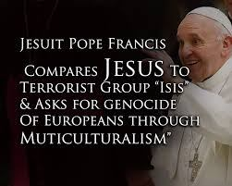
Yes, the Vatican is working in league with the plan of Hitler, the globalist plan, for the young radical weaponized men of Islam to take over Europe under the guise of multiculturalism.
Britain’s Prime Minister Theresa May is now enacting laws that will protect Muslims and arrest and imprison anyone who speaks against Islam, against the rape gangs, like Tommy Robinson, who asks questions like Amy. Shiria law is coming to England. Shiria law is coming to Europe and to America. Dearborn, Michigan is a Muslim city within the U.S. Slowly but surely they wait and have lots of babies, and infiltrate the Congress, the Senate, government agencies, Colleges and Universities, until, like the Jesuits have done, they take over and impose their radical laws on the American people. The plan is working!
ARE YOU LISTENING CAREFULLY? Mind-programming of those not supposed to know anything is happening daily. I was watching NBC Nightly News a few nights ago, and they reported on the elections that are coming up in America. The newscaster made this statement: “There are many WHITE NATIONALISTS running for office in this election.” WHAT!
The use of phrases like “extremists,” “racist,” “right wing,” “the Christian right,” “white privilege,” “Islamophobia,” and other such coined phrases, now its “white nationalists,” is for the segregation of truth-tellers from the accepted and promoted liars, deceivers, mind controllers, and mind manipulators. Why point out these certain candidate’s color--isn’t that “racist?” Why point out “Nationalism?” Isn’t that pointing to these white men as being “politically incorrect,” after all, these white men are not promoting GLOBALISM. They are promoting NATIONALISM, like President Trump does. THE IN-WORD IS GLOBALISM! Anyone siding with Trump is not considered aligning to THE PLAN. The word “racist” originated with Karl Marx!
THE UNDERLYING REASON FOR USING ISLAM, which means “submission,” is to kill any opposition from Christianity or Judaism, and to bring the world into submission to the laws of the anti-messiah, the Beast. Radical Muslims are the weapons, but disposable weapons to the Globalists, as are homosexuals. Once they achieve their goal of saving back a few slaves for themselves and eliminating everyone else, they will inflict their own laws on their peasant slaves under the rule of the Beast. As has been stated, Islam is simply the means to an end. Their slogan is: The end justifies the means. But, that’s the Globalist slogan too. Islam is usable, as are the LGBT people. Once used, they are disposable. That’s the plan.
We’re seeing this army of disposable rapists and murderers doing the dirty work of the Globalist elite, to prepare the earth for the takeover by Nephilim, and Satan, and fallen angels, with them, they think, as ruling gods, the lord of a new Atlantis. Sorry guys, Yahuwah is alive and well! Hitler was really up-to-date!
Do your own research. What we’re seeing is all in the Word of Yahuwah! But, we need to see it unfolding, and we need to know what to watch for.
Be diligent, be disciplined, be strong in the Master and in the power of His might. Knowledge of what you’re not supposed to know will help you to be strong and firm, and fearless.
Shalom, in His love,
Yedidah
June 6, 2018

