ISRAEL AND SURROUNDING NATIONS
ITS ALL UNRAVELINIG, EXPLODING, BREAKING LOOSE
Shabbat Shalom!
Here is an update of this evening in Israel that I want to share with you. Hal Turner has really covered it well. It’s all unraveling, exploding, breaking loose, and happening just as planned by the globalists, including Israel and America.
I got an e-mail today from a dear friend in Tiberias. Rioting in Tiberias, some trying to hang on Arab! I love Israel as my homeland. I love the people. I grieve for what is happening there with the demanded vaccines, the breaking of the Nuremberg Code, and now war within Israel.
However, you know as well as I do that Israel has a roll to play right now so that the antichrist/Beast of Revelation 13 can come to power and rule from Jerusalem. You’ve heard about the arrival of Israel’s false messiah that is now adored by rabbis and religious people in Israel as their messiah. It was believed by the rabbi that he would come during a time of war, and so it is. But, of course, we know he is not from Yahuwah.
This war within modern Israel has been set up from the early 1900s, following the details of the Mazzini/Pike Plan of 1871. Please refer to the article under the Mikvah of Israel Our Eternal Inheritance, “The Pike-Mazzini Plan of 1871: The Plan For Global Government – The Perfect Execution of Parts I, II, and Now Part III.”
Today, May 14th, was the anniversary of the establishment of the nation of Israel in 1948. Tomorrow is the day that Israel was attacked by surrounding nations May 15, 1948. May 16th is Nakba Day. I’ve written on that, but again, it’s the day of fury, rage, hate, and violence against Israel becoming a nation. In the midst of this internal war, other nations are getting involved, and the Arabs and Palestinians not in the “concentration camps” of Gaza and Tukaram are going to riot even more.
Word has gone out by believers in Israel asking for prayer. Please spend time today praying for the people of Israel. Yahuwah is allowing this. He’s letting it go forward, for these things are part of the tribulation, the time of “Jacob’s troubles,” before Messiah returns. But, we love the people, and we want Yahuwah to protect them, to protect the IDF and the IAF soldiers and pilots. They are under orders to do what they do, righteous order or not. Right now, there is little righteousness coming from the heads of government and the military, much like what is happening in the U.S.
As Hal Turner points out, if Iran gets involved, and the U.S. gets involved, we may be looking at Jeremiah 50-51 sooner than later because Russia will get involved. Russia is all ready set off coast, in the Artic, in Venezuela, etc. to attack the U.S. If so, China will attack, and Russian’s new allies within and without – France and Germany, and on and on – Iran, North Korea… etc.
We’re sitting on the edge of an explosion that will be heard in all nations – for WWIII must break out according to plans in the Middle East in order for the antichrist, the false messiah, false savior of the world, along with aliens, and UFOs, etc., to be released to fulfill their part in end-time prophecy.
So dear ones, read what Hal has posted tonight, and pray, pray, pray.
“Jordan and Israel Armies EXCHANGING GUNFIRE on Jordan Border”
WORLD NEWSDESK 14 MAY 2021 - Hal Turner reporting
“A very serious situation is occurring at the border between Israel and Jordan at the West Bank; troops from both Jordan and Israel are now exchanging gunfire.
After hours of clashes between Jordanian unarmed civilians and US controlled/trained Jordanian security and military forces of Jordan at the borders with the West Bank in the Jordan Valley; the civilians managed to cut the fence and are pouring in to the West Bank for the first time since 1967.
This has caused Israeli Defense Forces to fire shots at those civilians, and in response, the Jordan Army has begun firing at the Israeli troops.
After Israel sent police into the Al Aqsa Mosque to use stun grenades and tear gas, and Israeli courts began using Jewish land claims from PRIOR TO THE CREATION OF ISRAEL to justify evicting Arabs from the Sheik Jarrah quarter, Hamas, which controls the Gaza Strip, started firing rockets into Israel.
In response, Israel sent fighter jets to drop 500 pound bombs on Gaza, and re-send police into the Al Aqsa Mosque using stun grenades and tear gas AGAIN.
That Israeli reaction resulted in Hamas firing upwards of a thousand rockets and newer, more powerful missiles, and unleashing armed drones to strike into many sections of Israel.
The bigger rocket barrage and drone strikes resulted in Israel tasking 160 planes to strike 150 targets inside Gaza, three-times-each, making the tally 450 strikes, which took place last night.
Just this week, the Israeli Defense Force admits striking in Gaza a total of six hundred (600) times. They also say that Gaza has fired "over 1600 rockets" so far this week.
Yesterday, four rockets were fired from Southern Lebanon into northern Israel. They landed in open fields, away from any civilians and away from any structures. IT turned out the rockets were launched by Palestinian groups and NOT by Hezbollah, which controls Lebanon.
Experienced watchers of this region say the firing of rockets from southern Lebanon was a not-so-subtle reminder to Israel that they can be attacked from the north, and this warning was designed to stop any Israeli plans for a ground invasion into Gaza.
Today, tens-of-thousands of Iraqis, Jordanians and Lebanese began heading by car, truck or on foot, toward Israel, to help the Palestinians there. Video below is one such example:
In addition, thousands of SYRIANS have stormed into the Golan Heights to show their outrage at Israeli actions. Those Syrian crowds are growing larger:
Convoys of vehicles are also moving in Egypt toward the Gaza Strip to assist Palestinians
Overnight, roving gangs of Arabs and other roving gangs of Israelis, beat up people on the street in a number of Israeli cities.
It is as close to civil war as any nation can get without an open declaration. Civil society is taking sides in this latest Israeli-Palestinian Gaza fight situation, and the engagement of civilians on both sides in ripping away civility in many areas of Israel.
In fact, expert observers say the fighting taking place between Arabs and Israelis in so many cities, is doing far more damage to Israel than anything the Palestinians in Gaza have done. Israeli society seems to be falling apart, violently.
Intelligence experts are carefully watching what Hezbollah is doing in Lebanon. If Hezbollah decides to enter the fray between Israel and Gaza, that would effectively mean that Iran would be engaged, because Iran funds and arms Hezbollah; and that would be an existential threat to the state of Israel. [That’s the idea of the globalist plan]
Should Hezbollah engage, the United States may be asked by Israel to engage. If the US does so, then Russia would have a thing or two to say about that and the Russians might choose to engage as well - albeit in support of Iran/Hezbollah/Palestinians.
Then too, with Jordan Army troops exchanging gunfire with Israeli Army Troops, that's another flash point in and of itself.
Finally, Egypt announced they would re-open the Raffah crossing to evacuate injured from Gaza. Egypt made clear they are sending Red Crescent workers through that crossing and those workers are operating Egyptian army vehicles/jeeps. Egypt went out of its way to make clear that any attack upon any Red Crescent vehicles would be deemed an attack upon the Egyptian military requiring a response.
This situation has the very real potential of exploding into vast warfare on little or no notice.
UPDATE 12:56 PM EDT -- Riots are now being reported at Damascus Gate in Jerusalem.
Stay tuned.
UPDATE 1:45 PM EDT --
Egypt announced that if the attacks on Gaza are not stopped, relations with Tel Aviv will be suspended.
Moments ago in Gaza:
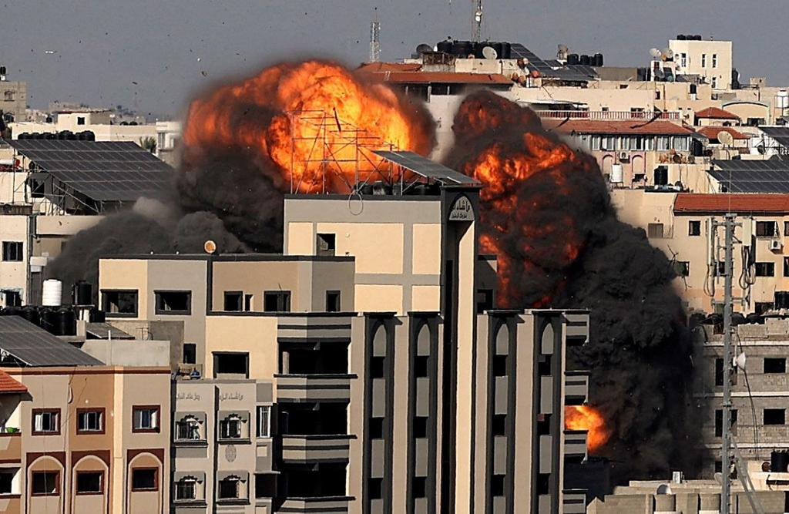
UPDATE 2:38 PM EDT --
As of Now Israel has Declined US Envoy's Offer of Ceasefire. Right now Israel is refusing to negotiate a ceasefire, rejecting efforts of the UN, US and the Egyptians.

2:45 PM -- Oh Boy . . .
Israel: "There will be no ceasefire with Hamas."
Hamas: "We refuse any ceasefire with Israel and we will fight to the end."

UPDATE 4:58 PM EDT --
3 rockets fired from Syria at Israel, rocket warning sirens didn’t sound.
Israeli fighter jets fired seven heavy rockets on the building of Palestine's Interior Ministry.
Hamas-run Health Ministry in Gaza says 126 killed, including 31 minors, and 950 wounded from IDF strikes so far THIS WEEK.
Palestinian Health ministry: 6 killed and 91 wounded in today’s rioting in the West Bank.
Israel IDF says 2,500 rockets have been fired at Israel and Iron Dome intercepted 1,000 of them. The prior ten years Iron Dome intercepted around 2,500 rockets since it was operational in 2011. So in just 96 hours it intercepted as many as in several years. That’s BIG because it dramatically changes the Iron Dome "invincibility" perception: Not 90%. Only 40% success rate.
UPDATE 5:15 PM EDT --
At 5:00 PM eastern US Time, it became May 15 in Israel, which is Nakba Day for the Palestinians.”
Love, Yedidah
May 14, 2021

