IRAN: PULLING TOGETHER LOTS OF NEWS AND HIDDEN TRUTH
Things are not as they appear!

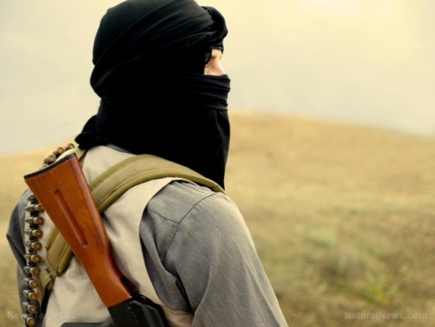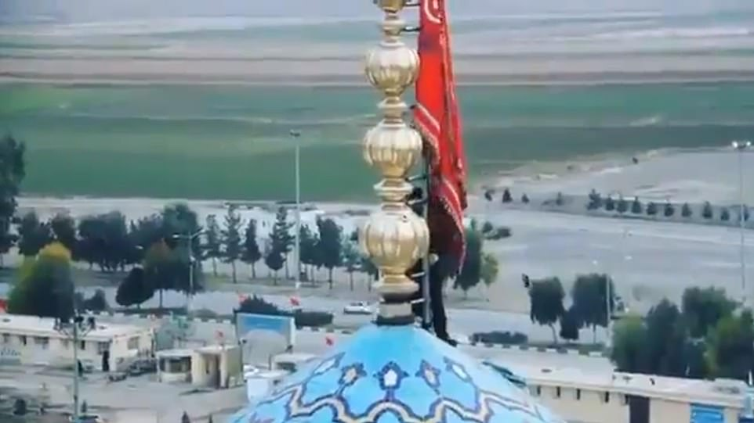

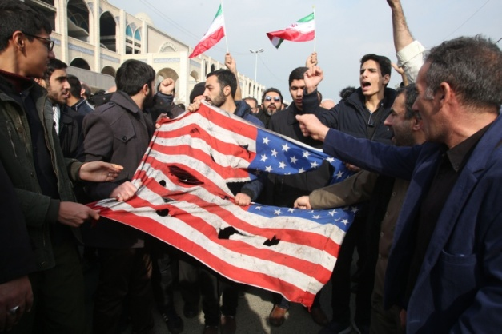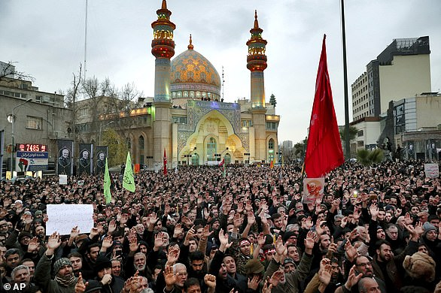
This article covers a lot of foundational material to help you see why this is not going to “blow over.” I share some shocking statements, but they’re true. Please share with others! Please prepare yourself and your family! We’ve entered the time-tunnel that ends with the coming of Yahushua Messiah!
Since the attack on the American Embassy in Iraq by Iranians and their Hezbollah proxies, and the counter-attack ordered by President Trump which resulted in the assassination of Iran’s #1 military Commander General, talk of war has been escalated greatly. But, this scenario has been planned for many decades, back to 1871 in the Pike-Mazzini Plan for three world wars to bring about a new world order. The plan was set in motion in modern times in the days of George W. Bush’s presidency. At that time, as George W. Bush told General Wesley Clark, America had to bring down and “take out” seven nations, the final one being Iran, before the new world order could be established. The first six nations have been “taken down and out” and now Iran is next. However, Iran’s “taking down and out” is not really to take Iran down and out, but to set up a situation prophesied in Isaiah and Jeremiah and Revelation so many thousands of years ago, about the destruction of America. America was created with a “secret destiny” to bring forth Nimrod/Osiris/Apollo once again to world power, whom we call the antichrist or anti-messiah – the Beast entity of Daniel 2, 7, and Revelation 13. Revelation 9:11 calls him “Apollyon” in Greek, “Abaddon” in Hebrew. In today’s Greece, the names Apollo and Apollyon are used, both meaning “destroyer,” “lawless one,” as in II Thessalonians 2:3, Revelation 9:11, 11:7; and 17:8.
Iran is a key nation in the Ezekiel 38:5 line-up, under its ancient name of “Persia.” Iran told Israel 2 to 3 years ago that they did not want to go to war with them. Iran helped Syria, as did Russia, in a war that Obama started. Iran set up bases in Syria, but did not attack Israel. The war with Iran was provoked from the start. Inside military intelligence associated with key watchmen of Yahuwah let us know that Israel’s Mossad trained ISIS and Al Qaeda terrorists, both groups created by America, to blow up the tankers in the Straits of Hormuz, so that Iran could be blamed. Iran kept a cool head during it. The deception against them at times could be easily proved. But with the killing of their #1 Commander of the elite Al-Quds Force, Qussam Soleimani, Iran has been pushed beyond their ability to use restraint.
Threats are going back and forth between President Trump and the Iranian President and the Ayatollah Al-Khomeini. In the midst of it all, great revival has broken out in Iran as the people are tired of the dictatorial reign of the Ayatollah, and of Islam itself, and many are being born again through faith in Jesus. The believers are greatly persecuted, many imprisoned and killed.
Word has reached us that during the 3-day funeral for Qussam Soleimani, if people would not attend his funeral, they were shot dead on the spot. Yes, whole groups of people who resisted attending the funeral have been shot dead. I would assume that many of them were Christians.
As you can see from the picture, above, a red flag has been raised over the dome of the Al-Jamkaran mosque, the most “holy” mosque of Iran. This is the red flag of war. It is not just any flag for any war. It is the flag indicating the war that will result in the bringing forth of their messiah, the Maudi.
The raising of this flag of the war to bring forth their messiah, the Maudi, is no light thing! This is a statement to America, to the British, and to the world.
Right now the British are sending troops to the region, and many troops are coming from America. Iraq wants all Americans out of Iraq, by proclamation of their Parliament in the last two day.
The American Embassy in Baghdad is the largest American Embassy in the world. You can read my last two articles to update you as to what I continue writing here: “U.S. Embassy Attacked in Baghdad – War With Iran Is Closer Than Ever” and “The Killing of Soleimani Has Gone Global – America Preparing for Retaliation,” both under the mikvah of Present Reality.
President Trump has threatened Iran with 52 attacks, one attack for each of the 52 Americans held hostage in Iran in the 1970s. Iran has promised 35 attacks, naming Tel Aviv and Washington D.C.
The Ayatollah Khomeini has put out an 80,000 million bounty on Trump’s head.
At the funeral for Soleimani, each participant was charged 1 dollar (in their currency of course) to add to the 80,000 million bounty. So, those not attending the funeral and not paying their 1 dollar were shot immediately by the military police. This is under Sharia Law! So pray much for the Iranian believers who are risking their lives to proclaim the Good News of salvation by Jesus/Isa. “Isa” is Arabic for Jesus, and the Iranians speak Farsi, not Arabic, yet it is said that they call Him “Isa,” also spelled “Essa.”-- whatever name they call Him, they are saved by their faith in Him, and are risking their lives for their faith. HalleluYah!
I’ve studied so much, and I’ve lived in an Arab/Palestinian country of Jordan for 8 years, and loved it I might add, as well as in Israel about ½ of another 8 years, in both countries among Arabs and Palestinians, that I understand all sides from all people groups. I lived with Jordanians but met people from every country in the region and became friends with a few of them from Sudan, Egypt, Iraq, Syria, Lebanon, and even Saudi Arabia. Thus I’ve seen and heard the lies told by America and other western nations that totally distort the truth going back to the late 1800s. Therefore, I am very skeptical of siding with my own nation who has plotted and planned with the leaders of the world government since 1871 to bring forth the new world order. However, since the Presidency of George Bush, Sr., when he announced the need for a world government in 1990, the moves of America to destabilize the Middle East in preparation for Mazzini/Pike Plan III, World War III, have been put in motion. In May of 1999, while watching CNN Europe in Aqaba, Jordan, I saw and heard the announcement of the one world government being established for myself first hand, from the Pentagon or White House by James Reuben. A friend phoned in to report that it was being announced by BBC Europe also, and that the leader of it was the President of the United States, then Bill Clinton, and the military arm of it being NATO. It was NOT reported on any American news. Later I talked to a man in Wales who said he heard the announcement on his T.V. of the new world order being established in May 1999.
I suggest you read: “America’s Secret Destiny”/Mikvah of Preparation and “The Pike-Mazzini Plan of 1871: The Plan For Global Government – The Perfect Execution of Parts I, II, and Now Part III/Mikvah of Israel, Our Eternal Inheritance.
I know that this is NOT about destroying the evil Iran! Iran is a key player in the Ezekiel 38 scenario. Please refer to: “Ezekiel 38 and 39 – Directly Linked to the Return of Messiah/Mikvah of Israel, Our Eternal Inheritance.
In 1992, as I was reading Jeremiah 50-52, Yahuwah spoke very clearly to me: “This is America.” I wrote out all the scriptures to do with end-time Babylon, givin comments as to their relationship with America, like Isaiah 10, 13, 18, 45, Jeremiah 25, Jeremiah 50-51, Zechariah 2, and Revelation 18.
I took my findings to my pastor, Robert Muwire. In it I mentioned the timing of the attack by nations from the north on end-time Babylon being in the Autumn/”Fall.” The next Sunday, Pastor Muwire, who became personal friends of Netanyahu, having prophesied over him during his first term in office, Jonathan Cahn, the mayor of Ariel, also, came running up the aisle very excited, saying that everything I wrote was what God had shown him, but I added the timing of Fall.
In the years since 1992, many of the watchmen now realize that America is historically end-time Babylon. In America’s secret destiny, back to the early 1600s, America was created to bring back Nimrod, founder of Babel/Babylon, and to restore his power and his spirit over the earth, as I wrote above. By the 1st century CE, Rome was known as the “second Babylon.” Kepha, in I Peter 5:13, gives a message from Babylon. He’s not talking about Iraq. He’s talking about Rome. The spirit of Babel moved over Western Europe and on into America, the chosen nation.
Christian reporters today appear to view President Trump as a god. He can do no wrong, and Iran can do no right. To them, Israel is the “holy land” and its leaders can do no wrong, its rabbis are holy, and all they plan to do is holy.
Oh Abba! The deceptions to deceive “even the elect” are abounding and multiplying!!! They are so much like the 1st century Pharisees who cried to Pilate “we have no king but Caesar.” They destroy Truth by their fallacious beliefs and alliances. In the days to come, enemies will be those of our own household and of a chosen religious group. Christians will turn on other believers (Mark 13:9-12)
When the Word says to “flee Babylon” which is in the Word over and over in context of the last days, it is talking also about religions of man. For religion is lying deception – all of it – all of it – all of it! To flee to another country, you must be led by the Spirit and have prepared. Fear will get you only defeat! (Luke 21:25-26)
The only rightful Teacher of absolute 100% Truth is the Spirit of Yahuwah who does 40 things in the true new birth to transfer us from the kingdom of darkness into the Kingdom of light, following repentance. We must then ask Messiah Yahushua to baptize us into the Spirit of Yahuwah so that He resides within our re-born spirit, to teach us, lead and guide, convict, direct, comfort, and give peace.
There are 9 gifts of the Spirit (I Corinthians 12:1-11), and without them, like “discernment,” we cannot continue on to know Yahuwah and Yahushua as Persons. Religion robs all mankind of having a personal relationship with Them. Yes, there are some good pastors – especially in nations of great persecution. They know little, for few have a Bible, but they are pure of heart and what they know, they live.
Yahuwah’s Spirit is my only Teacher. He brings me confirmation as I need it. Therefore, I have learned from the Word as a whole, and by watching events since 1985, especially since 1999 from Jordan, and learning truth from actually being in the Middle East, this planned war with Iran is for one purpose.
That purpose is to give Russia, China, North Korea, Iran, Turkey, Germany and France, etc. a reason to attack and destroy the United States! You might say “what! Germany and France! – Never!” Oh yes, they have made pacts with Russia recently and they hate America. Cuba might also join in, along with inside terrorist groups.
To understand Jeremiah 50-51 and other Scripture passages about America in prophecy, please refer to “Thirty Clues and More…”/Mikvah of Preparation. I share many of the things that Abba taught me in 1992. Also refer to the original article “End-Time Babylon”/Mikvah of the Great Adventure, in which I go over other Scriptures as well.
Below is a map of known terrorist groups inside America. Many Iranian sleeper cells are in the U.S. as well as over a million U.N. troops, who are mostly Russian and Chinese. Russian and Chinese troops along with many terrorist and drug-related gangs are inside, and ISIS has camps in all 50 states.
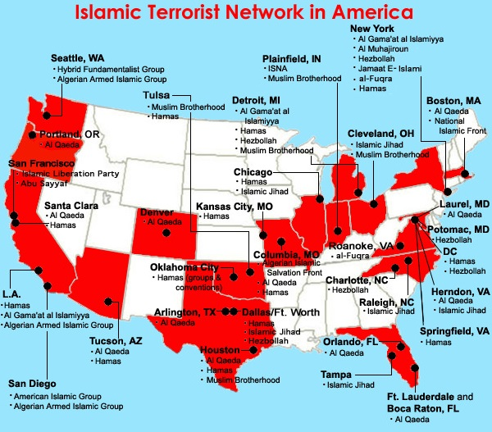
I highly suggest that you read the article on Natural News by Mike Adams, “PREPARE for Iran to activate terror cells across America and attack the power grid, water supplies and vulnerable infrastructure,” January 05, 2020. Excerpts from the article are below.
Steve Quayle is giving warnings for us to prepare in the U.S. This is NOT going to “blow over.” This has been planned for centuries. America has to be taken down in order for the one world government to rise. In the Chinese map of their Belt and Road Initiative for world trade notice that the whole north American continent is left out. Why? – Most likely because we’re not able to doing any trading!
Those commodities listed in Revelation 18:11-13 are only traded one place on earth daily – New York City – Wall Street Stock Exchange, including the trafficking of “souls,” of children and young adults--pedophile and other sexual trafficking.
Read carefully what will happen to New York City and its harbor in Revelation 18. It will be destroyed in one hour. Notice the wording that is also in Isaiah 47.
I listened to the Christian minister reporting on what’s happening with Iran, and while he is a good reporter and truthful in facts, the attitude is “we have no king but Caesar.” There is a mindless loyalty to the American government, to Donald Trump, and to the Israeli government among most Evangelical/Charismatic Christians. Most of His people are clueless as to what’s really going on. Pray for the people, because many are being deceived to support what is planned by Satan’s kingdom. His people are perishing from lack of Truthful Knowledge!
So, being disgusted with the ignorance flowing forth from Christians in their misguided loyalties, knowing what I know of reality, last night I checked with Steven ben Nun YouTube. Steven is ex-CIA and has contacts in the highest of places to get the highest of inside news that is available. Thus his “opinions” are accurate… and starkly cross the opinions of those who go with the flow of their chosen pastors and teachers. He said exactly what I knew from Abba, and he’s risking his life to tell the truth! I’ve been reporting stark truth about America and even President Trump’s purpose in it all. I pray for President Trump. He’s being used. If he’s freed to be the real President with real authority of his own, he’d be very good, for he is a financial genius, who has the ability to bless America.
Abba has always confirmed to me what He has shown me, so that I’m not off into opinions – but can back what I say by facts and the whole of the Word of Yahuwah. Make sure you are hearing from THE TEACHER Himself.
Here is a quick critique of what Steven ben Nun said last night:
One of his Middle East informants said that the red flag over the dome of Iran’s most sacred mosque means “a severe war is coming.” The British are sending ships to Iran. The U.S. is sending many groups of troops. “It seems to be a war will happen with Iran,” Steven said, “it has to happen to bring about the new world order they’re talking about.” Yes!
About Trump’s boast of hitting 52 Iranian targets if they strike one US target, ben Nun says that “whoever is telling Trump what to do …,” in other words, Trump is playing his part in the game well. Yes, it is a reference to the 52 Iranian hostages. Yes, Trump is under orders. But, he’s not the first President to be under the orders of the world’s fallen angel principalities, powers, and hybrid agents.
Trump is indebted deeply to the Rothschilds and George Soros, to name just two. Everything we’ve seen since at least 9/11 to date has had a false flag attached to it, so that others are blamed for what America does to bring about the new world order, fulfilling our “destiny.” Be sure to read “America’s Secret Destiny”/Mikvah of Preparation. It says so much that makes what we see to make sense.
Our government and bankers and corporation leaders supported Hitler, and brought many Nazis into the U.S. from 1945–the early 90s under Operation Paperclip, for technology and mind-control information which has been used on the American citizens.
China was given the plans for the Neutron bomb personally by President Obama, while the creator of the Neutron bomb was pleading with him not to do it, with tears. So, China can wipe out all the people and leave the infrastructure if they want to, or use an EMP, or just bomb Sanford, Texas, and set the natural gas reserve that runs coast to coast on fire. China and Russia and North Korea are the nations from the north of end-time Babylon that will also be joined by many other nations in the destruction of America. As in the article listed above on the Mazzini/Pike Plan of 1871, Part III, war in the Middle East will lead to the one world government as President George W. Bush told General Wesley Clark. So Iran is simply the bait! Mikvah of Israel, Our Eternal Inheritance (2019)…
The real nation that they want to taken down and out is America!
Steven ben Nun said of Iran, that if they attack the White House or somewhere in Washington D.C., “it will galvanize America to go to war with Iran.”
Hollywood movies have been made since the 70s about an attack on Washington D.C. Hollywood tells what is going on and what is planned but hidden.
Steven said what may be the most likely scenario: “I wouldn’t be surprised if an attack on Washington would be a staged attack, as was 9/11.”
In other words, if Iran hits a target in Washington D.C., or New York, or even if America does it and blames it on Iran, the results will be to unite the nation to go to war. Would America stage an attack on the White House or some other place in Washington DC, or in New York, to provoke war? In a heart-beat!!! Look at the horrendous results of the staged false flag 9/11/2001 – war, war, and more war.
Iran had a democratic government under the Shah. President Jimmy Carter had him taken out of office and the reign of the Ayatollahs began. The destabilization of the Middle East in preparation for what might start soon, has gone on for a long time. According to Scripture, various Middle Eastern nations today had their “return” for the last days and the judgment of Yahuwah – like Elam, former name of Persia, today’s Iran. There is a large province in Western Iran named “Elam.” Remember Chedorleomer? I sure do! He was the king of Elam. (Genesis 14)
Jeremiah 49:39: “And it shall be in the latter days that I turn back the captivity of Elyam,” declares Yahuwah.
When did He turn back their captivity and establish them as the modern nation of Iran, from being ancient Elyam and ancient Persia? The name Iran was adopted as the country’s official name in 1935. April 1, 1979, thanks to the evil of America, the Shah and his family were exiled, and the Ayatollah Khomeini, Islamic clerical opposition leader, returned from 14 years of exile in Iraq and France, to rule the country. Under the Shah’s rule Israel would never have been threatened at all. He brought peace. But, in fulfilling the Shabbati-Frankists agenda, there must be no peace in the Middle East, for it is the trigger to bring about a new world order.
If you are a researcher, a reader for truth, I recommend David Icke’s 900-page book, Trigger, that takes you from the 9/11/2001 false flag to the present day – world-rule by the followers of the 1666 Jewish messiah Shabbati Tzvi and later his disciple Jacob Frank. Jacob Frank taught the belief of a reverse Torah for salvation, as the Babylonian Talmud teaches. He infiltrated Judaism, Christianity, and Islam, all governments, all financial institutions, all education institutions, commerce, trade – you name it, he and his followers have infiltrated it.
The Illuminati, begun by the son of a rabbi, Adam Weshaupt, the root of the Shabbati-Frankist Zionists, and Jesuits of the Vatican, founded by the Jewish Ignatius Loyola, a product of the infiltration of Shabbati-Frankist into the Roman Catholic Church, are the top world rulers of today’s world and have been since the late 1600s. America was chosen to bring the plot to fruition. For a short version of this doctrine of reverse-Torah, redemption by sinning, please refer to the article: “1666: Shabtai Tzvi and Redemption Through Sinning”/Mikvah of Israel, Our Eternal Inheritance. It is shocking information, I know, but very, very real. David Icke spends many pages laying it out in great detail in his book, which is very correctly, I might add.
Steven ben Nun says what Abba has led me to say: “This will have the same results as 9/11 – a reason to go to war with Iran, which would draw Russia and China to destroy the U.S. The destruction of America is the goal so that the world government can arise.”
I’ve written much on this scenario in previous articles. I would not be surprised if there was a direct targeting of the subduction zone in Cascadia, or of the San Andreas Fault Line, or of the New Madrid Fault Line., so that the whole west coast falls into the sea and America is split in half from the Great Lake to the Gulf of Mexico. That’s a real possibility that even F.E.M.A is preparing for. Russia proved what a direct hit would do in their July 2019 hit at Ridgecrest and China Lake, California. The direct target beam hit so deep into the earth that tens of thousands of earthquake tremors resulted, and it’s still shaking.
Steven said: 9/11 was an inside job: “…something the Mossad was jumping up and down celebrating” 9/11 actually launched the final Mazzini/Pike Plan III to end in a new world order.
All my life, I’ve been a loyal and law-abiding American citizen. I have loved my country and was educated to believe in its goodness and its righteousness. I pledged allegiance to the flag with all my heart. I am still a law-abiding citizen, but no longer under illusions. I’ve realistically been led to learn the truth of its origin, purpose and evil that is also associated with its mind-programming and experimentation on the American people from the late 1800s at least.
I know this might sound speculative, but consider: Revelation 9:11 tells of the rise of antichrist from the pit, and the rising of demonic powers that leads to a final world war. (Read Revelation 9 with Joel 2) The army of in Joel 2 is the same army as in Revelation 9, both manifesting like a locust swarm.
What happened in New York on 9/11/2001 did just that – it caused a gigantic leap forward towards the rule of antichrist, the invasion of earth by fallen angels and demons, and the final war that will lead to the government of Satan’s kingdom.
Perhaps that is not speculation!
Now thousands of U.S. troops and British troops, too, are on their way to Iraq.
And by agreement of the Iraqi Parliament, Iraq is calling for all Americans to leave, and to stop training the Iraqi military. Steven said that it is possible that a war with Iran would include a war with Iraq also.
Iranian Members of Parliament united in chanting “death to America.” This was yesterday – January 6, 2020. I remember when Iran said they’d strike the “little satan” first and then the “big satan,” referring to Israel and America. Steven said that yesterday Iran again made the “little satan,” “big satan,” threat, but now Britain is called the “little satan” and the U.S. retains its title of “big satan.”
Iran is threatening Tel Aviv. You might say that Iran is very inferior in weaponry compared with America, and Iran will be crippled quickly within their own country. Uh… think again. Actually, their weaponry is far superior to America’s in many ways. Steven’s inside source said that they may even try to hit Haifa with a new weapon that China has given Iran – like an atomic bomb but not …
In early 2019, it was reported that China boasted in giving Iran the most sophisticated weapons on earth – weapons that can strike so fast that no defense system can block them. Could China use the Neutron bomb on Israel and/or America? Russia’s weaponry is far advanced than what the U.S. has too. Obama reduced our military down to the lowest level before World War II broke out. He left the military with a void of soldiers, sea men, and air men, and experienced officers in many arenas. Obama left our military with a lot of needs for basic maintenance on ships and planes, and technology in general. Yes, Israel has hidden weaponry that is powerful, stored underground. But, will they use it?
Yahuwah allows what man does in order to bring about His plans. He’s not “out-planned.” He is in control!!! He has seen the set-up of man, and allowed it to go forth. When Messiah steps in, it will be over – forever. “Come Yahushua Come!”
A friend of Steven and Jana ben Nun said she had a dream. She saw Trump sitting at his desk in the Oval Office with a huge snake sitting on his shoulders whispering in his ear.
As Steven pointed out, Messiah and John the baptizer called the Pharisees “seed of vipers,” or “brood of vipers.” The Pharisee lineage and/or Khazar lineage of today’s chief rabbis are in control under the Shabbati-Frankist hierarchy, under the Babylonian Talmudic law that is international law, particularly Chabad, to which President Trump and Jared Kuhner are devoted. The elite ones are part of the Shabbati-Frankist elite ruling class of planet earth. This whole thing is planned from the pit of hell, to say the least, and tragically the U.S. government is the facilitator of it all.
The Pentagon was not for the killing of Soleimani! One of ben Nun’s Pentagon sources said that Iran had technology that the U.S. cannot stop or handle. He said “we’re getting in over our heads.”
Early on, Steven reported from Pentagon inside sources that the U.S. Abraham Lincoln would not enter the Straits of Hormuz because of what they knew Iran could do to them. “Iran has sophisticated technology the U.S. does not have, or can the U.S. contend with it,” Steven said. They have the backing of Russia and China! North Korea gave them nuclear weapons years ago and taught them to use them.
I want you to read Mike Adam’s article. In it, he shares what Americans need to do to prepare for any type of attack. Look at the map again above. He said to stay away from major cities, and get somewhere in the country. The terrorists that will be loosed in America will target the big cities. I know, I’m in a danger zone, but just 5 miles south of me is open prairie, with cows, buffalo, horses, chickens, farm land, and nothing but few little towns. To the north and east however, is Dallas and Fort Worth, and even Arlington is on the map above. Montana and Wyoming look good.
Steve Quayle’s funny. He asked various geologists “what about the volcano under Yellowstone?” They told him it has a .0001% chance of blowing. Yahuwah actually sent Henry Gruver to Yellowstone to silence the volcano, which he did. When you do correct intercession for Abba and He can trust you to only say and do what He says to say and do, it can be very exciting (smile).

EXCERPTS FROM the Article by Mike Adams January 5, 2020:
“PREPARE for Iran to activate terror cells across America and attack the power grid, water supplies and vulnerable infrastructure” -January 5, 2020 – Mike Adams
“…What most Americans don’t yet fully realize is that Barack Obama helped fund these terror networks through a complex international money laundering scheme that delivered over $150 billion to Iran during the Obama administration. At least $1 billion went to fund Iran’s nuclear weapons program, with full knowledge from Obama. Obama also helped Iran capture a U.S. drone and two Navy boats in order to give Iran U.S. military encryption technology…As a result, radical Islamic terror cells have a pervasive presence in New York, Boston, Seattle, San Francisco, Orlando, Tucson and many other cities.”
“The way these terror networks operate is by fitting in with society while waiting for the once-in-a-lifetime command to “activate,” at which point they carry out deadly attacks on various targets that would produce the highest casualties, via asymmetric warfare.
In other words, these terror cells are your neighbors, your local dry cleaner owners, Uber drivers and retail workers. They’re everyday people who have spent years embedding themselves in society, but their long-term goal is to destroy America by any means necessary, and that’s what they’ve trained to carry out.
CITIES are the death zones: First off, it’s crucial to understand that all the targets will be found in cities, not rural areas. That’s because asymmetric warfare needs high densities of human targets to achieve the desired goal of mass death. This simply cannot be achieved by attacking farms or rural residential areas.So if you’re still living in a city for some reason, understand that you are now in the target zone for terror cell attacks. If you live in a city and don’t have a plan to escape the city on foot, complete with emergency water filters, food and firearms, then you obviously have some sort of twisted death wish. Vulnerable infrastructure is surprisingly easy for terrorists to destroy…
The second point here is that America’s infrastructure was not constructed with any real sense of making it resistant to domestic terrorism attacks… Thus, if Iran activates its terror cells across America, any rational person should fully expect to see disruptions in the power grid, water systems, food deliveries and fuel infrastructure.
As I’ve explained before, cities are artificial constructs that rely on a steady stream of food, electricity, fuel, bandwidth and water to survive. When any one of those is cut off, cities begin to rapidly collapse into chaos and panic.
The average American — with a few exceptions such as soldiers, fire fighters, police officers, EMTs, etc. — has never seen anything close to the carnage that will unfold when Iran activates a domestic war against America on U.S. soil.
America has become weak. It’s true.
Things you really need to get done in 2020, hopefully before the bombings begin. If you’ve never taken a pistol or rifle training course, make 2020 your year to get that done.
You are now living in “Battlefield America,” and the war will be brought here this calendar year. In fact, Iran and Barack Obama have both worked toward this for a very long time. It is Obama’s billions of dollars in laundered money delivered to Iran, after all, that helped fund this war on America. And all the Democrats are rooting for the Islamic terrorists, in case you haven’t noticed. Their mask has come off, and Democrats are now 100% in alignment with radical Islam when it comes to hating America and hoping for America’s total destruction.
I think our good and faithful watchmen-brothers have said it all well.
Americans must throw away their lollypops, cotton candy, and cherry soda, and get a 55-gallon tank for storing water, canned food, and a colloidal silver unit. In an EMP attack, Americans would be instantly back in the early 1800s, no electricity. Think about that. Pray about that. But, also act! This is not a fear-mongering report, it’s for real. Psalm 18!
In His love and blessings, Yedidah
January 7, 2020

