ISLANDS SHAKING!
PUERTO RICO EARTHQUAKES and the PHILIPPINE VOLCANO TAAL

“A picture is better than a thousand words.” Pictures and maps below… Yahuwah’s Word also speaks about this in the last days. Excerpts from Revelation 16:17-20: “And the seventh messenger poured out his bowl into the air, and a loud voice came out of the Dwelling Place in heaven from the throne, saying `IT IS FINISHED.’ And there came to be noise and thunder and lightning. And there came to be a great earthquake, such a mighty and great earthquake as had not come to be since men were on the earth…And great Babel was remembered before Elohim to give her the cup of the wine of the fierceness of His wrath. And every island sank and disappeared, and the mountains were not found.”
We are seeing a building up of instability in the earth’s crust, tectonic plates are moving, and magma is rising. Messiah warned us of great earthquakes.
30-40 years ago 2-3 active volcanoes might erupt in a day. 2020: There are 24-28 erupting every day. Earthquakes happening in 1993-1994: About 4,500 each year of varying magnitudes. 118,000 earthquakes were registered in 2014. There are tens of thousands of earthquakes occurring now of 2.0, or higher, up to over 7.0.
In 2019, the Philippine Islands were hit with 29 typhoons. 2019 was a record-breaking year for typhoons in the whole region. Now tens of thousands are facing a massive eruption of Taal Volcano. In its initial eruption, January 11, 2020, an ash plumb rose nearly between 11 miles into the air. Ash fell on everything around it, all over farms and the capital city, Manila, just 35 miles to the south.
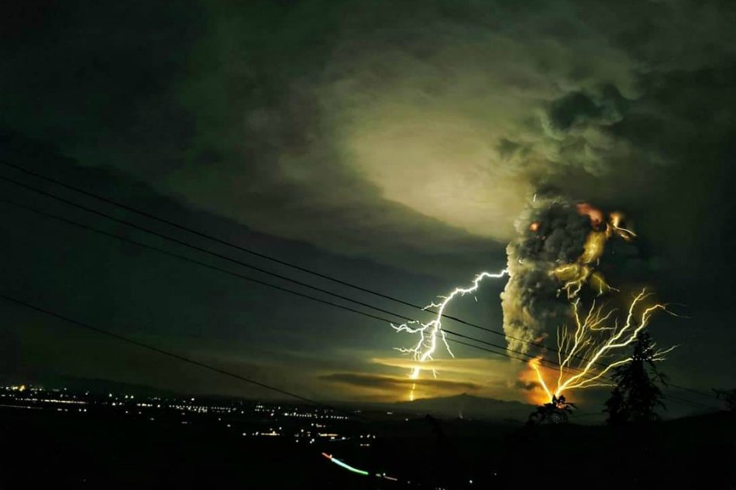
It is 37 miles south of Manila, the capital of the Philippines
Taal Island sits off of Luzon Island. Taal is spewing ash and steam but is expected to explode very soon. What will it do to Manila and surrounding villages and towns?

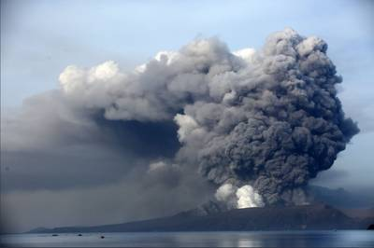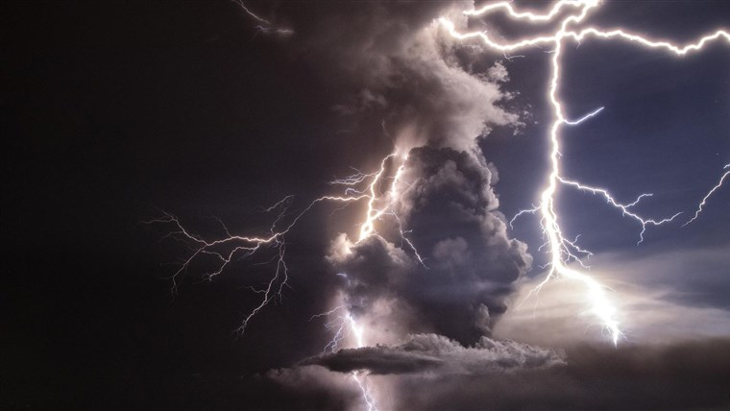
January 2020 – note fishing boats near the island
Thousands are fleeing the area January 12, 2014

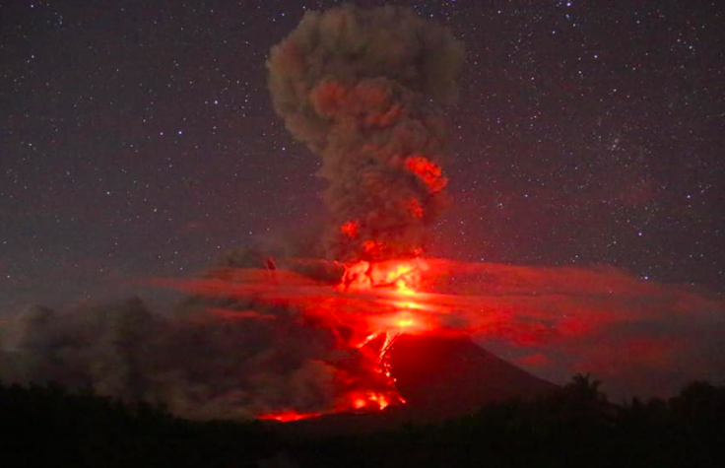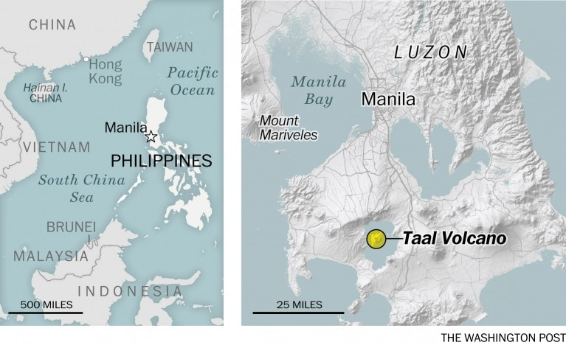
Manila airport shut down

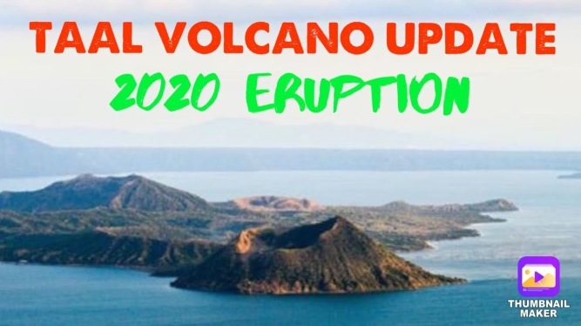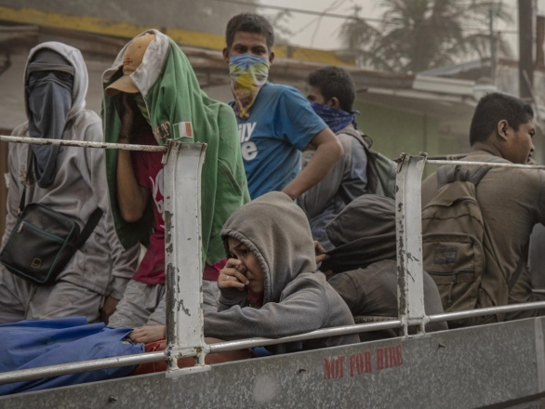
It is covering everything with ash … everyone must wear face masks inside enclosures and of course outside

Paul Begley reporting January 12, 2019: “Breaking: `Massive Volcano Erupts Philippines Evacuations of Thousands’ ”
“The initial eruption of Taal caused a 3.9 earthquake over the region of Luzon.
The big eruption is imminent according to volcanologists. So they’re evacuating as many as possible.”

As reported with maps and pictures in “Happening Right Now! Australia Wildfires! Temperatures So Hot People Won’t Be Able to Live There.” Pleases also read: “Extreme Earth Changes Take Center Stage, and Rightfully So”/both Mikvah of Present Reality. Australia is burning in many regions. Over a billion animals have perished. People are fleeing into the ocean to escape the fires.
Puerto Rica is shaking to its destruction with large earthquake one after another, with many over a 3.0 magnitude. This began with a 6.4 not long ago.
A friend of Paul Begley’s, Jose from Tennessee, came to Puerto Rico to visit his family just before the earthquake. He has been driving around taking pictures, assessing the damage. He said the ground has not stopped shaking. He told how horrible the damage was – shortages of food and water, gasoline lines for miles, but the pumps shutting down – no more gas. The entire island of Puerto Rico has been without power for at least two weeks, the infrastructure is in shambles.
Online New: “Magnitude 5.9 earthquake - Affected countries: British Virgin Islands, Dominica, Saint Martin, Saint Maarten, Guadeloupe, Montserrat, Puerto Rico, Saint Kitts and Nevis, U.S. Virgin Islands, Caribbean Netherlands, Saint Barthélemy, Antigua and Barbuda, and Anguilla, 3 miles from Barina, Yauco, Puerto Rico, Yauco, Puerto Rico · Jan 11, 6:54 AM – Puerto Rico was the epicenter.
A 6.5 and a 5.8 earthquake struck the following day after the 5.8… 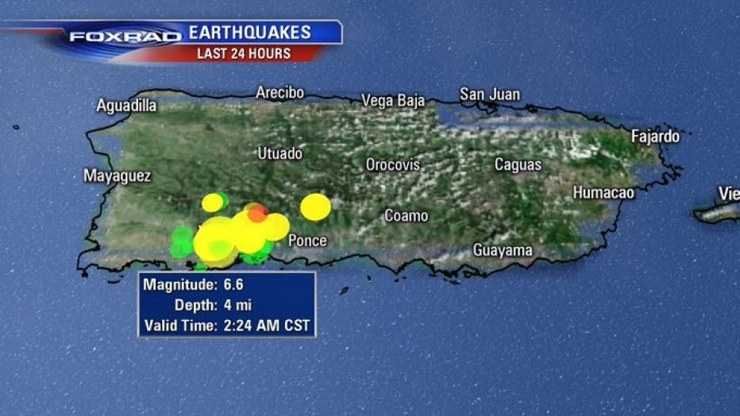
After shocks have been rather large since … January 11-12, 2020
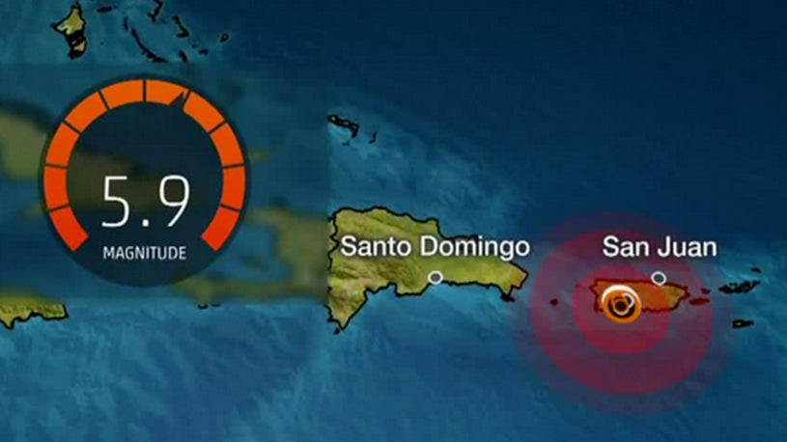
The weather channel… The 5.9 on January 1th rattled other islands, but the epicenter was in the heart of Puerto Rico. Their capital is San Juan.
The weather channel commented: HUNDREDS OF THOUSANDS COULD BE WITHOUT ELECTRIC POWER FOR OVER A YEAR. Right now, the whole Island is without power.

Here are a few pictures of Puerto Rico January 12-13, before I wrap this up:
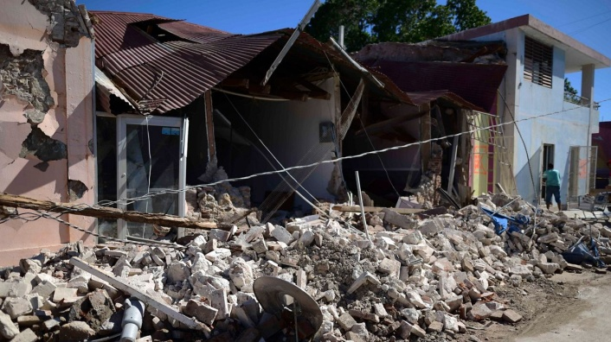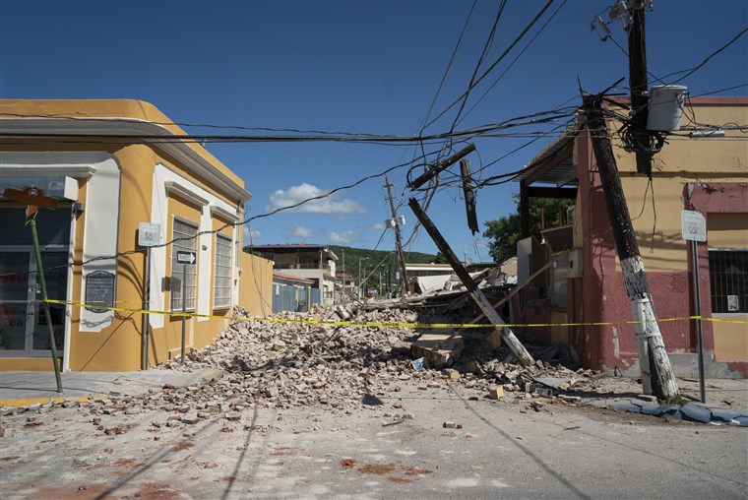

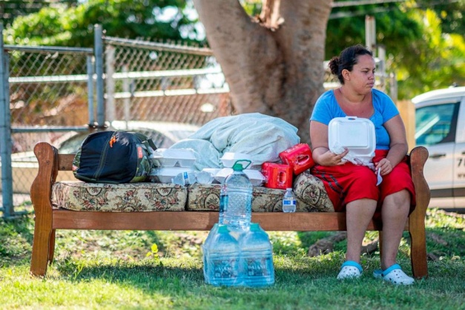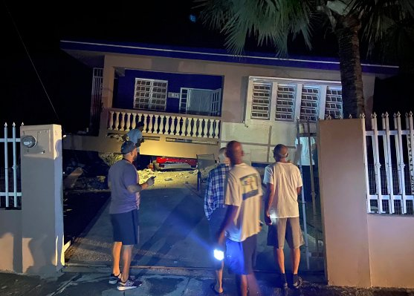
People are sleeping outside for fear their houses will collapse if they stay inside
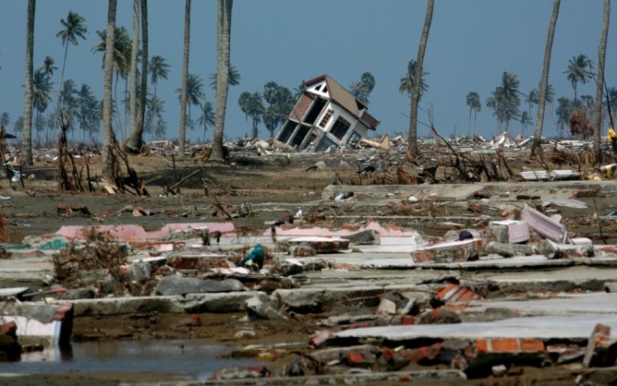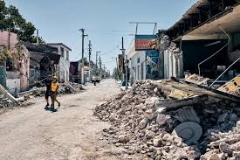
Every day the aftershocks continue… and Puerto Rico is a U.S. Territory!

Excerpts from Isaiah 24:1, 17-22: “Behold, Yahuwah is making the earth empty and making it waste, and shall overturn its surface…For the windows from on high shall be opened and the foundations of the earth be shaken. The earth shall be broken; the earth shall be completely shattered; the earth shall be fiercely shaken. The earth shall stagger like a drunkard.”
Haggai 2:7: “For this says Yahuwah of hosts, `Once more, in a little while, I am shaking the heavens and the earth, the sea, and the dry land.”
Excerpts from Hebrews 12:25-29; 13:14: “…Yet, once more I shake not only the earth but also the heaves. And this `once more’ makes clear the removal of

what is shaken, as having been made, so that the unshaken things might remain.
Therefore, receiving an unshakable Kingdom, let us hold the favor, through which we serve Elohim pleasingly with reverence and awe, for indeed, our Elohim is a consuming fire…For we have no lasting city here, but we seek the one coming.”
Little more can be said, except “pray.”
Everything we have attached our emotions to for our security, our safety, our peace, our satisfaction, our enjoyment, and our emotional stability in general will be gone. Right now, fault lines world over are shaking, on land and in the sea.
A massive volcano on the Canary Islands is unstable. Scientists are very concerned. If it erupts fully it has the potential of sending a tsunami with massive 100’ high waves across the Atlantic to slam into the East Coast from Canada, down to South America.
The Cascadia Subduction Zone situation is critical, plus the San Andreas Fault situation and the New Madrid Fault situation, too, are becoming more critical by the day as more earthquakes hit the areas. American has 69 volcanoes, about 12 in Idaho alone. But, the Ring of Fire around the Pacific Ocean Rim is highly unstable as a whole, fraught with volcanoes - on land, on islands, and under the sea.
Luke 21:25-26, preceding the return of Yahushua: “And there shall be signs in the sun, and moon, and stars, and on earth anxiety of nations, in bewilderment at the roaring of the seas and agitation, men’s heart fainting from fear and from the expectation of what is coming on the earth - for the powers of the heavens shall be shaken.”
But, if our faith is firm, unshakable, no matter what happen, we will go on to victory and eternal life if we remain loyal to our Creators.
Pray for the people of Puerto Rico and the Philippines. Pray for many to be saved as the true believers begin to witness of the true salvation through the death and resurrection of Yahushua/Jesus. Both nations are mainly Rome Catholic in religion.
In the love of Elohim, Yedidah
January 14, 2020

