“KINGS OF THE EAST” JOIN FORCES TO SUPPORT
EACH OTHER IN THE BATTLE AGAINST
PROVOKING WESTERN WARMONGERS

Revelation 16:12-18, ISR: “And the sixth messenger poured out his bowl on the great river Euphrates, and its water was dried up, in order to prepare the way of the kings from the east. 13And I saw coming out of the mouth of the dragon, and out of the mouth of the beast, and out of the mouth of the false prophet, three unclean spirits, as frogs, 14for they are spirits of demons, doing signs, which go out to the sovereigns of the entire world, to gather them to the battle of that great day of יהוה the Almighty. 15“See, I am coming as a thief. Blessed is he who is staying awake and guarding his garments, lest he walk naked and they see his shame. 16And they gathered them together to the place called in Heḇrew, Har Meg̅iddo. 17And the seventh messenger poured out his bowl into the air, and a loud voice came out of the Dwelling Place of the heaven, from the throne, saying, `It is done!’ 18And there came to be noises and thunders and lightnings. And there came to be a great earthquake, such a mighty and great earthquake as had not come to be since men were on the earth.”
I Corinthians 15:51-55: “51See, I speak a secret to you: We shall not all sleep, but we shall all be changed, 52in a moment, in the twinkling of an eye, at the last trumpet. For the trumpet shall sound, and the dead shall be raised incorruptible, and we shall be changed. 53For this corruptible has to put on incorruption, and this mortal to put on immortality. 54And when this corruptible has put on incorruption, and this mortal has put on immortality, then shall come to be the word that has been written, `Death is swallowed up in overcoming.’ 55 `O Death, where is your sting? O grave, where is your victory?’”
I’ve done a detailed study, and copied off lots of pictures showing the River Euphrates now is being almost all dried up from its source. Plus, not too many months ago, a massive earthquake shook southern Turkey, southern Syria, north Iraq, and shut down the Ataturk Dam near the source of the Euphrates, causing a diverting of water from the source downward. Yes, the Euphrates is drying up. See the article under the Mikvah of Present Reality # 307: “A Prophetic Look at the Deadly Earthquake in Turkey Near the Headwaters of the Euphrates River.”
Genesis 2:7-14: “And יהוה Elohim formed the man out of dust from the ground, and breathed into his nostrils breath of life. And the man became a living being.
8And יהוה Elohim planted a garden in Ěḏen, to the east, and there He put the man whom He had formed. 9And out of the ground יהוה Elohim made every tree grow that is pleasant to the sight and good for food, with the tree of life in the midst of the garden and the tree of the knowledge of good and evil. 10And a river went out of Ěḏen to water the garden, and from there it divided and became four riverheads.
11The name of the first is Pishon, it is the one surrounding the entire land of Ḥawilah, where there is gold. 12And the gold of that land is good. Bdellium is there, and the shoham stone. 13And the name of the second river is Giḥon, it is the one surrounding the entire land of Kush. 14And the name of the third river is Ḥiddeqel, it is the one which goes toward the east of Ashshur. And the fourth river is the Euphrates.”
Still to this day, a tributary of the River Euphrates runs along as a park-stream north of Jerusalem below Jeremiah’s birthplace of Anatot. I was there doing intercession with 3 Israeli ladies in 2013. Below Anatot is the lovely little river-stream, in Hebrew Ein Prat.
Here are two pictures of the River Euphrates flowing into Iraq. Prophetic? YES!
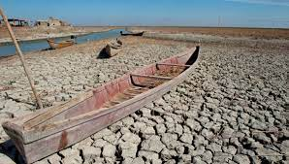

TWO ARTICLES EXPLAINING THE UNITING OF RUSSIA AND NORTH KOREA AND ITS POWERFUL CONNECTION TO PROPHETIC SCRIPTURE
*****The second article, from a Steve Quayle Briefing, adds important additional information explaining more of what is said in Article 1. [To sign up for Steve Quayle’s “Private Briefings” go to gensix.com.] The Briefings give insider intel that you’re not supposed to know.
Note: In Article 1 I highlight some things in red for myself – simply because these are places where I lived during my months in Russia in 1999. Really strange to think that I was where Kim is now. Learn all you can! All prophecy of Messiah’s return is happening!
Kim Jong Un is not a crazy man. He’s a brilliant nuclear physicist. Under an assumed name, he studied for his PhD in a university in Switzerland. He has a weapon’s arsenal that is huge – as you’ll see from these two reports. Russian technology, on the other hand, nuclear and electronic warfare, is unsurpassed in the world overall. These two military geniuses, “kings of the East,” have joined forces!
China, also, is a major “king of the East” – who will join with Russia and North Korea in their annihilation of the United States. Fascinating how this is all coming together as the Word has shown us in detail for thousands of years.

ARTICLE I:
“Will Russia Trade Fighter Jets For North Korean Artillery Shells?
Kim Jong Un examined high-end Russian fighters as concerns mount that it will supply Russia with gobs of ammunition for the war in Ukraine” BYTHOMAS NEWDICK|PUBLISHED SEP 15, 2023 THE WAR ZONE
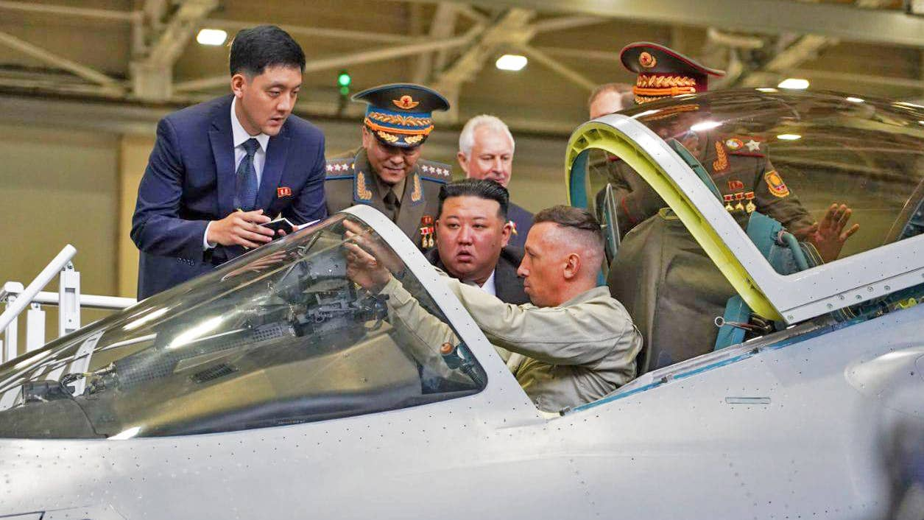
Photo by Gov of Khabarovsk Reg/M. Degtyaryov/Anadolu Agency via Getty Images
SHARETHOMAS NEWDICKView Thomas Newdick's Articles
North Korean leader Kim Jong Un visited a factory that builds advanced fighters today as his tour of Russia continues. Kim inspected manufacturing facilities at the Komsomolsk-on-Amur Aircraft Production Association, or KnAAPO, based in Komsomolsk-on-Amur in the Russian Far East, leading to no shortage of speculation that North Korea might be preparing to trade artillery shells and other materiel for new — or at least newer jets to overhaul its badly aging air force.
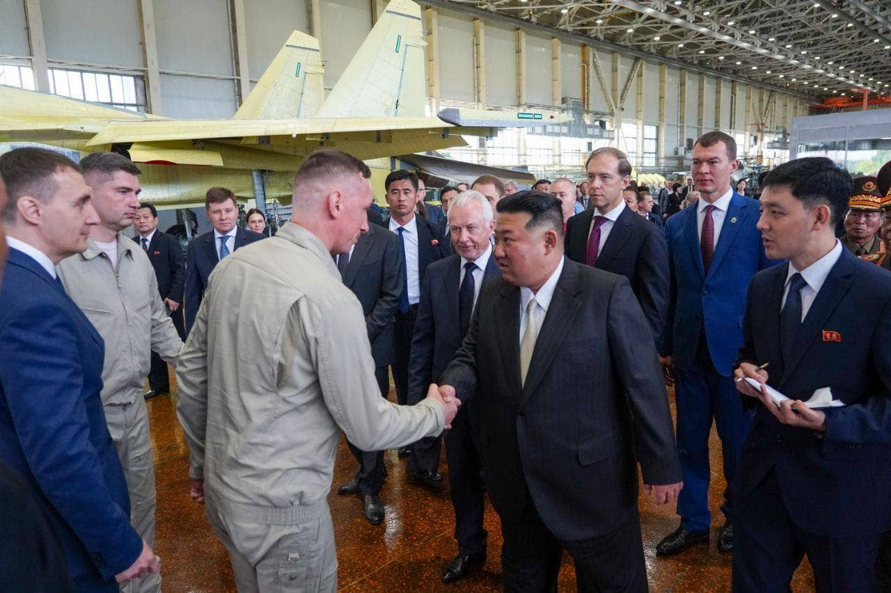
North Korean leader Kim Jong Un visits the KnAAPO aircraft factory, accompanied by Russian Deputy Prime Minister and Minister of Industry and Trade, Denis Manturov (third from right), on September 15, 2023. Photo by Gov of Khabarovsk Reg/M. Degtyaryov/Anadolu Agency via Getty Images
Official photos released of Kim’s visit to KnAAPO showed the North Korean leader accompanied by Russia’s Deputy Prime Minister and Minister of Industry and Trade, Denis Manturov. Kim was seen looking into the cockpit of a Su-57 Felon next-generation fighter, as well as in the final assembly hall. (picture above)
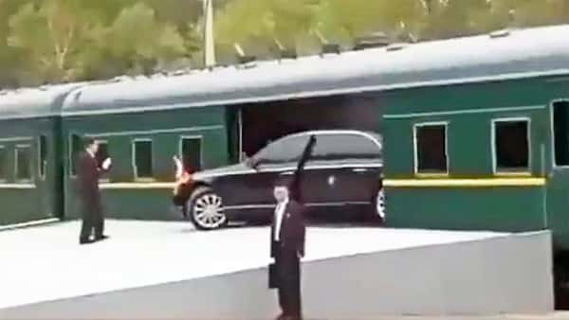
Kim’s visit to KnAAPO came on the third day of his trip, which marks a very rare visit to a foreign country by the North Korean leader. Kim arrived in Komsomolsk-on-Amur in his favored style — aboard his specially equipped armored train, which had previously brought him across the border and then to the port city of Vladivostok.
Kim’s trip has also included meeting Russian President Vladimir Putin at the Vostochny Cosmodrome, a space facility in the far eastern Amur region. Discussions here reportedly included satellite technology, which North Korea is keen to obtain, as well as a potential deal to provide North Korean arms to Russia. An inspection of Russian Navy Pacific Fleet assets in Vladivostok is also planned.
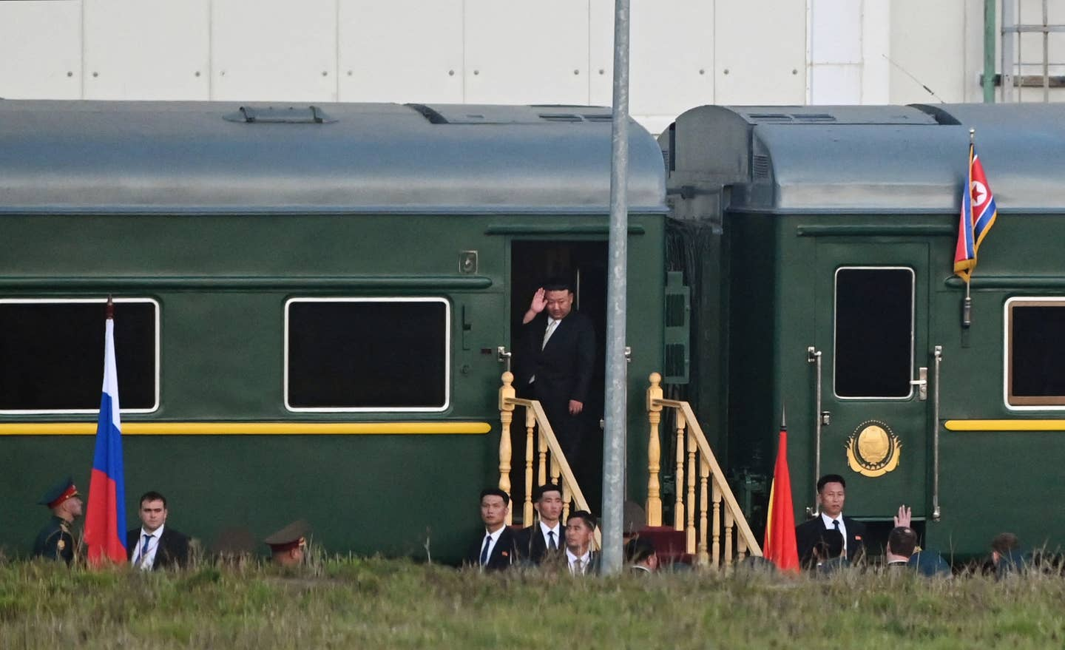
Kim Jong Un leaves Vostochny Cosmodrome in the Amur region on September 13, 2023, via his armored train, after talks with President Putin. Photo by PAVEL BYRKIN/POOL/AFP via Getty Images
While the specifics of any such deal to provide Russia with North Korean armaments have not been disclosed, Kim’s visit has repeatedly been framed by both countries in the context of Pyongyang’s staunch support for Russia against its Western foes and Russia's need for North Korean ammunition. There has also been an exchange of rifles between Kim and Putin, the symbolism of which can hardly be overlooked.
Mikhail Degtyarev, regional of Khabarovsk Krai, where the KnAAPO facility is located, took to the Telegram messaging app to confirm Kim’s visit to the factory and also provided the following statement: “Our fathers and grandfathers fought together against Japanese militarism, our country supported North Korea in its fight against the United States’ imperialist ambitions in the 1950s, and today we jointly stand up to the pressure of the collective West.”
Clearly, the Su-35 and Su-57 jets produced by KnAAPO would represent a huge upgrade over the severely outdated equipment that North Korea’s air arm currently flies. It’s possible that Moscow is offering these aircraft, or other advanced technologies to North Korea in order to secure the kinds of weapons it requires in high volumes — notably large volumes of artillery ammunition, rocket artillery, and anti-tank missiles, for example.
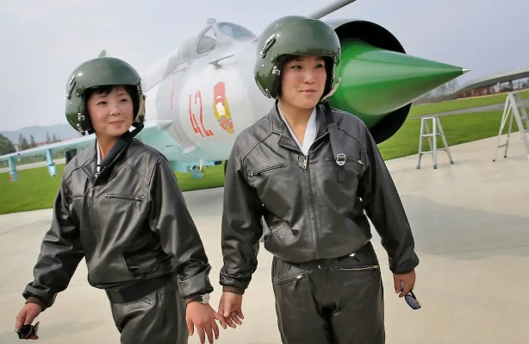
Two female pilots make an appearance in front of a MiG-21 fighter during North Korea’s first airshow in 2016. AP
It should also be noted that the Su-57 has so far not secured any export orders and has only been rewarded with strictly limited orders, so far, from the Russian Ministry of Defense. India, formerly a partner in the program, dramatically pulled out, while an apparent pitch to Turkey failed to attract any serious interest beyond photo opportunities.
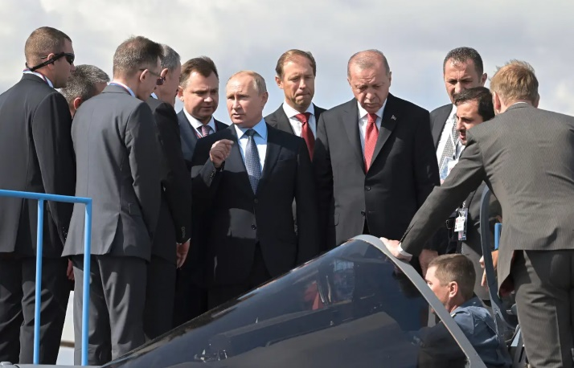
Putin and Turkish President Recep Erdogan examine a Su-57 at the MAKS airshow outside of Moscow in 2019. Sergey Guneev / Sputnik via AP
Planned deals to sell Su-35s to Egypt and Indonesia both collapsed, apparently under U.S. pressure and a proposal to transfer to Iran some of the jets already built for Egypt has so far not materialized.
Clearly, the current political climate, production limitations, and strict sanctions are already making the export of Russian defense equipment very complicated.
A customer without such scruples, such as North Korea, could be an attractive alternative if the deal is right. If the Iranian deal does fall through, Pyongyang could also emerge as a potential candidate to buy the surplus Su-35s, too.
As well as fighters, North Korea would also almost certainly be interested in other Russian products, too, whether related to the modernization of other parts of its armed forces or to assist in furthering its own missile and space programs.
There remains the question, however, of what kinds of technologies Russia will actually be willing to share with North Korea. After all, in exchange, Russia would likely be seeking comparably unsophisticated munitions. Here, North Korea would be easily able to shore up gaps in Russian production capacity, with the potential to draw upon thousands of artillery pieces and literally millions of rounds of artillery ammunition and deliver them rapidly to meet the demand for the war in Ukraine.
Even if top-of-the-line Su-35s and Su-57s are not on the table, other less capable aircraft would still be a massive upgrade for Pyongyang compared to its existing fleet of older Russian-made jets, including old MiG-29 Fulcrum fighters and Su-25 Frogfoot ground-attack aircraft. Almost anything available from Russia would be sought after, whether MiG-29SMTs, Su-27s, or Su-30s. Even a supply of spare parts and overhauls of its current types would be of great value to Pyongyang.
On the other hand, Western officials, and the U.S. government in particular, are increasingly concerned that the deepening relationship between Moscow and Pyongyang is paving the way for more direct North Korean assistance for Russia in its war in Ukraine. Washington has already warned that North Korea would “pay a price” if it helped arm Russia at this point.
In a statement yesterday, U.S. National Security Adviser Jake Sullivan said he had discussed the possible repercussions of the Putin-Kim summit with his counterparts in South Korea and Japan. “They noted that any arms exports from the DPRK [Democratic People’s Republic of Korea] to Russia would directly violate multiple U.N. security council resolutions, including resolutions that Russia itself voted to adopt.”
North Korea has repeatedly denied providing Russia with weapons for the war in Ukraine, despite claims from the United States that it has done so, including arming the notorious Wagner Group private military company. More surprisingly, North Korean-made artillery rockets have also ended up in Ukrainian hands, although it’s unclear if these were captured from Russian positions or allegedly seized at sea by a friendly country and donated to Ukraine.
A South Korean Foreign Ministry spokesperson, Lim Soo-suk, said yesterday: “I think Russia has already tested the North Korean shells in battlefields and is now ready to expand its use going forward.”
For South Korea, the prospect of North Korea receiving high-end defense technology from Russia, in turn, is especially alarming.
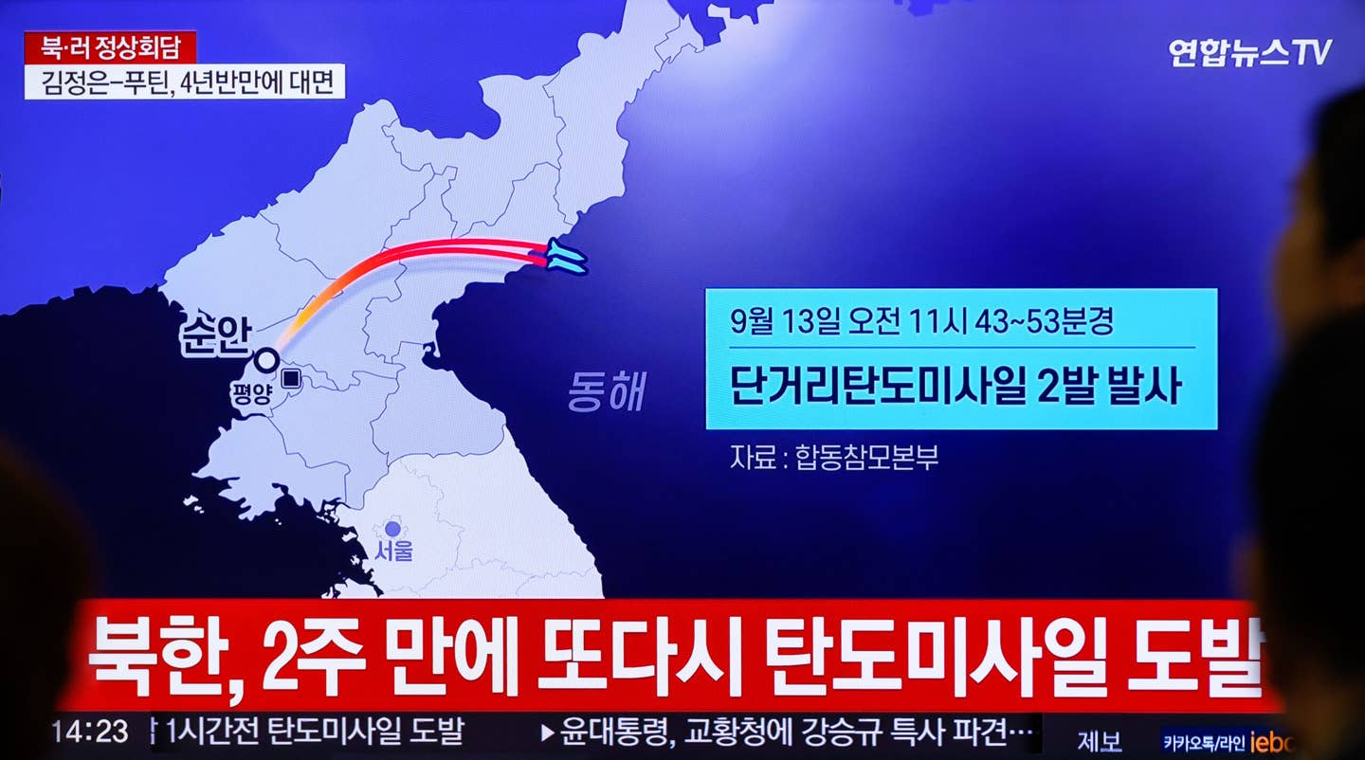
September 13, 2023: A TV screen shows a South Korean report on North Korea firing two short-range ballistic missiles into the East Sea, during the visit to Russia by Kim Jong Un. Photo by Kim Jae-Hwan/SOPA Images/LightRocket via Getty Images
Lim warned Russia of “very negative impacts” on its relations with Seoul if it continues to expand its military cooperation with North Korea.
Lim said: “We express our deep concern and regret that despite repeated warnings from the international community, North Korea and Russia discussed military cooperation issues, including satellite development, during their summit.” Ironically, Russia and South Korea previously had a military relationship of their own, primarily based around Moscow delivering various kinds of arms —including armored vehicles and anti-tank missiles — to Seoul as a way of paying back debts incurred during the Soviet era.
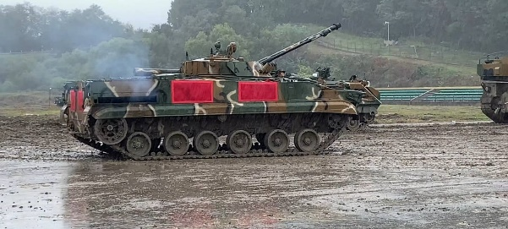A Russian-supplied BMP-3 infantry fighting vehicle operated by the 3rd Armored Brigade of the Republic of Korea Army (ROKA), seen in a video from January 2020. 박종훈/Wikimedia Commons
Specifically, Lim highlighted concerns about Pyongyang benefiting from “Any science and technology cooperation that contributes to nuclear weapons and missile development, including satellite systems that involve ballistic missile technologies.”
Here it is worth recalling Kim’s visit to the Vostochny Cosmodrome this week, where talks are known to have touched upon possible Russian assistance for North Korea’s space program, which could well also encompass technology transfer related to ballistic missiles.
Kim’s current trip to the Russian Far East — which the Kremlin says will last “a few more days” — is also just the start of what looks set to be a series of reciprocal visits.
Yesterday, the Kremlin confirmed that Putin had “gratefully accepted Kim’s invitation” to visit Pyongyang, although a timeline was not disclosed. Ahead of that, Moscow said it will “quickly prepare” to send Foreign Minister Sergei Lavrov to Pyongyang, with a trip expected in October.
Behind the symbolic value of Kim’s current visit, however, it remains unknown whether North Korea is poised to acquire at least newer fighters from Russia, however badly it might need them.
What is clear is that the Kremlin is now doing its utmost to forge a deeper relationship with North Korea, including across the military domain, and that this is very likely driven by an urgent need for artillery ammunition to help sustain its war in Ukraine. With that in mind, Moscow may well be willing to offer its own high-tech arms as well as technology transfers if it means it can obtain the weapons it needs. [Yedidah: Needed cooperation between two nations of the 4 linked together to wipe out America; “Babel has fallen, has fallen.” China also, and Iran- the 4 of Scripture, the 4 or 2024]
Contact the author: thomas@thewarzone.com

STEVE QUAYLE PRIVATE BRIEFINGS SEPT 18 2023 N KOREA AND RUSSIA PREPARE FOR WAR AGAINST THE WEST SEPTEMBER 18TH 2023 SQ PRIVATE BRIEFINGS Copyright © GenSix Productions 2023, All Rights Reserved
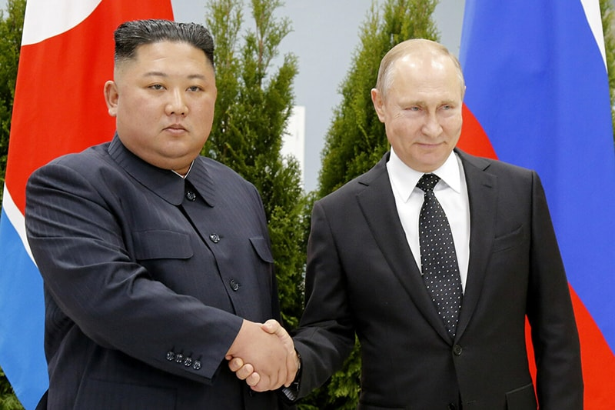
“And cursed the God of heaven because of their pains and their sores, but they refused to repent of what they had done. The sixth angel poured out his bowl on the great river Euphrates, and its water was dried up to prepare the way for the kings from the East. Then I saw three impure spirits that looked like frogs; they came out of the mouth of the dragon, out of the mouth of the beast and out of the mouth of the false prophet.” Revelation 16:11-13 [This is just before the 7th trumpet, which signals the coming of Yahushua and the raising of the dead “incorruptible.”]
Steve Quayle: “What is about to take place is not only foretold in scripture, but it will also unfold exactly as Jesus predicted: ‘There will be great distress, unlike any that has happened since the beginning of the world, and unlike anything that will happen again...’ What Jesus meant ladies & gentlemen, is that we’re not just going to have World War III, or just mass-starvation and plagues, but every imaginable upheaval colliding simultaneously!
Picture this, the ‘leaders’ of the West finally drag us into a full-scale war with Russia, along with China & North Korea – while many of the BRICS nations take sides AGAINST the U.S. Well, this isn’t World War II anymore. GONE is the blind patriotism of the past where mothers & fathers willingly sent their children off to die knowing the sacrifice was noble and the cause justified. All but a select brainwashed group of sheeple are dramatically AGAINST going to war, with a large amount of the population beyond suspicious of American ‘leadership.’ These Dis-United States has never been more divided, and the vast majority wants nothing to do with bloody conflict. Let me spell it out: Millions of Americans would not only protest such a war, but they would actually take up arms against the technocrats that pulled us into it! This would happen in a majority of countries across the globe, something that has never happened before in all of history. In other words, every country fighting each other, while citizens of every country fight against their own countries!
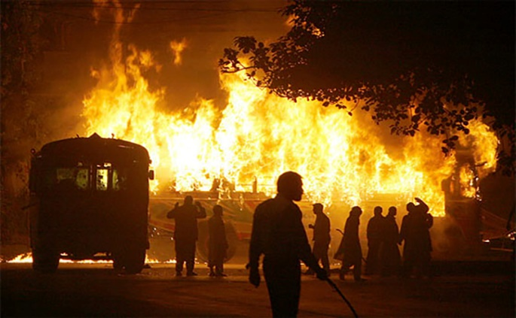
No doubt the ‘Rich Men North of Richmond’ already know that they would receive only a sliver of support from Americans. And as the civil unrest and chaos breaks out across the world, Martial Law will quickly be declared. There would be few factions ON ANY SIDE not fighting some other faction as our current civilization unravels and Jesus’ words became reality. Nothing sane or normal would appear to remain as the Kings of the East, Russia, China & North Korea, mercilessly attack America and all our allies. Their nuclear first-strike will be swift and severe, leaving the U.S. no time to react.
The smoldering society that tries to live on in the aftermath will have no chance unless individual household leaders prepared for the coming onslaught -- thoroughly!
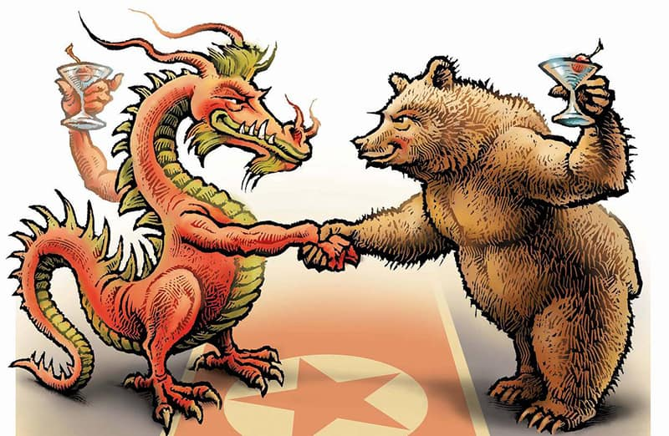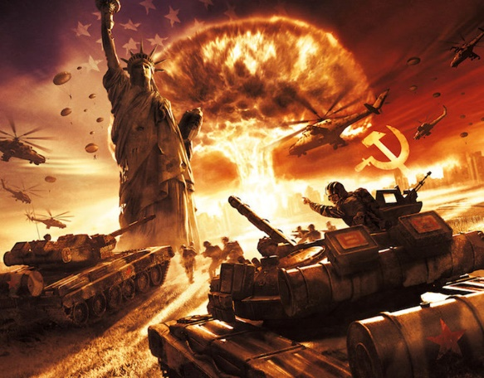
Finally, please read over Science Guy’s latest PDF report, below, and let it be yet another wakeup call to get ready for this ‘Dark Winter.’ The reason Jesus Christ WARNED us as He did is that we must not try to picture what’s coming as anything we’ve ever seen or read about. This terror will be an entirely new variety where the word normal is LITERALLY forgotten as grocery stores are obliterated, supplies no longer ship, and all our food, water & air are poisoned as acts of war against humanity! Only your faith in Jesus will help you withstand the coming tribulations as God Almighty watches over and preserves those children who have trusted in Him!”

Science Guy: Date: September 18, 2023 “Subject: NORTH KOREA-RUSSIAN TRADE ALLIANCE WHAT IT MEANS TO THE WORLD AND WHY YOU SHOULD CARE THIS ALLIANCE HAS BEEN INCREASING FOR A WHILE HOWEVER IN THE LAST 72 HOURS SOME DRAMATIC CHANGES HAVE OCCURRED WHICH HAVE RADICALLY ALTERED THE RUSSIA – NORTH KOREA ALLIANCE.
FIRST LOOK IS WHAT WAS THE TRIGGER FOR THE SUDDEN CHANGES:
1 ABOUT 72 HOURS AGO NATO OPENLY ANNOUNCED THAT THEY WERE INCREASING THE TROOP ALLOCATION ON THE RUSSIAN BORDER FROM 300,000 TROOPS WITH EQUIPMENT TO 3.5 MILLION TROOPS WITH EQUIPMENT. LOOKING AT THIS IN DETAIL WE DISCOVER SOME CRITICAL DETAILS NOT MENTIONED IN THE MASS MEDIA NEWS ANNOUNCEMENT: 1.1 THE “CLAIM WAS MADE” THAT THE TROOP INCREASE WOULD OCCUR TO “DETER AND PREVENT RUSSIA FROM EXPANDING THE WAR”.
1.2 THE SECOND BIT OF KEY INFORMATION WAS THE FACT THAT THIS WOULD OCCUR WITHIN A MONTH. 1.3 WHAT WAS NOT SAID WAS WHERE NATO WOULD FIND 3.5 MILLION TROOPS WITHOUT CONSCRIPTING (DRAFTING) THEM.
1.3.1 THE ANSWER HONESTLY IS THAT ALL NATO COUNTRIES WOULD BE FORCED TO CONSCRIPT NEW RECRUITS AND SEND THEM OUT WITH LITTLE (3 WEEKS TRAINING) OR NO TRAINING TO THE BATTLE FIELDS ALONG THE RUSSIAN BORDER.
1.3.2 IF YOU PAUSE EVEN 1 MINUTE TO THINK ABOUT THIS YOU WILL REALIZE THAT THE HATRED AGAINST THE HIGH-LEVEL POLITICIANS IN THE USA AND ALL NATO COUNTRIES FOR PROVOKING WHAT WILL BECOME WORLD WAR 3 WILL BE INTENSE AND LIKELY CAUSE RIOTS. WHY WOULD RIOTS HAPPEN?
1.3.2.1 TAKING THE SONS AND DAUGHTERS AND PUSHING THEM INTO A WAR WITHOUT THEM CHOOSING TO GO TO WAR (OR EVEN NEEDING TO GO TO WAR EXCEPT FOR THE FACT THAT THE USA IS PROVOKING AND FORCING THE WAR).
1.3.2.2 SECONDLY TO SUPPORT 3.5 MILLION TROOPS ON THE BATTLE FIELD WILL CAUSE THE RATIONING OF FOOD AND FUEL AND THE RAW MATERIALS WHICH ARE USED TO MAKE MANY PRODUCTS AND DIVERTING THEM FOR WAR TIME ALLOCATION AND USE. 1.3.2.3 THIS WILL DRIVE THE PRICES IN THE STORES AT A FASTER RATE THAN THEY ARE INCREASING NOW AS WELL AS EMPTY THE SHELVES OF KEY ITEMS.
1.4 THIS NEXT PIECE OF INFORMATION WILL HIT YOU BETWEEN THE EYES: 1.4.1 80 PERCENT OF THE GOODS AND SERVICES YOU FIND IN THE STORES IN THE USA COME FROM CHINA: 1.4.2 SINCE CHINA IS AN ALLY WITH RUSSIA REGARDING WORLD WAR 3 THIS MEANS THAT THE AVAILABILITY OF 80% OF THE PRODUCTS YOU ARE USED TO BEING ABLE TO BUY WILL NOT BE AVAILABLE AT ANY PRICE!!! 1.4.3 WHY YOU ASK? THE ANSWER IS SIMPLE WHY WOULD CHINA MAKE THINGS FOR A COUNTRY THEY ARE AT WAR WITH?
1.4.3.1 THE ANSWER IS SIMPLE THEY WOULD NO LONGER MAKE AND SHIP THE ITEMS TO AN ENEMY COUNTRY THEREFORE THE ITEMS WOULD NO LONGER BE AVAILABLE ON THE SHELVES IN STORES OF THE USA AND EUROPE!!! 2 NOW IF YOU PAUSE AND CONSIDER THE RADICAL EFFECTS OF THE RUSSIA-NORTH KOREA ECONOMIC AND NOW WAR ALLIANCE THERE ARE MANY CRITICAL DETAILS TO CONSIDER WHICH DIRECTLY AND INDIRECTLY AFFECT EVERY AMERICAN: 2.1 AS STUPID AS IT MAY SOUND TO YOU, NORTH KOREA HAS BEEN AT WAR MENTALLY AND ACTIVELY PLANNING FOR A HOT WAR WITH THE WEST AT SOME POINT IN THE FUTURE. WILL IT BE NOW THIS YEAR OF 2023?
WHAT DOES THIS MEAN? HERE ARE SOME CRITICAL EXAMPLES OF DIFFERENCES: 2.1.1 155 MM HEAVY ARTILLERY SHELLS: 2.1.1.1 UKRAINE HAS BEEN USING AT LEAST 7000 ROUNDS PER DAY IN THE CURRENT ACTIONS WITH RUSSIA. 2.1.1.1.1 7000*30 = 210,000 SHELLS PER MONTH WHICH THE USA AND NATO GAVE TO UKRAINE, AND THE USA STOCKPILE OF THIS AMMUNITION IS NOW AT A CRITICAL LOW LEVEL AND CAN NOT SUPPORT A WAR OF ANY REAL SIZE. 2.1.1.1.2 IN ADDITION THE USA FACTORY WHICH MAKES THE SHELLS CAN ONLY MAKE 80,000 SHELLS PER MONTH IF THERE ARE ZERO SUPPLY CHAIN ISSUES. CURRENTLY THE ACTUAL REAL DELIVERY NUMBERS ARE CLOSER TO BETWEEN 50,000 AND 60,000 SHELLS PER MONTH BECAUSE OF SUPPLY CHAIN ISSUES WHICH ARE OUTSIDE THE CONTROL OF THE FACTORY. 2.1.1.2 RUSSIA HAS BEEN USING ABOUT 7,500 TO 8,000 SHELLS PER DAY IN UKRAINE: 2.1.1.2.1 8,000 *30 = 240,000 SHELLS PER MONTH. 2.1.1.2.2 THE RUSSIAN STOCKPILE IS NOT LOW AND RUSSIAN FACTORIES ARE CURRENTLY MAKING ABOUT 300,000 SHELLS PER MONTH. 2.1.1.3 HERE IS THE SHOCKER FOR ALL THE READERS OF THIS REPORT: 2.1.1.3.1 NORTH KOREAN FACTORIES ARE EASILY ABLE TO MAKE 2 MILLION ROUNDS OF THE 155 MM SHELLS PER MONTH IF THEY CAN GET THE RAW MATERIALS. 2.1.1.3.1.1 WHY IS THIS? IT IS BECAUSE THE 155 MM ARTILLERY GUNS ARE VERY STABLE DEVICES AND HAVE A GOOD RANGE. 2.1.1.3.1.2 FROM THE KOREAN DMZ TO SEOUL SOUTH KOREA THE 155 MM ARTILLERY GUNS CAN EASILY HIT THE CITY. 2.1.1.3.1.3 NORTH KOREA HAS AT LEAST 35,000 SUCH GUNS AIMED AT SOUTH KOREA. 2.1.1.3.1.4 NORTH KOREA HAS MORE THAN 7 MILLION SHELLS IN INVENTORY. 2.1.1.3.1.5 THEY HAVE OBVIOUSLY BEEN PLANNING TO RAIN FIRE DOWN ON SOUTH KOREA AT SOME TIME IN THE FUTURE. 2.1.1.3.1.6 THE FIRE FROM NORTH KOREA TO SOUTH KOREA MAY BE 2023 IF WORLD WAR 3 GOES FULLY HOT LIKE NATO IS EXPECTING IT WILL BASED ON ADDING 3.5 MILLION TROOPS TO THE BORDER WITH RUSSIA IN EUROPE.
2.2 NOW TO SOME ADDITIONAL NEWS WHICH IS CRITICAL IN THE SITUATION: 2.2.1 BEFORE NATO MADE THEIR ANNOUNCEMENT REGARDING THE 3.5 MILLION TROOPS, NORTH KOREA AND RUSSIA HAD WORKED OUT A DEAL EXCHANGING FOOD, FERTILIZER AND SEEDS TO HELP NORTH KOREA IN EXCHANGE FOR 300,000 TO 500,000 TROOPS TO HELP RUSSIA IN ITS WAR AGAINST THE WEST. 2.2.1.1 IN ADDITION RUSSIA WILL BE FEEDING THE NORTH KOREANS WHILE THEY ARE FIGHTING FOR RUSSIA. 2.2.1.2 FOOD AND FERTILIZER AND SEEDS IS A HUGE DEAL FOR KIM JUNG UN BECAUSE IT PROVES TO HIS PEOPLE THAT HE IS A STRONG AND WORTHY LEADER. 2.2.1.3 WHEN THE NATO ANNOUNCEMENT WAS MADE PUBLIC NORTH KOREA INCREASED THE NUMBER OF TROOPS TO 1 MILLION TO GO TO RUSSIA, AND RUSSIA INCREASED THE FOOD AND SUPPLIES HELP TO NORTH KOREA. 2.2.1.4 IN ADDITION RUSSIA AND NORTH KOREA ARE EXCHANGING ADVANCED WEAPONS TECHNOLOGY AND SUPPLIES.
.2.1.5 ALSO RUSSIA IS TRADING RAW MATERIALS IN EXCHANGE FOR 500,000 TO 1 MILLION 155 MM SHELLS PER MONTH WHICH WILL ALSO ALLOW NORTH KOREA TO BOOST ITS PRODUCTION OF 155 MM SHELLS TO 2 MILLION PER MONTH. THIS IS A WIN FOR RUSSIA AND NORTH KOREA. 2.2.1.6 IN ADDITION THERE ARE OTHER THINGS PUTIN AND KIM JUNG UN DISCUSSED BUT WE WILL NOT SEE WHAT THOSE THINGS ARE UNTIL LATER BECAUSE IT WAS A ONE-ON-ONE TALK AND ONLY THE TRUSTED INTERPRETERS (ONE FOR PUTIN AND ONE FOR KIM JUNG UN) WERE IN THE ROOM WITH THEM). WHILE DETAILS ARE NOT KNOWN PRECISELY THE TOPIC AREAS ARE KNOWN: 2.2.1.6.1 ROCKET TECHNOLOGY (ESPECIALLY ENGINE AND GUIDANCE TECHNOLOGIES) 2.2.1.6.2 NUCLEAR WEAPONS TECHNOLOGIES. 2.2.1.6.3 DRONE TECHNOLOGIES.
2.3 ADDITIONAL IMPORTANT INFORMATION ABOUT NORTH KOREA: 2.3.1 THE SIZE OF THE MILITARY THIS IS BEFORE THE PUTIN-KIM JUNG UN DEAL OCCURRED: 2.3.1.1 1,280,000 REGULAR ARMY ON ACTIVE DUTY 2.3.1.2 600,000 RESERVES (ROTATE IN FOR DUTY REGULARLY) 2.3.1.3 5,889,000 PARAMILITARY COMPLETELY TRAINED AND LIKE THE RESERVES THEY ROTATE IN TO SERVICE TO KEEP READY 2.3.1.4 7,769,000 TOTAL TRAINED MILITARY FOR COUNTRY
2.3.1.5 ALSO A QUIET DEAL HAD BEEN DONE BEFORE THE MEETING ABOUT 2 MONTHS AGO AND 200,000 TROOPS FROM ACTIVE DUTY ARE ALREADY IN RUSSIA AND HAVE PLENTY OF FOOD AND AMMO. 2.3.1.6 THE INITIAL 500,000 CAME FROM THE RESERVES TO GO TO RUSSIA 2.3.1.7 THE NEXT 500,000 CAME FROM THE PARAMILITARY 2.3.1.8 ALL OF THE NORTH KOREAN SOLDERS WHO VOLUNTEERED FOR DUTY GAINED SPECIAL BENEFITS FOR THEMSELVES AND THEIR FAMILIES SO GETTING 1 MILLION PEOPLE TO SIGN UP TO GO WAS LESS THAN 1 DAY’S EFFORT.
2.3.2 THE NEXT IMPORTANT DETAIL IS THAT EACH NORTH KOREAN SOLDIER GOING TO RUSSIA HAS HIS OWN AK-47 GUN AND 10,000 ROUNDS OF AMMUNITION RESERVED FOR HIM ON THE TRAIN. 2.3.2.1 IN ADDITION THERE IS 20,000 ROUNDS OF BACKUP AMMUNITION PER SOLDIER IS ALREADY ALLOCATED.
2.3.2.2 THE WEST CAN NOT COME CLOSE TO THE LEVELS OF AMMUNITION WHICH RUSSIA AND NORTH KOREA, (AND CHINA WHEN THEY ENTER THE WAR) HAVE. THE WEST IS NOT EVEN CLOSE!!!! (NOTE: NATO ADMITTED AS PART OF THEIR ANNOUNCEMENT THAT THEY HAD TO GROW THE AMMUNITION SUPPLY BY 5X ALMOST INSTANTLY, AND FIND THE 3.5 MILLION GUNS FOR THE SOLDIERS TO USE.)
2.3.2.3 THERE IS NO DOUBT THAT THE NORTH KOREANS WILL BE VICIOUS FIGHTERS BECAUSE SHOULD THEY DIE A HERO’S DEATH THEY WILL BE HONORED AND SO WILL THEIR FAMILY. 2.3.3 NORTH KOREA HAS SOME SPECIAL RESOURCES WHICH GIVE THEM GREAT ADVANTAGE: 2.3.3.1 THEY HAVE ONE OF THE LARGEST THORIUM DEPOSITS IN THE WORLD. 2.3.3.2 THEY ALSO HAVE THE LARGEST DEPOSIT IN THE WORLD OF A NEUTRON ABSORBING CLAY WHICH IS ESSENTIAL TO BUILDING TR3 AND TR4 TYPE GRAVITY MANIPULATING CRAFT WHICH ARE SAFE FOR HUMAN TRAVEL. 2.3.3.2.1 NOTE: I AM SURE THESE TOPICS WERE PART OF THE ONE-ON-ONE DISCUSSION PUTIN AND KIM JUNG UN HAD.
3 IN ADDITION PEOPLE IN THE WEST MUST REMEMBER THAT RUSSIANS, NORTH KOREANS, AND CHINESE THINK VERY DIFFERENTLY THAN WESTERN MINDS. 3.1 FOR EXAMPLE RUSSIANS, NORTH KOREANS, AND CHINESE DO NOT FEAR USING THE NUCLEAR WEAPONS AGAINST THEIR ENEMIES IN A WAR TO SAVE THEIR OWN COUNTRY AND WAY OF LIFE. 3.2 ALSO RUSSIANS, NORTH KOREANS, AND CHINESE DO NOT TRUST AMERICANS. 3.3 THEREFORE THE WESTERN MILITARY PLANNERS ARE VIEWING THE WORLD FROM A VERY FLAWED VIEWPOINT WHICH WILL BE THE DOWNFALL OF THE WEST.
4 HERE ARE A COUPLE OF VERY PRACTICAL EXAMPLES OF SOME LOGISTICS THINGS WHICH ARE CRITICAL FOR WAR TIME. 4.1 THE RAILROAD GAUGE BETWEEN WESTERN EUROPE AND EASTERN EUROPE ARE DIFFERENT. THIS IS BECAUSE EASTERN EUROPE INFRASTRUCTURE WAS BUILT UP USING TECHNOLOGY AND RAIL AND ELECTRIC POWER SPECIFICATIONS FROM THE SOVIET UNION. 4.1.1 WHAT THIS MEANS FOR LOGISTICS IN VOLUME IS THAT WHEN A TRAIN WANTS TO CROSS FROM WESTERN EUROPE TO EASTERN EUROPE (OR BACK TO WESTERN EUROPE FROM EASTERN EUROPE), IT MUST STOP AT THE RAIL CHANGING POINT AND THE WHEELS OF THE TRAIN CARS ARE CHANGED TO THE NEW GAUGE BEFORE THE TRAIN CAN PROCEED. 4.1.2 SINCE THE NATO ANNOUNCEMENT OF THE 3.5 MILLION TROOPS AND EQUIPMENT WHICH NEEDS TO GO FROM WESTERN EUROPE TO EASTERN EUROPE, THERE HAS NOT BEEN ANY INCREASE IN WORKERS OR ADDITIONAL IMPROVEMENTS IN CHANGE OVER TIME FOR TRAINS CROSSING THOSE BORDERS. 4.1.3 THIS IS CRITICAL BECAUSE NOT ALL THINGS CAN GO DIRECTLY BY AIR OR SEA TO THE DESTINATIONS SO TRAIN AND ROAD LOGISTICS BECOME CRITICAL. 4.2 YET AT THE SAME TIME RUSSIA AND NORTH KOREA ADDED 4X THE LABOR FORCE AND EQUIPMENT TO DO THE WHEEL CHANGES GOING BETWEEN NORTH KOREA AND RUSSIA TO MINIMIZE THE DELAYS AT THE CHANGE OVER POINT.
[the bubble-brained west vs. the efficient-minded Russia]
4.2.1 THIS IS A VAST DIFFERENCE IN THINKING BETWEEN THE RUSSIA NORTH KOREA ALLIANCE AND NATO WHICH WILL AFFECT THE WESTERN LOGISTICS EFFORTS!!!
5 THERE ARE SEVERAL OTHER KEY DETAILS THE WEST HAS NOT CONSIDERED: 5.1 WHILE IT IS TRUE THAT THE USA HAS SUPERB SEMICONDUCTOR DESIGNERS, THE USA DOES NOT HAVE THE FOLLOWING THINGS: 5.2 5.2.1 FUEL AS WELL AS ELECTRIC ENERGY TO POWER A SUDDEN INCREASE IN ENERGY DEMANDS TO SUPPORT A RAPID RAMP UP IN MANUFACTURING. 5.2.2 WATER TO GROW ENOUGH FOOD TO FEED THE USA AND BECOME A BREAD BASKET FOR EUROPE AGAIN. (THE TRUTH IS THE USA IMPORTS PRODUCE FROM EUROPE TO MAKE UP THE DEFICIT). 5.2.3 THE USA NO LONGER HAS HIGH VOLUME METAL REFINING AND PROCESSING FACTORIES. 5.2.4 THE USA DOES NOT HAVE FACTORIES TO MAKE EVERY DAY ITEMS LIKE TOOLS ETC. 5.2.5 AND WORST OF ALL THE USA DOES NOT HAVE TRAINED PEOPLE TO WORK IN THE NEW FACTORIES TO BE BUILT OR EXPANDED TO MEET A WAR TIME REQUIREMENT. 5.2.6 TO HAVE A RAMP UP WOULD TAKE AT LEAST 5 YEARS AND ANY WAR WOULD BE LOST BY THAT TIME!!!!”
SHALOM! SHALOM! PRAY AND PREPARE! Isaiah 13, Jeremiah 50-51, Revelation 18, and so many other Scriptures are being fulfilled now very quickly. Refer to the podcasts on Jeremiah under “Audio Messages” on comeenterthemikvah.com.
America is not the nation we were before January 2020. Our Constitution is about totally dead. According to lots of prophetic Scripture, America is on its way to total destruction. The blood of the innocent cries out, and Yahuwah is in judgment mode, as He was before the Flood (Genesis 6). Not only has America been the leader in the greatest evil earth has ever known since Genesis 6, but is the epicenter of Lucifer-Satan’s takeover for the fulfillment of the final prophecies before Revelation 19.
Messiah said: “As it was in the days of Noah so shall it be at the coming of the Son of Man,” referring to Himself. The Word focuses on His first coming and His second coming – over 200 prophecies to do with His second coming. We are inside the final “days” before He returns.
Yet, the mainstream ignorant and foolish go on as if all will continue on as it always has been,” to their doom--physically and spiritually. That’s what Kepha/Peter warned about in II Peter 3!
As individuals, we are at war with the works of Lucifer-Satan, fallen angels, Nephilim, Rephaim, alien creations, etc. For us, by being filled with Yahuwah’s Spirit after a true new birth, we can learn to do “spiritual warfare,” as the Word gives details, with weapons far MORE POWERFUL than anything mankind can create.
“The weapons of our warfare are not carnal, but are mighty in Elohim (Father and Son) to the pulling down of strongholds.” (II Corinthians 10:3-6; Ephesians 6:10-18.) The power comes from the indwelling of Yahuwah in a re-born spirit – so that He is the One who fights with us and for us, within us. The powers of darkness fear His Presence. They fear the power we have because of the blood of Yahushua Messiah! The spirit-dead idiot-religious ones say that the book of Acts is not for us today – following the implanted thought of Satan himself - because if we went by Acts 2-3, 8, 9, 19, etc. and were filled with Yahuwah Himself – we would be unconquerable. With Him within we win, without Him within we lose.
In His love, Yedidah - September 20, 2023

