LET’S TALK ABOUT JUNE 2023

I hope you have read Jonathan Cahn’s newest book: The Return of the Gods. If you have, you understand the month of June and its “celebrations” that go back thousands of years. You understand the roots of what is happening right now – and June is the chosen month for them to be out in the open. Here I perhaps present shocking information for those of you who have been wallowing in deception and lies to keep from becoming too fearful. I will include notes from Jonathan Cahn’s interview with Steve Quayle near the end of May, in which he tells many blow-away realities to do with why June, and how the goddess Ishtar, aka Semaramis, Astarte, Asteroth, Venus, Diana, etc. has returned to turn the U.S.A. into an abomination before Yahuwah and the world in general.
Of course, you American citizens are not too shocked at this: “Biden to Host Largest Pride Celebration In History, as Economy Teeters on the Brink of Collapse” by Jason Walsh, June 8, 2023 – The Daily Fetched

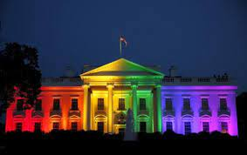
By: Jason Walsh June 8, 2023 The Daily Fetched
The LGBTQ+ Pride celebration hosted by Biden will be the largest of its kind “in history” for the White House. Biden is also set to announce new measures aimed at pushing transgenderism and other progressive ideology.
Reuters reported that Thursday’s event is being billed as a celebration of” LGBTQ+ families” and will see performances from singer Betty Who and DJ Queen HD.
As Breitbart reported: “The event will also focus on so-called `book bans’ being implemented in parts of the United States, with Biden’s Department of Education to announce the appointment of a new special coordinator who will be tasked with tackling the perceived problem. Across the country, our nation is facing a spike in book bans, and these efforts disproportionately target the LGBTQI+ community as well as communities of color,” one Biden admin spokesman said regarding the announcement. `These aren’t just attacks on the rights of LGBTQI+ Americans; they are part and parcel of a coordinated attack on our democracy,’ they added.
Such so-called `bans’ have become a major weapon for progressives both in the United States and beyond, with LGBT+ ideologues using school and state decisions to pull certain books from the children’s sections of bookstores and school libraries as evidence of a hate campaign against them.”
The main BOOK being pulled in once “Christian nations” is the Bible, and Bible story books for children. In England a person now can be arrested and put in jail for saying anything that might offend someone who is LGVTQI+ whatever else.
Some while back, the United Nations has suggested there are 100 different genders, and children as young as kindergarten age, age 5, should choose their gender. Last I knew, after 6,000 years, at least, of human history as we know it, when a baby is born, they either have boy body parts or girl body parts. I don’t think that’s changed any.
Another thing the U.N. is introducing for children age 5, kindergarten, is how to sexually satisfy themselves with their own body, i.e. masturbation. The goal – stop fertilization, stop having babies - stop reproducing humans. The goal is to rid the earth of full-blood, DNA intact, real human beings in the likeness and image of Yahuwah and Yahushua.
Here’s a second article:
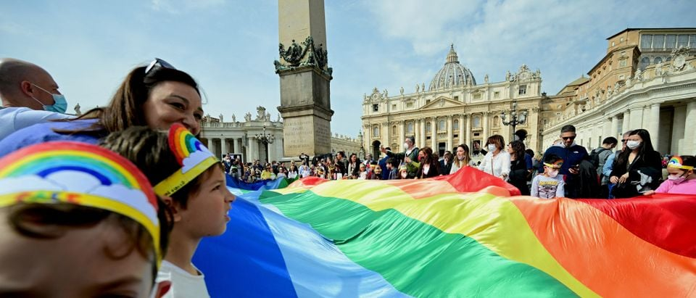
“JUNE IS GAY PRIDE MONTH IN ST PETERS SQUARE IN THE VATICAN TOO”
June: Gay Pride Month! Yes, this is in St. Peter’s Square in the Vatican. [Daily Caller, Sarah Weaver, June 1, 2023]
“The U.S. Embassy to the Holy See is flying a Pride flag at the embassy building in the Vatican during the month of June to honor Pride Month, prompting online backlash from Catholics. During the month of June…Gay Pride Month 🏳️‍🌈. [U.S. in Holy See] stands with the LBGTQI+ community against discrimination and other forms of persecution because of who they are and whom they love,” the embassy tweeted Thursday, along with a picture of the flag hanging from the embassy building.
US embassy to Vatican again flies Pride Flag as Biden administration backs 'LGBTQIA+' advocacy. The U.S. Embassy to the Holy See has again flown a Pride Flag, as President Joe Biden reiterated his commitment to supporting LGBT advocacy and, apparently, transgender-affirming health care for children.” From the Catholic News Agency: ““US Embassy to Vatican flies LGBT ‘Pride’ flag for month of June”
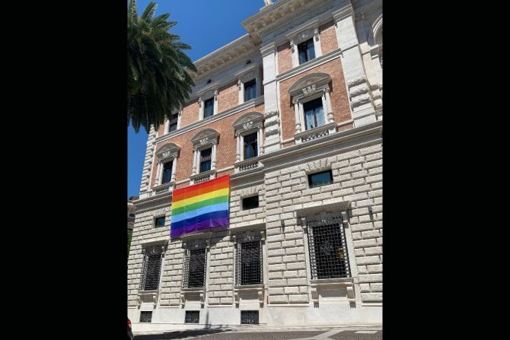 U.S. Embassy to the Holy See displays LGBT "Pride" flag during month of June,
It’s all out of the closet on the front porch. Now we see that Disneyland celebrates Gay Pride Month.
Visitors walk past a LOVE sign with Mickey Mouse painted in the LGBTQ Pride flag colors at the Disney Springs complex at Walt Disney World in Lake Buena Vista, Fla., on July 6.
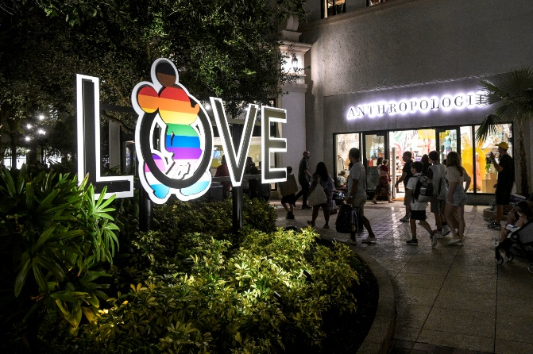
“Disneyland After Dark: Pride Nite is a separately ticketed, sold-out event. It celebrates the LGBTQIA+ community and allies. Pride Nite occurs June 13 and 15, 2023, inside Disneyland Park. This after-hours event, like other Disneyland After- Dark events, includes special entertainment, Disney characters, one-of-a-kind photo opportunities, dance parties, cavalcades, specialty menu items, event merchandise and more! What is especially fun about After Dark events is that adults can DisneyBound and dress up”
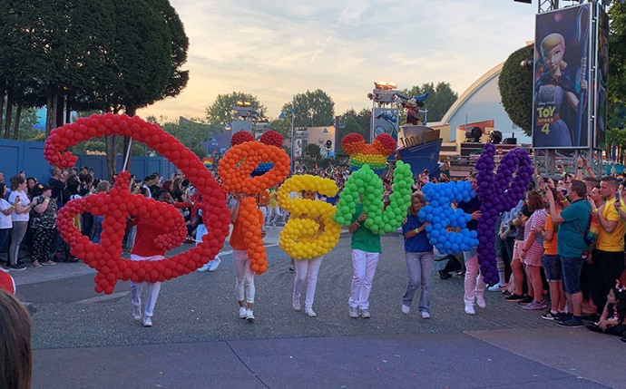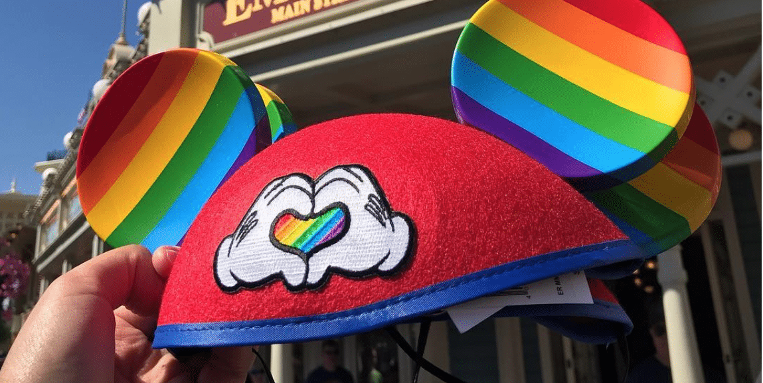
Disney’s First Gay Pride Parade – “Gay Days at Disney”
There are even events for children to introduce them further to the transgender agenda presented in public schools. The younger they can be taught about gender, about sexual satisfaction, about rebellion against authority, and choosing what causes them to succeed and be appreciated, the better – the fallen ones agree.
It’s all about the return of Ishtar, goddess of transgenderism, and along with her the return of Moloch, and Ba’al.
Ishtar presented herself as both a woman and a man. Here are some of my notes from Jonathan Cahn’s interview by Steve Quayle, May 22, 2023:
Wife of Ba’al – aka Ianna, Venus, Astarte – the great prostitute – Rev. 18 – Zechariah 5 – this is the great whore of Babylon who headquarters in NYC. She’s THE harlot of Revelation 17-18 – an adulteress – a spreader of sexual perversion – goddess of sex. She hung out in taverns – her temple – and promoted the use of “drugs,” as an enchanter – aka “pharmakia,” Greek: “sorcery, witchcraft.”
She revels in music that is intoxicating … “sex, drugs, and rock and roll” goddess of sorcery – This goes back to Genesis 6:1-4, the books of Enoch, Jasher, and Jubilees
The Genesis 6 and “after” – the Rephaim/giants were “homosexual.” Perversion is rising quickly, as the fallen angels increase to overtake what Yahuwah called “normal.” Foundation of sexuality – destroying family, destroying babies, children, - this leads to demonic possession - i.e. Romans 1. The “gospel” initially took out the power of the goddess in the western world in the first centuries after Messiah rose again. Now as Lucifer’s time is “short,” Ishtar joins Lucifer, Ba’al, Moloch, and all the other fallen angels and Nephilim for revenge.
Idolatry has taken over America to the extreme. It’s not just the worship of god-carved “idols” and material goods, but the worship of one’s “self” as a god. Seduction/destruction is being done by fallen angels. People are only seeing on an earthly mental plane, and do not see the dimension of the fallen ones at work – therefore they are sucked into the seduction so easily and are destroyed.
Jonathan talked about the reason in paganism for sacrificing one’s child to Moloch or Ba’al – to get financial prosperity, to get blessed in every way by appeasing the god. It is no different in America today. Modern parents today usually leave their children with strangers in public schools with no thought behind it, so that the public school system can train them to be good hell-bound Luciferians, to only think of themselves and the pleasures of material goods and carnal desires. Most first world parents are focused on their own prosperity, i.e. my money, my house, my possessions, my position, my honor, my respect, my “worship” of my abilities. “Stars” and “idols” are too words used for big-shots in the movie industry of Hollywood, or sports heroes, for example.
Jonathan Cahn says this is the one main reason behind abortion -- having a child is going to mess up the woman’s ability to rise in her career, boost her popularity, get what she wants for herself. If she pg with a baby out of wedlock, she probably doesn’t want to flaunt the face that she’s “shacking up.” Thus the sacrificing to Moloch, as Israel was doing before the Babylonian captivity.
Jonathan remembers the same Hollywood star that I remember at the Emmy awards who came to the podium to get an important award. She told the audience that if she had not had an abortion, she would not have won an Emmy. I remember hearing her say that. She sacrificed her child to Molocah, Ba’al, for fame and fortune.
In ancient times, when they offered up their child, the officials played drugs, played loud music, so that the ones offering up their child wouldn’t hear their screams.
Isn’t it like that now – fill ones’ self with drugs, so that they don’t hear, see, feel the pain of others, or of their own mind? Kill the screams; kill the pain – shove done more pills – offer yourself to the gods to get what you want. It’s rampant world over now. The Beast is with us in actual reality right now.
“…they passed their children through the fire” the Bible says of ancient sacrifices. Jonathan said that we do the same thing. We kill babies by using chemicals. But, then, as in Hollywood, the White House, the Pentagon, the U.N., babies and children are thrown on a barbeque grill and cooked for cannibalistic dining. There are even restaurants in NYC that serve cooked human flesh. This is true of older children too - the ones raped and then butchered and barbequed.
Modern abortionists and those having abortions often say it is a “holy sacrament,” a “holy sacrifice.” It is no different than in ancient Greece or Rome – offering babies and children up to the gods – the fallen angels – to Lucifer.
Jonathan: “This is spiritual, and it is spiritually demonic. That’s what it is.”
Quayle says that openly in the West, Satanists were saying that abortion is a sacred rite – an offering to Satan. It is called “the sacrament of abortion.” They openly say they are sacrificing to Satan.
Ishtar says in one tablet “I am a woman.” In another tablet she says “I am a man.” The blurring of genders causing confusion is causing people’s minds to be confused so that the fallen ones can take them on to deeper and deeper confusion, to evil, to depravity they did not know existed. Once so taken over they justify their beliefs in religious terms so often. In one of the praise hymns to Ishtar, it says “you turn a woman into a man; you turn a man into a woman.”
Jonathan called her “Atola.” She’s an ancient female deity who became the principal representative of Semaramis – queen of heaven, mother of god.
Of Ishtar it is said: “…she grinds away the masculinity of men.”
Her priests in her temple were men dressed up as women, wearing make-up, acting like women. Parents would bring their children to the temples to see the men dressed up “in drag.” It’s just like today, parents take their children to a library so that drag queens can read them stories and joke with them, and act silly, and entertain them. This desensitizes children to the reality that a man is acting like a woman because he wants to be a woman.
The first publicly recognized gender change was a man who was changed as much as possible into Christine Jorgenson. I actually did “it’s” house insurance papers when I worked in California for Lakewood Savings and Loan in the Insurance Department.
This goddess, a fallen angel principality and power, Ishtar, wants to possess a whole generation of children, or have them murdered in the womb or sacrificed afterwards. Jonathan: Today 25% of high school children believe they are not heterosexual. “Heterosexual: Those sexually or romantically attracted exclusively to people of the other sex.” Just a few years ago, those saying they were not heterosexual were 1%.
Steve: 70% of women of high school age it is statically said have considered suicide. Steve said that now we have hopelessness and despair and confusion and disorganization so that young people are not secure, they are tossed to and fro and so contemplate suicide. Canada has legalized assistant suicide for those 13 and older. Doctors even encourage it.
As Steve said, a young person’s identity is being taken away as young as 5. Hope is taken away. Fear is replacing security and peace. Confusion reigns. They don’t know where to turn. There is no solid teaching on the eternal world … just feel-good religious nothingness. Thus, spooky religion like New Age religion is taking over. The Bible is totally being taken out of the picture. Pride and arrogance and use of self-will over caring about others is dominant. They have no direction. Many are oppressed or suppressed, and so they want out.
Jonathan talked about the changes in wording to niceify the evil. Instead of calling it gender mutilation, it is called “gender affirmation.” Anyone using words of truth are mocked and vilified. Jonathan says it is totally satanic (Isaiah 5:20).
Hebrew: “shadim,”/destroyer means to take a person away from what they are …
Steve: Duke University: 2, 3, and 4-year-olds are taken there for sexual mutilation by parental request - called “gender re-assignment.”
Surely, the chief fallen angels are on the loose. Since September 23, 2015/2016 a new cycle began … the striving of the Spirit is ended. The fallen ones had their 120 years (1896-2016) prophesied by Yahuwah via Genesis 6:1-4. The striving ended, and the release of the fallen ones for their final “short time” began.
The “rainbow” was/is the sign of the ancient goddess Ishtar, ISIS, Catholic Mary… and all her other names. Biden declared same sex marriage, then lit up the white house in rainbow colors, as you see above.
The rainbow was a symbol of the end of Yahuwah’s judgment by flooding the earth with water. The rainbow now is a symbol of Ishtar and the judgment of Yahuwah before Messiah returns.
“Let’s talk about June,” Steve said. “This is all supernaturally orchestrated.”
Ishtar is the “goddess of parades.” Her “gay pride” parades of today for example. In ancient times – the goddess “possessed the month of June,”
She is the goddess of pride. June is known in America as “gay pride” month with “gay pride” parades. The gay pride rainbow flag – color #1 represents sexuality – the last color represents the “spirits” of homosexuality.
Jonathan asks: Is it natural that the US Embassies all over the world are flying the rainbow flag? Putin, President of Russia, told the Embassy in Moscow to get out “and take your rainbow flags with you.”
Jonathan asked: “Is it natural that our high schools and middle schools and elementary schools are flying the rainbow flag now?” “This rainbow flag is linked to being possessed by the goddess,” Jonathan said. They want the youth gender changed and possessed by Nephilim (demons).
“It was said that Ishtar stretches herself across the sky like a rainbow to wage war,” Jonathan said. She’s waging war on the human race in allegiance to Lucifer.” The Greek Island of Lesbos is where the word “lesbian” came from. A woman poet established it as a lesbian island. She was the high priestess of the goddess Ishtar.
Lavender was the color worn on the head that attracted the spirits – today many women have dyed their hair lavender.
On June 26th Obama lit up the White House when he was President with the rainbow flag colors. It was the 10th of Tammuz on the Hebrew calendar. In ancient writings, the 10th of Tammuz was the day of homosexuality men with men, women with women. So on that day Obama celebrated with lighting up the White House.
June 1969 New York: In his book, Jonathan tells the story of the Tavern and the take-off of gay pride from there … (the story is in his book) It was called “the Stonewall Riot.” On that night in 1969 all the signs of the “Enchantress” began appearing in New York City. Ishtar was known as the goddess of the gates. NYC is known as the “Gateway City” - the main entrance into the US for commerce - Revelation 17-18.
The great whore of Zechariah 5 also. Is this “woman” whose origin is in Shinar, or Babel, founded by Nimrod – Semaramis, his wife/mother – the same “woman” of Revelation 17-18 who rides the Beast? The great whore … the one whose cup is filled with the blood of the innocent?
She represents the goddesses of the ancient world beginning with Semaramis, who, after giving birth to Tammuz, was called “the mother of god,” and “queen of heaven.” Her little boy, the son of the sun god Nimrod was named Tammuz. Ezekiel 8 – women making cakes in honor of Tammuz. The day of homosexuality in the pagan world – the 10th of Tammuz.
After Nimrod’s death, his wife/mother, Semaramis, told that she was impregnated by the rays of the sun from the sun god, Nimrod. She gave birth to the son of the sun-god and named him Tammuz. Tammuz became the lover of Ishtar – her “boyfriend.”
Jonathan told how Ishtar was also known as the goddess of the tavern. The outbreak of gay pride and anger and defiance began in a tavern in June of 1969. Jonathan said she’s also the goddess of prostitution – known as the great whore or harlot. SO THERE YOU GO. Zechariah 5: She returns to her place in Shinar – NEW York City. She is “Mystery Babylon” the great whore – Isaiah 47 with Revelation 18.
Her vengeance is focused on those who believe in the God of the Bible, the Savior, the Messiah of the Bible. Thus, she holds the cup filled with martyrs’ blood.
In the midst of the rioting that night, a dance breaks out – that goes back to the ancient goddess in the words of the song they were singing. A woman inside the tavern that night encouraged the riot … Ishtar was known as the goddess of the storm – that incited upheaval. The woman that encouraged the riot that night – her last name was “Storm.”
Steve said that the majority of Hollywood are professing witches, warlocks, satanists, cannibals … yet known as “stars,” and “idols.”
Continuing on with Jonathan: “Whenever you take God out of the equation, you’re going to have the destruction of life.” Jonathan told: In Nashville not too long ago, a “trans-woman” came in and shot children and a teacher in a Christian school, killing them. The demoniac of the Bible dwelt in the hollows, in caves, in hollowed out places. The last name of the woman who shot the children was “Hale” - which is an ancient name for “hollows.” From BBC news: “Police said the suspect was 28-year-old Audrey Hale, who identified as transgender. Hale was armed with three guns, including a semi-automatic rifle, and was shot dead by police.”
“The gods that have come back, have come back with a real agenda.” The demons in the demoniac were cast out by “Jesus,” Cahn said, “so they are trying to get Jesus out of the culture.” “They were cast out by the Word of God, so they’re trying to get the Word of God cast out of the culture.”
Remember Sodom is connected to the homosexual movement. Yahushua called down fire on it, and Gomorrah, and 2 other such cities. He will call down fire again!
The re-entrance of Ba’al. Ba’al as a fallen angel-god is, today, trying to track down all the Eliyahu’s. He is trying to get all to bow to Ba’al as in I Kings 18. Those with the authority of Eliyahu are a great threat to them. The goddess, Ishtar, is transforming the Christian nations to where they do not even resemble what they were as a Christian nation. Moses: “Who is like you O Yahuwah among the gods?” He showed Himself more powerful than the gods of Egypt which were simply fallen angels and Nephilim.
The power and ability of the fallen ones has increased greatly. This is because the 120 years promised to the chief fallen ones began in 1896 and ended as we went into 2016 on the Creator’s calendar on Yom Teruah, September 23, 2015/2016. On that day Yahuwah’s Spirit stopped “striving” with them, and has let them do now their evil to the max before Yahushua comes with His wrath. It is amazing how many things ended on that day 9/23/2015 – including America’s 70-year allotment as a “super power.”
If you look understand the Great Seal of the U.S. on the back of the dollar bill, that pyramid began in 1776, and the bricks end at the top with 2016 Gregorian calendar. I recommend “The Eye of the Phoenix” DVD Chris Pinto Director, and Tom Horn’s book Zenith 2016.
Bottom line is that the fallen angels are entering earth by the tens of thousands and once again mating with human women and producing modern-day Nephilim, and/or Rephi’im. Lucifer thinks he’s in control – and he is, but Yahuwah holds the rope around his neck.
This gay pride thing in June is not just some modern idea. It goes back centuries, even a few thousand years. Make adjustments – don’t let your children be baptized into the deception of Ishtar. It is causing so many young people to feel hopeless, so they are committing suicide. Pray like you’ve never prayed before.
In His love, Yedidah – June 8, 2023

