**MAUI FIRES ARE NOT NATURAL! TARGETING ENERGY WEAPONS FUTHER GLOBALIST CLIMATE CHANGE LIES!**

The pictures below are close to what I posted in previous articles 2018 to do with the California fires that were also not natural, but geoengineered “weather warfare.” Please refer to: “Mysterious and Definitely Not Natural California Wildfires” 2018 #95.0 under Present Reality – LOOK AT THE PICTURES!

I highly recommend Steve Quayle’s book: *Weather Warfare and Other Unnatural Disasters*. It goes into explaining so much of what we’re seeing – devastation to foster lies, lies, lies, so that the people will willingly go along with the great deception of “climate change” and submit to eating bugs, staying locked down, and in fear of the consequences of believing the truth. Here’s an article and below it are pictures of the Maui – Hawaii – fire. Note **the similarities in pictures between the California and Maui fires. LUCIFER’s servants AGAIN!**

**FIRES IN HAWAII NOT NATURAL TARGETING CHILDREN**

“Lahaina, Maui Update”: I am in Hawaii now and speaking to numerous insiders and locals. Here is the shocking news: The amount of fatalities is confirmed to be 67 currently, but is expected to be more than 500 but less than 1000. [now over 1,400]   
 **Many of the fatalities will be children who were at home because they canceled school.  Parents worked and were not there to evacuate the children**. Kids had no idea they needed to leave and by the time they noticed their homes or apartments were on fire, it was too late.    
 **The government is worried about how we will react when we learn that the fire department left the fire earlier in the day and claimed it was 100% contained knowing that the winds were expected to be 70mph by the afternoon.  This is against all fire control protocols**.  The fire department should not have left the original fire unattended.  They are scared that the public calls for accountability will be more than they can control and protests and riots will occur. They plan to lock down Lahaina for several months.  It will take months to clean up the hazardous and environmental contamination. They won’t have enough housing for the displaced.   
 There were 2,000 unaccounted for this morning. They accounted for 700 of the missing today.  But there are still 1300 missing.   
Three options as to what happened in Lāhainā:   
 1. Like Corruptifornia, they never upgraded the infrastructure and pocketed the cash instead. (I have direct evidence this is the case because about a week ago, before the fires, I saw a post on IG where Lahaina had numerous broken power lines because they were never replaced or fixed).   
 2. **New World Order globalists used Directed Energy Weapons**.   
 3. Most likely it is BOTH 1 and 2.   
 Globalists Launch Climate Terrorist Attack Against Citizens in Maui Destroying Lives and Property 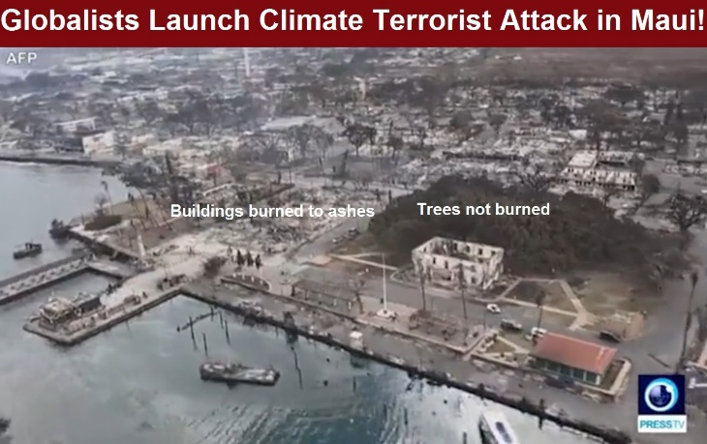

Definitely targeted – as in fires in California a few years back – and in other countries – buildings ash trees standing

**How can a “natural wildfire” burn buildings and cars and leave trees standing? Image Source:**[**Where Can We Buy Some of Those Fireproof Trees They Have In Maui?**](https://rumble.com/v36m2g5-maui-fires-where-can-we-buy-some-of-those-fireproof-trees.html) **by Brian Shilhavy Editor, Health Impact News**

Hundreds of people are feared dead and entire towns have burned to the ground in **Maui, Hawaii, in what is clearly a climate terrorist attack by billionaire Globalists against the citizens of Hawaii, primarily on the island of Maui**.

Similar to what we have previously reported about past fires in California and Canada where the evidence is overwhelming that **these fires are not natural at all**, photos and video footage coming out of Maui right now clearly show that this is NOT a natural “wildfire” in their tropical climate, as buildings and cars burn to ashes while trees and other wooden structures are still standing.

See some of our previous coverage on these unnatural fires:

[**Wildfires that are Not Natural – Product of the Geoengineering Agenda**](https://healthimpactnews.com/2023/wildfires-that-are-not-natural-product-of-the-geoengineering-agenda/)

The original headline I was going to use for this article was “U.S. Government Launches Climate Terrorist Attack Against Citizens in Maui Destroying Lives and Property,” but then I realized that when most people think of “government” they are thinking about those who are (s)elected to public office.

**But the reality is that the world’s billionaires and bankers are the ones who control the actions of “government,” and nowhere is that more evident than in Hawaii, the playground and hideout of the rich and famous.**

Over 10 years ago, I had dinner in Los Angeles with a former Senator from Hawaii to talk about the “war zone” in Hawaii between the big Biotech companies who were taking over Hawaii’s agriculture, and those who were promoting organic small-scale and traditional farming techniques that did not involve poisonous chemicals.

**Just as Hawaii was the focal point of bringing the U.S. into the conflict during World War II**, so today it appears that it is the focal point in the agricultural war of the 21st century. **Hawaii today is the centerpiece for two vastly contrasting methods of producing food: the development of genetically engineered seeds and the development of Korean Natural Farming.**

Biotechnology, with genetically modified seeds as their centerpiece, has taken over the food supply of the United States.

Hawaii, with its isolated and pristine ecosystems, is a perfect testing ground for the biotech’s testing and development of genetic engineering.

Full article: [Hawaii War Zone: GMO Biotech versus Korean Natural Farming](https://healthimpactnews.com/2013/hawaii-war-zone-gmo-biotech-versus-korean-natural-farming/)

Now, 10 years later, it is evident that these Globalists in Hawaii are putting into place the next item on their agenda: new 15-minute “smart cities”.

But to build these new cities, the existing ones, which are run primarily by small business owners catering to the Island’s tourist industry, need to be burned down.

These future prison camps are being marketed to the public as “paradises” – how fitting for Hawaii.

Hawaiian lives mean nothing to these globalists, just as **many people were murdered in Hawaii during the attack on Pearl Harbor, which happened with the full consent of the U.S. Government in order to get the public’s approval to enter WWII and enrich the bank accounts of the bankers and those who manufacture weapons of mass destruction in the U.S.**

See: [Pearl Harbor: Roosevelt’s 9/11](https://jamesperloff.net/pearl-harbor-roosevelts-911/)

And we can name names when it comes to the Globalists who run Hawaii today.



The politician they have (s)elected to implement their Climate “Green” Plans for Hawaii is Governor Josh “Green,” who just a few weeks ago gave a keynote address at the United Nations explaining how Hawaii was going to be the first state in the U.S., and the first place in the entire world, to convert to “100% renewable energy” and roll out the WEF’s sustainable economic plans.

Peggy Hall of The Healthy American is my go-to person who does deep dives into these “wild fires” that appear to be anything but natural, and have all the markings of the result of energy weapons.

We have [featured her work before](https://healthimpactnews.com/2023/wildfires-that-are-not-natural-product-of-the-geoengineering-agenda/), including the work of Robert Brame, a forensic arborist who has analyzed 38 California fires and has come up with hundreds of photographic evidence of IMPOSSIBLE normal fire behavior.

**PICTURES BELOW SHOWING THE RESULT OF DIRECT ENERGY TARGETED FIRES – AS IT WAS IN CALIFORNIA IN 2018 - HOUSES BURN TO ASH BUT TREES REMAIN**

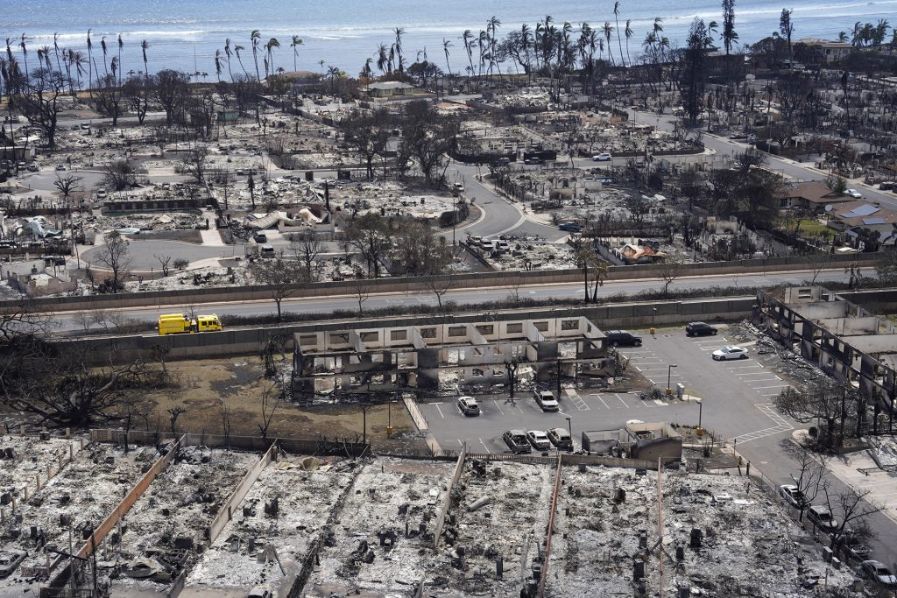

Same as in California 2018, – fire totally turning all homes to dust – at the same time, trees not burned. What burns non-organic materials, even countertops, and cars, yet leaves trees, even grass? Weather warfare, geoengineering – direct target weapons, energy weapons. Why? To make a case for a lie – “climate change,” that is manmade. This lie will be used to suppress mankind under a weight of rules no one will survive – call “global government under antichrist.”

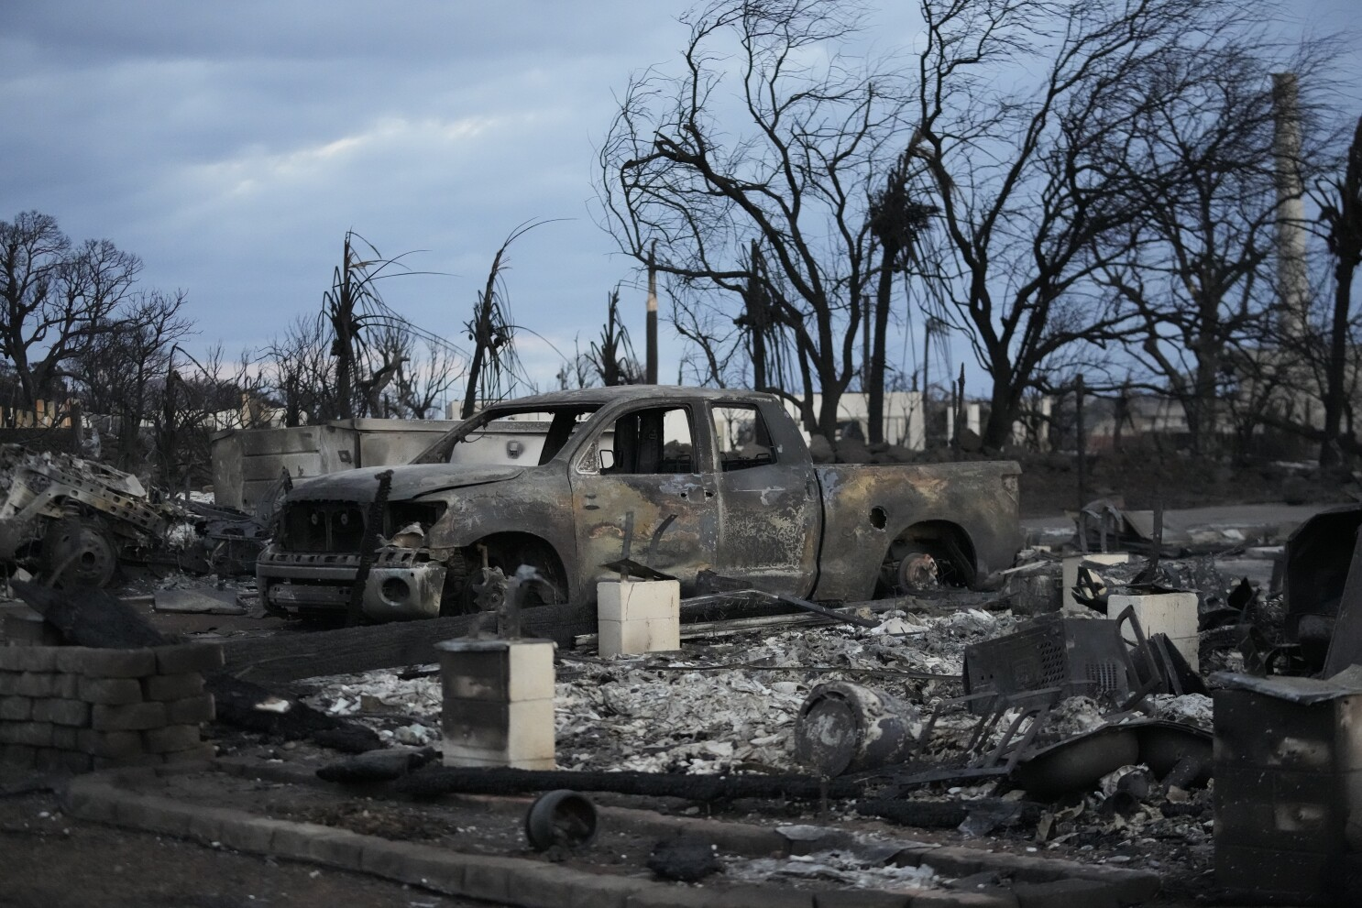

What’s wrong with this picture?

Houses, cars, totally destroyed, metals too, but trees continue unburned

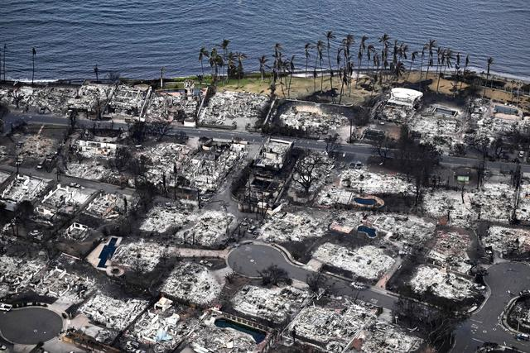

Ashes to ashes, dust to dust, but not the trees please! Isn’t this a bit strange?

California 2020 all over again.

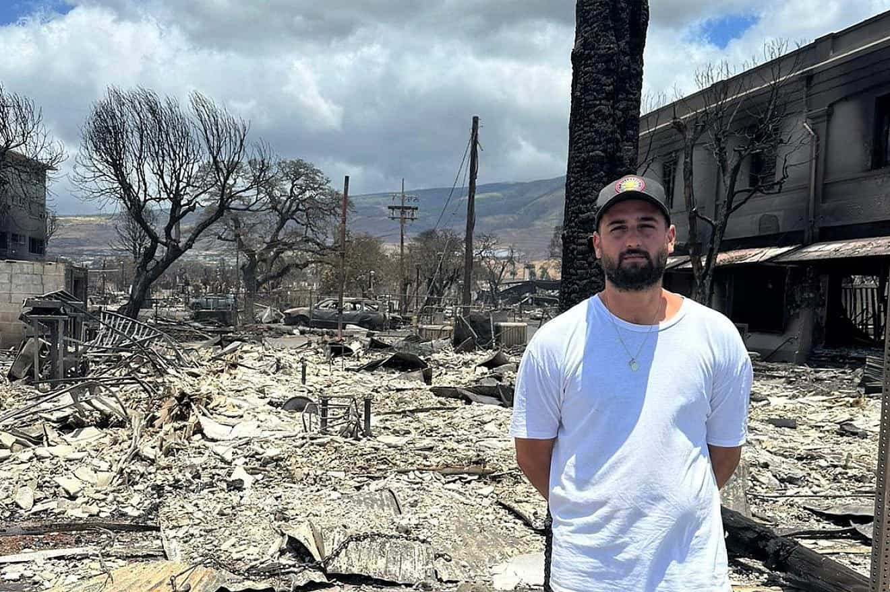

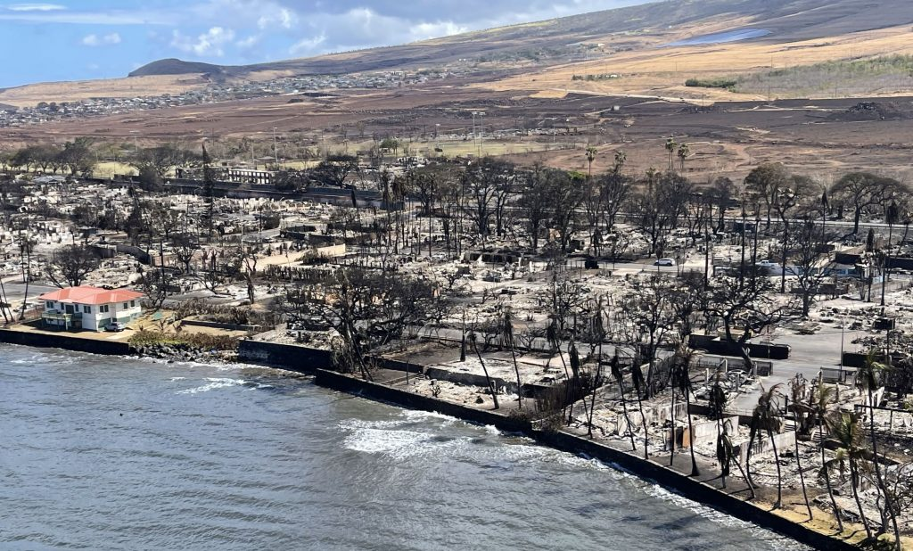

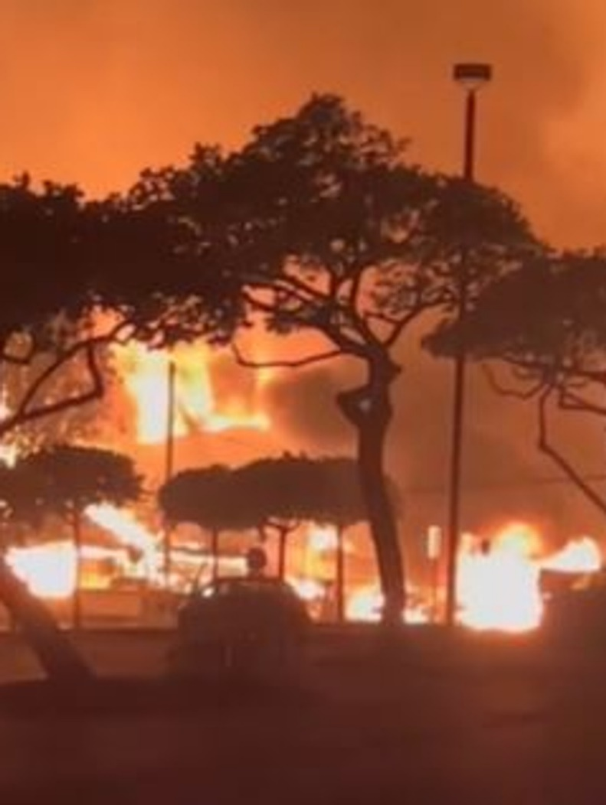

Seek Abba with all your heart, submit to His instructions, obey Him, align with the soon-coming King of kings and Master of masters by hearing Him in your spirit so that you are never afraid, never in ignorance, never deceived.

In His love, Yedidah – August 15, 2023