NEWS UPDATE FROM BOTH SIDES OF THE FENCE

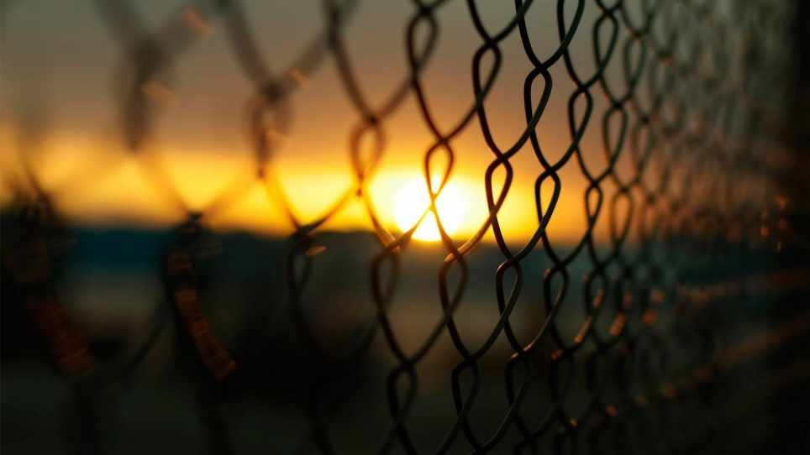
The path of the righteous is like the light of dawn that shines ever brighter until the full day. The path of the wicked is like darkness. They do not know at what they stumble.” Proverbs 4:18-19
Full invasion from the dark kingdom, from under the earth, on the earth, above the earth, from other dimensions, and from the cosmos, has taken place, taking over human bodies and human minds, in which is the human will. A great number of government rulers are not fully humans. They have one goal: The enthronement of Lucifer, aka Satan the accuser on earth, in the body of the Beast ruler of the final Empire. They want all recognition of the Creators banished, and only a world of their making to survive. By the slyness of the Nachash of the Garden the world’s people, as a whole, for whatever reason, are quickly deciding to do whatever the forces of the Nachash says to do, so that they might be on the “safe side.” All of while what we are seeing to reach this goal is illusion, fantasy, deceptions, lies, and fear-mongering control mechanisms as well as great mind control debauchery.
Then on the other side of the fence are those who do not have any other goal but to please Yahushua and Yahushua and live in Their dimension forever. Of this mind-set are the ¼ of the parable of the sower in Mark 4: The invited guests, the trained attendants, “friends of the Bridegroom,” and the marked and sealed Bride. All are invited to the wedding Feast, and all are eternally blessed!
We are moving into a deep darkness that is now covering the earth like a thick blanket. Yet, we await the dawn that gets bright and brighter – the coming of our Savior, the Master, Yahushua Messiah. Isaiah 60:1-2: “Arise, shine, for your light has come! And the esteem of Yahuwah has risen upon you. For look, darkness covers the earth and great darkness the people, but Yahuwah arises over you, and His esteem is seen upon you.”
Today, the people of America, Canada, Britain, Europe, Africa, Asia, the Middle East, and the rest of the whole earth in general, are on an elevator going down into the depths of darkness. At the same, the remnant-few, whose hearts are so intertwined with the heart of Yahuwah and Yahushua that they walk in the light of Their Presence and love to obey Him to do His will, are rising and unifying and preparing to go forth unto the full day, the brightness of the noon-day. I am so excited to see this happening, and to be a part of it.
As you know, America is no longer a free nation, no longer under the Constitution, no longer governed by any semblance of righteousness--the few righteous remaining are being crushed. We are coming out the other side of a coup – a Bolshevik coup. Kamila Harris is a openly professing Marxist, and proud of it, as now many senators and congressmen, and others in government are showing their siding with Communist China. The one thing that literally terrifies them the most is Truth. There is already talk of putting Biden aside and letting Kamila rule with her own version of a Vice President, perhaps Pelosi.
On of the pages of Isaiah and Amos in the context of the return of Yahushua, we read Isaiah 59:14 and Amos 5:10: “For right-ruling is driven back and righteousness stands far off. For truth has fallen in the street, and right is unable to enter…” [keep reading vs. 15-20 about the return of Yahushua] “They hated the one who reproves in the gate, and they despise the one who speaks the truth.”
We in America are moving quickly towards martial law, a military-controlled nation, an invasion by China on our northeast border from Canada, and the attempted fulfillment of what the Chinese Military Chief has boldly said publicly about wanting the death of every man, woman, and child in America. That would include the hundreds of public elected officials in D.C., plus governors and mayors on the take from China, who now think they’re in good with the coming rulers.
We’re also watching the purposed build-up of WWIII with Iran as the guinea pig to start it all. Back when George W. Bush was President, he informed General Wesley Clark that 7 nations had to be taken down in power before the new world order could begin, the final one being Iran.
It is hard of me to watch the evil that has been, and is, taking over in the Middle East, with all the horrendous lies told, and fingers point at who is “bad,” since at least 2011. Living in the region for 16 years, I learned to see through the lies.
I suppose you truth-lovers know that the recent actions of the evil ones are based on nothing but lies, i.e. that Trump supporters were the violent mob who tried to destroy the Capital on January 6th. Hum…January 1, 2020, the beginning, using a false flag attack on the U.S. Embassy in Baghdad that set the stage for all that has followed. Trump actually made a video early the morning of January 6th, telling his supporters to “go home,” and let peace rule. But that video was almost immediately taken down since it would cause their plan to not work. BLM and Antifa went ahead of the Trump supporters who were maintaining a peaceful protest, and as the movie footage showed, the guards at the door of the Capital opened the doors for them. It was staged and Trump supporters walked right in to it. Hate rhetoric by public news media is stirring anger against Trump supporters, using them as a reason for the impeachment and other measures of takedown.
Most of you know that the Marines are the military division that protects and backs the President. One of Quayle’s article-references yesterday from military intelligence told this: “Marine Corps. Rebukes Pelosi: 'WE DON’T WORK FOR YOU!' General David H. Berger, Commandant of the United States Marine Corps., refused House Speaker Nancy Pelosi’s request to use the Corps. to safeguard Biden’s Jan. 20 inauguration from Trump supporters.”
Oh how we bless and pray for the righteous military, the righteous in government, the righteous among humanity, who stand against the forces of darkness in natural ways and spiritual ways!

Excerpts from: “IS AMERICAN DESCENDING INTO A MILITARY DICTATORSHIP PRIOR TO BIDEN'S SWEARING IN?” Dave Hodges, January 16, 2021
“Biden would be a fool if he believes that he is going to run the military. Right now, they are operating with complete authority, regardless of who the President will be on January 20th. It is their senior officers who are most at risk for a purge. This development leads an important question.
Is the Stafford Act going to be invoked? … Presently, there are 20k National Guard troops in DC. That number is expected to grow by 30K. It is interesting that nobody is asking who put these troops in place and who is ultimately in charge. The CSS has learned that these troops are not answering to Biden or Trump. This is a DOD operation. The DOD is now running the military.
In waning days of the Trump administration, it appears, on the surface, that Trump has given in. In fact, when it comes to invoking the Insurrection Act of Executive Orders 13848 and 13959, Trump failed to pull the trigger. In fact, I am hearing two conflicting reports on the mental status of the President. One report says he is working with the DOJ to put the country in martial law. The other report states that he is a shell of himself and has given full authority to the DOD.
There are multiple reports which state that mechanized CHICOM military units are on the move. They are, or have, moved to an area adjacent to Minnesota, Wisconsin and Michigan. Paul Martin has chimed in on this development with a source that says that the CHICOMS are ready to cross border as all training has ceased. [CHICOM: Chinese Communists]
…As an aside I want to note that the CHICOMS have been given carte blanche to move anywhere within Canada. Attention people of Canada, you are in grave danger. Trudeau has abandoned you and has totally sold out to the globalists and is permitting the CHICOMs, the new world policeman to use your country as a staging area from which to invade the United States. When the CHICOMS are done with the United States, they will turn their attention to your country. Canada, because of melting icecaps will soon be the fresh water capital of the world.
You can bet on the fact, that the Chinese will seize the opportunity to act when the US becomes mired in Civil War. Right now, there is strong sentiment among the DOD to postpone or cancel the Inauguration. No, Trump will not become President. As of Thursday, the DOD is considering this action because they are not confident that either President can protect them or their top Generals who would be executed in a CHICOM occupation.
Please consider this fact: China desperately needs to expand and seize required assets to help with the restoration of its economy.” …

I add that China’s people are starving, and they want our land and water supplies, our cattle and other edible animals, our goods, our houses, our land, our cars, our planes – they want everything.
In the meantime, Joe is saying that he’s going to force the vaccine, and call in F.E.M.A. If you’ve kept up with my reporting, you know that their death camps are open, all 851 of them complete with guillotines, and as Steven ben Nun has reported, it will be inside of the “camps” in secret underground facilities that the international Noahide Laws of the Babylonian Talmud will be used to execute all Christians, Messianic, and Hebrew Roots believers for their belief in the Deity of Yahushua/Jesus and for those guarding the Torah who are not DNA related to the Jews via their mother. Please refer to my many 22 articles, beginning with the foundational one: “Beware of the Noahide Laws,” American Laws/International Laws” under the Mikvah of Present Reality. The others between December 2018-December 2019 under the Mikvah of Israel, Our Eternal Inheritance.
Mike Adams added this on January 13th: “…now 20,000 armed National Guard troops are descending on Washington D.C. even though Joe Biden won’t even be inaugurated there. He will be sworn in, if that happens, in front of a green screen in a studio where he can attempt several takes to maybe get the words right.
With Italy’s government now collapsing, and the Pope rumored to have been arrested, and a raid having taken place on the Leonardo company that provided the satellite infrastructure used by the deep state to steal the election, it’s obvious that major events are under way on the world stage, all pointing to something much bigger taking place in the next seven days.”
On top of this is the provoked and diabolically set-up WWIII using Iran as the reason, when the reason is shockingly NOT Iran. I won’t go into detail here, but keep up with it if they’d like via Steven ben Nun, israelinewslive YouTube.
The beast system is indeed rising into place as it’s host nation must be taken down. Since 1992, I’ve been reporting on the chapters in the Bible that point to the final imagine of Nimrod in the earth and his plan for world rule – America. (Isaiah 13, 47, Jeremiah 50-51/America, Revelation 18/NYC).
Historically, the spirit of Babel, the spirit of Nimrod and his tower, moved out of what is now Iraq, across Europe, Rome being known as the “second Babylon” from the 1st century CE, into America, chosen to be the final Babylon by the mystery religions of England. Please refer to: “30 Clues and More…” Mikvah of Preparation and/or End-Time Babylon, Mikvah of Present Reality.
GET ON THE LIGHT-SIDE OF THE FENCE AND PRAY! PREPARE! PRAY! PREPARE! PRAY! PREPARE! “Through Yahuwah we have the victory until eternal life.”
In the love and joy, peace and blessing of Yahuwah and Yahushua, Yedidah
January 16, 2020

