NOT-TOO-FUTURE PROTEIN

Warning! Do not read this article before eating, or preparing food. It contains seven pictures, five of which you don’t want to see if you’re hungry. So much for humor! This is really not funny – because “they” are dead-serious.

What amazes me is how plans to create famine, then leave mankind with a new do-or-die diet, goes back a such a long way. It’s amazing how this scenario matches edicts of Antiochus Epiphanes, forcing those of Judea to do as he said or be killed – one of which was to eat pork. He wanted to paganize them in all ways because he hated the set-apart edicts of Yahuwah.
The first laws of practical set-apartness unto Yahuwah begin with Leviticus 11. Since the Creators don’t want us putting the preverbal sand in our gas tanks, They made sure that we knew what to eat and what not to eat in order to maintain maximum healthily operational fitness and mental clarity.
He clearly stressed that we are not to eat the garbage collectors of earth and sea that He created, because then we’d be ingesting the garbage they collected, which is bad for our health. He’s so practical! Yahuwah made various creatures for various purposes. Some we loathe may have been made by Nephilim scientists in a laboratory before the Flood while playing with gene splicing, add a little here, remove a little there, and technology we don’t know about yet.
Now, to satisfy their sadistic sense of humor, the Nephilim, returned and new, want to take the illegal critters and shove them literally down our throat. Of course, some of the things we don’t want to love are good for something, but some must be leftovers from a Nephilim laboratory somewhere.
In China, they eat whatever small tidbit swims in the ocean or crawls on land – including snakes. They sell them in open markets, placed in rows of bamboo baskets. The snakes are kept in cages. Chickens are alive in cages. Pick your chicken and they’ll cut off its head and pluck its feathers for you. Or, you can carry your chicken home by bringing your own cage to carry onto the bus. China has 1.8 billion people, so food is whatever is edible. Pork is the chief meat. Millions of hogs perished in the last two years in floods, and also from swine flu, in China.
The planned and created famine for the world will leave people with little to eat except what is crawling or slithering. However, in addition, the big talk for a few decades has been “cannibalism,” even scientifically discussed as a good source of protein, ranging from aborted babies to something like a “Soylent Green” cracker that is “people.”
In meat markets, ISIS hung dead Christians for sale as meat to eat in Syria. Abortion, cannibalism, occultic “spirit cooking,” and other heinous evils beyond “normal,” are part of comedy routines in Hollywood, causing audience to laugh - and laugh hard. Refer to my article “Cannibalism”/Mikvah of Present Reality.
We read gruesome stories of cannibalism in the Bible, like during the two-year siege by Nebuchadnezzar before he weakened the people to the point where he came in with his troops and carried them off to Babylon without a fight. In those stories, we read of mothers eating their babies. Starvation does awful things to people’s minds. We’ve all heard of the “Donner party.”
For us, we have Psalm 33:18: “See, the eye of Yahuwah is on those fearing Him – on those waiting for His kindness, to deliver their lives from death and to keep them alive during famine.”
King David said, “I’ve never seen the righteous forsaken of his seed begging bread.” Yahuwah is very interactive with His set-apart ones. You don’t hear about Jeremiah, Barak, or Ebedmelek starving in Jerusalem, do you?
The proposed diet for protein can be beaten simply by mixing lentils with grains like wheat. Many beans, legumes, nuts, seeds, and grains provide protein, especially when eaten together. Food combining for protein is something for you to study up on! I was a vegetarian for 7 years – wow was I healthy and strong! I learned food combining.
Books and articles are out there! Lentils, a legume, and wheat make a complete protein. Individual foods also have protein. There are vegetarian burgers on the market, but some of them have ingredients you don’t want to eat. Read the ingredients. Make your own veggie burgers! Learn!
The CDC and WHO ordering the euthanizing of healthy cattle, pigs, and chickens in America is a horrible thing! Clean, innocent animals euthanized because of a very diabolical agenda. Farmers are plowing up their crops because there is no place to sell them. Crops and orchards are failing – all because one world government plans to kill all but 500,000,000 usable slaves for the Elite world rulers to control
We read in the books of the Maccabees where mothers watched their children killed for refusing to eat pork and so defile themselves.
One thing is for sure: We must not defile our identity with Yahuwah and our Savior Yahushua! Our identity is that we are “loved children.” We can’t throw that away for a short time of life under the tyranny of the Beast/antichrist/anti-messiah. Life is short at best. We have eternity to look forward to, if indeed, we are truly born again by faith in the shed blood of Yahushua/Jesus for our salvation, and in His resurrection for our eternal life.

Two articles to feast on…
“EU ‘Green’ Agenda Calls For Eating Bugs To Save the Planet Urges that environmental goals `will not happen without a shift in people’s diets.’ ”
Steve Watson | infowars.com - May 25, 2020
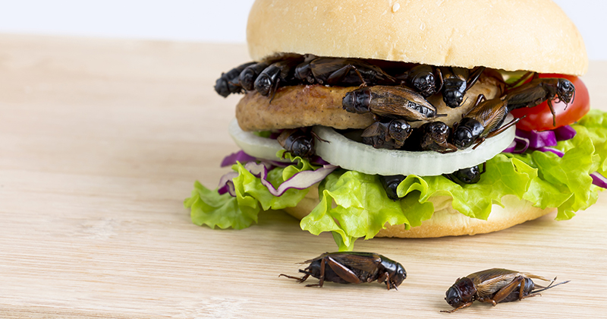
A new EU draft policy announced last week calls for “insect-based proteins” to be extensively promoted as a replacement for animal products, to save the environment.
The European Commission announced the Farm to Fork (F2F) Strategy, touting it as a `fair, healthy and environmentally-friendly’ program that will focus on `increasing the availability and source of alternative proteins such as plant, microbial, marine, and insect-based proteins and meat substitutes.’
…EU centric news site EURACTIV, noted that the policy is calling for eating bugs, and spoke to Constantin Muraru from the international platform of insects for food and feed (IPIFF), an EU non-profit organization which represents the interests of the insect production sector. Muraru lauded the idea of both humans and animals eating more bugs, saying that there is `enormous potential.’
`Currently, the EU is heavily reliant on the importation of feedstuffs, but the disruption in the past few months with the coronavirus outbreak has made it increasingly apparent that we must look to make our agriculture more self-sustainable,’ he said. `Insects can be produced locally and are a highly nutritious, protein-rich foodstuff that can be produced in high quantities in a small area,’ he added.
The EU continues to push the idea of eating bugs, with its Food Safety Authority having approved the sale of bugs as `novel food’ earlier this year, meaning that they are likely to be mass produced for human consumption throughout the continent by the end of the year.
`These have a good chance of being given the green light in the coming few weeks,’ the secretary-general of the International Platform of Insects for Food and Feed, Christophe Derrien, told The Guardian. The craze for eating insects stems from UN guidelines that `promote insects as a sustainable high-protein food.’
As we have previously highlighted, eating bugs has been heavily promoted by cultural institutions and the media in recent years because people are being readied to accept drastically lower standards of living under disastrous global ‘Green New Deal’ programs. This will be exacerbated by the expected economic recession, or even depression, caused by the coronavirus outbreak. This is why globalist publications like the Economist have been promoting the idea of eating bugs despite the fact that the kind of elitists who read it would never consider for a second munching on crickets or mealworms.
Unsurprisingly, restaurants are now seeing a big uptake for worm burgers, otherwise known as ‘bug macs’, or cricket based cuisine.

“Why some aren't bugged by adding insects to diets” by Allison Klein The Washington Post - Monday, January 14th 2019
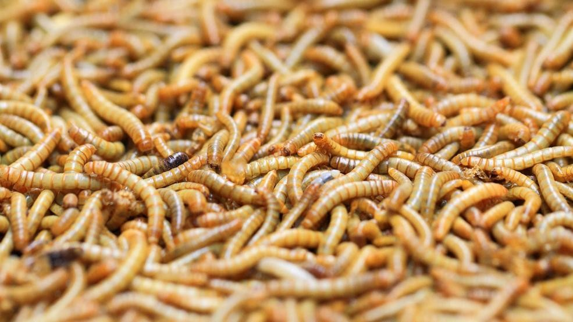
Flour worms as diet food for people and animals
“It's the time when New Year's resolutions have us on our best behavior. For some people, that's January with no booze. For others it's showing up at the gym.
And for a growing number of people, it means eating insects. What? Yes, insects. Why? Generally, people say they do it for their health and to try to save the planet.
Crickets, mealworms and grasshoppers pack a lot of protein and minerals, and take far fewer resources to produce than animal meat. Insects are popular in other parts of the world, and they are eaten by an estimated 2 billion people. They are sometimes a fine dining experience in countries such as Mexico and Thailand, where they have been a staple for centuries.
The problem for the entomophagy (humans eating insects) movement in the United States is that a lot of people think it is gross. But there are signs that bug eating is making inroads into the U.S. diet, including in Seattle, where toasted grasshoppers regularly sell out at Mariners games. Some adventurous New York chefs are developing insect recipes, and you can get packaged edible insects (one brand is called Chirps) delivered to your door.
Personal technology is also getting on board: A popular health and fitness app recently added insect nutritional information to its diet plan so you can track your bug consumption.
The Lifesum app also has a suggested bug recipe (grasshopper tacos). It's the same app that was on the forefront of the eco-health trend `plogging,’ allowing its members to track calories burned as they jog and pick up trash.
The company is trying to do the same with insect eating, basically hoping to nudge people toward something that's good for the Earth, if they can stomach it. Insect farming produces 1 percent of the greenhouses gasses as the same amount of cattle or pigs, according to a report by the Food and Agriculture Organization of the United Nations.
`We're always on the lookout to figure out what's happening in the world of food,’ said Lifesum chief executive and co-founder Henrik Torstensson. `We're trying to do something that's interesting and not just rudimentary.’
Lifesum says it has 30 million users, the majority of them in the United States. Early results show that people are starting to use the insect part of the app slowly. The company wouldn't release exact numbers but said most are young women in urban areas who are incorporating some insect eating into their diet. Torstensson likens it to being a vegetarian 20 years ago.
`Eating insects is much bigger outside of the Western world, it taps into mega trends in food and health,’ he said. `If you go back 20 years to the mid-90s, if you were a vegetarian it was seen as something unusual. It has similarities to this.’
According to people who eat insects, the gateway bug is crickets, often in powder form. Then comes eating whole bugs, exoskeleton and all. In a 2017 interview with the BBC, Angelina Jolie can be seen with her children cooking and eating a tarantula and some bugs in Cambodia, a moment that was celebrated by bug-eating enthusiasts.
The powder can be added to most foods, cooked or raw, and helps people get over the ick factor of eating a formerly living being that looks like a little alien.
`If I told myself in Middle School I'd be eating bugs, I probably would have screamed,’ said Joy Nemerson, 24, an insect-eating enthusiast who lives in New Haven, Conn. Now, she tries to cook with bugs about twice a week. `It's a large part of my identity,’ she said.
The week before Thanksgiving, she attended what she called a `BugsGiving’ in Brooklyn, co-hosted by edible bug advocate and chef Joseph Yoon, who cooked a 10-course meal using bugs in each course. Nemerson said she has tried to spread the bug way of life, including a favorite recipe she makes for friends and family, which is a three-layer pizza with cricket powder in the dough and red sauce, and mealworms on top. She also works cricket powder into her recipe for cinnamon rolls (hop cross buns). She said the powder doesn't have much taste, perhaps a slight earthy flavor, but it packs a lot of protein.
`Once you get into it, it's pretty easy,’ she said. `For me, the coolest thing about eating bugs is that evolutionarily, it makes a lot of sense. If you believe we came from monkeys, monkeys eat a lot of bugs.’
She said it does take some getting used to - eating whole crickets and grasshoppers - because of the crunch. As flavors, she describes crickets as tasting nutty, grasshoppers as smoky, caterpillars as similar to chicken, ants as lemony and ant eggs as tangy.
She said she doesn't use the Lifesum app, but she's familiar with Entomo Farms, the Canadian bug farm that has partnered with Lifesum. The farm raises about 100 million free-range crickets every six weeks in facilities they call condos. They also farm mealworms.
President Jarrod Goldin said the crickets they farm have a natural six-week life cycle, and are harvested at the end of that cycle. He sees a big future for insect eating, calling the practice `the planet's most sustainable food source,’ and saying that as time passes, consumers care more and more about where their food comes from and its impact on the environment and their health.
`The way consumers are looking at food is changing,’ he said. `They're looking at data, which drives health and wellness, it drives consumers to look at the nutrition profile of the food they are going to eat.’ Goldin, who is in business with his brother, said he doesn't just raise insects as the family business - he and his family eat them with gusto, every day. He credits the crickets in his diet with what he describes as better energy and gut function. His family will often start the morning with a cricket-powder, soy-milk smoothie.
`My wife does most of the cooking in the family,’ he said. `If she is baking muffins or chocolate chip cookies, she'll throw in cricket powder. Almost the way you use salt. You can put a pinch of salt in anything.’ A pepper grinder filled with roasted crickets sits on his dining room table so anyone can add an extra hit of cricket powder to a meal.
He said his family also snacks on whole seasoned roasted crickets by the dozens, and his school-aged nephew has an interesting habit in the morning: If he is eating a bowl of cereal, he'll drop whole crickets in there with the milk for added crunch and protein. Goldin argues that there's nothing unsavory about it.
`Yucky food is unhealthy food,’ he said. `Food that promotes wellness is the opposite of yucky.’
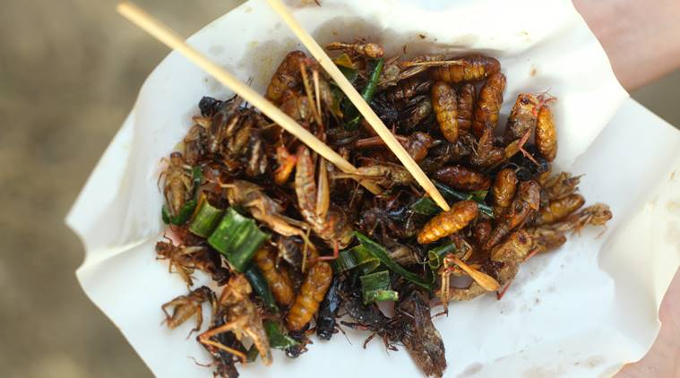
Though insects and worms can make most people cringe, they can also serve as a great source of nutrition. (Source: Getty Images/ Thinkstock)

Part of an AP article “Do Bugs Grow on Trees?” from June 16, 2005
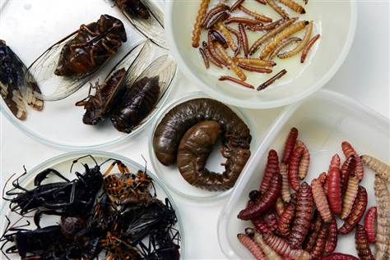
Dario Lopez-mills / AP
Several insects being studied for their nutritional value are seen at the zoology building in Mexico's National Polytechnic Institute last month in Mexico City, Mexico
updated 6/16/2005
MEXICO CITY — “Like many people in his town in the southern Mexico highlands, Gerardo Carrillo looks forward to harvest time in August. That's when he can pick greenish caterpillars off the trees and boil them with a little lime. `They're good,’ says the 53-year-old gardener. `They taste a little like grasshoppers.’ As Mexico's centuries-old tradition of eating bugs becomes more lucrative — maguey worms and ant eggs are showing up as exotic fare at expensive restaurants — researchers are trying to convince poor villages to cash in on these pests as a means of income. With a protein content as much as twice that of beef, bugs could also become a welcome diet supplement among the estimated 20 million extremely poor Mexicans who live on incomes of $1 per day or less.”

I’ve heard the thoughtless question asked recently: “Why don’t those in Kenya, the Middle East, and Asia, eat the locust that are eating their crops?” They are eating them, but the swarms in the multi-billions! Certain types of locusts may be legit on Yahuwah’s menu. I haven’t checked that out lately. However, IF locusts, which are insects, are all you have to eat because no green things remain--no vegetables or fruits--you’d suffer malnutrition.
It is said of “John the Baptist, that he ate “locusts and wild honey.” However, Carob pods on the Carob trees in the Middle East are called “locusts.” The Carob pods are a healthy substitute for cocoa/chocolate, but also good for you. I ate lots of carob as a vegetarian.
Online info: “The carob (Ceratonia siliqua) is a flowering evergreen tree or shrub in the legume family, Fabaceae. It is widely cultivated for its edible pods, and as an ornamental tree in gardens and landscapes. The carob tree is native to the Mediterranean region and the Middle East.”
So “John” might have enjoyed this “legume,” which, mixed with grain, would produce PROTEIN.
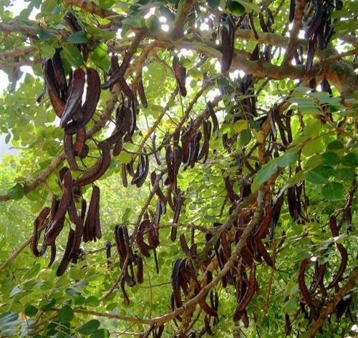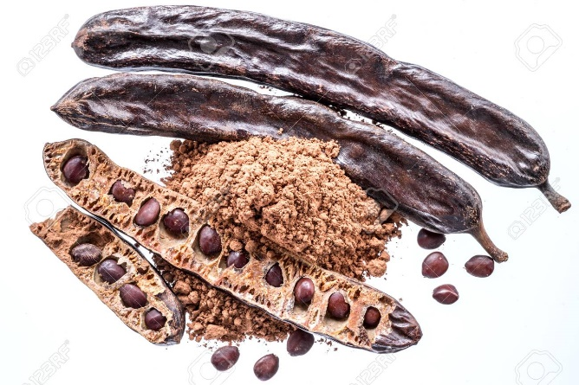
Carob tree with pods Carob pods, with seeds ground into carob powder
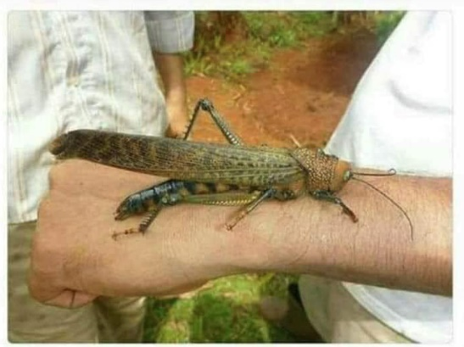
The locusts now swarming Africa and the Middle East in swarms of billions each, are 20 times the size of a normal locust. Credit Jason Lubell (The Big Wobble, May 20, 2020)
Be loyal to Yahuwah! He will not fail you! HalleluYah!
In His love, Yedidah
May 27, 2020

