NEW ZEALAND CYCLONE AND EARTHQUAKE
What Is The Hidden Truth?

They’ve run out of body bags?
Background information: The nations that evolved out of the Greek-Roman Empires with the culture of paganism, and massive rejection of Yahuwah, God of Israel - His Covenant, His Messiah, His Word – His Plans – His Nature, His ways, His thinking, He, Himself and His Son. The religion borne out of Rome under Constantine, 4th century, that became known as “Christianity,” was not what was borne out of Yahushua Messiah’s death, resurrection, and His plan for our redemption. The Protestant Reformation restored basics that at least would get a person “saved,”/“born again,” – HalleluYah! Yet, as far as set-apartness to prepare the born again for eternity in the Kingdom and rewards in it, very little was said. It became a religion like all religions, ceremonial, proud-filled, and dead.
The “First World” nations are such because their citizens are mainly from the House of Israel, the ten northern tribes scattered into all nations in 722 BCE – ended September 13, 2007 CE (2,700 years of separation from their Hebrew roots).
In the mid-1990s, the Spirit of Yahuwah began moving to restore the House of Israel to their Hebrew roots, which they had lost, as Hosea said so well, and Zechariah too. But, quickly religion set in, and the House of Israel with knowledge of Hebrew roots went overboard with “Jewishness” in total ignorance of who they were really attaching themselves to and why. In other words, Lucifer and fallen angels with him, led by Nephilim, too, made sure that these gung-ho religious Ephraimites would end up denying the Savior in order to fit in with their Babylonian Talmudic agenda.
I recommend you read the mini-book for history after the death of the apostles: The Foundation of Deception, offered on amazon in paperback and Kindle form, but also under the Mikvah of Present Reality, #1.0/comeenterthemikvah.com.
So today, being holding tanks for the children of Abraham, Isaac, and Jacob, the First World nations are under the judgment of Yahuwah for their turning their back on Him and on His Son and Their salvation – speaking of primarily: 1) The United States of America, 2) The U.K. and Ireland, 3) Western Europe, 4) Canada, 5) Australia, 6) New Zealand and the islands around it like Tasmania.
I suggest you purchase Ya’ir Davidy’s classic The Tribes, which locates the various ten tribes by history, culture, nature, and particularly by DNA. Only the children of Ya’cob started schools, founded hospitals, nursing homes, manicured their lawns and flowers and had gardens of all types. Fascinating how various groups are traced to them besides these major groups by their love of order, discipline, desire for achievement, and worshipping a monotheistic God – as Christianity does in its “trinity doctrine.” I also recommend “Exposing the Trinity Doctrine” under the Mikvah of Present Reality #4. I’ve been told by Messianics it is one of the best articles they’ve read. It’s a mind-blower, but it is true!
I do not give my opinions, if I have an opinion, which is almost never. I say it’s my “opinion” if it is. I live from my re-born spirit, and what Abba Yahuwah gives me peace about, from all my studying as well, His confirmation of truth is what I share with others. That makes life a whole lot easier! Why waste time with mental wrangling when we have the Spirit of Yahuwah to guide our thinking in His peace?
You can’t prepare for the Kingdom by yourself, choosing what you “think” or “feel” is right. The forces of Lucifer, fallen angels, Nephilim have access to your mind, your emotions, your will, and your body! Only He who dwells in your eternal re-born spirit can tell you absolute truth (John 16). Only when He is in control of your mind and emotions and will, can He alert you to the enemy’s attempts and help you overcome all of their abilities. Isn’t that “logical?”
So that’s my introduction for this article on New Zealand, and the judgment of Yahuwah in the earth right now - which He is allowing judgment on the nations that have boldly rejected He and His Son.
In the United States, the Democratic Party publicly said they would have nothing to do with “God” in their Party platform. The son of Donald Trump publicly said in a speech, “What has Jesus ever done for us?” Klaus and Harari of the WEF have mocked God and Jesus several times, as Klaus said: “Jesus is fake news.” He warned us (Matthew 10): “You will be hated by all men for My Name’s sake.”
A few years back, the Air Force stopped Christian witnessing, let chaplains and pastors go, and now the whole of the military demands vaxxing or “get out.” Yet all branches of the military promote the transgender, LBGTQ agenda. On bases, men who think they are women can take a shower in a woman’s bathroom, and the women had better not complain. Thus, we have a military that fits the description of end-time Babylon’s military in Jeremiah 50-51 very, very clearly.
I Peter 4:16-18: “But if one suffers being Messianic, let him not be ashamed, but let him esteem Elohim in this matter. 17For it is time for judgment to begin with the family of Elohim; and if it begins with us, what will the outcome be for those who disobey the gospel of Elohim? 18And, `If it is hard for the righteous to be saved, what will become of the ungodly and the sinner?’…
UH WHAT? “Hard for the righteous to be saved…” Oh come on Peter, this is America – what do you mean by “hard?” We don’t do “hard!!!”
Oh yea, Matthew 7:13-14: 13Enter through the narrow gate. For wide is the gate and broad is the way that leads to destruction, and many enter through it. 14 But narrow is the gate and narrow the way that leads to life, and only a few find it…”
Not too many “believers” know those verses, nor do they want to know them. It is hard because Yahuwah wants us to press into knowing Him and leaning of Him as our heavenly Father. If all was easy, comfortable, and convenient, we wouldn’t feel the need to know Him.
The “I am god” nature of those in western cultures, primarily the U.S., in their pride and arrogance and “jezebel spirits,” of control of “self” and others. Yet, the greatest evil the world has ever known has come from America, especially in its 70 years granted by Abba before its destruction. “Hey, where’s that in the Bible?” You missed a few articles (smile). The 70 began when we did what we did to Japan in 1945 August after they had already surrendered, which was not far before Yom Teruah - going into 1946 on the Creator’s calendar.
A lot happened on that September Yom Teruah passing from 2015 to 2016! A lot of “time’s up” happened. I’ve written about 20 articles on that transfer of time.
Here is information on what happened in New Zealand. The tragedy is that thousands died in this disaster, and the bodies keep washing up, and the government is acting like it’s a holiday. Why? I think this information will clarify.
Pardon the cuss word in the first sentence, but in this case, it’s justified!

NEW ZEALAND CYCLONE AND EARTHQUAKE They Have Run Out of Body Bags (Online comment from a New Zealander February 25, 2023)
“Can someone explain to me why this is not on every MSM outlet? They have run out of body bags in Hawke’s Bay, NZ. Thousands of people missing! Thousands have died! The government is doing jack sh*t. All work to save people and retrieve bodies are being done by the people!!!!”
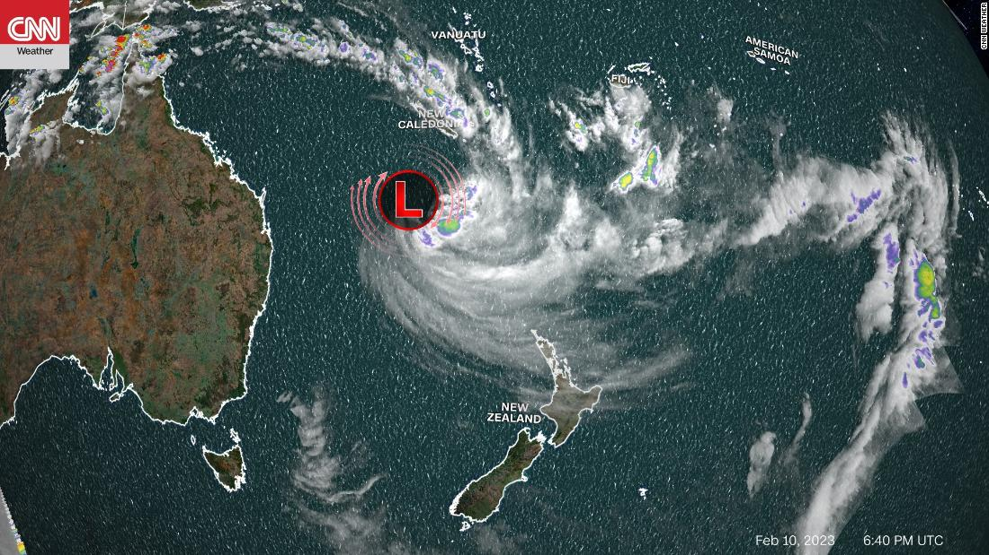
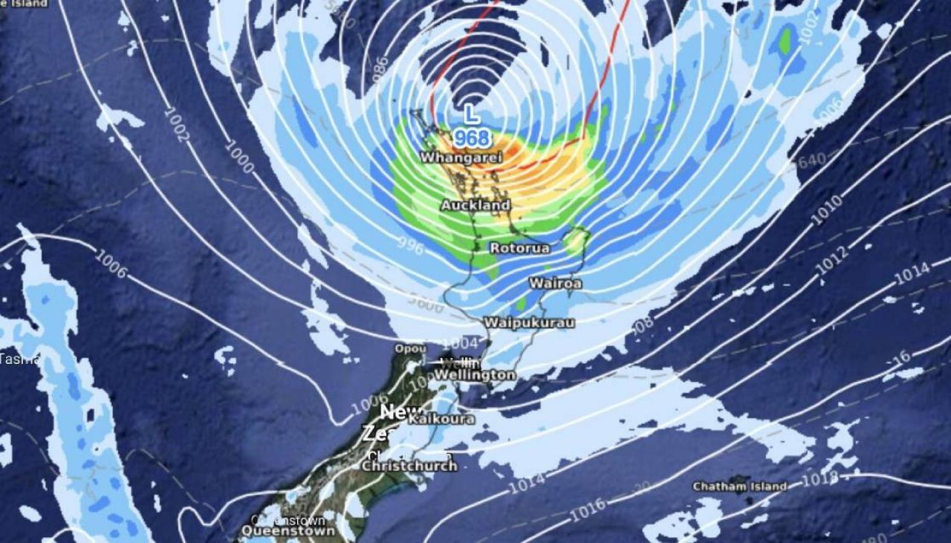
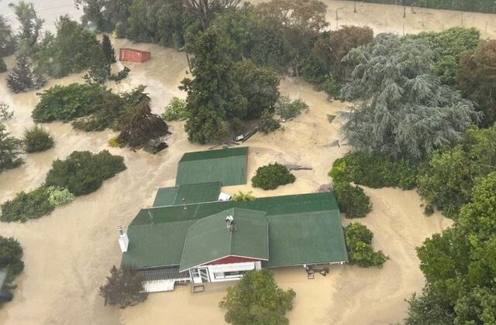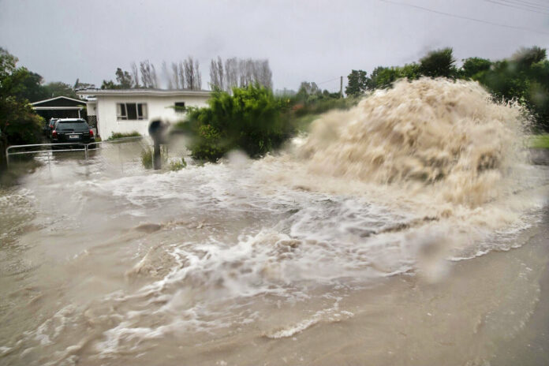
February 15, 2023 CDP News
“New Zealand has had a very rough start to 2023 with numerous disasters hitting the island just six weeks into the year.
An earthquake described as both 5.7 and 6.1 M, struck off the coast of New Zealand early evening on Feb. 15. No damage was reported, but the quake was felt across North Island. This followed immediately on the heels of Cyclone Gabrielle, the worst storm to hit New Zealand this century. Hundreds of landslides were expected, in part because the ground was already unstable after several days of record rains fell in New Zealand at the end of January 2023 and continued into early February. One-third of the country’s five million people have been affected by the cyclone, which is reported to have caused more damage than the previous weeks of flooding.
Auckland, a city of 1.6 million people, is located on the North Island. It is the largest city in New Zealand. On Jan. 27, an estimated 9.8 inches (240 millimeters) of rain, equal to a summer’s worth of rain, fell on Auckland, making it the city’s wettest day on record. Additional rain fell on Jan. 31, hindering recovery activities.
Given the intensity and the amount of previous rainfall, the ground was waterlogged, and rivers were full. This provided little capacity for the absorption of new rainfall. It also created risks for landslides and river overtopping. This led to the evacuation of hundreds of people.
Gabrielle brought an additional 6 to 16 inches of rain (dependent upon the location), along with extremely high winds (ranging from 55 to 80 mph on the mainland and higher in outer areas). Flooding ensued, with levels reaching the second story in many houses, with residents trapped on their roof tops.”
The death toll has not been told, except for comments like the one above – the news is not reporting the extent of the deaths – and bodies disappearing (?). It sounds like in China where the bodies were burned in huge incinerators by the thousands.”
Feb 18, 2023, 12:47 AM: “There has been massive devastation in New Zealand from cyclone Gabrielle. East Coast, Napier, Gisborne. People, animals, food. All gone from some areas. NZ media and government are covering up the number of people dead from the storm. Massive coverup from the general public. I have been hearing that the storm was geoengineered by HAARP. Steered to directly hit NZ said info on the "net" That is part of the depopulation agenda 30. What worries me, with a government complicit in this crime against humanity, and they get away with it. The question is " WHO'S NEXT.? "

Feb 22, 2023, 5:20 PM UPDATE –
“Mainstream media is hiding the real death toll from the public. A friend told me yesterday, 6000 - 10,000 is closer estimate to the death toll. 4 dams released water during the storm, which caused the tsunami effect and lots of silt, dams were for orchard irrigation dams for Genesis power company. There were approx. 2000 Islanders working there fruit picking too. NZ government is still in denial, but some press talking.”
https://dailytelegraph.co.nz/news/ive-seen-hundreds-dead-rescue-helicopter-pilot/

Daily Telegraph New Zealand, February 27, 2023 UPDATE
A RESCUE HELICOPTER PILOT OPERATING IN THE HAWKE’S BAY SAYS HE HAS SEEN HUNDREDS OF DEAD BODIES WHICH HAVE YET TO BE RECOVERED.
The pilot spoke to a contact of DTNZ on condition of anonymity. He told our contact the rivers and flooded areas were ‘littered with bodies floating in the water’ and that these were New Zealand’s ‘darkest days.’ ‘I’ve seen hundreds of dead bodies’, he said.
New Zealand’s foreign owned and government-funded legacy mainstream media put the current death toll at 11 though ‘thousands are still unaccounted for.’
After initially refusing international offers for help, Prime Minister Chris Hipkins is now accepting them. (picture below)
A National State of Emergency has been declared – for only the third time in New Zealand’s history. Hipkins said Gabrielle was the biggest natural disaster in New Zealand ‘this century’. Meanwhile looting of Hawke’s Bay properties continues. … Many social media users were concerned the government and legacy mainstream media were suppressing information about the death toll and instances of organized crime looting and threatening to kill Hawke’s Bay residents.”
Chris Hipkins, New Zealand Prime Minister
So folks, who is targeted for extinction first of all? Yes: the House of Israel, AND the House of Judah (i.e. Kurds, Palestinians, old-family Arabs, blacks across N. Africa, etc.) The attack on Yahuwah’s born-again children will begin shortly in the form of segregation, then hate, violence, leading to mass martyrdom. Isn’t that just what Yahushua said in Matthew 10 and 24? Who were the disciples specifically sent to? - THE HOUSE OF ISRAEL/EPHRAIM/JOSEPH-THE 10 NORTHERN TRIBES! (Matthew 15:24; 10:5-6)

