PLANET EARTH BREAKDOWN
CONTINUING AND INCREASING IN INTENSITY

From Revelation 11:15-18: “And the seventh messenger sounded and there came to be loud noises in heaven saying `The kingdoms of this world have become the kingdoms of our Master and of His Messiah, and He shall reign forever and ever.’ … And the nations were enraged and Your wrath has come, and the time of the dead to be judged and to give rewards to Your servants the prophets, and to the set-apart ones, and those who fear Your Name both small and great, and to destroy those who destroy the earth.’ ”
This is a general overview update! Why do I keep writing article updates about the continuous and increasing destruction of planet earth, about geo-engineering, chem.-trails, the terraforming of the earth to meet the specification of the fallen angels? Why do I take time to refute the lies used to promote population reduction?
The answer is because the destruction of Earth is, I believe, the major sign that Yahushua must come soon, or His creation will be totally unable to sustain life.
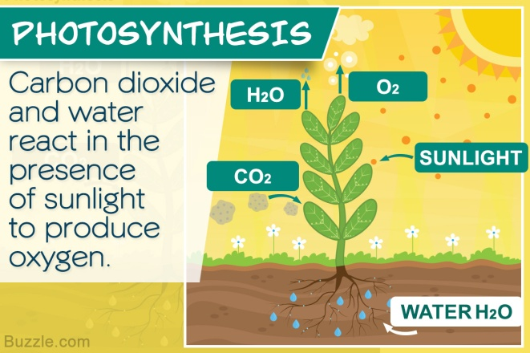
CO2 is touted big and loud by “environmentalists,” as the cause of “global warming.” Because near 8 billion people exhale CO2 with every breath, they say we have to depopulate the earth to stop all the exhaling of carbon dioxide (CO2).
Photosynthesis is nature’s process that produces oxygen, and creates the right conditions for the growth of crops, flowers, trees, grass, and everything else that is beautiful on earth. Keep breathing folks! We’re helping creation live a little longer!
Note: Photosynthesis has the same enemy as does all of Yah’s creation! Have you noticed the sunlight getting dimmer, and the blue of the sky getting lighter in color? It takes CO2 (Carbon dioxide), mixed with sunlight and water, to make the crops grow. Nature’s photosynthesis allows trees, and all green plant life, to give off oxygen. So we breathe out what nature needs to live and prosper healthily, and nature gives us what we need to breathe healthily, what we need to eat healthily, and what we need to receive from sunlight. Does this make Revelation 7:1-3, 8:7-11, and 9:4 more understandable? The “green” is being destroyed.
Jeremiah 4:24-28: “I looked and there was no man, and all the birds of the heavens had fled. I looked and I saw the garden land (Hebrew: “Carmel”) was a wilderness, and all is cities were broken down at the Presence of Yahuwah at His burning displeasure. For thus says Yahuwah, `All the earth shall be a ruin, but I shall not make a complete end. On account of this, let he earth mourn and the heavens be dark because I have spoken, because I have purposed and shall not relent, nor do I turn back from it.” (Isaiah 24)
The enemy is working hard at another Genesis 1:2 and Jeremiah 4:25-28. The fallen angels and their angel/human hybrids have given mankind the technology to destroy the earth, and it is well into being done.
To learn how far we’ve come in a short time using technology to destroy the earth: Here is a sampling of key articles to check out for details:
1) “Terraforming the Earth – We Have Little Time Left! – Our Planet is Being Radically Destroyed to Prepare it for “Them”/Mikvah of the Heart of Elohim
2) “Geoengineered Wildfires, Burning of Green Things, Oceans and Waterways Dying, Earth Overheating: Revelation 7, 8, and 9”/Mikvah of the Heart of Elohim
3) “Creation Groaning”/Mikvah of Present Reality
4) “Earth is Cracking Like an Egg – Historic Earthquakes and Volcano Eruptions, Plus Chunks of Earth’s Mantle Are Peeling Off”/Mikvah of Present Reality
5) “The Oceans and Their Sea Life Are Being Purposely Murdered”/Present Reality
6) “Just in Time for Halloween – Designer Chem.-Trails”/Present Reality
7) “Chem.-Trails Part II – More Serious Than You Can Imagine/Present Reality
8) “Radiation Clouds--Another Earthquake at Fukushima--Oceans Dying--the Earth is Cracking--`to destroy those that destroy the earth’ ”/Present Reality
9) ***70 Years of Weather Geoengineering – 70 Years of Man’s Destroying Earth’s Life Support Systems”/Present Reality
10) “Mysterious and Definitely Not Natural California Wildfires”/Present Reality
11) “Creation is Shaking! The Recent Escalation of Earthquakes, Volcano Eruptions, Weather Anomalies, and Worldwide Crop Destruction”/Present Reality
12) “Shaking Truth to the Surface – Earthquakes Increasing, Secret Underground Horrors Exposed, Seas Rising, the California Shelf Cracking”/Present Reality

The slow extinction of what we need to live on this planet is being taken from us and even justified by the perpetrators of global murder. Study, ask questions, do research, seek Abba’s mind! Let the Spirit of Yahuwah tell you what you need to learn, then study under His direction! Oh how you must hear from Abba at all times; your re-born spirit must always be open to His eternal dimension!
I feel deep within my spirit the grief of Yahuwah and Yahushua, the Creators of all that was “good.” (Genesis 1) We must “enter into the fellowship of His sufferings,” aligning with Yahuwah and Yahushua, for the pressure (“tribulation”) is building on earth and in heaven, and coming to a breaking point where Yahushua has to return or else there will be no life left on earth.
Like our marvelously complex bodies, every part working together for our good, the earth was created totally for the good of Yahuwah’s people. Now, in the days just before Messiah comes, it’s all being purposely destroyed. By fallen angel-given technology even our magnetosphere, our radiation protection belts, Van Allen belts, that protect us from the sun’s rays, the Ionosphere above us that protects us from outer space, our food crops, the trees, all “green” vegetation –all are being systematically destroyed. The destruction of “green things” should alert you!
So few study His Word, led and taught by the Spirit, so they remain ignorant. “My people perish for lack of knowledge, because you have rejected knowledge, I have rejected you…” (Hosea 4:6)
Genesis 1:2 is being replayed! What Jeremiah saw in Jeremiah 4:24-28 is being replayed. Isaiah 24, Haggai 2, Hebrews 12:25-29: The earth is literally shaking. Creation is groaning: Romans 8.
Nearly all of these things have been, and are being, directed by fallen angels and Nephilim, using their highly advanced technology given to human scientists in America, Russia, China, and a few other nations, since 1945.
Weather warfare is very real. I recommend Steve Quayle’s excellent revealing book: Weather Warfare and Other Unnatural Disasters. It’s for real!
Baptist Indiana Pastor Paul Begley (paulbegley.com YouTube) is attempting to keep us alerted to daily current events related to end-time prophecy, like the daily 40-70, earthquakes worldwide that are over 2.5 in magnitude. He is keeping up with volcano eruptions and things like the recent discovery of the Methane gas leaks on the floor of the Atlantic off of North Carolina. He is keeping up with the increase in temperatures, and the wildfires in the Arctic Circle, besides the tragedy in Hong Kong and the escalation of war with Iran. I love his humor - we have to keep joy or we perish!
223 specific prophecies throughout the Bible point to the time-period when Messiah will return, and all of them happening, or in the process of happening simultaneously right now! Yet, most pastors of churches, messianic leadership, preachers, Bible teachers, and especially the pubic news, remain silent on major issues that affect the core of our very lives. For the most part, it’s us and Elohim!
Genesis 1:1-3a: “In the beginning, Elohim created the heavens and the earth. And the earth came to be formless and empty and darkness was on the face of the deep. And the Spirit of Yahuwah moved on the face of the waters. And Elohim said, `Let there be light…”
There was a time after the initial creation of earth and the cosmos that the fallen angels rebelled against Yahuwah out of jealousy towards His plans for His new family. They began destroying the earth: “…and the earth came to be formless…” The fallen ones “terraformed” the earth to their liking, destroying earth’s life support systems, and making it uninhabitable. THIS IS EXACTLY WHAT THEY ARE DOING AGAIN NOW!
Genesis 1:3 and following is definitely a re-creation of a destroyed Earth.
Be sure you’ve read article #1 listed above, “Terraforming the Earth…” Many watchmen are using the word “terraforming” now to do with geoengineering.
So much of the destruction of our planet is man’s doing! And, America leads the “so much of it is man’s doing.” Also, so much of it is techno-warfare between power nations. For example, it has become obvious that there was a direct target hit by an enemy on Ridgecrest, California that actually killed thousands of bees at the same time it destroyed an underground military base.
I’ve reported on the death of bees via aluminum in chem.-trails. Without bees our crops are in danger of not being pollinated. The 6.8 earthquake on July 4th and the 7.1 earth on July 5th in the Ridgecrest, China Lake area, caused aftershocks that have not stopped. They now number in the 10s of thousands!
Multiple fault lines in California are sudden starting to shake and affecting each other. Tectonic plates are moving, and magma underneath is moving. Many of America’s 169 known volcanoes are starting to shake, quake, and move magma underneath.
Do the words of Yahuwah click more now with Isaiah 14:9 as Yahuwah speaks to Satan: “Sheol (death, hell, the grave) from beneath is excited about you, to meet you at your coming. It stirs up the dead for you, all the chief ones of the earth; …” Read Isaiah 14:11-20. The underworld is preparing for Revelation 19:19-21 and 20:1-3! The signs of earth’s destruction is evident everywhere, as mankind as a whole turns their backs on the Creators to worship other gods and make themselves their own gods to worship and obey.
A few days ago, Pastor Begley brought out what began on New Year’s Eve, December 31, 2010, which has not stopped since. It is obvious that something happened at that turning point on the Gregorian calendar that opened the door for all Bible prophecies to begin to be fulfilled rapidly.
It is amazing that beginning the first week of January 2011, President Obama began singlehandedly destabilizing the Middle East, starting wars, creating coups, removing national leaders from power putting in terrorists, creating ISIS, etc.
Paul Begley’s broadcast of August 5, 2019 updates us on what began December 31, 2010. On that day, Abba told Begley that it was the beginning of something that would not end until Messiah comes. And it has not ceased.
On that New Year’s Eve, thousands of black birds fell from the sky in Bebe, Arkansas, and thousands of fish suddenly died in the Arkansas River. Immediately, upon getting the news, I noticed a pattern, began doing research and reporting.
Only one species at a time were dying in a single nation, or in one small location, and another species in another nation. This was happening in rapid succession all over the world, not just birds over land and fish in rivers, reservoirs, waterways, lakes, and ponds, but sea life in abundance, even great numbers of Crustaceans. Very few times do different species die together in the same nation. It has continued like that for 8 years.
The patterns send one message: Planned and purposed targeting by intelligent sources! The same with worldwide wildfire patterns, hurricane patterns, heat wave patterns, other severe weather patterns, crop destruction patterns—intelligent sources behind the disasters, sources with extremely high technology. Be sure to read article #9 above “70 Years of Weather Geoengineering – 70 Years of Man’s Destroying Earth’s Life Support Systems”/Present Reality.
In Alaska, America has the world’s greatest Ionosphere heater: H.A.A.R.P.
It literally attacks the delicate balance of Earth’s life support systems, like heating the Ionosphere and bouncing that heat into the oceans, killing the oceans, melting the North Pole (Arctic) and the South Pole (Antarctic), raising world temperatures. The seas are not rising because of fallacious “global warming!” We’re actually entering a cooling stage.
America has also tampered with the magnetosphere. Plus, Earth has holes in its radiation protection belts due to the U.S. military exploding 3 atomic bombs in our radiation protection belts/Van Allen Belts in 1958 which protect from the sun’s radiation. Doesn’t that just “blow” your mind! I yell out a BIG “WHY?” It’s INSANITY!
Yes, insanity! However, we know why! Satan and his forces, using human beings, have taken over earth and are running the “end game.” Supposedly the destruction of our Ionosphere is for “military purposes.” H.A.A.R.P has loads of registered patens all with “how to do it” details.
Please, for real in-depth information on America’s destruction of Earth’s life support systems, I highly recommend an amazing documented book: ANGELS DON’T PLAY THIS HAARP BY Dr. Nick Begich and Jeane Manning. Learn the truth!
The technology for this destruction goes back to Nicola Tesla in at the turn of the 20th century. The timing is not long after the return of the certain fallen angels and Nephilim in 1896 for their “120 years.” Yes, I’ve written and podcasted all about it! The 120 years of the Spirit’s “striving” ended in April of 2016. They have been given “short time” before Messiah comes and removes them.
Because of Nephilim technology from at least 1945 to date, we have weapons of war, great flying machines, robots, GMO foods, earthquakes/volcano activity, hurricanes, cyclones, typhoons, tsunamis, floods, drought, blizzards, wildfires, and loads more. Earthquake fault lines are being purposely shaken, moving the tectonic plates, moving the magma, shaking the core of the earth. This is besides the daily bombardment by chemical spraying (“chem.-trails) of deadly poisons from airplanes, military and commercial jets. This causes dementia, even in bees, because of the high aluminum content. Come on folks! America has 350+ products on the market that Americans use all the time that contain unnecessary aluminum. Fluoride is another silent killer hidden in many products, now aborted baby parts.
The chronic bird, fish, and animal die-offs appear to be random, but they’re not. Back in early January 2010, it was obvious to me that the die-offs were an experiment to target one specific DNA of one particular species at a time? It’s for experimentation purposes connected to die-off of the human race.
Fallen angels teach their eager students to practice on species of birds, animals, cattle, pigs, etc., with the goal of targeting certain DNA in certain humans. After all, both fallen man and fallen angels have joined together to bring about a common goal--world government--under the rule of a returned Nimrod/Osiris/Apollyon.
Targeting of particular DNA is also going to be used to identify the descendants of Ya’cob and the DNA of the truly born again children of Yahuwah.
Recently, Pastor Begley noted that a whole flock of sheep just ran and jumped off of a cliff to their death in Turkey. What was being beamed at them? What spirits got into them? Folks, portals are opening all over the earth for the fallen ones to come through to join with the spirits of their dead hybrid offspring to bring about the rule of Satan and his son over earth. Carnal, rebellious, and/or ignorant believers, open portals daily to the influence of these spirits by their flesh-appeasing fascinations, sin, and self-exaltation. The only way to avoid this is to be 100% submitted to the Spirit of Yahuwah, so that He can protect you. Otherwise, you have no protection. Deception is coming through open portals of the mind.
These experiments in weather warfare, conducted since 1947, are designed to bring death to human beings. Read the article listed above about the direct microwave targeting wildfires in California. Wildfires in Greece last year also show signs of microwave-targeting. The U.S. military already has on-the-ground microwave weapons to be used to target individual people.

BEGLEY’S REPORT USING JULY 2019 AS AN EXAMPLE:
Hosea 4:1-4: “Hear the word of Yahuwah you children of Israel for Yahuwah has a case against the inhabitants of the land: `For there is no truth or kindness or knowledge of Elohim in the land. Swearing, and lying, and murdering, and stealing, and committing adultery have increased. And bloodshed follows bloodshed. Therefore the land mourns, and everyone living there languishes, with the beasts of the field and birds of the heavens. And fish of the sea are taken away.”
Zephaniah 1:2-3: “`I shall snatch away all from the face of the earth,’ declares Yahuwah. `I snatch away man and beast. I snatch away the birds of the heavens and the fish of the sea and the stumbling blocks with the wrong, when I shall cut off man from the face of the earth,’ declare Yahuwah.”

“July 3:
40 tons of fish died off in a river in Vietnam
74 dolphin washed up on the shore in the Ukraine
6 dead large sea turtles washed up on the shore in Brazil
July 4:
Hundreds of thousands of fish died in another river in Vietnam
350 tons of fish suddenly died in Indonesia
July 4th and 5th the 6.8 and 7.1 earthquakes in Ridgecrest, California that so have produced around 80,000 aftershocks
July 6:
Hundreds of thousands of mussels died in the waters of Northern California
July 8:
Thousands of fish found dead in a river in Brazil
Thousands of fish wash up in a lake in New York
July 9th:
350 dolphins dead on the shore of Crimea
July 10:
4 dead large sea turtles found on a beach in Italy
July 11:
Hundreds of dead fish washed up I a river in Ontario, Canada
7 dead gray whales washed up in Alaska
July 12:
40 dead dolphins washed up in Bulgaria
July 13:
Hundreds of dead fish was up in a river in Mexico
Thousands of dead fish washed up on a beach in Guatemala
July 14:
Massive die off of fish in China
Dozens of birds fall from the sky dead in Australia
3.4 million pigs die of swine flu in 62 provinces of Vietnam
July 15:
Thousands of dead fish found in a lake in Indonesia
Massive die-off of fish in a dam in Turkey
32 large sea turtles lay dead on a beach in Brazil
July 17:
Hundreds of dead fish found in a lagoon in Chicago
Hundreds of dead birds found in New York
July 19:
Thousands of dead fish found in a canal in New Orleans
150 big sea turtles found dead on another beach in Brazil
60 dead whales found along a beach in Iceland
July 24:
Thousands of dead fish wash up on a beach in North Carolina
Massive fish die-off in a lake in Indiana
Seagulls fall from the sky dead over the Ottawa River in Canada
Hundreds of dead fish found in a creek in Iowa
Thousands of dead fish wash ashore onto a beach in Portugal
40,000 pigs die of swine flu in Bulgaria
July 25:
Hundreds of dead fish found in a river in Gabon
10s of tons of dead fish found in a reservoir in Indonesia
July 26:
Huge die-off of Salmon in a river in the Yukon – Alaska
July 27:
180 tons of dead fish in a fish farm in Thailand
July 28:
Thousands of dead fish found on a shore in Indonesia
10s of tons of dead fish suddenly die in another part of Indonesia
Large die-off of fish found in Mexico
July 29:
Thousands of dead fish are found in the Arno River in Italy
Hundred of water birds fall from sky dead in Spain
Thousands of dead fish found in a lagoon in Mexico
July 30:
Thousands of birds drop dead in Mexico
Thousands of dead birds fall from the sky over Summerset, England – a total mystery to Britain
Dozens of dead birds fall from the sky in Russia
Hundreds of baby sea turtles found dead on a beach in Mexico
Hundreds of dead fish and eels found dead in a canal in London
200 Reindeer found dead in Norway.”
Begley thunders: WHERE’S THE MEDIA ON THAT?

From January 1, 2011, reports were flowing in daily of massive die-offs in many countries, huge die-offs of Crustaceans from the ocean along England, tons of fish die-offs in Brazil – so many reports for 8 years. July 2019 is not unusual!
One of the articles above is about the purposed “murder” of the seas and sea life. It breaks my heart. Since the radiation disaster to do with the nuclear reactor in Fukushima, Japan, a few years ago, radiation has not stopped flowing into the Pacific Ocean, even showing up in cow milk and salmon and crops in California. Cancer has increased because of it, too, along the California coastal areas.
The oceans are dying from the U.S. Navy dumping deadly pollutants into the oceans and the horrendous amount of plastics that are dumped into the oceans. The Great Barrier Reef of Australia is dying.
I just read about the crisis in the Marshal Islands. The US stored barrels of chemical waste on one of the low-population inhabited islands, and now its leaking onto land and into the sea. It is causing sickness and cancer in the people, and the oceans are taking this highly radioactive chemical waste to the shores of many nations. I ask: WHERE’S THE MEDIA ON THAT!
Paul Begley also mentioned the destructive electromagnetic waves emitted by H.A.A.R.P. into our Ionosphere. Why heat the oceans by bouncing electromagnetic waves off our Ionosphere? To make melt the ice caps to get the trillions in wealth under ice, and at the same time make it look like we have “global warming.” These things are not random, but carefully planned.
Birds are sensitive to the atmosphere they fly in. Electromagnetic waves, chemicals sprayed into the atmosphere could bring them down. The oceans, seas, lakes, rivers, canals, waterways, and reservoirs are being polluted. The food chain is being destroyed in the oceans so that the larger sea mammals are dying of starvation. But, why 8 years of mostly all one species at a time dying off?
Methane gas has been photographed in July bubbling up off shore near Islands of North Carolina. This is a highly flammable and dangerous gas. It is under the sea all around the East Coast, the Gulf Coast, and the West Coast of America. The escaping underwater Methane gas is a new photographed phenomenon.
When the BP Oil Rig blew up in the Gulf off of New Orleans, I did extensive research about the methane gas, and the dangers of it. At that time also, there was no way to stop the oil that was spewing out into the Gulf. Years later it is still polluting the waters of the Gulf.
Online information: “On April 20, 2010, the oil drilling rig Deepwater Horizon, operating in the Macondo Prospect in the Gulf of Mexico, exploded and sank resulting in the death of 11 workers on the Deepwater Horizon and the largest spill of oil in the history of marine oil drilling operations.”

Paul Begley YouTube, July 20 2019:“BREAKING: Dangerous Methane Bubbling North Carolina Coast”
“39 miles off the coast of North Carolina the gas is bubbling from the sea bed – a science sub is taking pictures to assess the problem for NOAA:
National Oceanic and Atmospheric Administration

Video: from the Charlotte Observer June 19, 2019
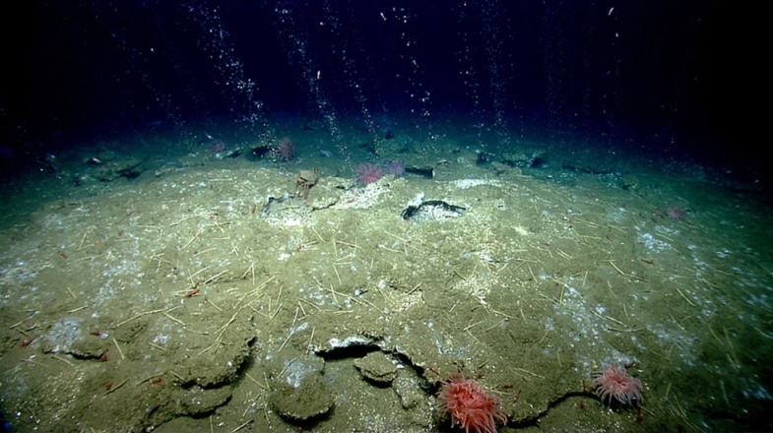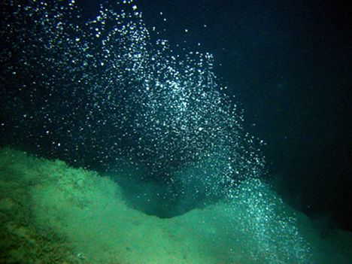
Pictures from science submarine of NOAA June 18, 2019 sea floor off coast of NC
[Refer to the article: “Fire Ice” (Methane Hydrate), July 2011. It is highly flammable] This leak is around Bodie Island, off the North Carolina Coast.
There are hundreds of methane vents off-shore along America’s East coast, around the Gulf of Mexico, and along the West Coast.

Seafloor off Outer Banks island is 'field' of bubbling methane plumes ...
https://www.charlotteobserver.com/news/local/article232675262.html
Begley reported: “Breaking News: Heat Wave Around the World
Map Begley showed:
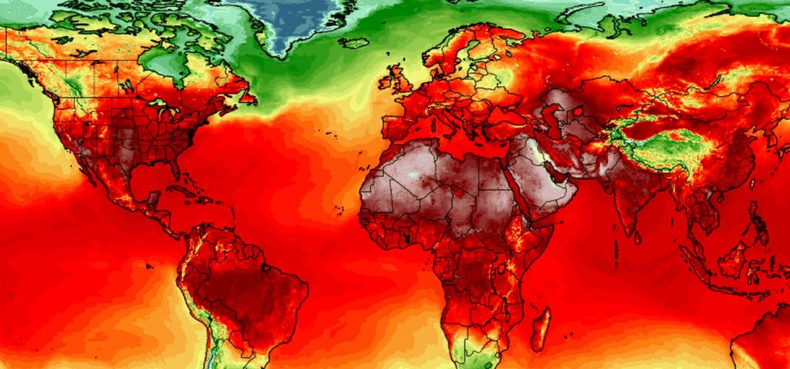
“A Deadly Heat Wave After the Hottest June On Record” - Time Magazine
https://time.com
If the heat continues, and the methane continues to rise, the seas could turn into a fiery explosion off the east coast and Gulf. The heat is extremely high in Canada, the U.S., the U.K., and parts of Europe.

BBC: “Dangerous heat wave starts hitting US and Canada - 19 July 2019

“The world experienced its hottest June on record this year”.
Alaska heat wave: Anchorage hits record temperature. Warming threatens Himalayan glaciers! Earlier this month, the U.S. State of Alaska, part of which lies inside the Arctic Circle, registered record high temperatures.”
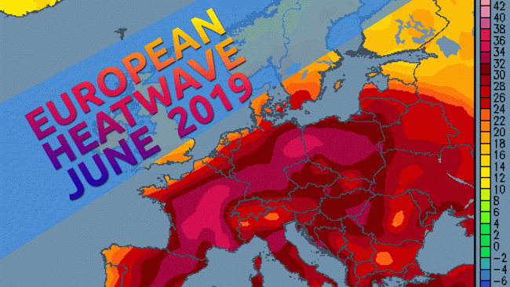
June hottest month worldwide ever recorded in human history
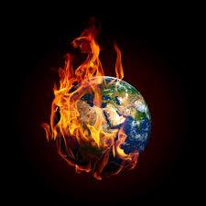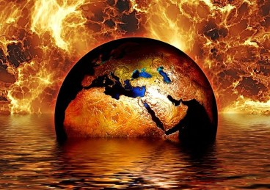
The “terraforming” of the earth by fallen angels and Nephilim, with the assistance of human lackeys, is very real, to make it uninhabitable, with no food supply, totally a desert wasteland. There are water shortages worldwide now.
The Lion of the Tribe of Judah is on His way

From Paul Begley’s report:
*****THE Magnetosphere is being heated and has caused ice to melt in the Arctic and clear ice from large areas of land. Our magnetic poles are being affected. Rays are coming at the earth from a huge binary system are being caught by the magnetosphere that is sending these heated rays into the core of the earth from both poles. We’re also in a pole shift.
We’ve been in a pole shift since 2007. I wrote about it with details back then. It was even reported back then by Brian Williams on NBC Nightly News.
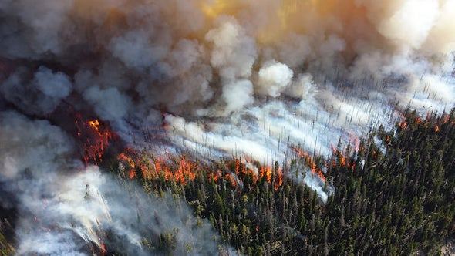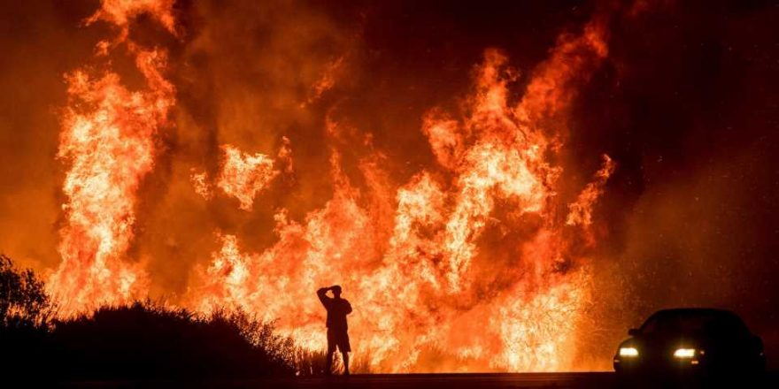
Arctic wildfire
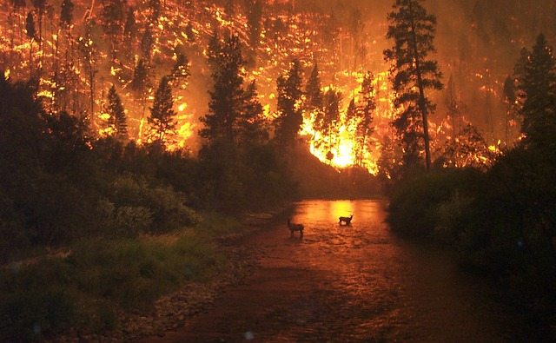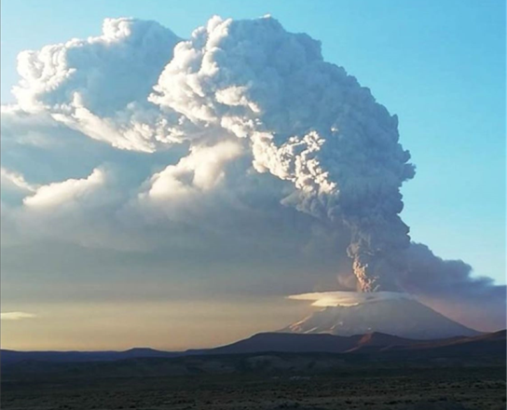
Left: Sweden fires from the Arctic Circle Right: Ubinas Volcano, Peru
Add volcano eruptions and earthquakes: Ubinas volcano Peru had a violent eruption throwing fire and smoke 40,000 feet into the air, (7 miles).
It appears that Yahuwah is now stepping in to begin His judgments. He will accelerate the judgments to embrace the whole world to fulfill His Word. It may even scare those who are doing the geoengineering, wondering who is taking control now, who is accelerating things that they can’t even do. By the time they realize Who is doing it, it may be too late for them to repent.

ARCTIC FIRES BURNING OUT OF CONTROL
The fires are burning trees, crops, green plants, grass, whole forests, millions of acres, burning wildlife, animals, birds, insects, reptiles, and amphibians. The fires are polluting the air, blocking the sun with ash, limiting photosynthesis, thus diminishing oxygen on the planet, and the ability of crops to grow. Many of the fires are purposely started for the purposes above, to destroy life on planet earth.
The fires in the Arctic are melting the ice, revealing treasures of gold, minerals, precious jewels, also oil and gas deposits, also Nephilim ruins and other historic treasures of great value. The poles are great treasure houses.
Many, if not most, of the fires are purposed to expose the treasures. They’re also started to destroy the earth’s beauty and natural resources to get rid of the humans
Northern Canada Yukon is on fire, Alaska, the Arctic Circle: This is an unprecedented happening – historic happening.
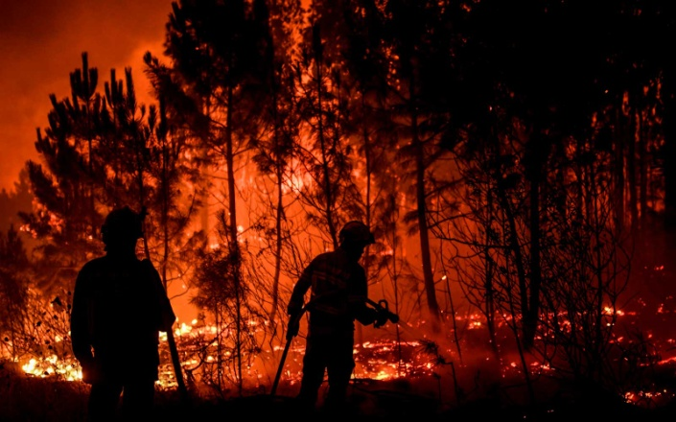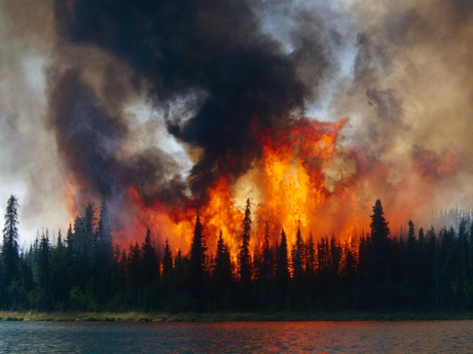
Left: Fire in Portugal Right: Fire in the Arctic Circle

Smoke in the skies is now coming down over the Great Lakes and south. The fire and smoke has now come into Greenland.
The Russian Arctic and Sweden are on fire too …
This is on top of the smoke from volcanoes erupting, spewing fire and ash into the outer atmosphere. One that erupted recently in Peru sent plumbs of smoke 40,000 feet into the air--around 7 miles.
“Wildfires are blazing in Portugal, unprecedented” Paul said--in Macao in Central Portugal. This is 200 miles south of Lisbon, capital of Portugal. July 21st: 1,800 fire fighters trying to top the blaze. The moon was turned red from the soot in the air.
Arizona is a burning inferno in the northern Flagstaff area. “The heat wave has caused a massive outbreak of lightning strikes,” Paul said. Fires are breaking out in Idaho and western and central Montana.
Earth’s magnetosphere can’t keep up with the heating of the core of the earth.
Earth’s core is heating up and the magna under the volcanoes is beginning to move, to liquefy.
According to the Word the judgment of Yahuwah has begun to fall. There are two goals being worked out:
1) The final goal of all that the fallen ones are doing now is to turn the earth into a wilderness so that Yahuwah’s creation is finally wiped out.
2) “They” have deceived money hungry humans into helping them build a new world order, in which they will reign as gods. The goal is to take earth’s population down to 500,000, with remaining humans as their slaves. However, the deceit is that once they get the human puppets to destroy the earth, they will destroy them.
The only thing they’re not reckoning on is that in between their plan to rule the world and their destroying it, Messiah Yahushua will split the skies and take over. They will go into the lake of fire, and a new earth and a new heaven will be created.
(Isaiah 65 and 66, II Peter 3, Revelation 21-22)
All that we’re seeing is a deception by the evil ones who promise a new world order for the ruling Elite. This human “Elite” is doing all sorts of things to destroy the planet, thinking they’ll be saved to rule it. Oh the horror they’ll go through when they realize that they will also die with the common folk. Satan’s goal is Genesis 1:2! Is your re-born spirit open to Yahuwah’s eternal realm so that you can hear Him give instructions and directions, and talk to you personally!
In His love, shalom!
Yedidah
August 8, 2019

