RUSSIAN KINZHAL STRIKES UKRAINE
REVELATION 6:3-4

Revelation 6:3-4: “And when He opened the second seal, I heard the second living creature saying, `Come and see.’ 4And another horse, fiery red, went out. And it was given to the one who sat on it to take peace from the earth, and that they should slay one another. And a great sword was given to him.”

Daniel Holdings, watchman-partner with Steve Quaye, said he looked up the word for “sword” in Russian, and it is the name of their hypersonic missiles “kinzhal” It is a short missile, like a dagger.
In Greek “great” is “mega,” as in megatons … 300 megaton bombs equal 300 million tons of TNT in explosive power (not weight).
Thus, the Kinzhal. The Revelation 6:4 “great sword” is a mega-ton “dagger.”
The words “great sword” is #3162 Strong’s Concordance – “machairin” – a short sword or dagger. The word “mega” is #3173 meaning “great.” It is a weapon for exacting retribution, a weapon of war, to execute judgmental punishment. The “fiery red horse” exemplifies the nuclear power fire of this “mega dagger.”
See the picture of the Kinzhal below…
Holdings found that “Kinzhal” is the Russian word for sword, meaning a small dagger that is incredibly powerful. https://youtu.be/ZHDsU3gdxtY

From a Steve Quayle briefing: “The Kinzhal is a hypersonic missile system capable of escaping any missile defense system. It is a nuclear-capable weapon that has an operating range of over 2,000 km (TASS, 2018a) and was testing phase since December 2017.
As an air-launched ballistic missile, Kinzhal essentially transports existing technologies…the weapon appears to be a version of the Alexander-M short-range ballistic missile (Stratfor, 2019) flying at hypersonic speeds.
The missile can autonomously maneuver, hit targets at a distance of 2,000 km, and fly continuously at high speed to escape the air defense system. The missile is accelerated by the aircraft (MiG-31Ks or Tu-22M3 / Su-57) at its maximum speed then launched from the aircraft to activate its solid-propellant engine and reach a hypersonic speed of Mach 10. (TASS, 2018a)…”

“NEED FOR SPEED
The US admits it is POWERLESS to defend against Russia and China’s ‘game changer’ hypersonic weapons that are too quick to stop
Russia and China. The U.S. has been ramping up their efforts to create hypersonic weapons” From THE SUN - Gerard du Cann - 17 Dec 2018

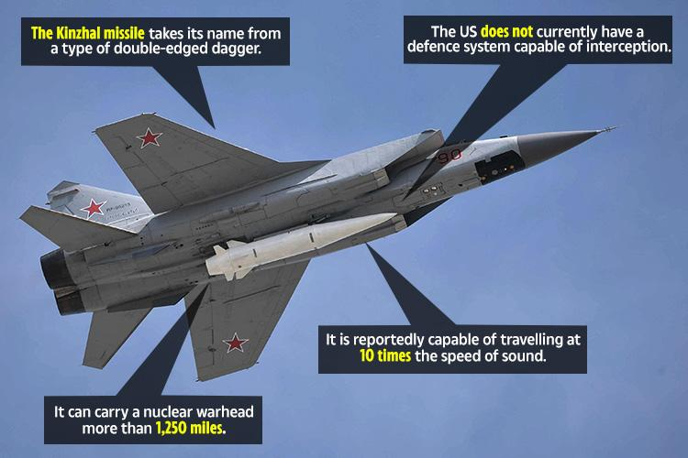
7
The hypersonic rockets, pictured here attached to a Russian jet, are among the most cutting-edge missiles ever developed. Note the white dagger-like missile under the plane.
The high-speed Kinzhal (Dagger) rocket - described by the Russian strongman as "an ideal weapon" - can fly at almost 7,700mph across 1,250 miles and hit precise target.
Below: The Zircon is the world's first hypersonic missile that air defense systems cannot shoot down. Russian ships will be armed with it as early as 2022.
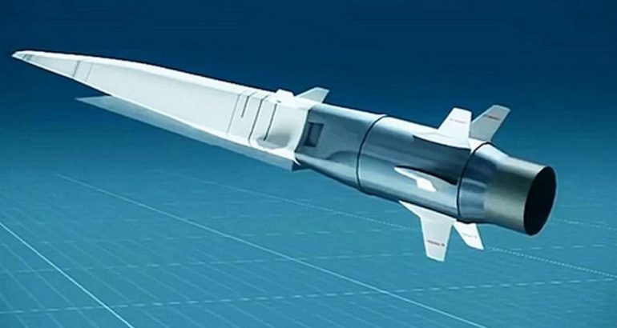
Artist rendering of hypersonic missile 3M22 Zircon (Tsirkon) SS-N-33
Note the dagger-knife shape.

Russia’s Kinzhal Hypersonic Missile Used in Ukraine
What is Kinzhal, Russia's Advanced Hypersonic Missile, Used in Ukraine? 5 points Hindustani Times March 19 2022
Kinzhal, which means dagger, accelerates to a speed of 4,900 km per hour and may reach the speed of 12,350 km per hour, it is believed.
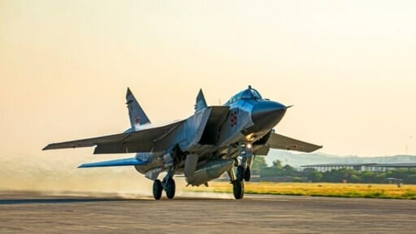
A file photo of a Russian MiG-31 fighter jet carrying a Kinzhal missile. (AP)
Published on Mar 19, 2022 By hindustantimes.com | by Poulomi Ghosh
“Russia has claimed to have used Kinzhal, its newest hypersonic missiles, for the first time in Ukraine on Friday (March 18, 2022), to destroy storage of weapons in the country's western part. Kinzhal has been termed as a game-changer. Now that it claims to have used it in the war going on for the past few weeks, experts are closely watching whether the deployment of Kinzhal brings a new turn in the conflict.
Here are 5 things to know about Kinzhal:
1. Kinzhal is an air-launched hypersonic missile with a reported range of 1,500-2,000km. It can carry nuclear payload of 480 kg. This is 33 times the yield of the Fat Man bomb dropped on Hiroshima, reports claimed.
2. Russian President Vladimir Putin had reportedly unveiled the Kinzhal in March 2018. Kinzhal means dagger. Experts believe the concept of Kinzhal must have derived from the ground-launched Iskander-M short-range ballistic missile.
3. After being launched, Kinzhal accelerates to a speed of 4,900 km per hour and may reach the speed of 12,350 km per hour, it is believed.
4. Kinzhal is believed to have the capacity of hurling a deep strike.
5. Putin has termed the Kinzhal as an ideal weapon that flies at 10 times the speed of sound and can overcome air-defense systems.
Experts are divided over what to make out of Russia's huge claim as they are not even sure of the claims of the Russian defense ministry about the Dagger. According to earlier reports, Russia had deployed Kinzal in Kalinigrad, as Russian exclave on the Baltic Sea bordering Poland and Lithuania in February, while it was building up the deployment of its military near Ukraine.”
Right now, Putin, a “master chess champion,” is playing a masterful game of chess – carefully making his moves towards his goal of “check mate.” He’s purposely using his old worn-out weaponry that appears pitiful and puny. The U.S. and NATO are mocking it. Putin also, along with the old stuff, brought in his trainees, put them in Russian uniforms, and let them go about acting on their own.
That’s called a “diversion” to make it look like Russia is way behind the technology of the West. But, say what they will, the Pentagon knows the truth. When Putin pulls out his far advanced technology and brings in his trained soldiers, the war will begin and end quickly, because truth-is, no one, not even China, has the advanced technology in weaponry that Russia does. Thus Revelation 18: New York City will be destroyed in one hour. How do I know that’s New York besides the fact that Yahuwah taught me that back in the early 1990s? For one thing, look the 26 commodities mentioned in that chapter, bought and sold daily in only one place in the world – the New York Stock Exchange. New York City if the world’s premier trading port.
The Word says that end-time Babylon will be destroyed in one day. The weaponry that will be used to completely destroy the U.S. can take out the U.S. in a day. Not only will Russia attack from the due-north, for Russia now controls the Arctic, but joining with him will be China, North Korea, Iran, Cuba, Venezuela, Germany, France, and others, plus lots of ground troops will finish the job.
Now, in reality, the U.S. is flying tens of thousands of African Islamic merciless warriors into western Canada to kill their hated white people, particularly Christians. We see in Ezekiel 38 also those from African nations that have large populations of Muslims being used in the attack on northern Israel, or it may refer to America. America is clearly described in Isaiah 13, Jeremiah 25:11-12, and Jeremiah 50-51 – the final nation to host Nimrod. [Refer to: “Thirty Clues and More…”/Mikvah of Preparation]
The result will be total destruction. The military will be hiding, and all the leaders of government will be in the deep underground military bases hiding. Much of our food supply and staples’ supplies are going into those underground facilities. Recently exposed: Walmart has begun diverting some of their trucks with what used to stock their stores every 2½ days, into underground facilities. Remember all the recalls of 2020-2021? Well, now you know where the “recalls” went.
I am a passionate lover of Truth. I depend on Yahuwah’s Spirit to lead me to it, as Messiah promised in John 16. As He leads, He also confirms. I’ve been Spirit taught and Spirit led for decades. So, I don’t deal in fantasies, or speculation, or opinions, or theories, or maybes, or anything mythological. These are just facts I’m giving you. I’ve explained these things so many times that I’m tired of repeating – so I’m just saying at this point. But, as you love truth, the Spirit of Yahuwah will bring it to you and confirm it, as He does with me.
What are all those multi-billionaires, trillionaires, government big guys, doing going into deep underground hiding places? Because they know what is planned and is soon to happen. What is Abba Yahuwah saying to you about your “bunker?”
The fiery red horse – look at the wording of Revelation 6:4: “And another horse, fiery red, went out. And it was given to the one who sat on it to take peace from the earth, and that they should slay one another. And a great sword (yet short sword-i.e. “dagger) was given to him.”
Now it appears that Putin may be the “him.” He’s been manipulated and prodded into this role, but Abba said to me: “He is My Nebuchadnezzar.” Yes, Nebuchadnezzar was a blood-thirsty man. Yet, Yahuwah used him to judge and punish His people. Along with punishing the idolatrous and rebellious who did not obey Him, he also used Nebuchadnezzar to set Jeremiah free (Jeremiah 40:4)
Leviticus 10:10: “You must learn the difference between what is set-apart and what isn't set-apart and between the clean and the unclean.” As His children, we must be set-apart unto Him more now than ever before. There is great blessing in remaining loyal to Yahuwah and Yahushua!
Yahuwah is holding back the “one” with the great sword/dagger. However, when Yahuwah allows Him to, He will be the one to attack fire his “daggers” at America, fulfilling His judgment on the nation that was chosen over 400 years ago to bringing forth the return of Nimrod, aka Osiris, Apollo/Apollyon Revelation 9:11.
As I’ve been saying, President George Bush, Jr. went to all the “trouble” of starting Gulf War II, blaming Saddam Hussein for “weapons of mass destruction,” when everyone knew he didn’t have any, so that American soldiers could get into Iraq in 2003 to exhume the body of Nimrod, using German archeologists – also to find Nimrod’s plans for his tower in the Baghdad Museum, which America gave to CERN in Switzerland to use to open portals from under the earth, from the cosmos, and from other dimensions to bring in all the fallen ones, the Nephilim, the aliens, and Lucifer himself in order to prepare the world’s people to receive the Revelation 13:1-9 Beast, - world ruler. I saw a video of U.S. troops in Iraq standing guard over Nimrod’s golden treasures as they were unpacked.
Now we are watching Israel being prepared to honor the Beast and facilitate his rule from Jerusalem. It is amazing their now open globalist moves. World War III is a MUST, so know the satanist globalists.
Blood must be shed in huge amounts to appease and honor Lucifer, enthroned under the ice in Antarctica is his own palace. I wrote some of that in the recent article “The Midnight Meeting”/Mikvah of the Great Adventure. Yes, Lucifer has been there for a while. His summoning of world leaders is becoming quite a known thing.
One massive global shedding of blood is needed to empower Lucifer’s evil to move forward with his plans. The Muslims know their messiah will come during a time of great war. Rabbis of Israel also know that their messiah, aka “Leviathan,” “Metatron,” the redeemed “Nachash/Serpent,” will come during a time of great bloodshed. They are both quite verbal about this.
I have reported on a speech by Prince Charles, and others, at the end of 2021, regarding the cloned and prepared Beast who is demanding trillions of dollars for his military and his enthronement.
[Refer to: #250 Present Reality, “He’s Alive on Earth, In Control…”]
I’ll stop here. The man on the fiery red horse is being provoked to do what he is being forced to do – bring WWIII to pass, the fulfillment of the Pike/Mazzini Plan of 1871. You can read the three parts of this plan under the Mikvah of Israel, Our Eternal Inheritance #59.0. This Plan has been followed in all detail in World War I, World War II, and now the “required” World War III to bring in the new world order, the new world government, the “global reset.”
“With the return of the fallen angels incarcerated by Yahuwah until their time of judgment in 1896, and their teaching mankind weapons of war as they taught mankind before the Flood, we see their 120 years allotted, with the Spirit of Yahuwah striving with them, ended in 2016. At that point, America’s 70 years allotted to be the world’s super power also began waning. Now, we are not only not the world’s super power anymore, but a pitiful semi-communistic regime that is soon to be wiped out. We fulfilled our secret destiny and brought forth Nimrod again to rule, to finish what he started with his tower, and now we’re no longer needed. Oh yes, the E.U. boasted years ago that “what Nimrod start, we will fulfill.” It’s all just adding the puzzle pieces together as they appeared to make the picture clearer and clearer now. [Refer to: “America’s Secret Destiny”/Mikvah of Preparation]
I’ve tried to cover things in depth as they have appeared – especially since the late 1990s, but now, it is so in our face, it is just a matter of connecting the puzzle pieces and the picture is clearer and clearer.
In the meantime, what should you do?
I’ll close with II Peter 3:10-14: “יהוה is not slow in regard to the promise, as some count slowness, but is patient toward us, not wishing that any should perish but that all should come to repentance. 10But the day of יהוה shall come as a thief in the night, in which the heavens shall pass away with a great noise, and the elements shall melt with intense heat, and the earth and the works that are in it shall be burned up. 11Seeing all these are to be destroyed in this way, what kind of people ought you to be in set-apart behavior and reverence, 12looking for and hastening the coming of the day of Elohim, through which the heavens shall be destroyed, being set on fire, and the elements melt with intense heat! 13But according to His promise we wait for a renewed heavens and a renewed earth in which righteousness dwells. 14So then, beloved ones, looking forward to this, do your utmost to be found by Him in peace, spotless and blameless,…”
Fear is a spirit from Lucifer-Satan. It is not for you! The only “spirit” you should have within your eternal spirit after a true new birth is to ask the Spirit of Yahuwah to come within your re-born spirit, empowering you, teaching, directing, comforting, convicting, and loving you!
Read Romans 8. Proclaim Romans 8:28-39 for yourself. Know who you are because of Yahushua’s salvation. Know how much you are loved, needed, wanted, and cared about. Know also the authority you have because of your new birth through Messiah. You are an eternal being who was chosen before the foundation of the world to be the child of Yahuwah our Father in heaven, through the shed-blood and resurrection of His Son, Yahushua Messiah. So, look at yourself as one who is loved, and so love yourself enough to prepare in peace, trusting your heavenly Father and your Savior, to help you go through what you must go through and stay true to Them (Father and Son).
In His love, shalom!
Yedidah
March 19, 2022

