RUSSIA’S DEMANDS REJECTED – WAR PROVOKED!
and THE LA PALMA VOLCANO 2007 2017 AND 2022

I want to give you an update on several events that are rising to the top, not in public news, of course, but in a reality that they don’t expose.
I am going to start with the Cumbre Vieja volcano on La Palma Island, Canary Islands, Spain. I started following this in 2017 when I saw an article about its danger, not remembering that I had read about it in one of Steve Quayle’s classic.
Last night, I reviewing the contents of Steve Quayle’s book Weather Warfare and Other Unnatural Disasters, I saw where he wrote the book in 2007. Here is what he wrote about the volcano that has been erupting since mid-September, making historic eruptions, with hundreds of good-sized earthquakes. The island has split further recently. Look at what was feared by volcanologists in 2007 and in 2017. Now, the volcano appears to be in a “silent” mode, however, the magma pressure may be building for a larger explosion. We’ll see!
Weather Warfare ...Pages 185-186: 2007: “Armed with the knowledge of what had caused megatsunamis, geologists next started looking at volcanic areas near the ocean, which might cause another megatsunami. They searched records and maps to see if they could spot the telltale signs of an event. What they found was terrifying. One such area exists today, which could register such an event. The area in question is on La Palma, one of the Canary Islands, where the island’s southern volcano erupted in 1949, leaving a long crack down the side of the volcano. The crack has already slipped a few yards, and, should it break free, would dump a mountain of debris into the Atlantic. Should that amount of material suddenly plunge into the Atlantic, it would create a massive megatsunami. Such an event is not unlikely, either, since a future eruption would seem only a matter of time…when it does, 500 billion tons of rock will fall into the Atlantic. The results will be something like from the movie “Deep Impact.” The wave is likely to surge across the entire Atlantic in a few hours, and will most likely sweep away much of America’s east coast, climbing 12.5 miles inland.
Boston, New York City, Miami, and other cities along the American and Caribbean coast lines will basically be swept away in a wave that climbs as high as sky scraper when it reaches land. The disaster is coming. The only question is when, and that’s a question only God knows the answer two – unless `someone’ employs explosives that will encourage the La Palma cliffs to fall ahead of time.”
Here is part of the article I saw in 2017 while doing research on the increase in erupting volcanoes. As I read this article, Abba Yahuwah spoke to me in my spirit, troubling me, “keep watch on this.” So, I’ve been following this since the danger was publicly stated in 2017. Since September, I’ve been following this almost daily, as well as the truth that’s being held from those on America’s West coast.
The potential of a megatsunami hitting the East coast of America, beginning in Nova Scotia and going down to Brazil, is real. Today, technology exists that can split the island, that can set off a violent eruption, that can cause earthquakes to shake deep into the earth, and volcanoes to erupt violently.
Below is part of the 2017 article through which Abba alerted me to watch this:
“La Palma volcano ALERT: Magma is MOVING! Expert warns ‘significant’ distortion in Canaries: LA PALMA volcano’s red-hot magma has risen after its recent flurry of earthquakes causing the ground on the Canary Islands to “significantly” rise above ground level, experts said. - By Rebecca Perring – October 18, 2017 – Daily Express
“Volcano experts discovered the ground in the area surrounding local hotel Teneguia Princess Hotel has risen by about 1cm to the south and 3.5cm upwards over the past year, according to GPS sensors regulating ground deformation.
The shocking results from the Volcanological Institute of the Canary Islands (Involcan) come after the archipelago was rocked by two separate seismic swarms in the area surrounding the deadly Cumbre Vieja. One of the world's leading experts in volcanology, Professor Takeshi Sagiya, from the Nagoya University, described the GPS data as ”significant." He said the recorded change in height looked significant compared with the changes in the last year.
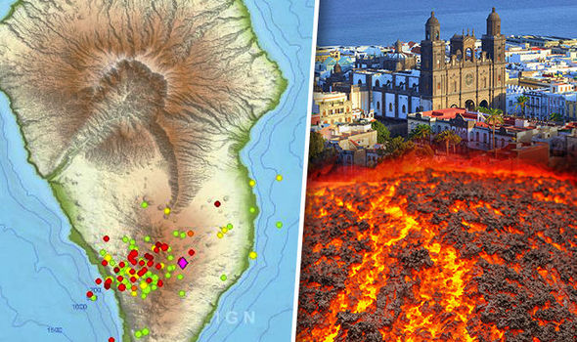
Experts have warned the movement of the ground formation is significant
La Palma has seen two separate seismic swarms in the last few weeks
We assume the magma accumulation lies below the seismic swarm and thus raises the ground above. Scientist Stefan Scheller: The GPS sensor is located about 3.5 to 4.5 miles south of the centre of the latest seismic swarm. There were 44 earthquakes recorded up to 2.1 magnitude hit between Friday at 1.52pm and Saturday to 4.17am. [2021: hundreds of earthquakes, many 4.1 or higher]
They followed another seismic storm the weekend before, which saw about 50 tremors in three days, between 1.5 and 2.7 on the Richter Scale, sparking fears the islands most active volcano was about to erupt…October 12, 2017: Fears are growing that the deadly Cumbre Vieja volcano could erupt after a “swarm” of seismic activity hit La Palma.”
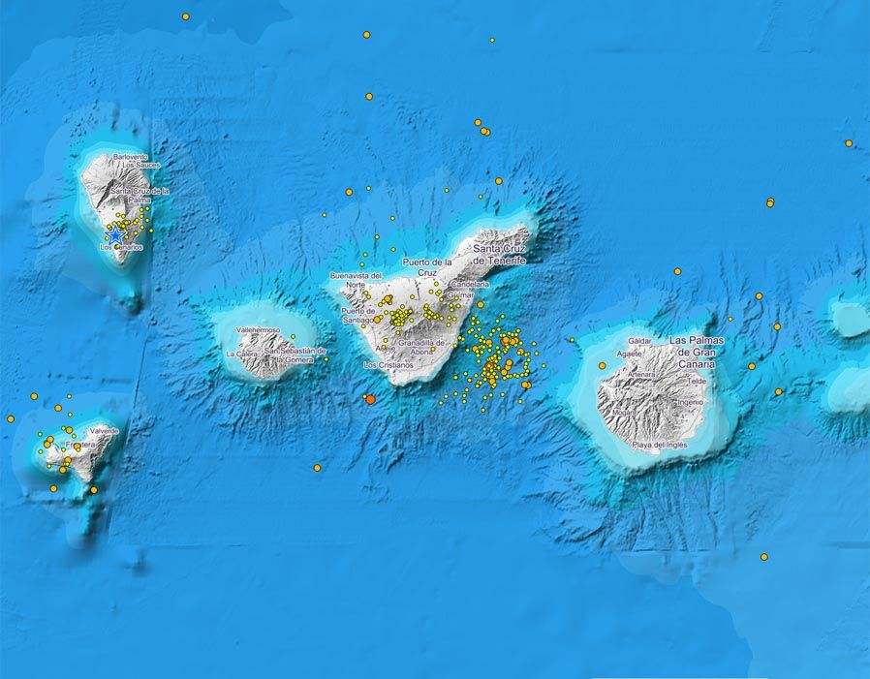
The map shows the recent earthquake activity in La Palma (2017)
La Palma volcano: Seismic swarms in ridge of Cumbre Vieja
“A circular elevation of the ground about 7 km around the centre means a quantity of raised rock with a volume of approximately 5 million m³, which corresponds to approximately 12.5 million tons of rock…”
The dreaded eruption began in mid-September 2021. Today, we look at the number of earthquakes and this report in 2017, and see how the eruption of 2021 is so vastly stronger, earthquakes vastly stronger, and potential of creating a megatsunami very possible.
Yes, it appears that the volcano is quietening down, but it appears several things are quietening down, too. War talk is still just talk. More diseases are being brought to light, whether man-made or not. We sit on the preverbal box of dynamite. Yet, Abba has things for us to do for Him – so instead of sitting on the box, or being in the box, we must hear from Him and obey quickly one step at a time. He is giving His individual instructions to His children. Every day study the Word, and cry out to Abba to show you His will so that you quickly can do it.
Tragically, most people are dependent on the lying, deceiving, public news, all geared to mind-programming people into compliance with the lies and deceptions and the will of the new world order, so I realize that truth is mocked as being the lie. Some of you have tried to warn your family and friends against what you know is deadly, only to have them laugh or mock, even become defiant against the truth you are pleading them with. Satan’s nature and thinking is taking over the earth.
Today, pressure is coming down on the unvaccinated – the unvaccinated being accused of causing ill health, and creating a risk for others. Yet it is the vaccinated ones who are dangerous – with the after-vax “shedding.” The vaccinated are accusing the unvaccinated as causing health problems. Biden is coming out against the unvaccinated. The rhetoric lies are horrendous. When truth is given in its starkest form, to warn of danger, many mock – glibly saying “I don’t believe that.”
Youth are being vaccinated without parental permission, causing trauma in homes. The human DNA-changing RNA messaging, not a vaccine at all, not only contains microscopic robots (nanobots) to be activated in one’s body, enhanced by 5-G, hooking them up to A.I. control, more and more, one shot at a time, also with mental control abilities by A.I., but also has living “immortal” creatures in it like Hydra Vulgaris, aborted baby cells, toxins, and Nephilim/giant DNA, and other things to destroy the immune system and send blood clots to the lungs, heart, brain, etc. So many are dying. Vaccinated babies and children are suffering from heart problems due to the “vaccine.”
Don’t stop warning people! We can’t have the blood of others on our hands because we kept the truth to ourselves. We must all be faithful watchmen as long as we can. I know it’s heart breaking – people are cold and calloused against hearing the truth to the point of wanting to harm the truth-tellers.
Below is an update, clearly showing the provoking of Russia and the rejecting of Russia’s simple demands for peace. All the while, the Beast, the anti-messiah, is alive and well – preparing for his entrance once the world goes into chaos and America is destroyed. The 2 witnesses, along with their “company” of 144,000 who have been prepared and are waiting their translation onto Zion, are on planet earth waiting. The take down of the U.S. according to Scripture, by powers to our north leading the way, has to take place before all barriers are removed for the Beast’s entrance, and for the ministry of the two witnesses to begin.
From Don’tspeaknews.com – news you’re not supposed to speak about
December 16, 2021
“On December 10, Russia's Ministry of Foreign Affairs publicly made statements to NATO about Russia's security concerns. The Russians wanted cast Iron assurances from United States that Ukraine will never, ever, be admitted in to NATO, also Georgia. The Russians believe it is going too far. And say they will be forced to act if their demands are rejected. About eight hours later, they were rebuffed by Stoltenberg at NATO who answered them flatly with "no." NATO will not meet Russia's security demands. Three days later, the Russian Foreign Ministry sent a re-issued version of those same demands to NATO, only this time, they contained a Date-Certain. If Russia's security demands were NOT agreed to by a date-certain, Russia would address those concerns using military force.
Russia sent this re-issuance via Hand-Delivery, by Russian Government Diplomatic Staff. The document copies were hand-delivered to all NATO primary Executives, such as Biden at the White House and Boris Johnson at #10 Downing Street; all delivered by hand, by Russian Diplomatic staff.
Today, NATO's Jen Stoltenberg issued a formal reply to Russia on behalf of all NATO Members. "Russia's demand for security assurances from NATO, and other demands, are rejected." Stoltenberg just confirmed that Ukraine and Georgia will be admitted in to NATO in the near future.
Now, the information the government found out that I obtained, and does not want me revealing: Already, military assets are being moved in to place as I write this: US is deploying F-15s in to Romania. Aircraft Carrier Strike Group on the move through the Mediterranean. US/NATO Troops are being moved in to eastern Europe.
Three weeks ago, very, VERY, quietly, the US began loading M1A1 and M1A2 Abrams Tanks onto Roll-On Roll-Off (RO-RO) vessels in the United States. It took about a week for the first of those ships to transit to Greece. Upon arrival, the tanks were unloaded. In the past two weeks, the United States has sent slightly more than 1,000 M1A1 or A2 Abrams tanks to south eastern Europe. They also sent between 35,000 and 45,000 U.S. Troops in the same time period. Prior to these tanks and troops arriving, the U.S. has the equivalent of ONE armored division in all of Europe. As of today, they have enough for THREE Armored divisions, or, in the alternative, TWO armored Divisions and two or three Infantry Divisions.
Tomorrow, the Pentagon will begin AIRLIFTING weapons to Ukraine.
So Russia's effort to avoid a conflict by diplomatic negotiation of their security concerns has been flatly and deliberately rejected. The West clearly wants war and, it looks today, they're going to get what they want.
Here's the problem: If NATO enters any conflict between Russia and Ukraine, then ALL NATO COUNTRIES will immediately become legitimate targets for Russia to attack. That includes us here in the United States.
Given the fact that Russia now has hypersonic missiles which the US cannot defend against, things won't go so well for us here. YOU have precious little time to top-off preps to keep yourself and your family safe, warm, dry, and fed.”
Of course, the west wants war – WWIII! Like WWI and WWII, WWIII was planned back in 1871. The plans have been meticulously followed. Please refer to:
“The Pike/Mazzini Plan…”/Mikvah of Israel, Our Eternal Inheritance.
WWIII was planned to be the final war to bring in the new world order. Satan needs blood sacrifice once again to bring his “son” onto center stage for world takeover. In America alone, the sacrificing of babies and children has reached an all-time high.
As with centuries ago, the jaguar god of today, whose statue has been placed outside the United Nations Visitor’s Center – the god of the Aztecs, Maya, and Incas – the bloodthirst god who demands blood so that he can come to world power - is at work with all the fallen angels, Nephilim, aliens, hybrids, and human servants to reach Satan’s goal. Satan demands more abortions, more child sacrifice, more death of humans worldwide, and anything else on earth that has the nature of the Creators – like gentle mammals of all types, doves and kind birds, green plants, flowers, food crops … anything that is beautiful radiates the nature of the Creators – so to counterfeit, they paint the jaguar god in bright multi-colors – yet he is evil and merciless.
Below is a much better picture than I previously acquired, showing the hybrid jaguar statue and its brilliant colors – “Guardian of Peace and Security” – definitely NOT! Its wings represent its resurrection to godhood. It represents the Beast to come who will demand all humans dead. He’s not “Leviathan” or “Behemoth” of Revelation 13, for that beast has 7 heads (7 empires) and 10 horns (10 regional divisions), but the jaguar represents the god of human sacrifice to bring in the Beast to power.
Among ancient Aztecs, Maya, and Incas, this god promised 1,000-year reign for those who worshipped him. Hitler said he would bring in a 1,000-year reign. Other great conquerors, anti-messiahs, of the past have promised their followers a 1,000-year reign. Those lake-of-fire-bound fools can only counterfeit what Yahuwah and Yahushua have said, done, and will do. Yet, most of earth’s people, including Christians and Messianic people, are falling for the lies of the counterfeits!
A picture of the jaguar statue outside the United Nations: 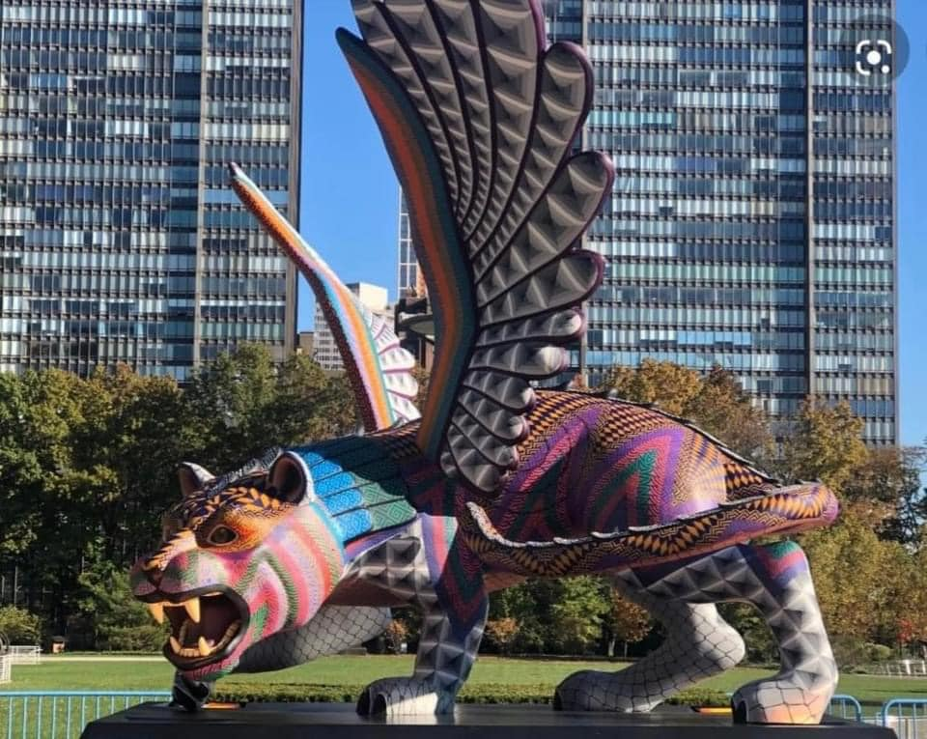
However, for us who are not ignorant of the enemy’s “devices,” – his plans, his strategies, his goals, we stand like bystanders, watching the unfolding of prophetic reality before our eyes, knowing what is being planned to happen, yet we stand in peace, knowing our Abba is in control. And so, the tension builds – for we know what Yahuwah has allowed us to know by His Word and in our spirit. Thus, every day, we are in the Word more and more, focusing on what He puts into our spirit to do, so that we do it with joy and peace – always looking forward, never backward.
Isaiah 55:11-13: “…so shall My word be that goes forth from My mouth;
It shall not return to Me void, but it shall accomplish what I please, and it shall prosper in the thing for which I sent it. 12For you shall go out with joy, And be led out with peace; the mountains and the hills shall break forth into singing before you, and all the trees of the field shall clap their hands. 13 Instead of the thorn shall come up the cypress tree, and instead of the brier shall come up the myrtle tree; and it shall be to the Lord for a name, for an everlasting sign that shall not be cut off.”
We know, those who “know their God” shall walk through the flood, and through the fire of the enemy, and come out “unscathed.” Let faith and boldness rise! We are victorious for eternity because of Abba Yahuwah and Yahushua Messiah!
The wicked have their direction and eternal finality. The true children of Yahuwah have their direction and their eternal finality. We see what is happening and pray. We intercede for others. We do spiritual warfare and proclamations of His will when facing enemies. The blood of the Lamb and speaking in the heavenly language of the Spirit are two of the main weapons against enemies. Proclaiming the Word out loud, personalizing it, with faith, with boldness, also is a “weapon of warfare that is not carnal, but might to the pulling down of strongholds.” (II Corinthians 10:3-6; Ephesians 6:10-18) We are “more than conquers” through Him who loves us (Romans 8:31-39).
May our peace and security, safety, and joy, only be found in Yahuwah and
Yahushua Messiah! Shabbat Shalom, Yedidah
December 18, 2021

