SPEAKING AS A TEXAN
GEOENGINEERING! WEATHER WARFARE! NO DOUBT ABOUT IT!

“In this world you will have tribulation, but be of good cheer, I have overcome the world.” John 16:33
“You shall go out with joy and be led forth with peace, the mountains and the hills will break forth before you…” Isaiah 55:12
In my state, millions are without power, millions without water, pipes freezing and bursting, the electric grid is about to collapse, the economy is collapsing, and here I am collecting articles right and left which tell me exactly “why,” - which I know is absolutely true.
I have a warm house. No power outage. I found out that this is because across the street is an assisted living facility for the elderly, and the power will not be shut down for them, thus, I, and my neighbors, are equally blessed.
I’ve kept my indoor faucets dripping, and I’ve had water. I have been concerned, however, with the state of pipes off the garage due to temperatures below zero, or between zero and 10. SO AND THUS, yesterday afternoon I was sitting in my living room answering e-mails, and there was a knock on my door. It was the young couple living on the other side of this duplex. They informed me that water was gushing out of my garage into the street. Oooo-K She was on the phone calling the leasing company. I had no idea what to tell the young man who was trying to find the water meter to turn off the water. She got hold of the leasing company and workers were sent out right away. They had been at a house 5 minutes away… uh … “Abba, is that You?”
They turned off the water. It was the pipe running into the hot water heater that had not just burst, but put a gaping hole in the wall. The couple had just gone out to their car, and saw water pouring down my driveway. They came right over. The flood had just begun.
I opened my kitchen door to look into the garage, to open the door for the young man to check things out, and it sounded like a mini-Niagara Falls. They men worked on it for about 45 minutes. They said they had to let the pipes drain. So, I was without water last night and this morning. “Piece of cake…”
In 1964, I was on the Navajo Indian Reservation in Arizona and New Mexico for three months with a group called “Practical Missionary Training.” I lived in a round mud and stick Navajo “hogan” at one point. We ran out of water and had to make a run into Utah to get the barrels re-filled. We learned how to use miniscule amounts of water and recycle the water for many uses. During my seven extended trips to Africa, I lived a lot of the time in mud huts, or mud, cow-dung and straw houses – no inside water. No toilet facilities on the Navajo reservation of Africa. I learned how to survive and do well on very little – invaluable training!!! When I was in China three times in two years, I lived with what they called “adequate.” Adequate simply means you have the most basic of what you absolutely need and that’s all. I loved it. Three bunk beds in one tiny room, and 1 bathroom. The kitchen was the size of a closet. But, wow, we had super fellowship and super adventures together.
Pastor McQueen said this is a dry run for us in Texas. Their electricity was off about 10 days, and their water for 3 days. They did fine. My son and daughter-in-law helped with wood and generator, and etc. Such things sure brings out the good in the good.
Another hard freeze last night - 12 degrees F … The young lady next door brought me two gallons of water. She gave me her phone number and said to call them if I needed help. This morning, the men came back and got the water back on in the house. Men from the local Water Department will be coming out to fix the pipe that was broken. It is now “capped off.” Then the other men will return to repair the gaping hole in the back wall. In the meantime, I have water, and the water heater is working fine…. Deep inhale, long exhale!
On February 15th, the day the temperature dropped below zero, with a minus 16 chill factor, I was supposed to be at the dentist office getting my permanent dentures. It snowed about 4 inches, and then froze. Today, the snow is starting to melt, and underneath the snow, streets, driveways, my garage, is solid ice.
Yesterday, I was re-scheduled for a dental appointment on a sunny day in the 60s next week. Isn’t Yahuwah good!!!
What are the odds of that young couple noticing my flood and coming to help me right away – calling the leasing office for me and then coming to make sure I’ll alright and bringing me water? They look to be in their early 20s. But folks, this is small town Texas, and most all the people are just that way.
I want you to get real familiar with this website:
Exposing the climate engineering ... www.geoengineeringwatch.org
Please read: “70 Years of Climate Geoengineering…”/Mikvah of Present Reality to understand what has happened to Texas and why.
I have collected loads of info. that all dove-tails on recent happening in my state. Mike Adams also lives in Texas as do several other key watchmen. They have prepared well – wood stove, garden, green house, stored water, generators, stored food, etc. Good for them!!!
Last night my son and his wife came to check on me. They have been led to the same information in different packages but all aligning to what I have. Texas was hit by “weather warfare” to send a message that the President and his buddies don’t like what our Governor is say or preparing to do. Yip - it was an attack to send a message, i.e. “You do what we say, you say what we tell you, and you won’t get anymore attacks.”
In the meantime, in the last few days, the Governor of North Dakota, and the Governor of Florida, joined the Governor of Texas in making bold proclamations, that defy the wicked policies of the President. Yes, a draft has been made and approved for Texas to secede from the USA. Governor Abba boldly declared that Texas would be a “sanctuary state” for gun owners, and we would not observe the proposed gun confiscation. Texas stood up against the tyrannical takeover during the election - if you’ll remember - and other several states joined in. The Supreme Court, you’ll remember, threw out the case, just like they threw out all the proof that Trump won the election. Now the existing one sitting in the Oval Office is afraid of the military who supported Trump, because he knows he didn’t win honestly. Thus, the treatment of, or I should say the mistreatment of, the National Guard during the inauguration time - before, during, and after.
The first of many Executive Orders put in front of Biden the day after the inauguration, for his signature, was the abortion order that no matter if the Supreme Court overturns Roe vs. Wade, women can still get legal abortions.
Now why would that be #1? Other suspicious executive orders were signed. There is a huge chance, he did not write them. He brought some forward from his days as the lackey of Obama. I’m not politically oriented. I just know who is on what side, and who is on the other side.
Please join us in prayer for the Governors who want to do right by their people. I know, Texas is a trial-run state for the vaccine, but Abbot made a bold and public statement that the vaccine would always be voluntary. Pray that he holds the line, because he is giving other Governors the support they need to declare the truth and their stand for it.
Take a look at why the attack on the Texas grid was so obviously!
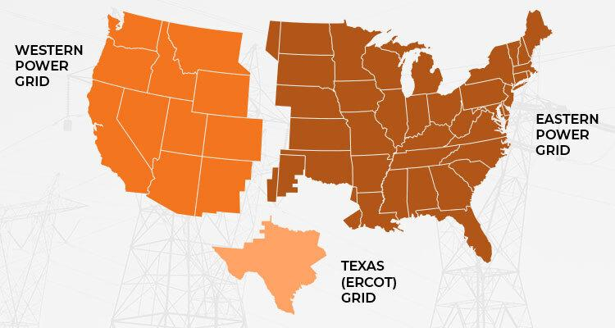
Three power grids run most energy in the United States
Here’s just a little of what I’ve found out that nails the “weather warfare” reality down solid. It’s not a theory of fantisizers, it follows a pattern I’ve traced that began around 1947. Be sure to read: “70 Years of Geoengineering…”/Mikvah of Present Reality.
I remember a few years back under the Obama administration, Governor Perry of Texas did something that cross Obama’s will and made him angry. Within 24 hours, a storm hit Austin, capital of Texas, Governor’s headquarters, so hard that the river swelled up quickly and people were washed down the river to their death.
Like I said, pray for these good Governors who are taking stands that the puppet masters who are pulling the strings of the President don’t like. The governor of North Dakota has some real issues with the Executive Orders that the President signed the next day after his inauguration. Protect the Governors Father who really care about their people!
Take a look a some specifics in these few articles:

“TEXAGEDDON: WHO’s Really Behind it and WHY?” Feb. 17, 2021 by Weaver, Tap News: “Globalist-Directed Geoengineers Aim Their Powerful Weather Weapons at the Lone Star State to Conduct Covert - Acts of False Flag Geo-terrorism”
Let’s be clear: the deliberate deep freeze of Texas is unparalleled by any standard. There is simply no historical precedent for both the record-breaking cold temperatures and snowfalls so far south in Texas. With this irrefutable knowledge, Occam’s razor tells us that such a catastrophic weather event was fastidiously geoengineered by all the usual suspects. How could such an historic weather calamity not be the product of very stealthy weather manufacturing after highly sophisticated atmospheric manipulation?
But why, pray tell, would the New World Order globalist cabal order such a devastating cataclysm? Because Texas is a very RED state and ready to rumble with the Biden administration—that’s why!
In point of fact, the Abbott administration is prepared to roll out a series of measures and mandates that all serve to reclaim their various long-neglected constitutional state’s rights.
Not only that, but Gov. Gregg Abbott executive team has prepared legislation that will fly in the face of Biden’s 2021 plan to lock down the state (and every other state). These upcoming governor’s EOs will also push back hard on Biden’s absurd and unlawful Executive Orders that are promoting Obama’s ultra-liberal cultural Marxist agenda. “Texas won’t have it. None of it. And Team Biden knowns it.”
So, the career political criminals inside the Beltway have unleashed the most destructive weather weapons they can muster in 2021.

WEATHER WARFARE: An unprecedented 2.7 million customers in Texas are without power…with temperatures near zero.
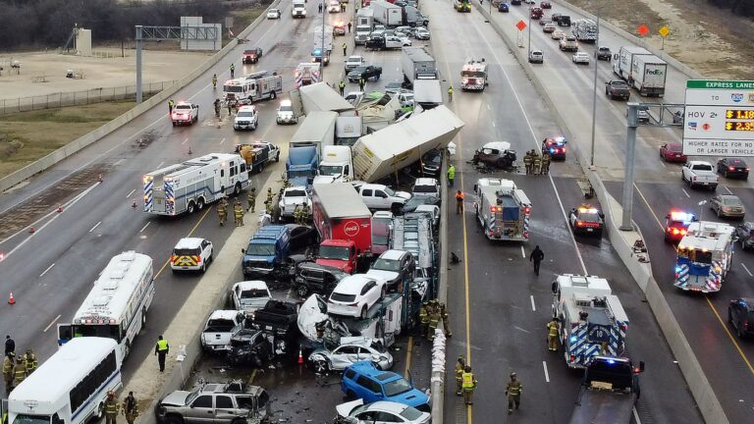
Even the 133-vehicle pile-up in Fort Worth, Texas that killed 6 and injured many more on February 11 was no accident of fate or fluke of nature.
Conservative states, with long-established Republican majorities in both legislative chambers, are always targeted by the exceedingly dangerous geoengineers, especially when they are the largest states in the nation.
Both Texas and Florida clearly wield way too much power and influence nationwide to avoid the attention (and wrath) of The Powers That Be.
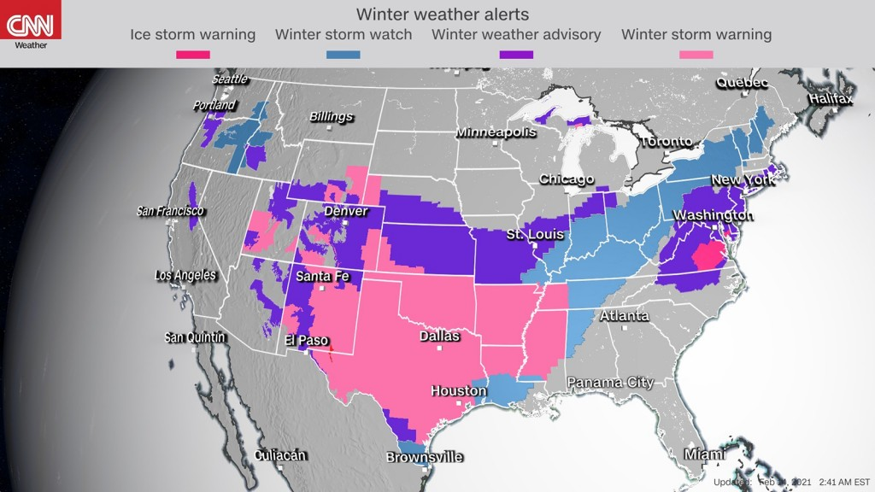
TEXAS TARGETED WARNED NOT TO SECEDE FROM THE USA
February 18, 2021 – ANP
[***YEDIDAH’S ARTICLES: “5-G: HAARP, the Military, and the Forerunning of Earth’s Destruction” and “70 Years of Weather Geoengineering – 70 Years of Man’s Destroying Earth’s Life Support Systems” - both Mikvah of Present Reality]

'The Powers That Be Are Determined To Take Down Texas': Soon After Texas Politicians Endorsed Legislation To Secede From The USA, Texas Got Absolutely Clobbered
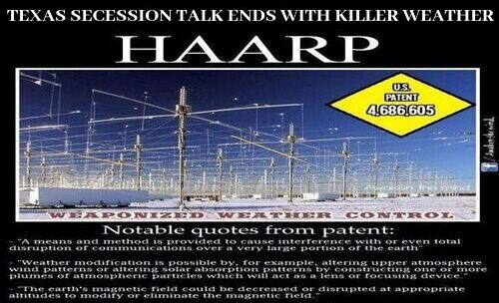
By Stefan Stanford - All News Pipeline -
Just less than two weeks ago, on February 5th, The Guardian published this story titled `Texas Republicans endorse legislation to allow vote on secession from US’ within which they reported the State’s GOP chairman, Allen West, was just the latest Republican to come out in support of declaring Texas an independent nation.
Now almost two weeks later, coincidentally, (though most likely not!), the LA Times has put out this story titled `Amid severe weather and power crisis, Texas legislators stop talking about secession.’ Its electrical system worked well for decades — but it wasn’t ready for unexpected cold. Does anybody else find it quite odd, that soon after Texas started talking about seceding from the US with Joe Biden and radical Democrats 'in charge', Texas has been hit by a series of absolutely debilitating storms and power grid outages?
As an ANP reader who commented, February 16th: `I personally don't think this was mother nature but HAARP weather warfare. The powers that be are determined to take down Texas. Just my own humble opinion.’

“Texas Goes Dark – 45% US Wheat Damaged – Grand Solar Minimum
by Ice Age Farmer | Feb 16, 2021
“45% - 50% of the US Winter Wheat crop is estimated to have been damaged…”
Ice Age Farmer is from Texas.
Article titles: “Frozen Wind Turbines Soaring Spot Electricity Prices How the Arctic Freeze is Rolling the Texas Energy Market”
From Feb. 4, 2018: “Infrastructure Failing Power Grid Faltering…”
“Half of Texas’ Wind Turbines Frozen in Winter Storm – Limiting State’s Power Output”
Temperatures fell to minus 20 and minus 30 in parts of the Plain’s states. Iowa, Nebraska, Kansas … as well as Oklahoma and Texas. Argentina is thinking of holding onto its wheat crop rather than exporting, and so are other nations because of global famine. Today nearly 50% of Texas’ winter wheat crop froze to death.
If this was caused by the weather controllers who have been working at destroying food supplies world over for many decades, then they were buy in Texas the last few days.
Another report tells of 8 million gallons of milk having to be poured down the drain by dairy farmers because there was no way to get it to processing plants and to markets with a truck transport shut down, but also electricity shut down.

“TEXAS GOVERNOR CALLS FOR TEXAS TO BE A SECOND AMENDMENT SANCTUARY”
Governor Greg Abbott Calls For Texas to Become a Second Amendment Sanctuary State - RUSTY WEISS FEBRUARY 14, 2021 The Mental Recession
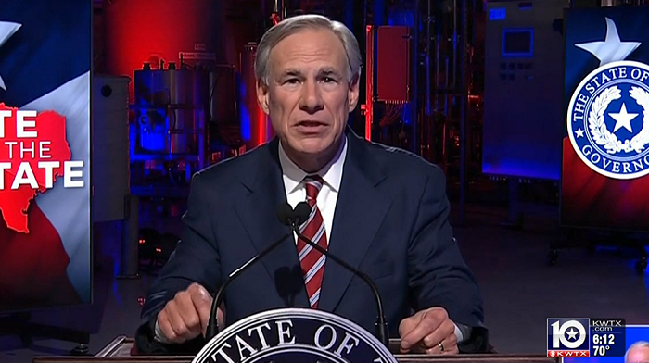
Texas Governor Greg Abbott is trying to prevent Democrats from treading on Texans’ gun rights, calling on his state to become a “sanctuary” for the Second Amendment. In his State of the State address last week, Abbott said, “Texas must be a Second Amendment sanctuary state.” “Politicians from the federal level to the local level have shouted: ‘Heck yes, the government is coming to get your guns,'” he said. “We won’t let that happen in Texas.”

BLACKOUTS CASCADE BEYOND TEXAS IN DEEPENING POWER CRISIS
Javier Blas, Brian K. Sullivan and Naureen S. Malik, Feb 15 2021
(Bloomberg) -- Blackouts are spreading across the central U.S. and into Mexico as an energy crisis that has already brought Texas’s power grid to its knees deepens.
As more than 2 million homes and businesses in Texas are already without power, the operator of an electric grid spanning 14 states from North Dakota to Oklahoma ordered utilities to start rotating outages to protect the system from failing amid an unprecedented cold blast.
`It’s a step we’re consciously taking to prevent circumstances from getting worse, which could result in uncontrolled outages of even greater magnitude,’ the grid operator, called the Southwest Power Pool, said in a statement Monday. `In our history as a grid operator, this is an unprecedented event.’”

Texas Republican chairman calls for SECESSION after Supreme Court unanimously dismisses demand to overturn Donald Trump's defeat
Republican Party of Texas Chairman Allen West suggested states should secede from the union in a statement responding to the SCOTUS decision
'Perhaps law-abiding states should bond together and form a Union of states that will abide by the constitution,' he said
The Supreme Court refused to hear a Texas-based case that President Donald Trump wanted to use as a vehicle to overturn the presidential election result
By NIKKI SCHWAB, SENIOR U.S. POLITICAL REPORTER and GEOFF EARLE, DEPUTY U.S. POLITICAL EDITOR FOR DAILYMAIL.COM 11 December 2020
Republican Party of Texas Chairman Allen West suggested states should secede from the union after the Supreme Court refused to hear a case.”
So, as you can see, Texas is a big problem for the reigning powers that be - the ones much higher up than Biden, or Harris, Pelosi or Hillary.
Also, legislation and action is being set up to go against “domestic terrorists,” like those “conspiracy theorists” who believe the QAnon lies. No, Qanon is NOT a “conspiracy theory.” It is an A.I. counterintelligence program of the three major intelligence agencies of America – the DIA, CIA, and NSA. It is a mind-control program to slot/list/identify and take down those that emotionally get caught up in the lies they are told. These agencies contrive a story that will inflame the emotions of the ones they want to take down anyway – like up-top, Evangelical Christians, patriots, veterans, “Trump Supports,” conservatives, loyalists to the Constitution – you know the “good old boys” we used to appreciate. They give out false hope to an expectant group, then pull the rug out from underneath them when the truth is exposed. This is what the Jesuits did many decades ago in introducing the pre-7-year rapture of the whole church doctrine, and paid John Nelson Darby to take it to the American people.
Please refer to two important articles: 1) Warning! Nine lies…” and 2) Dismantling a Highly Dangerous Collage/both under the Mikvah of Present Reality.
The ones now ruling the world do not like the Christianity of the southern states either – conservative states, patriotic states, veteran-friendly states, and old-fashioned ideas of love and hospitality. It’s so nice here in this little town of Texas where the people are so helpful and kind, and look at life through a Christian view – even if they’re not believers. So, you noticed in the map above on page 5, that it was not just Texas that received the disdain of the evil ones, but other southern states like Texas. Farm crops also suffered as well as the people in other states.
Texas pumps more oil than any other nation … so of course, the multi-billionaries don’t want to lose the oil, nor the natural gas reserve!
While writing this article, the workers returned and got my water back on. A Water Department technician is going to come and take care of the pipes outside, and then the leasing office helpers will return and fix the BIG hole in the wall where the water crashed through – like I said, it sounded like Niagara Falls flowing out of the wall onto the garage floor and out into the street.
All the while – peace reigns as a constant in my spirit. The spirit of man, located in the belly area, as Messiah so aptly said in John 7:37-39. Peace only reigns in the spirit of man, and is not dependent on circumstances, as it is allowed to totally control the negative-reacting soul (mind/emotions).
So, folks, if you are not living life abundantly, with peace reigning in your mind, keeping you calm even with bad news from alt-news telling you the truth, then what’s your problem? Not tanked up on the Word, prayer, and praise?
As true born-again believers, we have the privilege of giving our spirit and soul, our “spirit man” that is eternal and lives inside our body, “over to the rule of the Spirit” - WHO IS Yahuwah. To reject His rule is to reject Yahuwah. Maybe you appear real spiritual to those in your group, but how do you appear to Yahuwah?
To reject the Son, Yahushua, as Master, Redeemer, Savior, Messiah, and soon-coming King, and the right of Yahuwah’s Spirit to indwell your spirit, is to lose out on all the authority that Yahushua bought back for us that we lost in the Garden of Eden. It is like signing your eternal death warrant.
Right now, by the Barna Group survey, only 6% of America “Christians” believe the Bible is the Word of God, believe in the virgin birth, the Deity of Yahushua, the miracles of the book of Acts for today, and the ability to be filled with the Spirit and communicate with the throne room through His Presence. Messianic religion, in general, is now under the total control of the viper seed Pharisee spirits of Satan. The nature of pride and unloving criticism against anyone who disagrees with them is the nature of demons, and it is “by their fruits you shall know them.” Those who are not bowing to man’s religion, but learning from the Spirit, being transformed by the Spirit, are taking on the nature, way, and thinking of Yahuwah – two entirely different breeds of human beings.
In other words, the great apostasy, falling away from faith, has not only begin but it is in full operation to the eternal death of over 1.5 billion people claiming to be “believers.” Christianity boasts of 2.4 billion, including 1.2 billion Catholics and 1.2 Protestants of all denominations. The sealed remnant is symbolically 144,000 – give or take a few. The persecuted believers, for the most part, know what it means to be redeemed and so the Word is priceless to them. The ignorant, naïve, and loving-it group is huge in the western world - few take Him seriously.
Jeremiah 5:31, Yahuwah speaking to His children: “The prophets have prophesied falsely, and the priests rule by their own hands, and My people have oved it so. And what are you going to do at the end of it?” Almost no one considers “the end of it.”
So, my bottom line is: Firmly take your side and stand on it; don’t wait for Messiah to make the decision for you (Revelation 3:15-17).
If you love truth, Truth will lead you to its self. If you love Yahushua and the Word, He will lead you to people who want to hear about His salvation and others with whom you can fellowship. Whatever is the driving force of your life, you will be led to get more truth, more understanding, more knowledge. If you do not love truth, it will be taken from you (II Thessalonians 2:8-12). People do not know to prepare because they do not seek Truth with all their heart from the Truth Himself – the One who said: “I AM THE WAY, THE TRUTH, AND THE LIFE, NO MAN COMES TO THE FATHER EXCEPT THROUGH ME.” We reap what we sow.
Thank you for praying for us here in Texas. Some of you e-mailed me to find out how I was doing. THANK YOU SO MUCH!!! SHABBAT SHALOM!!!
Love, Yedidah
February 19, 2021, Friday – SHABBAT SHALOM!
P.S. 4:30 PM: I asked my daughter-in-law to bring me a few things from the store yesterday, mostly fresh things. She came in a little while ago with a sack of less than ½ of what I had asked for. She said the big supermarket H-E-B was emptied of all fresh things, dairy items, cheeses, meats, baked goods, canned goods, packaged items, etc. -- the whole store was EMPTY! Walmart, Kroger – all empty. Transport trucks were not running, i.e. icy roads. She got me the last cottage cheese and the last 2 of the Sabra Garlic Hummus. She went to a farmer’s market, almost all of his produce froze. What will it be like when national famine hits!

