SOUTH AFRICA
LEARN AND WATCH!

The American news is not reporting the heinous genocide going on in South Africa. Why? - What is happening there has been slowly fermenting in America for decades. South Africa is a test case that sets the agenda for the same to be done in America, the UK, Europe, and in many other parts of the world. The slaughtering of Christians that I reported on recently in “Our Brothers and Sisters Are Being Slaughtered – Public News is Silent! Churches Are Silent! Are You Silent?/Mikvah of the Heart of Elohim, is not being reported on in American news nor in the news of most countries. We are seeing the increase in martyrdom that will take place all over the earth (Revelation 7:9-17; Revelation 20:4-6)
Hate for white people in America is growing, fueled by violence, paid for by men like George Soros. The fires are being stoked in universities by Professors. These things are a result of long-range plans, and the perpetrators don’t want their plans exposed until absolutely necessary. Here are some things to know about what is going on in South Africa. You can see the roots of it putting out sprouts in American soil right now. We are watching a worldwide Communist Revolution!
Our sister Mandi in South Africa, the one who translates articles of mine into Afrikaans, sent me this historic view: “The Western Cape of South Africa, originally belonging to the Khoisan (Bushmen), is now starting with succeeding of the Cape away from the rest of South Africa. The following from an article off a website: `It has been documented in historical record that the Original people of the land that has become the Sovereign State of Good Hope were what is now known as the Khoisan Nation. These people are often referenced as “Bushmen” or “Hottentots”, but they are the original inhabitants of the area that now forms the Sovereign State of Good Hope, and therefore, they are the only legitimate group that can claim they were there before the first white settlers arrived in the Cape in 1652. In fact the Khoisan were once the largest group of human inhabitants on Earth, but their culture and way of life has slowly been eroded over many thousands of years, and they are an endangered group, having been marginalized, sidelined, ignored and forgotten by the ruling African National Congress government. So in a nutshell the Khoisan have now stood up and declared that they want to separate their land from the rest of South Africa (like the Brexit) and persons are invited to seek citizenship in this new country. This has not been covered in international media.
Thanks to the advice and guidance of Law Professor Winston P. Nagan, the opportunity has been created for the Khoisan King to step up and help South Africa by withdrawing from the corrupt and murderous government that currently terrorizes South Africa. Professor Nagan is himself was born in South Africa and is also a descendent of the Khoisan Nation. His experience, expertise and credentials is vastly impressive, and thus it cannot be disputed that the King has been advised by the finest legal professionals from across the world, and that his act of secession is a recognized lawful process in accordance with International Law, United Nations Law, and African Union Law.
Today the King of the Khoisan served an eviction notice to the Parliament buildings in Cape Town and told them to move the Parliament buildings to Pretoria, and hoisted their flag. Obviously this came with big opposition, their flags were taken down, and there is now talk that President Ramaphosa will institute Marshall Law within 5 days. Which is so convenient since the U.N. is already inside South Africa as per my earlier mails and translation. The Sovereign State of Good Hope has a huge following!
There are many conflicting views on this. Are they working to create the chaos in order to bring order? Cyril Ramaphosa was in a video where he said that South Africa will bring about a new world order through our association with SADEC and BRICS--conglomerates of Brazil, Russia, India, China and South Africa. We know that our government is a shadow government and run by England still--Illuminati.
Are they genuinely just trying to create a new space where the Boer doesn't get slaughtered? I am asking, if this chief wants all the whites in a concentrated area, won’t it be easier for them to kill them off? The Jews got on trains thinking they were going to get work!” One thing’s for sure, this is serving the goals of the Globalist Elite!
Let’s look at articles that show the intensity of this rising conflict nationwide.
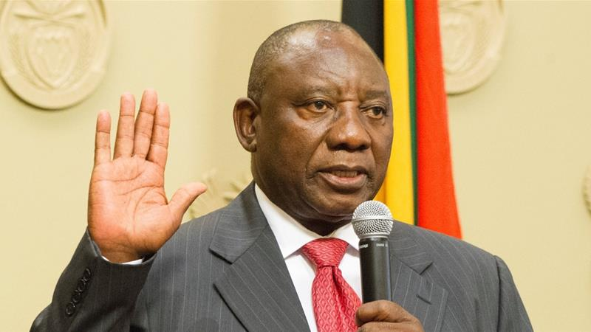
Cyril Ramaphosa
“South Africa’s Turn to Communism Exposed in U.S. by AfriForum” by Alex Newman – The New American – May 9, 2018
“DALLAS, Texas — On a recent trip to the United States, leaders of AfriForum, Africa's largest civil-rights organization, exposed the South African government's growing extremism, including official plans to steal land from European-descent farmers as well as escalating calls for violence and murder against minority communities. Indeed, violence, especially against farmers, is already off the charts.
In an interview with The New American magazine in Dallas, one stop on the trip to America that also included a stay in Washington, D.C., AfriForum Deputy CEO Ernst Roets explained how serious the situation was getting. Among the key concerns he expressed were the so-called `farm murders’ in which innocent families — falsely accused by government of `stealing’ the land — are mercilessly tortured and murdered. Thousands have been slaughtered, including babies. Meanwhile, political leaders openly sing songs advocating genocide.
Another top worry expressed by Roets and his organization surrounds the government's plans to expropriate land from white farmers without compensation. The ruling alliance, composed of the African National Congress and the South African Communist Party, is moving increasingly toward full-blown Marxism-Leninism as part of what they refer to as the `Second Phase’ of the “National Democratic Revolution.” The Parliament recently voted overwhelmingly to change the Constitution and legalize the theft of property.
At the same time, Roets said there was growing pressure targeting the Afrikaner people, their language, and their culture. For instance, authorities are increasingly forcing Afrikaans-language primary and secondary schools to accept non-Afrikaners in what many view as an effort to erase Afrikaans education. Just recently, Roets said, the courts dealt a devastating blow to the Afrikaans language at the university level, too.
The New American has been warning about the situation in South Africa, and the well-documented Communist Party affiliations of key revolutionary leaders there, for more than 30 years. More recently, this magazine began sounding the alarm in 2012 after Genocide Watch pointed to evidence of government incitement to genocide in South Africa.”

White South African farmers claiming persecution at home seek refuge in Australia - 22 May, 2018 RT
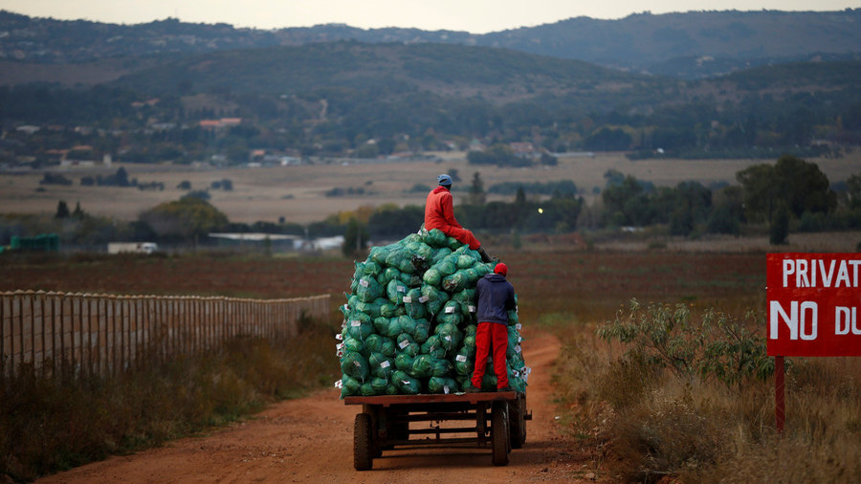
Siphiwe Sibeko / Reuters
“More than 200 farmers from South Africa have applied for humanitarian visas in Australia after allegedly suffering attacks for being white, according to the Australian Home Affairs Ministry… News reports emerged earlier this year revealing that white farmers in South Africa had faced persecution after the country's government approved a new law allowing for the confiscation of their lands, which would be transferred to black citizens… Ramaphosa pledged to hand the lands owned by white farmers since the 1600s to black citizens of the country without compensation for the owners. South Africa’s 50 million citizens are predominantly black, but 72 percent of farmland reportedly belongs to whites…
The legislation evoked strong disapproval both in the country and internationally, with a reported upsurge in violence against white farmers. Last year, some 82 people were killed in a record 423 farm attacks, and there have been 109 attacks and more than 15 murders in 2018, Afriforum, a South African civil rights group reported in March.
The controversial reform may jeopardize commercial farming in the country, according to the Transvaal Agricultural Union of South Africa. Experts say that the South African government may repeat the mistake made by the government of Zimbabwe, which had passed a state-sanctioned purge of white farmers in 1999-2000. The measure plunged the country into famine.”
Since May a lot has happened. There has been a literal slaughter of white farmers taking place. White farmers are being forced to flee from their homes and their land, to save their lives and the lives of their families.
South Africa Calls for 300,000 Gun Owners to Turn Over Their Weapons
By José Niño - Gunpowder Magazine - August 2018
“South Africa is opening the door for tyranny. The Constitutional Court of South Africa recently ruled that 300,000 gun owners must turn in their firearms… Now that the High Court’s initial ruling has been overturned, gun owners who failed to renew their firearms licenses must hand in their firearms to the nearest police station, where authorities will then proceed to destroy them.
Many naïve political observers will paint this event as a casual gun control scheme, but any astute student of politics will recognize that the floodgates are now open for further encroachments – not only on the gun rights of South Africans, but also on others facets of their lives. A look at South Africa’s current political climate will give us an idea of the potential ramifications of this gun control scheme.
…From countries such as Cuba to the Soviet Union, aspiring demagogues have used gun confiscation to disarm the populace. Logically, an unarmed populace will put up little resistance against their tyrannical acts…In South Africa’s case, farmers and their workers are already suffering ongoing attacks against their property. One could only imagine what it would be like for these persecuted farmers once they are stripped of their right to self-defense.”
Steve Quayle’s comment on this: “IF YOU WERE WHITE WOULD YOU TURN IN YOUR GUNS, WHEN THE LEADER OF S.A. HAS SUGGESTED KILLING ALL WHITES, WITH MEN WOMEN AND CHILDREN ALREADY BEING SLAUGHTERED NOW?”

“Final Warning: White South Africans Must Flee Their Country Immediately!”
Dave Hodges – The Common Sense Show – August 21, 2018
“South African Government Preparing to do the Unthinkable: Because of a high court ruling in South Africa, over 400,000-gun owners now possess illegal firearms. These gun owners are now under government order to turn their guns in. Many people around the world see this as one of the last steps to clear a path to direct totalitarian government in which genocide of White South African farmers to the ultimate goal. The South African government is known as one of the most corrupt in the world. Now it is preparing to be one of the most deadly.
Not only is the government becoming more totalitarian on guns, but it is also seizing farmland from white farmers without compensation. The disarming of the populace being just one more step in controlling the people? …
War isn’t this century’s biggest killer. The University of Hawaii maintains a site and a course on democide, which is defined as death by government. More specifically, it is genocide by government.
Recently, 15,000 White South African farmers were granted asylum by Putin, but it is not enough to ward off what is coming…
Conclusion: The Obama people took this country down a very slippery slope and Trump has done nothing to counter this police state mentality, which is the Obama legacy. They are seeking to disarm as many Americans as possible. The historical precedent, and subsequent danger, has been well-established. Therefore, I will not belabor a well-established point, that all 19 genocides in the 20th century were preceded by gun confiscation. Why should we consider Obama’s actions, and Trump’s inaction in this matter, to be any less threatening?”
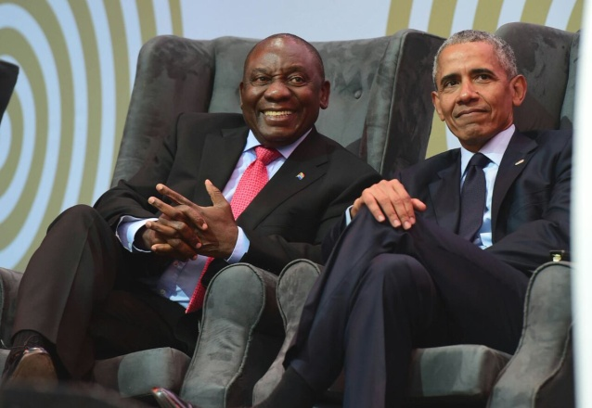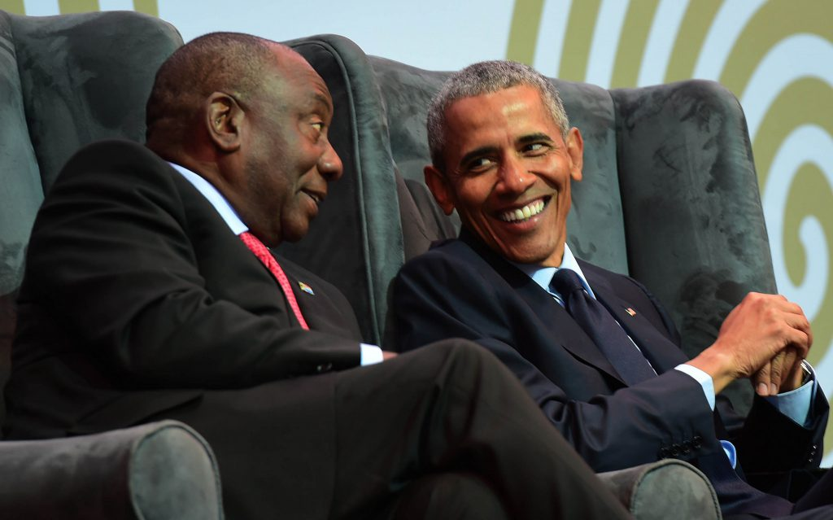
Obama with Ramaphosa at the 16th Nelson Mandella Lecture July 17, 2018

“The 'Death Lists' Have Been Drawn Up and Exterminations Have Begun: What's Happening In South Africa Today is a Look at America Tomorrow - 'A New Red Famine Is Growing Where the Red Blood of White Farmers Flows Into the Dying Earth'” By Stephen Sanford – All News Pipeline – August 21, 2018
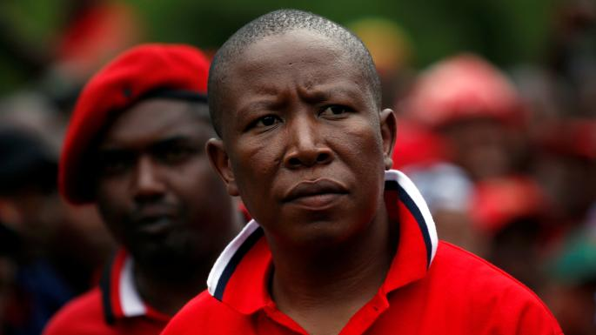
Julius Malema told people to occupy white-owned land and said South Africa was controlled from London - MIKE HUTCHINGS/REUTERS – “`We will not slaughter whites just yet,’ says South African firebrand…”
“According to the website Genocide Watch and their story `The 8 Stages of Genocide,’ the nation of South Africa under new South African President Cyril Ramophosa is now in Stages 6 and 7 leading to full-scale genocide. With stage 6 being 'preparation' and stage 7 being 'extermination', what is happening in South Africa right now should be a huge warning to Americans with former US President Barack Obama recently sharing a stage with Ramophosa at a time when efforts were being ramped up there to carry out Stage 7.
…RELATED FLASHBACK story from Gateway Pundit: `Racist South African Political Leader Julius Malema: “Go After the White Man… We Are Cutting the Throat of Whiteness”
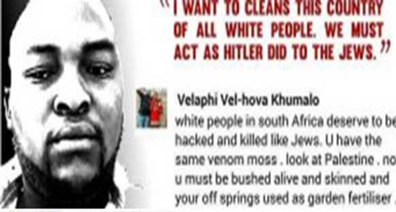
With South Africa now at the end stages of Stage 6 of genocide, the preparation stage where future victims are identified, and Stage 7 'exterminations' already being carried out there to the tune of one white farmer being murdered there because of their skin color every few days, let's take a quick look at Stage 6 and Stage 7 of genocide before proceeding… (check out the article)
From News.com.au we learn that the South African government has begun the process of seizing land owned by white farmers there after two white farmers refused an offer of one tenth of their property's value to vacate.
As Infowars reports in this new story, two different times dating back to 2017, South African Simon Roche had come on to Infowars to warn that land confiscation from white farmers was going to be happening soon. And while the completely complicit mainstream media here in America never sounded the alarm bell because seizure of land from white farmers in Africa perfectly fits the 'global socialist agenda' of gov’t ownership of all land and 'reparations', Gunpowder Magazine had reported last month that the Constitutional Court of South Africa had also recently passed a law there that required 300,000 people in the country to turn in their firearms…See how tyranny works, America?
Steve Quayle has warned us that what is happening now in South Africa is clearly part of the globalists overall agenda and as has long been warned, the disarmament of a group of people often proceeds total genocide…
As this August 8th story at Front Page Mag reported, Barack Obama himself recently shared a stage with South African President Cyril Ramaphosa, a man who had come to power by promising to seize land from white farmers while redistributing the land to others that Ramaphosa's government selects. [See photos above of Obama with Ramaphonsa]
Also reporting that one white farmer is being murdered in South Africa every 5 days, their story warns that the ethnic cleansing that is now being undertaken there with the full support of the South African President who had just met with Barack Obama tells us more than we'll ever get from the mainstream media.
From the Front Page Mag story: `South Africa’s agricultural sector has been steadily in decline.’ Farms used to provide millions of jobs. Now they offer less than a million. Wheat planting has fallen to a third, cotton to a tenth. A country that once exported wheat, is now importing millions of tons while its agriculture sector fails. The decline of South Africa’s agriculture has gone hand in hand with what it euphemistically calls its land reforms. White farmers have been murdered or driven off their land. But land seizures, legal and illegal, with compensation or with a hatchet, haven’t made South African agriculture more productive. Instead South Africa is becoming increasingly dependent on agricultural imports to feed its people.
Like Zimbabwe, South Africa is due to revisit the same implacable economic consequences of land seizures that took the Soviet Union down the road to famine and terror. Toward its end, the USSR, despite possessing territories that had once bulged with rich harvests, had gone deep into debt to buy food from the United States. The African National Congress’ Communist roots are taking South Africa down the same path as its fallen Communist masters, and with the same miserable results…
The Atlantic `How To Kill A Country’ subtitled `Turning A Breadbasket into a basket case in 10 easy steps - the Robert Mugabe Way’ documents Rhodesia's fall after a mass eviction of white farmers from the nation: `The country's economy in 1997 was the fastest growing in all of Africa; now it is the fastest shrinking. A onetime net exporter of maize, cotton, beef, tobacco, roses, and sugarcane now exports only its educated professionals, who are fleeing by the tens of thousands. Although Zimbabwe has some of the richest farmland in Africa, children with distended bellies have begun arriving at school looking like miniature pregnant women.’
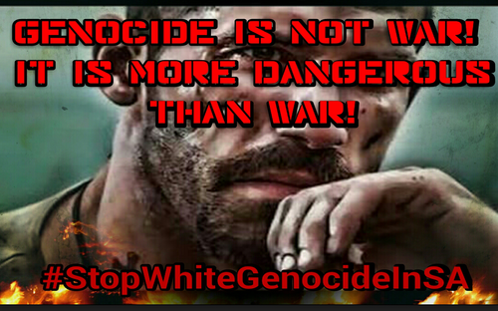
And as Breitbart UK recently reported, the British government appears to be whole-heartedly backing the so-called 'land reforms' that are taking place in South Africa that they describe as 'Soviet-style expropriation without compensation'. Why would the government of the UK back white genocide? More proof the UK has fallen to tyranny?
…Once again, from this very important Front Page Mag story: `Meanwhile the plight of South Africa’s white farmers continues to be ignored. The ANC genocide has been slowly unfolding for a generation with the complicity of the same leftist leaders who covered up Communist genocides in the Soviet Union, Communist China and Cambodia…This will only encourage a further outpouring of racist attacks on white farmers…’ South Africa, like the Soviet Union and Venezuela, like Cambodia and Cuba, is not just an atrocity, it’s a cautionary tale. Ideology, more than race, connects the scattered strands of the leftist killing fields. To pretend that what happened there cannot happen here would be ignoring the lessons of history.
And a new red famine is growing where the red blood of white farmers flows into the dying earth.”
Infowars.com - August 23, 2018: “The South African government is openly seizing land from white farmers and killing them. President Trump spoke out on Twitter, calling for Secretary of State Mike Pompeo to “closely study the South Africa land and farm seizures and expropriations and the large-scale killing of farmers.”
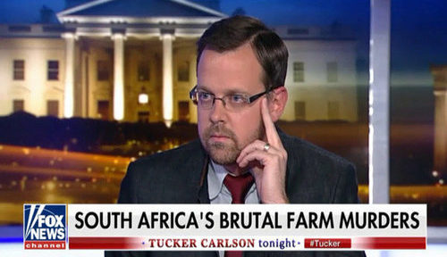
Fox News is reporting …
Dear brothers and sisters: Learn, and apply what you learn to what you are seeing in America, in the U.K., in Australia, and in Europe. The creation of race wars is just another way for nations to subjugate and takeover their people.
What you are seeing here in South Africa with the confiscation of land and property without compensation is simply the takeover of Communism, aka Nazism (National Socialism), Fascism, or Feudalism. All these forms of government take from hard-working citizens to give to the lazy and the greedy.
According to the Executive Order signed by Barack Obama December 31, 2011, as I wrote in “U.N. Peacekeeper Troops in America, Violence, Covert Agendas, and the Disappearance of 21 Trillion Dollars”/Mikvah of Present Reality, the U.S. government can take whatever you own and give it to whomever they wish, including your children. You can be arrested for saying anything the government doesn’t like, being accused of being a terrorist with no legal assistance – just imprisonment with no legal rights at all, or “re-education” in FEMA camps, or death for those that “resist.”
What is happening in South Africa is endorsed by the Pope and the Globalist Elite – it’s pure Communism. It is already written as an Executive Order in detail by Obama. Please read: “The New Executive Order,” (use the search menu) which gives details. Americans: Your property is not yours, your children are not yours, your money is not yours--we ARE under a communist (Nazi-Fascist) regime!
Wouldn’t it be wise to lay down your life now in service to the Master while you have a chance? His promise is still: Luke 18:28-30!
Remain in Shalom, pray, praise, proclaim, and hearing Yahuwah’s Spirit.
In His love, Yedidah
August 23, 2018

