THE CROSSING POINT

THE BEGINNING OF FULL SCALE WWIII

The provoking of Russia, the breaking of all treaties ever made with Russia by the U.S. and NATO, the vilifying of President Putin, the Biolabs in Kiev specializing in diseases created for specific Russian ethnic groups, the lying propaganda of western news, the mocking of Putin’s simple requests to protect his people, the lies, the deceit, the propaganda, the mind-programming, the attacks on Russian infrastructure and productivity – all of this evil was drummed up in the Luciferic mind of the programmers of President Biden and the NATO hierarchy in order to blame Russia for what they did – to make Russia the bad guy in the eyes of the world, knowing their superiority in weaponry and military worldwide – to invoke Russia to attack the U.S. and do for China what China wants – i.e. the death of every man, woman, and child in America, as stated publicly.

The scriptures are clear in detail: i.e. **Isaiah 13, 47, the book of Nahum, Jeremiah 25:11-12, Jeremiah 50-51, Revelation 18** (NYC). Those are main ones. America was given 70 years before judgment. It began in August of 1945 when Japan surrendered for the second time to the U.S. America became the great super-power of the world. America used those 70 years (1945-2015) to corrupt the entire world with drugs, with pornography, with child-sex trafficking and slavery, with abortion, with the trafficking in dead baby body parts, with violent music, violent movies, the introduction of demons and other fallen angels-opening portals ad doorways into the cosmos and the underworld for their entrance into earth, and on an on. If it was on the heart of Lucifer, America did all to make sure he was appeased.

In 1945, Operation Paperclip began – the bringing in of hundreds of Nazi scientists, school teachers, mind-programming specialists, space travel experts, into the United States of America to take over in all fields to begin destruction.

In 2003, America created Gulf War II in order to get into Iraq and exhume the body of Nimrod, fly it to the U.S. for cloning under the guidance of the Pentagon and DARPA scientists. The plans of Nimrod, aka Osiris, aka Apollo/Apollyon (**Revelation 9:11**) for his tower (Genesis 11) were found and given to CERN who has been busy opening portals with Nimrod’s instructions. Finally, DARPA scientists were terrified, but proud, that they found a way to reinstate his spirit within his clone – amidst the groaning and moaning inside the sealed vault under the Denver Airport.

Thus, now that America’s secret destiny has been fulfilled, to reinstate Nimrod into the land of the living, America is no longer needed. It’s people for 120 years, from the return of the original 120 fallen angels in 1896 to 2015/2016, used as their guinea pigs for experimentation on body and mind, emotions, and will, turning the American people into will subjects for Lucifer. Now we note that Christianity has fallen suit, for the most part, and is teaching much heresy, even denying the Savior who bought us back to the Father by His own blood. The strong and hearty American people went from the “Little House on the Prairie” types to weakened people, giving in to horrendous sin openly with pride. A people who have given in to Lucifer and the fallen angels. A people in love self-gratification - ease, comfort, convenience, materialism, wealth, power - mind-programmed from childhood.

So, finally, to start WWIII, as the Mazzini/Pike Plan of 1871 wrote out so well by Albert Pike of the Scottish Rite Free Masons in America, and Giuseppe Mazzini, leader of the Illuminati wrote out in detail. WWIII finally designed to usher in the long-planned new world order. Please refer to: “America’s Secret Destiny,” and America’s 70 Years, Mikvah of Preparation” for details. It was planned as far back as the 1500s.

The removal of all solid foundation on righteousness has been removed, and those who still stand for the righteousness of our Creators are considered terrorists by the intelligence agencies on their list of 71 – i.e. “Evangelical Christians.”

Thus, we see this nation under Lucifer provoking a professing Christian nation, Russia, vilifying their President, lying through their teeth about everything, to make the world cheer on the U.S. and NATO and despise Russia. China has joined Russia now, as has North Korea, and Iran, and soon Germany will also, and other nations.

The weak militaries of the US, purposely weakened by President Obama, and NATO, are bold in speech, but could not stand up to anything in Russia’s arsenal. Russia’s weapon technology is mind-boggling. One bomb can take out all of New York City and surrounding area. In fact, it was declared that technologically only 4 of Russia’s supersonic bombs of massive size could take out the major cities of America. This would correspond to **Jeremiah 50-51**, where nations of the north would destroy New York City (**Revelation 18**) in one hour, and the nation in one day. From launch to impact – 90 seconds off shore. Russian submarines are in U.S. waters, as are Chinese, Russia and China and North Korea are sitting, waiting, on the north border, and in Venezuela Russian missiles are aimed at the Gulf cities.

Americans think everyone thinks like they do – that’s a laugh. I’ve lived overseas in 4 countries, in the Middle East 16 years, been to 36 nations, including Russia and China, and their thinking is entirely different. The spirit of ancient warriors is the Middle East and Asia – no game playing, no verbal trickery – just straight talk and straight action – something America does not fathom.

Here are eight pictures and two maps from an update on Russia in Ukraine. Not only did America blow up the Russian Nord Stream I and II pipelines that brought natural gas from Russia to Germany, but sabotaged the Crimea Bridge in the last few days. It was all blamed on Russia – blowing up their own possessions. Yet, such ridiculous lies are believed. Faith in liars is a dangerous mind-set.

Russia has had enough. Putin has tried and tried from the beginning to bring peace. The West wants no peace. They want annihilation and a one world government. They want to rid the earth of all competition – from those believing in a Creator, a Savior, the Bible and its laws against sin. So yesterday Russia has begun bombing, not full power by any means, but to let them know he’s had enough of trying to make peace.

I ask you to pray for President Putin and the Russian people. I spent 3 ½ months in Russia working with Ebenezer and the Jewish Agency. I learned a lot about the people, about their nation, about their ways of doing things. It was probably my most miracle-packed 3 months of my entire life.

**8 PICTURES, 2 MAPS – REPORTING OCTOBER 10 2022**

**News as Steve Quayle reports: “Russian Duma announces that the West has made a declaration of war without rules. Now we find that the Crimean Bridge was destroyed an AMERICAN missile.”**

**Hal Turner: “RUSSIAN ATTACKS MASSIVE INSIDE UKRAINE OCT 10, 2022”**

**“MASSIVE RUSSIAN ATTACKS IN PROGRESS INSIDE UKRAINE; Zelensky's Office Hit By Missiles!”** [World](https://halturnerradioshow.com/index.php/en/news-page/world) [Hal Turner](https://halturnerradioshow.com/index.php/en/authors/author/HalTurner) 10 October 2022 Hits: 31312

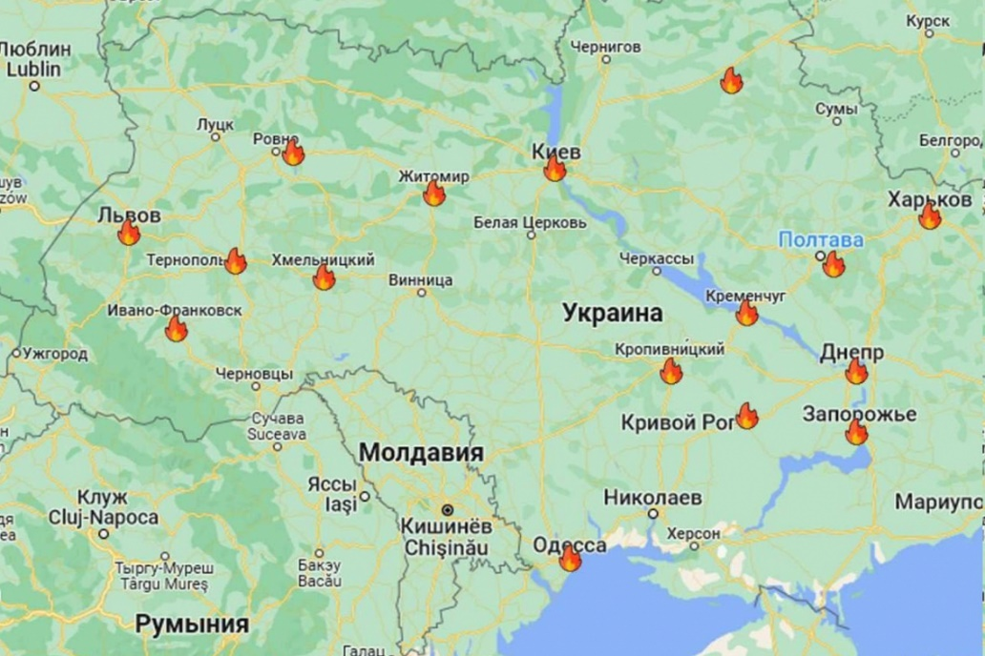

**After the bombing of the Crimea Bridge by Ukraine, it appears Russia's "Kid Gloves" have come off.  Kiev, and a dozen other cities in Ukraine, are under Russian missile attack.  Russian Fighter jets and bombers saturate the skies.  Damage is heavy, and continuing . . .**

This is a fast-developing story, check back for LIVE updates . . .

**UPDATE 9:30 AM EDT --**

Attack in central Kiev: Now, Kiev residents know how the people of Donetsk felt as Ukraine pounded their city for years . . .

[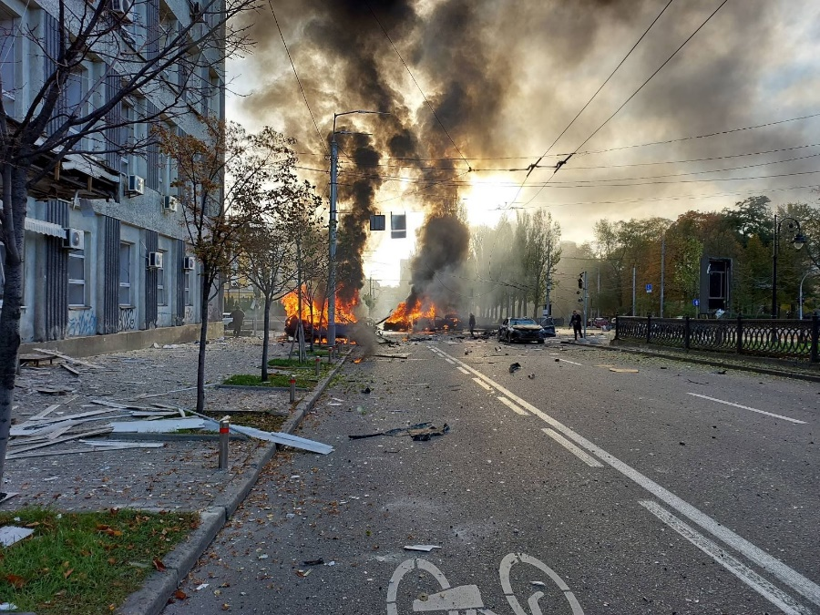](https://halturnerradioshow.com/images/2022/10/10/10-10-2022-CentralKievMissileHit-1.jpg)[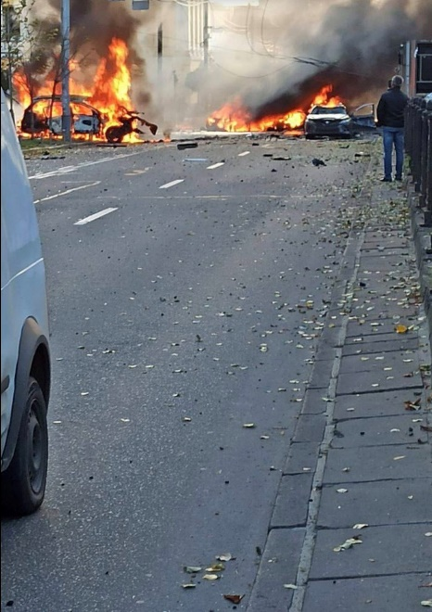](https://halturnerradioshow.com/images/2022/10/10/10-10-2022-CentralKievMissileHit-2.jpg)

**INSERT**: **Info wars comment**: Professor Sachs: ‘Ukraine Needs To Stop Bombing Nuclear Power Plant And Blaming it on Russia’ [by Steve Watson](https://www.infowars.com/author/12/) October 10th 2022 Infowars

[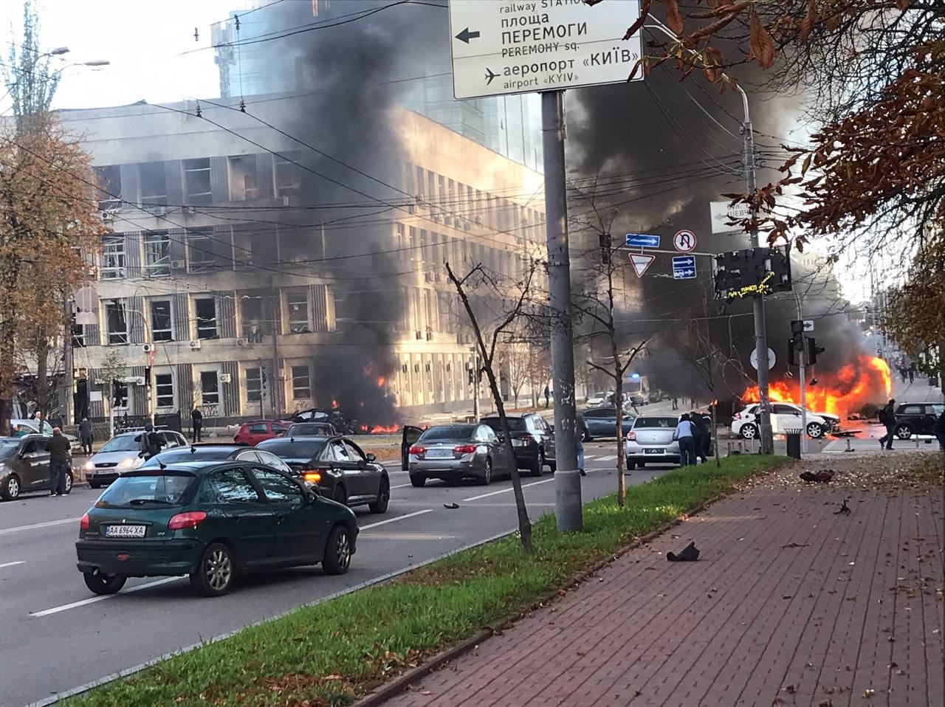](https://halturnerradioshow.com/images/2022/10/10/MoreMissileStrikesUkraine.jpg)

**Ukraine President Zelensky's Office hit by Russian missile strike!**

**UPDATE 9:40 AM EDT --**

During the night, Russia deployed twenty-thousand (20,000) troops on the border between Ukraine and Belarus!

**Also, 9:42 AM EDT --** Mykolaiv region now reports a large number of Russian jets attacking.

City of Lviv has lost electric power

Deputy Chairman of the Russian Federation Council, Dmitry Medvedev, issued a statement saying "**a direct response to the terrorist act of Ukraine on the Crimean bridge "can only be the direct destruction of terrorists."**

**9:44 AM EDT --** **The office of Ukrainian Secret Intelligence Service, (SBU), was hit in Kiev -- Video below:**

**9:48 AM EDT --** **SIGNIFICANT RUSSIAN ATTACKS ARE CURRENTLY UNDERWAY IN ALL PARTS OF UKRAINE \*\*\***

**9:55 AM EDT --** Another series of explosions throughout Ukraine. It is reported that the attacks are made on government, military, Intel infrastructure. Russian missile attacks have been reported in multiple cities across Ukraine, including in Dnipro (VIDEO BELOW), Lviv, Zhytomyr, Khmelnytsky and Ternopil.

[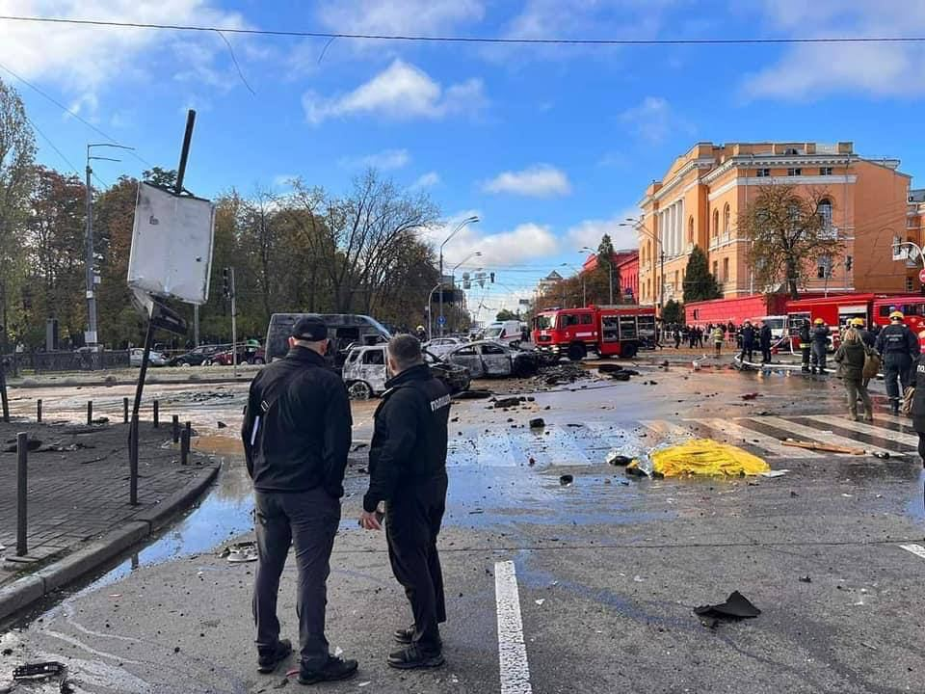](https://halturnerradioshow.com/images/2022/10/10/MoreMissileStrikesUkraine-2.jpg)[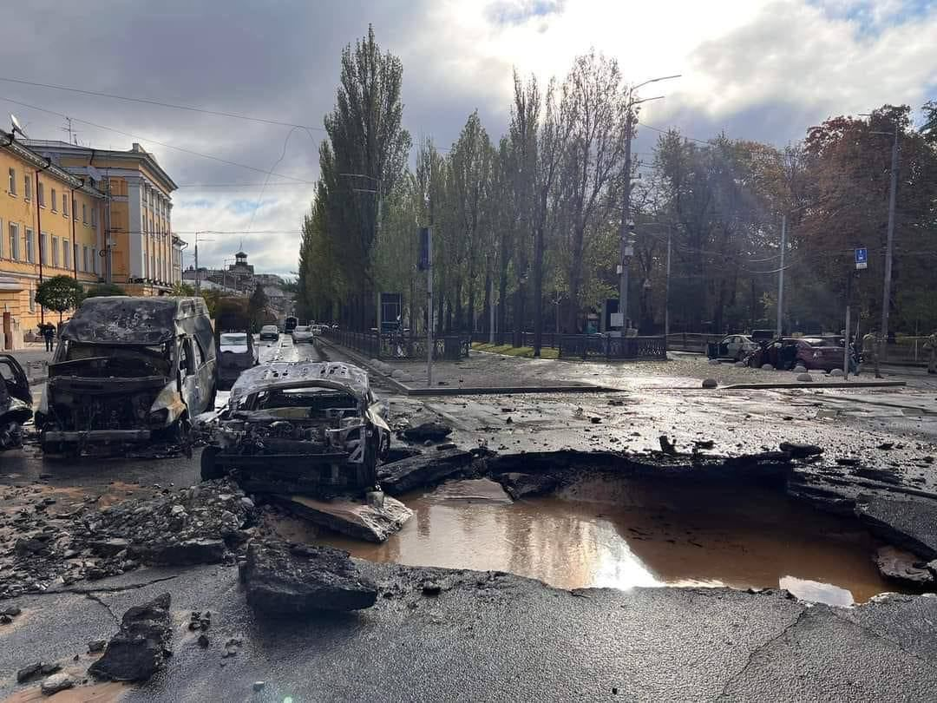](https://halturnerradioshow.com/images/2022/10/10/MoreMissileStrikesUkraine-3.jpg)

**UPDATE 10:00 AM EDT --**

City of Lviv Thermal Power Plant destroyed:

[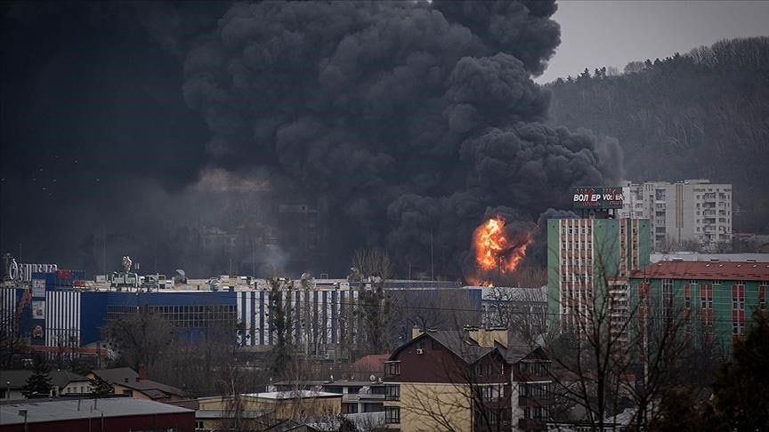](https://halturnerradioshow.com/images/2022/10/10/Lviv-thermal-power-plant-destroyed.jpg)

**UPDATE 10:15 AM EDT --**

Video of missile hit in Dnipro:

-- **REPORTS OF MORE THAN A DOZEN MISSILES LAUNCHED FROM THE BLACK SEA**

**-- Kharkov metro trains have stopped working**

**-- Ukrainian railways report damage to the contact network in Western Ukraine and train delays.**

 -- **75% of internet traffic is lost in Ukraine, netblocks data**

**UPDATE 11:22 AM EDT --**

**Kiev Thermal Power Plant #6, destroyed:**

**Kiev "101 Business Center" Hit:**

**MORE:**

**-- Explosions are reported in Krivoy Rog.**

**\*\*BULLETIN \*\***

**Russia: "We disabled the "Starlink" satellites" being used by Ukraine Army.**

**-- US EMBASSY IN KIEV:  
  
"The U.S. Embassy urges US citizens to shelter in place and depart Ukraine now using privately available ground transportation options when it is safe to do so."**

**-- Russian President Vladimir Putin had a top-level video conference with his National Security people this morning:**

**[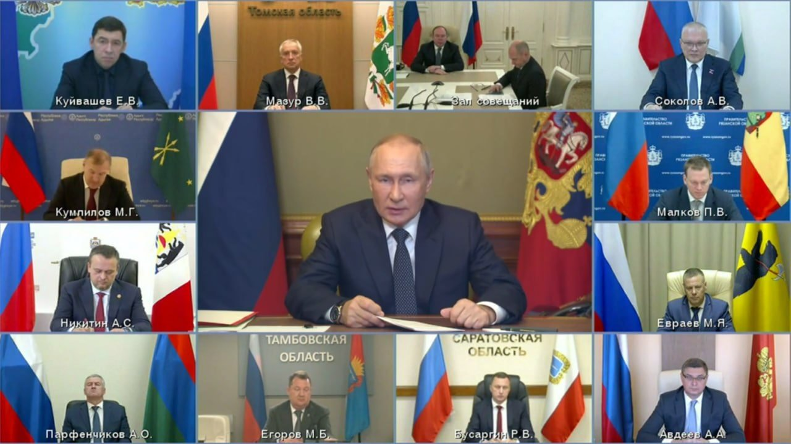](https://halturnerradioshow.com/images/2022/10/10/PutinVideoConferenceWithTopRussianOfficials.jpg)**

**-- WATER AND ELECTRIC INTERRUPTION IN KHARKIV. TOTAL BLACKOUT IN KHARKIV**

**\*\*\*\*\* FLASH \*\*\*\*\***

**BULLETIN - URGENT - URGENT**

**German Embassy in Kiev hit by Russian air strike, BILD reports.**

 (**HT REMARK:** If this is true, then German Territory has been "attacked" by Russia.   Germany may try to invoke NATO Treaty, Article 5, collective self defense.  If they invoke it, and NATO agrees, then World War 3 has officially begun.)

 [Note from Quayle 6:06 October 10th – **the German Embassy was an abandoned building since February 2022 – no one was in it, no one was injured**]

**-- Lviv has lost its water supply**

**\*\*\*\*\* FLASH \*\*\*\*\***

**UPDATE 12:40 PM EDT --**

**NATO CAUGHT HOUSING ACTIVE-DUTY ARMY TROOPS FROM NATO COUNTRIES, IN ZAPOROZHYE; Planning surprise offensive using those troops! Russia ATTACKED the housing blocks where those NATO troops were being housed, including five-thousand (5,000) Polish regular, active-duty troops. The Russian missile strikes killed so many, NATO had to call-off the surprise offensive. Here's a photo of the housing block where the NATO troops were being housed in Zaporozye, Ukraine:**

**[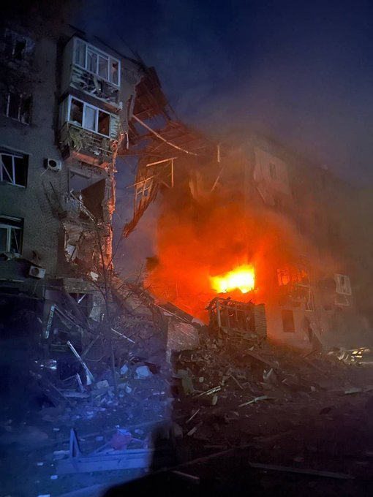](https://halturnerradioshow.com/images/2022/10/10/NATO-Troops-Zaporozyhe.png)**

**Now reports going around from Ukrainian media that mobile communications are down all over Kharkov Oblast.**

**UPDATE 12:44 PM EDT --**

**Statement by President Vladimir Putin:  "it is simply impossible to leave the crimes of the Kiev regime unanswered.  In case of continued attempts to carry out terrorist attacks on the territory of the Russian Federation, the responses will be tough and correspond to the level of threats."**

**UPDATE 12:58 PM EDT --**

**Electric grid connections from Poland to Ukraine now destroyed.   Power cut.**

**-- Estonia is preparing to formally recognize Russia as a terrorist state, chairman of the foreign affairs committee of the Estonian parliament**

**-- Russia's Medvedev, deputy chairman of the Russian Security Council, says Ukraine strikes only "first episode" of response.**

**UPDATE 1:02 PM EDT --**

**Total electricity blackout in Lviv, Ternopil, Sumy, Kharkiv, Poltava regions after Russian missile strikes at critical energy infrastructure in Ukraine.  Map below:**

**[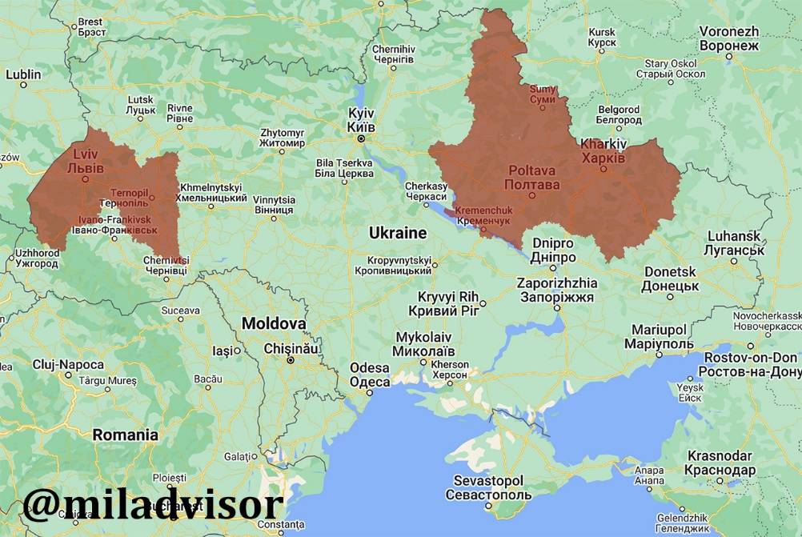](https://halturnerradioshow.com/images/2022/10/10/BalckoutMap-10-10-2022.jpg)**

**UPDATE 1:28 PM EDT --**

**From October 11, Ukraine stops exporting electricity to other countries to stabilize its own energy system, - Ukrainian Ministry of Energy**

**\*\*\* BULLETIN \*\*\***

**Poland advises its citizens in Belarus to leave the country.**

------------------------------------------------------------------------------------

In conclusion: I RECOMMEND THAT YOU KEEP UP WITH THESE IMPORTANT REPORTS BY SUBSCRIBING TO HAL TURNER’S SITE, WHICH ALSO HAS RADIO PROGRAMS, AND STEVE QUAYLES PRIVATE BRIEFINGS AND BROADCAST (stevequayle.com) Around 2005, Abba gave me Steve Quayle as a truth-filled gift!

OR, EVERYDAY, CHECK THE MOST IMPORTANT EVENTS FROM TRUTHFUL SOURCES AT stevequayle.com. STEVE QUAYLE POSTS HAL TURNER’S ARTICLES.

… PRAY FOR THE PEOPLE INVOLVED WHO ARE SUFFERING AND HAVING TO MAKE DECISIONS THEY DO NOT WANT TO MAKE – LIKE PUTIN, LIKE HIS DUMA, LIKE HIS PEOPLE, AND ALSO FOR THOSE IN THE NATIONS PERPETRATING THE LIES TO CAUSE DESTRUCTION. Lots of suffering, and a lot more to come because of lies.

HUMANS ARE CREATED IN THE IMAGE AND LIKENESS OF YAHUWAH. PRAY THAT THROUGH THIS MANY WILL FIND THE SAVIOR TO CLING TO – WHETHER THEY CALL HIM JESUS, OR ISA, OR YESHUA, OR YAHUSHUA…

In the savior’s love, Chag Sameach! Yedidah - October 11, 2022

**Sukkot begins tonight for 8 days … blow the shofar at the full moon (Psalm 81:3) Celebrate the Feast of Tabernacles … Messiah will tabernacle among us in His Kingdom! HalleluYah Revelation 11:15-19!**