THE DANGEROUS BUILD UP ON AMERICA’S WEST COAST, EAST COAST, GULF COAST, AND BORDER WITH CANADA RIGHT NOW!

Brothers and sisters, I’ve been reporting on this for some time – however here we have a situation that has the potential to set in motion Jeremiah 50-51 and Revelation 18, also Isaiah 10 and 13, compacting end-time events even more. Like I said, once Abba Yahuwah gives the word to let all end-time prophecies fly forward, we’re going to either cross the Red Sea to the other side in the power of His might, or be trampled by Pharaoh’s army.

Stevequayle.com December 8, 2020: “*HIGH ALERT*~ *ENORMOUS FLEET OF VESSELS IS NOW ALREADY ON ITS WAY TO THE WESTERN HEMISPHERE(!)” Hal Turner Update-article
SQ; “AMERICA IS PREPARED TO FIGHT A 4 FRONT WAR AGAINST CHINESE ATTACK-WEST COAST, EAST COAST, GULF COAST, AND CANADIAN BORDER”
The enormous fleet of naval vessels that is on its way – belong to Iran. This fleet is on its way to Argentina. Iran and Argentina are uniting. As Quayle says: America is prepared to fight on our west coast, east coast, north border with Canada, and in the Gulf. Cuba also sits near the Gulf, if they get into the fray. Online: “Iran is sending its biggest fleet yet of oil tankers to Venezuela filled with fuel in defiance of U.S. sanctions to help the isolated nation”
Iran joins with Venezuela. Russia has joined with Venezuela. Russia has put rocket launchers in Venezuela turned towards the U.S.

From Zero Hedge December 6, 2020
“The 'Biggest Ever' Flotilla Of Iranian Tankers Is En Route To Venezuela With Fuel by Tyler Durden -- “
“The daily American military newspaper Stars & Stripes alongside Bloomberg reports this weekend that Iran "is sending its biggest fleet yet of tankers to Venezuela in defiance of U.S. sanctions to help the isolated nation weather a crippling fuel shortage," based on sources familiar with their movements…This appears to be the first instance Iran has sent such a large fleet, which may potentially include smaller military escorts or patrols, or even armed commandos on board. Things could get `interesting,’ especially when Iran crosses the Caribbean Sea, given the concentrated presence of US Navy war ships there.”
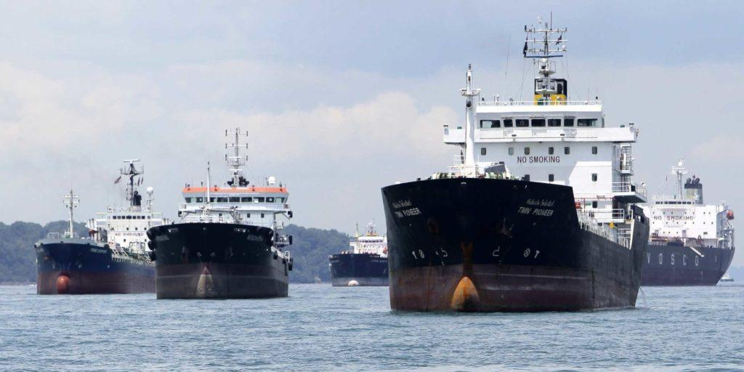

I’m sure some of you have been keeping up with the presence of China on the West Coast and in the Gulf, and on the Canadian border with America, and Russia on the East Coast, and other nations in league with them, like North Korea, Iran, Venezuela, Cuba, France and Germany. But, right now, the American Navy, and Army, Air Force, and Marines are in high alert – especially the Navy.
Here is the latest report. Hal Turner is keeping up with this closely to do with the build-up of China in the South China Sea, to do with Taiwan, and Japan, and the U.S., as well as right off our shores here in America. They’re also fighting a war with India. But, folks, the military ability of China and Russia is greater than the military technology of America. They have supersonic missiles that we can’t shoot down. They have space technology we don’t to shoot at targets on earth from outside our atmosphere. When their attack begins, it will be focused and over with in a short time.
Here is the most recent report from Hal Turner, from Quayle’s site:
“OMINOUS: U.S. POSITIONING NAVAL VESSELS OFF EAST & WEST COASTS; MASSIVE TROOP MOVEMENTS IN CONUS” HAL TURNER 08 DECEMBER 2020

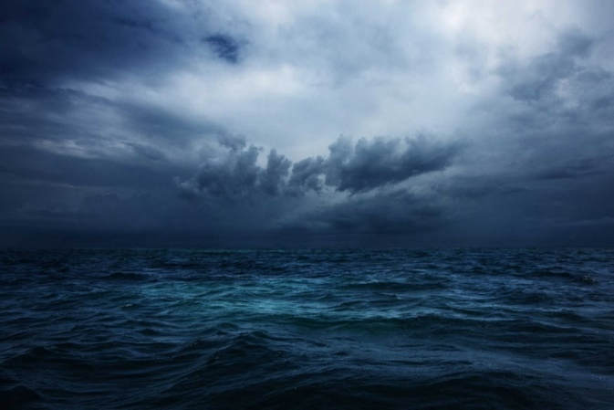

Over the past four days, there have been MASSIVE movements of troops, equipment and supplies WITHIN the continental United States (CONUS).
Today (Tue., Dec, 8), the US Navy is positioning Aircraft carriers and their strike groups off both the US east and west coasts. It appears we are preparing to defend ourselves from an invasion. China?
Late Saturday, no fewer than 25 C-17 aircraft were in the skies over the USA, carrying troops and equipment from around the nation . . . ALL going to Nellis Air Force Base. Also, late Saturday, no fewer than 12 C-130 aircraft were also on the move, ALSO ALL heading into Nellis. On Sunday, locals on and around Nellis reported the base was "swarming" with soldiers and Marines. They also reported seeing a vast array of land fighting vehicles coming out of cargo aircraft.
NAVAL DEPLOYMENTS
This morning (December 8th), according the US Naval Institute, the Navy has deployed THREE (3) Aircraft Carriers, plus a Landing Helicopter Dock (LHD) off the US West Coast, and TWO (2) Aircraft carriers and their Strike Groups plus another LHD off the US East Coast. Off the West Coast is the USS Carl Vinson in the Pacific (NOT AT PORT) along the Oregon/Washington Border,
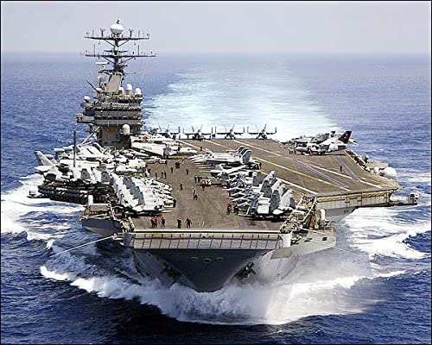
the USS Essex (LHD) off the coast of San Francisco,
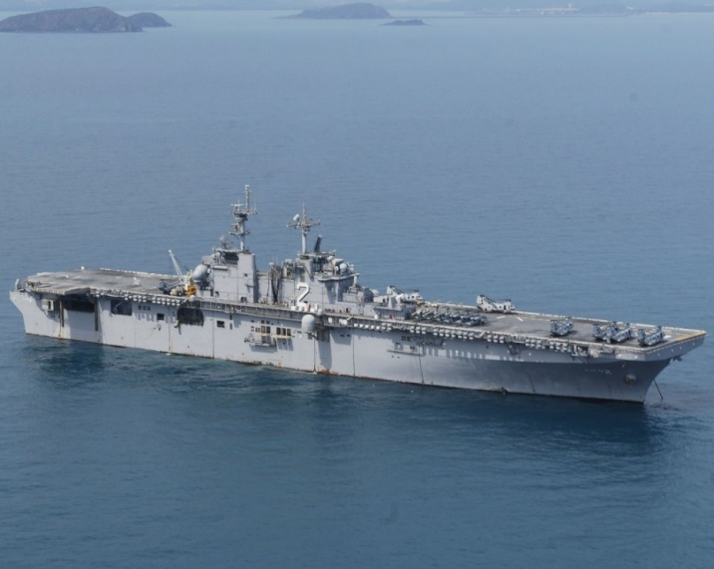
and the USS Theodore Roosevelt and its Strike Group off the coast of Los
Angeles

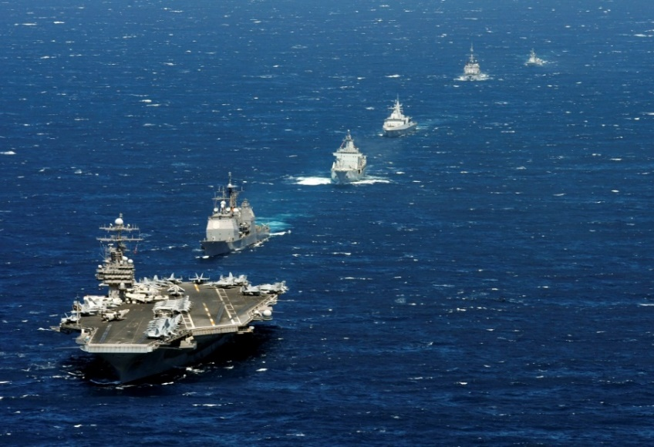
Off the East Coast are the USS Dwight D. Eisenhower off the Coast of Connecticut,

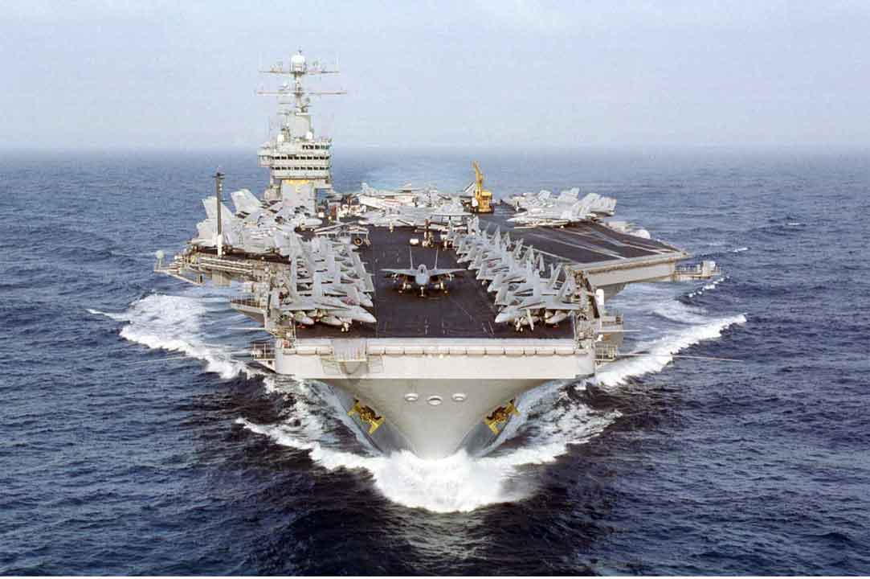
the USS Gerald R. Ford off the coast of New Jersey,
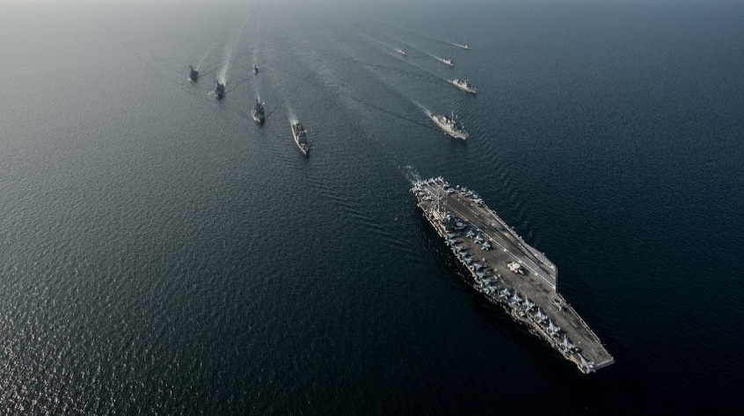
and the USS Iwo Jima off the coast of South Carolina . . .
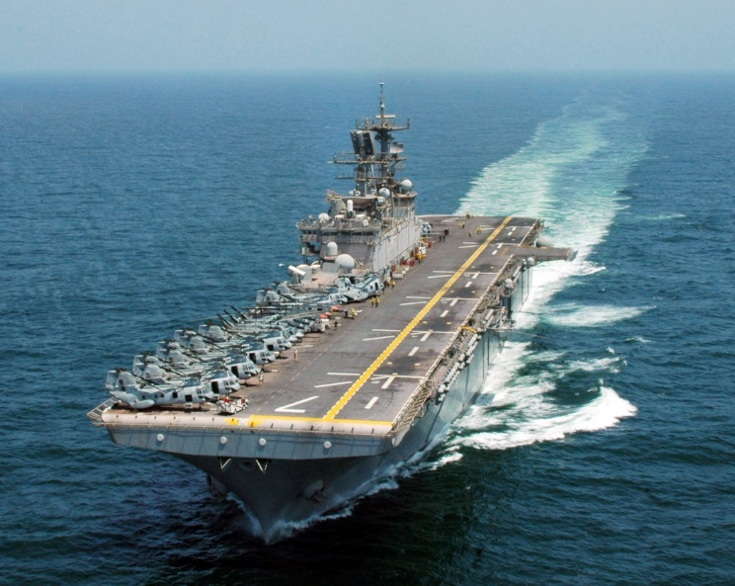
The map below lays out the approximate location of the vessels:
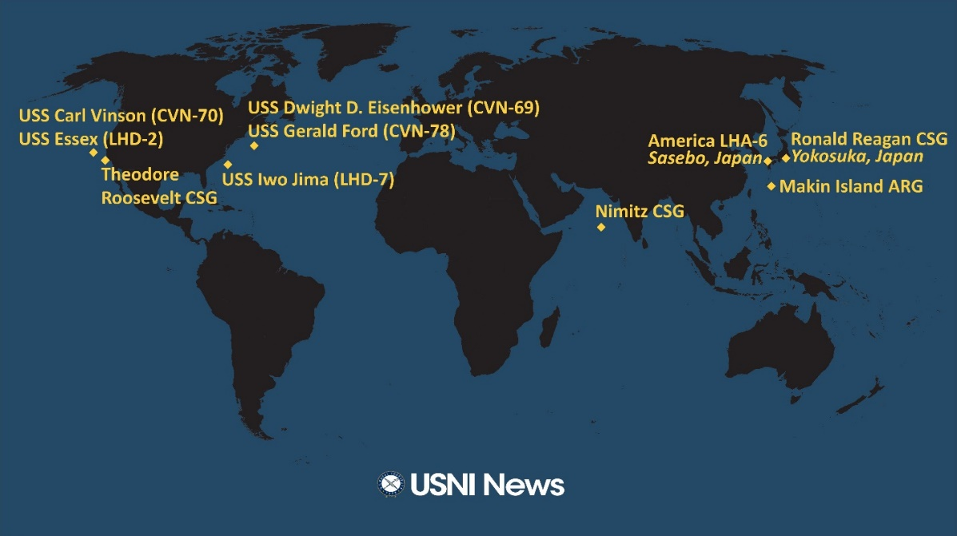
Given these new naval deployments, and the very large, sudden, movement of troops into Nellis AFB, one gets the impression that the United States is preparing to defend its homeland from actual invasion.
Hint: That may actually be the case.
Word in Intelligence circles says that if the Supreme Court voids any or all of the November 3 election due to the massive fraud and violations of the US Constitution with changes to election laws, the lawless extension of voting for weeks, in violation of 3 USC 1 & 2, the Democrats are planning on asking the United Nations to INVADE to depose Trump as a "Dictator." There is also word within Intelligence circles that the states of California, Oregon, and Washington, plus New York, might actually try to secede from the Union if Trump gets four more years, and may need to be forcibly brought back under US control, the same way renegade southern states were handled back in the 1860's Civil War."
China and Russia are deploying their naval assets in such a way that transit to the US would not take long! China is positioning out in the Pacific. Just this morning, the British revealed they have been tracking "the entire Russian Northern Fleet" off the British Coast this month, as the Russians head out into the North Atlantic for something.
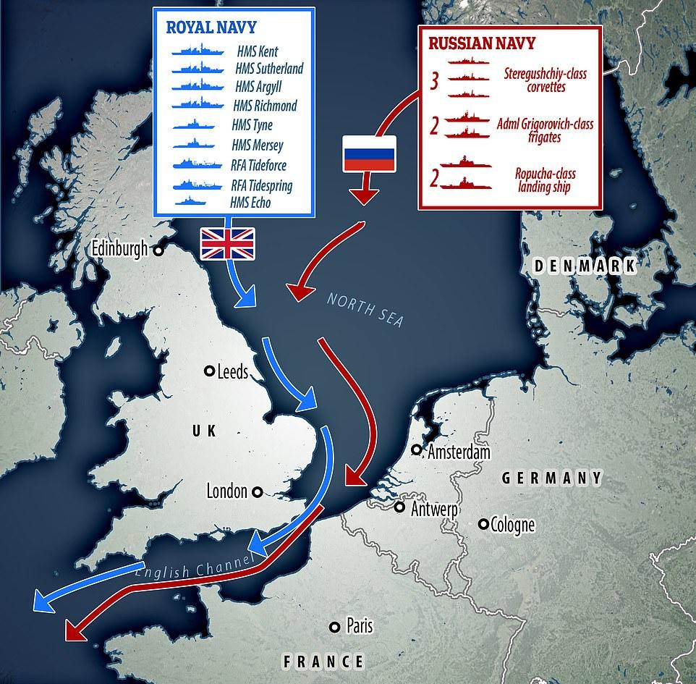
One possibility is they are heading toward the Mediterranean to deal with Syria and perhaps Turkey. But what if they're **NOT** going into the Mediterranean?
What if they're positioning out in the Atlantic to arrive as "requested" along the US East Coast? It sounds corny, but we won't know until we know and that will be a few days. Stay tuned folks. We're seeing history unfolding.”

All we can do is be prepared mentally, emotionally, physically in obedience to the Master’s directions, and spiritually attuned to Him at all times – much in prayer, much in praise – much in peace.
Yahuwah is compacting. Let nothing surprise you or take you off guard. Stay spiritually clothed in His armor, especially having on the helmet of salvation - your hope of deliverance.
Psalm 140:7-8: “Oh Master, my saving strength. You have covered my head in the day of battle.”
I Thessalonians 5:8: “You who are of the day should be sober, putting on the breastplate of faith and love, and as a helmet the expectation of deliverance.”
Keep your head covered with faith, knowing that our Abba is a deliverer!
Happy Hanukkah – beginning tomorrow night. Shalom, Yedidah, December 9, 2020

