**THE ELIJAH INTERFAITH INSTITUTE MOUNTING MT. SINAI NOVEMBER 13, 2022**

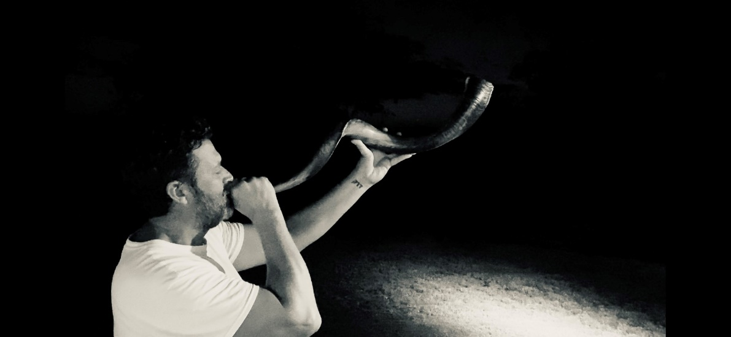

Blow the Trumpet in Zion! Warn the people! The army of Lucifer is gathering for the destruction of all life on earth! **Joel 2:1-2**: “[Blow](https://biblehub.com/hebrew/8628.htm) [the ram’s horn](https://biblehub.com/hebrew/7782.htm) [in Zion;](https://biblehub.com/hebrew/6726.htm) [sound the alarm](https://biblehub.com/hebrew/7321.htm) [on My holy](https://biblehub.com/hebrew/6944.htm) [mountain!](https://biblehub.com/hebrew/2022.htm) [Let all](https://biblehub.com/hebrew/3605.htm) [who dwell](https://biblehub.com/hebrew/3427.htm) [in the land](https://biblehub.com/hebrew/776.htm) [tremble,](https://biblehub.com/hebrew/7264.htm) [for](https://biblehub.com/hebrew/3588.htm) [the Day](https://biblehub.com/hebrew/3117.htm) [of the LORD](https://biblehub.com/hebrew/3068.htm) [is coming;](https://biblehub.com/hebrew/935.htm) [indeed,](https://biblehub.com/hebrew/3588.htm) [it is near—](https://biblehub.com/hebrew/7138.htm) a day of darkness and gloom, a day of clouds and blackness.”

I suggest you review “The Day of Yahuwah” #36.0 Present Reality – when Yahuwah’s judgment turns to wrath just before Yahushua returns as King of kings!

Abba led me to information about this interfaith group for several reasons. It’s not just any group that is ignoring Yahuwah and Yahushua, but a very specific group including sustainable development and religions of pantheism, that have great Luciferic overtones of Nimrod – poking Yahuwah in the eye with his “tower” along the path of eradicating He and His Son all together – the goal of Nimrod in **Genesis 11**. First, I will introduce this group.

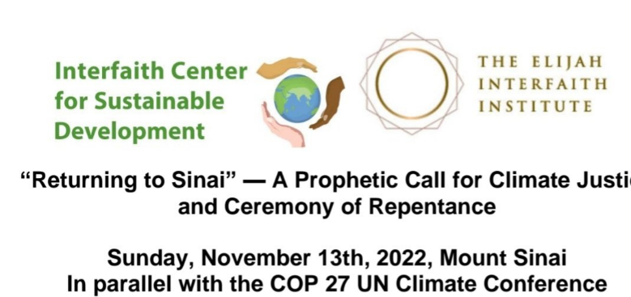

Here comes an “interfaith” group of pagans, worshippers of spirits, nature worshippers, pantheists – many gods – calling themselves “the Elijah Institute - who worship the gods of Ba’al, Ashteroth, Gaia, and thousands of other gods in the Hindu group. It’s ludicrous of course!

Now, they want to climb Mount Sinai in Saudi Arabia, the mountain the real Moses climbed to get the Ten Commandments from Yahushua (Exodus 19-20), to “repent” of harming the earth, and laying down 10 commandments to save the earth. They love the creation more than the Creators, having denied the Creators in favor of Lucifer’s regiment of gods – fallen angels, Nephilim, aliens (i.e. grays, mixtures of species) and sinful man in the garb of religion.

From the Elijah Board of World Religious Leaders – their own statements:

“The Elijah Board of World Religious Leaders brings together some of the world’s most prominent religious figures from Judaism, Islam, Christianity, Buddhism and the Religions of India. The Elijah Board of World Religious Leaders is unique in mission and scope. It brings together an unparalleled group of religious leaders from all over the world in a profound exchange of ideas that leads to deep engagement with each and spiritual friendship between participants. **This paves the way for transformation within religions and their teachings**. It provides a platform and an opportunity for these religious leaders to collectively address today’s problems from within the resources of their own traditions. The wisdom of multiple traditions is shared as a collective voice, respecting diversity and difference. This voice is created in concert with the scholars of the Elijah Interfaith Academy, who serve the Board in its reflections.”

<https://elijah-interfaith.org/about-elijah/the-elijah-board-of-world-religious-leaders>

From a sister in Messiah: “Here is a look at their logo and the title of the conference as it appears on their web page. Now, I don’t know about you but I can’t think of a much more serious affront to God then this. Yes, it’s just a mountain … but it is not just any mountain… it’s the place where God met Moses for an event (the giving of the law and the establishment of the Mosaic covenant) which was so powerful, so important that history was forever changed. As noted below in the following text it would be impossible to overstate the grand scope (and implications) of what happened on that mountain not only in terms of the people themselves but for the world as well.” In their own words:

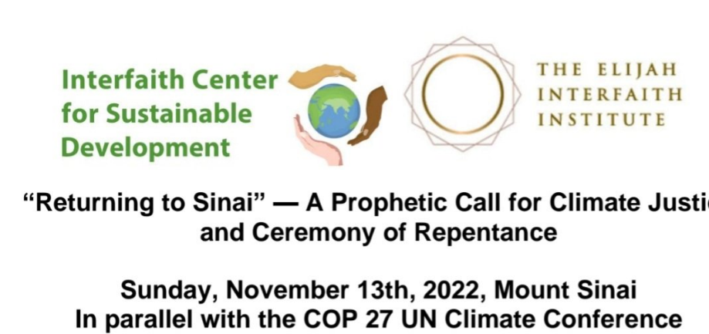

“We return to Sinai in a movement of repentance and quest. We seek a new vision for humanity and its endangered existence, and we seek to receive and amplify a message of life sustaining living and habits that humanity needs to hear today. In this spirit, the project partners will bring together premier religious leaders from the world’s major religions to gather upon Mount Sinai to engage in a first ever Climate Repentance Ceremony, and to put forth a prophetic interreligious call to action: “Climate Justice: Ten Universal Commands” (emphasis mine)

**“Goals of the Event**

• Inspire and unleash the power of religions, religious leaders and faith communities as change agents for climate action and as sources for inspiring and motivating discussions among politicians and civil bodies.  
• Motivate action among religious communities and the wider public to curb climate change.  
• Invite media to cover religious leaders’ advocacy in combating climate change.  
• Promote a coalition of religious leaders to work together for climate action.  
• Generate new faith-inspired climate education materials for broad use”

*This is just a sampling from their page which I am including here if you would like to read more. <https://interfaithsustain.com/returning-to-mt-sinai/>

If you’ve read my letters and articles lately, you know the high significance of the date November 13, 2022 for Elohim and for us. Many things are planned against Elohim (Yahuwah and Yahushua) during November, and against His people.

The judgment of Yahuwah is in the earth in many ways few know about, but soon will. While the “great falling away” of **II Thessalonians 2:3** is happening, the lines of division are drawn – who is on Yahuwah’s and Yahushua’s/Jesus’ side and who is on the side of Lucifer, fallen angels, Nephilim, aliens, and the lake of fire.

The rejection of the Word by so-called “believers” is a horrible thing to know about. The rejection of the book of *Acts* for today is also a horrible thing – separating “believers” in Jesus/Christians and Messianic believers, from the power of Yahuwah within to transform us into His likeness, with His nature, ways and thinking – cutting away the process of set-apartness and uniting with the Master of our lives.

The rejection of the Bible, the Word, worldwide is horrifying – but there is a remnant of the “few” walking the narrow way to the narrow gate that leads to life, even through hard times, who overcome the enemy by their faith and go on to represent Elohim in the earth till the coming of Yahushua Messiah.

I was led to take notes on this “interfaith group” who has replaced the Bible with the “save the planet” agenda.

Why did these pantheists choose the name Elijah when Eliyahu stood against everything they say they believe in? **I Kings 17 and 18** tells of the real Eliyahu/Elijah, a Levite priest, who went before Ahab basically saying: “It will not rain because I said so …” Eliyahu proclaimed drought as Yahuwah’s judgment on a sin-filled people – the ten tribes of the House of Israel, whom He finally scattered into the nations in 722 BCE with a 2,730-year punishment. That ended on Yom Teruah September 13, 2007/going into 2008 on the Creator’s calendar. Great celebration in Jerusalem honored that ending.

This Eliyahu conducted a contest between Yahuwah and the prophets of Ba’al and the prophets of Ishtar/Ashteroth – prophets who were under the authority of the high priestess Jezebel, wife of Ahab. It is this Eliyahu who is now on earth as one of the two witnesses of **Revelation 11 (Matthew 17:1-8)**.

Yahuwah is preparing a people to stand with Elohim in the face of the Beast, as did Eliyahu (My El is Yahuwah). This is also known as the **Daniel 11:32** company. Notice this people is in context with the Beast reign. **Malachi 4:5**: This returned Eliyahu is with us, and is uniting families of His people together under Messiah Yahushua (Yahuwah is salvation).

Now let’s look at **the specific date** **members of this Interfaith group want to climb Mount Sinai**. **I wouldn’t bother you with this ridiculous group except when I saw the date, I got chills. It’s not a random date.**

You know by the last new moon that we are in the month of Heshvan, the 2nd month on the ancient pre-**Exodus 12:2** calendar. **Exodus 12:2** was added “for us.” It did not erase Yahuwah’s creation calendar.

**Genesis 7**: On **Heshvan 17**, Noah and family were sealed into the ark, and the deep broken up, the heavens broke up and the rains fell that flooded the earth.

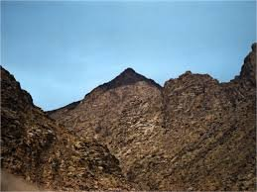From the PDF “Return to Sinai”: **The Elijah group’s own statements of Nov 13th:**

“This provides a major moment when the attention of media and participants can be turned to interreligious climate messaging and a transformative vision. On Sunday, November 13th, religious leaders will return to Mount Sinai, a mountain whose memory and meaning loom large as a place of revelation in the collective consciousness of Christianity, Judaism, Islam and others. It is a site for turning to God and receiving God’s message. We return to Sinai in a movement of repentance and quest. We seek a new vision for humanity and its endangered existence, and we seek to receive and amplify a message of life-sustaining living and habits that humanity needs to hear today. **In this spirit, the project partners will bring together premier religious leaders from the world’s major religions to gather upon Mount Sinai to engage in a first ever Climate Repentance Ceremony, and to put forth a prophetic interreligious call to action: `Climate Justice: Ten Universal Commandments.’”**

From a sister in Messiah in “Return to Sinai”

The **Interfaith Center** has something entirely different in mind. **Our sins are not against God (according to them) but against his creation – the environment**. And a new covenant between nations and religions must be enacted if we are to save not people, not souls but the ground upon which we walk. **Ten Universal Commands must be put in place that will unite all people with one singular goal –** saving the planet. And last but not least, I suppose (although not stated) – **a leader like unto Moses, or even Jesus who can lead the people out of the** wilderness **of planetary destruction and catastrophe to the promised land of environmental protection and utopia as you will see in what they term a** new vision. After Moses met with God his face shone brightly from the glory of the encounter and the people on seeing this pledged as one to follow God and to be his people.

But Sunday November 13th will be a very different event. There will be no meeting with God, no tablets of stone and no covenant enacted by God. Instead, there will be a good deal of hand wringing and self-flagellation amidst pious speeches over sins against the environment so grievous (according to them) that a new set of commandments must be enacted, a new covenant written and a pledge to and for change in order that our collective sins may be forgiven – not by God of course – but by the Universe – this is an Interfaith group, after all – with no belief in the one true God.

***As we close out the remainder of the year, **I think the numbers of the date of this event (11/13/22) pretty much says it all** …. and should this event go forward as planned, I expect some rather severe consequences to unfold as a result. Ascending Sinai in this manner for this purpose is about as God rejecting as you can get …and that is saying something given the times we are living in.

**11 – disorder, chaos and judgment …13 – rebellion and lawlessness … 22 – a double** **portion of disorder, chaos and judgment…”**

**My conclusion: I got chills when I realized that November 13th is the 17th of Heshvan 2022!!! The date-numbers are NO coincidence, nor their occult meanings. Lucifer knows that Yahuwah is increasing His fury to judge the earth’s people, but also to judge him, and his fallen angel servants, Nephilim servants, alien servants, and human servants. Yahuwah is allowing the “disorder, chaos, and judgment” to fall on a “rebellious and lawless humanity.” Yes, the 22, double 11, is a double portion of judgment. Yes, we are entering real tribulation!**

**Folks, this is no coincidence of a silly religious group. The Elijah “inter-faith” group is tied into worldwide “sustainable development” groups. I know about this from living in Panama. It’s Luciferic! This is a group of humans of pantheistic religions who have zero regard for the Creators of all.**

**I encourage you, during November 13th, to read Genesis 6, 7 and 8 and to hear Abba’s heart. He does not want to judge. No good father wants to punish his children. But a good father must punish what is defiling them by their own free will.**

**The judgment of the Flood was 6 weeks. Yahuwah is no sadist. He hits hard and then restores. He’s a good, good Father! He is love, kindness, companionate, merciful. However, we are in the days of Noah. We are also in the days of Revelation’s finalities. Yahuwah must defend His people and His own reputation and that of His Son. He must separate the wheat from the tares and the chaff (Matthew 13). He must be who He is.**

**We go through overcoming, enduring to the end! Religions of man are fakery, fantasy, including western civilization Christianity. Sinful or self-righteous, those whom Yahuwah and Yahushua don’t know personally, Messiah will say to them: “I don’t know you.” The new birth is a total committal to a Master who trains the truly “saved” for the Kingdom and eternity. It’s no game.**

**The month is November is a critical month for changes – for mind-set changes, spiritual changes, and action for changes, as Abba leads. Indeed, set apart November 13th to seek Abba with all your heart. This act of climbing Sinai – one of the five main portals of Yahuwah into His Presence, the other 3 being in the area of East Jerusalem, 1) Temple Mount 2) Zion/City of David 3) Mount of Olives.**

**As the song says: “So on and very soon we are going to see the King…”**

**In His love, Yedidah**

**November 2, 2022**