THE FRAMING OF RUSSIA TO ADVANCE THE PLANS OF GLOBALISTS

Yes, blunt title. However, that is what we’re watching. We’re watching satanic globalist, one world government nations, under the Beast rule already, using Russia, a non-globalist country, a democratic country, to blame the treachery of WWIII on. [Refer to: “The Pike-Mazzini Plan of 1871”/Mikvah of Israel #59.0]
The U.S. and N.A.T.O, controlling Ukraine for their own evil purposes, most likely started this whole thing by ordering them to move troops to the Russian border to threaten Russia. Remember that the U.S. took down one president of Ukraine to put in the present President, a usable person.
President Putin of Russia responded to Ukraine’s aggression by taking troops to the Ukraine border, and asking Ukraine, the U.S., and NATO to respect and protect Russia’s borders. However, the U.S. and NATO are not going to respect Russia’s simple request to not threaten his nation’s borders. The U.S. and NATO thus began provoking Russia to the point of exasperation to provoke him to make a first move. Putin is trying to protect his people and his nation. He’s built bomb shelters for most all, especially in cities, underground. In the Moscow area, many of the people are already in the shelters.
Like Crimea before, who voted to join with Russia and leave Ukraine’s jurisdiction, now two breakaway republics, LUHANSK AND DONETSK, have voted to join Russia. In response, Ukraine has begun bombing citizens of these two states. The day before the people were in the streets cheering the Russian military.
Now, Ukraine has requested Turkey to close the Dardanelles and Bosporus Straits to the transit of Russian Navy ships.
We now know that if Ukraine joins NATO, the U.S. will be able to put their nuclear missiles inside Ukraine and aim them at key Russian targets and cities inside Russia. From launch to hitting targets--5-7 minutes flight time. Of course, Russia cannot allow that. The whole plot is to push Putin into doing something they can use to blame him for starting WWIII.
All Russia has asked of NATO and the U.S. is that the borders of Russia be secured, so that there is no invasion by Ukraine- for that is what Ukraine was threatening. Now more treaties, like the Minsk treaty, is being violated. In the US the Constitution has been under the bus, and we are fast becoming a communist country, Chinese style. Thus, in establishing a new world order under the Beast-reign, all freedom of human beings has to be dissolved, and evil unleashed.
The heinous thing about it is besides the slaughter of innocent people by Ukraine, Russia is being blamed for it all, and his only request was for the protection of his nation and his people.
Yes, it is evil to the core, but we’re watching Part III of the 1871 Pike-Mazzini Plan WWIII being put into effect. They have to blame someone besides the true perpetrators. It’s a 9/11 repeat, with public news mind-programming the willfully ignorant. If you’re smart do NOT watch or listen to public news, and thus open your mind up to deception, lies, manipulation, and evil.
It’s called the Hegelian Dialectic. Create the problem, then stir in the solution, which gives liberty to do what the perpetrator wanted to do in the first place. 9/11 sure opened doors for the US to go into other countries and do what they wanted to set in motion for the Beast rule.
As David Icke tells in detail in The Trigger, we find out who really was behind 9/11/01, launching the 7th millennium. He includes material I’ve been studying and writing on since my days of living in Israel, and meeting Barry Chamish. Absolutely true reality.
9/11: The U.S.’s CIA, with the approval of the military and the government, and the Israeli Mossad. The CIA and Mossad again, training ISIS and Al Qaeda, both US mercenaries, made it look like Iran was bad, giving Israel an open door to attack Iran in Syria and in Iran to provoke an attack on Israel – blaming Iran. This goes back to what President George Bush, Jr. told General Wesley Clark – that 7 nations had to be taken down to pave the way for the new world order, #7 being Iran. All that destabilizing, and starting of wars in 2011 by Obama – all to start WWIII.
Russia, out for justice, for Bashar Assad, Iran, and the Christians and Kurds inside Syria went to Assad’s aid, and also Iran’s aid. Yes, Putin is a brilliant warrior who knows who is evil and who is not. How few understand what he does? Lovers of truth understand. Putin is a master chess player and a master at understanding war moves. He loves his country. His country is DEBT FREE. His country is now the top military power in the world. His country has been very blessed since 1991, when they became democratic. Now Putin wants to help other countries, like Crimea, and like Luhansk and Donetsk, to be “un-communized.” He wants them to be democratic countries.
No, I am not a voice for Russia. I just know what is. I spent 3½ months in Far East Russia in 1999. I loved it. It was peaceful. I worked with the Jewish agency to help Russian Jews make Aliyah in Israel.
“RUSSIA RECOGNIZES LUHANSK AND DONETSK AS `INDEPENDENT STATES’ Ukraine Declares MARTIAL LAW” Hal TURNER FEBRUARY 22, 2022
“The Ukraine Army is making what is described as `massive bombardment’ of areas in Luhansk and Donetsk, including far south near Mariupol. Reports from inside Ukraine are saying `Massive bombardment by Ukraine, internet keeps cutting out, talked to some of the people who are stationed near Mariupol front, they say that Ukraine has made a breakthrough in the frontline.’ …also last night, the Russian embassy in Washington DC sent out mass emails just before 11pm with an attachment which back up claims that there are mass graves of civilians in Luhansk; people murdered by the Ukrainian government!
Meanwhile in neighboring Belarus, a stunning development: Trucks carrying the brand new S-550 satellite-killer missiles, were seen traversing the public roads, less than 70 miles from the Poland Border. These new Russian missiles can hit and destroy US/NATO GPS and communication satellites in space; rendering the entire war-fighting capability of NATO, almost useless.
US/NATO troops rely heavily on satellite communications to coordinate attack and defense operations. They also rely heavily on Global Positioning Satellites (GPS) for travel and precise targeting of missile strikes. US/NATO missiles rely almost completely on GPS satellites to hit their targets. ALL OF THAT would be rendered useless if Russia fires its S-550 satellite killer missiles! The entire war-fighting capability of NATO would grind almost to a complete halt.
If things "go hot" between Russia and NATO, those satellites would likely be taken out very early, leaving the entire NATO war machine stuck. Once the satellites were hit, there would be almost no way for the US to defend Europe, and all of Europe could fall to the Russian Army.
Remember, it's only about 450 miles from the Russian border to Vienna Austria; about the same distance as New York City to Rochester, New York and Niagara Falls. With NATO Command, Control, and Communications crushed by S-550 missiles, and Europe having spent almost nothing on its own defenses for decades because they sat back and relied upon the United States, the world order could change almost overnight…It is now appearing to many observers that things are, in fact, headed toward "going hot" between Russia and NATO.”
Remember, Russia is not the aggressor. Ukraine made the first move, and public media has been painting a picture to blame Russia for everything.
NATO is literally attempting to surround Russia with military bases, troops, armor, and worst of all, missiles. The Russians have watched this situation develop for years, since the then-Soviet Union imploded in 1991.
Back in 1997, when East Germany and West Germany were re-unified, the West assured Russia that NATO "would not move one inch eastward." That turned out to be a vulgar lie. And there is now factual, empirical proof that the US, UK, France and Germany did promise Russia that NATO would not move east…So the Russians see they were LIED TO by the US, UK, France, and Germany.
The Russians know they have been deceived, and now, with NATO trying to bring Ukraine into the fold, Russia faces an Existential crisis. If Ukraine is allowed to join NATO, then NATO will be able to place US Missile defenses upon Ukraine soil. Those missiles would have about a five-minute flight time to Moscow, and about a 7-10 minute flight time to Russia's strategic nuclear missile silos. Russia simply cannot defend itself from missiles that have a flight time of only five minutes from launch to impact.
For the past several YEARS, Russia has been saying this publicly. They have been openly saying they cannot (and will not) tolerate American missiles on Ukraine territory with a five minute flight time to Moscow. No one in the West listened.
So last December, Russia put forth a request for written, legally enforceable, security guarantees. They asked for certain things to be agreed to in a legally enforceable format, to assure Russia's security.
Russia's requests were laughed at and denied.
Well, it now appears that Russia is going to have the last laugh.” Hal goes on to show how Russia could easily stop the evil – and that brings us to Jeremiah 50-51 (USA) and Revelation 18 (NYC). Russia can take out NYC and DC in 1 hour. They can take out major cities all over the U.S. in one day – destroying the nation.

“Ukraine Is A Part Of Russia, Meaning Russia Can Enter At Any Time...
Ukraine is Not a separate country. It was not registered as such.”
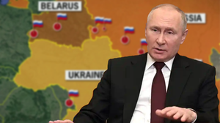
“The Secretary-General of the United Nations has stated that Ukraine has not applied for border registration since 1991, so the state of Ukraine does not exist....
And we don't know about it! 04/07/2014 UN Secretary-General Ban Ki-moon made a stunning statement, the distribution of which in Ukrainian media and the Internet is banned. The conflict between the two countries was discussed at the session of the UN Security Council. From this, the following conclusion was drawn:
Ukraine has not registered its borders since 12/25/1991. The UN has not registered the borders of Ukraine as a sovereign state. Therefore, it can be assumed that Russia is not committing any rights violations in relation to Ukraine.
According to the CIS Treaty, the territory of Ukraine is an administrative district of the USSR. Therefore, no one can be blamed for separatism and forcibly changing the borders of Ukraine. Under international law, the country simply has no officially recognized borders. In order to solve this problem, Ukraine needs to complete the demarcation of borders with neighboring countries and obtain the agreement of neighboring countries, including Russia, on their common border. It is required to document everything and sign treaties with all neighboring states.”
The European Union has pledged its support to Ukraine on this important issue and has decided to provide all technical assistance. But will Russia sign a border treaty with Ukraine? No of course not.
Since Russia is the legal successor of the USSR (this is confirmed by the decisions of international courts on property disputes between the former USSR and foreign countries), the lands on which Ukraine, Belarus and Novorossiya are located belong to Russia, and nobody has the right to be without them Russia's consent to dispose of this area.
Basically, now all Russia has to do is declare that this area is Russian and that everything that happens in this area is an internal matter of Russia. Any interference will be seen as a measure against Russia. On this basis, they can annul the elections of May 25, 2014 and do what the people want! According to the Budapest Memorandum and other agreements, Ukraine has no borders. The state of Ukraine does not exist (and has never existed!). Alexander Panin

Russia Goes After Ukraine to Stop Unbridled Attacks of Civilians
Ukraine Resumes Fighting; Shells Luhansk Despite Presence of Russia Peacekeepers HAL TURNER 22 FEB 2022
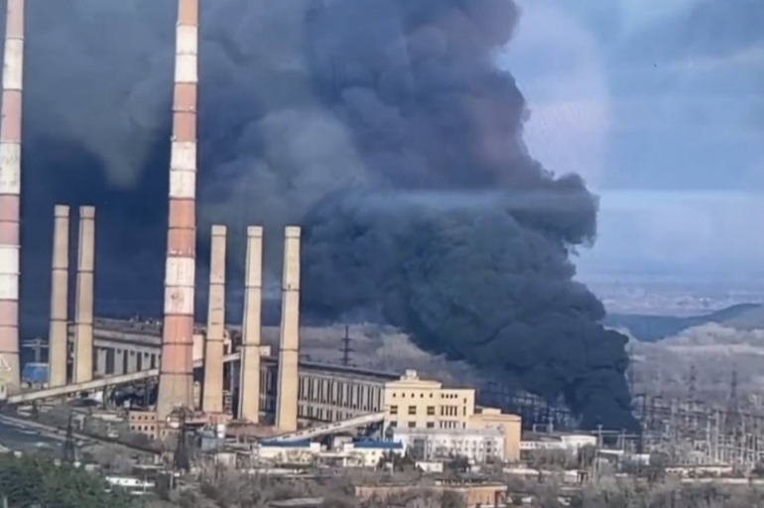
https://halturnerradioshow.com/index.php/en/news-page/world/ukraine-resumes-fighting-shells-luhansk-despite-presence-of-russia-peacekeepers
The Ukrainian Army (UA) resumed military attacks against Luhansk and Donetsk early this morning, despite the presence of Russian Peacekeeping troops, and a stern warning from Russia President Putin that hostilities had to stop, or Kiev would bare the full brunt of responsibility. Around 6:00 AM eastern US time, GRAD Missiles were launched by UA, striking the electric generation plant in Luhansk and starting a fire there.
The use of GRAD Missiles has been confirmed: For the first time since 2018, the Armed Forces of Ukraine used the BM-21 Grad, firing five missiles at Donetsk, the DPR representative office at the Joint Center for Control and Coordination of the Ceasefire said. It comes after Russia formally and officially Recognized Luhansk and Donetsk as "Independent states" because Ukraine has waged war against those two states since 2014.
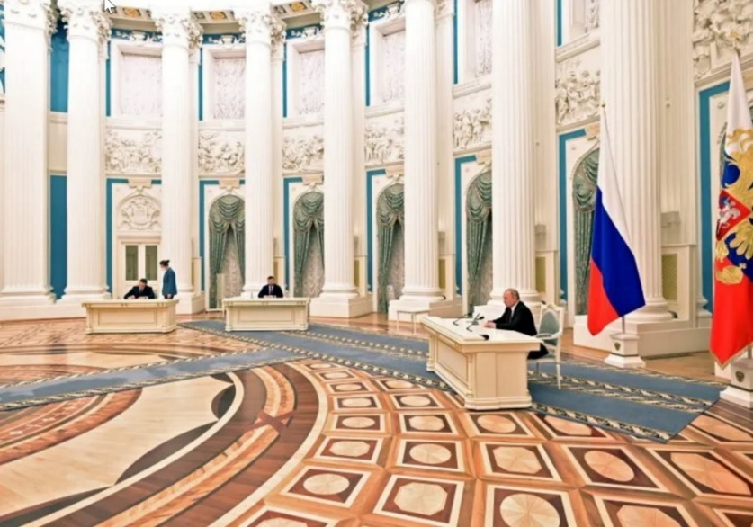
In the photo above, the Leader of Luhansk is seated far left, the leader of Donetsk is seated in the center, and Russian President Putin is seated at far right.
Upon the signing of the Decree recognizing the independence of the two states, the leaders of Luhansk and Donetsk asked President Putin for immediate assistance in protecting the civilians of those two states. People there have been under attack by Ukraine on and off since 2014, and only very recently have the attacks escalated causing quite a number of civilian deaths, and damage to civilian homes.
Within hours of the signing of a Decree which recognized Luhansk and Donetsk as Independent, President Putin gave permission for Russian Army forces to enter those two states as PEACE KEEPERS. Troops rolled into the area in regular transport buses. Tanks, artillery and armored personnel carriers rolled-in as well.
***People on the streets of Donetsk and Luhansk CHEERED: Elsewhere, citizens celebrated with fireworks: And elsewhere too: Cars with Flags convoyed down city streets in happy celebration: President Putin went on Russian television for almost an hour to explain the situation to his nation.
***Putin’s speech, delivered from his desk in the Kremlin, was a masterpiece of history and facts.
Putin talked about Ukraine's efforts to get away from their former Soviet past and Russia influence which Ukraine calls "de-communization."
Putin then went on to point out that the entire existence of Ukraine was due to Communist Bolsheviks. He said "You want de-Communization? That suits us fine. But don't stop halfway. We are prepared to show you what real de-Communization actually means…"
He then spoke bluntly about how Ukraine was created, pointing out that Ukraine was created by Lenin. "It was Lenin who was the architect and engineer of Ukraine. Given that reality, de-communization would involve giving Ruthenium back to Romania. Transcarpathia back to Hungary. Logograms/Livov back to Poland and Donbas back to Russia."
(HT Remark: If those regions were to be given back, there would literally be no Ukraine at all.)
Putin went on to talk about the fall of the then Soviet Union, reminding Ukraine that when it fell, its debts were supposed to be repaid by each former Republics on a pro-rata basis, but it was Russia that assumed all the post-Soviet Debt, and Ukraine repaid none of it, saying "In the 1991-2013 period, Ukraine owed hundreds of billions of dollars to Russia. Russia took it upon itself to pay all Soviet debt. Finished in 2017. But Ukraine never honored its commitment to return certain property."
He then went on to point out that Russia always had good cooperation with Ukraine but that was harmed by the vast corruption in Ukraine, and how the nation itself literally STOLE Russian gas traveling through pipelines. He then said Ukraine tried to use gas (energy) to Blackmail Russia, and how Ukraine was nothing more than oligarchs enriching themselves and doing nothing for the people of the country. He also cited the rise of Neo-Nazis in Ukraine, and how they were harming people there, unabated by the law.
Putin then did what the West might find unthinkable: He pointed out that the overthrow of Democratically-elected President Viktor Yanukovich in 2014, was the work of Europe and the U.S. Calling out the 2014 coup for being west backed, he said the US embassy in Kiev was flowing out $1 million a day to fund the Maiden Revolution!
He went on to say UKRAINE WAS NOT ABLE TO ACHIEVE STABLE STATEHOOD AND HAS THEREFORE HAD TO RELY ON FOREIGN COUNTRIES LIKE THE UNITED STATES. " Then he went further by directly saying "UKRAINE IS MANAGED BY FOREIGN POWERS, THIS AFFECTS ALL LEVELS OF AUTHORITIES" and wound-up his remarks with this: "Ukraine was never a true nation. Ukraine is a colony with puppets at its helm." (HT REMARK: By saying this, Putin made clear Ukraine is a completely illegitimate state and so is its government!)
He also went on to say "For the past month, there has been a steady stream of Western weapons to Ukraine." He mentioned NATO training missions too and then said "NATO headquarters can directly command Ukrainian troops."
He continued by saying "Ukraine joining NATO is a matter of time." "The risk of a sudden strike on Russia will be increased several times."
Next comes Putin saying that he will not allow such a thing. `We don't want to believe it, but it's true.’ NATO's weapons could hit Russia as deep as Volgograd, Kazan, Astrakhan. Radars will penetrate as far as the Urals. `Long-range missiles would cover all of Russian territory. Reaching Moscow would be within half an hour to five minutes by hypersonic missiles. That is a knife to our throat."
Russia has the right to take actions to protect ourselves and we plan to do that. As he ended his remarks, Putin told Ukraine that hostilities against Luhansk and Donetsk had to cease immediately or Kiev will bear the full brunt of its actions." Video of the Full speech to his Nation is at the bottom of this story and this version has verbal English translation. Not three hours later, Ukraine began shelling again.
As Russian forces began to arrive, they were met by cheering crowds of citizens in Luhansk and Donetsk, some who were waving Russian flags and celebrating with local fireworks displays! Cars mounted Russian and LPR/DPR flags and drove around the cities to cheers from locals who felt they would finally be protected from the months and years of Ukrainian attacks.
At about 11:30 PM eastern US time last night, the REAL trouble actually began; Ukraine resumed shelling despite the entry of Russian Peacekeepers.
Ukraine renewed shelling of Donetsk and Lugansk
At 23:20 - Ozeryanovka: fired 7 shells of 82 mm calibre, 0 AGS grenades;
At 01:55 - Zamozhnoye: fired 12 shells of 120 mm calibre;
At 02:45 - Bogdanovka: fired 12 shells 120 mm calibre.
Once Ukraine resumed shelling, Russia began moving additional military assets to the area. A Massive naval flotilla took up station around southern Ukraine.
Landing ships, major warships, submarines and aircraft effectively dominate the Black Sea. And the visible preparations extend into the Mediterranean. It appears overwhelming.
At about 5:30 AM eastern US time Tuesday, Russia's lower House of Parliament, the Duma, voted to approve the Friendship Treaty with Donetsk People's Republic in Eastern Ukraine. The separate approval of the same Treaty with the Luhansk People's Republic was to follow shortly and would be approved. The vote was 400-0 in favor of the recognition and got a standing ovation in the State Duma.
******** FLASH ********3:01 PM EST --
Putin: Minsk agreements no longer exist. Ukraine must be demilitarized, give up NATO ambitions. Lavrov: Ukraine does not have Sovereignty - Outside Control Story HERE”
I was talking about this to a few people. One of which went into a snarl and said, “Russia’s a communist nation and always will be.” I simply said, “no it is not.”
So, folks: “Is Russia a Communist Nation? The answer is No! Russia can no longer be seen as a communist country. The communist Soviet Union ended on December 26, 1991...”
“Is Russia a democratic country today? The 1993 constitution declares Russia a democratic, federative, law-based state with a republican form of government. State power is divided among the legislative, executive, and judicial branches.”
IT IS NOT A COMMUNIST NATION … the people have voting privileges. It is a fast-developing nation. Bumper crop harvest 2021. Totally out of debt 2021. Military super power of earth now. Scripture reveals that Russia will destroy the communist nation of America, now patterned after hard-core Chinese Communism, as per Jeremiah 25:11-12, 50-51, Revelation 18.]
HAL’S UPDATE
“Russian Federation Council GRANTS PERMISSION For Use of Russia Forces `Outside the nation’" HAL TURNER 22 FEBRUARY 2022
At 11:05 AM eastern US time Tuesday, the Russian Federation Council, it's version of the US Senate, granted permission for the use of Russian military forces outside the nation. This was the last legal step needed for President Vladimir Putin to engage Russian Army forces as he sees fit.
Hal remarks: “The Nazis in Ukraine would be well advised to pack their bags and run like hell. It appears the Russian Army is about to be completely unleashed against these violent, lying, double-dealing fools.”
May Abba guide Putin with all wisdom, and especially protect those in his army and in the breakaway provinces who are His children!
THE INEVITABLE: If Ukraine joins NATO with NATO standing with then, the US will put its troops inside Ukraine with its missiles that can reach Russia’s most populated areas, and military facilities, in 5-7 minutes, then Putin will be forced to attack the U.S.
Tragically, that’s the plan. Provoke Russia to have no other option but to attack the US, then blame it on Russia. Of course, into that fray will come China, North Korea, Iran, Germany, France, Venezuela, Cuba, and others already on the inside.
Is this just another scare that will go away? NO! The U.S. Senate is being flown to Mount Weather underground facilities in Virginia, and planes with government officials are being flown to the Denver Airport to stay in underground facilities.
Problem is with all this trying to save the Luciferic big guys is that Russia’s bunker buster bombs are 20 years ahead of what the U.S. has, so all underneath facilities will be destroyed. No where to hide! We have Yahuwah – best bomb shelter ever!
Abba spoke to me a few days ago: “Putin is My Nebuchadnezzar.” Just as Nebuchadnezzar of Babylon was the instrument in Yahuwah’s hands to punish His people and drive them from the Land, so Putin will be used to bringing Yahuwah’s judgment on a very evil nation that has turned against His Law and condemned His Word as a “hate crime book,” while promoting all the evil it speaks against.
There comes a point when we cannot pray anymore for the people in general in America. For Yahuwah has set His judgment in motion. Also, as Jeremiah wrote, other nations from the north, like China, North Korea, and nations from the south, like Cuba, and Venezuela, and from the east, like France and Germany, will come upon the land of America like a great hoard. Then the troops inside the nation will take what is left to take.
“Mike from around the world” statements about Putin on Feb 17, 2022: [Mike is a top official in U.S. military Intel]
“Putin is a military genius. He confused NATO back then he took Crimea.”
“NATO has zero control over Putin.” “No one can control Putin.” “He has surrounded Ukraine. But the lie of the western public news is that he is pulling back. No, he is not pulling back – just repositioning. He is surrounding Ukraine with 200,000 troops.” “Every time Putin makes a move, NATO gets confused.” “Putin is straight-forward; he won’t waver.” “Putin has a `poker face.’ “He is cold and calculated.” “He has a hook in the jaw of Ukraine.” “Putin was the head of the KGB of `Mother Russia.’ “He is proud of his country. He is proud of his people.” “NATO is nervous. They’re trying to save face.” “NATO is new world order globalist. Putin is not new world order or a globalist.”
“Mike” said there was a “shadow force” in Ukraine, and they are dangerous. It is this shadow force and its criminals that Joe and Hunter are afraid of losing. So, at the root level, the criminal communistic (Chinese-owned) USA government and military is coming against a democratic nation who has thrown off communism.
Note: Hal Turner Feb 24, 2022:
The US is moving all their Congress to their Nuke Bunker at Mount Weather
“AIRCRAFT HAVE BEGUN TRANSIT FLIGHTS TO/FROM MT. WEATHER IN VIRGINIA. This is the Emergency Nuclear Attack Bunker for the United States Congress.
The Mount Weather Emergency Operations Center is a government command facility in the U.S. Commonwealth of Virginia, used as the center of operations for the Federal Emergency Management Agency (FEMA). Also known as the High Point Special Facility (HPSF), its preferred designation since 1991 is "SF."
The facility is a major relocation site for the highest level of civilian and military officials in case of national disaster, playing a major role in continuity of government (per the U.S. Continuity of Operations Plan).
Mount Weather is the location of a control station for the FEMA National Radio System (FNARS), a high frequency radio system connecting most federal public safety agencies and the U.S. military with most of the states. FNARS allows the president to access the Emergency Alert System.”
Abba is in control of His timing. Nothing will override His will.
Have you read the last article “Where is Your Bomb Shelter?” Feel unloved by your government? Truth: If you are in the perfect will of Yahuwah and moving in His perfect timing, then He’s got you covered – with His tallit.
In His love, Yedidah
February 24, 2022

