THE HORRORS - THE UNIMAGINABLE EVIL
WORLDWIDE MIGRATION
THROUGH DARIEN GAP TO THE US BORDER

The hidden evil done to migrants coming from all over the world, the kidnapping and sex trafficking of thousands of children, the Brownsville, Texas border, and the mindboggling unimaginable actually happening from Darien Gap in Panama through Texas! Read this article carefully. Pray with the power of Yahuwah’s Spirit!
It is hard for me to even fathom the enormity of this unimaginable evil from a nation who was once teaching the Bible in public schools and universities, and sending missionaries all over the world. No longer “America,” we have returned to our roots as Amaruca – the “land of the plumed serpent,” – the gods of the Aztecs, the Maya, the Incas by different names. To this god children were sacrificed by the millions. Under the name “America” now is known as the center of child sacrifice and offerings to Lucifer all over the world, the trafficking in human souls, as Revelation 18 describes, out of the port of NYC mainly.
The nation who wore the crown of righteousness at one point in its history, at least among the people, now wears the horns of the Beast.
tit. The Beast is now on earth and functioning as the world ruler among the elite of Lucifer’s friends, from Washington D.C., NYC to the Vatican it headquarters under a cloak of respectability. However, Yahuwah is exposing the evil for those who love Truth. A cloud of darkness is settling over the majority who do not love truth.
Here I give you notes from two major sources on the migration, and the journey from Panama to the U.S. border through Darien Gap – both explained by on-site Michael Yon. I give you related information on the over 2,000 missing children in Maui who were separated purposely from their parents during the fire this August.
I give you several key pictures …
As I have received this information from one who was on-site, through a strategic interview that you can view yourself on thehagmannreport.com: Episode 4511: “Unfiltered Update on the Orchestrated Global Invasion” – August 24, 2023
As much as I know of the evil done to babies and children worldwide, centered in America underground, Hollywood, White House, Pentagon, U.N. etc., The exposing of the enormity of the sex trafficking of children from age 5 and the human sacrifice to Lucifer done in America and worldwide, has left me numb. It has left me wanting to cry but able to … it’s too horrifying. Michael Yon has been on-site of these horrors and is reporting to us the truth. It is backed up by the report of even the Council on Foreign Relations – from which report I got several of the pictures posted below.
Does Yahuwah have the right to judge what He hates? Proverbs 6: He hates harm done to the innocent.
First of all, the article on the missing children from the Maui fire. The children were told not to go to school that day, due to a possible hit by a hurricane moving east to west.

ARTICLE I:
MAUI FIRES – WHERE ARE THE MISSING CHILDREN?
Over 2,000 Children Missing From Lahaina Public Schools Two Weeks After Maui Fire - August 25, 2023 greatgameindia
“On Thursday, the Hawaii State Department of Education released a report indicating that 2,025 students are missing from the Lahaina public school system. This happened following a destructive fire on August 8 that devastated Lahaina town on Maui Island.
Before the fire, the Lahaina school district was composed of four schools: two elementary, one intermediate, and one high school. These schools had a combined enrollment of 3,001 students.
Unfortunately, due to fire damage, all the schools are currently closed. One elementary school sustained extensive damage and might not reopen for a while.
The other three schools were also harmed by strong winds, debris, and soot. The report does not discuss whether many of the absent children perished in the fire.
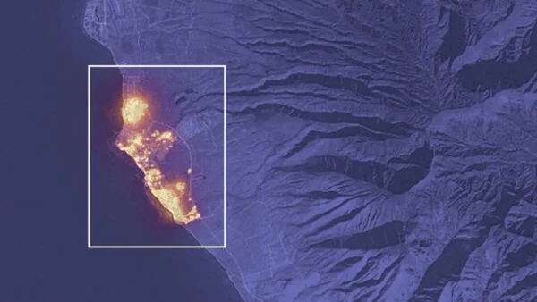
This image captured by the Landsat 8 satellite on Aug. 8 shows how flames engulfed large parts of Lahaina. (Image credit: NASA Earth Observatory/Lauren Dauphin)
According to the report dated August 21, here’s what happened to the 3,001 students who were enrolled on August 8:
538 students have reenrolled in other public schools.
438 students have joined the State Distance Learning Program (SDLP) for English and Hawaiian language learning.
The remaining 2,025 students are not accounted for. They have not re-enrolled in other public schools or chosen distance learning.
Government authorities have not been transparent regarding the number of children who lost their lives in the fire. Even after two weeks, they only confirmed 115 documented fatalities, with an estimated 850 to 1,100 individuals of various ages unaccounted for. An inventory of those believed to be missing has not been made public.
On the day of the incident, youngsters attending schools in Lahaina were advised to remain at home. This was due to strong winds from a hurricane offshore. Numerous children were by themselves as their parents were at their workplaces.
The report from the Associated Press on Wednesday featured a father who managed to rescue his own children from the fire. However, he’s deeply tormented because he couldn’t save the kids of his neighbors (excerpt):
A lot of the survivors are furious and troubled, thinking that even a brief notice could’ve prevented numerous lives from being lost.
According to Baird, in his vicinity near Lahainaluna Road, there were many kids who were alone at home when the fire approached.
We needed like 10 more minutes, and we could have saved a lot of kids,” he said, choking back tears. “If we’d just had like a 10- or 15-minute warning.”
In the aftermath of the calamity, the family went to a mall in Kahului recently. They were seeking a glimpse of normalcy. During this outing, they unexpectedly bumped into a friend of their son. The kids just don’t have a filter. So, their son ran up and was just telling our son, you know, ‘This kid is dead. This kid is dead.’ And it’s like, all my son’s friends that they come to our house every day,” he said. “And their parents were at work, and they were home alone. And nobody had a warning. Nobody, nobody, nobody knew.”
Children, home from school, were left at home, while parents went to work. All communication was shut down so they could not correspond with each other. Yes, many burned to death, but what about the 2,025 unaccounted for?
Knowing what I’ve learned for years now, most likely they were taken out of their homes before the US military began the beaming of the lazars and the starting of the fires, to be sold as sex slaves on the extremely fast-growing “market.”
My thoughts a few days ago: This is heartbreaking… no warning sirens, water turned off, communications shut down, evacuations forbidden, schools cancelled so kids could stay home. Yet, FEMA was conducting a Fire and Rescue Conference next island over. They could have helped but opted out.
It was a mass murder event, a military event. Now it is happening in western Canada – exact same conditions – help shut down, evacuation shut down, water turned off, local firefighters not able to do anything – people trapped, police ordered lockdowns … Is that going to be part of what’s coming with more lockdowns – fires and people burning to death?
Refer to the recently posted article under the Mikvah of Present Reality #324.

ARTICLE 2:
An excerpt from a Daily Mail article August 24, 2023: “Maui fire investigation: Maui's top emergency officials were on a different island for a disaster training as flames flared and did not join response call until five hours after the deadly wildfires begun
The annual FEMA disaster meeting was held on August 8 in Waikiki Beach, Honolulu, on the island of Oahu - a 30 minute flight from Maui. While Hawaii's top emergency coordinators were meeting, wildfires were breaking out in Maui, with the Upcountry Fire reported around midnight. Lahaina's fire flared up later in the morning: a school was evacuated at 6:40am and it was declared contained by 9am - only for evacuations to begin at 3:30pm
By HARRIET ALEXANDER FOR DAILYMAIL.COM UPDATED: 07:11 EDT, 24 August 2023

ARTICLE 3:
“Crossing the Darien Gap: Migrants Risk Death on the Journey to the U.S” John Moore/Getty Images By Diana Roy, Author and Sabine Baumgartner, Photo Editor June 22, 2022 Council on Foreign Relations
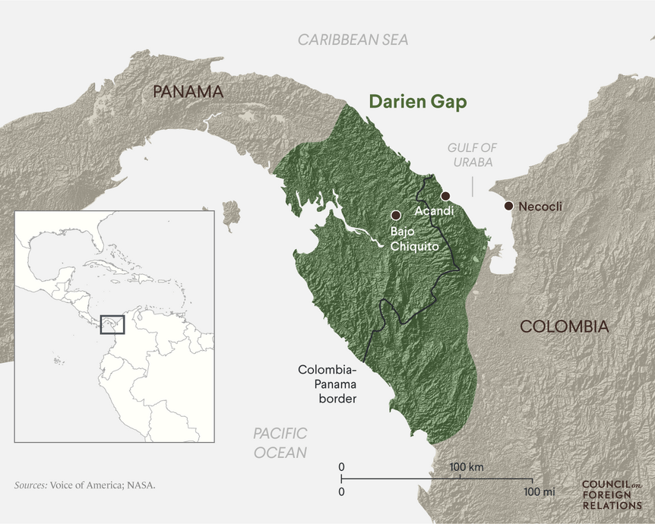
According to the Panamanian government, more than 248,000 migrants crossed [link in Spanish] the Darién Gap en route to the United States in 2022, up from just a couple hundred people annually a decade ago. Over forty thousand of them were children. The majority of migrants were from Venezuela, followed by Ecuador and Haiti—including Haitian children born in Brazil and Chile—but some hailed from as far away as Angola, Bangladesh, and Uzbekistan.
DARIÉN GAP: The rough terrain and steep trails of the gap make the journey even more challenging. John Moore/Getty Images
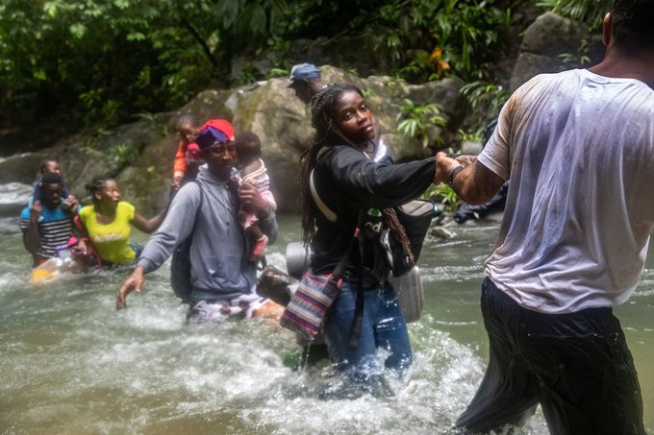
Migrants travel by foot through the jungle as there is no road. Many of them will pay guides to accompany them for part of the journey. John Moore/Getty Images
“The journey was really quite hard, especially when the rain came. It was just mud, rivers and going up mountainsides non-stop,” one Haitian migrant told Al Jazeera. “There were pregnant women, we had to walk in rivers … children were fainting, and even men, at times, who couldn’t continue.”
“The Darién Gap is an imposing obstacle on one of the world’s most dangerous migration routes. The remote, roadless crossing on the border between Colombia and Panama consists of more than sixty miles of dense rain forest, steep mountains, and vast swamps. It is the only overland path connecting Central and South America. Over the past few years, it has become a leading transit point for migrants in search of work and safety in the United States, as authorities have cracked down on other routes by air and sea”
“In 2023, the total number of migrants crossing the gap could soar to as many as four hundred thousand, a record high. As of July, over 251,000 migrants have already made the trek; this is more than the entirety of 2022.”
Migrants travel by foot through the jungle as there is no road. Many of them will pay guides to accompany them for part of the journey. John Moore/Getty image
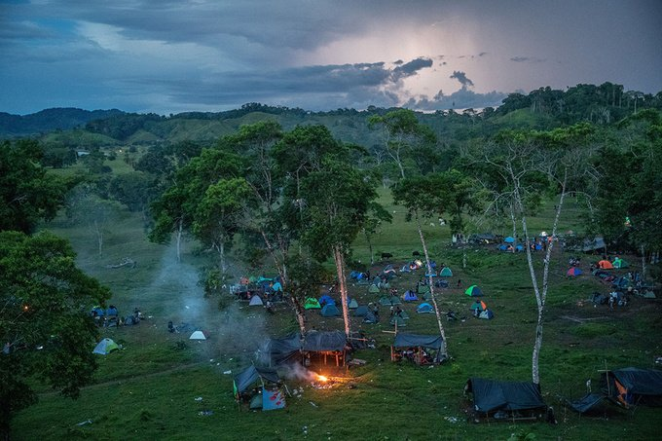
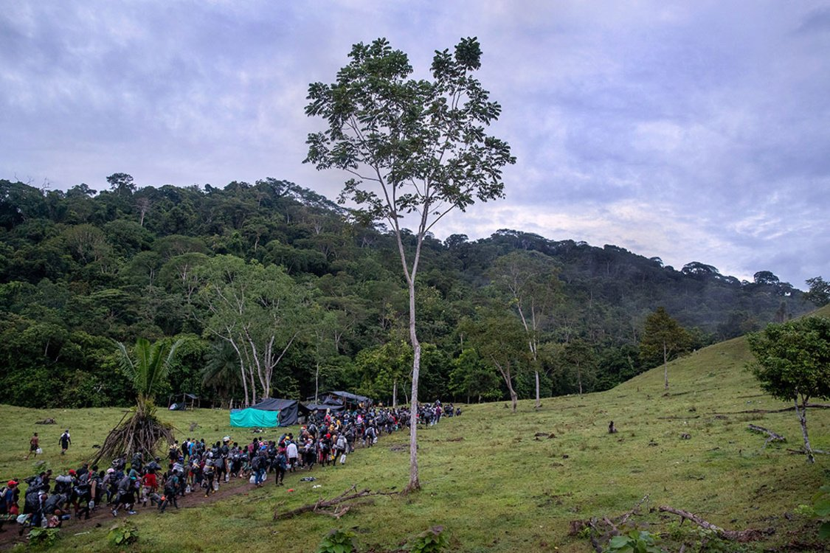
“Once in Acandí, migrants will head for the Darién Gap jungle, a dangerous hike that can take ten or more days. Many pay to be led by local guides, or `coyotes.’ Along the route are smugglers and criminal groups, including members of the Revolutionary Armed Forces of Colombia (FARC) and the Gulf Clan, a paramilitary group and Colombia’s largest drug cartel. These groups often extort and sexually assault migrants. “Deep in the jungle, robbery, rape, and human trafficking are as dangerous as wild animals, insects and the absolute lack of safe drinking water,” Jean Gough, regional director for Latin America and the Caribbean at the UN Children’s Fund (UNICEF), said in an October 2021 news release. “Week after week, more children are dying, losing their parents, or getting separated from their relatives while on this perilous journey.” UNICEF estimates that half of the children who crossed in 2022 were under five years old, and at least one thousand were unaccompanied or separated.”

ARTICLE 4:
“Report from Michael Yon on site at the UN Sponsored Migration Camp at Darian Gap Panama”
https://www.naturalnews.com/2023-04-12-photos-videeo-of-un-sponsored-human-migration-camp-at-darien-gap.html
EXCLUSIVE: Bombshell photos, video of UN-sponsored human migration camp at Darien Gap where global migrants assemble for transport to the United States
Wednesday, April 12, 2023 by: Mike Adams
(Natural News) Brighteon.com founder Mike Adams interviews war correspondent Michael Yon who is on site at the UN migration camp (San Vicente) at the Darien Gap in Panama, where both the United Nations and the USA are funding mass human migration activities to shuttle migrants from all over the world into the United States.
Migrants moving through this UN camp include people from the Middle East, Europe, Haiti and China, among many South American citizens. As part of the interview, I was able to speak with a Chinese couple (in Mandarin) and confirm their country of origin (mainland China) and their destination (the United States). If you’re wondering why Chinese nationals are pouring through the Darien Gap in Panama, you’re not alone.
Very few Americans are aware of this bombshell story, and Michael Yon is breaking the news to a global audience, via Brighteon.com. (See photos below.) A massive expansion of the camp is currently under way, helping funnel more migrants across the Darien Gap where they will be transported to the U.S. border to illegally cross into the United States, all with help from the US Dept. of Homeland Security and the Biden administration.
A United Nations program to flood the United States with illegals from around the world
The UN organization pushing this is called the “IOM,” carrying the tagline, “Making migration work for all.” See: IOM.int
The IOM issues press releases about the mass migration moving through the San Vicente camp. See this article as an example.
Mike Adams said: “Michael Yon joined me on Brighteon Broadcast News for a video tour of the facility, which features buses, tents, a Western Union money transfer, rape kits distributed to women by the IOM (with chemical contraception pills), plus reports of mass rapes, violence and many other examples of human suffering. The full video will be posted here as it becomes available.”
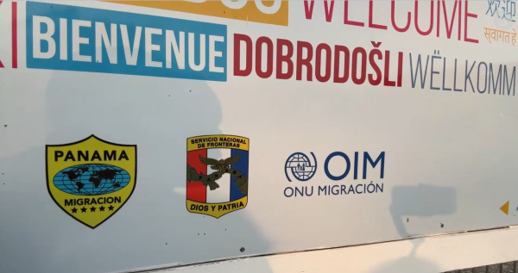
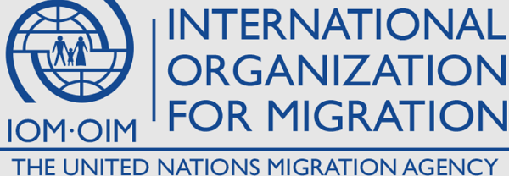
Michael Yon: “Notice the logo of the IOM features a shattered world / split world, in which a family is ensnared in a swirling pattern that indicates planet Earth. The message is clear: Use family migration to shatter the world.”
“Here’s a group of mostly Haitians who are very happy and excited to be given government assistance to bypass legal migration routes and simply be transported to the United States and dropped off in U.S. cities, all courtesy of the Biden administration. Michael Yon is on the scene, giving us the full tour. He has several urgent warnings for America, as revealed in the full video interview.
Michael Yon in front of one of the processing tents where migrants are granted passage and then transported by bus.”
“The USA and UN expect these women to be raped, so they give them rape kits which are essentially chemical abortion pills.”
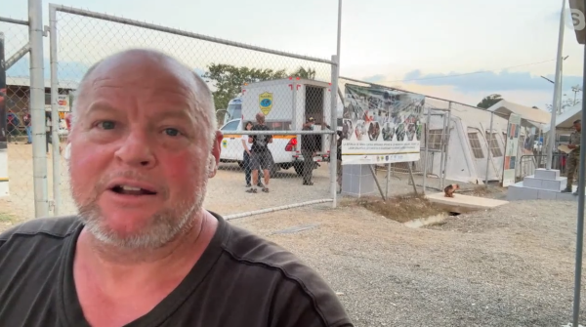
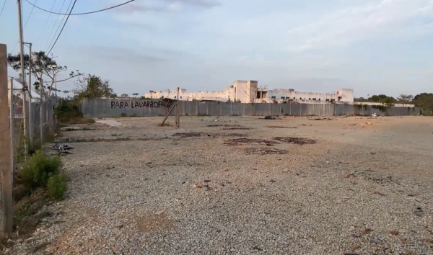
“This lot is the expansion zone of the UN migration camp, where new construction is planned to greatly increase the human throughput of the facility.”

ARTICLE 5:
This is the big pull-together article. Here are notes I took from an interview of Doug Hagmann and Steve Quayle of Michael Yon on August 24, 2023 “Global Invasions of Nations” Episode 4511 “Unfiltered Update…”
PLEASE LISTEN TO THE INTERVIEW AFTER READING THE NOTES SO THAT YOU HEAR FROM ABBA FOR YOURSELF. PRAY WITH PROCLAMATION AND SCRIPTURE FOR CHILDEN BEING KIDNAPPED FOR SEX-TRAFFICKING.

STEVE QUAYLE MICHAEL YON - INVASIONS OF NATIONS
Ep 4511: Michael Yon & Steve Quayle – Unfiltered Update on the Orchestrated Global Invasion & Consequences | The Hagmann Report | Aug. 24, 2023 BY HAGMANN REPORT ON AUGUST 24, 2023
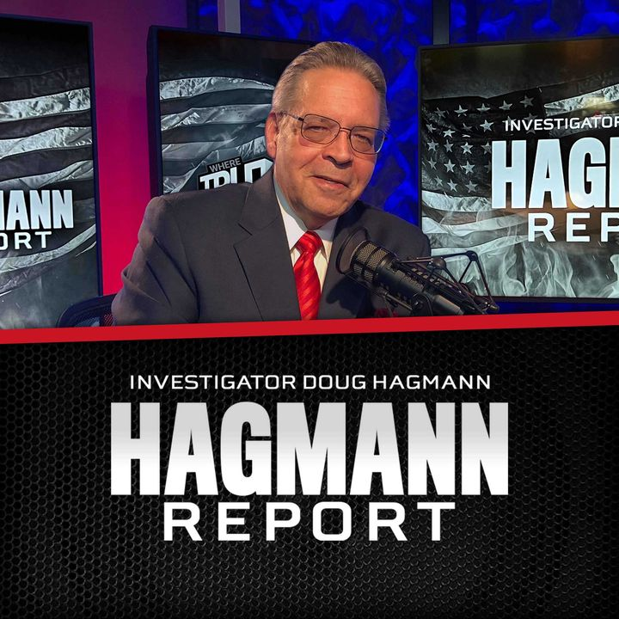
Michael Yon bio: At age 19, Michael Yon successfully completed Green Beret training. His Green Beret experience taught him the art of observing and surviving in the most dangerous environments on earth. Combining his skills as a writer and a photographer, and with the encouragement of fellow veterans, Michael began his correspondent career by traveling to Iraq in December of 2004. That was the first step in his nearly 20-year journey—traveling the globe to report on world events firsthand. He has traveled to more than 80 countries including China, India, Bhutan, and Vietnam.
Michael said that Panama and the Netherlands were two strategic migration crossing places. Michael Yon: “The invasion is larger than you think. The planned collapse of America is well underway.” A quote posted by Doug Hagmann regarding Michael Yom’s telling us what he has seen firsthand. He has been to 90 countries, some very dense and intense, and seen the evils first hand.
10,000 illegals are crossing the US southern border by the day.
From the Bahamas to Florida is another route, as well as Haiti to the US southern border.
Yon said there were Chinese spies in the CIA.
Approximately 860,000 children have been trafficked under the Biden Administration to do with the US southern border crossing, as well as more at the US-Canada crossing. These children are sold for high prices for sex trafficking.
The WEF and China are working together on this. Selling children, especially 4 and 5 year olds, is netting billions of dollars for traffickers to divide up.
Yon indicated that it was around 2016 that this “industry” – the trafficking in human bodies – really began to be a huge lucrative “industry.”
[Yedidah: 2016 is when the Spirit took His hands off the fallen ones to give them their “short time,” before Messiah comes. It began a cycle that ended on Yom Teruah 2022, going into 2023 on the Creator’s calendar.]
Yon said: “Information wars is the highest form of warfare.” Tell lies, deceive both sides, and the spoils go to the biggest liars.
He said “there’s just not going to be enough food to go around.” “People will resort to cannibalism.” He’s talking about America. That is what happened in Jerusalem before Nebuchadnezzar attacked the final time.
Michael Yon said that Japan and Taiwan had a very close relationship – good relationship. I find that encouraging. They are both in danger of attack by China.
Ishigaki Island off of Taiwan … Japan has a missile base there… Taiwanese may be fleeing there, he said, and the people of Ishagaki will have to flee … so there is a point of tension too.

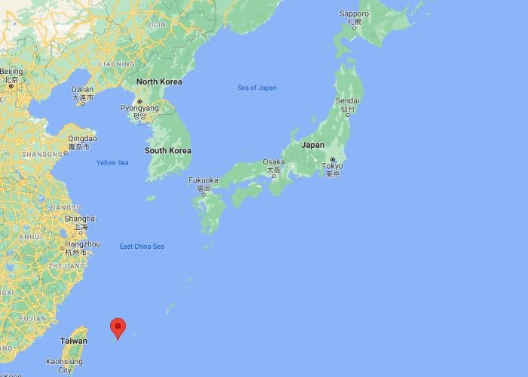
Ishigaki Island off Taiwan is a Japanese Island – tourist place, a tropical paradise
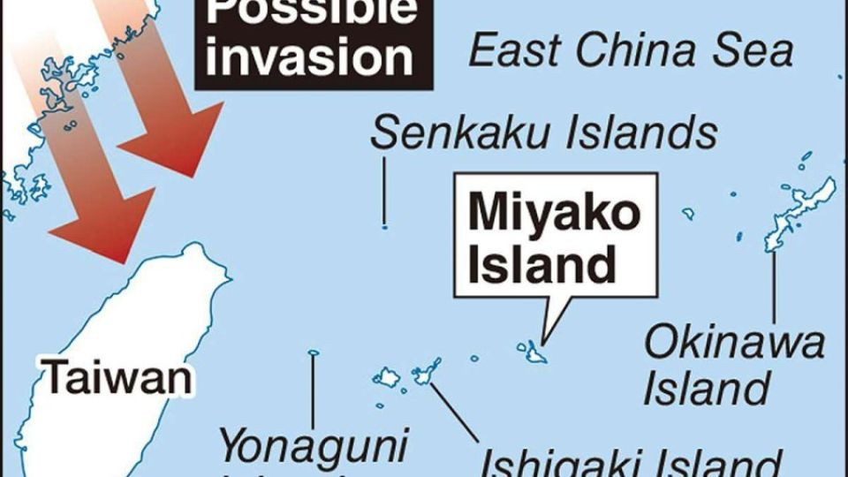
Possible Invasion route for China

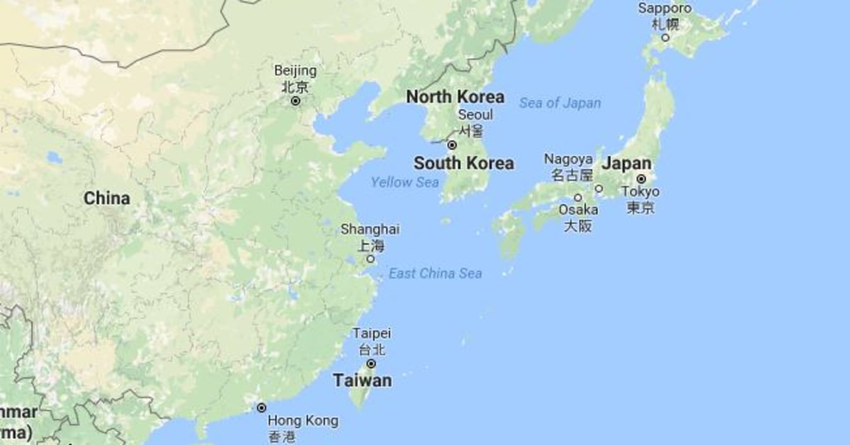
Japan is in danger from North Korea too. Michael says that North Korea hates about everyone. They don’t have friends. Japan is hated by China and North Korea. The US is on China’s payroll. Hundreds of government leaders to the President himself, and state governors are taking millions of dollars each from the Chinese to do as they say to bring the end of America.
Doug Hagmann said that Gary Haven was interviewed with Michael Yon a few days ago. Gary is a Texan we’re proud of. Gary said that that Governor Abbot had better do something to stop the child trafficking taking place as families cross the US border, and their children taken, or else great backlash will come on him and Texas … I’ve been wondering about that. Can’t Texas do something about what’s going on at the border – letting in thousands of Chinese military-age men, but the child trafficking going on there? It’s mass murder that’s happening for these children – and it is the Texas border.
Michael’s response to the calloused in the Texas government who are bought and paid for by China, or by other groups to keep them silent, and they don’t really care about the child trafficking. [Yedidah: I’m sure Abbot is the same – as long as he gets his money from China, it’s OK. He allowed that Chinese general to get something like 200 thousand acres of southern Texas land, with an airstrip on it, to develop it – for what?]
Chinese are pouring into southern Texas and being taken to their military bases throughout America to prepare for taking us down. Lucifer is paying off any opposition in the US government. So, how is Texas going to succeed, or do anything China doesn’t like?
A drunken Congressman from Wisconsin called Michael to take him to the Darien Gap. Lots of rape going on there. Michael was mad: “Righteous Indignation.”
“Bought out people,” he said.
Steve Quayle to Michael: “You can’t be bought, so they are trying to find a way to marginalize you or shut you up.” “They fear those who know too much.”
Pray for Michael Yon’s safety, Doug Hagmann, Steve Quayle, Mike Adams, Gary Haven – all who are telling the truth!
Steve said to Michael: “You are confronting the sick pathological liars in the universe, and they fear you.” These sick ones know he knows too much.
He said a lot of these children kidnapped at the border for trafficking are being held captive at a large former Walmart Super Center right downtown Brownsville, Texas. He said the parking lot is filled with workers, so no one can get close to the store opening.
Surely the border police know this. The border police are giving the Chinese soldier-age man crossing the border cell phones so they can contact their leaders inside the US. Michael asks why no one is there rescuing the children. They knew they are there – the city officials know. The governor Abbot knows, the Texas legislature knows. Why is there no raid on the facility that is a major hub of the trafficking?
Lots of Walmart stores during the time of Jade Helm were shut down, and various levels were dug underground. Shelves were made into beds. They became holding tanks for kidnapped children.
Michael told how the children are being flown to Jacksonville, Florida, Orlando, Tampa, etc. to places all over the earth where they’re bought to be used for sex, torture, and sacrifice to Lucifer. They are being flown out on charter flights. The children have hired “escorts” – i.e. 19-year olds-20-year olds, with a high school education diploma. Over 8, 600 escorts known about.
Each escort is in charge of 5 children. Some are not “children,” but early teen- age girls hired out for prostitution. But, the most popular being bought by the ultra-rich are children between 4-6. Often the children are picked up at their destinations at baggage claim. [Yedidah: I find it interesting that the UN is targeting children in kindergarten, ages 5 primarily, with the gender lies, and explicit sexual orientation, need for vaccines, etc. Germany has announced rooms put in public schools for children of kindergarten age to get naked and feel one another.]
Michael said a lot of the border patrol people are Patriots, good people, they hate what is happening, yet they’re isolated and can’t do anything to stop it – the trafficking is too huge an operation. [Something strange about that. If they are good people, why are they not sounding the alarm and releasing the children? Of course, they are threatened with death otherwise.]
Michael told how the children are taken to hotels, where they’re picked up and taken to their destination where they’re sold into sex slavery. “With migrants crossing the Darien Gap, so many children disappear.”
To keep their jobs the Border Police say: “we’re just following orders,” and do nothing. Steve said, “It’s the line used in the Nurenberg Trials by those who ran the concentration camps – “we’re just following orders.” It is what is being said in western Canada by police who won’t let fire victims evacuate, or food come in to them, or firefighters be able to put out fires.
Steve said to Michael: “You’re exposing the real face of evil.” He also said the horrifying thing is that our government is directly involved in making it happen – the trafficking of children, drug trafficking, trafficking of babies and children for human sacrifice, etc., while setting up murderers/terrorists in five-star hotels, giving them up to $40,000-dollar pre-paid credit cards, phones, 3 meals a day in the hotels, while they wait to hook up with their “officers,” like Chinese officials.
Politicians are becoming incredibly wealthy being paid for the “use” of these children.
Steve quoted from Revelation 18 – the 26th “commodity” of NYC – “trafficking in the souls of men,” or mankind, babies, children, innocent youth and adults.
Yes, being shipped out, so many of them, via NYC – city of the great whore of Babel.
“Baba-lu” – the gate of Lucifer … NYC – the gateway into the US and out of the US. A lot of the trafficked older girls are bought as prostitutes to be hired out to others – making a lucrative income for lots of people who take the money they make.
Michael really came down on Abbot. Michael said that Abbot was down there by the border. He said nothing about the Texas electrical grid which is in shambles. He said nothing about the border crossing or the trafficking of children. Of course not, he’s on China’s payroll, in the pocket of all those who pay him to be quiet.

Michael says Abbot is BIG with the WEF. That’s really bad! The World Economic Forum is an epicenter of Lucifer’s plans being put in action.
Michael told how Abbot was in McAllen Texas a lot. Where is that?
“McAllen is the largest city in Hidalgo County, Texas, United States, and the 22nd-most populous city in Texas. It is located at the southern tip of the state in the Rio Grande Valley, on the Mexico–United States border.”
It is a trafficking corridor, a crossing corridor.
The big trafficking corridor is from the Darien Gap through Panama and Costa Rica.
The WEF has headquarters in Detroit. Detroit is a key Great Lakes area.
Michael talks about the invasion of those who are taking over the nation while the paid-off ones wallow in their success – we’re being filled up with every evil grouping on earth from all over the earth.
Right now the Kurds are fighting the Turks inside Japan.
What is happening is that ethnic groups are fighting other ethnic groups everywhere. Michael said he loved the Kurds, and he loved the Turks. He has been in 80 different countries. He loves the people. [Yedidah: Michael sounds like me. In his talking about different places, his travels, his being with different people, I can identify with so many, having been in 39 different countries on five continents outside the US. Abba wants us to see. He wants us to know. He wants us to join with His heart and comfort Him, for He has to judge sin!]
Steve said that Maui was a microcosm of a whole picture – the FEMA training on another island while Maui burned – they did nothing to help. The FEMA dudes stayed in 1,000 dollar-a-night hotels, while the Island representatives from Maui stayed in hotels at ½ that rate or less. But it was a good time for the training of fire fighters by FEMA as the people burned on the nearby island of Maui.
Steve speaks about all the food recalls – “never before in the history of the US have there been so many,” he said. The food is going into the underground bunkers for the ultra-rich and ultra evil to eat on while everyone else burns alive or is nuked, or thrust through with a sword, blown away with a gun, etc. While the nation starves, the ultra-rich banquet.
He was in Hong Kong for 7 months before the police kicked him out. He must have been verbal and they shut him up. He said he was kicked out by the British police. When he asked why he was being kicked out, the British policeman said: “I am just doing my job.” Ohmagosh…
He was in about 100 of the Hong Kong major protests. So, he was frontal.
Chinese police station in Panama City? – PRAY WITH THE FIRE OF THE SPIRIT!
Love to you all, Yedidah, August 28, 2023

