THE LIES CONTINUE AS PLANS GO FORWARD
THE LIES BELIEVED BY MOST

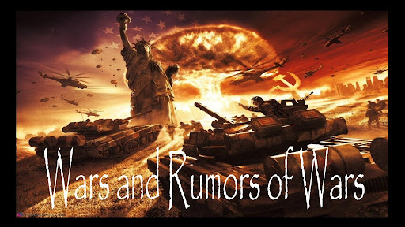

Please be sure you’ve read the article 319.0 under the Mikvah of Present Reality, entitled “Exposing a Big Plot and a Big Lie – Emergency Conditions Remain.” This is a sequel to that article, and will be 320.0 under the Mikvah of Present Reality!
In this article I will first give you quotes from articles of the mainstream news so that you can see the blatant lies and hostilities aimed at the minds and emotions of the apathetic, the fearful, the “leave me alone” crowd, the quick-to-hate crowd, and people unify under the plan of Lucifer-Satan, who is increasingly taking over to control their mind, emotions, and ultimately their will. Then I will give you exhortation and wisdom as to how to embrace truth, act on it, and go forward.
NATO was hoping for Ukraine to open a leak of widen an existing leak in the nuclear power plant so that Russia could be blamed for it. Steve Quayle reported yesterday that about 15 planes of Ukraine were flying over the power plant. It wouldn’t take much for them to open a leak, blame it on Russia, then NATO would open Article 5 of their directives, and use that to move into Ukraine and station their weapons on the Russia border. These 25-year-behind Russia military geniuses have a mind like Lucifer-Satan – they think they can destroy Russia and move in. In the meantime, Russia has the most powerful nuclear force on earth. You’ll learn how fast Russia has amassed troops, knowing of the plot.
From “Night Shadows,” an excellent summary by Stewart Best: “NATO’s Insane Lust for WW3 as Rumors Abound: We made it through the 4th of July and so now we wait for more news concerning Ukraine and NATO's insane lust for WW3 as news claims evacuations around the nuclear power plant have been mostly completed, and it appears that orders have been given to a wide area to `pack your bags’ and bring your `papers.’ This will be blamed upon Russia, but it will be a NATO/BIDEN war operation to bring NATO into the conflict under Article 5. Russia has long stated that she will use NUKES on the EU and America if the West keeps on with their invasion plans to circle Russia and then invade and divide up Russia's land. The Bible agrees that Russia and her allies will in fact rise up and destroy America/Babylon. The timing of all this is in the hands of the Lord, but it does appear that we are right on the verge of this. Then we have the Sun and CME activity along with strong UV radiation and more...”
I’ve followed this whole “lying wonder” scenario from the very beginning, keeping up with almost daily. I’ve reported clearly on the lies and exposed them. It is a fact that ALL Vladimir Putin wanted to do was to protect his homeland from the beginning. The U.S. and NATO leaders literally laughed at him when he wanted to make peace. It was awful to hear the mockery to Putin. In 2014, Putin was invited to a meeting in Europe to discuss and sign the Minsk Agreement. It was a farce by NATO to get Russia to believe that they would defend him if he was attacked. Putin signed the agreement. Then a few months ago, Angela Merkel, former leader of Germany told the truth – that the Minsk Agreement was a ruse to get Russia to relax, so that they had time to proceed with their plans that are being executed now by the U.S., NATO, and the UK – plans to deceive and blame it on Russia and the bring the world into the New World Order.
The greedy western nations also saw Russia as a treasure trove of things needed – minerals, metallic elements, natural resources, food crops, wealth untold – so they have plotted for Russia to be vilified and destroyed so they can take all they want. Biden has actually been quite open about it.
The whole thing is an elaborate lie, and yet Russia is being provoked and hedged in to the point where they either go forward and destroy the enemies or be destroyed. It’s tragic. The U.S. and European bankers had the Czar of Russia and his family murdered to start the “Communist Revolution,” and bring in Stalin. The bankers made billions of dollars on WWI.
The U.S. put Mao Tse Tung into power in China to bring in Communism and kill Christians. The Rockefellers praised Mao for his excellent form of government.
Barak Obama and Hillary created ISIS and other terrorist organizations and started the war in Syria, when it was a stable nation, as was Egypt under Mubarak. But Obama actually told Mubarak to get out, while the U.S. C.I.A. installed the Muslim Brotherhood in power. In each case, including the U.S. removing the good Iranian leader to be replaced by Islamic leadership, and replaced the ruler of Ukraine with Zelensky, etc. etc. etc. – always the replacements took the nation into war.
The U.S. backed Hitler, and U.S. major companies supplied his needs. Jewish rabbis became overlords of concentration camps as did Jewish rabbis in Russia under Stalin.
What appears to be “bad” is good, and what appears to be “good” is bad.
Isaiah 5:20-21: “Woe to those who call evil good and good evil, who put darkness for light who put bitter for sweet and sweet for bitter! Woe to those who are wise in their own eyes and shrewd in their own sight.” “WOE” is what Yahuwah says to those who turn peace upside down and blame the evil on those who are innocent of it. As Quayle says: “Putin loves his people more than Biden hates his.”
I give you a few quotes from Lucifer’s press and broadcasts. If you are so dead of spirit as to waste your time on “public news,” or TV at all, Satan’s #1 mind-programmer from the 1940s, the “Cyclops” of the fallen ones, then you might believe these lies, but you sure on not on Yahuwah’s “wave length.” In 1997, Yahuwah firmly stopped me from watching TV.
In Jeremiah 25, we read that the end-time result of what Nimrod started in Babel (Genesis 10) would one day be destroy utterly. The wording of Isaiah 13, and so many other chapters is that the final end of what Nimrod started, the end-time Babylon of “Mystery Babylon,” Revelation 17-18, tells of its total annihilation. The only way it could be totally annihilated would be nuclear destruction and a “mop-up” crew to take down any survivors. Both of those things are now in place for America.
I’ve been writing and teaching it since 1992, when Yahuwah said to me clearly as I read Jeremiah 50-51: “This is America.” Yes, Isaiah 10, 13, 18, 34, 47, Obadiah, Nahum, Habakkuk, Revelation 17-18/NYC – is the end result of what Nimrod started in order to open a portal into the dimension of Yahuwah and go up and “kill God,” as Anthony Patch put it.
That is still his goal. In Genesis 11, Yahuwah put a stop to it. He will put a stop to it in our day but not until almost every one of the 8 billion people on planet earth are dead. Messiah said that if He did not return, NO flesh would remain alive. This is the goal of Lucifer and the fallen angels – to kill all that reminds them of Yahuwah and Yahushua (Elohim).
Sha’ul in II Thessalonians 2 described today perfectly, particularly the great falling away of once-believers in the Word, because “truth has fallen in the street, and those who speak the truth make themselves a prey.” (Isaiah)
I have now finished the podcasting of the book of Jeremiah. The book of Jeremiah is focused on the nation that is the largest container today of the House of Israel/Ephraim/Joseph (the 10 northern tribes of Jacob) and the House of Judah (the 3 southern tribes of Jacob) – end-time Babylon, America. Revelation 18 is focused on New York City. America has had its 70 years promised, as in Jeremiah 25. And it used those 70 years to establish the greatest network of evil over the earth than any other nation in history – a destroyer of all that Yahuwah and Yahushua have willed for us. It’s goodness – a great lie, hidden under beautiful wrapping paper. The world is not fooled. Today, America is scorned, hated, mocked – and multi-millions are calling for our destruction.
Yet, the reality of it is happening now. All 200+ prophecies in the Word describing the demise of America and the UK, and western Europe, and Canada especially are being fulfilled. WWIII has begun. America, and U.K., and NATO have declared war openly on Russia.
Russian President Vladimir Putin has been forced by evil manipulation to defend its homeland. The evil propaganda lies of public news is angering to say the least. The true watchmen of Yahuwah are speaking out boldly.
Yes, Putin has had to tell the West to back off. He never wanted to enter Ukraine. His nation is probably the most advanced and prosperous nation on earth right now, with the most powerfully technologically advance war machine on earth – both in various types of bombs with abilities 25+ years advanced than anyone else, electronic warfare, far advanced than anyone else. Just Russia’s hyperbaric bombs, and thermobaric bombs – the U.S. has nothing like them. The submarine ability to launch them is far beyond anything any other nation has. Russia has been holding back, using a mercenary army inside Ukraine. But, once the nuking begins it will not stop, and America is begging for the fulfillment of what is written in Isaiah, Jeremiah, Revelation, etc. etc. Yahuwah Word is coming to pass. He has to judge His people for His people are rejecting the Word and His Son by the multi-millions, while carrying on the façade of “church.” Russia is the only outspoken and noted Christian nation on earth. It has told the U.S. embassy to leave, and “take your rainbow flags with you. Do you realize that all U.S. Embassies around the world fly the U.S. flag and also the rainbow flag of the LGTBQ etc.?
Yahuwah will allow the most brutal country to do the “clean-up” after the nukes are dropped – China. China has boasted that they will kill every man, woman, and child in America. China continues to boast, while filling the U.S. with their soldiers.
China is pouring its troops across the Mexican border in great numbers. But, for many years, Chinese troops and Russian troops and Iranian troops, have been hidden in the U.S. for “such a time as this.” “Sleeper cells” are all over the U.S.
Yes, Russia has told the Pentagon what targets his nukes will hit – 100 targets at this point, whole cites, and all military bases underground particularly. It is also known that a false flag pulled off by America may bring it on – as the false flag known as 9/11, which was the CIA and the Israeli Mossad, no Arabs involved. I strongly encourage you to read David Icke’s The Trigger for details, and also to learn who is AT THE TOP of world rule. “Illuminati,” yes, but who is at the top of them? I have studied these things for decades, and Icke writes the truth.
Just a few days ago, Biden ordered an evacuation of all the underground facilities for the big-wigs hiding out – because Russia has “bunker buster bombs” that would destroy them right away. Denver, Cheyenne Mountain, Mount Weather, the tunnels under the White House, etc. etc. – bunkers are being inhabited by the fearful ones, as Jeremiah 51 tells us. But, now, because of the reality of what Russia is saying they will do “IF” they have to, Biden is evacuating the main center of the government – where so much of DC has been transferred to – Denver – the “provincial Capital” of the U.S.
Russia has let England know the cities he will destroy if forced to do it. England has declared war on Russia. NATO has declared war on Russia. Russia has sent a Poseidon submarine with 100 megaton nuclear bombs near England and NATO.
These bombs can be launched and hit their target in 90 SECONDS.
Russia has told NATO that each one of the capital cities of their union is targeted with a 100-megaton nuclear bomb. One bomb can take out New York City, or London, or Paris, or Berlin, etc.
Does Putin want to do this? Did he ever want to do this? NO, NO! The thriving Russian economy is beginning to fail because of the expense of war. The Ruble is the most powerful money on earth because it is backed by solid gold only. America’s dollars are backed by the government’s hot air – they are worthless, nothing but lies back the dollar. Yet, on the back of the dollar bill is the plan from 1776 – that is to reach fruition 2016. The great “eye of Horus” will overshadow the U.S. and bring it under Lucifer’s control. Do you want to understand the symbolism on the dollar bill? To learn the meaning of the pyramid on the back of the dollar bill and the 2016, I recommend Tom Horn’s Zenith 2016. In my research, I have learned of many things that ended in 2016, and began in 2016 - a whole new cycle of prophetic events, and reported much on it – about 14 articles I remember.
I highly recommend that you purchase the DVD “Eye of the Phoenix” sold by Adulum Films – Chris Pinto, which you can get used on Amazon for very little money. I think I paid about $5.50 for my copy – but that a few years ago. The first two of the series of DVDs are 1) The New Atlantis and 2) Riddles in Stone, 3) “The Eye of the Phoenix.”
Want to know the truth about the real purpose of America being established? I wrote from Manley P. Hall’s book about this in the article under the Mikvah of Preparation “America’s Secret Destiny.”
Yes, England has received Russia’s map of key cities to be targeted. Here is a news headline from Hal Turner, July 5, 2023: “Britain Closed Waters Off Its East Coast July 4, Looking for Russian `Poseidon’: “Intelligence sources inside the UK have revealed the British were extremely worried that Russia may have already deployed at least one of its `Poseidon’ torpedoes off the UK coastline to create a nuclear tsunami that would destroy most of the country without warning.”
No the planned strike on the power plant, false flag, to blame on Russia was not pulled off July 5th or 6th, as was planned. However, that plan is still in effect. It’s not over – NATO has to get into Ukraine and they’ll blame their reason on Russia. You might also want to subscribe to Hal Turner’s reports.
Putin’s most likely nuclear targets in the UK MAPPED as escalation looms. The UK is perhaps Russia's greatest international foe within range of the Kremlin's 6,000 warheads. By OLLIE CORFE July 5, 2023
If so, where would Putin aim his missiles? Express.co.uk has plotted where the UK’s early Cold War Governments consider most at risk.
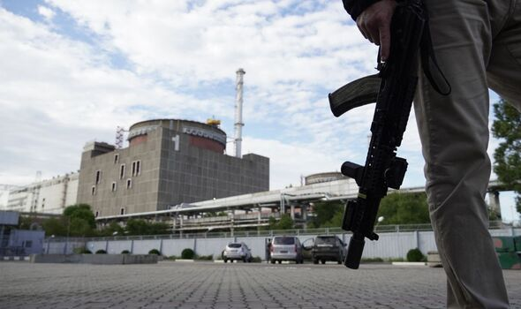
The Zaporizhzhia plant has been under Russian control since the early days of the war (Image: GETTY) “The consequences of a meltdown at the Zaporizhzhia Nuclear Power Plant in southern Ukraine would be calamitous. Aside from the destruction in the immediate 30km (19-mile) radius, the plume of radioactive elements could see contaminated matter fall all over Europe.
This was the case when one reactor in Chernobyl blew back in 1986 – Zaporizhzhia has six. Hamish de Bretton-Gordon, former commanding officer of the UK's Joint Chemical, Biological and Nuclear Regiment, previously told Express.co.uk that “when Chernobyl blew up a lot of contamination actually landed in north Wales, so at this stage one can’t predict it.” He added that current weather conditions would have the invisible radiation cloud blow “westwards” – putting the South of the UK at risk. Even more dangerous, however, is the fact that once detonated, the nuclear threshold would have been crossed in war for the first time since 1945.”

Map of proposed targets in the UK…
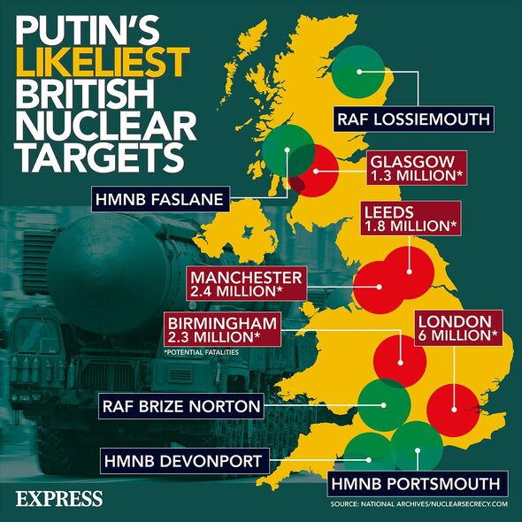

Quotes from “Russia Threatens to NUKE the United Kingdom, Launch Unstoppable Torpedo to Create Radioactive Tsunami Feb 2023:
“That is the concerning revelation shared by Daily Star on Wednesday after a Russian broadcast threatened to “obliterate” the UK and permanently submerge the nation underwater. According to the broadcast, which was uploaded to Twitter via an account called Terror Alarm, Putin's chief propaganda reporter Dmitry Kiselyov claimed two Russian super-nukes launched from Moscow could `wipe the British Isles off the map.’ `Russia could obliterate the UK with its new hypersonic Satan-2 missile,’ Kiselyov said before adding that Russia is poised to `plunge Britain into the depths of the sea using underwater robotic drone Poseidon’.
Kiselyov’s devastating threats come just days after former UK Prime Minister Boris Johnson revealed Putin “personally threatened” him with a missile strike during a phone call shortly before Russia’s February 24, 2022 invasion of Ukraine.”
Yedidah’s Note: Russia entered Ukraine to de-Nazify it and protect “Mother Russia” from Ukrainian threats, NATO threats, and US threats. Get the wording right! Russia wants peace! They tried to make peace, but were laughed at the U.S., NATO and Britian. In 2022-2023 England proudly boasted of blowing up the Russian Nord Stream pipelines. Then Biden proudly boasted of blowing up the Russian Nord Stream Pipelines. It turns out that it was the U.S. that did it. These pipelines took needed fuel into Germany and other NATO nations. Russia was blamed for blowing up their own pipelines. How absolutely evil. Russia has been blamed for what the U.S. has done under recent presidential authorities for several years, from cyber- attacks, to everything else that America has done to blame them.
Go to Abba about it. Get His wisdom and understanding and STAY AWAY FROM PUBLIC NEWS!!! At least go to stevequayle.com for a list of relevant articles daily, and be led by the Spirit as to what to read and what to ignore. At least you’ll get an overview of the times we’re in – from truthful accurate sources! I recommend that you go to gensix.com and subscribe to the private briefings which give you information up front from the finest of sources, truthful for over 51 years. Yes, you have to pay about $12.00 a month for the briefings. But, then, you’d be ahead of knowing the truth and how to prepare of 99% of the world’s people. Love truth and Yahuwah will make sure you get it.
THE NUMBER ONE SOURCE OF TRUTH is the Word of Yahuwah. Listen to the podcasts of Jeremiah and read the introduction chapters of other prophets. Do your own homework under the guidance of the Spirit of Yahuwah and do not be deceived. Messiah warned us DO NOT BE DECEIVED.
As Quayle reported, 15 Ukrainian planes were seen over the nuclear power plant on July 5th. The power plant already has a leak. If the leak is widened by Ukraine, Russia will be blamed, giving NATO the right to declare their Article 5 and bring NATO into the Ukraine, making Ukraine part of NATO. From the beginning this has been Russia’s fear – giving NATO the right to come right to the Russian border and fire nuclear weapons into Russia. At that point, calm, calculated, chess-player Putin will declare “CHECK MATE” on England, NATO, and the U.S. who back it all.
I was an avid chess player for many years. I understand that playing it “cool” and “straight-faced,” holding back and being patient is the way to win. It requires a type of military general’s mind – to assess all possibilities, and then proceed to outwit your opponent as fast as possible within a few moves. This is the mind of master chessman Vladimir Putin. But, folks, the public news is lying big time – straight out lies told. Stop listening to lies. Go to Abba about it, and listen to the seasoned granddad watchmen who know the truth and report the truth.
Such a man of cool calculation was also Nebuchadnezzar, and his Captain Nebuzaridan. They knew Jeremiah and his two friends were working for what was right, and everyone else, including Judah’s King, was working for destruction, provoking Nebuchadnezzar. Nebuchadnezzar was patient. Yahuwah was patient. Yahuwah called Nebuchadnezzar “MY SERVANT,” over and over in Scripture.
And again, as Yahuwah said to me in April “Vladimir Putin is My Nebuchadnezzar.” Nebuchadnezzar laid siege to Jerusalem for 2 years before the final take down.
Patience and wisdom are the key. The news media is lying through their teeth as usual. Ukraine has lost the war already. They’ve been selling the billions of dollars- worth of weapons sent to them by the U.S., and other nations, on the black market. Zelensky lives in a 25+ million-dollar house. Zelensky is a puppet of the evil ones.
America is out of ammunition for our soldiers. We are at the most pitiful condition possible, which was planned – especially executed by Obama and now Lloyd Austin with the “woke-joke.” The great military leaders were forced out by Obama who insisted that they sign a document pledging loyalty to him only. The great ones wouldn’t sign it.
Today folks, you are going to be require to go along with a loyalty oath to one known as “anti-messiah,” the “the beast” of Revelation 13 – a world ruler filled with Satan. Don’t let fear take over!!! Stand firm “in the power of His might.”
Those who “go along to get along” will damn their eternal souls forever. The martyrs are spoke of in Revelation 6 and 7. Millions will choose death rather than deny “Jesus” as their Savior, or whatever they call Him.
As Joshua told the people, whose name was actually Yahushua meaning “Yahuwah is salvation,” as Moses renamed him in Numbers 13: “choose you this day whom you will serve.” “Having done all to stand, stand therefore…” Ephesians 6:10-18: We go “through” and He is with us!
In the love of Yahuwah and Yahushua,
Yedidah July 7, 2023 (777)

