THE LIGHT HAS GONE OUT IN D.C. AND
IN THE NATION IT NO LONGER REPRESENTS
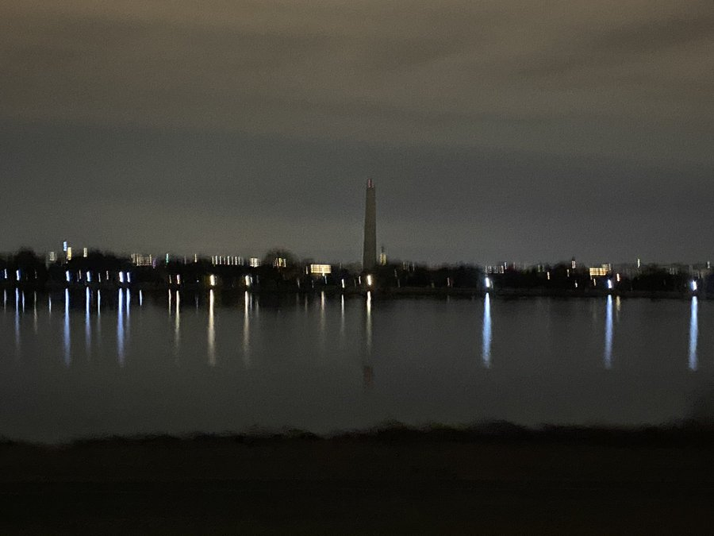
Washington Monument in the dark January 25, 2021
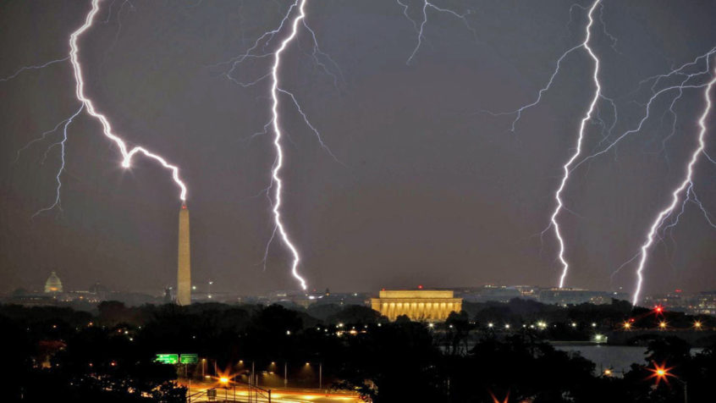
Yahuwah’s judgment has been passed, the prophetic Word is coming to pass, and the nation which was established as the final Babylon, with the capital established to control it, has now opened its doors to the destruction prophesied in Isaiah 10:1-25, 13, and 47, Jeremiah 25, 50-51, Revelation 18, etc.
Along with New York City, the financial and economic center of the world’s commerce and trade, and D.C., the epicenter of the evil that has spread to the world, the nation and world-supporter of great sacrifice to Lucifer, the enslaving of the nations to sin and evil, is dark, very dark, as the hoards of Satan’s kingdom prepare for his Beast-system to conquer all and his son to take the throne of world rule.
In an article, I shared this past September some pictures taken of naive Christians bowing down on their knees, laying hands on the Washington Monument in prayer. Though their intensions were good, they opened portals/doorway for demonic activity. I ask you to purchase the DVD “Belly of the Beast,” and learn the truth about this monument and so much more. It is truth-filled information.
I have been a faithful and loyal American, a good citizen, a law-abiding citizen. In no way and I “bashing” my country! However, the truth has been gushing forth, especially in the last ten years, and we cannot adore or worship our glorious nation anymore. The evil is seeping to the surface and cannot be stopped. Yahuwah is showing us the truth, uncovered by faithful born-again men who love our Savior and promote the Word.
I encourage you also to order Chris Pinto’s 3 DVDs “The New Atlantis,” “Riddles in Stone,” and “The Eye of the Phoenix” to understand America’s secret destiny, and how a lot of it is shown openly on the back of the $1.00 bill. You can buy these used from Amazon for a decent price. In order to focus your loyalty on the Kingdom of heaven, you must know what, and who, controls the Kingdoms of earth – now more than ever. There are physical points on earth that especially draw the fallen ones and their Nephilim offspring. Washington D.C. is one of their strongholds!!!
Up front, I want to give you information given on a Hagmann Report Special this week featuring Steve Quayle and Tom Horn sharing information they’ve not shared before. Here is a sampling:
Tom Horn talked about the room in the Capital that is below the Capital Dome. “The Capital Dome is really an antichrist-Luciferic prayer room,” he said. Above this “prayer room” is a painting of George Washington seated on a throne surrounded by gods and goddess with the 72 5-pointed stars surrounding him. The 72 “kosmocraters” of fallen angel spirits that govern the earth from the outer atmosphere. “From beneath the floor of the rotunda, the Beast will rise.” Tom refers to the Capital Dome rotunda.
Horn: “The most powerful stargate on planet earth is in the US Capital dome.” The Capital is also known as “the Temple.” “It is a spiritual center of the Luciferic plans for planet earth. The antichrist will come up through the floor of the Capital, under the dome.” Yes, that is what he said, and I know from my years of studying and my visit there, sitting just under the rotunda, that he is telling the truth.
I know he’s telling the Truth. When a President dies, he is placed in a casket right under the rotunda of the Capital, right under the “Apotheosis of Washington,” the deification of Washington painted in the ceiling, sitting among gods and goddesses, encircled with the 72 “stars” of the principalities and powers, “kosmokrators” in Greek.
Why are the dead Presidents’ caskets put under the rotunda? So that he might achieve apotheosis also. Please read “America’s Secret Destiny”/Mikvah of Preparation. It is factual. There is more to it, but I’ll stop there. Read the article with the quotes by Manley P. Hall – and the goal to bring back Nimrod, Osiris, Apollo – Apollyon (Revelation 9:11). This must explain why the Capital building itself is filled with such great evil and fallen angel activity.
Again, this is what Horn said: “The reincarnation of Osiris-Apollo will be through the dome into the capital” – a spiritual temple, a Luciferic prayer center, a portal/doorway/stargate from the kingdom of darkness into our earth.
Does this help you understand why the false flag of January 6th was connected to the Capital Building, which gave the powers of darkness the right to go after Christians, Conservatives, Patriots, “Trump Supporters,” “White Supremist,” now labeled “domestic terrorists.” Historically, right now, the U.S. military of all branches has been told to “stand down,” and purge out the “domestic terrorists.”
This ought to send you to prayer. I include a news clip about this below.
The Egyptian god Anubis is one who holds the keys to the underworld, as in the underworld of the dead. This is Revelation 9:1. A huge statue of the Anubis was sailed in New York Harbor past the Statue of Liberty, also a pagan goddess.
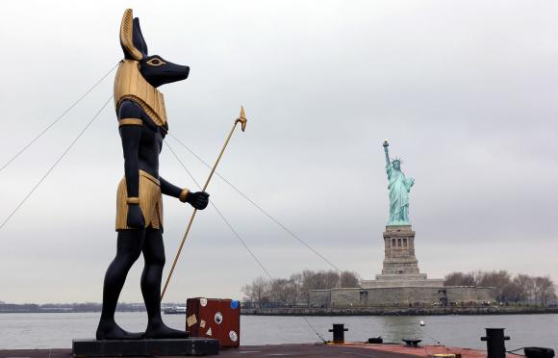
In the interview with Doug Hagmann, Horn and Quayle reported that earth is riddled with underground tunnels in which the Nephilim lived, and still do. I know that regarding the tunnels under the Andes, under Peru, under Ecuador.
The Capital building with its dome, the womb of Isis, is an actual stargate/portal, the place where the beast will come through onto the earth,” Horn said.
Yes, beneath the floor of the capital in the crypt, tomb of Washington. The tomb is empty. Washington is not there; he is risen to be a god. Washington risen into the presence of the gods … This is a counterfeiting what Messiah did …
So, as Horn points out, the Capital building with its great rotunda, is the epicenter of America’s heart – the reason for America’s founding – to restore Osiris to power over the earth – Nimrod, Apollo – Apollyon/Abaddon.
This gives more credence than ever to 9/11 being a chosen date based on the reason for its false-flag creation by the Mossad and CIA, is based on the rising of the one in Revelation 9:11. Horn said that the great financial reset is on the back of the dollar bill, and so it is. Learn about that in the DVD, “Eye of the Phoenix.”
On its dome of the Capital building symbolic of the womb of Isis sits a pagan goddess statue. In front of the Dome, down the long Washington Mall, stands the Washington Monument, symbolizing the phallus of Osiris. Osiris/Nimrod, Apollo/Apollyon of Revelation 9:11, facing the pregnant womb of Isis, pregnant with the god Horus, another symbol of antichrist, the Beast, the “dark prince” ruler that is rising into his position even now.
Astronomy-wise, D.C. sits on the cusp of the constellations of Virgo and Leo--the woman and the lion, as seen in the sphinx. D.C. is filled with symbols of Egypt and other nation’s gods. The pre-Flood sphinx is a time clock – of when these two principalities join together, time, as we know it, will gather together. In 2010, I was there at the Great Pyramid of Giza and the Sphinx. You might want to read David Flynn’s book Cydonia, the Secret Chronicles of Mars, which is a lot more than Mars.
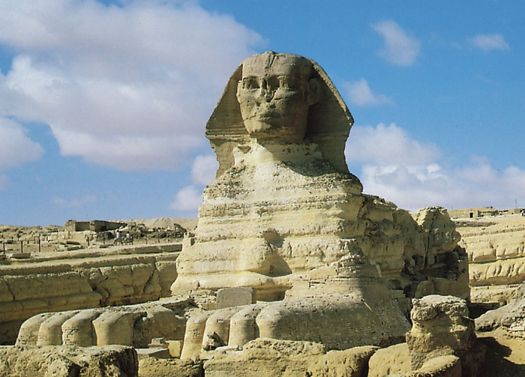
Sphinx: a pre-Flood time clock – representing the constellation Virgo (the woman), and Leo (the lion)
Wall Street in New York was the original “capital” site of American government where George Washington ruled from. When Washington D.C. became the Capital, U.S. government leaders wanted to call it “Rome.” What is the connection between Washington D.C. and Rome? Look at these pictures:
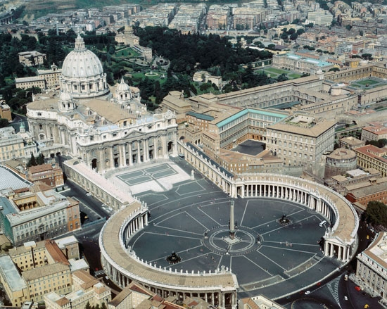 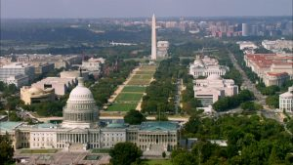Apotheosis of Washington, US Capitol Dome
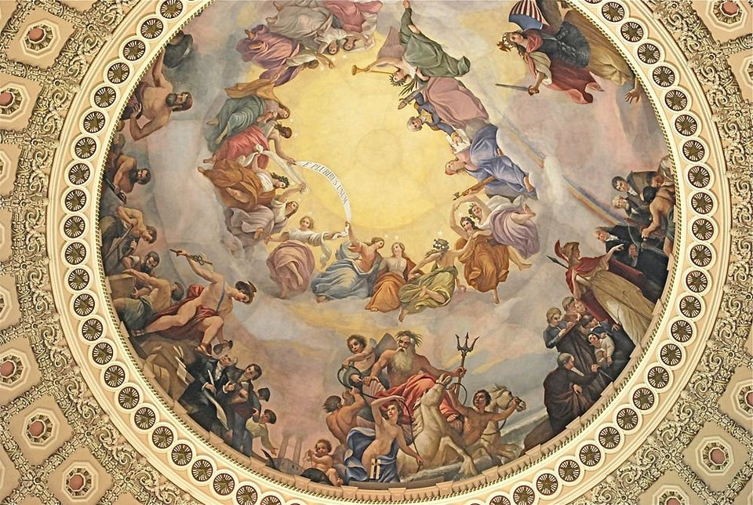
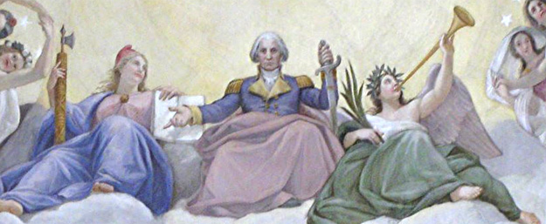
The Apotheosis of Washington (detail), Constantino Brumidi, 1865, United States Capitol Building rotunda
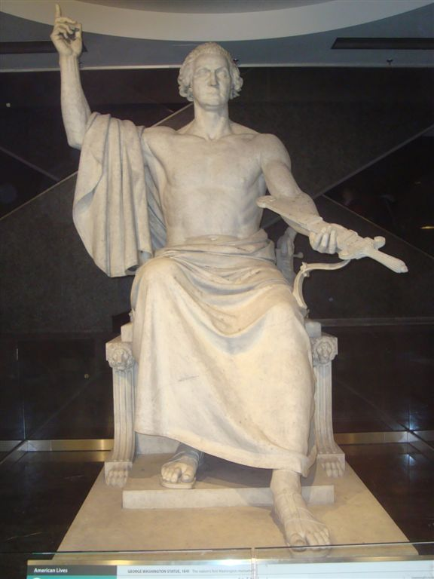
George Washington Statue - National Museum of American History, Washington D.C.
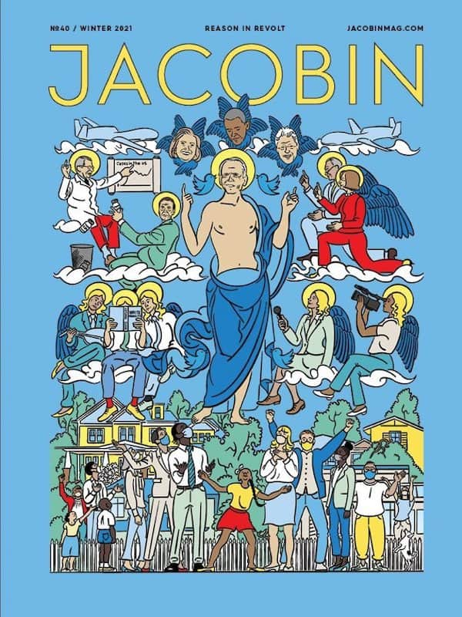

“SOCIALIST JACOBIN MAGAZINE COVER PORTRAYS BIDEN AS JESUS, WORSHIPPED BY THE CITIZENS”

From Justus Knight’s YouTube presentation January 25, 2021
Like Obama was portrayed as a deity, even as “Jesus Christ,” here also is Biden.
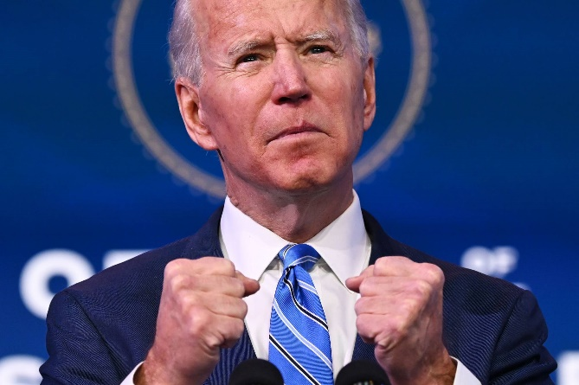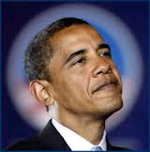
Knight commenting on the cover of the magazine:
Notice the drones hovering
Notice Hillary, Bill and Obama at the top whispering in his ear
Notice Fauci on the left and on the right is Pelosi and Chuck Shiemer
In the center are house and senate people reading memoires, and also public news greats video-taping.
On the bottom are us “little people” who are to worship the new god-Biden. the little people are dutifully wearing their face masks.
Notice that no one above Biden’s feet is wearing a mask, only the “little people” wear masks and look up at his feet.
CBS News: Fauci says he has that “liberating feeling” from working in the new Biden administration (what a statement!)
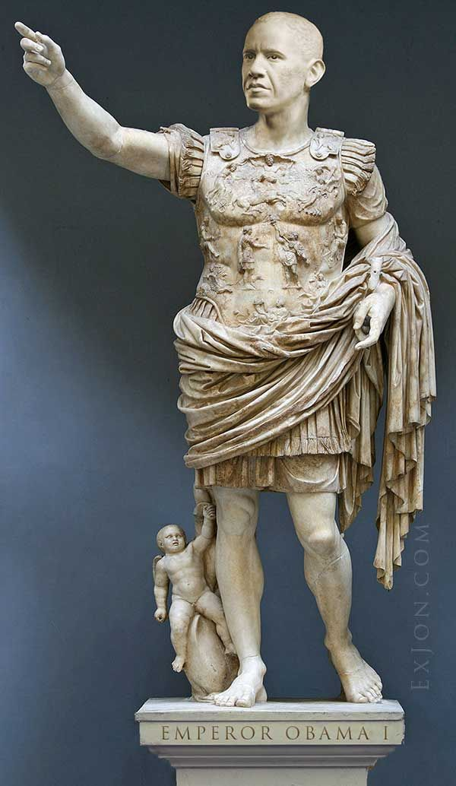
Look familiar? Here we go again with the deification of another President.
People makes gods out of people, exalting them, enthroning them … making statues to them, erecting symbols of them as gods, like the Washington Monument, symbolic of the legendary phallus of Osiris… the symbol of the Beast.
All Presidents, except for 2-3, are related in the bloodline of the Illuminati, a hybrid bloodline that goes back to Nimrod. Therefore, as I clearly wrote in “America’s Secret Destiny,” Mikvah of Preparation, America was the chosen nation to bring forth the world ruler from way back 1500s, early 1600s. Pintos 3 videos clearly give facts to prove that. This is where “give us a king” ends up – as in I Samuel 8.
Truth is sprouting up like grass of the field, and the enemy is trying to mow it down, but it is springing up faster than they can mow. The nation has always been under special care of the fallen angels to bring about what we are seeing now – the disposal of the nation as a used rag, a dead lab rat, something no longer needed. I found out inside information that we never elected a President, that was planned out 4-8 years ahead as part of the goal that has been set in motion now. Their lineage going back to Nimrod.
We’re lived with deceit, lies, in a fantasy world that has created weak and trusting people in what the leaders tell us. People have become so dependent on government assistance also, and know nothing of trusting Yahuwah.
His people are so mentally detached from Him that they are not studying and applying the Word, nor acting on truthful information from Yahuwah’s servants.
Now, America is under the final judgment of Yahuwah. I’ve gone over those Scriptures in detail so many times in articles and podcasts about America. Now it is open knowledge for all to see. Even men like Steve Quayle are mentioning Jeremiah 50-51 in regards to America, and other watchmen too.
As of yesterday, our Military has been told to “stand down.” Did you know that? Do you know what that means? This is a historic event in the last few days. The military can do nothing without permission by the new Commander in Chief, whose picture appears on the Jacobian magazine dressed like a Roman god. Steven ben Nun reported on it this morning.
“US Military Ordered to Stand Down within 60 days to Purge Patriots and Constitutionalists (i.e. White Supremacists and Extremists”
NATION NEWS DESK 04 FEBRUARY 2021 Hal Turner
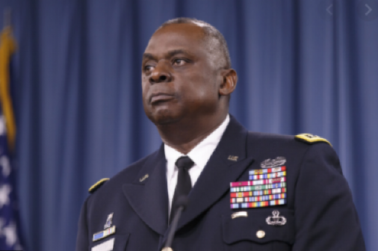
“A full-fledged Communist Purge is about to strike the United States armed forces. New Secretary of Defense Lloyd Austin has directed a service-wide stand down to take place in the next 60 days. Each military branch will schedule a stand down to allow each service to have "needed discussions" on extremism in the ranks. The order came during a meeting Austin held Wednesday with:
@thejointstaff
@USNavy
@usairforce
@USArmy
@USMC”
Folks, let us all rise out of the filth we’ve been confined in by lies, into the clean air of the Kingdom of Light. Colossians 3:1-3, NAS: “Therefore, if you have been raised with Christ, keep seeking the things that are above, where Christ is, seated at the right hand of God. 2Set your minds on the things that are above, not on the things that are on earth. 3For you have died, and your life is hidden with Christ in God. 4When Christ, who is our life, is revealed, then you also will be revealed with Him in glory.”
This promise is for those who have died to the old life and truly been born again, raised to new life in Him, all things becoming new. If, indeed, you life is submitted to, hidden in, Yahuwah and Yahushua, then you will be able to enter the Kingdom of heaven, even now through your re-born spirit.
Let us breath free by shaking the lies out of our mind and embracing Truth with all your heart so that you do not trust man anymore. We are warned in the days to trust no one (Micah 7, Jeremiah 9, Matthew 10).
Our full trust must be in the Heavenly Father we know, hear from, and obey, and His Son, our Master who is training us for reigning in His Kingdom. To continue on with the façade of life in the world is insane. Ya’cob said in James 4:4 that to love this world is to be at war with Yahuwah. Press in with worship, praise, declaration of the blood of the Lamb, and your freedom because He rose again. There is only Deity found in two: Yahuwah and Yahushua. To deny that, puts “deity” back into people, or into one’s self. The question is: Do you know Them personally, and do They know you? Do you know them so well that you absolutely trust Them with everything and you remain in peace? Do They trust you to obey and be a good child in Their family?
Let the fire of the Spirit cleanse, the water of the Spirit wash, the fruit of the Spirit teach and transform, and the oil of the Spirit empower you with His nature, ways, and thinking.
In His love, Yedidah
February 10, 2021

