THE PRESSURE BUILDS TO
FORCE RUSSIA AND CHINA TO ATTACK THE U.S.
O ABBA! HAVE MERCY ON YOUR PEOPLE! THEY DO NOT WANT WAR!

Here I will give you up-to-date information that has broken my heart, having been with the people in both Russia and China. Human beings who don’t have any Luciferic-Satanic agendas are all shocked and horrified at the attacks of the U.S. and NATO to provoke war. Now China is moving into Eastern Europe to join with Russia.
In 1992, while reading Jeremiah 50-51, Abba said to me: “This is America.” I began doing research in the Word and found that end-time Babylon, the nation groomed to restore Nimrod to life again for world rule, aka Osiris, Horus, Apollo, the Apollyon of Revelation 9:11. Oh so much research and reporting through the years, and now the watchmen know also – as the “chosen ones” by secret societies over 400 years ago, America has been steadily working to bring to pass the resurrection and restoration of the Nimrod/Gilgamesh of Genesis 10 and 11, who by DNA manipulation “became a gibbor,” a giant, a Nephilim. Manly P. Hall described it so well in his book The Secret Destiny of America. My article gives the highlights of that book: “America’s Secret Destiny”/Mikvah of Present Reality.
American soldiers watched as German archeologists unearthed Nimrod’s/Gilgamesh’s his body in 2003 in Iraq, having started war with Iraq as an excuse to get to his tomb and to his plans for his tower in Baghdad. All was recovered and flown back to the United States. The plans were given to CERN to do what Nimrod intended to do with his tower – open the portals into the underworld, into Tartarus and loose the fallen angels, and into other dimensions and into the cosmos to bring back all those fallen ones, their offspring and their creations (aliens), to rule earth once again. Once the war kills multi-millions, Lucifer will give the orders for the Beast/Nimrod incarnate to take his place of world rule.
The Globalists long for a return to the “Golden Age” of the fallen angels before the Flood. So, here we are “in the days of Noah” (Matthew 24), not just in spiritual theory, or doctrine, or eschatology reasoning, but literally down to the last cell in his cloned body. The details of the “days of Noah” are details we are familiar with now. As judgment fell them on the fallen ones, so judgment from Yahuwah has begun to fall now – and upon all those in league with the fallen ones (the “Nephal”).
Lucifer rules the world leaders now from his palace and throne under the ice of Antarctica, summoning them there for instructions that they faithfully carry out. The world rulers bow to him, and tell him that whatever he says to do, they will do.
Refer to: “The Midnight Meeting” and “He’s Here, and in Control…”
How pathetic that the children of Yahuwah, for the most part, don’t care what Yahuwah or Yahushua say - they don’t obey Them anyway. They want to rule their own lives and the lives of others, and do not bow to His will. Yet, they expect to go to heaven when they die because they have a religious belief system. How tragic!
Psalm 120:7: “I search for peace; but when I speak of peace, they want war!”
“Mike from around the world,” a military intelligence officer with high statis, said on Thursday night, March 31st, in an interview on Paul Begley’s program, said this: “DEEP STUDIES ON HUMAN DNA SHOW THAT MANKIND HAS NO COMMONALITY WITH ANYTHING ON THIS EARTH – EXPOSING THE REALITY OF INTELLIGENT DESIGN FROM SOMEONE OUTSIDE OF THIS EARTH.” We are eternal beings, with His stamp of ownership on us.
Animals, birds, fish, needed insects, and all green things and life forms that the Creator spoke forth for our good, have unique composition, but only humanity has the eternal stamp of the Creator individually on our DNA.
Everything just about that has been brought into this world by fallen angel creation, given to mankind, is for the destruction of our DNA and our life itself. Therefore, the air, food, water, clothing, chemicals used in so many things, are all tainted with things now that destroy the fulness of life-giving elements. Those in league with Lucifer and the fallen angels, the Globalists in particular, want to do away with Yahuwah and Yahushua, and everything that is in Their likeness and image. Seeing His likeness and image on earth really upsets them drastically. Thus all the things that have been done to break us down in health, strength, mental abilities, including mind-programming, has been done and is increasing. The goal is the death of all pure humans and life forms created by Elohim. (Genesis 1:1)
“In the beginning, Elohim (Father and Son), created the heavens and the earth. The fallen ones took over the earth and destroyed it (Genesis 1:2). In Genesis 1:3, Messiah spoke the re-creation into existence as the Word of Yahuwah. Now, the fallen ones are at it again, to destroy everything that reflects the nature, ways, and thinking of the Creators (Colossians 1).
The greatest tragedy of all is that His people are so apathetic and cold towards He and His Son, so resistant to knowing Them, submitting and obeying Them, so hardened against Messiah’s return, any responsibility to promote Him to others, and basically so against Their rule by Yahuwah’s Spirit from within.
The great separation is in progress of humanity into two groups, the truly born again and the truly lake-of-fire-bound. All who try to straddle the fence between will be vomited out of His mouth at His coming (Revelation 3, Laodicea)
The globalists must have World War III as a great sacrifice of those who are innocent – babies and children (abortion/pedophilia/cannibalism), and of all who stand strong for Messiah Yahushua, who stand with His Deity, as with His Father, unwavering in faith and great love for Them and Their Word. The worldwide attack on true Bible-believing redeemed ones is getting worse by the day. This is why the United States and NATO are pushing so hard. The global news is programming the people of this world that good is evil and evil is good – nothing but lies.
The war is on to get of anything that has the image and likeness of Yahuwah stamped on it. Our very DNA as human beings is the signature of Yahuwah on us as in individual. We are “one of a kind.” The expressed goal now is, through nuclear holocaust, to kill at least 250 million Americans within a day, beginning with Washington D.C., and New York City (Revelation 18), and then other cities across the U.S. with Russia’s highest technology of 300 megaton bombs. No one on earth has the high technology in weaponry that Russia has, not even China. America is at least 20 years behind both in weaponry technology.
According to the Word, no flesh will be saved alive in America when it is all said and done, and the beheadings and soldiers and criminals on the ground finish off the other 80,000.
Now for what has brought me to tears and prayer today, for you also to make a matter of prayer and petition to Abba for mercy on His children right now, especially in China.
Here are two very sobering reports from today. Yes, China has landed in Serbia, with troops and planes. Serbia hates NATO so is not belligerent against China. They come to the aid of Russia. What are the police in China screaming at the people they are beating and arresting? We will go to war with America.
Did you know that Chinese and Russian hypersonic nuclear missile technology is now took up so that they can launch for each other in partnership? China can launch for Russia; Russia can launch for China. “Mike from around the world” said on Paul Begley’s broadcast March 31st: “Putin cannot attack just one nation – he will attack many, i.e. the U.S., Israel, the U.K., Germany, France. He would be losing if he only attacked one nation at a time. Yes, he can attack many at once. China and Russia can link their systems of hypersonic missile. China can launch, and Russia can direct their missile.” As you read in Jeremiah 50-51, you see how these two primary nations to the north of America can work together to hit many cities at the same time.
The terrible things happening in Shanghai - Shanghai is very dear to my heart. I was in Shanghai in 1995, leading a team of 3 men, one being my husband, and 2 young men from Switzerland. By that time, I was very familiar with traveling inside China. We flew to Shanghai but took the train coming back to Hong Kong – a 36- hour trip through the country. I loved it. After doing what we were sent there to do, we had one free day in Shanghai to go visit places like the Yu Gardens. Now things are happening there that are so sad to hear about.
I had a chance to go to Taiwan as a missionary in 1966, but did not go. All my friends were getting married and I was very lonely. i paid a very high price for that decision for 30 years. But Abba won out, and I made up for a lot of lost time in the ensuing years from 1996. My heart is with the believers in China and Russia. Read Brotherhood of Darkness about what really happened, how Taiwan actually had the upper hand and the US fought against Formosa/Taiwan in favor of China. It was very sad. Now, once again it is the same.
President Jimmy Carter made the statement that if China attacked Taiwan in the future, we would stand with China. President Biden spoke with President Xi of China in 2021, telling him that if China went to war with Taiwan, America would stand with China. Biden and many American politicians now are up to their ears in taking money from China for China’s takeover of the U.S. We’ve had our coup.
Several years ago, I wrote how America was becoming more and more like China in its severe communist goals. Now we know – it is true. The social credit system of China is being brought into the U.S. for example. The unmerciful death of babies is another example. The utter unmerciful no-feeling for the deaths of children and humans in general is settling over the world, as it is in China.

April 14, 2022
“Shanghai Descends into Chaos as Taiwan Military Distributes Survival Handbook to Citizens in Preparation for China Invasion”
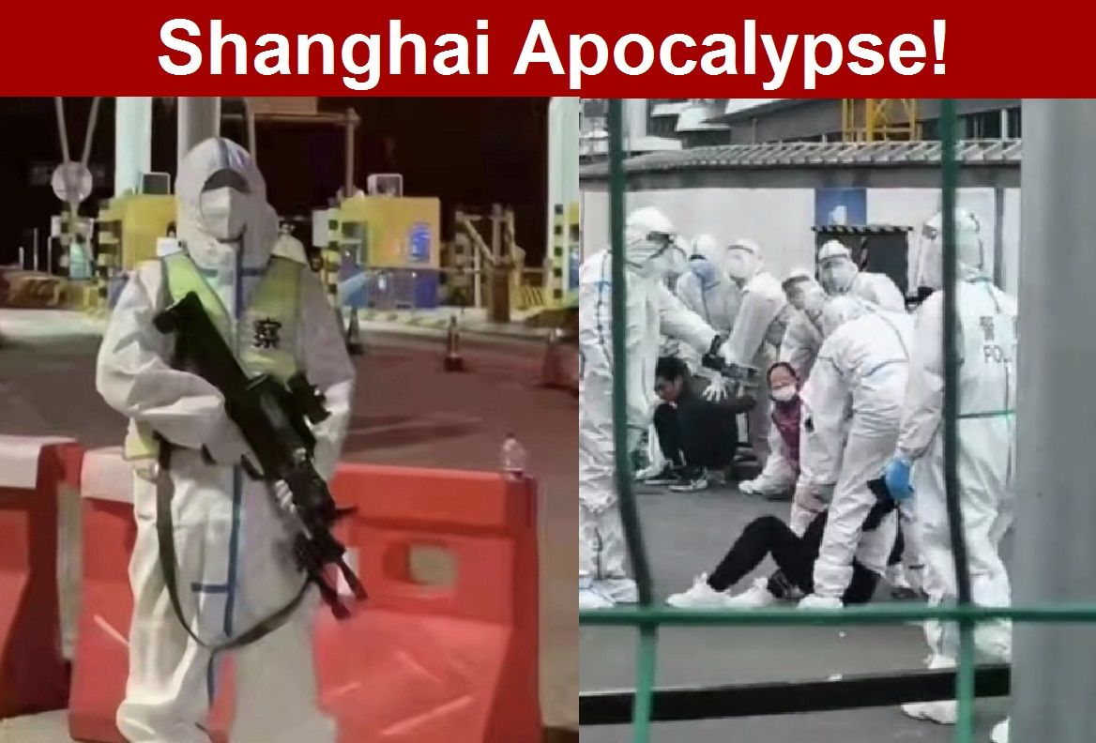
by Brian Shilhavy Editor, Health Impact News
“Reports coming out of Shanghai show riots now breaking out among desperate people fighting back against police forcing people into quarantine concentration camps, and horrible side effects from the Sinovac COVID-19 vaccines where people are reportedly dropping dead soon after the shots. In nearby Taiwan, the military is taking unprecedented measures by distributing a 28-page public emergency handbook to prepare their citizens to handle an imminent Chinese invasion.
Meanwhile, here in the U.S. the corporate media continues to focus on Ukraine, while many in the Alternative Media have been distracted for the past few days on “snake venom” that is allegedly infecting municipal water supplies…the implementation of the Great Reset and New World Order that is unfolding before our very eyes in China.
Shanghai is China’s largest city and largest port, and what happens there affects the rest of the world, especially in regards to the collapsing supply chain. Here is a video report that is from our Bitchute channel. It is also on our Odysee channel and Telegram channel.
People locked down in their apartment buildings are developing a barter system to try to stave off starvation. What is happening in Shanghai should be a wake up call to everyone to start preparing for what is coming next.
Taiwan is doing a wake-up call by distributing information to people to get ready and prepare, but people in the U.S. seem to be distracted by an overflow of information right now, and if you don’t focus on preparing for something on the scale of what is happening in Shanghai, it could literally cost you your life.”
Watchmen of the Ezekiel 33:1-7 caliber have been warning for several decades to prepare. It’s coming to the U.S. It is coming to the entire world. Nimrod has been cloned and is working with world leaders now to bring about this war, under Lucifer’s orders down under in Antarctica. All of their people are in unity.
Hardly any of Yahuwah’s people are in unity. This is why He must have a remnant – not to bring great revival to the world so that the paganized, anti-Word, churches are flooded with people they can lie to, at least in the Greco-Roman-culture nations, aka “1st world nations,” globalist nations. The only true believers are in unity as per John 17, around Yahushua Messiah and His soon return.
Here is information regarding what the U.S. has done to Russia. I hope you can watch this short video, and hear the heart of the Russia’s crying to Russia to attack the U.S. – they understand the U.S. wants Russia to attack them.
Just hearing the people, knowing that they speak from the tragedy of what the U.S. just did in blowing up one of their ships in the Black Sea, killing many, and for what? It was the U.S., NATO, and Ukraine who actually started the whole thing by positing troops on the Russian border. Putin tried and tried for diplomatic solutions until he realized that they plot was to get him to do their dirty work of destruction. Putin is not a Globalist, but is being manipulated by globalists, and he knows it.
The World Economic Forum and their Great Reset, is all about one world everything, so that those not being injected with the now-new viper venom in the injection, will not be allowed to buy, sell, or live.
If nano-bots, toxins, Nephilm/giant DNA, human DNA-destroying elements, immune system destroying elements, causing brain tumors, heart attacks, changing humans into “things” to be hooked up to A.I. (aka alien intelligence/alien implants), and lets not forget the hydra vulgaris tentacled “immoral” creatures in the soup too, now viper venom – what is the goal for humanity by these in league with the “viper seed” and the fallen angels! Isn’t it interesting that they defend the use of tentacled creatures living in our blood stream, and viper venom as being “good for us?”
RUSSIA FURIOUS OVER SINKING OF MISSILE CRUISER "MOSKVA" - TALKING "WW3" World Hal Turner 15 April 2022
The Russian people are enraged beyond words over the sinking of their Black Sea flagship, the Guided Missile Cruiser "Moskva" and they are already publicly saying on TV that they are in World War 3 with the United States.
Barrages of Russian missiles were launched late last night against at least 8 different "fronts" inside Ukraine, hitting targets in Kiev, Kharkov, Nikolaev, and elsewhere, causing thunderous explosions.
The video below shows the sky over Kharkov at about 9:45 pm eastern US time:
On Russian television, the mood was ferocious anger, and the remarks being made were specific: Russia is already in World War 3, Russia is at war with the United States/NATO, and more. Here's a small sample:
One source familiar with the unfolding events, told me the following:
The cruiser sank. There were many victims on board. There was a monstrous explosion of ammunition and airborne missiles. I think there may be several hundred dead, if not almost the entire crew. So there will be a backlash.
That same source then SPECULATED what he believes the Russian response will be: The RF Armed Forces will hit Bankovaya, the Ukrainian Defense Ministry, the GUR building and other facilities in Kyiv. In addition, a strike on the Baltic states or arms convoys in Poland or the Czech Republic is possible.
There will be strikes by the RF Armed Forces on bridges along the western border of Ukraine, on bridges in Kyiv, on bridges across the Dnieper.
There will be strikes on railway bridges in Western Ukraine and on transport hubs and interchanges, on junction stations, and so on.
There will be strikes on the barracks and control centers. Blows are prepared from all trunks. They will strike from the Caspian, from the Black Sea, from the Crimea, even from the Baltic and from Kaliningrad. There will be shelling by Belarusian artillery and Belarusian rockets.
The strike will be three waves, massive volleys, there will be up to a thousand missiles at the same time.
Heavy artillery, RSZO. In the Kiev region, Kiev, Kharkov, Nikolaev.
He wrapped-up his speculation by telling me: WAR IS GOING TO A NEW LEVEL!!! WATCH. This story is still developing, check back for updates.

UPDATES from Hal Turner - 8:24 AM EDT April 1
Russian Defense: We will increase the number and size of missile attacks on Kiev.
Russian Defense: More than 30 Polish mercenaries were killed in Kharkov.
Among the prisoners in Ukraine there are military personnel of NATO countries, said Senator Klimov of the Russian Federation Council.
“We already have prisoners among the military personnel of NATO countries, we will show all this when we conduct trials, and the whole world will see what really happened,” he said

***** BULLETIN *****
UPDATE 8:32 AM EDT --
The United States has received an official Diplomatic Note from Moscow which says, in sum and in substance "Russia demands the United States stop arming Ukraine" and then threatens "unpredictable consequences" if such arming of Ukraine continues.
This is stated in an official diplomatic note from Moscow.

https://halturnerradioshow.com/index.php/en/news-page/world/russia-furious-over-sinking-of-missile-cruiser-moskva-talking-ww3
From the video: The Russian people are furious over sinking of the battleship “Moscow” – and rightfully so. The provoking of Russia to war will result in Jeremiah 50-51, Revelation 18, and with China joining in, Isaiah 13, 47, Jeremiah 25:11-12 – total annihilation of citizens of the U.S. It is so near!
Let us unite with Yahuwah in what is justice for His people, because no matter where you live in this world – it’s in your face now.
Hal Turner sad lament regarding what is being told to support the total lie of a good Ukrainian government: “Perhaps if the government they're trying to defend didn't spend eight years bombing civilians in Luhansk and Donetsk, or sign the Minsk Agreement then utterly fail to abide by it for five years, or absorb NAZIS into its government, police, and military, none of them would be in the position they're in now. It's hard to feel sorry for men who are trying to defend the indefensible (ideologically.) They are CHOOSING death.”
“The people involved do not understand the overwhelming truth behind all the lies that are being told to the Ukrainian people and the people of the world to vilify Putin when it is the U.S. behind its own plea to be destroyed – using NATO, Ukraine, Poland, Russia, China, etc. etc. to do their dirty work – and blame it on someone else.”
News Reports 4/11/22 AM: "Americans Are in Charge in Ukraine" – reported by a French journalist.
I pray that this Passover weekend has been very special for you! At our Prayer Center, we had three days of meetings, and our Seder yesterday, with worship and teaching, and sharing, and praying, and rejoicing. It was precious! Will we have such freedom this time next year?
Let us rejoice that we don’t have to go the way of the lost into the eternal lake of fire. We can give our lives totally to Yahushua as our Master and be filled with Yahuwah’s Spirit so that we are transformed into new creations, set apart for the Kingdom of Light.
Don’t think about the government leaders who are causing all the trouble, but think about the people in these nations as individual human beings, so many of them our brothers and sisters in Messiah. They are going through severe tribulation. But, also pray for yourselves and the citizens of America and the U.K. and Europe, and all nations, because this is only a beginning. Once the Beast actually comes to power and is backed by all nations, then the depths of tribulation will begin. The events will be swift. Prepare in all ways. You can’t escape it all. Abba is in judgment mode, and yet He still looks to His children to see us through.
This coming Sunday is First Fruits, Resurrection Day! It is a priceless time to enter into the joy of our salvation and embrace our eternal homeland forever. Let us be more focused on how we are to prepare in every way for the return of the King of kings and Master of masters. (Revelation 11:15)
Shalom, Yedidah,
April 18, 2022

