**THE SABOTAGE OF RUSSIAS NORD STREAM PIPELINES**

**HOW IMPORTANT IS IT FOR YOU TO UNDERSTAND?**

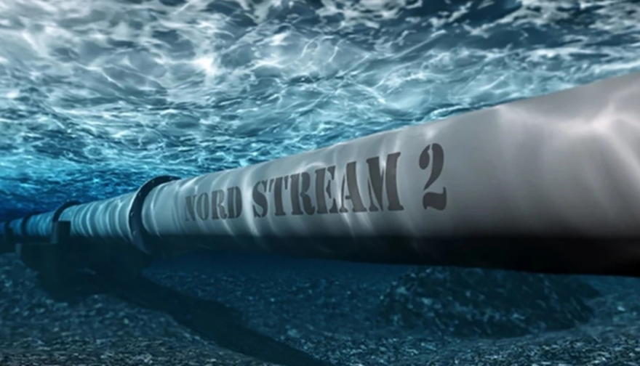

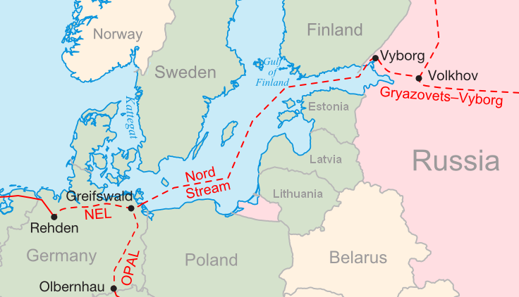

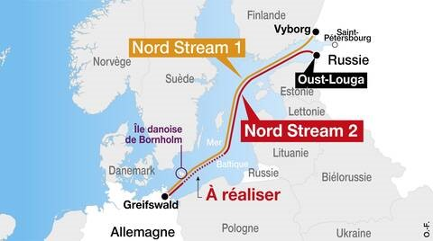

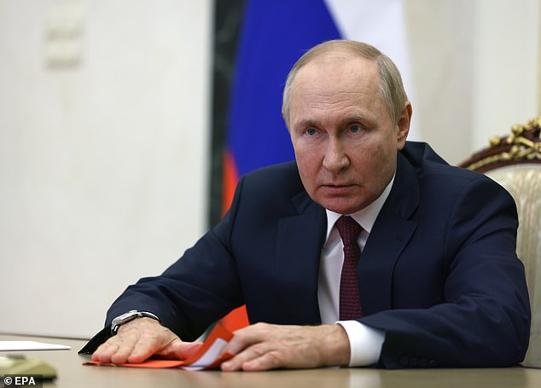

**Russian President Vladimir Putin said the 'sabotage' against Nord Stream is an 'act of international terrorism'**

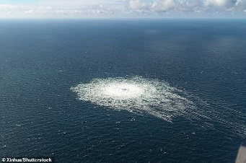

“Thousands of tons of natural gas is now leading into the Baltic Sea, causing a dangerous swell that has disrupted shipping and may cause an environmental catastrophe if the leak cannot be stopped” As Tucker Carlson of Fox New says, notes below, methane gas is spilling out, and into the air – dangerous!

As Steve Quayle, Hal Turner, and other watchmen in with insider intelligence in the highest of places know that the vilification of Vladimir Putin is an abomination on all western medica, of course the epicenter of lies and mind programming coming out of the U.S. public news controlled by those who control President Biden.

What we are doing to Russia from the start, as I have shared with you diligently, it’s all been a lie. Ukraine moved to the border of Russia, threatening Russia. Putin responded. Putin tried and tried to negotiate peace with the U.S. and NATO, but they literally mocked him, because their purpose in the vilification of Putin and Russia is to incite WWIII.

Three world wars were planned in 1871, and written out. They became known as “the Mazzini/Pike Plan.” WWII and WWII were carried out exactly as written. Now, WWIII is being provoked – because after WWIII, the new world order will be set in motion! The globalists, the WEF, and the fallen angels under Lucifer, are working hard to get rid of all opposition, including all humans in general who would stand against their take over. As you’ll read below, Biden bragged about blowing up the pipeline as did a representative of the State Department. Blame it on Russia – absolutely insane! The pipeline was working so well, getting needed gas to Germany. Is this one more confirmation that as Germany has said, if Russia attacks the U.S., and they will, Germany will join Russia. Why is Biden and NATO following suit with him provoking Russia, whose weapons technology is so far superior to that of the U.S. and NATO it is pathetic – and I mean pathetic.

Our military is described well in the book of **Nahum**and **Jeremiah 50-51**, and to do with New York City in **Revelation 18**. President Obama made sure our military was weakened to a pre-WWII condition. Biden has made sure our military is so weak it is pathetic. Yes, our military is being turned into those who are “like women.”

**I’m not going to share all of Steve Quayle’s Private Briefing here. You should go to his website and subscribe to them for yourself: stevequayle.com Yes, they cost a small amount of money each month – but they are well worth it and contain knowledge gained over 50 years of Quayle’s astute reporting. So, he gives no opinions to do with reality – he just reports correctly as well as gives us his zeal for our Savior. I’ve been absorbing his truthful-news reporting since about 2003, and never once have I heard him report falsehood. But, turn on the TV, which was created in the 1930s by Nazi Germany, and get what the TV really is: The world’s greatest mind-programming device of Satan on the planet!**

“BIDEN SABOTAGING THE NORD STREAM PIPELINE HAS STARTED WORLD WAR III!

SEPTEMBER 30TH 2022 [SQ PRIVATE BRIEFINGS](https://www.gensix.com/category/sqpb)

Copyright © **GenSix Productions** 2022, All Rights Reserved

Steve Quayle: **“Ladies & gentlemen, ‘World War is at Our Door.’ Conflict and death on a massive scale has come about in the past for MUCH LESS than what we’ve done with the Nord Stream.** I stated in our last PRIVATE BRIEFING that our so-called leaders have been poking the Russian hornet’s nest, but this really takes the cake. **The puppet-actor Biden bluntly told the world that he would take out the pipeline, and now the pipeline has been sabotaged**. The United States couldn’t be more red-handed with guilt concerning who could have done such a thing. **And it wasn’t just Biden, other American officials promised that the Nord Stream was going down well before this act of terrorism occurred**. Frankly, the obvious nature of their actions has me freshly baffled over just HOW DUMB we can be!



**The great bear that is Russia is about to carry around three ribs in its mouth as spoken about in the book of Daniel. And those three ribs will likely be the U.S./Canada, Britain, and Europe**! **The Russian bear will soon be eating his fill of flesh, and nothing is going to stand in his way**.”

“And there before me was a second beast, which looked like a bear. It was raised up on one of its sides, and it had three ribs in its mouth between its teeth. It was told, ‘Get up and eat your fill of flesh!” **Daniel 7:5**

[AMAZINGLY CLEAR now … this prophecy was a mystery until now. The “bear” has been poked, prodded, provoked, etc., So far Putin has been the master chess player that he is, and held his plans back for check mate, but how much can he take of his pure evil? The world news has vilified Putin and Russia with lies, lies, and more lies and the Western world citizens have believed it.

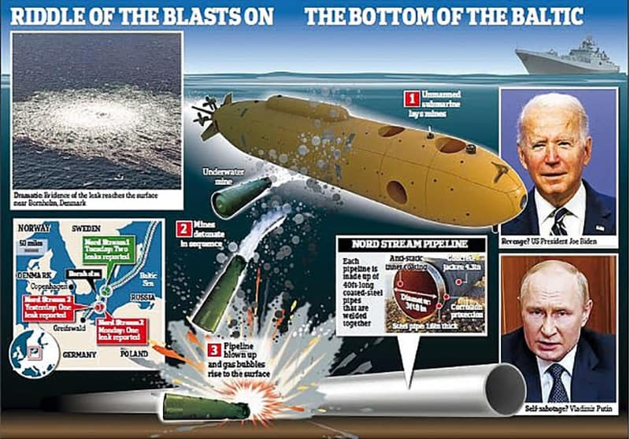

Bottom Line: **What we’ve done against Russia and the Nord Stream pipeline is AN ACT OF WAR”** ('Germany and EU Have Been Handed Over a Declaration of War:' He gives a link in his briefing)

Scripture comes to mind when I feel the frustration of being a citizen in a country that has become a stench in the nostrils of the entire world:

“If the foundations be destroyed, what can the righteous do?” Psalm 11:3

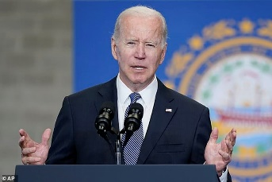

“So then, what can we do? Nothing except cling to Jesus and the Living God, trusting that He sees our faithfulness to Him and to nothing else. I do not consider the Biden Administration 'my government' in any way, shape, or form.

Please accept that America is going under and **the coming ‘day of trouble’ will soon swallow up everyone who has not made preparations to weather the storm**. Prepare while there remains a sliver of time left. The hourglass has already shattered; the sand is pouring out. The next news headlines you may see could be the announcement of full-scale war in every corner of this planet. I cannot say it more clearly than this: **WE ARE OUT OF TIME**!”

**Included in the briefing: “SCIENCE GUY SPECIAL REPORT: SABOTAGING THE NORD STREAM HAS STARTED WORLD WAR III**

Date: **September 30, 2022 Subject: THE MOST DEADLY AND DANGEROUS WHO DONE IT IN THE LAST 1000 YEARS AND CAN END YOUR LIFE IN LESS THAN 20 MINUTES IF YOU WANT TO KNOW WHAT I AM TALKING ABOUT I AM TALKING ABOUT THE DESTRUCTION ON THE NORD STREAM 1 AND NORD STREAM 2 NATURAL GAS PIPELINES.**

**HERE ARE THE KEY FACTS OF THE EVENTS WHICH TOOK PLACE:** 1 **NORD STREAM 1 PIPELINE HAS BEEN RUNNING FOR SEVERAL YEARS DELIVERING NATURAL GAS FROM RUSSIA DIRECTLY TO GERMANY WITHOUT PROBLEMS OTHER THAN ROUTINE REPAIRS**. 2 NORD STREAM 2 WAS BUILT AND TESTED BUT NEVER TURNED ON BECAUSE OF GEOPOLITICAL ISSUES. IT WAS PLANNED TO DOUBLE THE NATURAL GAS DELIVERIES TO GERMANY TO ESPECIALLY HELP THE INDUSTRIAL USERS OF GAS AS RAW MATERIAL IN MANUFACTURING AS WELL AS AN ENERGY SOURCE. IT WAS PARKED AT 104 BARR READY AT ANY TIME TO COME ONLINE AND DELIVER NATURAL GAS TO GERMANY IN HIGH VOLUME. 3 NORD STREAM 1 WAS SHUT DOWN FOR TECHNICAL REPAIRS AND WAS AWAITING THE RETURN THE TURBINE SENT TO CANADA FOR REFURBISH WORK BUT WAS STALLED IN BEING RETURNED BECAUSE OF SANCTIONS. 4 UNTIL MONDAY NIGHT SEPTEMBER 25, 2022, **LEADING INTO TUESDAY SEPTEMBER 27, 2022, BOTH THE A AND B PORTIONS OF THE NORD STREAM 1 PIPELINE SYSTEM WERE IN NORMAL PARKING CONDITION**. 4.1 **THE NORD STREAM 1 PIPELINE SYSTEM WAS “PARKED” BECAUSE DELIVERIES WERE STOPPED FOR GEO POLITICAL AS WELL AS TECHNICAL REASONS**. 4.2 ON TUESDAY LINE A OF NORD STREAM 1 HAD A SUDDEN DROP IN PRESSURE FROM 104 BARR DOWN TO 7 BARR WHICH INDICATED A LARGE LEAK (HOLE) IN THE A PIPE OF THE SYSTEM. 4.3 THEN A WHILE LATER THE B LINE OF NORD STREAM 1 DROPPED OFF FROM 104 BARR NORMAL PRESSURE DOWN TO 7 BARR PRESSURE CLEARLY INDICATING A LEAK (HOLE) IN THE B SIDE PIPE. 4.4 **THIS CLEARLY SAID THAT BOTH HALVES OF THE NORD STREAM 1 PIPELINE HAD BEEN DESTROYED BY DELIBERATE DESTRUCTION CAUSED BY UNDERWATER EXPLOSIONS AND NOT NATURAL CAUSES**. 5 **UNTIL MONDAY NIGHT SEPTEMBER 25, 2022, TUESDAY SEPTEMBER 26, 2022, BOTH THE A AND B PORTIONS OF THE NORD STREAM 2 PIPELINE SYSTEM WERE IN NORMAL PARKING CONDITION**. THE PIPELINE HAD NEVER BEEN BROUGHT INTO SERVICE BECAUSE IT WAS BLOCKED BY GERMAN CHANCELLOR OLAF SCHOLZ WHO STOPPED THE PROJECT AT THE INSISTENCE OF **JOE BIDEN WHO SAID ON MULTIPLE OCCASIONS ON TV THAT HE HAD THE MEANS AND REASON TO STOP THE PIPELINE PROJECT TO DAMAGE THE CASH FLOW OF RUSSIA**. 5.1 ON TUESDAY LINE A OF NORD STREAM 2 HAD A SUDDEN DROP IN PRESSURE FROM 104 BARR DOWN TO 7 BARR WHICH INDICATED A LARGE LEAK (HOLE) IN THE A PIPE OF THE SYSTEM. 5.2 THEN A WHILE LATER THE B LINE OF NORD STREAM 2 DROPPED OFF FROM 104 BARR NORMAL PRESSURE DOWN TO 7 BARR PRESSURE CLEARLY INDICATING A LEAK (HOLE) IN THE B SIDE PIPE. 5.3 **THIS CLEARLY SAID THAT BOTH HALVES OF THE NORD STREAM 2 PIPELINE HAD BEEN DESTROYED BY DELIBERATE DESTRUCTION CAUSED BY UNDERWATER EXPLOSIONS AND NOT NATURAL CAUSES**. 6 THE SEISMIC INDICATIONS WERE SHARP POINTS OF HIGH ENERGY MODERN EXPLOSIVES. WHY IS THIS IMPORTANT? 6.1 SOME PEOPLE TIRED TO PUT FORTH THE CONCEPT THAT IT WAS LANDSLIDES WHICH RUINED THE PIPELINES. 6.2 OTHER PEOPLE TRIED TO SAY IT WAS LEFT OVER WW2 UN-EXPLODED BOMBS THAT HAVE BEEN SITTING UNDERWATER FOR 80+ YEARS WITHOUT EXPLODING. 6.3 **THE ONLY EXPLANATION WHICH MAKES LOGICAL SENSE IS THE DELIBERATE SETTING AND TRIGGERING OF MODERN ULTRA HIGH ENERGY UNDERWATER EXPLOSIVES WHICH CAN ONLY BE DONE BY VERY FEW COUNTRIES**. 7 NOW WE TALK ABOUT WHO THE POSSIBLE PARTY OR PARTIES WHO WOULD WANT THE PIPE LINES DESTROYED. 7.1 THE FIRST AND MOST OBVIOUS CHOICE IS NONE OTHER THAN JOE BIDEN JR. THE CURRENT SUPPOSED PRESIDENT OF THE USA. WHY CAN THIS BE CLEARLY STATED? 7.1.1 **ALL OF THE SANCTIONS PRESSURE AGAINST RUSSIA COMES FROM JOE BIDEN HIMSELF** AND HIS PRESSURE ON EUROPEAN LEADERS EVEN IF THE SANCTIONS LITERALLY DESTROY THE ECONOMY OF EUROPE AND DRIVE IT BACK TO THE 1700’S. 7.1.2 SECONDLY **JOE BIDEN SAID ON MULTIPLE OCCASIONS SAID HE HAD THE REASONS AND TECHNOLOGY TO DESTROY THE NORD STREAM 2 PIPELINE AND PREVENT IT FROM EVER DELIVERING NATURAL GAS TO GERMANY**. 7.1.3 **THIRD JOE BIDEN ALSO SAID THAT NORD STREAM 1 HAD TO BE TAKEN OUT OF SERVICE AS WELL**. 7.1.4 WAS HE JUST SPEAKING AS SLEEPY JOE OR WAS HE DEADLY SERIOUS? UNTIL THE DETAILED UNDERWATER FORENSICS ARE COMPLETED WE MUST ASSUME THAT HE WAS VERY SERIOUS. 7.1.5 ASK YOURSELF WHAT IF SLEEPY JOE AND VICTORIA NULAND WERE WATCHING THE UNDERWATER TEAMS WORKING JUST LIKE TRUMP DID. ASK YOURSELF THIS QUESTION BECAUSE BOTH OF THEM TALKED ABOUT IT LIKE IT WAS A DONE DEAL IN FACT JUST BEFORE THE LEAKS OPENED. WAS IT JUST COINCIDENCE? I THINK NOT BUT THINK AND MAKE YOUR OWN CHOICE. 7.1.6 THERE IS ANOTHER REASON WHICH YOU NEED TO BE AWARE OF WHICH IS THE ONLY OTHER PIPELINE WHICH FEEDS GERMANY AS WELL AS MUCH OF EUROPE GOES THROUGH THE UKRAINE AND HUNTER BIDEN IS ON THE BOARD OF DIRECTORS OF THE COMPANY AND GETS A COMMISSION BASED ON THE VOLUME OF GAS FLOWING TO THE UKRAINE FOR USE IN THE UKRAINE AS WELL AS THE COMMISSION ON THE GAS TO THE REST OF EUROPE. SO, THE BIDEN FAMILY HAS A VESTED INTEREST IN MAKING SURE THEY RETAIN A GRIP ON THE GAS FLOW. 7.2 THE SECOND CHOICE IS PUTIN HIMSELF. 7.2.1 THIS WOULD BE ILLOGICAL THINKING ON HIS PART BECAUSE RUSSIA WAS EARNING MORE THAN THE COST OF THE PIPELINES IN NATURAL GAS SALES TO GERMANY AND EUROPE. 7.2.2 IT IS ALSO ILLOGICAL BECAUSE RUSSIA CAN HALT THE GAS FLOW AT ANY TIME BECAUSE THEY CONTROL THE SOURCE SIDE OF THE PIPELINE SYSTEMS AND HAVE NO NEED TO DESTROY THEIR OWN ASSETS UNDERWATER WHERE IT IS HARD TO REPAIR AND RESTORE. 7.3 WOULD OTHER POTENTIAL EU COUNTRIES TRY TO DESTROY THE PIPELINE SYSTEMS IN THE LOCATION THE PIPELINES WERE DESTROYED? HIGHLY UNLIKELY BECAUSE THE REST OF EUROPE NEEDS GERMAN PRODUCTS AS WELL AS ENERGY FROM GERMANY TO STAY ALIVE. 7.4 IT IS ONLY UNDERWATER FORENSICS WHICH WILL TELL THE FULL DETAILS UNLESS ONE OR MORE PEOPLE INVOLVED IN THE EFFORT CONFESS. 8 NOW WE GET DOWN TO WHERE THE RUBBER HITS THE ROAD: **THE BOTTOM LINE IS THAT THE DESTRUCTION OF THE NORD STREAM PIPELINES IS VIEWED BY THE ENTIRE RUSSIAN LEADERSHIP AS AN ACT OF WAR**. 8.1 THIS MEANS THAT NO MATTER HOW YOU SLICE THE PIE, RUSSIA CAN NOT COMMIT AN ACT OF WAR AGAINST ITSELF, AND ANY OTHER PLAYER WHO HAS THE REQUIRED EXPLOSIVE TECHNOLOGY IS A MEMBER OF NATO. **THIS MEANS THAT IN FACT IF JOE BIDEN ENGINEERED AND ORDERED THE DESTRUCTION OF THE PIPELINE SYSTEMS. HE HAS IN FACT STARTED WW3**.

NOW IS THE TIME TO BE RIGHT WITH GOD AND CONFESS YOUR SINS TO JESUS AND LITERALLY PREPARE FOR NUCLEAR WAR!!! **RUSSIA IS WELL PREPARED WITH BOTH SHELTERS FOR THE CIVILIAN POPULATION AS WELL AS FSB (RUSSIAN SECRET POLICE) RUN UNDERGROUND CITIES. THESE CITIES BEGAN CONSTRUCTION DURING THE COLD WAR SOVIET ERA AND HAVE NEVER STOPPED IMPROVING.** THESE UNDERGROUND CITIES AND FACTORIES AND CITIES ARE RUNNING 24/7 BUILDING WAR EQUIPMENT AS WELL AS WHOLE FACTORIES HAVE BEEN DEDICATED FOR ADVANCED TECHNOLOGY DEVELOPMENT FOR DAILY USE NOW BUT ALSO FOR REBUILDING RUSSIA AFTER A NUCLEAR WAR. NONE OF THE WESTERN COUNTRIES HAVE ANYTHING LIKE THIS AGAIN I WILL SAY NOW IS THE TIME TO BE RIGHT WITH GOD AND CONFESS YOUR SINS TO JESUS AND LITERALLY PREPARE FOR NUCLEAR WAR!!!”

NOW LETS HEAR FROM TUCKER CARLSON OF FOX NEWS:

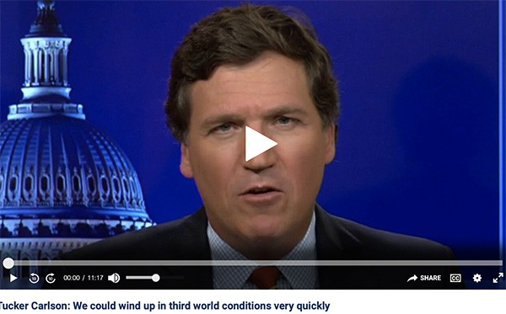

Tucker said: **“Blow up the Nord Stream Pipeline. That is a declaration of war to the greatest nuclear power in the world**.”

**Notes from Tucker’s Fox News Update October 3, 2022**

**PUTIN CALLS 'SABOTAGE' THAT DESTROYED NORD STREAM GAS PIPELINE AN ACT OF 'INTERNATIONAL TERRORISM'**

Tucker says the bubbles coming up from the pipelines are as wide as ½ mile. The bubbles contain methane gas – extremely dangerous release into earth’s atmosphere. Two major underground explosions each one equivalent of hundreds of tons of TNT – then the pipelines began leaking – so sabotage YES! In a press meeting, Biden actually said he wanted to take out the Nord Stream pipeline. A question was asked about how he’d do it. His response, “**I promise you we will be able to do it**.”

Putin is being blamed for it! But, that’s stupid - but Russia is being blamed for everything. The President of Poland said it was sabotage. The gas pipeline in working order would ensure Germans fuel to heat homes and cook with, etc. So, in this senseless act of terrorism by most likely Biden and friends, the saboteurs are injuring the German people greatly. Now Nord Stream I and II are pouring natural gas into the Baltic Sea.

**Carlson said blowing up a methane gas pipeline would have only one reason – to start WWIII. Yes, that’s Biden’s objective – to start WWIII so that America is taken out, and perhaps Britain, Europe, and Canada along with it.**

State Department **Victoria Newland** speaking before Russia took action against Ukraine for breaching its borders, said clearly that **if Russia went into Ukraine, “one way or the other, we will have to take out Nord Stream I and II**.”

**Tucker shows a Video Biden bragging that he’d destroy the Nord Stream Pipeline!**

Natural gas relea ses Methane into the atmosphere … a key element in “global warming” Biden said. The Baltic pipeline carries natural gas from Norway into Poland.

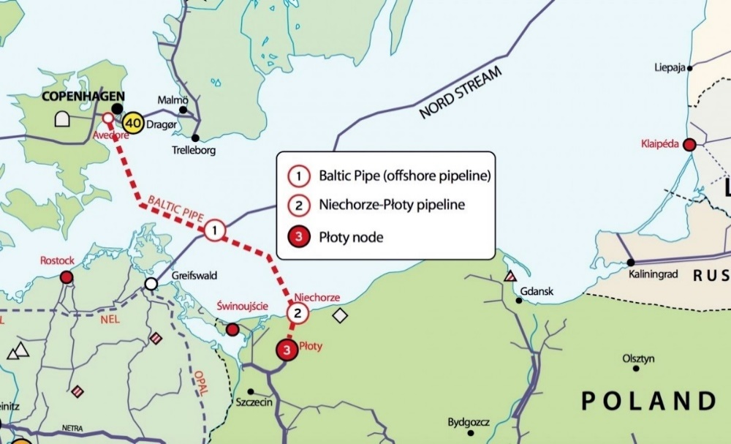

Very interesting – get rid of natural gas delivery from Russia, leaving natural gas delivery to Poland from Norway. It cuts out the competition in the region (Carlson said that after I thought it)

Tucker reported that the White House today is not denying responsibility for blowing up the Nord Stream I and II pipelines. **Why attack the German people, as Carlson said, leaving them for the winter in third world conditions**?

Then comes the commercial from the State Department – without natural gas, everyone can get an electric car. Is this a play to get rid of natural gas, freeze the northern hemisphere’s people, drive them to give electrics cars, and become “do as you’re told” third world citizens? It’s all about several reasons at one time.

Carlson says **“The Biden Administration is destroying countries everywhere.”**

If you read “America’s Secret Destiny,” you’ll see how plans go back into the 1500s. You see Jesuits coming over on the Mayflower to execute the plans. They along with many Secret Societies of Europe, and the Illuminati, and the Shabbtai Tzvi – Jacob Frank world-controlling reality, Free Masons, as led by Albert Pike when he and Mazzini of the Illuminati conceived the plan for three world wars, Ultra Zionists working through the Talmudic rabbis, the Kabbalah rabbis, all join in union to give the world over to Lucifer for his control and that also of the fallen angels. Then you understand better the reason for the exhuming of the body of Nimrod in 2003 in Iraq, his cloning, the Beast on earth, and Revelation 13 - which has happened and is in process of happening.

WWIII is being provoked so hard by America. America is no longer needed for Nimrod and Lucifer to take their throne. In fact, America stands in the way of Lucifer’s total take over, because of so many true born-again Christians in the nation who are also of the House of Israel/Ephraim/Joseph. The plans for the destruction as described in the Bible are now so easy to carry out with Russia’s technology. The great nations of the north that destroys end-time Babylon/America, ruled by the Babylonian Talmud, as is international law, are clearly known now as Russia, China, and North Korea. Iran also is a major player with them.

Where do you stand in relationship with Yahuwah and Yahushua? Are you a good servant of the Master? Are you preparing for the Kingdom? Are you preparing others for the Kingdom. The fearful and cowardly, so says Revelation 21:8 will go into the lake of fire along with the great sinners – for faith and fear cannot co-exist.

Shalom, blessings, love, Yedidah

October 5, 2022