THE THIRD OF FIVE WAVES OF COSMIC ENERGY HIT EARTH AT 12:30 AM EST JUNE 7, 2020

Massive waves of energy have been hitting earth periodically for several years. They are mainly coming to earth from the opposite side of the sun. Scientists are watching this closely. Five specific waves of energy were predicted a few years ago. Two have happened, this morning we were hit with the third. These waves of cosmic energy carry intense radiation. When they hit earth, all life on earth is affected in some way. We’re seeing an increase in the radiation wave spikes, in general. A massive force, not yet fully identified, is moving into our solar system. It has a tremendous gravitational pull. It is sending great debris fields our way also.
Most people are so turned in on themselves in their little in-box existence, that if it does not happen in their backyard, they say it isn’t real. Reality is, that we are being hit with debris coming from several sources. No major asteroids have hit yet, but some very large ones have whizzed very close to earth in the past month. Their number is increasing to many a day. From recent news, for your information: “NASA is tracking a giant asteroid which may be taller than the Empire State Building. It’s set to skim Earth’s orbit June 6th.” It missed us!
Noting insurance claims, and in-nation reporting just in the last few days, 400 homes have been hit by meteors, cars smashed, people even killed, as an on-going phenomenon, one that increasing in various parts of the world.
No American news will not report on anything that distracts people from their mind-conditioning chaos-programming. So, I thought I’d share this with you about today’s event. I include actual Schumann Resonance charts taken this morning. You might have felt headaches, back pain, or some unusual physical phenomenon around, or after, 12:30 AM EST last night. If so, you might have been affected by what I share.

Breaking: "MASSIVE WAVE as Energy Hits Earth" (Cosmic Pulse)
Paul Begley YouTube, June 7, 2020 reporting
Begley showed graphs showing the spike of energy as it hit the earth. I found them on google, and share with you below.
The energy waves are coming from a binary system, in the opposite direction of the sun. They are not coming from the sun! Begley reported from ShadOwburn3d, showing Schumann Resonance instruments, so I knew what to look for on google.
I had a headache this morning, light but felt, and wondered why. I don’t have headaches. Perhaps it was from the waves of energy, which are radiation waves that hit the earth at 11:30 PM CST June 6th, or 12:30 AM EST June 7th.
Begley got in touch with the ShadOwburn3d channel person, he subscribes to Begley’s site, and they confirmed that what “Mike from around the world” said was 100% true. “ShadOsburn” reported that “storms, magnetism, and the Psyche of Living Life will be affected by this.”
These waves of energy greatly affect the magnetosphere. Earth’s radiation protection abilities are lowering.
I didn’t get to sleep until right at 12:30 – hum… interesting. This morning’s major spike (June 7, 2020) at 12:30 AM EST. Begley said “this might be the largest recorded wave of energy to hit earth ever.”
Begley said: “This is the shock wave ahead of the debris field and the asteroids.” He said to expect higher magnitude earthquakes, more volcano eruptions, and tsunamis, as a result of this.
So, with this publicly available data, it is possible for us to monitor current and potentially upcoming geomagnetic activity. All the charts and graphs are live feeds from the various government or university sources.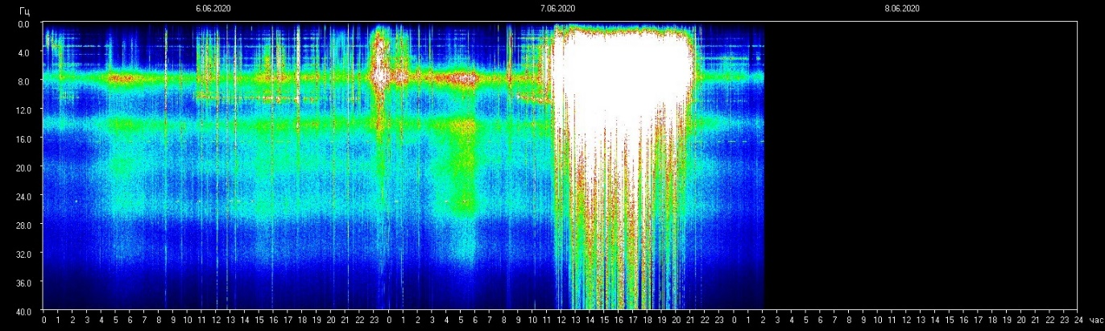
Above, right, we see the major spike at 12:30 AM June 7, 2020 EST
Below, left, we see a huge spike 4 hours apart from the big one at 12:30 AM EST
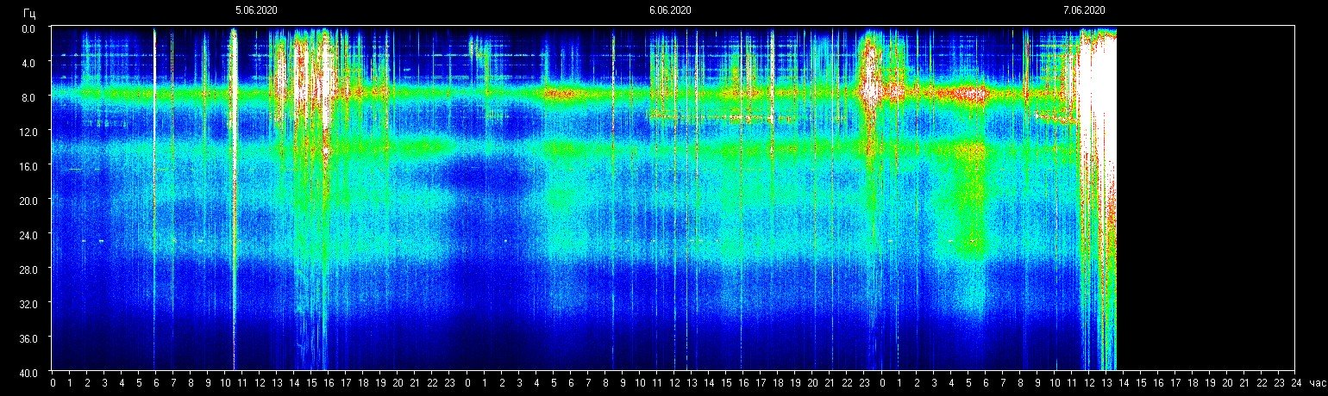
April 5, 2020 below
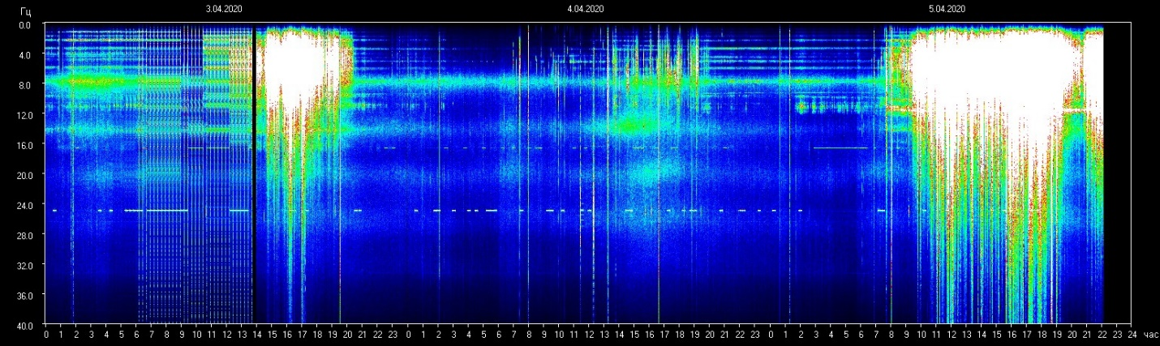
Chart above: April 5, 2020:
From a New Age article with the April 5th graph: “Energy Update: Gaia’s Schumann frequency responded today, with waves of higher frequency that reached a peak of 76 HZ at one point and are still fluctuating upwards in this moment. Gaia’s Ascension is ongoing and can be seen in the raising rhythm of her ‘heartbeat’ into higher frequencies, waves that many of us have been tracking for a few years now as they are an interesting indicator of ongoing Awakening.”
My Comments:
April 5, 2020 was what we call “Palm Sunday,” the day that began the week matching Messiah’s final week perfectly. In His week, He died on a Wednesday just before sunset.
On the previous Sunday, Yahushua road via donkey into Jerusalem for the required 4 days of “inspection” for a Passover Lamb for the nation. The final Lamb for the nation had to be perfect, blameless, spotless, and approved by the highest authority – the High Priest. Yahushua was welcomed with “Hosana, Hosana.” The High Priest was furious. The people laid palm branches down for His donkey to ride on, hailing Him as King. This began the 4 days to declare Him the perfect, unblemished sacrifice.
By lies and deceit, the High Priest saw to it that on the morning of the 14th of Aviv, He was nailed to the tree. They couldn’t find anything wrong with Him, so they slandered Him using false witnesses. Yahushua died with the weight of our sin on Him on Wednesday just before sunset, our April 8th 2020. Passover seder began after sunset into Aviv 15, the eve of April 8th. Yahushua was buried before sunset the 14th of Aviv. As with Jonah, He was in the grave 72 hours. Then He arose victorious just after the sunset of Shabbat night, beginning April 12th, in 2020 - Sunday, the “first day of the week.”
The massive spike of April 5th appears to be bigger than the one this morning. Was it simply a coincidence, or was it a message from Abba? Did Yahuwah declared His Son blameless and spotless, the perfect sacrifice, and all earth joined in to applaud?
The words of the new age commentary above read: “…interesting indicator of ongoing Awakening…The heartbeat of earth is increasing.” Yes, the earth and the entire cosmos is “groaning,” waiting for the coming of Yahushua and the resurrection/awakening of those who died in faith throughout human history!
We’re not finished with the spikes from this wave of energy! More will come, and increase in intensity.
Begley said “the effect on the magnetosphere will be great. Expect heating of the earth, the sun will be scorching greatly.” This scenario is in the Word in many places, in the Prophets, told by Messiah, in the writings of the Apostles, and in the book of Revelation. Revelation 16 says the sun will scorch men with fire?
This morning’s spike is much bigger than the 2nd wave in August of 2017.
Our earth’s rotation is not right. We’re in a pole shift. Our magnetosphere is weakening. Our radiation protection across board is weakening, our Ionosphere is being torn apart by man, as in H.A.A.R.P. 5-G is blanketing the earth, and radiation levels are greatly increasing. So, if you didn’t feel very great this morning, neither did the earth!
In His love, shalom! Yedidah
June 7, 2020

