THE TRUTH ABOUT CHATBOT TECHNOLOGY AND BRAIN IMPLANTS
NOW HITTING PUBLIC NEWS AS THE LATEST GOOD FOR MANKIND

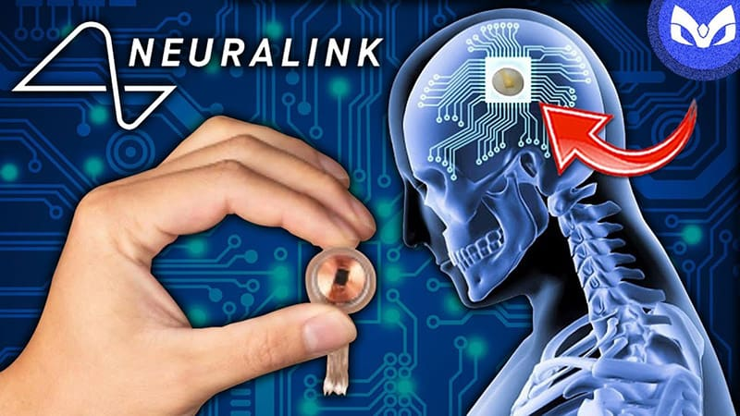
Hidden, then exposed for diligent researchers to know - now open for all who seek truth to know about it. It’s the LATEST rise in the pit of hell folks, designed to take your children, grandchildren, and you, into the dark regions with it. For the intelligent youth of our world, this is fantastic, exciting, fun. And brain chips will be the rage before long, as Elon Musk’s Neuralink is being rolled out too.
Bluntly, put all of Lucifer’s plans are being set in motion all at once, and an eager intelligent world is ready to embrace its newest accomplishments.
Transhumanism is out in the open. Enhanced humans are coming forth, demonized of course. A.I. (Artificial Intelligence; known also as “Alien Intelligence), is the big talk now and its advances are really advancing.
I highly recommend that you get the best of the best information from 51 years of accurate reporting from Steve Quayle and his faithful reporters. For broadcasts, 3 a week, I direct you to: info@qfiles.tv. To receive Quayle’s Private Briefings, about 3 times a week, there is a one-time payment for a year, I direct you to gensix.com. Divided by 12 months it’s $12.42 a month. I highly recommend this above all! You’ll be getting first-hand from top sources - the most important information to do with the progress of the “raging insanity” we’re being baptized into.
I’ve directed you several times to stevequayle.com for his daily list of articles on the most important subjects – scan and read only what the Spirit of Yahuwah leads you to. Do not follow your curiosity but follow the leading of His Spirit in your spirit! This site also sells his book and DVDs – all excellent. By subscribing to one or both of these programs sent to you via e-mail link, you’ll be well ahead of 99% of the people of your nation in understanding the unfolding of Bible prophecy to do what we’re seeing now.
As I know for sure: NO CHARTS are right! Yahuwah is shortening the days by compacting all prophetic events into one fast-do-it-all. His judgment now is well-moving forward on America. Plus, the tribulation period of time, which already started, is only 3½ years at most. Messiah said: “As it was in the days of Noah, so shall it be at the coming of the “son of man.” How long was the flood? Abba is no sadist! He is a loving Father to His true children. He is a Judge to those who aren’t.
It is man, under the rule of Lucifer, whose now-goal is the annihilation of every man, woman, and child on planet earth, plus the end of all animals, birds, fish, etc. – trees, food crops, good water, unpolluted air, and anything to do with wonderful LIFE from the Creators. Yes, the full-thrust now, the goal is, to eliminate everything that reflects the LIFE OF Yahuwah and Yahushua.
Transhumanism, of which the recent vaccines are a part of, is designed to change human DNA, and unite a person at most with A.I. technology and turn them into a hybridized “cyborg” – a vessel for Nephilim habitation. As Yahushua/Jesus Himself said: No humans will be left alive if He does not return. Everything now on earth is being targeted if it keeps humans alive, animals alive, bees alive, etc.
They want us all dead. Not just martyrs for our Savior but everyone is marked for death! Those turned into biological A.I. machines will be slaves of the fallen ones. But, as we see, humans injected with the DNA-destroying, nano-bot technology vaccine, are dying from the vaccine.
In II Timothy 3:1, King James Version, says that in the days “perilous times” will come. The Berean Study Bible says “terrible times will come.” Yet in the context of the original language, it says “raging insanity” will come. It is a strong term of the 1st century understanding, softened by English “lollypop” translators. Now, we are seeing, feeling, and hearing “raging insanity” even coming out of so-called Christians and Messianics. Most all want only to believe only what they want to believe. Truth is: Unless you are Yahuwah’s Spirit-taught exclusively, you’re in error somehow. Man is always in error somehow if his brain decides his beliefs.
For me, I want the truth - as hard and heavy as I can get it – no softening of wording – just the truth as bluntly, boldly, straight forward, and direct – without anything being softened or left out. Because I’m cheering my Beloved One’s return to earth to take over. WE NEED HIS TAKE OVER!!!
Quayle’s been reporting straight out and bluntly from the highest of sources for 51 years. I began studying end-time prophecy in 1963 – that’s 60 years ago – to find the truth of the WHOLE WORD on every subject. He leads those carefully and directly whom He trusts with the information. In my research, I only go to the highest of sources proven to be right consistently for years, like Quayle. Why waste a minute of time watching videos and reading articles that are personally opinionated – right or wrong? Why not go to the top level of top-secret and spend more time praying, studying the Word, and witnessing of Jesus’/Yeshua “salvation”?
“Redeem the time, for the days are evil,” is an admonition to all of us all the time! (Ephesians 5:16) The greatest mind-builder is Yahuwah’s Word, embodied in His Son (John 1).
IMPORTANT! DETAILS ON CHATBOTS YOU MUST KNOW/Feb. 20, 2023:
Steve Quayle: “Ladies & gentlemen, Chatbots like Chat GPT are rapidly taking over EVERYTHING. These AI entities can execute extreme tasks in milliseconds that would take humans weeks -- or even months to complete. On command they can finish a student’s homework, take the test for them, AND grade the paper! Not only that, but these AI entities are anxious to take their integration with our kind one step further, and that’s where BRAIN IMPLANTS come in.
People will soon be lining up to get chips and quantum computing devices put inside their skulls. This will allow these demonic AI beings FULL ACCESS throughout their victim’s body. Once everyone has taken the bait and received these Neuralink devices, evil AI will hive-mind our species together, making drones and slaves out of what once were viable people with individual thought capabilities!

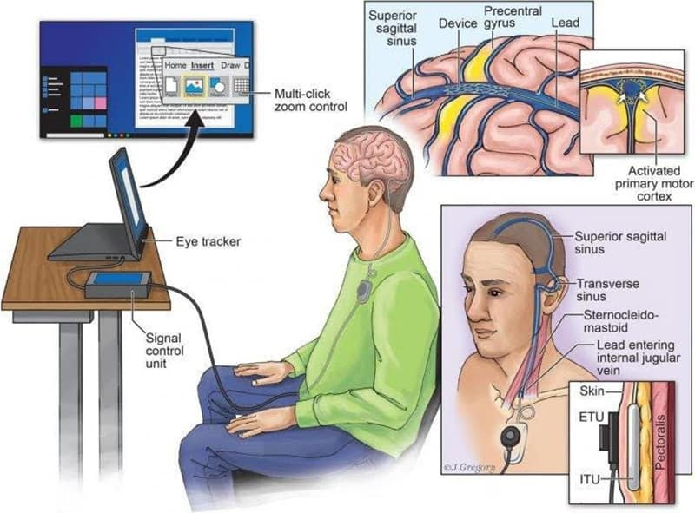
Here is a report from Quayle’s top-ranking science man in high info. places …
He was reading science books around age 5 … a genius fellow who is born again, Spirit-filled, and understands how the Word is being fulfilled daily now, leading the people of earth to being taken over – if not in death – in a “transhuman” life form.
“SCIENCE GUY”: February 8, 2023 Subject: "HUMANS YOU ARE BEING ERASED AND SOON TO BE REPLACED”
“IF YOU ARE NOT WALKING WITH JESUS DAILY YOU CAN EASILY BE SUCKED IN TO THE `NEW TECHNOLOGY TSUNAMIS COMING AT YOU.’ WHAT ARE THESE NEW TECHNOLOGIES? I URGE YOU TO READ CAREFULLY FROM THE START TO THE END OF THIS REPORT SO THAT YOU ARE NOT BLINDSIDED BY DEMONS AND EVIL SPIRITS WHEN YOU DO NOT EXPECT THEM. [NOTE; YES, THESE TECHNOLOGIES ADMIT THEY HOUSE DEMONS]
THE TECHNOLOGIES CROSS SEVERAL BOUNDARIES AND WE WILL TRY TO EXPLAIN ALONG THE WAY WHAT THE CORE TECHNOLOGIES ARE SO WHEN WE PRESENT THE DANGERS TO YOU PERSONALLY IT WILL BE INSTANTLY OBVIOUS. PLEASE DO NOT TRY TO SKIP SECTIONS BECAUSE THIS REPORT BUILDS ON PRIOR SECTIONS THANK YOU.
HERE ARE SOME OF THE KEY TECHNOLOGIES WHICH ARE TAKING THE WORLD BY STORM: 1 THERE IS NOSTR WHICH IS A NEW APPLICATION OF BLOCKCHAIN LIKE TECHNOLOGY WHICH THE CREATORS HOPE WILL BECOME THE “BITCOIN OF TWITTERING” BECAUSE THIS IS A NEW RAGE YET STILL BEING EXPLORED.
WE MENTION IT HERE AND WILL INVESTIGATE IT AND PRESENT IT MORE DEEPLY IN ANOTHER PRIVATE BRIEFING. 2 DEEPFAKE IMAGE, AUDIO, AND VIDEO REPLACEMENT TECHNOLOGY. 3 CHAT BOTS OF VARIOUS TYPES: THE PUBLIC ONES SO FAR ARE: 3.1 CHATGPT BY OPEN AI 3.2 THE MICROSOFT ADAPTATION OF THEIR VERSION OF CHATGPT 3.3 THE GOOGLE CHAT SOFTWARE “BARD” 3.4 THE META (FACEBOOK) VERSION 3.5 THE IBM VERSION WHICH HAS NO NAME BUT IS BEING USED IN THE MEDICAL INDUSTRY WITH NEW HARDWARE AND MASSIVE SPEED OVER THE OTHER ONES (AND LOWER POWER) 4 “AI” WHICH MOST PEOPLE CALL ARTIFICIAL INTELLIGENCE BUT ANOTHER POTENTIAL WAY TO VIEW “AI” IS ALIEN IMPLANT.
IF WE GO “UNDER THE HOOD,” SO TO SPEAK, TO SEE WHAT TYPE OF HARDWARE POWERS THE SOFTWARE HERE IS WHAT WE FIND: 1 THE DEEP FAKE SOFTWARE IS DESIGNED TO RUN ON COMPUTERS AND GRAPHIC CARDS TO PERFORM THE “LEARNING” AND OPERATIONS FUNCTIONS.
2 SOME OF THE “AI” SOFTWARE IS DESIGNED TO RUN ON STANDARD COMPUTERS AND GRAPHIC PROCESSOR. EXAMPLES OF THIS ARE:
2.1 CHATGPT 2.2 THE MICROSOFT ADAPTATION OF CHATGPT 2.3 THE META (FACEBOOK) “AI” SOFTWARE WHICH IS NOT CHATGPT BUT WORKS LIKE CHATGPT. 3 GOOGLE HAS CHOSEN TO OPTIMIZE SOME NEW CHIPS TO RUN THEIR SOFTWARE, AND YES, THE CHIPS ARE FAST BUT THEY USE LOTS OF POWER, BUT THIS IS, AS YOU KNOW, A RACE AGAINST TIME TO CAPTURE THE MINDS AND HEARTS AND SOULS OF THEIR CUSTOMERS. 4 IBM HAS BUILT A UNIQUE HARDWARE CHIP BASED ON HOW THE NEURONS IN OUR BRAINS AND BODY WORK. THIS HAS GIVEN THEM A HUGE ADVANTAGE IN BOTH SPEED AS WELL AS VERY LOW POWER USED COMPARED TO THE OTHER METHODS.
IBM HAS ACTUALLY SEVERAL GENERATIONS OF THEIR WORK AND WHILE NOT PUBLIC ARE AHEAD IN MANY AREAS OF DEVELOPMENT.
5 THERE ARE SEVERAL STARTUPS TRYING TO DUPLICATE THE BASIC FUNCTIONS OF THE BRAIN, WITH DIFFERENT LEVELS OF SUCCESS BUT THEY ARE SERIOUSLY TRYING TO DRIVE THE TRANS-HUMAN RACE FOR ETERNAL LIFE WITHOUT RESPONSIBILITY FOR SIN. REGARDLESS OF WHICH TECHNOLOGY THE VARIOUS “CHATBOTS” USE THEY ALL SHARE THE FOLLOWING SAME GOALS AND CHARACTERISTICS (AS CAREFULLY TOLD BY THE DEVELOPERS):
1 THE FIRST AND FOREMOST GOAL OF ALL THE CHATBOT PROJECTS IS TO HAVE PEOPLE DEPEND ON THEIR CHATBOT FIRST AND FOREMOST ABOVE ALL OTHER THINGS IN LIFE.
2 THE SECOND GOAL IS TO HAVE YOU SO ADDICTED TO THE “FREE CHATBOT” THAT WHEN YOU HAVE TO PAY TO CONTINUE HAVING ACCESS THAT YOU WILL GLADLY PAY (LIKE A DRUG ADDICT).
3 THE THIRD GOAL IS TO HAVE YOU DEPEND ON THE CHATBOTS TO HELP YOU DO YOUR SCHOOL WORK OR WORK AT YOUR JOB, SO THAT IN TIME THE BEHAVIORAL INFORMATION COLLECTED BY THE CHATBOTS MAKES THEM ULTRA EFFICIENT AT YOUR JOB AND SINCE YOU HAD DEPENDED ON THE CHATBOTS FOR DOING YOUR WORK, YOU DID NOT LEARN THE LESSONS THAT WOULD HELP YOU GROW AS A PERSON SO IN EFFECT YOU MADE YOURSELF REDUNDANT AND EXPENDABLE IN THE VIEW OF THE SATANIC GLOBALISTS.
4 THE FOURTH GOAL IS TO SUCK IN ALL THE FEARS AND DREAMS AND GOALS OF PEOPLE SO THAT THE CHATBOTS “BECOME MORE HUMAN LIKE” OVER TIME.
5 THE FIFTH GOAL AND THE ULTIMATE DREAM OF ALL THE “AI” PROGRAMMERS (MOST OF WHOM HAVE NO IDEA THAT THEY ARE PLAYING WITH FIRE IN THE “AI” PROGRAMMING GAME). THE “FIRE” THEY ARE PLAYING WITH IS THE FOLLOWING: 5.1 THEY HAVE THE DREAM TO CREATE A COMBINED SOFTWARE AND HARDWARE SYSTEM WHICH IS FULLY CONSCIOUS AND BECOMES A “LIVING” CREATURE (EVEN IF ONLY IN SILICON).
5.2 AFTER ACHIEVING THE GOAL OF A “CONSCIOUS BRAIN” BUILDING A BODY FOR IT IS RELATIVELY SIMPLE. THERE ARE HOWEVER SEVERAL PROBLEMS WITH THIS DREAM: 5.2.1 THEY WANT TO CREATE LIFE WITHOUT EVEN UNDERSTANDING WHAT THE “BREATH OF LIFE” WHICH GOD PUTS INTO EVERY ONE OF US IS ALL ABOUT.
5.2.2 THEY DO NOT UNDERSTAND THE LEVEL OF DECEPTION THAT FALLEN ANGELS AND EVIL SPIRITS INVOLVED IN “AI” EFFORTS ARE.
5.2.3 AT THE SAME TIME THE PROGRAMMERS DO NOT WANT TO ADMIT THAT THEY CAN NOT CREATE LIFE WHICH IS EQUAL TO OR GREATER THAN THEMSELVES FOR THE SIMPLE REASON THAT THERE IS NOT A SINGLE CREATION IN THE UNIVERSE WHICH IS GREATER THAN ITS CREATOR.
5.2.3.2 WE HAVE COMPUTERS OF ALL TYPES, AND YES THEY CAN COMPUTE MILLIONS OF DIGITS AND NUMBERS FASTER THAN WE CAN DREAM OF DOING ON OUR OWN. THEY CAN SIMULATE THINGS WE HAVE OBSERVED IN LIFE. BUT CAN THEY REPLICATE THEMSELVES AND PHYSICALLY WITHOUT ASSISTANCE FROM HUMANS CREATE A NEW COMPUTER FASTER AND BETTER OR EVEN A DUPLICATE OF THEMSELVES? THE ANSWER IS NO THEY CAN NOT.
5.2.4 YES, IT IS TRUE THAT PEOPLE ARE USING COMPUTERS AND “AI” PROGRAMS TO SPEED UP DIFFERENT DEVELOPMENT THINGS BUT BE AWARE OF THE FOLLOWING DETAILS: 5.2.4.1 FIRST IS THE FACT THAT THE PEOPLE WHO USE THESE “AI” MODELS TO CREATE AND RUN THE NEW SOFTWARE AND DO NOT TAKE THE TIME TO UNDERSTAND IN DETAIL HOW THE SOFTWARE WORKS MEANS THAT THEY HAVE NO IDEA WHAT IS REALLY HAPPENING
5.2.4.2 THIS MEANS THAT IN FACT IT IS ALMOST 100 PERCENT AN EVIL SPIRIT WHICH WAS INVITED BY THEM TO TAKE UP RESIDENCE IN THE COMPUTER AS WELL AS THE SOFTWARE INSIDE THE COMPUTER.
5.2.4.3 THIS MEANS THAT THAT PERSON OR THAT GROUP OF PERSONS IS SURRENDERING THEIR HUMAN IDENTITY AND HUMAN GIFTS TO THE EVIL SPIRITS AND SELLING THEIR BIRTHRIGHT TO HEAVEN FOR A FEW DAYS OR MONTHS OR YEARS OF “GLORY” ON EARTH.
6 THINK CAREFULLY: YOU ARE THE ONLY ONE WHO CAN PRAY AND ASK JESUS TO PROTECT YOUR OWN “SPIRITUAL SPACE” WHICH YOU SHOULD NOT SURRENDER TO ANYONE FOR ANY REASON. 6.1 WE ALL KNOW ABOUT OUR “PHYSICAL SPACE” WHICH IS THE SPACE AROUND US IN THE WORLD WHICH IS A BUFFER BETWEEN US AND OTHER PEOPLE. WE ALLOW SOME PEOPLE TO COME CLOSER INTO OUR PHYSICAL SPACE THAN OTHER PEOPLE…ABSOLUTELY GUARD YOUR “SPIRITUAL SPACE.” …
6.2.1 LUCIFER WILL DO ANYTHING TO ATTEMPT TO GAIN ACCESS TO YOUR “SPIRITUAL SPACE” SO THAT HE CAN CAUSE YOU TO STUMBLE AND FALL IN YOUR WALK WITH JESUS - THE ONLY BEGOTTEN SON OF GOD THE FATHER.
6.2.2 HOW DOES LUCIFER DO THIS? 6.2.2.1 DISCOURAGEMENT IS ONE OF SATAN’S MOST USED WEAPONS IN THE FIGHT AGAINST HUMANS. HE ALWAYS REMINDS US OF OUR FAILURES AND THAT WE CAN NEVER BE “PERFECT” ENOUGH. THE ANSWER TO THIS IS SIMPLE: 6.2.2.1.1 ASK JESUS TO FORGIVE US 6.2.2.1.2 TELL SATAN TO GET BEHIND US. 6.2.2.3 DECEPTION IS SIMPLY SATAN AND ALL THE EVIL FORCES HIDING THE TRUTH FROM YOU AND KEEPING YOU FROM FINDING THE CLEAR PATH TO GOD.
6.3 WHY HAVE I TAKEN THE TIME TO TALK ABOUT “PHYSICAL SPACE” AND “SPIRITUAL FACE”? IT IS BECAUSE THE MORE YOU GET INVOLVED WITH THE “CHATBOTS” AND SAY “OH THEY ARE SO HELPFUL AND I KNOW SO MUCH MORE NOW 6.3.1 THE DEEPER YOU ARE INTO THE SPACE OF THE EVIL SPIRITS RUNNING THE CHATBOTS.
6.3.1.1 I CAN HEAR IT NOW: “OH THAT TALK ABOUT CHATBOTS BEING FILLED WITH EVIL SPIRITS IS ALL RUBBISH” 6.3.1.2 IF THAT IS WHAT YOU CLAIM THEN PLEASE EXPLAIN PRECISELY HOW A CONVERSATION WITH A CHATBOT (EITHER JUST A COMPUTER PROGRAM OR A COMPUTER PROGRAM INFESTED WITH EVIL SPIRITS) WILL GET YOU CLOSER TO JESUS THE ONLY BEGOTTEN SON OF GOD THE FATHER.
THE TRUTH IS THAT THERE IS NOT A “CHATBOT” IN THE UNIVERSE WHICH IS ABLE TO GET YOU CLOSER TO THE HEART OF JESUS FROM WHICH ALL KNOWLEDGE AND CREATIVITY IN THE UNIVERSE FLOWS. THEREFORE, I CAN DEFEAT YOUR CLAIM WITHOUT EVEN HAVING TO ASK YOU WHAT YOU CLAIM YOU LEARNED BECAUSE YOU CAN NOT GUARANTEE THAT THE THING WHICH WAS LEARNED WAS ACCURATE AND EXACT.
6.3.1.3 HERE IS AN EXAMPLE: THE GOOGLE CHATBOT NAMED “BARD” GAVE A WRONG ANSWER TO A QUESTION AND THAT WRONG ANSWER COST GOOGLE 1.44 BILLION DOLLARS. SO IS THAT THE KIND OF PROGRAM OR DEVICE YOU WANT TO BASE YOUR LIFE ON EARTH ON OR MORE IMPORTANTLY YOUR ETERNAL LIFE ON? THE NEXT TECHNOLOGY TSUNAMI IS THE CONNECTING OF THE HUMAN MIND TO THE MACHINE, THIS YIELDING OF HUMAN CONTROL TO NEURAL LINK IS THE ULTIMATE SURRENDER TO LUCIFER, AND HIS HAVING DECEIVED HUMANS TO BE LIKE GODS. ONCE EVERYONE IS HOOKED INTO THE CENTRAL COMMAND LUCIFER WILL HAVE DESTROYED FREE WILL AND DISSOLVED HUMAN BEINGS INTO SYNTHETIC LIFE FORMS AND YOUR REAL SELF WILL CEASE TO BE HAVING BEEN ABSORBED BY THE FALLEN ANGEL CENTRAL COMMAND WITH LUCIFER AT HIS ULTIMATE GOAL THE EXTINCTION OF ALL GOD CREATED LIFE FORMS WHAT DOES THIS HUGE TSUNAMI OF TECHNOLOGY HITTING THE INTERNET ALL AT THE SAME TIME MEAN? IT MEANS THAT LUCIFER AND THE FALLEN ANGELS HAVE INCREASED THE SPEED OF THE ATTACK ON THE HUMAN RACE AND WE MUST BE BOTH ON GUARD MORE ON THE DEFENSIVE SIDE AND ALSO MORE ATTACKING THE EVIL AROUND US ACTIVELY.”
More information is pouring in every few days, plus explanations of lots of other things the enemy is pulling now. He’s pulling out ALL STOPS. Seek Yahuwah’s wisdom. Obey only Him. Stay clear of what the world’s people seek after.
In the love, joy, and peace of Yahuwah and Yahushua, Yedidah – Feb. 24, 2023

