THE UNITED NATIONS AND THE NEW JAGUAR STATUE AT ITS GATE
THEIR SYMBOL OF PEACE AND SECURITY

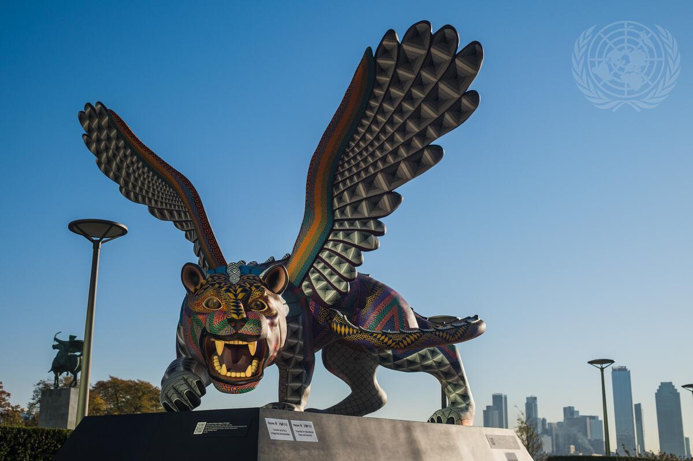
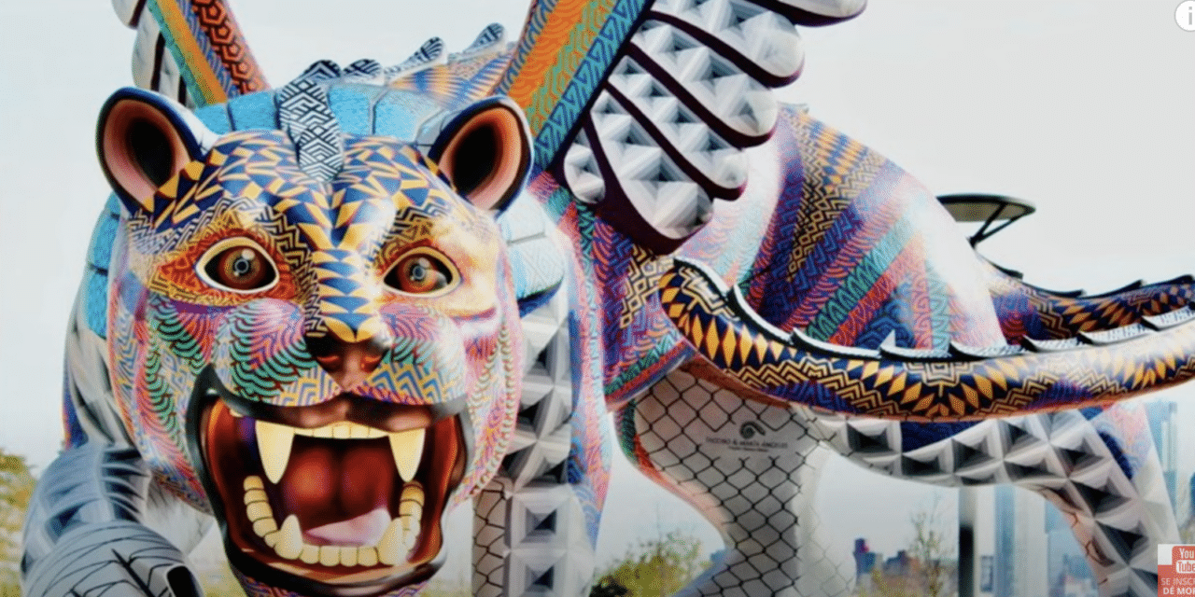

A GIFT FROM MEXICO TO THE UNITED NATIONS – WHY NOW?
The U.N. is exposing its roots and its goals for bringing the Beast to power for the world’s people to embrace as good. It’s true meaning is well hidden, while known well to the servants of Lucifer.
No, the jaguar is not the symbol of the 7-headed, 10-horned, Leviathan of Revelation 13:1-9. However, it is an ancient symbol of the fallen angels and their Nephilim offspring with human women among the Aztec Indians of Mexico. The worship of the jaguar god resulted in the slaughter of tens of thousands of children and adults in its honor, for the jaguar god demanded blood sacrifice. The statue was given to the United Nations by Mexico recently.
“The sculpture was created by artists Jacobo and Maria Angeles called the “guardian for international peace and security” and sits on the Visitor’s Plaza outside the UN Headquarters.”

WHAT IS THE MESSAGE OF THE JAGUAR STATUE?

I’m going to give you a few notes from Paul Begley’s broadcast on last Thursday night, December 9, 2021, from his guest “Mike from around the world.”
Mike starts out talking about how close it is until the whole shelf of the West coast, Vancouver, Canada down into Mexico breaks off into the sea. The USGS has had a gag order on the quakes happening in the Pacific Ocean off the Cascadia region and the San Andreas region. Now they are sharing some of the continual big quakes of 5.0 and above without comment.
The Cumbre Vieja volcano on La Palma Island, which has been erupting violently since the week of September 11, 2021 in Spain’s Canary Islands, is now splitting the island, as the magma flow burst forth from the bowels of the earth. In the same way, on the west coast, the magma is moving, the tectonic plates are moving, the 11 volcanoes to the east are coming alive.
So, here’s my questioning. Jeremiah 51:42, 55 clearly state that waves come upon end-time Babel, the returned Nimrod’s parent nation, the “Apollyon,” and destroy it. Is it possible that the expected tsunami from La Palma across the Atlantic, and the expected breaking off of the western shelf on the Pacific, will happen close to the same time? The Deagle Report of the Rockefeller Foundation has a graph that shows America’s population being reduced from 350 million down to about 60 million almost overnight by 2025. They must know something is being planned to be orchestrated by the technology of the fallen ones in the hands of the weather warfare/new world order humans. The “full-court press” is on to depopulate the earth quickly down to 500 million – to be hybridized and hook up to A.I. (Artificial Intelligence/Alien Intelligence) – as slaves of the fallen elite.
Both events of unnatural “natural” disasters on both coasts, which could include the New Madrid Fault Line splitting the U.S. in two, could happen close together. The need for nuclear attack would be unneeded, only the “clean up” of those remaining alive by all the tens of thousands of Chinese and Russian soldiers inside the U.S. and their terrorist, criminal, assistants.
In the meantime, so nice of Mexico to give this satanic jaguar statue to the United Nations to be put outside their Visitor’s Center.
No, it is not Leviathan of Revelation 13 with 7 heads, 10 horns, and bestial appearance representing the 7 empires of the past out of which the final Beast arises to rule the earth. However, the jaguar god of ancient Indian tribes in Mexico who worshipped the jaguar and offered human sacrifice to the fallen angels, carries a message.
From on-line information: “As for the mythology and legends, the jaguar was seen as a god in Peru, Mexico, and Guatemala, in pre-Columbian America. The Mayans, Aztecs, and Inca all worshiped the jaguar in some form. In the pantheon, the jaguar god was second only to the snake god in religious importance.”
Here are pictures of ancient symbolism of the jaguar god of the Aztecs:

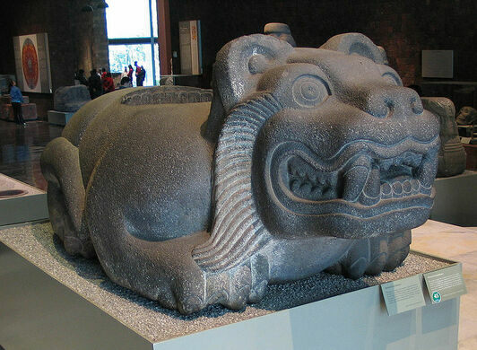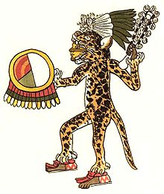
Ancient statue of Aztec Jaguar god The Aztec warrior god

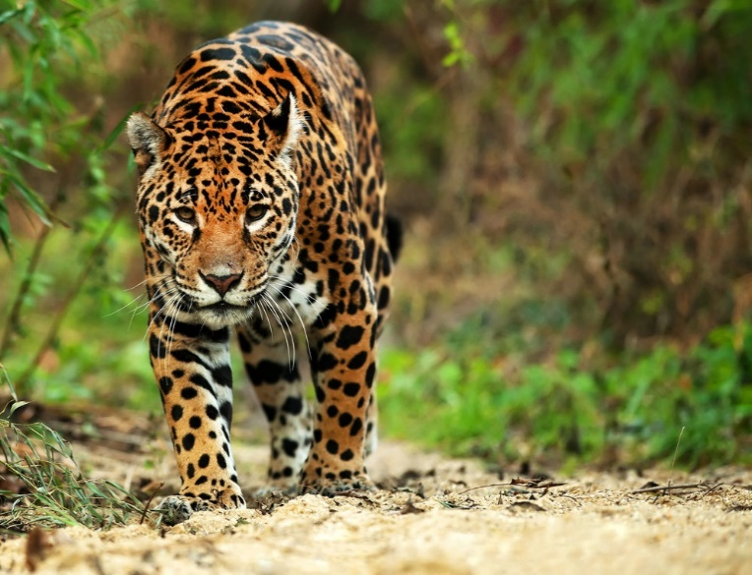
This powerful cat, the jaguar, can kill with one blow of its paw.

NOTES FROM MIKE FROM AROUND THE WORLD ON THE STATUE OF THE JAGUAR GIVEN BY MEXICO TO THE UNITED NATIONS
“The statue is a god-like image of a jaguar. The jaguar was the symbol of the Mayan culture, a blood-thirsty culture of human sacrifice, as were the Aztecs and Incas of Mexico.
Mike said that the fallen ones will amass around this statue – the one of the god-jaguar given to the United Nations.
Mike said: “To have it displayed in such brilliance in front of the satanic United Nations speaks of one thing – human sacrifice must happen in order to appease the coming of Lucifer and the Beast, who will rule earth.”
Mike told how on earth the jaguar god did not have wings, but in his resurrection, the jaguar takes on wings. Thus, the United Nations is saying they will resurrect him from the underworld – to be the god of the nations.
Mike: “The jaguar is representative of power, and authority, and rule, valor, and the embodiment of aggressiveness. He represents the god of the underworld.” So the jaguar represents Lucifer-Satan incarnate ruing the earth. The U.N. is controlled by Satanists.
The U.N. says that this jaguar god is the guardian of peace and security.
Mike said “It is time for that door to open.” He spoke of the door opening for the entrance of the Beast, the 7th Beast, Leviathan. Mike said that the setting up of this statue of the resurrected jaguar sent to the U.N. by Mexico is honoring something. Yes, it is honoring the rising of Nimrod’s spirit from the underworld into his cloned body – to take his place as the “resurrected one,” in the earth.
In Revelation 13, when it talks about the “deadly wound” of one of the 7 heads, or empires, of this Beast being healed. The word in Aramaic is not “healed,” but “resurrected.” The one in Revelation 9:11 is resurrected to enter his cloned body from his own DNA – Nimrod/Gilgamesh/Osiris/Apollo-
Apollyon. America, from the late 1500s, early 1600s, was the chosen nation to bring him back and restore him to power. America was founded by both those who were born again Bible believers, but also by those who secretly mixed in among them of the “Order of the Quest,” and other European secret organizations. Their goal was the return of Nimrod. Part of the stated goal of the E.U. was to aid Nimrod’s return to power.
As most of you are aware, the U.S. started a war, based on lies, with Suddam Hussein, in order to get into Iraq with our soldiers in 2003. Our soldiers oversaw the unearthing of Nimrod’s body, his treasures, and his parchments on the building of his tower. The parchment-instructions on the Genesis 11 tower were given to CERN to open portals into the underworld to bring forth what has been kept there until now. Look at what rises with Nimrod – locust type creatures who are given the power to sting all who do not have the seal of Yahuwah in their forehead.
The jaguar represents the Aztec, the Maya, those who shed the blood of tens of thousands to their jaguar god.
The message of this jaguar statue is that the beast from under the underworld is ready to rule – whose rule will be overseen by the United Nation and its role also as false prophet. Its power is rising as things like this statue bring fallen angel and Luciferic power into the earth. The human sacrifices to the fallen angels, Lucifer, and the Beast are increasing. Recently tens of thousands of children were sacrificed – after the ½ million world over at Halloween. This increase in blood sacrifice is to assure the fallen ones of the support of earth’s “elite.”
Thus, in being so proud of this statue, the United Nations is announcing the Beast has arisen! The god promised the ancient Aztecs a 1,000-year reign over he earth.
***Mike told how the Maya, Aztec, and Incas were frenzied to sacrifice children, babies, and adults to the jaguar god so that he would return to earth and set up a 1,000-year kingdom. Today, very few have any emotion or desire for Messiah Yahushua to return. Professing believers care little about Him, or deny Him entirely.
Mindboggling but true: All the great pagan nations and rulers were offered, by Satan, a 1,000-year reign on the earth. Look at Revelation 20:4-7. The 1,000-year reign is also foretold in Isaiah 35, and Isaiah 65, etc.
All that “father of lies” can do is counterfeit the words of Yahushua to Yochanan the apostle on Patmos, that He would reign in His Kingdom 1,000-years on this earth before we go into eternity.
The Hindu god Shiva stands at the entrance to CERN who now has Nimrod’s technology to open portals, doorways, gates, stargates into the cosmos or under the earth.
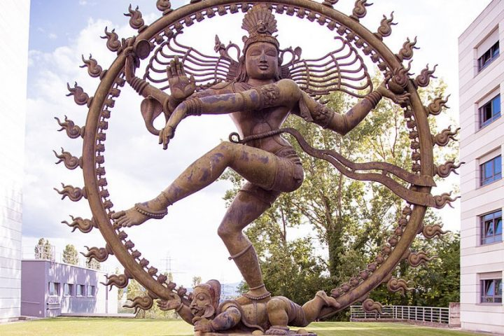
The god Shiva, the Destroyer, Hindu god dances as it crushes This is outside the headquarters of CERN on the Swiss-French border, where the force of the Great Hadron Collider opens portals into the underworld and the cosmos.
Do you see the 3 sixes in the symbol of CERN?
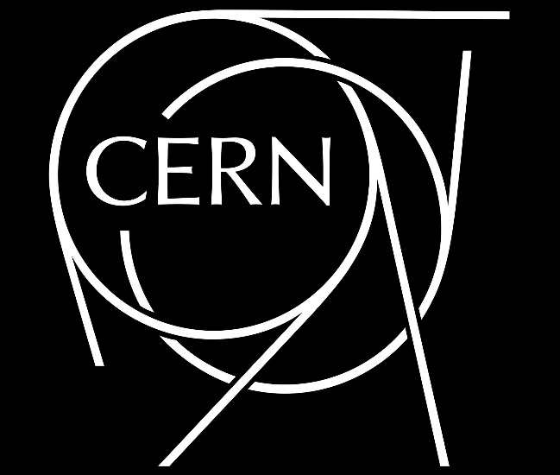
Who identifies with Shiva?
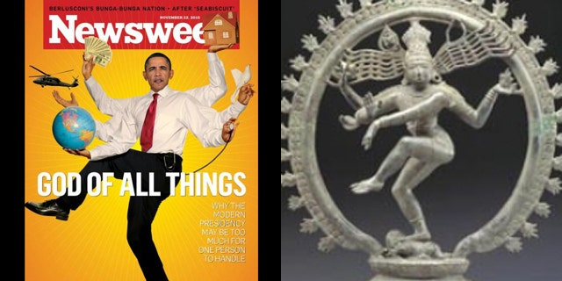
(Newsweek/AP) What is Obama’s message to the world?
Mike returns to his speaking of “the door.” He says that a door has opened and the beast has arisen onto the earth, and the door is wide open for him to go through. Actually, and in reality, “He is invited by the U.N. to take his throne.”
Mike talked about the power of the Beast to take over the minds of people. He said that so many believers are saying, “I’ll never worship the Beast.” Yet, Mike said, “they’ll be the first in line to bow to him.” Why is this? Review the truths in the article “The Greatest Warning of All.” Thought implanting into the subconscious mind - technology can do this.
“Along with the technology to implant thoughts is the ability to implant good feelings about doing something a person would never ordinarily do.”
The UN is saying that this is a wonderful gift from Mexico to the world. It’s all about “peace and security.” Mike said that two other such statues of the jaguar will be put up – one overseas, and another in South America.
I Thessalonians 5:3: “When they say `peace and safety’ then sudden destruction comes upon them, as labor pains upon a pregnant woman, and they shall not escape.” Daniel 8:24-23!
Mike said that in the U.N., in their religious areas like that of the black stone, as in the picture in the 3rd article of this series under the Mikvah of Present Reality, they are conducting seances and doing human sacrifices. The U.N. is a false prophet to the world, the forerunner of the Beast, and the enforcer of laws over all the people of earth.
Mike concluded: “Time is so precious, every day is precious, and we’re running out of time…” Right on!
Why has Abba has had me writing now 4 key articles on the U.N. and its true purpose? I only know that it has to do with what is about to happen that we must prepare for. Please share these articles. This is “present reality.”
Shalom, love, and blessings in the resurrected Yahushua Messiah!!! Yedidah
December 12, 2021

